THE IMPACT OF INTIMATE PARTNER VIOLENCE (IPV) ON POST-TRAUMATIC STRESS DISORDER (PTSD) IN WOMEN IN SUB-SAHARAN AFRICA

BY

ERROL MCCALLA

STUDENT NO: 2028568

MODULE: INTRODUCTION TO RESEARCH

MODULE CODE: BMHP5005

NOVEMBER 2023

ABSTRACT
Introduction: The well-being of victims of intimate partner violence (IPV) is greatly impacted, with mental health in Sub-Saharan Africa being particularly affected. The present research examines the prevalence of PTSD in women from Sub-Saharan Africa who have experienced IPV. It seeks to identify risk factors for the onset of PTSD and investigate useful therapies to lessen its effects.
Background: Sub-Saharan Africa has high rates of intimate partner violence (IPV), which frequently results in PTSD due to unique societal circumstances and gender inequalities. However, due to certain cultural characteristics, the complexities of the relationship between IPV and PTSD in this particular location are still not well understood.
Rationale: This study addresses the prevalent yet under-researched psychological effects of IPV on women in Sub-Saharan Africa. It seeks to provide an empirical basis for interventions and measures of support that are culturally appropriate.
Methodology: his study methodically gathers and synthesises the body of existing literature through a Systematic Literature Review (SLR). This approach reduces bias and adheres to health research standards, providing a thorough grasp of how IPV affects PTSD in women from Sub-Saharan Africa.
Results: The research identifies a significant prevalence of PTSD among Sub-Saharan African women affected by IPV. PTSD often coexists with other mental health issues, contributing to a heavier burden on survivors. Diverse risk factors for developing PTSD include traumatic events, comorbid mental disorders, and socio-demographic characteristics. Effective interventions include trauma-focused therapies, psycho-education, community-based programs, school initiatives, couple-based programs, and initiatives involving men and boys to prevent IPV.
Conclusion: The high risk of PTSD among women affected by intimate partner violence in Sub-Saharan Africa highlights the need for comprehensive intervention techniques. To combat PTSD, the complex risk factors call for specialised, culturally aware interventions.
Recommendation: Enhancing school-based programmes, funding community-based empowerment projects, creating culturally sensitive trauma-focused therapies, and integrating mental health services must be top priorities for legislators and healthcare professionals. To solve the issues encountered by women impacted by IPV in Sub-Saharan Africa, men and boys must participate in preventive activities and work together across sectors.

1. INTRODUCTION
Intimate partner violence (IPV) is a major public health concern, with detrimental impacts on victims' physical, mental, and psychological health (WHO, 2022). The effect of intimate partner violence (IPV), especially on women survivors' mental health, has garnered a lot of attention lately. Like many other regions, Sub-Saharan Africa is not immune to intimate partner violence. This study examines Post-Traumatic Stress Disorder (PTSD), one of the most common mental health issues brought on by intimate partner violence (Koenen et al., 2017). Intimate partner violence (IPV) victims frequently endure traumatic events that can lead to post-traumatic stress disorder (PTSD), a condition characterised by avoidance, hyperarousal, and reliving of the trauma symptoms. The disease significantly impairs the overall well-being and quality of life of persons who experience it (Leserman et al., 2005). To completely comprehend the intricate relationships between PTSD and IPV in the cultural, societal, and private contexts of the African subcontinent, more study is nonetheless required.
This study examines the prevalence of PTSD in women from Sub-Saharan Africa who have experienced intimate partner violence, emphasising its regional public health significance. It explores the complex interplay of risk factors associated with PTSD, essential for designing effective, culturally sensitive interventions.

2.1 Background to the Study
According to WHO (2022), millions of women worldwide are impacted by intimate partner violence (IPV), which is a global public health issue. Consistent with this worldwide tendency, Sub-Saharan Africa is noted for its distinct social contexts, socioeconomic differences, and cultural variety (Wado et al., 2021). All forms of violence committed by a current or past intimate partner are included in IPV, including physical, sexual, psychological, and emotional abuse. According to Jewse and Morell (2010) and Shannon et al. (2012), women in Sub-Saharan Africa face increased danger because of the intricate interplay of cultural norms, gender inequality, and resource constraints, which compound the abuses. With an overall incidence of 36%, Sub-Saharan African nations have recorded the highest rates of violence against women worldwide, above the 30% global norm (Garcia-Moreno et al., 2013). Due to stigma and fear of reprisals, these numbers probably understate the severity of the issue. Long-term psychological trauma is one of the effects of IPV that go beyond short-term physical harm and mental suffering.
Sub-Saharan Africa has the highest incidence of intimate partner violence (33% of women there) when compared to other regions (WHO, 2005). According to Cools and Kostadam (2017), the region's IPV prevalence even exceeds the global estimates of 30%. Spouse beating is highly prevalent in Sub-Saharan Africa since certain nations in the region accept and even defend it (Garcia-Moreno et al., 2013).
A serious mental illness known as post-traumatic stress disorder (PTSD) may be brought on by traumatic experiences like intimate partner violence (IPV) (Van Den Berg et al., 2017). It severely affects survivors' mental health and day-to-day functioning and is typified by symptoms like nightmares, flashbacks, hypervigilance, emotional numbing, and avoidance behaviour (APA, 2013). In Sub-Saharan African women who have been subjected to intimate partner violence, the impact of PTSD can be very great, impeding their capacity to heal, progress personally and professionally, and lead satisfying lives (Werner & Gross, 2010).
Despite the known relationship between IPV and PTSD, there is a research gap in understanding the specific dynamics of this relationship in Sub-Saharan Africa. The region's unique cultural norms, social structures, and individual factors interact in complex ways, influencing the likelihood of developing PTSD following IPV.

2.2 Research Rationale
The pressing need to address the psychological effects of intimate partner violence (IPV), which are frequently disregarded, on women in Sub-Saharan Africa is the driving force behind this research, especially about the emergence and ubiquity of post-traumatic stress disorder (PTSD). Despite the concerning prevalence of intimate partner violence in the area, little research has been done on the psychological effects of it, particularly PTSD. Healthcare professionals and politicians must comprehend the frequency and contributing factors of PTSD in IPV survivors. The empirical basis required to create treatments and support measures that are culturally and contextually appropriate is provided, which is presently missing. This study, therefore, seeks to close this important research gap.

2.3 Aim
This research aims to examine the impact of intimate partner violence on the development and prevalence of Post-Traumatic Stress Disorder (PTSD) among women in Sub-Saharan Africa.
2.4 Research Objective
The specific objectives of the study will be to:
- Examine the prevalence of post-traumatic stress disorder (PTSD) among women in Sub-Saharan Africa who have been victims of intimate partner violence (IPV).
- Explore risk factors that may influence these women's susceptibility to experience PTSD.
- Assess supportive programmes and interventions that have proven successful in treating and preventing PTSD among women who have suffered from IPV in Sub-Saharan Africa.
2.5 Research Question
In line with the above research objectives, the research questions will be;
- What is the prevalence of PTSD among Sub-Saharan African women who have experienced IPV?
- What are the risk factors associated with the likelihood of developing PTSD in women who have experienced IPV in Sub-Saharan Africa?
- What are the effective interventions and support measures that have been employed to address PTSD among women with a history of IPV in Sub-Saharan Africa?

3.1 METHODOLOGY
3.2 Research Design: Systematic Literature Review (SLR)
The selected approach for this study is a Systematic Literature Review (SLR) chosen as the study methodology. This study design involves systematically collecting and synthesizing existing research literature relevant to the research topic (Rother, 2007). The systematic literature review method was selected to provide a comprehensive and evidence-based overview of the impact of intimate partner violence on Post-Traumatic Stress Disorder (PTSD) in women in Sub-Saharan Africa. Because it reduces bias and error throughout the review process, the systematic literature review is currently gaining popularity among academics and researchers. The systematic literature review has gained prominence as a study tool and strategy in the field of health science (Cajal et al., 2020). SLR's goal in the field of health science is to lessen bias and improve research transparency across the whole study process (Cajal et al., 2020).
3.3 Justification for Adopting Systematic Literature Review
The systematic literature review is utilized in this study because it provides an extensive, evidence-based investigation of the effect of intimate partner violence on Post-Traumatic Stress Disorder (PTSD) in women from Sub-Saharan Africa. SLRs increase the transparency and trustworthiness of research by minimising bias, following organised techniques, and adhering to health science norms. Furthermore, by combining data from several research, SLRs offer a complete approach that leads to a thorough knowledge of the intricate aspects driving the development of PTSD in these women.

3.4 Search Strategy
3.4.1 Strategy for Inclusion
- Studies that concentrate on women in Sub-Saharan Africa.
- Literature related to intimate partner violence (IPV).
- Research addressing Post-Traumatic Stress Disorder (PTSD) as an outcome.
- Studies released between 2010 and 2023 to guarantee that the most recent findings are included.
3.4.2 Strategy for Exclusion
- Literature that had no direct connection to Sub-Saharan Africa.
- Publications written exclusively in English.
- Non-peer-reviewed papers, conference abstracts, and grey literature.

3.5 Sources of Literature
A thorough search approach was used to carry out the literature search efficiently (Periodic and Tanveer, 2019). Numerous resources were examined, including well-known databases like Open Grey, PubMed, Medline, ResearchGate, Scopus, and Web of Science. These databases were chosen because they guarantee the retrieval of high-calibre research papers due to their extensive coverage of social science and biological literature.

3.6 keywords
Intimate partner violence, domestic violence, gender-based violence, PTSD, women, Sub-Saharan Africa, and post-traumatic stress disorder were among the search phrases and keywords that were used. These keywords were successfully combined using boolean connectors (AND, OR, NOT). To guarantee a comprehensive search, synonyms and keyword variants were also used.
3.7 Data Analysis: The data analysis for this study primarily involves collecting and synthesizing existing research literature. It entails compiling pertinent papers, studies, and research articles from a range of sources. The collected literature is thereafter examined to determine whether it is pertinent to the research question. Subsequently, pertinent data, techniques, and important conclusions are taken out of the chosen studies. To address the goals and study questions, the findings are compiled and synthesised. Written descriptions are used to display the synthesis's findings.
3.8 Ethical Considerations
Protecting the rights, privacy, and anonymity of research participants is one of the ethical considerations in this study. This study does not include primary data gathering from human subjects because it is a systematic literature review. However, during the study process, moral standards including confidentiality, data security, and intellectual property rights shall be upheld.
This project does not require ethical approval due to its emphasis on published research publications and the removal of personal data collected from individuals. We have considered the ethical ramifications of studying delicate themes such as intimate partner abuse and post-traumatic stress disorder, and we will analyze with the highest regard for the participants and ethical research guidelines.

  - FINDINGS
4.1.1. Prevalence of PTSD: The findings of the study revealed that women in Sub-Saharan Africa who had suffered intimate partner violence (IPV) consistently and significantly had Post-Traumatic Stress Disorder (PTSD). Numerous research studies have shown this pattern, which highlights the long-lasting psychological effects of intimate partner violence (IPV) on survivors, especially women. For instance, PTSD associated with intimate partner violence is extremely common in Uganda, where the lifetime incidence of the disorder reaches 36.6% (Kingsley et al., 2023). Additionally, studies have demonstrated that PTSD linked to intimate partner violence frequently co-occurs with other mental health conditions, such as depression, anxiety disorders, and drug use disorders (Kingsley et al., 2023; Chernet and Cherrie, 2020; Jabbi et al., 2020).
4.1.2. Risk Factors Associated with PTSD: The analysis found that there are a variety of risk factors linked to the possibility of PTSD among women who have suffered IPV in Sub-Saharan Africa. These variables include a range of traumatic experiences, such as close relative deaths, illness, assaults, and physical injuries (Schock et al., 2016). PTSD risk may be further increased by co-occurring mental disorders, including anxiety and depression (Flory & Yehuda, 2015).
4.1.3. Effective Interventions and Support Measures: Several useful interventions and support strategies for women in Sub-Saharan Africa who have experienced intimate partner violence have been found through a thorough assessment of the literature. A few of these interventions are couple-based programmes, school-based educational initiatives, trauma-focused cognitive-behavioural treatment, psychoeducation, community-based empowerment programmes, and programmes that involve men and boys in stopping intimate partner violence. According to Schaal et al. (2011), one of the most important treatments for PTSD in IPV survivors is trauma-focused cognitive-behavioral therapy, specifically Narrative Exposure Therapy (NET). According to Demyttenaere et al. (2013), psychoeducation and awareness campaigns have been essential in mitigating stigma, improving comprehension of the effects of trauma, and encouraging impacted women to seek care. Furthermore, community-based treatments, such as programmes promoting women's empowerment, may lessen violence and enhance the mental health of impacted women (Jewkes et al., 2008). One important strategy for expanding access to care for women with a history of intimate partner violence has been the integration of mental health services into primary care facilities (Chibanda et al., 2016).

4.2 Discussion of Research Objectives Using the Findings
4.2.1 Research Objective 1: To examine the prevalence of post-traumatic stress disorder (PTSD) among women in Sub-Saharan Africa who have been victims of intimate partner violence (IPV).
An analysis of the frequency of post-traumatic stress disorder (PTSD) in women who have experienced intimate partner violence (IPV) in Sub-Saharan Africa identifies a noteworthy and alarming trend. This systematic literature analysis has revealed a constant and heightened occurrence of PTSD among IPV survivors, with a special focus on women, in support of the research objective of understanding the prevalence of PTSD in this particular demographic.
The severity of the issue is demonstrated by research conducted in Sub-Saharan Africa, such as the Ugandan study that Kingsley et al. (2023) emphasised. It is concerning to note that 36.6% of Ugandans have had IPV-related PTSD at some point in their lives. With far-reaching effects on women's mental health and general well-being, this research highlights the significant and long-lasting psychological effects of IPV on women in this area. Further evidence reveals a concerning pattern of comorbidity, with IPV-related PTSD frequently co-occurring with anxiety disorders, depression, and drug use disorders, all of which increase the burden of mental health issues that survivors must deal with (Kingsley et al., 2023; Chernet and Cherrie, 2020; Jabbi et al., 2020).
It is extremely important to learn that women who have suffered IPV in Sub-Saharan Africa have a high frequency of PTSD. It is a stark reminder to medical professionals of the need to put trauma screening into practice as soon as possible and make mental health resources more accessible in the area. The combined results of these investigations, supported by the studies carried out by Kingsley et al. (2023) and others, greatly advance our knowledge of the pervasiveness of PTSD among IPV survivors in Sub-Saharan Africa. This knowledge highlights the urgent need for all-encompassing intervention techniques to tackle this public health issue in a contextually and culturally relevant way.
Moreover, it is crucial to remember that studies carried out in various contexts, like Northern Nigeria and Western nations, replicate the high frequency of PTSD associated with IPV, albeit at differing rates (Wisco, Marx, & Keane, 2012). Research indicates that the prevalence of HIV-positive women is roughly 22% in Northern Nigeria, compared to rates of about 55% in Western countries. The issue's worldwide significance and applicability extend beyond Sub-Saharan Africa, as demonstrated by this resonance (Kingsley et al., 2023).

4.2.2 Research Objective 2: To explore the risk factors associated with the likelihood of developing PTSD in women who have experienced IPV in Sub-Saharan Africa
This study provides a comprehensive analysis of the research on the risk factors that contribute to the development of post-traumatic stress disorder (PTSD) in women who have experienced intimate partner violence (IPV) in Sub-Saharan Africa. This analysis helps to clarify the complexities surrounding this complex issue. Conducted through a systematic literature review, the study seeks to identify and analyse the complex network of factors that lead to PTSD in the context of IPV in this region.
The findings showed that traumatic events that occur at any point in a person's life are among the many risk variables linked to PTSD among IPV survivors in Sub-Saharan Africa. These events include experiencing physical harm, illness, or the loss of close family. They also include personal assaults such as intimate partner violence (IPV) (Schock et al., 2016). This emphasises the cumulative impact of trauma on affected women’s lives, revealing` how IPV's psychological effects intertwine with previous traumatic experiences.
Moreover, concomitant mental illnesses have been linked to an increased risk of developing post-traumatic stress disorder (PTSD), especially anxiety and depression (Flory & Yehuda, 2015). Given that mental health conditions are often interrelated, treating PTSD in survivors of IPV requires a comprehensive strategy that takes into account the whole range of psychological discomfort. Furthermore, research suggests that in Sub-Saharan Africa, sociodemographic factors are critical in determining an individual's vulnerability to PTSD. Kobayashi et al. (2019) have found that different degrees of risk have been linked to factors such as age, gender, marital status, education level, and employment position. Recognizing these differences emphasizes the need to tailor interventions to specific demographic groups.
Notably, the incidence of PTSD varies throughout the world; Nigeria, for instance, shows a wide range of prevalence because of the country's varied traumatic experiences and cultural contexts (Asuquo et al., 2017). As there may be large differences in risk variables and prevalence rates, this highlights how crucial it is to take into account the distinct cultural and contextual elements in each Sub-Saharan African nation when creating intervention strategies. Additionally, PTSD risk may be increased in urban slum environments that are marked by dense population and restricted access to infrastructure (Adiga et al., 2018). This emphasises how critical it is to address the unique issues that women in urban environments experience and to modify support programmes appropriately.
Numerous factors, such as low socioeconomic position, cultural norms, and gender attitudes, further aggravate the elevated risk of PTSD among women who have suffered IPV in Sub-Saharan Africa (Gass et al., 2011). These elements are associated with individual traits, legal enforcement, and poverty, all of which are situated within the social and cultural framework (Capaldi et al., 2012; Reitzel-Jaffe & Wolfe, 2001; Stith et al., 2004; Uthman et al., 2009; Linos et al., 2013; Kantor-Kaufman & Straus, 1987; Jewkes et al., 2002; Hahn et al., 2015; Gass et al., 2011; Rhodes et al., 2009). This complex chain of risk factors emphasises the need for comprehensive intervention strategies that address the societal determinants of women's well-being in addition to the psychological repercussions of IPV.
The interconnectedness of PTSD and the HIV/AIDS epidemic in Sub-Saharan Africa stresses the need for integrated approaches. Studies showed that public health issues are not separate from the psychological effects of IPV and that addressing these issues requires coordinated and integrated approaches (Campbell, 2008; Pico-Alfonso et al., 2006; Seth et al., 2010; Dunkle & Decker, 2013; Maman et al., 2002; Dunkle et al., 2004).

4.3.3 Research Objective 3: To assess effective interventions and support measures that have been employed to address PTSD among women with a history of IPV in Sub-Saharan Africa
The study conducted a comprehensive analysis of therapeutic interventions and support measures for treating post-traumatic stress disorder (PTSD) in women who have experienced intimate partner violence (IPV) in Sub-Saharan Africa. Through a methodical evaluation of the literature, the study sought to determine the effectiveness of several strategies used to lessen the psychological and emotional effects of intimate partner violence (IPV) on women in this area.
In the literature, several crucial interventions were found. IPV survivors have discovered that Narrative Exposure Therapy (NET), a type of Trauma-Focused Cognitive-Behavioural Therapy (CBT), is essential in managing their PTSD. The statement highlights the importance of individualised psychological interventions in helping women deal with the trauma they have endured (Schaal et al., 2011). Demyttenaere et al. (2013) discovered that psycho-education and awareness campaigns also have the effect of lessening stigma, improving comprehension of the effects of trauma, and encouraging afflicted women to seek help.
The wider community's role in supporting survivors and creating a healing environment is highlighted by the fact that community-based interventions, like women's empowerment programmes, have demonstrated promise in lowering violence and improving mental health outcomes among impacted women (Jewkes et al., 2008). Effectively addressing PTSD and related difficulties, better access to care for women with a history of intimate partner violence has been made possible by the integration of mental health services into primary care facilities (Chibanda et al., 2016).
Several school-based initiatives, such as "Safe Dates" and "The Fourth R," were also recognised in the study because they showed promise in lowering IPV-related victimisation and perpetration. These results highlight the need for early intervention and education to reduce the psychological effects of intimate partner violence on women in Sub-Saharan Africa over the long run (Wolfe et al., 2009; Ball et al., 2012).
Moreover, couple-based initiatives, including "Behavioural Couples Therapy (BCT)" and the "Pre-marital Relationship Enhancement Programme (PREP)," demonstrated potential in mitigating physical violence and substance abuse, often associated with IPV, fostering more positive relationship dynamics (Markman et al., 1993; Ruff et al., 2010; Miller et al., 2013). Initiatives like "Coaching Boys into Men (CBIM)" and bystander programs effectively reduced perpetration and negative behaviours among men, highlighting the importance of male involvement in supporting women who have experienced IPV (Banyard et al., 2007; Coker et al., 2015; Foshee et al., 2004).
5.1 Conclusion:
In conclusion, the reviewed research shows that women in Sub-Saharan Africa who have experienced intimate partner violence (IPV) have an alarmingly high prevalence of Post-Traumatic Stress Disorder (PTSD). This emphasises how urgently proactive intervention techniques are needed. The complex interplay determining the development of this mental health disease is illustrated by the many risk factors linked to PTSD following IPV, which include individual, cultural, and socioeconomic factors. Effective therapies and support measures, such as trauma-focused cognitive-behavioural therapies, community-based empowerment programmes, and school-based instructional efforts, have demonstrated promise in resolving post-traumatic stress disorder (PTSD) among impacted women. Notably, one of the most important components of effective interventions is the role that boys and men may play in avoiding IPV and helping women who are harmed. A thorough, multifaceted strategy that takes into account the particular sociocultural circumstances of Sub-Saharan Africa is needed to address the psychological effects of IPV on women.
5.2 Recommendation:
To tackle the severe psychological effects of intimate partner violence (IPV) on women in Sub-Saharan Africa, policymakers should give top priority to the integration of mental health services into primary care facilities, increase the number of school-based programmes aimed at teaching adolescents healthy relationship skills and life skills, fund community-based empowerment initiatives, create trauma-focused CBT that is tailored to the cultural context, support the growth of programmes that involve men and boys in bystander and supportive roles, and foster comprehensive collaboration between different sectors to address the many issues faced by impacted women.

REFERENCES
Adiga, A., Chu, S., Eubank, S., Kuhlman, C. J., Lewis, B., Marathe, A., et al. (2018). Disparities in spread and control of influenza in slums of Delhi: findings from an agent-based modelling study. BMJ Open, 8(1), 1–12. Available at: https://doi.org/10.1136/bmjopen-2017-017353
American Psychiatric Association. (2013). DSM-5. Diagnostic and statistical manual of mental disorders (5th ed.).
Asuquo, J. E., et al. (2018). Depression and posttraumatic stress disorder among road traffic accident victims managed in a tertiary hospital in southern Nigeria.
Ball, B., Tharp, A. T., Noonan, R. K., Valle, L. A., Hamburger, M. E., & Rosenbluth, B. (2012). Expect Respect Support Groups: preliminary evaluation of a dating violence prevention program for at-risk youth. Violence Against Women, 18(7), 746-762.
Banyard, V. L., Moynihan, M. M., & Plante, E. G. (2007). Sexual violence prevention through bystander education: an experimental evaluation. Journal of Community Psychology, 35(4), 463–481.
Coker, A. L., Fisher, B. S., Bush, H. M., Swan, S. C., Williams, C. M., Clear, E. R., & DeGue, S. (2015). Evaluation of the Green Dot bystander intervention to reduce interpersonal violence among college students across three campuses.
Cools, S., & Kotsadam, A. (2017). Resources and intimate partner violence in Sub-Saharan Africa. World Development, 95, 211-230.
Decker, M. R., Latimore, A. D., Yasutake, S., Haviland, M., Ahmed, S., Blum, R. W., (2004). Gender-based violence, relationship power, and risk of HIV infection in women and young adult women in low-and middle-income countries. Journal of Adolescent Violence Against Women, 21(12), 1507-1527.
Dunkle, K. L., & Decker, M. R. (2013). Gender‐based violence and HIV: Reviewing the Impact of stepping stones on incidence of HIV and HSV-2 and sexual behaviour in rural South Africa: Cluster randomised controlled trial. British Medical Health, 56(2), 188-196.
Dunkle, K. L., Jewkes, R. K., Brown, H. C., Gray, G. E., McIntryre, J. A., & Harlow, S. D., (n.d.). Evidence for links and causal pathways in the general population and high‐risk groups. American journal of reproductive immunology, 69, 20-26.
Flory, J. D., & Yehuda, R. (2015). Comorbidity between post-traumatic stress disorder and major depressive disorder: alternative explanations and treatment considerations. Dialogues Clin Neurosci, 17(2), 141–50. Available at: http://www.ncbi.nlm.nih.gov/pubmed/26246789 (Accessed 17 May 2017).
Foshee, V. A., Bauman, K. E., Ennett, S. T., Linder, G. F., Benefield, T., & Suchindran, C. (2004). Assessing the long-term effects of the Safe Dates program and a booster in preventing and reducing adolescent dating violence victimization and perpetration. American Journal of Public Health, 94(4), 619-624.
García-Moreno, C., Pallitto, C., Devries, K., Stöckl, H., Watts, C., Abrahams, N. (2013). Global and regional estimates of violence against women: prevalence and health effects of intimate partner violence and non-partner sexual violence. Geneva: World Health Organization.
Jewkes, R., & Morrell, R. (2010). Gender and sexuality: emerging perspectives from the heterosexual epidemic in South Africa and implications for HIV risk and prevention. Journal of the International AIDS Society, 13, 1-11.
Jewkes, R., Sikweyiya, Y., Morrell, R., & Dunkle, K. (2011). The relationship between implications for HIV risk and Intimate partner violence, rape and HIV amongst South African men: a cross-sectional Journal, 337, a506.
Kobayashi, I., Sledjeski, E. M., & Delahanty, D. L. (2019). Gender and age interact to predict the development of posttraumatic stress disorder symptoms following a motor vehicle accident. Psychol Trauma Theory Res Pract Policy, 11(3), 328–36. Available at: https://doi.org/10.1037/tra0000366.
Koenen, K. C., Ratanatharathorn, A., Ng, L., et al. (2017). Posttraumatic stress disorder in the world mental health surveys. Psychol Med, 47, 2260-74. doi: 10.1017/S0033291717000708 - PMID: 28385165.
Leserman, J., Whetten, K., Lowe, K., Stangl, D., Swartz, MS, Thielman, NM. (2005). How trauma, recent stressful events, and PTSD affect functional health status and health utilization in HIV-infected patients in the south. Psychosom Med, 67(3), 500-7. doi:10.1097/01.psy.0000160459.78182.d9.
Linos, N., Slopen, N., Subramanian, S. V., Berkman, L., & Kawachi, I. (2013). Influence of community social norms on spousal violence: A population-based multilevel study of Nigerian women. American Journal of Public Health, 103(1), 148–55.
Markman, H. J., Renick, M. J., Floyd, F. J., Stanley, S. M., & Clements, M. (1993). Preventing marital distress through communication and conflict management training: a 4-and 5-year follow-up. Journal of Consulting and Clinical Psychology, 61(1), 70-77.
Miller, E., Tancredi, D. J., McCauley, H. L., Decker, M. R., Virata, M. C. D., Anderson, H. A., O’Connor, B., & Silverman, J. G. (2013). One-year follow-up of a coach-delivered dating violence prevention program: a cluster randomized controlled trial. American Journal of Preventive Medicine, 45(1), 108-112.
Pico-Alfonso, M. A., Garcia-Linares, M. I., Celda-Navarro, N., Blasco-Ros, C., Echeburúa, E., and Martinez, M. (2006). The impact of physical, psychological, and sexual intimate male partner violence on women's mental health: depressive symptoms, posttraumatic stress disorder, state anxiety, and suicide. Journal of Women's Health, 15(5), 599-611.
Rother, E. T. (2007). Systematic literature review X narrative review. Acta Paulista de Enfermagem, 20(2), v-vi. https://doi.org/10.1590/s0103-21002007000200001
Ruff, S., McComb, J. L., Coker, C. J., & Sprenkle, D. H. (2010). Behavioural Couples Therapy for the treatment of substance abuse: a substantive and methodological review of O’Farrell, Fals-Stewart, and colleagues’ program of research. Family Process, 49(4), 439-456.
Schock, K., et al. (2016). Impact of new traumatic or stressful life events on pre-existing PTSD in traumatized refugees: results of a longitudinal study. Eur J Psychotraumatol, 7, 1–11.
Shannon, K., Leiter, K., Phaladze, N., Hlanze, Z., Tsai, A. C., Heisler, M., Iacopino, V., and Weiser, S. D. (2012). Gender inequity norms are associated with increased male-perpetrated rape and sexual risks for HIV infection in Botswana and Swaziland. PLoS One, 7(1), e28739.
Sonenstein, F., and Astone, N. M. (2015). Gender-based violence against adolescent study. PLoS One, 6(9), e24256.
Van Den Berg, L. J. M., et al. (2017). A new perspective on PTSD symptoms after traumatic vs. stressful life events and the role of gender. Eur J Psychotraumatol, 8(1380470), 1–12. doi: 10.1080/20008198.2017.1380470.
Werner, K., & Gross, J. J. (2010). Emotion regulation and psychopathology: A conceptual framework. In A. M. Kring & D. M. Sloan ( Eds.), Emotion regulation and psychopathology: A transdiagnostic approach to aetiology and treatment (pp. 13–37).
Wisco, B. E., Marx, B. P., & Keane, T. M. (2012). Screening, Diagnosis, and Treatment of Post-Traumatic Stress Disorder. Mil Med, 177, 7–13.
Wolfe, D. A., Crooks, C., Jaffe, P., Chiodo, D., Hughes, R., Ellis, W., Stitt, L., & Donner, A. (2009). A school-based program to prevent adolescent dating violence: a cluster randomized trial. Archives of Pediatrics & Adolescent Medicine, 163(8), 692-699.
World Health Organization (WHO). (2021). Intimate Partner Violence. Retrieved from https://apps.who.int/violence-info/intimate-partner-violence/
World Health Organization, WHO. (2012). Understanding and addressing violence against women. Geneva: WHO Press.

APPENDIX A

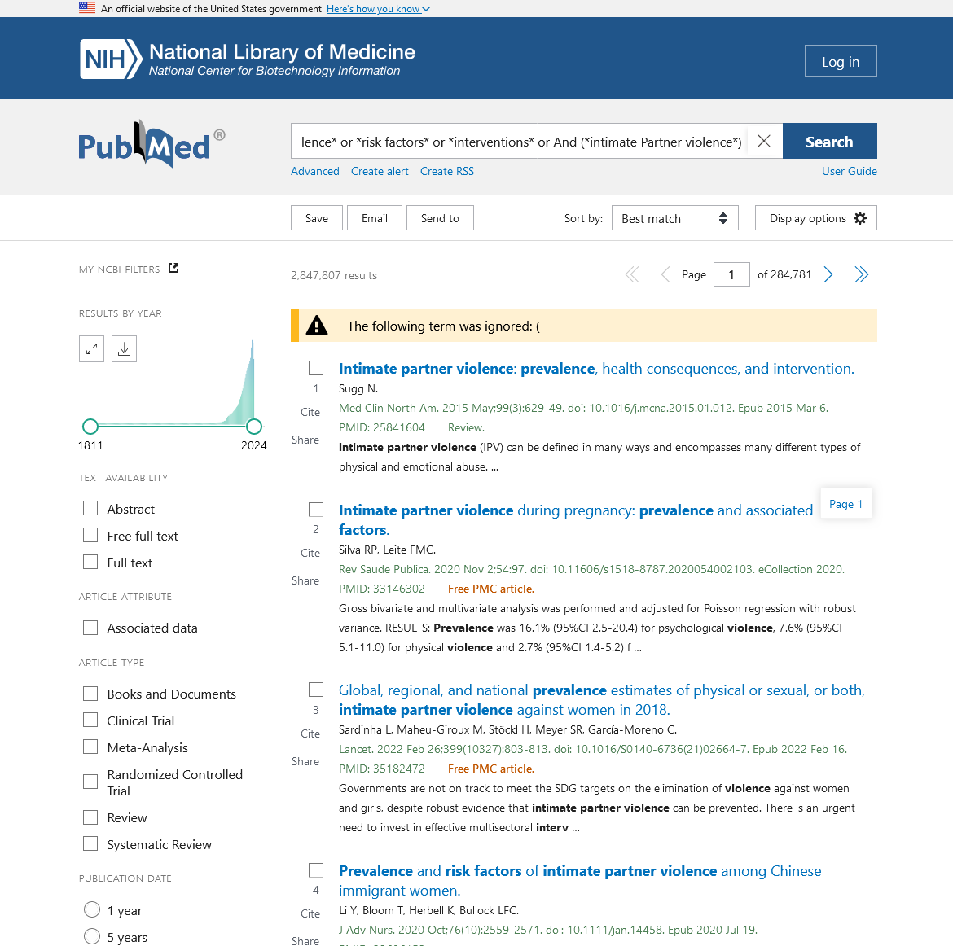

APPENDIX B

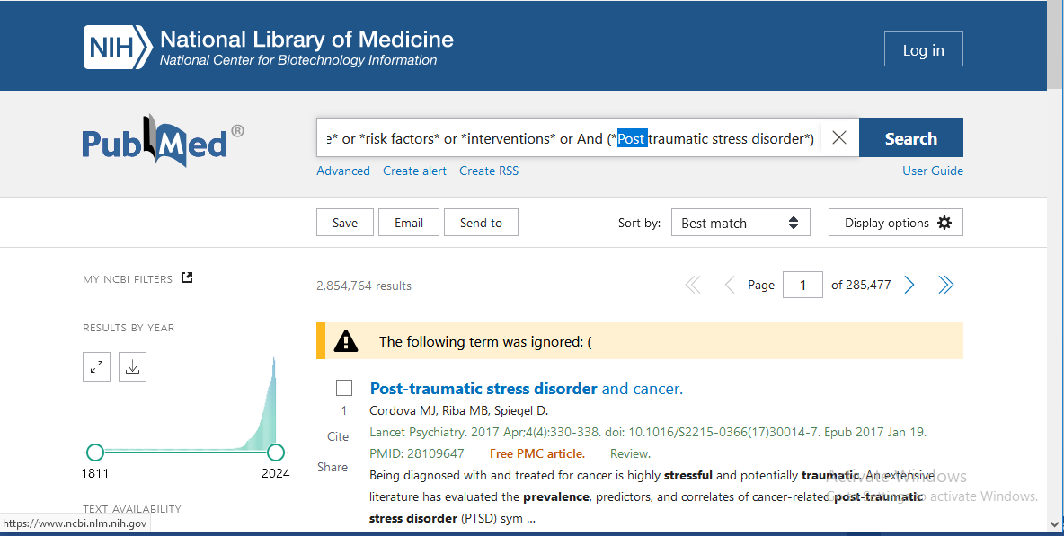

APPENDIX C



