Certificate of Higher Education Skills for the Workplace

Module: Digital Skills and Research Methods

Market Research And Developing Digital Content

Submitted By

Salma Siddika
Student ID 2118578
Date: 9th December 2022
Word count: 1556

Login details for website:
salma_siddika@hotmail.co.uk
password- salmasiddika2118578

Introduction:

In Digital Skills and Research Methods module, we have learnt about market researched. I have made business plan on online fashion boutique called “Seren” and created a questioner to analyse potential market. The questioner was distributed among individuals and responses were collected. The responses were used to create website for “Seren” and to create SEO strategy for the website. In this report I have discusses the importance of market research, questioner and the responses received and the impact of primary market research.
Importance of primary market research:
Market research generates information used to identify and define marketing opportunities and problems so that businesses can create, refine and evaluate marketing campaigns and monitor marketing performance. (Mooi, Sarstedt and Mooi-Reci, 2018)
Primary research is research businesses conduct themselves (or hire someone to do for them) It involves going directly to a source – usually customers and prospective customers in their target market – to ask questions and gather information. Examples of primary research are:
• Interviews (telephone or face-to-face)
• Surveys (online or mail)
• Questionnaires (online or mail)
• Focus groups
• Visits to competitors' locations (The Hartford, 2019)
Primary research is more custom designed according to business need.
• Relevant on research objectives
• Tend to be more up-to-date than secondary research
• Provides more in-depth insight - especially on customer opinions
• Produces meaningful results.
Before taking any strategic decision, businesses do primary research to find out very specific information that can influence the decision. For example a new business start-up to provide fusion clothing to UK market might need to find out market demand, demographic, financial situation to target specific market segment.
Additionally, primary research can provide data before the competitor which can give the business extra advantage. Primary research produces detailed insights into respondents.

Analysis of the questionnaire data:

In order to research the market for proposed online fusion fashion boutique “Seren” a questionnaire was created and sent to potential customers to get their responses.

The questions and the responses received discussed below:

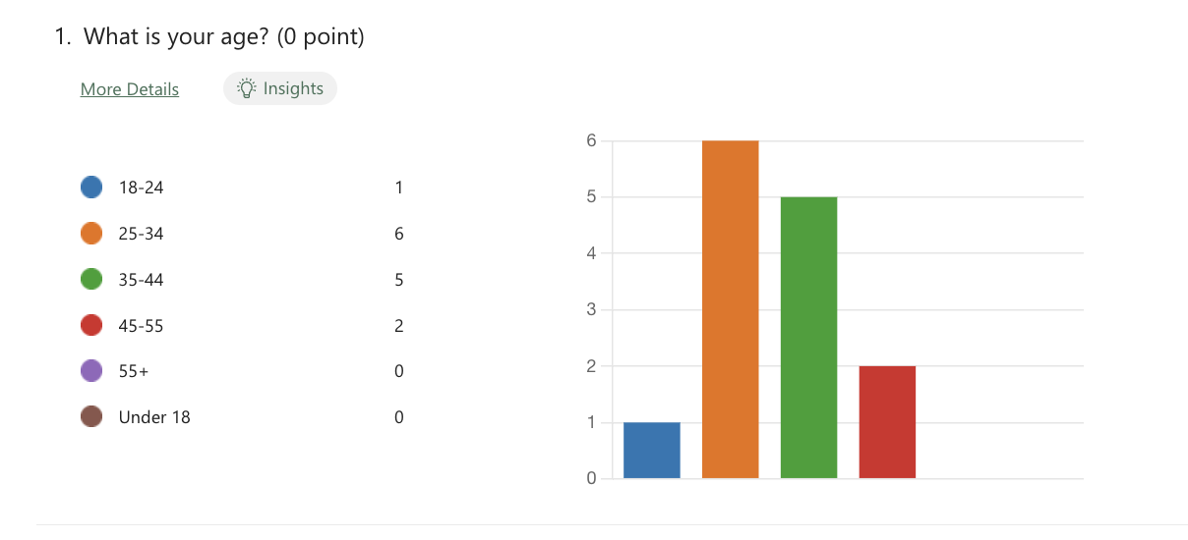
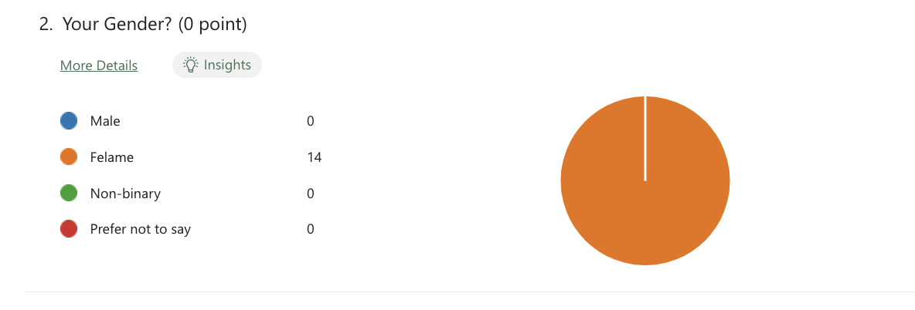
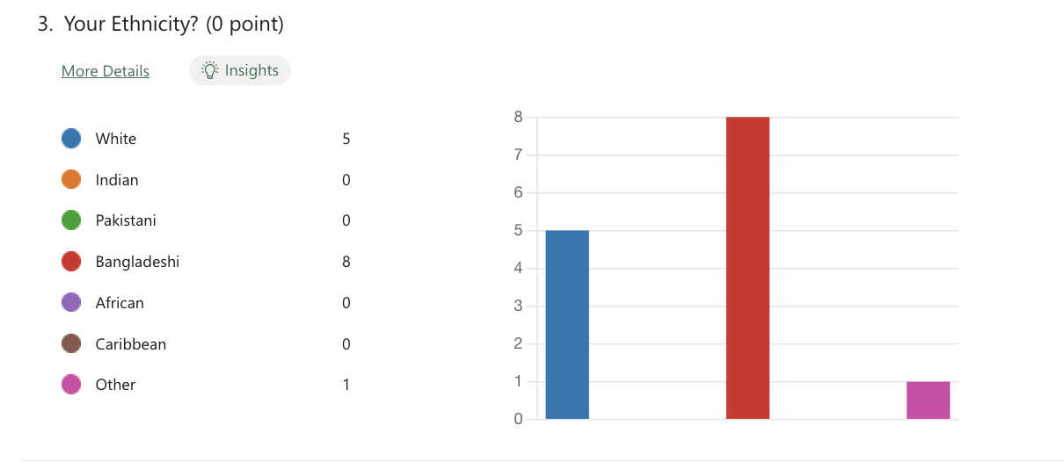
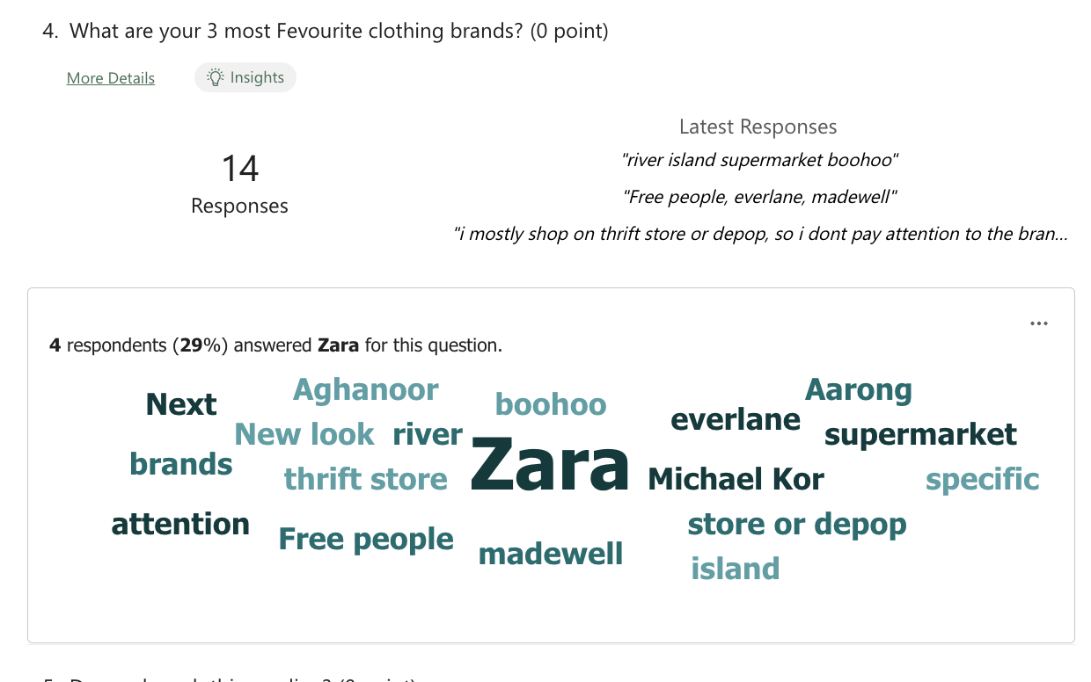
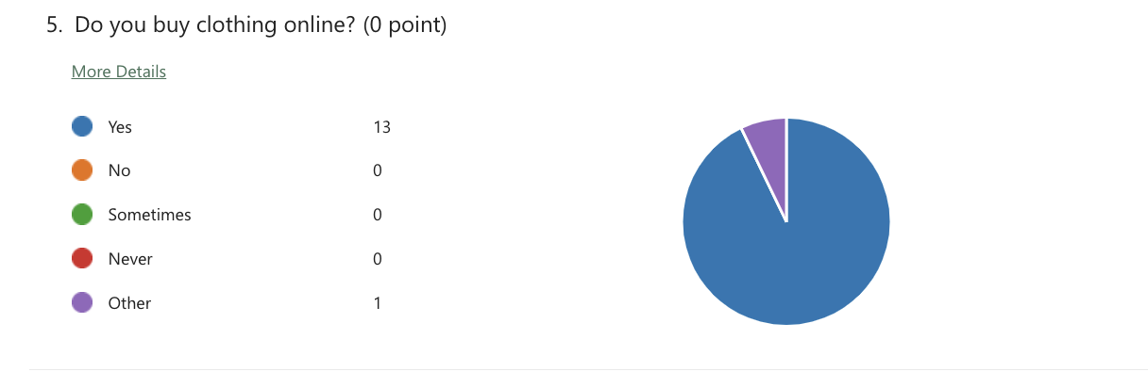
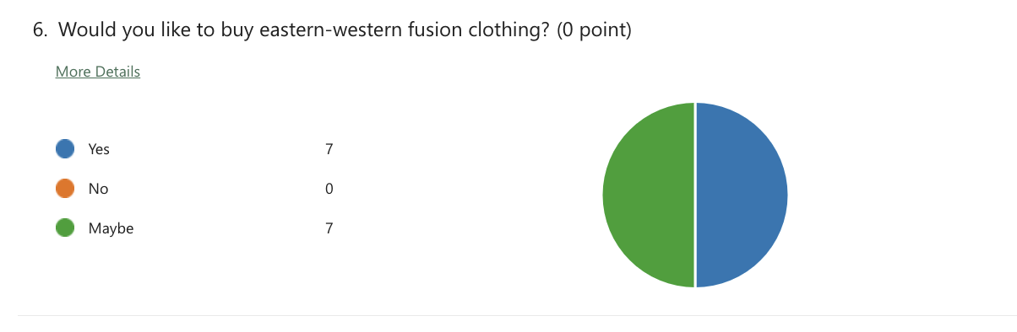
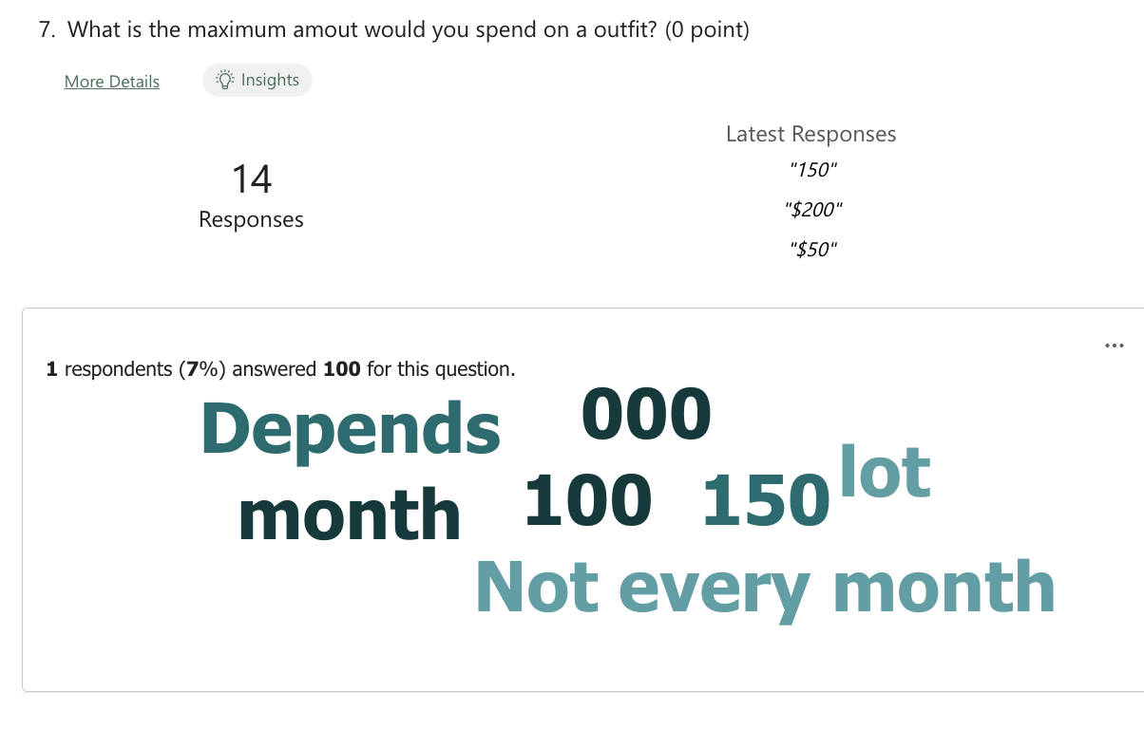
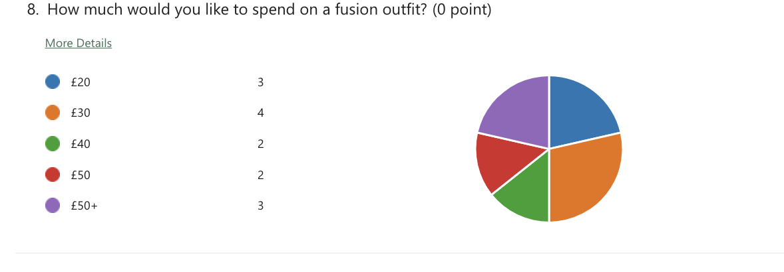
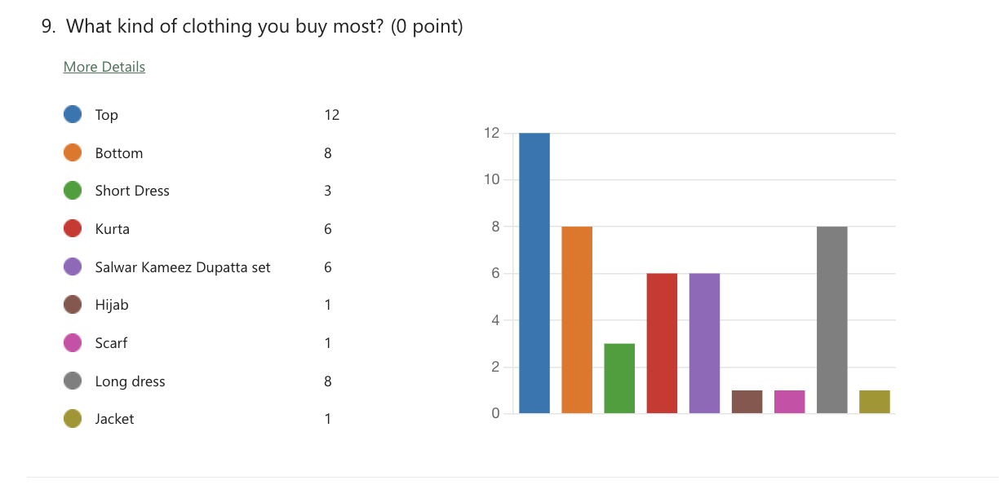
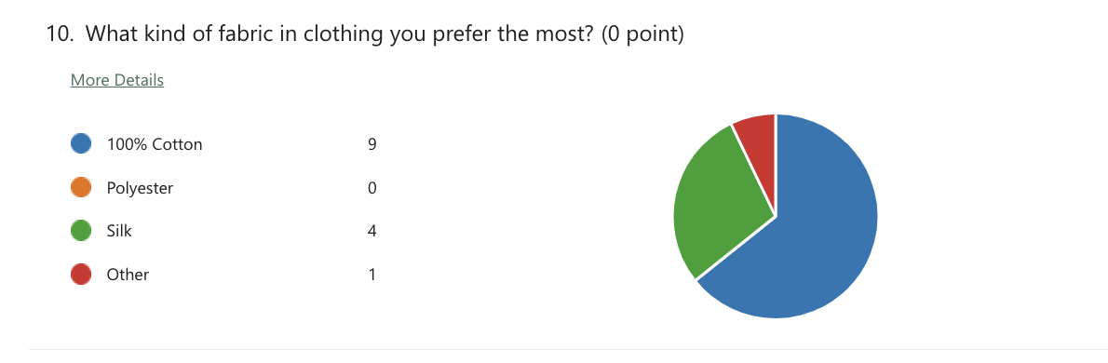
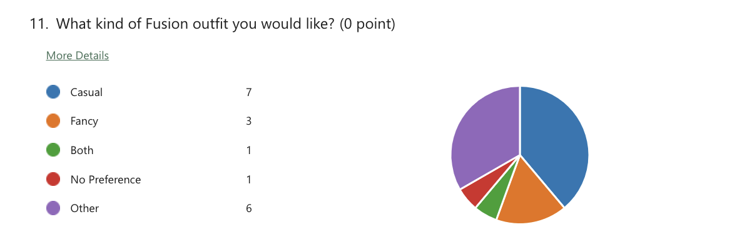
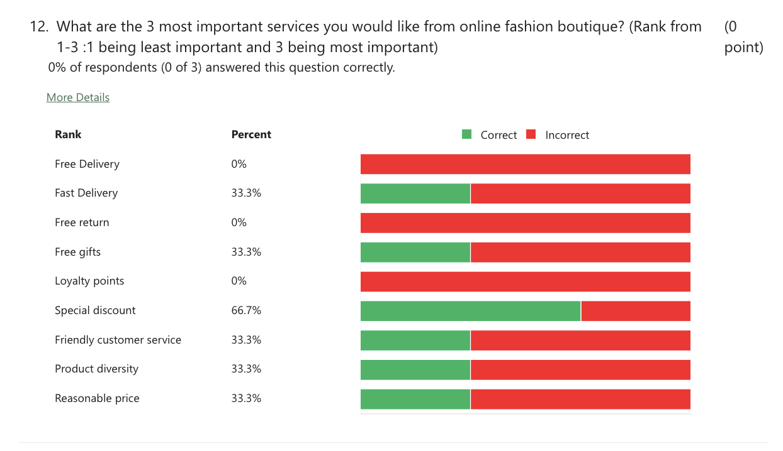

Summery and impact of the response:
Following table shows the impact and use of the responses received by the market research:

Question Number | Question | Impact of the response
1 | What is your age? | Determine the demographic to target customers.  (Ladies between 25-44 is the prime target customers.)
2 | Your Gender? | Determine the demographic to target customers.  (Ladies In the UK)
3 | Your Ethnicity? | Determine the demographic to target customers  (White and Bangladeshi)
4 | What are your 3 most Favourite clothing brands? | Helps product planning  (Clothing design)
5 | Do you buy clothing online? | Determine the demographic to target customers  (100% respondents shown interest)
6 | Would you like to buy eastern-western fusion clothing? | Determine business acceptability and demand  (100% shown interest)
7 | What is the maximum amount would you spend on a outfit? | Helps product planning  (Selling price)
8 | How much would you like to spend on a fusion outfit? | Helps product planning  (Acceptable price range)
9 | What kind of clothing you buy most? | Helps product planning  (Top, bottom and Long dress)
10 | What kind of fabric in clothing you prefer the most? | Helps product planning  (100% cotton has more response)
11 | What kind of Fusion outfit you would like? | Helps product planning  (Casual has more demand)
12 | What are the 3 most important services you would like from online fashion boutique? (Rank from 1-3 :1 being least important and 3 being most important) | Helps marketing planning  (66.7% of the respondents wants special discount)

How the questionnaire data influenced the website design, including colour theory.
I have created website containing 4 pages for my fashion boutique “Seren”- Home page, Product page , contact page and blog page

Colour theory used in the website

Website design elements include the use of colours, images, shapes, and photographs that are expected to give users a positive impression of the emotional appeal, aesthetics, or overall graphic appearance of the website. (Cyr et al., 2005); Everard and Galletta, 2006; Fornell and Larcker, 1981; Rousseau et al., 1998). Although there are a number of experimental studies on website design characteristics, these studies focus on the visual design of websites (Cyr and Trevor-Smith, 2004) or overall usability (Falk and Miller, 1992; Madden et al., 2000). ; West and Hepworth, 1991), which usually address the specific effects of colour on user perceptions, such as trust and satisfaction with website design.
I have used white, dull pink and brown as colour scheme for my website because pink feminine energy and love and romance. As target customers are Ladies, I have created my logo with mostly pink flowers and the website also have cool tone on pink. Light brown is associated with strength and reliability which should give customers sense faith in the business. White is the colour of purity and cleanliness. So overall customers should have a soothing experience while vising the website.

Screenshot of the website:

Home page

Home page has been used to inform and entertain customs. Slideshow has been used and attractive visual clues used to engage views. Special offer has been highlighted. Social media links have been used to encourage views to follow the business in social media.

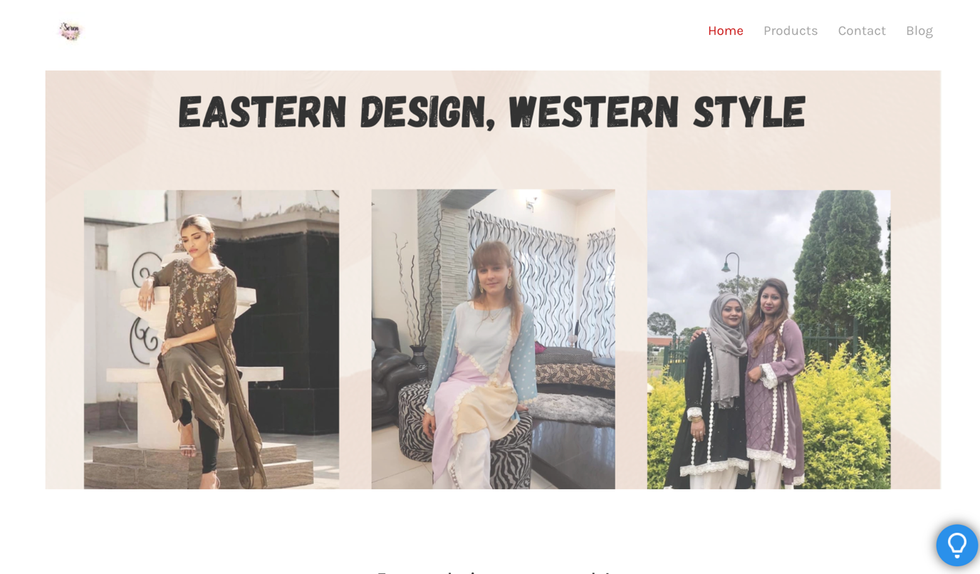
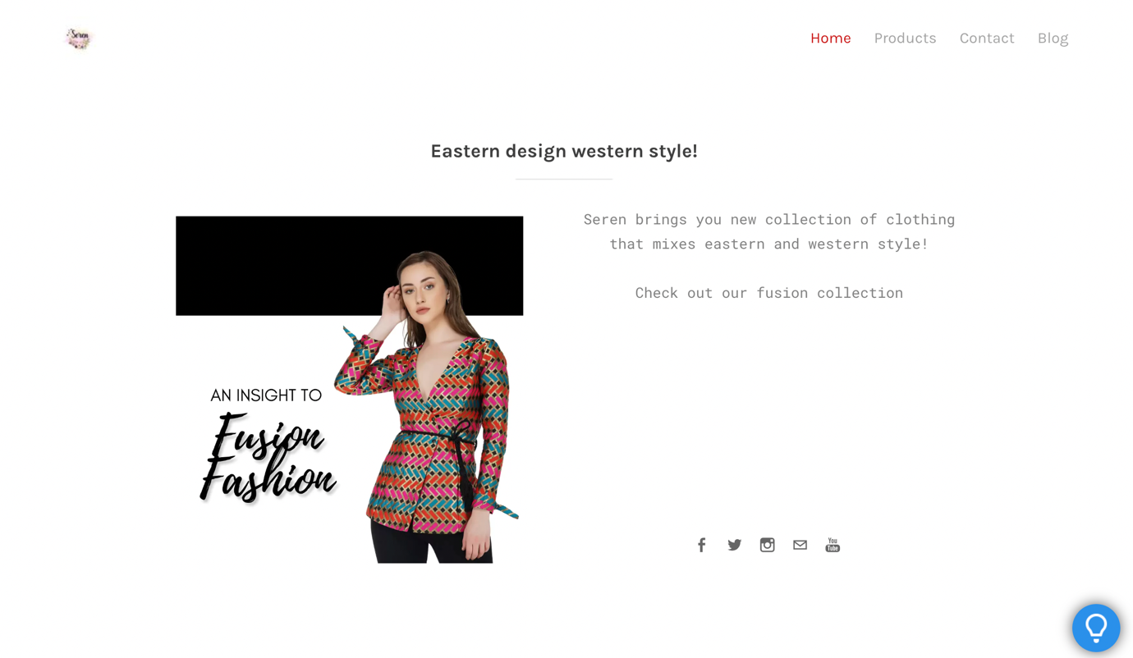
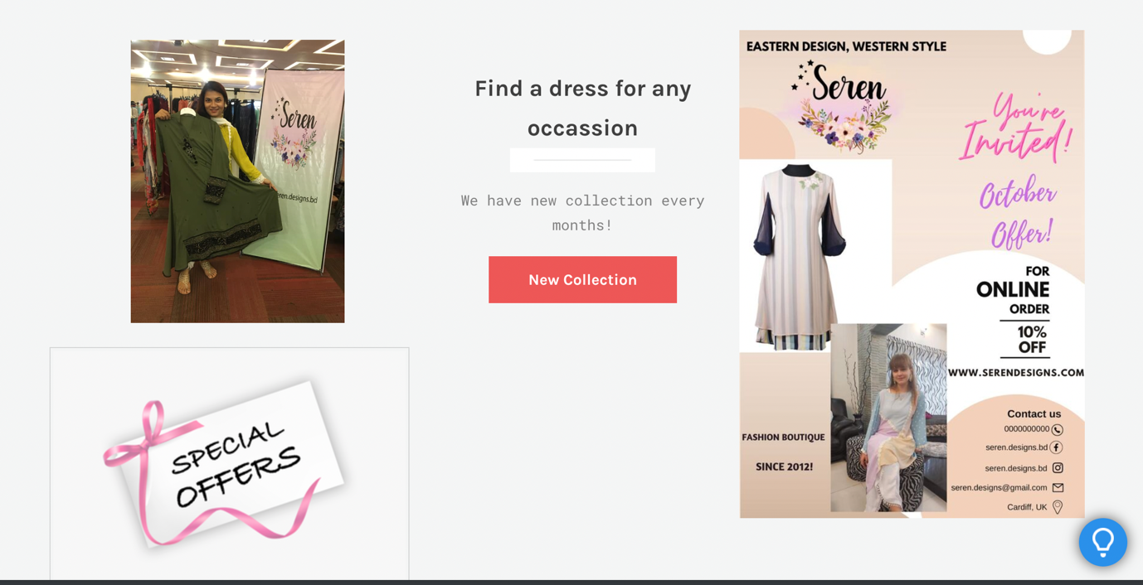
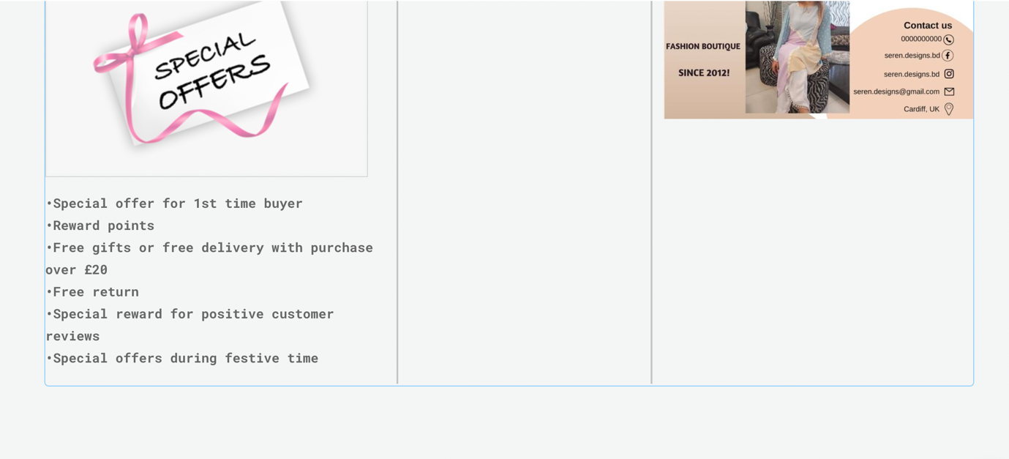
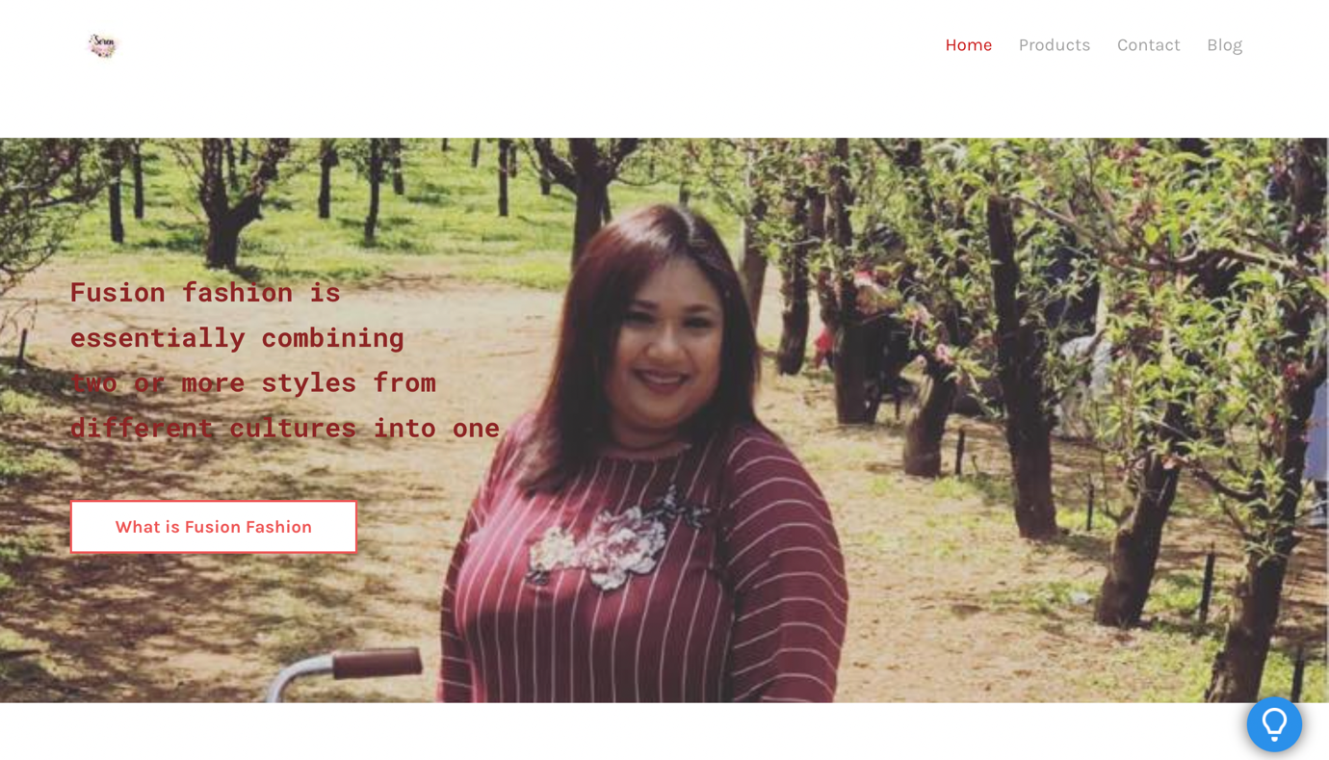
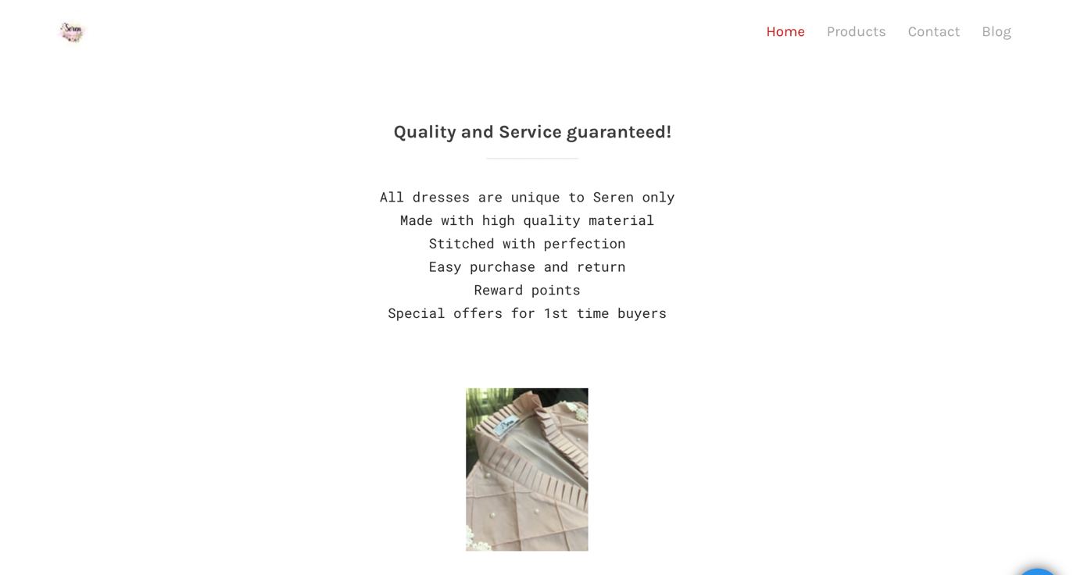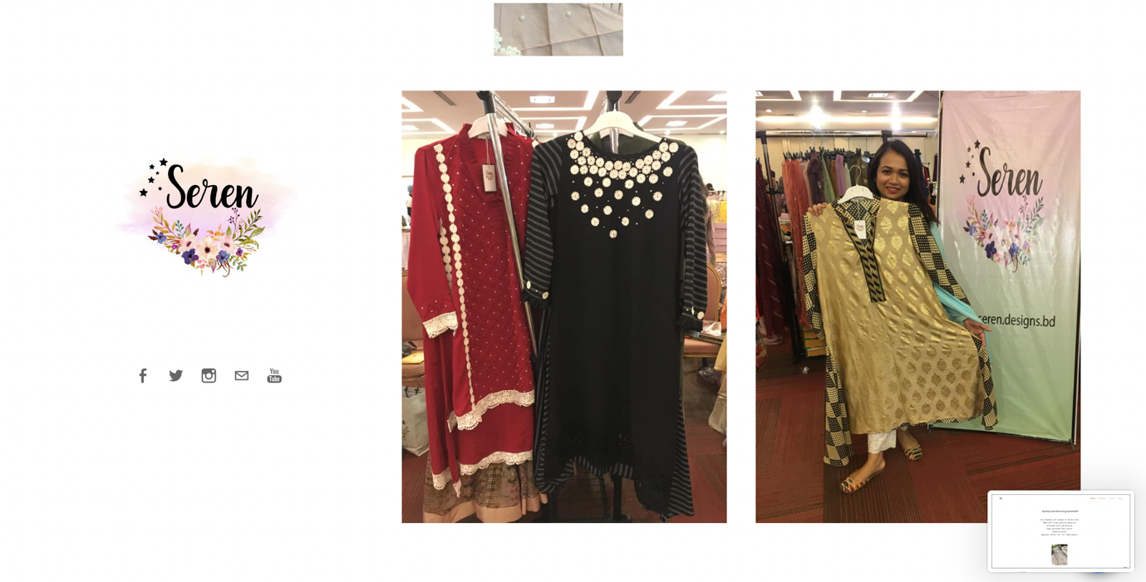

Product Page

Product page has pictures of new arrival items.
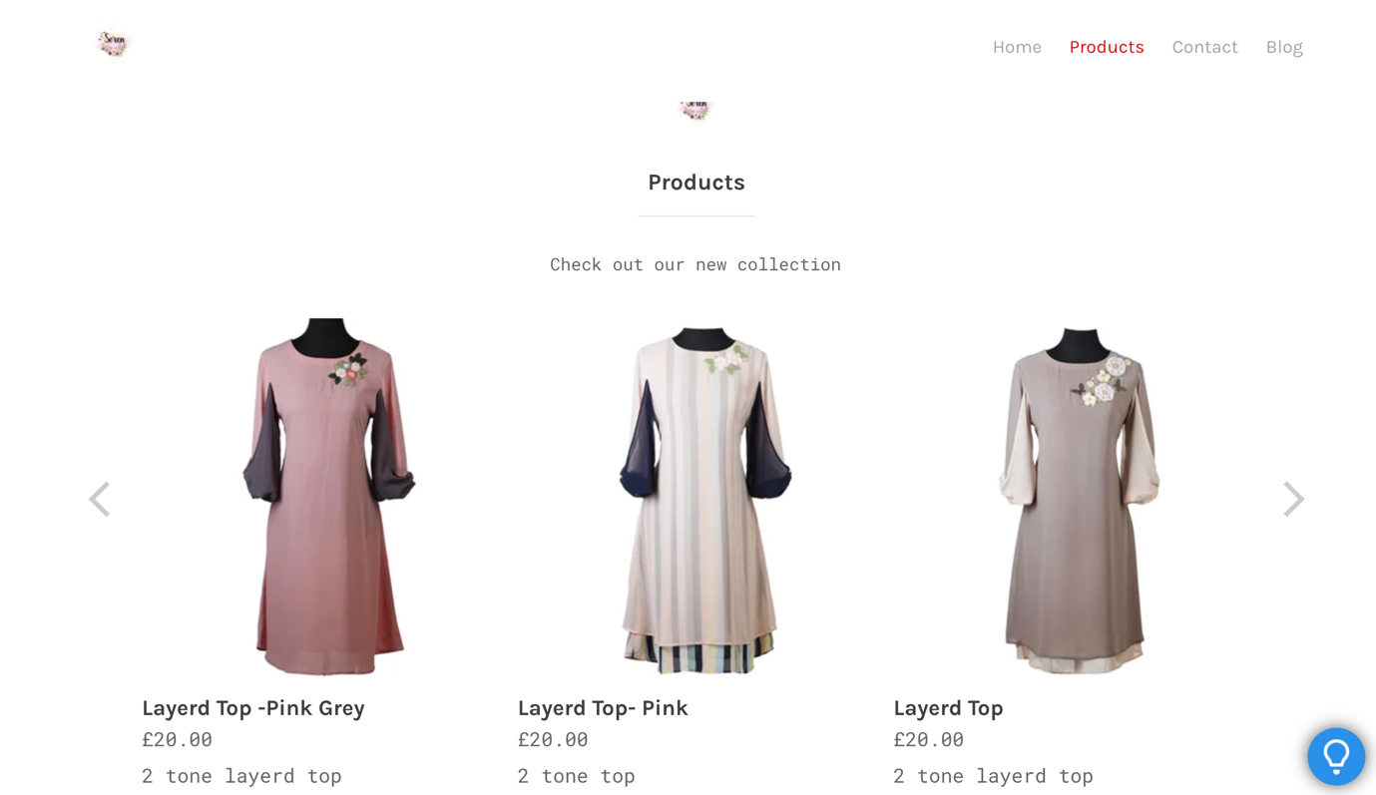

Contact page

Contact page has business address phone number, social media links and contact form.
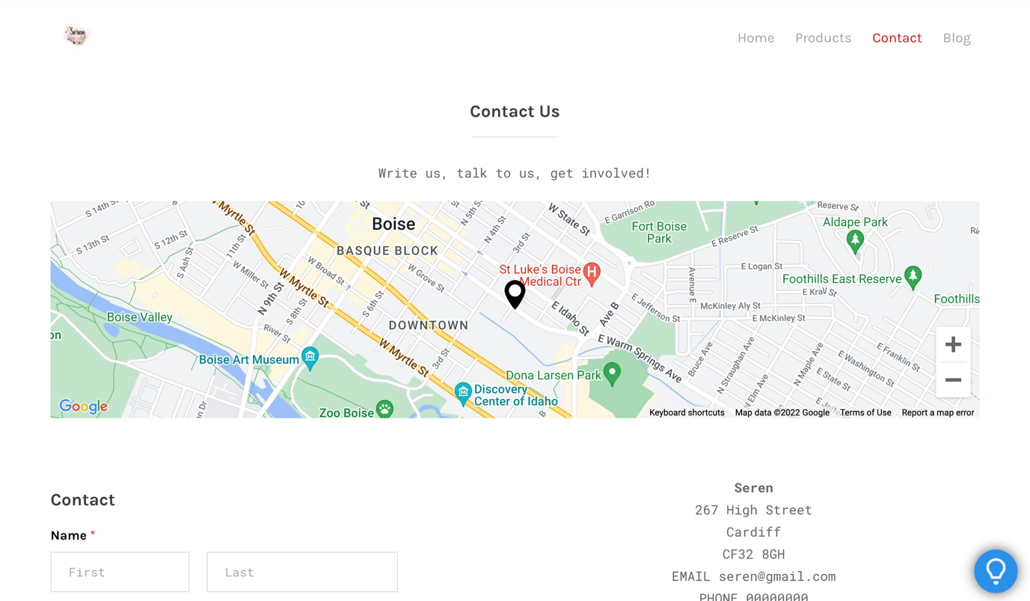
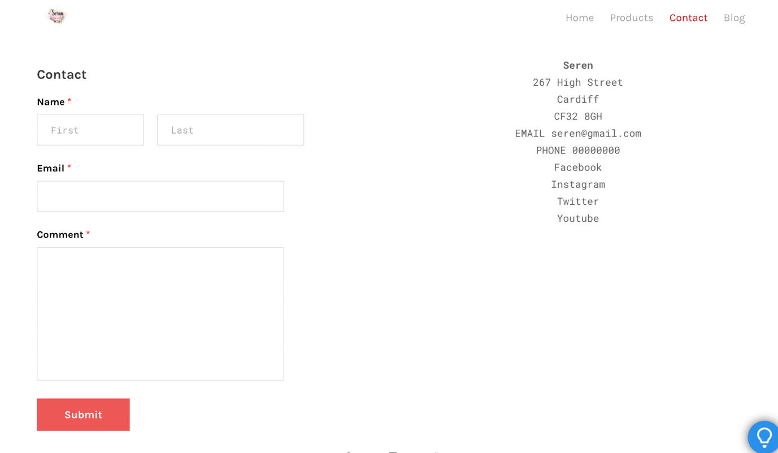

Blog page

Blog page has been used to educate potential clients about fusion fashion.
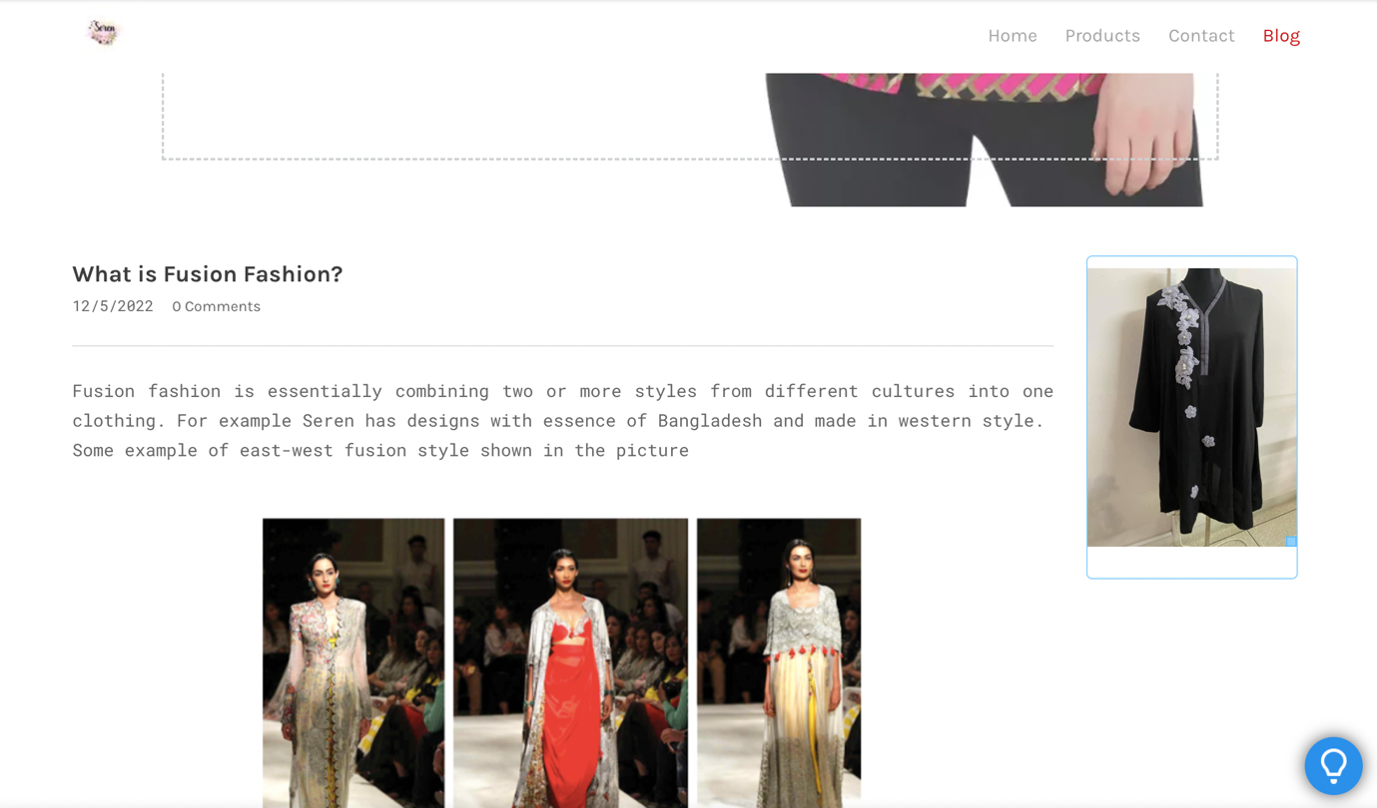

Importance Of SEO

SEO is an attempt to improve the search engine ranking of a website Google and other search engines prioritize content that they deem interesting, high quality, and relevant, and display that content at the top of search engine results pages. The higher a website ranks, the more it can encourage people to click, discover, read the content of the website. SEO helps to be more discoverable (Author Services, n.d.).SEO strategy should be incorporated into the website planning process well before the website it launched. SEO strategy should be well outlined before making the most basic technical decisions such Hosting Platforms and CMS. (Enge, E, 2012)

keyword research tools provide valuable insight into the mindset of potential customers. When users visit a search engine and enter a search query, they may be using a completely different language than expected. Even if the product or service has a solution available for the customers, they may start searching by describing their problem. For example, people with diabetes can simply type "diabetes" in the search box first and then search for diabetes medications and diabetic symptom relief in the next search. Taking the time to understand typical search sequences should influence SEO strategy. Other considerations include the demographics of target audience (male/female, age, income, etc.), where they live, and when. Demand for seasonal products, such as Valentine's Day cards, peaks sharply around the time of year and then declines sharply. The keyword research tools provide a way to explore all these factors. (Enge, E, 2012)

According to Ridings, L. (2019), approximately 61% of marketers believe that SEO is the key to online success,

SEO Strategy for Seren’s website:

Keyword targeting

Keywords are phrases that are commonly searched for on search engines such as Google, Bing, etc. They are a crucial part of determining website’s rankings. Using the right amount of keywords in the right places and in time will make pages climb up the leader boards of the search engines.

Primary research used in the SEO strategy:

First step of finding key words is brainstorming and find terms related to my business such as
fusion fashion
indie fusion dresses
fashion fusion dresses
fashion fusion online shopping
east meets west fashion
eastern western dress
Indian Dress
Pakistani dress
Indie Top

In this step I have taken help from Google search to populate a list of suggestions as below:

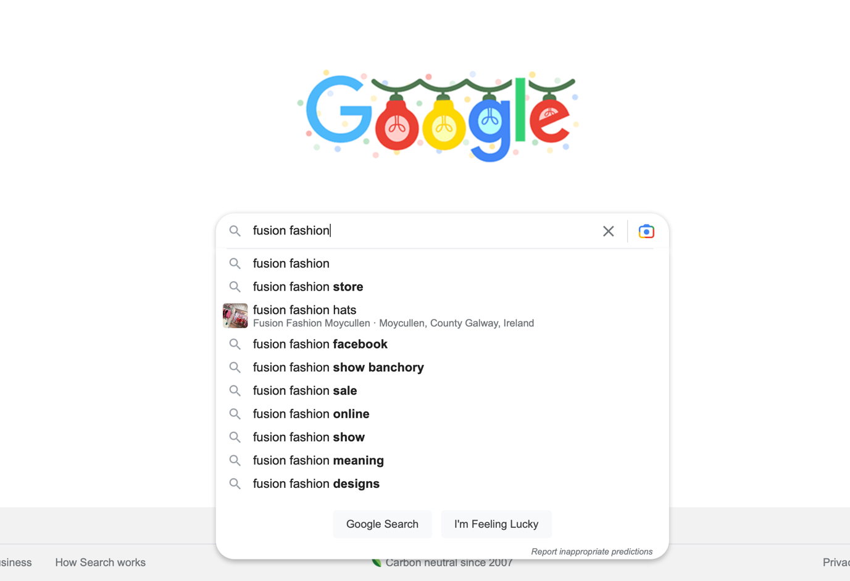

These are the best keywords for SEO because they come directly from Google which indicate that people are actually searching for these terms. This suggests that longer keywords (called "long tail keywords") tend to be less competitive than "short tail" keywords. (Dean, B. ,2019)

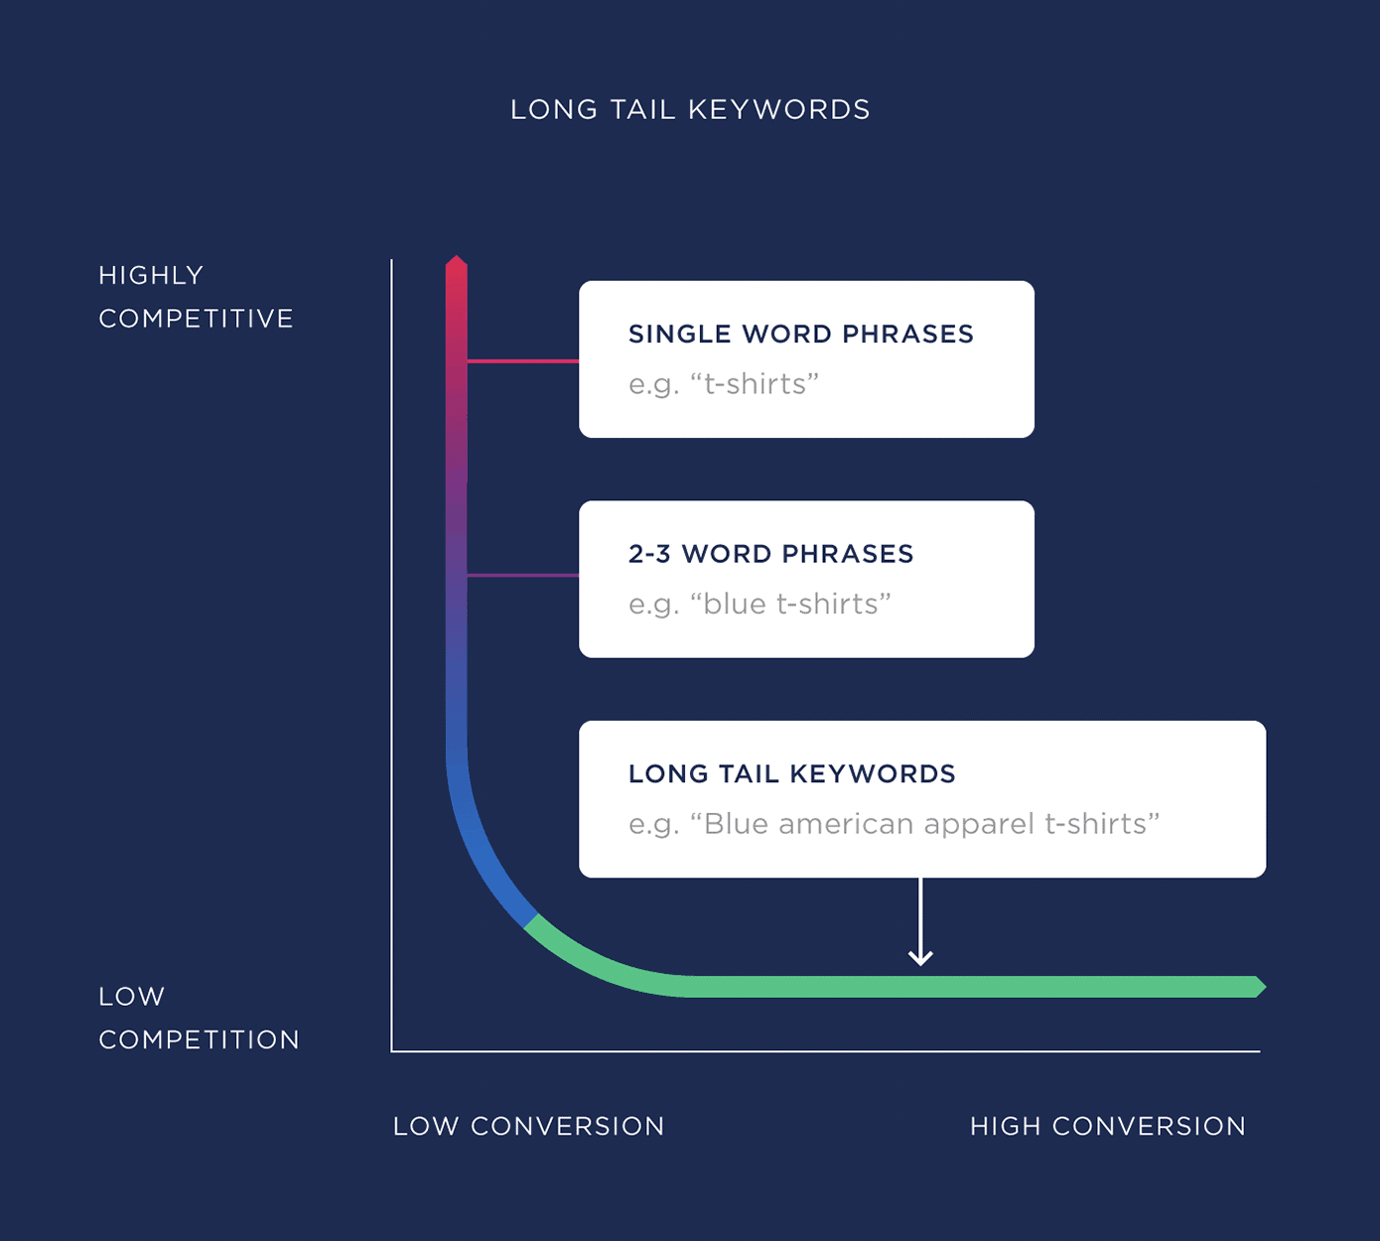

Image: Long tail keyword SEO Strategy (Dean, B. ,2019)

Another way to find SEO keyword is to think how the customers would search my business if I were them. I have used free keyword tool (WordStream, n.d.) to find keyword related to my business.

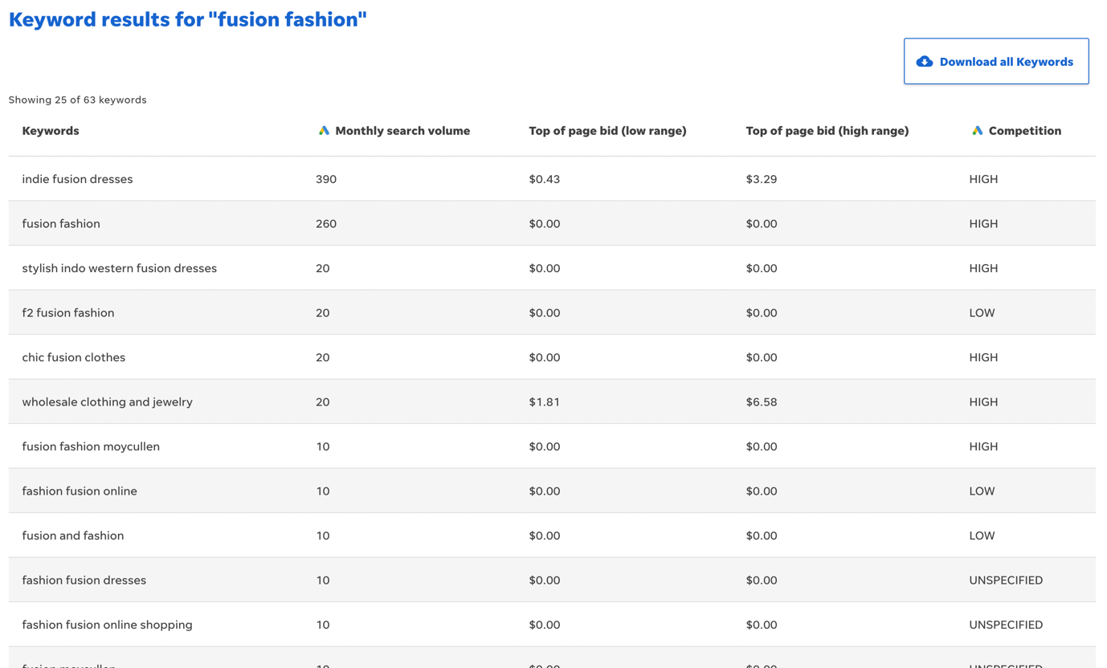

This tool showed me which keywords have more competition and which ones have low.
Second step
I have analysed the data collected from the responses in primary research and found out what are the most engaging key words to attract customers to my website. I found out all respondent answered they have knowledge about fusion fashion and they are interested in special offers. Respondent also stated that they would like cotton outfits and dresses the most. I have incorporated these findings to my SEO strategy.
After all these researches, I have come up with the SEO content strategy as below:
Fusion Outfit for Ladies UK
East west fusion dress
Indie outfit UK
Ethnic top dress
Eastern long dress
Cotton Kurta UK
Fusion outfit online,
Online shopping Indian dress
Special offer Indian outfit UK
Cotton long dress,
Cotton indie top UK
Special discount ethnic dress UK

Conclusion:

Market research provides important information about the potential market and business outlook. In this report I have discussed how I determined target customers and how I used the information to create my website and SEO strategy from primary market research.
References
Author Services. (n.d.). Search engine optimization for academic articles. [online] Available at: https://authorservices.taylorandfrancis.com/research-impact/search-engine-optimization-for-academic-articles/.
Cyr D., Bonanni, C., Bowes, J.(2005) Beyond trust: website design preferences across cultures. Journal of Global Information Management, 13 (4) (2005), pp. 24-52
Cyr, D., Milena, H., Hector, L. (2010) Colour appeal in website design within and across cultures: A multi-method evaluation. International Journal of Human-Computer Studies. Volume 68, Issues 1–2, pp 1-21
Dean, B. (2019). How to Create an Effective SEO Strategy In 2020. [online] Backlinko. Available at: https://backlinko.com/seo-strategy.
Enge, E.(2012). The art of SEO. O'REILLY, California.
Everard, A., Galletta, D.F. (2005). How Presentation Flaws Affect Perceived Site Quality, Trust, and Intention to Purchase from an Online Store. Journal of Management Information Systems, 22(3), pp.56–95. doi:10.2753/mis0742-1222220303.
Fornell, C, Larcker, D.F. (1981) Evaluating structural equation models with unobserved variables and measurement error. Journal of Marketing Research, pp. 39-50
Mooi, E., Sarstedt, M. and Mooi-Reci, I. (2018). Market Research. Springer Texts in Business and Economics. Singapore: Springer Singapore.
Rousseau, D.M. Sitkin, S.M. Burt R.S., Camerer, C. (1998) Not so different after all: a cross-discipline view of trust. Academy of Management Review, 23 (3) ,pp. 393-404
Ridings, L. (2019). 54 SEO Statistics That Will Impact Your Business in 2020. [online] Safari Digital. Available at: https://www.safaridigital.com.au/blog/seo-statistics-2019/.
The Hartford (2019). Types of Market Research: Primary vs Secondary | The Hartford. [online] Thehartford.com. Available at: https://www.thehartford.com/business-insurance/strategy/market-research/primary-second-research.
www.wordstream.com. (n.d.). 8 Expert Tips to Build a Winning SEO Strategy in 2021. [online] Available at: https://www.wordstream.com/blog/ws/2021/03/05/seo-strategy.
WordStream. (n.d.). Free Keyword Tool. [online] Available at: https://www.wordstream.com/keywords?cid=Web_Any_WordstreamGraders_FreeGraders_KWT [Accessed 7 Dec. 2022].

