
Applied Leadership and Management in the Workplace
Module Assignment Submission
Student Name: | Rachel Pritchard
Student Number: | 2515384
Module No: | BMSK4012
Module Title: | Enterprise and Intrapreneurship

Statement of Confirmation of Authenticity
By the act of making this submission, the student declares that this is the work of the student named above. The work has not, in whole or in part, been knowingly presented elsewhere for assessment, or where assessment has been built on a previous assessment, this has been identified. Where materials have been used from other sources it has been properly acknowledged. If this statement is untrue, the student acknowledges that an assessment offence has been committed.
Attention is drawn to the plagiarism and unfair practice policies of both the University and of ILM.



Vayah
Rachel Pritchard
Swansea, South Wales
Vayahuk@gmail.com

Vayah is a home-based custom gift business based in Swansea, creation high-quality custom products for every occasion. The business specialises in unique, affordable gifts designed to celebrate life’s special moments with exceptional customer service.

Table of Content
1.0 Executive Summary 4
2.0 Introduction and Business Identity 5
3.0 Personal Suitability and SMART Objectives 6
4.0 Market Analysis, PESTLE, SWOT, Competitors and USP 7
4.1 Target Market and Market Size 7
4.2 PESTLE Analysis 8
4.3 SWOT Analysis 9
4.4 Competitor Analysis 9
4.5 Unique Selling Point 10
5.0 Marketing and Pricing Strategy 10
5.1 Marketing Objectives 10
5.2 Marketing Strategy and 7Ps 11
5.3 Revenue and Pricing Strategy 11
6.0 Operations 12
6.1 Business Operations 12
6.2 Production and Customer Management 12
6.3 Health, Safety and Legal Compliance 12
6.4 Risk and Contingency Planning 12
7.0 Financial Information 13
8.0 Conclusion 14
References 15
Appendix A 16
Appendix B 19
Appendix C 20
Appendix D 21
Appendix E 22
Appendix F 23
Appendix G 24
Appendix H 25
Appendix I 26
Appendix J 27
Appendix K 28

1.0 Executive Summary
Vayah is a proposed sole trader business specialising in custom gifts, including stainless steel tumblers, slate plaques, clothing and seasonal gift bundles. The business will operate from a home-based workspace in Swansea and sell products through its website, social media platforms and local area. Offering both collection and UK delivery.
The business is aimed at customers looking for affordable, high quality custom gifts for birthdays, weddings, anniversaries, Christmas and other special occasions. Primary market research found strong customer interest in personalised products, with respondents placing the greatest importance on quality, reasonable pricing and supporting local businesses.
The owner has previous experience producing personalised products and has developed relevant skills in customer service, product design and business management. These skills, together with knowledge gained through university study, provide a strong foundation for operating the business successfully.
The business aims to establish a recognised local brand, build a loyal customer base and achieve sustainable growth through effective marketing, competitive pricing and excellent customer service. Marketing activities will focus on Facebook, Instagram, TikTok, work of mouth recommendations and local promotional activities to increase brand awareness and generate sales.
The business requires approximately £3,000 in start-up funding to purchase equipment and initial stock. Financial forecasts indicate that Vayah is expected to generate monthly sales revenue of approximately £1,230-£1,480, while maintaining a positive cash balance throughout the first year of trading. Overall, the business plan demonstrates that Vayah is financially viable and has strong potential for future growth.

2.0 Introduction and Business Identity
Vayah is a custom gift business based in Swansea, South Wales, run from home. The business is a sole trader that specialises in the design and production of custom gifts using sublimation and vinyl printing techniques. Vayah offers custom tumblers, mugs, coasters, slates, clothing and seasonal products. Vayah’s innovative, made-to-order items provide customers with meaningful and affordable gifts with a personal touch.
The business primarily caters to those seeking custom gifts for various occasions including birthdays, weddings, anniversary, new baby and memorials. Orders are placed though social media, but plans are for orders to be placed through a website, the business can deliver across the UK but also offers local collection in Swansea.
As a sole trader, the business benefits from simple administration, low operating costs and flexibility in responding to customer demand. The overall aim of Vayah is to establish a strong reputation for producing high-quality custom products, delivering excellent customer service and building a loyal customer base. In the future, the business intends to expand its product range and increase its online presence to support sustainable growth.
Alternative business identities, including a partnership and a franchise, were considered. A partnership could provide additional investment and shared responsibilities. However, it may also lead to disagreements over business decisions and profit sharing. A franchise would offer and established brand and business model but would limit creative freedom and involve franchise feed. As Vayah focuses on unique, personalised products and is operated by one owner, a sole trader structure provides the greatest flexibility, control and low start-up costs. According to GOV.UK (2025) a sole trader is the simplest business structure to establish and allows the owner to retain full control of business decisions.

3.0 Personal Suitability and SMART Objectives
The owner of Vayah possesses a range of technical, business and customer service skills that provide a strong foundation for operating a custom gift business. Experience in producing customised mugs, tumblers, slates and clothing using sublimation and vinyl printing has developed the technical ability required to create high quality products that meet customer expectations. Previous work has provided a portfolio of completed products, demonstrating practical experience and attention to detail.
Knowledge of customer service, local competitors and product pricing has been developed through operating the business and carrying out market research. In addition, experience using Microsoft excel to record orders, monitor sales and track profits has improved organisational and financial management skills. Marketing knowledge has also been developed through photographing products and promoting them on social media, resulting in customer enquiries and sales.
Strong organisational skills enable seasonal products and customers orders to be planned, while relationships with suppliers support the timely purchases of materials. However, there are opportunities for further development. Increasing knowledge of bookkeeping, tax requirements and digital marketing analytics will strengthen long term business performance and support future growth. As the business expands, developing relationships with additional suppliers will also reduce supply chain risks and improve business resilience.
A link of owner’s curriculum vitae is below that is included in Appendix A to provide further evidence of relevant experience and qualifications.

Objective | How will it be measured? | Where is it supported?
Increase custom tumblers sales by 10 units by 30th September 2026 | Monthly sales records using Microsoft Excel | Sales forecast and cashflow.
Increase Vayah’s social media following by 30 followers by 31st October 2026 through consistent weekly content. | Meta business suite analytics | Marketing Strategy and 7Ps
Establish relationship with four reliable suppliers by December 2026 to improve stock availability and reduce supply risks. | Supplier agreements and order records. | Operations and risks
Maintain a positive monthly cash balance by January 2027 through effective budgeting and sales growth. | Cashflow forecast and financial records. | Financial Information

4.0 Market Analysis, PESTLE, SWOT, Competitors and USP

4.1 Target Market and Market Size
Vayah operates within the custom gift market, offering customised products including mugs, tumblers, slates, clothing and seasonal items. The primary target market consists of adults aged 25-55, particularly parents, families and individuals purchasing gifts for birthdays, weddings, anniversaries, new baby and other special occasions. Although the business is based in Swansea, South Wales, products are available to customers throughout the UK through online ordering and postal delivery, allowing the business to reach a wider customer base.
Vayah’s target market consists primarily of adults around age 20-55 with disposable income who purchase personalised gifts for occasions such as birthdays, weddings and anniversaries. Initially, the business will focus on customers in Swansea and South Wales before expanding across the UK through online sales and social media. According to Swansea Council (2026) Swansea had an estimated population of 251,300 people, providing a substantial local customer base from which the business can grow. The business appeals to customers who value unique, high-quality products and prefer supporting small independent businesses rather than purchasing mass produced gifts.
Primary market research was conducted using an online questionnaire completed by nine respondents (Appendix B). all respondents stated they would purchase personalised gifts, while 67% expected to pay £10-£15 for a customised tumbler. The survey also found that supporting small businesses 44% and product quality 33% were the main purchasing factors, demonstrating demand for Vayah’s products.
Secondary research by Research and Markets (2025) indicates continued growth within the UK personalised gifts market due to increasing demand for customised products. Combined with the survey findings, this suggests sufficient demand to support Vayah’s growth.

4.2 PESTLE Analysis
A PESTLE analysis was undertaken to assess the external factors that could influence the success of Vayah. Understanding these factors enables the business decisions.
POLITICAL
Changes in the government policies relating to small businesses, taxation and consumer protection legislation may affect business operations. Vayah must ensure it complies with current UK regulations regarding product safety, consumer rights and online selling. Regularly reviewing government guidance will help the business remain compliant and avoid legal issues.
ECONOMIC
According to Consumer Price Inflation team (2026) the current cost-of-living pressures may reduce consumers disposable income, meaning customers may spend less on non-essential items such as custom gifts. Rising supplier costs and increasing postage charges may also affect profitability. To remain competitive, Vayah will regularly review its pricing strategy while sourcing products from reliable suppliers offering competitive prices.
SOCIAL
Consumer demand for custom gifts continues to increase as customers seek meaningful and unique products for special occasions. Growing consumers preference for supporting small businesses and purchasing customised products through online platforms also creates opportunities for businesses such as Vayah. This social trend supports the business’s focus on high quality custom products and excellent customer service.
TECHNOLOGICAL
According to Ofcom (2025) social media platforms such as Facebook, Instagram and TikTok have become important marketing channels for small businesses, with most UK adults using the internet regularly to access online services and social media. Technology also supports online payments, digital design software and order management systems, enabling Vayah to operate efficiently while reaching customers across UK.
LEGAL
As a sole trader, According to GOV.UK (2020) Vayah must comply with UK consumer protection legislation, including the Consumer Rights Act 2015 and GDPR requirements when handling customer information and hold appropriate public liability insurance. Meeting these legal requirements helps protect both the business and its customers.

ENVIRONMENTAL
Consumers are becoming increasingly environmentally conscious, creating an opportunity for Vayah to use recyclable packaging and minimise waste where possible. Demonstration environmentally responsible practices may improve customer perception of the business and strengthen its competitive position.
Overall, the most significant external influences on Vayah are economic conditions, increasing use of social media for purchasing decisions and changing consumer preferences for custom products. By monitoring these factors, the business can adapt its pricing, marketing and operations to remain competitive and support long-term growth.

4.3 SWOT Analysis
A SWOT analysis was undertaken to evaluate the internal strengths and weaknesses of Vayah, alongside the external opportunities and threats that may influence the business. According to Research and Markets (2025) SWOT is widely used strategic planning tool that supports organisations in assessing their current position and informing future business decisions.
The SWOT analysis (Appendix C) highlights several strengths that provide Vayah with a Competitive advantage. However, the business also faces several weaknesses. As a sole trader, production capacity is limited, meaning demand during busy periods such as Christmas may exceed the number of orders that can be completed. In addition, the business relies on external suppliers for blank products and materials, making it vulnerable to stock shortages or delivery delays.
There are significant opportunities for future growth. Expanding the product range, increasing social media marketing and supplying promotional products to local businesses could increase revenue and attract new customers. However, these opportunities must be balanced against external threats, including increased competition from established online retailers, rising supplier costs and reduced consumer spending during periods of economic uncertainly. Regularly reviewing pricing, marketing strategies and supplier relationships will help Vayah respond effectively to these challenges and support long-term business growth.

4.4 Competitor Analysis
Appendix D shows that Vayah competes with local and national online retailers. Although many competitors have established reputation, Vayah will differentiate itself through a wider product range, personalised customer service and competitive pricing. Unlike several local businesses that specialise in only one or two products, Vayah offers tumblers, slates, hoodies and seasonal gift bundles, allowing customers to purchase gifts for multiple occasions from one business. Direct communication, fast response times and high-quality products will help Vayah build customer loyalty and complete effectively within the personalised gift market.

4.5 Unique Selling Point
Vayah unique selling point is its ability to provide high-quality custom gifts with a personal and flexible customer experience. Unlike many large competitors, customers communicate directly with the business owner throughout the design and ordering process, allowing products to be tailored to individual preferences. According to The institute of customer service (2019) providing excellent customer service can create a competitive advantage by improving customer satisfaction and encouraging repeat business.
The business offers a wide range of customised products, including tumblers, mugs, clothing, slates and seasonal gifts, making Vayah a convenient choice for customers purchasing gifts for different occasions. Operating a home-based business also enables competitive pricing while maintaining high product quality.
Vayah will continue to strengthen its competitive advantage by providing fast communication, bespoke designs, flexible ordering options and excellent after-sales service. Combined with active promotion through Facebook, Instagram and TikTok these factors will help build customer loyalty, encourage repeat purchases and establish a strong reputation within the personalised gift market.

5.0 Marketing and Pricing Strategy

5.1 Marketing Objectives
The marketing objectives for Vayah have been developed using SMART framework to ensure the are Specific, Measurable, Achievable, Relevant and Time-bound. These objectives focus on increasing brand awareness, attracting new customers and encouraging repeat purchases during the first year of trading. According to Bitesize Learning (2023) Goal setting is an important component of success in any organisation. As a owner, the ability to define strategic, clear and realistic goals for your business can be the difference between success and failure.
OBJECTIVES
Gain 100 followers on social media within the first six months of trading.
Receive 10 customer enquiries through social media within the first two months of trading
Achieve 10 repeat customers within the first six months through excellent customer service.
These objectives will be monitored using social media analytics, customer order records and monthly sales to evaluate the effectiveness of the marketing strategy.

5.2 Marketing Strategy and 7Ps
Vayah will use the 7Ps marketing mix to ensure that every aspect of the business supports customer satisfaction and business growth (see Appendix E). The strategy has been developed using findings from the competitor analysis, customer survey and target market research. As a home-based custom gift business, the focus is on providing quality products, competitive pricing, excellent customer service and convenient online ordering. Each element of the marketing mix has been assessed for potential risks and how they will be managed to support long-term success.
The business will primarily promote products through Facebook, Instagram and TikTok, as these platforms were identified by survey participants as the places, they would most expect to find personalised gift business. Professional products photography, branded packaging and positive customer reviews will help build trust and encourage repeat purchases. Orders will be managed using a simple order tracking system to reduce delays and ensure customer receive clear communication throughout the purchasing process.
Overall, the 7Ps provide a structured marketing approach that aligns the products, pricing, promotion and customer experience with the needs of the target market while supporting the business objectives.
A detailed Marketing Action Plan outlining promotional activities, budgets, timescales and measures of success is provided in Appendix F. the plan supports marketing objectives by focusing on cost effective promotional methods, social media engagement and customer referrals to increase the brand awareness and sales during the first year of trading.

5.3 Revenue and Pricing Strategy
Vayah will generate revenue through the sales of custom products, including tumblers, slates, hoodies and seasonal gift bundles (see Appendix G). Offering a varied product range provides multiple income streams throughout the year and supports increased sales during seasonal events.
Prices are based on a cost-plus pricing strategy, with profit margin added after calculating material, packaging and production costs. Seasonal gift bundles will use bundle pricing to encourage higher-value purchases. Kotler et al. (2024) states that this approach reflects customer value, business costs and market conditions.
The prosed prices cover production costs while remaining affordable for the target market. Pricing will be reviewed regularly to reflect supplier costs and competitor pricing. Overall, the pricing strategy balances affordability with profitability, supporting sustainable growth while keeping Vayah competitive within the personalised gift market.

6.0 Operations

6.1 Business Operations
Operations are supported by the plans shown in Appendices H-J. Products will be produced from a home workshop using sublimation equipment, with orders manages through social media, the business website and an order tracking system. Risk management procedures will minimise disruption caused by equipment failure, supplier delays or illness.

6.2 Production and Customer Management
Customers will place orders through Vayah website or social media platforms, including Facebook and Instagram. Once a customer has confirmed the design requirements, an invoice will be created and the order recorded using a spreadsheet to monitor customer details, payment status and production progress. Payment will be taken before production begins.
Each custom product will be designed, produced and quality checked before being packaged securely for collection or delivery. After the order has been completed, customers will be encouraged to leave a review to help build the business’s online reputation. A detailed customer journey is shown in Appendix I.

6.3 Health, Safety and Legal Compliance
Health and safety procedures are important due to the use of heat presses, printers and electrical equipment. Equipment will be maintained according to manufacturer guidance, and the workspace will be kept clean, organised, ventilated and free from hazards. Customer information will be stored securely in accordance with UK data protection requirements.
The business will obtain appropriate Public Liability Insurance and Product Liability Insurance before trading. These measures help protect both the business and its customers while ensuring legal compliance.

6.4 Risk and Contingency Planning
As a sole trader, Vayah faces several operational risks, including supplier delays, equipment failure, illness and seasonal fluctuations in demand. To reduce these risks, the business will use alternative suppliers where possible, carry out routine equipment maintenance, maintain realistic production times and keep customers informed of any delays. During periods of high demand, orders may be limited to ensure quality standards are maintained. A detailed risk assessment and contingency plan is included in Appendix J.

7.0 Financial Information
The financial forecasts indicate the Vayah has the potential to operate as a financially sustainable business. The forecasts include start-up costs, expected sales revenue, monthly expenditure and projected cashflow for the first year of trading. These figures have been estimated using supplier prices, competitor pricing, expected sales volumes from market research and the proposed pricing strategy. A detailed cashflow forecast and projected Profit and Loss are provided in Appendix K.
START-UP COSTS
Vayah requires approximately £2,669 in start-up funding to purchase equipment and initial stock. These costs will be funded by a £3,00 start-up grant, meaning external borrowing is not required, Business Wales (2026) provides information on business support, funding and finance available to new businesses in Wales
REVENUE AND PRICING
Revenue will be generated through the sale of personalised gifts. Financial forecasts are based on the pricing strategy discussed in Section 5.3 and the projected sales shown in Appendix K.
Projected sales revenue is estimated at £1,230 per month during standard trading months, increasing to approximately £1,470-£1,480 during seasonal periods such as Christmas, Valentine’s Day, Mother’s Day and Father’s Day when demand for personalised gifts is expected to increase.
CASHFLOW FORECAST
The cashflow forecast (appendix K) shows that, despite high start-up expenditure, grant funding enables the business to maintain a positive cash balance throughout the year.
FINANCIAL VIABILITY
Overall, the financial forecasts indicate that Vayah is financially viable, with projected sales covering operating costs and supporting future business growth.

8.0 Conclusion
This business plan demonstrates the Vayah has the potential to become a successful and sustainable small business within the personalised gift market. Market research identified strong customer interest in custom products, with respondents valuing quality, affordability and supporting local businesses. The competitor analysis highlighted opportunities to differentiate the business through personalised customer service, a wider product range and flexible customisation.
The marketing strategy combines social media, word of mouth recommendations and local promotion to build brand awareness and attract more customers, while the 7Ps marketing mix ensures that the business meets customer needs effectively. A cost-plus pricing strategy allows products to remain competitive while covering production costs and generating profit. Financial forecasts suggest that the business is financially viable, with projected sales covering operating costs and maintaining a positive cash balance throughout the first year of trading.
Operational planning demonstrates that the business has the necessary equipment, suppliers and systems in place to deliver products efficiently while managing framework for launching and developing Vayah, with clear opportunities for future growth as customer demand increases.

References
Bitesize Learning. (2023). SMART goals: The meaning of this goal-setting framework, with examples. BiteSize Learning. https://www.bitesizelearning.co.uk/resources/smart-goals-meaning-examples
Business Wales. (2026). Thinking of starting a business [Review of Thinking of starting a business]. Business Wales; Thinking of starting a business | Business Wales. https://businesswales.gov.wales/thinking-starting-a-business?gad_source=1&gad_campaignid=21943230679&gbraid=0aaaaapv43oykuvsi7ckda7hp2q1ok7jui&gclid=cjwkcajw6rfsbhaqeiwa_yocpiwdrznsefw_34jaqagg4jav6ug6tfcsqlzsnu3tvdwjgnbuvdan4rocitkqavd_bwe
Consumer Price Inflation team. (2026, May 19). Consumer price inflation, UK. Ons.Gov.Uk; Office for National Statistics. https://www.ons.gov.uk/economy/inflationandpriceindices/bulletins/consumerpriceinflation/april2026?
GOV.UK. (2020). Business and self-employed - GOV.UK. Www.Gov.Uk. https://www.gov.uk/browse/business
GOV.UK. (2025). Become a sole trader. GOV.UK. https://www.gov.uk/become-sole-trader
Gurel, E., & Tat, M. (2017). SWOT Analysis: A Theoretical Review. Journal of International Social Research, 10(51), 994–1006. https://doi.org/10.17719/jisr.2017.1832
Kotler, P., Keller, K. L., Brady, M., Goodman, M., & Hansen, T. (2024). Marketing management (5th European edition.). Pearson. https://ezproxy.uwtsd.ac.uk/login?url=https://www.vlebooks.com/product/openreader?id=TrinityStD&accId=8886856&isbn=9781292458786&uid=^u
Ofcom. (2025). Online Nation 2025. https://www.ofcom.org.uk/siteassets/resources/documents/research-and-data/online-research/online-nation/2025/online-nations-report-2025.pd
Research and Markets. (2025, January 2). UK Personalized Gifts Market Analysis Report 2024-2028: Celebrity Influence and Social Media Boost Industry Prospects. Yahoo Finance; Yahoo! Finance UK. https://uk.finance.yahoo.com/news/uk-personalized-gifts-market-analysis-104600099.html
Swansea Council. (2026, February 9). Population. Swansea. https://www.swansea.gov.uk/population?lang=en
The institute of customer service. (2019). Institute of Customer Service | Membership Body for Customer Service. Instituteofcustomerservice.Com. https://www.instituteofcustomerservice.com/

Appendix A
Rachel Pritchard
70 Cadle Crescent, Portmead,
Swansea SA5 5HU
07949588030
Rachelpritchard07@gmail.com

Personal Profile
Motivation and creative business owner with experience designing and producing personalised gifts. Skilled customer service, order management and social media promotion, with previous retail experience providing a strong foundation in sales, communication and stock management. Currently developing Vayah with a focus on delivering high quality custom products and excellent customer service while continuing to develop business and marketing skills

Key Skills
- Customer service and relationship management.
- Personalised product design and production.
- Social media marketing.
- Order processing and organisation.
- Time management and attention to detail.
- Pricing and stock management.
- Cash handling and payment processing.
- Problem solving and communication.

Business Experience
Owner – Vayah (2026 – Present)
- Design and create personalised gifts.
- Communicate with customers to discuss custom designs and requirements.
- Manage enquiries, quotations, orders and payments.
- Create promotional content for social media platforms.
- Source products from suppliers while monitoring costs and quality.
- Packaging and prepare customer orders for collection or delivery.
- Develop pricing strategies based on production costs and competitor research.

Work Experience
Customer service advisor – Argos, Pontardulais Road, Swansea
October 2016 – February 2021
- Customer service
- Processing orders
- Handling payments
- Working to deadlines
- Stock management

Sales assistant – Home bargains, Cwmdu, Swansea
November 2010 – July 2015
- Customer communication
- Merchandising
- Stock control
- Working in a fast paced environment

Cleaner – Fairleigh House, Uplands, Swansea
February 2010 - November 2010
- Maintained high standards of cleanliness across residential areas
- Carried out daily cleaning of rooms, communal areas and bathrooms
- Followed health and safety and hygiene procedures
- Reported maintenances issues and supported staff with general duties

Cleaner – Asda, Llansamlet, Swansea
March 2009 – January 2010
- Carried out general cleaning duties throughout the store
- Ensured high hygiene standards in customer and staff area
- Worked early and late shifts maintaining cleanliness during trading hours
- Supported team members to ensure a safe and tidy work environment

Sales Assistant – Sweetmans Bakery, Morriston, Swansea
August 2007 – November 2008
- Served customers and handled cash and card payments
- Prepared and packaged bakery goods for sale
- Maintained a clean and hygienic food service area
- Provided friendly, helpful service to regular and new customers
- Assisted with stock rotation and display setup

Education
September 2006 – July 2007
Morriston Comprehensive – Hairdressing Entry Level 1
January 2005 – June 2006
Dyffryn Taf Comprehensive
September 2002 – January 2005
Bishop Vaughan Comprehensive

Hobbies & Interests
I enjoy designing personalised gifts and developing creative products for different occasions. I also enjoy researching marketing trends and learning new techniques to improve my business. Reading supports my continuous professional development and helps me develop new business ideas.

Appendix B
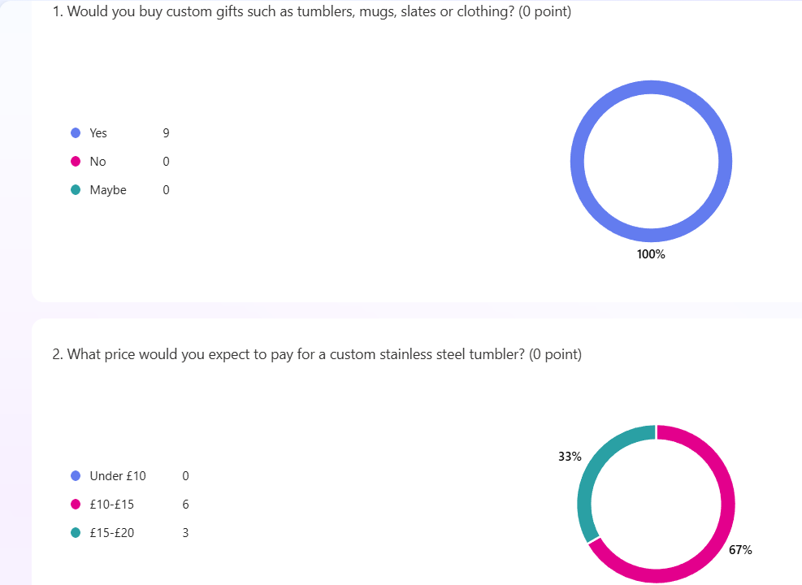

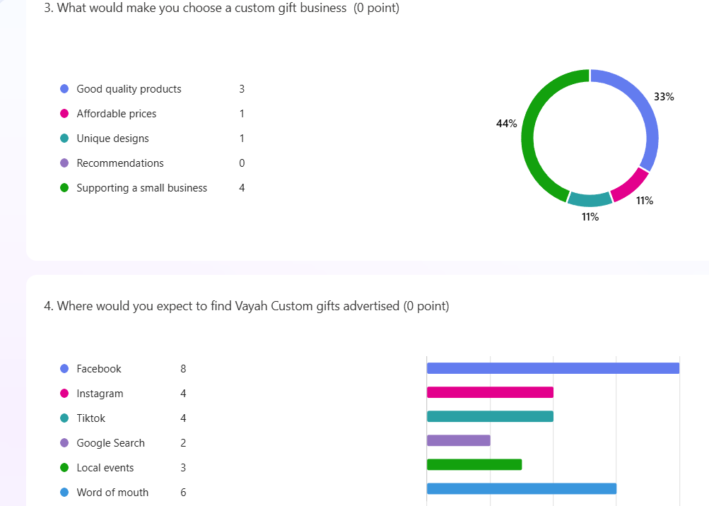

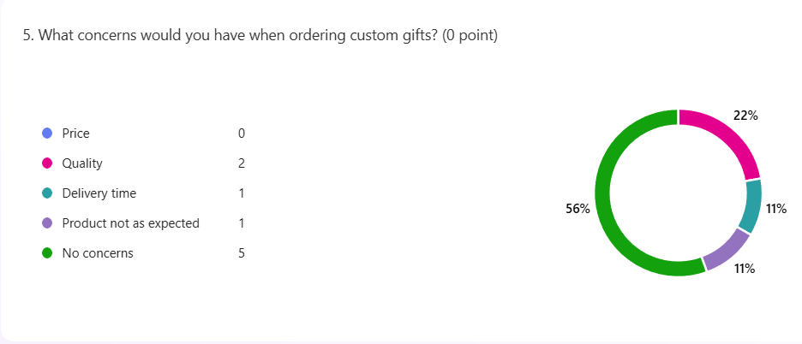

Appendix C
STRENGTHS | AWEAKNESSES
Home-based business with low overhead costs.  Custom products tailored to individual customer requirements.  Wide range of products for different occasions, encouraging repeat purchases.  Strong customer service and direct communication with customers. | Limited production capacity as the business is operated by one person.  Limited marketing budget compared with larger competitors.  Reliance on seasonal sales, particularly during Christmas and other celebrations.  Dependence on suppliers for stock availability and delivery times.
OPPORTUNITIES | THREATS
Growing demand for personalised and customised gifts.  Expansion into corporate gifts and promotional products.  Increased sales through social media marketing and e-commerce.  Developing new seasonal product range to attract repeat customers. | Increasing competition from online retailers such as Etsy.  Rising material, postage and supplier costs due to inflation.  Cost-of-living pressure reducing consumer spending on non-essential items.  Changes to social media algorithms reducing organic reach.

Appendix D
Competitors | Location | Products & Prices | Customer Reviews & Marketing | Strengths | Weaknesses
Cookies & Koa | Swansea | Personalised slates £18-£48 | Active on Facebook and Instagram with positive local reviews | Established local reputation and quality products | Limited products range compared to Vayah
Etsy Sellers | Worldwide | Wide range of personalised gifts £10-£30+ | Large online marketplace with customer reviews | Huge product selection and trusted platform | Quality and delivery vary between sellers
The Perfect Gift Co | Online (UK) | Large selection of personalised gifts | Strong website and social media presence | Well-known company and extensive product range | Less personalised customer service and higher prices for some items.

Appendix E
7P | What this means for my business | Risk or issue | How the business will manage this
Product | Vayah will sell a wide range of custom gifts including tumblers, mugs, clothing, slates and seasonal items. Products will be customised to customer requirements and made to order. | Customers may not be happy with the design or quality of product. | Focus on quality, clear product photos, detailed descriptions and design previews before production. Encourage reviews to build trust and show previous work.
Price | Prices will be set based on material cost, production time and competitor prices. Products will be competitively priced while ensuring a suitable profit margin. | Prices may seem as too high compared to competitors or too low cover costs. | Review material costs regularly, compare competitors and offer different price ranges and bundles options to suit customers.
Place | Order will be taken through Facebook, Instagram and website. Products will be posted across the UK and local collection offered. | Limited sales if relying only on local customers | Promote online to reach customers across the UK. Work with a reliable delivery service and off local collection where possible.
Promotion | Promotion will use Facebook, Instagram, TikTok, customer reviews, seasonal posts, competitions and word of mouth recommendations. | Social media may not reach enough customers or engagement may be low. | Post regularly, use good quality content, use hashtags and engage with followers. Encourage customers to leave reviews and share posts.
People | Excellent customer service will be provided by communicating quickly, being friendly, reliable and providing updates on orders. | High workload if too many orders arrive at once. | Limit custom orders at the start, use an order tracker spreadsheet, set realistic turnaround times prioritise communication.
Process | Customers will contact the business, confirm design, price and delivery details, pay and receive updates until delivery. | Poor order tracking could lead to missed messages, delays or customer dissatisfaction. | Use an order tracker spreadsheet, send confirmation messages, update customers throughout the process and keep all records.
Physical  Evidence | Professional branding, logo, product tags, quality photos, branded packaging, customer reviews and social media pages. | If branding or presentation looks unprofessional, customers may question quality. | Keep branding consistent across all platforms, use clear photos, branded packaging and encourage reviews to build trust.

Appendix F
Marketing activity | Target customer | Cost | When will this happen? | Aim | How will it be measured?
Facebook business page launch | Local customers and families in South Wales | £0 | Two weeks before launch | Build brand awareness and attract potential customers | Page views, followers, likes, comments and enquires.
Instagram and TikTok content | People interested in personalised gifts and seasonal products | £0 | Three posts per week | Increase engagement and showcase products | Reach, views, shares, enquires and followers
Flyers and posters | Local shops, community noticeboards and local businesses | £30 | One week before launch | Increase awareness | Number of enquires and local orders received
Referral offer  10% off | Friends, family and existing customers | Discount applied to qualifying orders | Launch week | Encourage word of moth marketing and repeat business | Referral code usage and repeat customer sales
Paid Facebook advertisement | Customers within the UK | £10 | During the first month | Increase website visits and generate new orders | Link clicks, enquires, orders and return on advertising spend
Seasonal promotions | Existing and new customers | £20 | Before key events | Increase seasonal sales | Sales during promotional periods compared with normal weeks
Customer review campaign | Existing customers | £0 | After every completed order | Build trust and improve reputation | Number of online reviews and average customer rating

Appendix G
Pricing Evidence
Product | Price | Cost to make | Competitor price | Pricing strategy | Reason
Tumber | £12.00 | £4.00 | £15.00 | Cost-plus | Affordable
Slate | £12.50 | £4.34 | £15.50 | Cost-plus | Affordable
Hoodie | £20.00 | £11 | £24.00 | Cost-plus | Affordable
Seasonal Bundle | £25.00 | £12 | £30.00 | Bundling | Affordable

Income Streams
Product | Selling Price | Expected monthly sales | Estimated monthly income
Tumbler | £12.00 | 40 | £480.00
Slate | £12.50 | 20 | £250.00
Hoodie | £20.00 | 15 | £300.00
Seasonal Bundle | £25.00 | 8 | £200.00
Estimated total monthly income |  |  | £1,230

Appendix H
Area | What will my business need? | Cost or evidence | Where does this appear in my plan?
People | Owner | Owner’s time | Operations
Location/premises | Home | No cost | Operations
Equipment | Sublimation printers, Cricut and Heat press | £2,168.98 | Operations
Suppliers | PenCarrie, MDP Supplies, Longforte and Tumblers UK | Websites evidence | Operations
Booking/payment systems | Social media, Website | Evidence | Operations
Health and safety | Secure Lock on summer house | Cost | Operations
Licences/permits/insurance | Public and Product Liability Insurance |  | Operations
Risk and contingency | Low sales, Supplier Delays, Inesses | Evidence | Operations

Appendix I

Stage | What happens? | Who is responsible? | What system/evidence supports it?
Customer finds business | Social media and Word of mouth | Owner | Advertisement
Customer enquiry | Enquiry on products, production time and delivery | Owner | Social media and email
Booking/order | Create a invoice and add to spreadsheet | Owner | Order tracker and confirmation
Preparation | Prepare order for delivery or local collection | Owner | Design software and quality check
Delivery/service | Package order and buy postage | Owner | Courier website
Payment | Receive payment | Owner | Website or bank transfer
Follow-up/review | Send email or message asking for feedback | Owner | Email or social media messenger

Appendix J

Risk | Likelihood | Impact | How the risk will be reduced | Contingency plan
Supplier delay | Medium | Medium | Use multiple suppliers | Order from alternative supplier
Equipment breakdown | Low | High | Regular maintenance | Outsource urgent orders or replace equipment quickly
Owner illness | Low | High | Plan workload and communicate with customers | Pause new orders until able to resume
Low sales | Medium | High | Regular social media marketing and seasonal promotions | Increase advertising and introduce special offers
High order volumes | Medium | Medium | Limit orders and prioritise work | Extend turnaround times and communicate clearly

Appendix K


