DS 1 Template

My Screenshots/Photos
- Please add 4–6 screenshots or photos of your digital life.
- You can use your phone or laptop.
- For each screenshot, write one or two sentences explaining what it shows.

Screenshot/Photo 1
[Insert Photo/Screenshot below]

[ lisent music.]]

Screenshot/Photo 2
[Insert Photo/Screenshot below]

[ help my wen I travel to university to not lose the way]

Screenshot/Photo 3
[Insert Photo/Screenshot below]
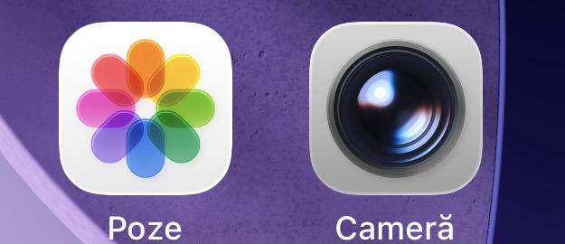
[ apps that’s storege my memoris photos video family time eryting, olso coduments on the university]

Screenshot/Photo 4
[Insert Photo/Screenshot below]
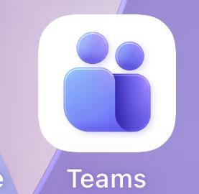
[make lectures on clases help a lot]

Screenshot/Photo 5
[Insert Photo/Screenshot below]

[information helps ]

Screenshot/Photo 6
[Insert Photo/Screenshot below]

[my gym app I scan wen I get in]

My Short Reflection
- Write 5–8 simple sentences about your digital life.
- You can use the sentence starters below if helpful.
Digital life is in continuous evolution, and in my life technology is important both to find information in a short time and to help me with daily tasks, I use my phone for GPS and for social networks it helps me connect with people who are far away, technology makes any problem much easier for me, technology helps us in an efficient way to give us the opportunity to talk to loved ones at a distance but also in a professional way by learning and finding information from multiple sources and sites.

Sentence starters
You can write more if you want.
Digital skills are important to me because I want a career in the field.

Submission Checklist
Before you submit, please check:
​​​ ☒ I added 4–6 screenshots
☒ I wrote short sentences for each screenshot
☒ I wrote my short reflection
☒ My work is my own
☒ My file opens correctly
​​☒ My file opens correctly

