

Student ID: 2432185
Student Name: Shivam Shaileshbhai Patel
Module: International Business Concepts
Module Code: LCMB7034
Lecturer Name: Chung Lai Johnny Wan
Word Count: 4901 Words
Submission Date: 21-11-2025

Contents
1. Introduction 12
2. Benefits and Challenges of International Operations 12
2.1 Why Unilever is Designated an MNC/TNC 12
2.2 Value Chain Definition and Rationale for Focus 13
2.3 Nature of Unilever’s Global Operations and Value Chain 14
2.4 Entry Modes Used by Unilever in International Markets 15
2.5 Key Benefits of International Operations 16
2.6 Challenges of International Operations 17
3. OLI Factors (Ownership, Location, Internalisation) and Their Impact on Entry into India 18
3.1 Ownership Advantages and Their Influence on Entry Mode 18
3.2 Location Advantages of India as a Host Market 19
3.3 Internalisation Advantages and the Preference for FDI 20
3.4 Integrated Impact of the OLI Framework on Unilever’s Entry Mode Choice 21
4. Cultural Differences Between UK/Netherlands and India and Their Impact on Entry Strategy 22
4.1 Power Distance and Its Influence on Management Approach 23
4.2 Individualism vs Collectivism: Implications for Marketing and Consumer Strategy 23
4.3 Uncertainty Avoidance and Brand Trust Building 24
4.4 Masculinity and Aspirational Positioning of Beauty and Personal Care Brands 24
4.5 Long-Term Orientation and Strategic Investment Decisions 25
4.6 Overall Impact of Cultural Differences on Market Entry and Expansion 25
5. Recommendations: SOP Adjustments for India 25
Recommendation 1: Strengthen Sustainability-Driven Packaging Innovation in India 26
Recommendation 2: Expand Hyper-Local Product Development and Cultural Customisation 27
Recommendation 3: Deepen and Digitally Enhance Rural Market Distribution and Empowerment Programmes 28
6. Conclusion 30
7. References 31

1. Introduction
Unilever is one of the world’s largest and most diversified fast-moving consumer goods (FMCG) multinationals, with operations spanning over 190 countries and a portfolio of more than 400 brands across personal care, food, beverages, and home care. The company’s extensive global presence, combined with its decentralised organisational model, has enabled it to remain one of the most influential multinational corporations (MNCs) in the global marketplace. This report evaluates Unilever’s international operations through a structured analysis focusing on its benefits and challenges of globalisation, internationalisation strategies, and global value chain activities. A critical OLI (Ownership–Location–Internalisation) analysis is conducted to investigate Unilever’s strategic entry into India, one of its most important emerging markets. The report further explores cultural differences between the company’s home country (United Kingdom/Netherlands) and India, focusing on their impact on market entry and business performance. Finally, strategic recommendations are provided regarding necessary adjustments to Unilever’s Standard Operating Procedures (SOPs) in India to ensure long-term success

2. Benefits and Challenges of International Operations

2.1 Why Unilever is Designated an MNC/TNC
Unilever is widely recognised as both a multinational corporation (MNC) and a transnational corporation (TNC) due to the breadth, complexity, and organisational structure of its global operations. An MNC is typically defined as a corporation that owns or controls production, distribution, and service facilities outside its home country (Cavusgil et al., 2020). Unilever clearly meets this definition, as it operates in over 190 countries and maintains more than 300 manufacturing facilities worldwide (Unilever, 2024). Its brands—including Dove, Lifebuoy, Lux, Vaseline, and Knorr—are produced, marketed, and consumed globally, with supply chains spanning multiple continents.
However, Unilever’s organisational structure extends beyond the conventional MNC model. According to Bartlett and Ghoshal’s (1989) typology, a transnational corporation integrates global efficiency, local responsiveness, and worldwide learning simultaneously. Unilever strongly reflects these qualities. Rather than centralising decision-making exclusively at headquarters in London and Rotterdam, the firm adopts a decentralised structure that empowers local subsidiaries to respond effectively to regional consumer needs. Hindustan Unilever Limited (HUL), the Indian subsidiary, is a prime example of this autonomy. HUL independently manages product development, marketing campaigns, supply chain networks, and distribution strategies tailored specifically to the Indian market, reflecting local cultural, economic, and climatic conditions.
This hybrid model—combining global strategic direction with local customisation—enables Unilever to leverage the benefits of global integration while remaining flexible enough to adapt to market heterogeneity. This dual characteristic validates its classification as both an MNC and a TNC.

2.2 Value Chain Definition and Rationale for Focus
To critically assess Unilever’s international operations, it is essential to begin with a clear conceptualisation of the value chain. Porter (1985) defines the value chain as a structured set of primary and support activities through which firms create value for customers. Primary activities include inbound logistics, operations, outbound logistics, marketing and sales, and after-sales service. Support activities—such as procurement, technological development, human resource management, and firm infrastructure—enable the effective execution of primary functions.
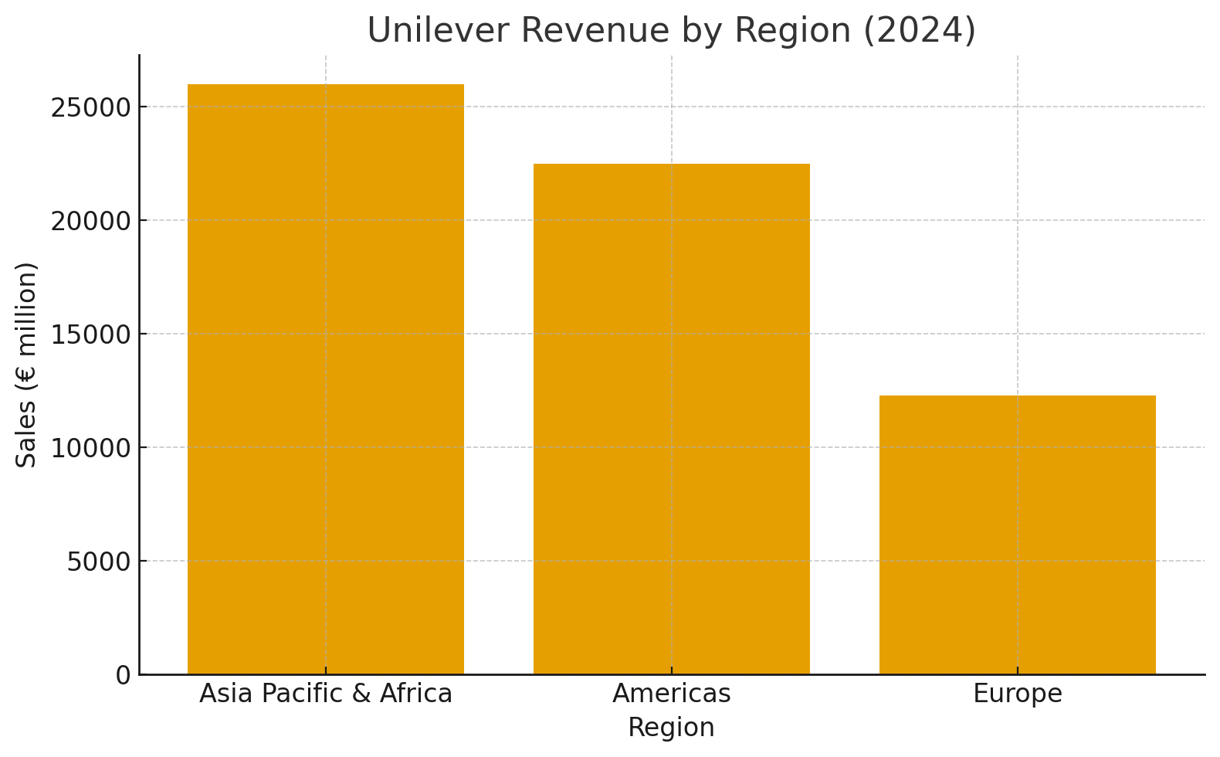

Although all value chain components are relevant, this analysis prioritises five key elements: research and development (R&D), sourcing, manufacturing, marketing and distribution, and financing. These specific activities are most strategically important for understanding Unilever’s competitive advantage and its operations across different international markets. Unilever’s success particularly hinges on its ability to innovate products (R&D), secure reliable input supplies (sourcing), manufacture efficiently at scale (operations), market effectively across cultures (marketing), and manage financial decisions across global subsidiaries (financing). By contrast, functions such as after-sales service or customer support are less central to the fast-moving consumer goods (FMCG) sector, where product usage is straightforward and customer contact is minimal. Therefore, the selected focus reflects both strategic relevance and industry-specific characteristics.

2.3 Nature of Unilever’s Global Operations and Value Chain

Unilever’s global operations reflect an intricate blend of standardisation and localisation, allowing the company to maintain global brand consistency while responding to regional needs.

R&D is fundamental to Unilever’s value creation. With innovation hubs located in the UK, the Netherlands, China, India, and Singapore, the company continually invests in product formulation, sustainable packaging, and advanced supply chain technologies. Local teams adapt global innovations to fit regional climates, consumer preferences, and cultural norms. In India, for instance, where weather conditions vary widely and skincare needs differ from Western markets, R&D centres develop products specifically targeting local issues such as hard water, monsoon humidity, and tropical skin conditions (HUL, 2024).

Sourcing is equally global in nature. Unilever partners with more than 150,000 suppliers and procures agricultural raw materials—including tea, palm oil, spices, and dairy products—from diverse regions. India serves as a significant sourcing hub, particularly for tea and botanicals used in personal care products. Sourcing practices are guided by sustainability frameworks such as the Unilever Sustainable Living Plan, which aims to minimise environmental impact and support ethical labour practices across the supply chain.

Manufacturing facilities are distributed globally to enable local production, cost reduction and operational agility. India alone hosts over 30 factories, producing goods such as laundry detergents, soaps, haircare products, and packaged foods for domestic consumption and export to South Asian and African markets. This localisation strategy allows Unilever to meet demand efficiently, reduce lead times, and mitigate risks associated with cross-border logistics disruptions.

Marketing and distribution are the most culturally adapted components of the value chain. In India, marketing campaigns reflect local values related to family cohesion, societal hierarchy, hygiene practices, and beauty standards. Unilever customises communication by producing advertisements in regional languages and designing culturally nuanced brand messages. A strategic pillar of its distribution model in India is Project Shakti, an initiative empowering rural women to act as micro-entrepreneurs selling Unilever products. This approach not only expands rural reach but aligns with social expectations of community participation and trust-building.

In financial terms, Unilever maintains a centralised global treasury system to optimise capital allocation, liquidity, and risk management. However, regional subsidiaries like HUL are listed on domestic stock exchanges (e.g., NSE and BSE in India), enabling them to raise capital locally, enhancing financial legitimacy and stakeholder confidence. This dual structure strengthens financial flexibility across markets.

2.4 Entry Modes Used by Unilever in International Markets

Unilever uses a diverse range of entry modes, depending on factors such as local regulation, market maturity, and strategic objectives. Foreign direct investment (FDI) is the dominant method, particularly in major markets such as India, Indonesia, Brazil, and China. Unilever entered India through FDI in 1931, establishing the Hindustan Vanaspati Manufacturing Company, which later merged into HUL. The use of FDI aligns with Unilever’s strategic need for control over production, brand standards, innovation transfer, and intellectual property protection (Dunning, 2000).

Mergers and acquisitions are central to expanding Unilever’s product portfolio and market share. The acquisition of GSK Consumer Healthcare’s Horlicks brand significantly boosted Unilever’s presence in India’s nutritional beverages market (HUL, 2020). Globally, acquisitions such as Ben & Jerry’s, Dollar Shave Club, and Seventh Generation illustrate its strategy of leveraging niche, high-growth brands.

Joint ventures have been employed in markets where regulatory barriers or the need for local knowledge is high. For instance, in China Unilever initially operated through a joint venture with Shanghai Toothpaste Company, enabling quicker market penetration and stronger local acceptance.

Licensing and franchising, although less prominent, support Unilever in extending its brand presence where direct investment is not cost-effective or strategically necessary. Nonetheless, FDI remains the primary mode due to Unilever’s preference for high control, integration of global standards, and long-term presence.

2.5 Key Benefits of International Operations

Unilever’s international operations deliver numerous strategic benefits. Revenue diversification is a major advantage. With over 58% of global revenue coming from emerging markets, Unilever reduces its dependency on mature markets and protects itself from regional economic fluctuations (Unilever, 2024). This diversification stabilises financial performance across economic cycles.

Economies of scale also play a significant role. Centralised procurement systems allow Unilever to purchase raw materials—such as palm oil and chemicals—at lower costs. Standardised global production technologies and processes further improve efficiency and reduce waste (Grant, 2021).

Expanding in emerging markets offers access to rapidly growing consumer segments. India, with rising middle-class incomes and increasing urbanisation, presents enormous opportunities for personal care and household products (Rao, 2022). Unilever’s strong localisation capabilities enable culturally relevant product adaptations and marketing strategies, strengthening competitive positioning.

Knowledge transfer among subsidiaries enhances organisational learning. Innovations developed in European laboratories—such as advanced formulations—are adapted for Southeast Asian and African markets. Conversely, cost-saving innovations and small-pack strategies pioneered in India, such as single-use shampoo sachets, have been adopted globally, demonstrating reverse innovation.

Strong global brand recognition further strengthens consumer trust, allowing rapid penetration of new markets and reinforcing competitive advantage across regions.

2.6 Challenges of International Operations

Despite these strengths, Unilever also faces significant challenges in its global operations. Cultural complexity is a major issue. Operating across diverse cultural landscapes requires profound understanding of consumer values, social roles, and behavioural patterns. Misjudging cultural nuances—particularly in sensitive categories such as beauty or hygiene—can lead to ineffective marketing or reputational risks (Hofstede, 2011).

Regulatory challenges are persistent, particularly in emerging markets. India’s regulatory environment—governing FDI, product safety, labelling, environmental standards, and labour laws—requires continual monitoring and compliance adjustments. Changes in taxation, import tariffs, and sustainability regulations can affect operating costs and strategic decisions.

Supply chain vulnerabilities pose additional challenges. Unilever relies on agricultural commodities such as tea, palm oil, and dairy, all of which are subject to climate-related disruptions, geopolitical tensions, and price volatility. Ensuring sustainable and ethical sourcing across diverse regions adds another layer of complexity.

Environmental sustainability concerns also create pressure. Despite progress under the Unilever Sustainable Living Plan, the company continues to face scrutiny regarding plastic usage, carbon emissions, and water consumption. Consumer expectations for environmentally responsible products demand continuous improvement.

Competition in emerging markets such as India remains intense. Domestic firms like Patanjali Ayurveda, Nirma, and ITC leverage deep cultural insights and cost advantages, creating strong local competition that challenges Unilever’s market dominance.

3. OLI Factors (Ownership, Location, Internalisation) and Their Impact on Entry into India

Dunning’s OLI (Ownership–Location–Internalisation) paradigm remains one of the most influential frameworks for explaining foreign direct investment and the strategic choices firms make when entering international markets (Dunning, 2000). The framework proposes that a firm will engage in FDI only when all three advantages—ownership, location and internalisation—jointly justify this choice over alternative modes such as licensing, exporting or joint ventures. In the case of Unilever’s entry into India, the OLI paradigm provides a clear analytical lens through which the company’s long-term strategy and operational decisions can be understood. Unilever’s sustained commitment to India, reflected in the scale of Hindustan Unilever Limited (HUL), is grounded in the interaction of these three factors.

3.1 Ownership Advantages and Their Influence on Entry Mode

Ownership advantages refer to the unique resources, capabilities and competencies that a firm possesses, which give it a competitive edge in foreign markets. For Unilever, these advantages are substantial and multidimensional, shaping its preference for high-control entry modes such as FDI. One of the most visible ownership advantages is Unilever’s globally recognised portfolio of brands—including Dove, Lifebuoy, Lux, Surf Excel, Vaseline and Knorr—which carry trust and familiarity across markets. In the Indian context, these brands facilitated smoother market penetration because Indian consumers generally associate multinational household names with quality, safety and reliability (Kapur, 2021). The strength of these brands provided Unilever with immediate differentiation from domestic competitors, making full ownership control advantageous.

Another pivotal ownership advantage lies in Unilever’s robust and globally integrated research and development (R&D) capabilities. With R&D centres spread across Europe, Asia and the Americas, Unilever possesses advanced technological expertise in product formulation, sustainable packaging and manufacturing processes. This is particularly relevant to India because the country’s diverse climatic conditions and unique consumer preferences require significant product adaptation. Unilever’s ability to develop culturally and environmentally tailored products—such as heat-resistant skincare formulations and hard-water compatible detergents—would be difficult to achieve through licensing agreements or joint ventures where the company would have less control over innovation processes.

Managerial and organisational capabilities further reinforce Unilever’s ownership advantages. Its transnational structure supports a balance between global efficiency and local responsiveness. While strategic directions and corporate governance principles are set at the global headquarters, significant operational autonomy is delegated to subsidiaries such as HUL. This decentralised and responsive management approach is particularly suited to India, a market characterised by diverse consumer segments and rapidly changing preferences. Only through full or majority ownership could Unilever fully leverage this organisational flexibility.

Financial strength also supports Unilever’s ability to enter through FDI. As one of the world’s largest FMCG corporations, it has both the capital resources and risk-bearing capacity to invest in manufacturing plants, distribution networks and acquisitions. These substantial ownership advantages collectively push Unilever towards a high-control mode of entry, favouring FDI over other alternatives.

3.2 Location Advantages of India as a Host Market

Location advantages concern the attractiveness of the host country and the extent to which the foreign market offers opportunities that justify investment. India provides several location-specific advantages that strongly encouraged Unilever to enter and remain in the market through FDI.

India’s massive population of over 1.4 billion represents one of the largest FMCG consumer bases in the world, with rising incomes, increased urbanisation and expanding middle-class demographics fuelling demand for personal care, household and packaged food products (Rao, 2022). Beyond demographic scale, India’s consumer market is highly dynamic, with strong growth prospects driven by long-term structural changes such as rural electrification, digital access and improved retail infrastructure. These demographic and socio-economic advantages make India a lucrative market deserving of significant foreign investment.

Cost advantages are another critical location factor. India offers relatively low labour and manufacturing costs compared to Western markets, enabling Unilever to establish local production at competitive costs. Moreover, the availability of local raw materials—such as tea, spices, dairy and herbal ingredients—supports Unilever’s global supply chain. India’s well-established agriculture sector plays a particularly important role in sourcing for Unilever’s food and personal care divisions.

Government policies also enhance India’s location attractiveness. Over the past two decades, the Indian government has continuously liberalised FDI regulations, simplified business procedures and offered incentives to foreign manufacturers. Initiatives such as “Make in India” have strengthened the manufacturing environment and reduced entry barriers for companies like Unilever (Government of India, 2023). The regulatory environment thus favours long-term investment.

Another location advantage is India’s geographical position within South Asia. Its proximity to neighbouring markets, combined with improving logistics infrastructure, enables Unilever to use India as a strategic production hub for regional exports. India’s high cultural diversity, along with its large rural and semi-urban segments, also provides opportunities for innovation in product formats and distribution models—opportunities that Unilever has successfully harnessed.

Together, these location-specific factors make India an attractive investment destination, thereby complementing Unilever’s ownership advantages and reinforcing FDI as the optimal market entry mode.

3.3 Internalisation Advantages and the Preference for FDI

Internalisation advantages relate to the benefits of keeping operations within the firm rather than transferring them to external partners. For Unilever, internalisation is a fundamental driver of its entry strategy because it operates in industries where quality control, brand integrity and intellectual property are critical.

Personal care, hygiene and food products require strict adherence to global safety and quality standards. By internalising production, Unilever ensures that its formulations, manufacturing processes and packaging meet consistent global benchmarks. Relying on local partners through licensing agreements would create risks of brand dilution, inconsistent product quality or unintended exposure of proprietary formulas. Internalisation therefore allows Unilever to safeguard its intellectual property, protect its brand reputation and maintain control over strategic decisions.

Efficiency gains also contribute to Unilever’s internalisation advantages. Integrated supply chains allow the company to optimise procurement, production and distribution. This integration supports economies of scale and enhances responsiveness to market changes. The widely recognised shampoo sachet innovation, for example, was developed and implemented rapidly because Unilever fully controlled its production and marketing processes in India. Such rapid adaptation would be hindered in arm’s-length market relationships.

Internalisation also supports Unilever’s commitment to sustainability. The company’s global frameworks—such as its Sustainable Living Plan—require close coordination across sourcing, production and distribution. Maintaining direct control over operations helps ensure that sustainability objectives are met and communicated clearly, which would be more difficult with external partners.

3.4 Integrated Impact of the OLI Framework on Unilever’s Entry Mode Choice

Taken together, the OLI factors clearly show why FDI was the most appropriate and effective entry mode for Unilever in India. Ownership advantages—including strong brands, advanced R&D capabilities, specialised managerial expertise and substantial financial resources—made high control desirable. Location advantages—such as India’s vast consumer market, low production costs, resource availability and supportive government policies—created favourable conditions for long-term investment. Internalisation advantages—particularly in relation to intellectual property protection, supply chain efficiency and global brand consistency—reinforced the necessity of retaining control rather than outsourcing operations.

By entering through FDI, Unilever not only secured long-term market presence but also built strong indigenous capabilities through HUL, now one of India’s most respected consumer goods companies. The OLI framework therefore provides a comprehensive explanation for Unilever’s strategic choice and helps illuminate how the company achieved sustained success in one of the world’s most competitive emerging markets.

4. Cultural Differences Between UK/Netherlands and India and Their Impact on Entry Strategy

Cultural differences shape almost every aspect of international business, from product design to organisational structures, communication, marketing and distribution. For consumer-focused firms like Unilever, understanding national culture is essential because product acceptance, brand loyalty and purchasing behaviour are strongly influenced by cultural norms. Hofstede’s cultural dimensions provide a structured and quantifiable way of comparing cultural patterns between Unilever’s home countries—the United Kingdom and the Netherlands—and India (Hofstede Insights, 2024). These measurable differences have directly shaped Unilever’s entry strategy, marketing decisions and operational practices in India.

4.1 Power Distance and Its Influence on Management Approach

Hofstede’s data show a stark contrast in power distance values: India scores 77, while the UK scores 35 and the Netherlands 38. This indicates that Indian society largely accepts hierarchical structures, clear authority and unequal power distribution, whereas Unilever’s home markets favour flatter organisational systems. As Unilever expanded into India, it adjusted its internal management style within Hindustan Unilever Limited (HUL) to align with local expectations. Senior leaders in India have more defined authority and decision-making responsibilities than their counterparts in Europe. This alignment has enabled smoother communication, reduced internal resistance and improved leadership credibility among Indian employees. A more centralised structure also facilitated faster decision-making in a complex and diverse market environment(Hofstede, 2011).

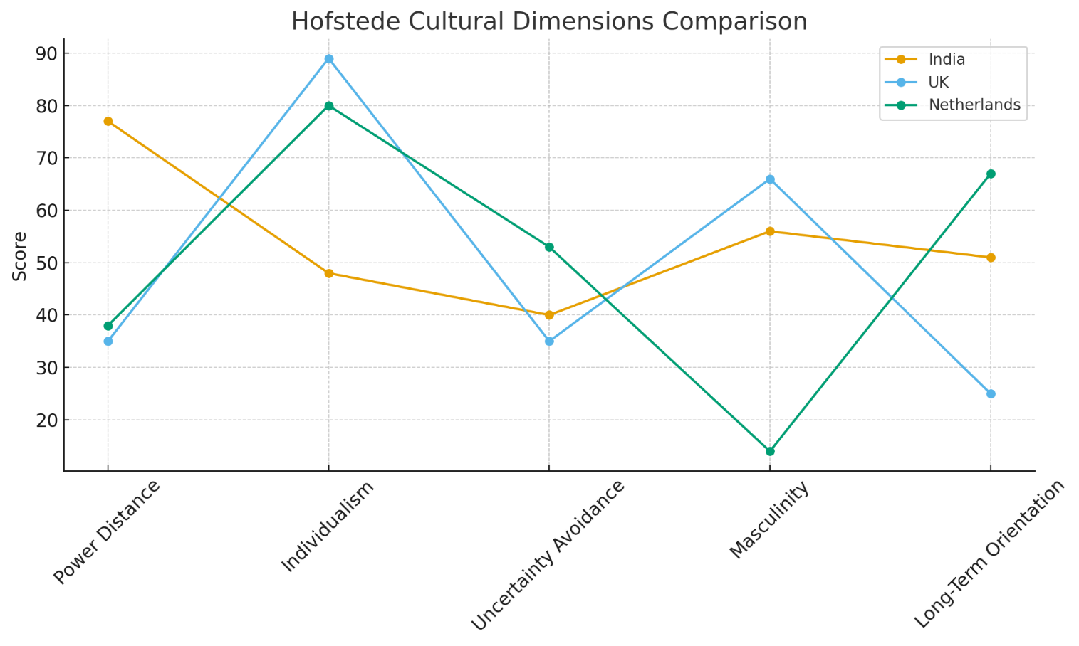

4.2 Individualism vs Collectivism: Implications for Marketing and Consumer Strategy

On the individualism dimension, India scores 48, placing it closer to collectivist societies, whereas the UK scores 89 and the Netherlands 80, both highly individualistic. In collectivist cultures, family, community and group belonging strongly influence consumer decisions. This cultural contrast played a decisive role in shaping Unilever’s marketing strategies in India. Campaigns such as Lifebuoy’s “Help a Child Reach Five” emphasise collective wellbeing, community protection and family responsibility—messages that strongly resonate with Indian audiences. Similarly, Surf Excel’s “Daag Acche Hain” campaign highlights social responsibility and emotional bonds within families, reflecting collectivist values. In contrast, Western campaigns for the same brands often focus on individual preferences, self-expression or personal achievement. This localisation underscores Unilever’s adaptation to cultural expectations.

4.3 Uncertainty Avoidance and Brand Trust Building

Uncertainty avoidance measures the extent to which societies feel threatened by ambiguity. India’s moderate score of 40 contrasts with the UK’s 35 and the Netherlands’ higher 53. For India, this creates a consumer base that values reassurance but is comfortable with moderate risk. Unilever has responded by positioning many of its brands around trust, heritage and long-term reliability. Products such as Lifebuoy, Lux and Pears stress their long-standing history, safety, dermatological testing and quality guarantees. Packaging often highlights certifications and factual claims, building confidence among consumers who prioritise reliability, especially in health and hygiene products.

4.4 Masculinity and Aspirational Positioning of Beauty and Personal Care Brands

On masculinity, India scores 56, indicating a society that values achievement, ambition and social advancement. By comparison, the UK scores 66, while the Netherlands is highly feminine at 14, emphasising modesty, equality and quality of life. In India’s aspirational environment, Unilever tailored its beauty and personal care messaging to reflect upward mobility, confidence and modernity. Historically, this included fairness-oriented messages—later revised to empowerment narratives after social backlash. Brands like Dove, Sunsilk and Ponds increasingly promote self-confidence, career ambition and personal success. These themes align closely with Indian consumers’ desire for progress and improvement.

4.5 Long-Term Orientation and Strategic Investment Decisions

Long-term orientation scores further highlight cultural differences. India scores 51, the Netherlands 67 and the UK only 25. This suggests that India values perseverance, thrift and future planning. This alignment has supported Unilever’s long-term commitment to India, demonstrated through investments in local R&D centres, sustainable agriculture partnerships and long-range supply chain improvements. Unilever’s Project Shakti, for example, reflects a long-term developmental approach, empowering rural women entrepreneurs and strengthening grassroots distribution networks over time.

4.6 Overall Impact of Cultural Differences on Market Entry and Expansion

The cumulative effect of these cultural contrasts has significantly shaped Unilever’s entry and growth strategy in India. Product adaptation was essential: climate-specific formulations, Ayurvedic ingredients, and low-unit-price sachets were developed in response to cultural and economic realities. Distribution strategies such as Project Shakti capitalised on collectivist rural community structures. Internally, Unilever adapted hierarchical management practices to align with expectations of authority and leadership. These culturally grounded strategies have enabled Unilever not only to enter the Indian market successfully, but to sustain long-term growth and develop one of its strongest global subsidiaries.

5. Recommendations: SOP Adjustments for India

To formulate robust and credible recommendations for Unilever’s continued success in India, it is essential to revisit the challenges identified in earlier sections of the report. Although Unilever remains one of India’s leading FMCG firms, the company faces increasing complexity in the competitive, regulatory and socio-cultural landscapes. Key challenges include: intensifying competition from culturally rooted domestic brands, heightened sustainability requirements relating to plastic waste and environmental impact, persistent difficulties in accessing the rural market at scale, and the need for faster and deeper product innovation that reflects diverse regional preferences. Additionally, shifts in consumer expectations—driven by rising incomes, digital adoption and cultural pride—require Unilever to further modernise its operational and strategic procedures.

The following recommendations propose targeted adjustments to Unilever’s Standard Operating Procedures (SOPs). These recommendations aim to enhance Unilever’s strategic agility, reinforce its ownership advantages, strengthen its exploitation of India’s location-specific strengths and ensure more effective internalisation of key processes. They are grounded in the OLI framework, supported by insights from cultural analysis, and designed to address both operational and strategic gaps.

Recommendation 1: Strengthen Sustainability-Driven Packaging Innovation in India

One of Unilever’s most pressing strategic challenges relates to rising demands for environmental responsibility, particularly regarding plastic waste. India’s waste-management infrastructure faces ongoing strain, and government regulations—including Extended Producer Responsibility (EPR) policies—are tightening annually. At the same time, Indian consumers, especially urban and upper-middle-class segments, are increasingly conscious of sustainability, actively seeking brands that minimise environmental harm.

To respond to these pressures, Unilever’s SOPs should be revised to establish a more rigorous and measurable sustainability-focused packaging framework. This updated framework should require all categories—including lower-priced sachets—to incorporate biodegradable, compostable or fully recyclable materials. Given India’s diverse climatic conditions, innovations must be suited to high heat, humidity and variable transport conditions. Current R&D efforts are positive but insufficient to meet the scale of regulatory and social expectations.

Unilever should expand local R&D dedicated specifically to sustainable packaging materials, exploring regionally available agricultural by-products (such as bagasse, rice husk fibres or bamboo cellulose) as potential base materials. These materials may reduce dependency on conventional plastics while creating economic opportunities for rural producers. The company should also incorporate lifecycle assessment (LCA) metrics into its SOPs so that environmental impact is measured consistently across all product lines.

From the perspective of the OLI framework, this recommendation leverages ownership advantages, particularly Unilever’s global R&D capabilities and innovative capacity. At the same time, it responds to location advantages, as India’s evolving regulatory environment and large eco-conscious consumer base create strong incentives for sustainable packaging. By internalising the innovation process, Unilever preserves quality control and intellectual property, reinforcing internalisation advantages. Integrating sustainability into SOPs thus ensures compliance, reduces risk and strengthens brand equity among environmentally aware Indian consumers.

Recommendation 2: Expand Hyper-Local Product Development and Cultural Customisation

Another significant challenge for Unilever in India is increasing competition from domestic firms—especially those rooted in traditional, herbal and Ayurvedic product propositions. Brands such as Patanjali, Dabur, Himalaya and Mamaearth have successfully positioned themselves as culturally authentic alternatives, appealing strongly to nationalist sentiments, natural-ingredient preferences and growing interest in traditional wellness practices. These firms are highly responsive to regional tastes and cultural preferences, giving them an advantage in local product relevance.

To address this competitive pressure, Unilever should revise its SOPs to formalise and strengthen hyper-local product development. While Unilever already conducts local R&D, the process must become more granular, systematic and culturally embedded. SOPs should require each product category team to incorporate structured regional insights into the innovation cycle—such as linguistic differences, climate variation, cultural rituals, beauty standards, dietary traditions and locally preferred ingredients.

Hyper-localisation may include:
• increasing the use of Ayurvedic and herbal ingredients where culturally appropriate;
• developing region-specific fragrances, textures and formulations;
• adapting product formats to local usage patterns and water-availability conditions;
• strengthening collaborations with local dermatologists, nutritionists, agricultural scientists and consumer panels;
• conducting more frequent ethnographic research within diverse Indian communities.

To institutionalise this approach, Unilever’s Indian R&D centres should introduce regular “Local Insight Review Meetings” as part of SOPs, ensuring that all new product proposals demonstrate cultural relevance alongside commercial viability. Additionally, local teams should work closely with small-scale regional farmers to source culturally meaningful ingredients, ensuring both authenticity and sustainability.

This recommendation aligns with Unilever’s internalisation advantages, as keeping product development in-house safeguards intellectual property and ensures quality and safety. It also enhances Unilever’s ability to leverage India’s location advantages, particularly rich biodiversity, cultural diversity and rapidly expanding demand for natural products. By combining its global brand strength with authentic localisation, Unilever can effectively compete against culturally embedded Indian brands.

Recommendation 3: Deepen and Digitally Enhance Rural Market Distribution and Empowerment Programmes

Despite strong efforts through initiatives such as Project Shakti, Unilever continues to face distribution challenges in rural India. With over 65% of India’s population living in rural areas, the market represents enormous potential, but infrastructure limitations—such as poor road connectivity, fragmented retail networks and inconsistent supply-chain visibility—remain significant barriers. Competition from low-cost regional brands is also intense, especially in states where rural consumers prioritise affordability and cultural familiarity.

To strengthen its rural presence, Unilever’s SOPs should integrate a more advanced, digitally enabled rural distribution model. This model should build on the strengths of Project Shakti but enhance scale, efficiency and empowerment. SOP updates could include:

a) Digital Ordering and Inventory Management

Introduce mobile-based ordering systems for Shakti entrepreneurs and small retailers, reducing dependency on intermediaries and improving stock visibility. Such systems can integrate local-language interfaces to support accessibility.

b) GPS-Enabled Route Optimisation

SOPs should mandate the use of GPS-enabled logistics routes to improve delivery efficiency, reduce transport delays and increase coverage of remote villages.

c) Micro-Financing and Skill Development

Provide structured micro-financing options for rural entrepreneurs, including interest subsidies and digital-skills training. This supports cultural values of collectivism and community empowerment while increasing business confidence and retention.

d) Rural Market Intelligence Units

Set up dedicated teams responsible for analysing rural consumer behaviour, seasonal consumption patterns and village-level cultural factors. Insights should be systematically integrated into sales planning and product innovation SOPs.

This recommendation leverages India’s location advantages, particularly its vast rural market potential and growing digital penetration. It also aligns with cultural findings: India’s collectivist social structure makes community-based empowerment programmes highly effective. Furthermore, by internalising distribution processes through digital tools and training, Unilever strengthens its internalisation advantages, reducing dependence on external distributors and enhancing resilience.

6. Conclusion

Unilever’s long-standing success in India demonstrates the company’s ability to combine global strengths with deep local responsiveness. The analysis shows that Unilever’s decision to enter and expand in India was strongly supported by its ownership advantages—including global brands, advanced R&D and financial capability—alongside India’s favourable location advantages, such as its large consumer base and competitive production environment. Internalisation advantages further supported Unilever’s preference for FDI, enabling tight control over brand quality, innovation and supply-chain processes.

Cultural differences between Unilever’s home countries and India significantly influenced the company’s strategies. High power distance, moderate collectivism and long-term orientation required adaptations in management, marketing and product design. Unilever’s sensitivity to cultural values has been central to its ability to build trust and maintain strong market presence.

However, emerging competitive pressures, particularly from culturally rooted Indian brands, along with regulatory demands and rural distribution challenges, indicate that further strategic refinement is necessary. The recommendations proposed—focusing on sustainable packaging innovation, enhanced hyper-local product development and digitally strengthened rural distribution—offer targeted solutions that align with the OLI framework and cultural insights. Integrating these adjustments into Unilever’s SOPs will strengthen operational efficiency, deepen cultural relevance and sustain long-term competitiveness.

By embracing these recommendations, Unilever can enhance its resilience and continue leading within India’s rapidly evolving FMCG landscape.

7. References
Bartlett, C.A. & Ghoshal, S., 1989. Managing Across Borders: The Transnational Solution. Boston: Harvard Business School Press.
Cavusgil, S.T., Knight, G., Riesenberger, J.R., Rammal, H.G. & Rose, E.L., 2020. International Business: The New Realities. 5th ed. Harlow: Pearson Education.
Dunning, J.H., 2000. The Eclectic Paradigm as an Envelope for Economic and Business Theories of MNE Activity. International Business Review, 9(2), pp.163–190.
Elkington, J., 2020. Cannibals with Forks: The Triple Bottom Line of 21st Century Business. 2nd ed. Gabriola Island: New Society Publishers.
Ghemawat, P., 2001. Distance Still Matters: The Hard Reality of Global Expansion. Harvard Business Review, 79(8), pp.137–147.
Grant, R.M., 2021. Contemporary Strategy Analysis: Text and Cases Edition. 10th ed. Hoboken: Wiley.
Government of India, 2023. Make in India Initiative. [online] Available at: https://www.makeinindia.com [Accessed 2 November 2025].
Hill, C.W.L. & Hult, G.T.M., 2022. International Business: Competing in the Global Marketplace. 13th ed. New York: McGraw-Hill Education.
Hofstede, G., 2011. Dimensionalizing Cultures: The Hofstede Model in Context. Online Readings in Psychology and Culture, 2(1). Available at: https://doi.org/10.9707/2307-0919.1014 [Accessed 1 November 2025].
HUL (Hindustan Unilever Limited), 2020. Annual Report 2020. [online] Available at: https://www.hul.co.in/investor-relations/annual-report/ [Accessed 11 November 2025].
HUL (Hindustan Unilever Limited), 2024. Company Overview. [online] Available at: https://www.hul.co.in/about/who-we-are/ [Accessed 12 November 2025].
Johanson, J. & Vahlne, J.-E., 2009. The Uppsala Internationalization Model Revisited: From Liability of Foreignness to Liability of Outsidership. Journal of International Business Studies, 40(9), pp.1411–1431.
Kapur, R., 2021. Advertising Strategies in Emerging Markets: Lessons from India. Journal of Marketing Communications, 27(5), pp.545–563.
Meyer, K.E. & Skak, A., 2002. Networks, Serendipity, and SME Entry into Eastern Europe. European Management Journal, 20(2), pp.179–188.
Peng, M.W., 2022. Global Business. 5th ed. Boston: Cengage Learning.
Rao, S., 2022. Consumer Trends and Market Potential in India: FMCG Sector Insights. International Journal of Emerging Markets, 17(3), pp.567–585.
Root, F.R., 1994. Entry Strategies for International Markets. 2nd ed. New York: Lexington Books.
Unilever, 2024. Annual Report 2024. [online] Available at: https://www.unilever.com/investor-relations/annual-report-and-accounts/ [Accessed 1 November 2025].
Verbeke, A. & Kano, L., 2016. The Transaction Cost Economics and International Business: Past, Present, and Future. Journal of World Business, 51(1), pp.1–8.
Yip, G.S., 2003. Total Global Strategy: Managing for Worldwide Competitive Advantage. 2nd ed. Upper Saddle River: Prentice Hall.

