

Does arming United Kingdom response officers increase safety: Focusing on Public perception, with links to serving Police Officer’s perceptions.

Tyler Daniels 2016515
School: UWTSD Swansea
Degree: Policing and Criminology
Due Date: 3rd July 2023
Word Count: 9947

Acknowledgements
I would like to thank my supervisor, Sergeant Gareth Davies and the rest of my team for supporting me whilst I undertook this project, assisting in answering the survey questions and in understanding the level of commitment needed to complete such a project.
Lastly, I would like to give sincere thanks to my fiancé and my mother for their support and kindness throughout. Their patience and understanding have motivated me throughout the completion of my degree and without such it would have been a difficult process. I feel privileged to have such a strong support system from my family and work colleagues alike.

Declaration
This work has not previously been accepted in substance for any degree and is not being concurrently submitted in candidature for any degree.
Signed Date: 21st April 2023
STATEMENT 1
This dissertation is being submitted in partial fulfilment of the requirements for the degree of BA.
Signed: Date: 21st April 2023
STATEMENT 2
This dissertation is the result of my own independent work/investigation, except where otherwise stated.
Other sources are acknowledged in the Reference Section.
Signed: Date: 21st April 2023
STATEMENT 3
I hereby give consent for my dissertation, if accepted, to be available for photocopying and for interlibrary loan, and for the title and summary to be made available to outside organisations.
Signed: Date: 21st April 2023
STATEMENT 4
I hereby give consent for my dissertation, if accepted, to be available on the university’s IT system to those who have consent to use the system.
Signed Date: 21st April 2023

Table of Contents

Chapter 1: Introduction 6
1.1 Introduction 6
1.2 Aim and objectives 7
1.2.1 Aim 7
1.2.2 Objectives 7
1.3 Structure 7
1.4 Conclusion 8
Chapter 2: Literature review 8
Chapter 3: Research method 15
3.1 Introduction 15
3.2 Research Strategy 15
3.3 Data Collection 16
3.4 Limitations and Potential Problems 17
3.5 Summary 18
Chapter 4: Data Analysis 18
4.1 Introduction 18
4.2 Data analysis 19
4.3 Survey findings 20
4.3.1 Theme one – Uncertainty 20
4.3.2 Theme two – For armed 21
4.3.3 Theme three - Against armed 23
4.4 Conclusion 24
Chapter 5: Conclusions and Recommendations 25
5.1 Introduction 25
5.2 Summary of primary findings 25
5.3 Recommendations 26
5.4 Limitations 27
5.5 Further research 27
5.6 Achievement of the objectives 27
5.7 Self reflection 28
Reference list 29
Appendix 1 – Online questionnaire 33
Appendix 2 – Online questionnaire results 39

Chapter 1: Introduction

1.1 Introduction

This chapter aims to provide a background into the subject matter, rationale for the study and outline the aim and objectives of the research.

The information this dissertation aims to collect is the opinion of the public and Police officers on whether arming UK Police Forces would make them feel safer. The term arming in this dissertation refers to the police officers being in possession of a firearm to conduct duties. There will be mention of the firearms policies adopted by other countries to compare perception of safety and how such policies affect this.

Over recent years, the United Kingdom has witnessed a rise in the use of illegal firearms. According to a report from The Office for National Statistics (2019) ‘there were 9,787 offences in which firearms were involved; this is a 4% increase compared with the previous year.’ With crimes involving the use of firearms making up around 0.4 per cent of all recorded offences in England and Wales and having doubled since the mid to late-1990s (Povey and Kaiza, 2006: 81), this topic is evidently relevant to the society in which we face today.

Following catastrophic major incidents such as The London Bombings and the devastating death of Nicola Hughes and Fiona Bone killed in the line of duty in Manchester in 2013, the question as to whether the Police in the United Kingdom should be armed, to protect the public they serve and themselves whilst on duty is often raised.

Worldwide only eighteen countries/territories do not arm they police officers, with the United Kingdom being one (Statista, 2020) this showing these countries are within the minority worldwide.

With the fundamental principle in UK policing being ‘policing by consent’ (Home Office, 2012), this meaning that for policing to be effective, there must be public support for a police service's actions, the public’s opinion on such matters is essential. A survey of 1,000 people by the Scottish Police Authority suggested 53% were supportive of arming UK police officers (BBC, 2015).

Not only is the opinion of the Public important but also the opinion of the serving police officers. A survey conducted by police union ‘PolFed’ showed that 42.5 per cent was for firearms to not be issued routinely to all officers, but for more to receive training and be issued with firearms as and when needed. (PolFed, 2017).

With uncertainty from rising levels of illegal firearms usage and the hostile situations currently seen worldwide, this topic is one that should be further discussed to ensure the highest level of safety can be obtained for the public by those who serve them.

1.2 Aim and objectives

1.2.1 Aim

The aim of this dissertation is to investigate whether serving police officers and the public they serve would feel safer if all UK Police officers were armed whilst conducting their duties.

1.2.2 Objectives

In order to satisfy the aim, the following objectives need to be accomplished which will provide the view of the current opinion from serving Police officers and the public.
- Objective 1: To systematically collect data from serving police officers regarding perception of safety if they were to carry a firearm as part of daily duty.

- Objective 2: To systematically collect data from members of the public regarding perception of safety if UK Police officers carried firearms whilst conducting their duties.

- Objective 3: To critically analyse the results, use such results to establish whether arming UK Police officers would increase the safety of officers and public.

- Objective 4: To provide a final conclusion on findings, if necessary, recommendations and self- reflection.

1.3 Structure

This dissertation will be structured with five main sections, each titled and included in the table of contents.

Chapter one thus far has provided an introduction into the dissertation topic, highlighting why such research is relevant and the reasoning for it being conducted. This chapter has also identified the main aim and the objectives necessary to achieve that aim.

Chapter two shows the literature review based on the topic subject of response officers carrying firearms routinely. This section will assist the reader to understand current issues that cause the discussion of arming UK Police, other studies that have investigated the relationship between Police and members of public whereby firearms are routinely used or have been used in a critical situation and highlight the Government policies at current.

Chapter three will explain the research methodology, identifying the means in which data will be collected to complete the objectives and how such will be analysed.

Chapter four will analyse the data collected from the research survey as discussed in chapter three, this data will be used to understand the officers and public’s opinion on arming Police and the impact on safety.

Chapter five will summarise the findings of the dissertation and review the aim and objectives set out to be achieved. Any recommendations and limitations to the research will also be discussed, as well as self-reflection on the researcher.

1.4 Conclusion

This chapter has provided the reader with an introduction to the topic, provided the aim and objectives to be completed and established the necessity and importance for such research to be conducted.

The following chapter will provide a literature review, furthering the readers knowledge, their understanding of the topic and previously conducted research.

Chapter 2: Literature review

This literature review will look thematically at research conducted by others and identify the opinions and results concluded. The aim of this literature review is to bring forth a clear understanding of research conducted prior and identify any gaps in the research. The prior studies and articles used focus on the opinion of police officers being routinely armed as part of daily duties. The studies look at opinions from members of public and serving police officers, in the UK and countries where firearms policies within their police service differs. By looking at both the public opinion and Police opinion in different countries, the factors such as cultural, geographical, and differing Policing policies can be compared. In order to structure this literature review the conceptual framework model has been used (Hassan, 2022).

The Metropolitan Police was established in 1829, the main aim in creating a reformed Police Service was to disassociate from the way the army had policed the population in the past. The officers were issued with dark navy uniforms compared to the bright red uniforms of the army. The new officers were given truncheons as a means of self-defence as appose to firearms (Smith, n.d.). The aim of this reform was to 'Police by consent' and to provide the public with an approachable Police force who were essentially Citizens in uniform (Home office, 2012).

The matter of arming Police Constables on the streets has been questioned for decades as well as today, usually on the death or serious injury of victims by armed criminals as can be seen from a BBC article that brought up the discussion.

‘Gunman Derrick Bird during his rampage through Cumbria left 12 people dead, Deputy Chief Constable Stuart Hyde said the unarmed officers tried to pursue Bird but could do nothing to stop the killings.
The incident has raised questions as to whether officers should be routinely armed on patrol.’ (BBC, 2010).

In recent years the level of violent crimes needing an armed response has increased as can be seen from the following statistics. There were 20,186 police firearms operations in the financial year ending March 2019, a 7% increase (+1,405) in the latest year and continuing the increase since the year ending March 2016 (Home Office, 2020).

The rise in crimes involving knives can also be seen in hospitals. In the five years to March 2017, the number of admissions for stab wounds increased by 13% in England and 17% in London, 39 children and teenagers were killed by knives in the UK and more than half of those were in the capital. (Niko Kommenda, Caelainn Barr and Voce, 2018).

These statistics show the importance of having the availability of armed response vehicles and brings the discussion of whether regularly unarmed officers need the protection of a firearm to ensure their safety and from this the safety of the public they serve.

Whilst conducting the research for this dissertation a severe incident occurred in Nottingham, in which three persons were killed after a man armed with a knife stabbed them to death and then used a stolen van in an attempt to injure further persons.

Prime Minister Rishi Sunak thanked the emergency services and said he was being updated on developments.
‘My thoughts are with those injured, and the family and loved ones of those who have lost their lives’ (BBC, 2023).

This incident shows that the subject of arming UK Police Officers is a topic that is relevant in today’s society and the use of firearms could have an impact on stopping the abilities of armed criminals.

However, on Tuesday 27th June 2023 a 17-year-old male was fatally shot by French Police officers after failing to comply with a traffic stop, ‘They asked the driver to turn off the ignition, but the car moved forward, one of the officers fired, fatally wounding the young man in the chest’ (BBC, 2023a). This has caused riots within the city of Paris, leading to hundreds of arrests and damaged property, the tensions between the public and the government continues to grow with the public questioning the necessity for firearms during routine traffic stops. This example shows the risks involved with regularly using firearms and the negative implications that can come as a result of taking a life which is deemed unnecessary by the public.

The policing style used for generations within the United Kingdom is that of 'Policing by Consent' first constructed by Robert Peel's Policing principles, which is commonly defined as,
'Policing not from fear but almost exclusively from public co-operation with the police, induced by them designedly by behaviour which secures and maintains for them the approval, respect and affection of the public' (Home Office, 2012).

Yesberg, Bradford and Dawson (2021) conducted an experiment looking at how the presence of a firearm changed the way people reacted to the Police. They did this by showing three groups of public images. The first group were shown images of non-armed Police officers, the second group shown images of armed Police officers and the third group were a selection from the two previous groups, these were prompted to think about terrorism prior to being shown images of the officers. The results of this study show the participants had more negative responses to police when armed. The major contributing factor being the idea of 'Group Membership' whereby persons feel connected to other persons through similarities of values and behaviour and therefore are more trusting of the others.

This above study and others alike have shown that public support for police depends, to a significant degree, upon the extent to which the police act as 'prototypical representatives' of the group (Yesberg, Bradford and Dawson, 2020). Given this information and looking at the history of Great Britain and British Policing, firearms have not been widespread and deemed as 'the norm' unlike other countries such as the USA. Therefore, seeing Police officers being militarised and carrying powerful firearms would create distance between the public and the police, thus meaning the public would not feel the previously mentioned 'Group membership'. With that in mind, the public feeling disassociated with the police due to the possible present of firearms means they are more likely to view them negatively, less trustworthy and feel their legitimacy is questionable. When the public have cohesion in their social environment and a sense of belonging, they are more likely to cooperate and comply with the rules that the Police uphold. However, the latter means the public would be less likely to obey the law and grant police legitimacy.

Results from this study show the majority of the public reacted negatively to armed officers, meaning they would be less trusting and cautious of police intervention. The police service relies on the public to cooperate in order to access information and intelligence and to ensure they comply with minimal risk. These results on firearms being widely used by the British police shows from the public perspective, the safety of the public would not be improved by the present of firearms as the public would be untrusting and disassociated with police, leading to lower crime reporting and less accessibility to vital information.

A study conducted by Hendy (2014) looked at the usage of firearms in European countries whereby there are many different policies controlling the use of firearms whilst on duty. Both police officers and the public views were considered in this research study. When focussing on the public view, the results from this are similar to those concluded in Yesberg, Bradford and Dawson’s (2021) research.

Arguments are made that arming Police officers ‘will result in Police officers becoming more aggressive when interacting with the public and that it will increase the risk of injury to the public and Police’ (Buttle, 2010). Not only this, but by providing the officers with firearms it means they feel almost unstoppable, having an ‘illusion of safety’ and are therefore more likely to engage in increasingly dangerous situations, resulting in further risk, providing a decrease in the safety of the public and Police officers involved (Roberts, 2010).

The main contributing factor towards the negativity of arming police officers in Hendy's (2014) study looks more at the demeanour and behavioural changes the officers could experience when being given a lethal weapon to conduct their duties with, rather than the possession of a firearms itself. The public in this sense are worried the possession of a firearm would alter the style of policing and give the police a disillusioned version of their abilities, causing more dangerous situations and taking more risks.

When considering the safety implications of arming police officers who are not regularly armed, it is important to understand the opinions of serving officers and the impacts on their safety also.

There is a long-standing argument in the British Police Force as to whether police officers should be armed, being one of the countries in the minority whereby officers are not regularly armed. Long (2016) an ex-serving Metropolitan Firearms officer put the following statement forward, 'Your job is to protect the public. How can you do that if you cannot first protect yourself?' which can be seen as a valid point in terms of if the officer is unable to go forward to minimize the risk presented then essentially, they are ill-equipped to provide their basic duty of protecting the public (Farmer and Evans, 2019).

An article from The Guardian put forward plans to have more firearms officers on visible foot patrol within areas whereby there is high levels of violent and serious crimes. Commander Kyle Gordan stated,
'If they leave the vehicle to do a patrol their weapons would be accessible and visible, what we are asking is can we use all the assets [of the Met], including armed officers, to enhance confidence and deter activity.' (Dodd, 2018).

This idea has been met with positive views, the public in these areas deserve a higher level of security however, it has been noted by ex-commander Victor Olsa these further patrols are likely to take place in areas with higher ethnic minority populations and therefore the police should be careful to not misinterpret this (Dodd, 2018).

This article also points out the implications on firearms officers when they have taken the lethal shot and executed their duty to protect themselves and the public. The article looks at how when a lethal shot is taken, rightfully the matter is investigated however, this can take years in some cases, and it leaves the officer feeling in the wrong and under additional stress. Due to this it has been seen in some cases that the firearms officers’ team up and 'Hold the public at ransom' stating if their colleague is not treated fairly and supported during the investigation process then they shall all refuse to carry arms, therefore jeopardising the safety of the public. The easiest solution to this would be to arm all officers on duty, this way all officers would have the same equipment so if certain members were suspended under investigation, it would not jeopardise the operational capability and safety.

From this research we can see that the officers who undertake the intense training to have the right to carry firearms whilst serving feel heavily scrutinised and feel as though they cannot do right. When they take the lethal shot, which at the time they feel is necessary to do so in order to save further lives and is essentially what they are employed to do, they feel let down by the system and are criminalised. Therefore, it can be argued that an officer with a firearm is going to make little effect on public safety and that of their colleagues if they feel overly cautious when conducting their duty.

The study conducted by Ross Hendy (2014) looked at Police officers in Norway and Denmark where their firearms rules differ from each other and in the UK. The study looked at the risk-management and officer behaviour linked with carrying a firearm on duty and used this to determine whether the safety for all involved was affected.
The Norwegian Police force are not routinely armed, they carry firearms inside their patrol vehicles and in order to use the weapons they must seek higher authorisation. In contrast the Police in Denmark carry their firearm on their person and therefore have immediate access, with no further authority needed to use the weapon.

One Norwegian Officer (Interviewee six) who was interviewed for the study stated, ‘That time delay to seek the authorisation and issue of firearms gave other officers vital time to mentally prepare for the incident, it enhanced time to plan the tactical approach and allowed for additional units to arrive’ (Hendy, 2014). From this it can be understood the Norwegian officer sees the time delay in seeking authorisation to access the firearm as an advantage, providing further time to risk assess, take action appropriately and therefore manage the situation safer, thus increasing the safety for both officers and the public involved.

The Danish officers always carry a firearm on their person whilst on duty and are allowed to deliver warning shots as an offensive tactic, however the research showed that many officers take long term sick leave after delivering these warning shots, or they struggle with their mental health after doing do and therefore the unit’s operational capability is compromised. This in turn has a detrimental effect on their safety perception and the actions they take.

Due to this the Danish Police force have adopted the ‘Stop and think’ model, whereby the officers take time before considering their firearms as a solution, the aim of this is to reduce warning shots therefore reducing officer sickness, suffering and reduce any lethal shots taken. It was noted by interviewee six that ‘Stop and think – That’s what we have been doing in Norway since, well before I started in the force almost 25 years ago’. This shows the Danish Police authority implementing a plan which is arguably a safety plan to improve the safety of officers and public as they have identified faults in their current policies.

As previously mentioned, the presence of a firearm can alter the officer’s perception of danger and therefore they are likely to get involved in more dangerous situations. This is evident in the comments made by a Danish Police officer in Hendy’s (2014) research, ‘I am feeling a little bit safer when I put my gun on because there are more situations I can handle’. This is first-hand information from a serving officer that states it is his gun that makes him feel safer and more capable of doing his job.

Another concern identified in this study was regarding safety when the officers discharge their weapons when the action was not planned or processed. For example, ‘Over half shots fired (56%) were before the officer was mentally prepared to shoot’ (Hendy, 2014). This links with the ‘Stop and Think’ process being adopted by the Danish Police to ensure any use of firearms has first been risk assessed and the necessity for its use is present, a policy which the Norwegian Police automatically adopt through their authorisation to access the firearms process.
Overall, the Police opinion on being armed varies between the locations in which the idea is proposed, the personal experiences and the perceived support they would face from their force in times of lethal force being used.

The Police Federation for England and Wales ran a survey in 2017 to seek the opinion from Police officers on whether all officers should be armed, the results are as follows:
‘Just over a third (34%) personally supported the idea of routine arming, compared to 23% in 2006, but 55.2% said they would be prepared to carry a firearm if it was decided all officers should be armed on or off duty. This was an increase from 44.6% in 2006. The greatest support 42.5% was for firearms to not be issued routinely to all officers, but for more to receive training and be issued with firearms as and when needed.’ (PolFed, 2018).

As can be seen the biggest support was for firearms not to be issued to all serving officers, however this is not officers refusing to carry firearms, they would like to be capable of carrying and using firearms if they were given the correct training, support, and the necessity for them to use the firearms was there.

In conclusion, there is a clear apprehension from both the public and Police officers when considering arming officers who are not routinely armed. The public perception focuses more on how the demeanour of the officer would change if they had a firearm in their possession, meaning they could be more inclined to involve themselves in more dangerous situations and taking further risks. The possible change in behaviour could also lead to separation between police and public, therefore hindering the critical trust and cooperation links. This in turn would affect the reporting levels from the public and intelligence providing meaning the safety level would be decreased.

Essentially the public does not fully object to Police officers being armed, however they need reassurance that such would not result in a lack of group membership with the Police, and they would remain Citizens in uniform.

The police opinion tends to depend on the history of the force in which they serve, as can be seen from the European study, if the officers have always been exposed to carrying a firearm, then they become reliant on such and cannot see how other forces can expect their officers to conduct their duties without a weapon. However, in contrast, officers who have never been in possession of a firearm on duty find it a concern to use a firearm when dealing with incidents and believe it could create more dangerous situations and increased risk levels and scrutiny to themselves.

Overall, the discussion about routinely arming officers is complex, it needs to consider Human rights, legislation, and the acceptance of public and officers in order to operate effectively.

Chapter 3: Research method

3.1 Introduction

This chapter provides an outline of the research methodology used to answer the research questions – Research strategy, data collection, data analysis, limitations and potential problems.

This research will look at the opinion of the public and police officers on whether the use and accessibility to firearms within the police forces makes them feel more protected and therefore safer.

In order to satisfy the aim for which this research is being undertaken, the following objectives need to be accomplished which will provide us the clear view of the current opinion from officers and the public.

- Objective 1: To systematically collect data from serving police officers regarding perception of safety if they were to carry a firearm as part of daily duty.

- Objective 2: To systematically collect data from members of the public regarding perception of safety if UK Police officers carried firearms whilst conducting their duties.

- Objective 3: To critically analyse the results, use such results to establish whether arming UK Police officers would increase the safety of officers and public.

- Objective 4: To provide a final conclusion on finding, if necessary, recommendations and self- reflection.

3.2 Research Strategy

To conduct this research the chosen method will be through questionnaires, these are send out via internet accessible links to the sample audience.
The reasons why this method of research has been selected are as follows:
- Faster – The time span needed to complete surveys online is on average two-thirds shorter than that of traditional research methods. The information is automatically accessible once the participant has completed the questionnaire and therefore the researcher does not have to physically make time to collect the information, meaning the analysis process is then quicker too.
- Adaptable – Having the ability to alter the questionnaire quickly and as you please, means that whilst in the planning process the creator can change certain elements if they feel it necessary, unlike paper copies where once printed it would mean a new set of questionnaires being altered and printed, causing the process to be longer and more expensive.
- Increased accuracy – Giving the participant the option to complete the questionnaire when they feel in the best position to do so and the option to return to the questionnaire to complete it when they are available, means the quality of the data is not reliant on their attentiveness and concentration.

The method in which these online questionnaires will be distributed varies between the sample audience groups. The aim is to provide twenty questionnaires to members of the public and twenty questionnaires to serving police officers, this is in order to understand whether the presence of firearms within the police force changes safety perception for those serving and those who the police are serving.

The questionnaires will be distributed to the members of the public via social media, this method will mean it can reach more participants due to the high level of population using social media and the ability for those who have completed it to share it with their friends online too.

For the serving police officers, the questionnaire link will be shared upon the South Wales Police’s intranet page that police officers’ access daily this will mean over 3,000 police officers will see this link, meaning the likely hood of achieving the sample target of twenty participants will most likely be met.

Both the sampling methods create an easily accessible way for the participants to complete the questionnaire and placing the links on platforms in which have high traffic levels means the data necessary to complete this research will be achieved in an easy to complete, easy to analyse means.

3.3 Data Collection

Given the research method of a questionnaire, the results will provide us with qualitative data. In order to analyse this information a content analysis approach will be taken. This technique looks at the content of the participates answers and identifies any themes or concept within their answers.

Unlike quantitative data where programmes can be run to create statistics in relation to the data collected, this research will be more about the concept and theories that are identified, looking more at the participant’s feelings and opinions on the subject matter.

The data will be collected then examined, the answers will be then sorted into units/themes, for example participants who feel safer with the presence of firearms, those who are unsure and those who do not agree. This will provide the overall opinion on the participants involved, from this the answers relating to how and why they feel such way can be used to try and understand the reasoning behind their decision. The data collected can be transferred into graphs to show a visual representation into the percentages of participants feeling one particular way, putting a visual in the data analysis section can aid understanding if the information is seen in a physical manner.

This method will enable the direct communication from the participants to be evaluated and can produce a further understanding of their thought process. Not only that, as mentioned above this method will lead to both qualitative data and ability to construct quantitative data.

3.4 Limitations and Potential Problems

There are several potential limitations and problems that could occur when conducting this research, the first being the possible sensitive nature of the topic. There could be participants who have been victim or may have witnessed situations whereby a firearm has been present and had a negative impact on them. This could be a person who has previously served with the armed forces or a person who has been involved/has connections to a person effected by a devastating incident. The research could therefore cause them discomfort and due to this they could refuse to take part, or the answers provided could be affected. To tackle this a user warning will be displayed at the beginning of the questionnaire to inform them of the topic and ultimately give them the opportunity to then stop participating.

Although there are many benefits from conducting the research through an online questionnaire, it could also cause some issues. The participants could be unfamiliar with online questionnaires if this is something they have never been involved in before. There could be difficulties with their internet connection and therefore the possibility the platform will not perform correctly on their device, or the data could be lost.

In particular with the police officer elements of the research, due to the dynamic role it could mean a high percentage of police officers will not have the time necessary to complete the questionnaire, or they could be halfway through and have an emergency call of which they need to attend immediately. In order to combat this, before starting the questionnaire there will be information regarding how long approximately it takes to complete and to ensure a safe quiet space is available to complete, the questionnaire also needs to be quick and easy to access and complete.

The data collected could be affected by the participants cultural and social differences, those involved could have lived in a different country whereby their police forces regularly carry firearms and therefore are used to this, or they could have experienced police brutality or believe that there is police corruption when it comes to dealing with different cultural and religious beliefs and therefore they could automatically think arming police officers would lead to further incidents.

There are limitations for timing available to the researcher, there needs to be strong time management skills in place in order to construct, dispense and analyse the data to a high standard that can be easily understood.

3.5 Summary

To summarise, this research will be conducted in a concise and clear manner using an online questionnaire, enabling easy access and a timely completion. Providing data which is readily available to analyse and used to answer the dissertation topic of whether arming UK Police increase safety, for the officers and the public. Each limitation has been considered and where applicable preventative measures will be put in place, to eliminate or lessen the effects of such.

Chapter 4: Data Analysis

4.1 Introduction

The previous chapter identified the methodology, the research and discussed why such methods were used. This chapter aims to achieve the third objective:

- Objective 3: To critically analyse the results, use such results to establish whether arming UK Police officers would increase the safety of officers and public.

This chapter will present and analyse the data that was sourced by the primary research undertaken. An online survey was constructed whereby 35 participants started the survey with 4 partially completing and 31 provided full results, thus enabling the perception of whether arming Police Officers in the United Kingdom increases safety to be collected.

4.2 Data analysis

Due to the style of questions asked from the online survey, the data collected from the results is qualitative. Therefore, after researching the most suitable methods of analysis for qualitative, it was decided that a Thematic analysis approach would be taken.

Thematic analysis is a method for systematically identifying, organising, and offering insight into, patterns of meaning (themes) across a dataset. Through focusing on meaning across a dataset, TA allows the researcher to see and make sense of collective or shared meanings and experiences (Braun and Clarke, 2006).

The data was collected via Smart Survey online platform, this enabled a time efficient method for creating the survey and distributing it via a weblink automatically created by the platform. The results were collected completely anonymously, the only question requiring information about the participant was whether they were a serving police officer, this way the researcher could differentiate the opinions of public and serving police officers.

The survey was predominantly completed by members of the public compared to serving police officers, this possibly allowed for less bias results, as those currently serving as police officers would have faced extremely dangerous situations whereby the present of a firearm could possibly have saved a life and therefore, they have first-hand experience of the discuss topic.

The figures are as follows;
(SmartSurvey, 2023)

The participants were informed of the reason for the research being undertaken on the introduction page of the survey, they were also given a warning that there would be mention of firearms should they wish to continue.

4.3 Survey findings

As previously mentioned, the method used for analysing the qualitative data collected from the online survey is through thematic analysis, the following theme were identified.

- Uncertainty
- Those in favour of firearms
- Those in disapproval of firearms

4.3.1 Theme one – Uncertainty

The term uncertainty was used to define those results that did not provide a definite answer, whereby the participants have clicked the ‘Prefer not to say’ option to answer the question or have left a comment showing that they are debating their answer. The official definition of uncertainty is ‘a situation in which something is not known, or something that is not known or certain’ (Cambridge Dictionary, n.d.).

Question three of the online survey asked participants ‘How would it affect your perception of safety if all UK Police carried Firearms? ’With the answer options being:

- Would make me feel safer.
- Would make me feel uneasy and scared.
- Would not have an effect.

There was also a requirement to provide a comment to further explain the response given. For this question 16.67%, 5 of participants answered, ‘Would not have an effect’. This being such a controversial and complex topic the number of participants providing an uncertain answer for this was surprising, having expected the responses to be at a higher uncertainty level. The findings from the literature review showed the public being ultimately uncertain overall to the idea of arming UK police. They did not oppose the idea however were unsure due to the implications of their behaviour and trust as can be seen from a study conducted by Buttle, 'will result in police officers becoming more aggressive when interacting with the public and that it will increase the risk of injury to the public’ (Buttle, 2010). However, given the fact that the UK public do not usually see their officers carrying firearms due to the current regulations within UK Police forces, their uncertainty could be due to being unfamiliar and therefore being uncertain. This can be seen from one comment left by a participant ‘This is only due to firearms not being carried in UK and is something I’m not used to’.

The following question asked, ‘Do you believe there is a need for UK Police to carry firearms?’ this question required a yes, no, or unsure answer to be selected. For this 19.35%, 6 participants answered unsure. The results for this question were similar to the previous question where less participants than anticipated answered unsure. This again can be linked to the fact it is a matter of which UK members of public are not used to due to the strict gun laws enforced within the UK. Again, within the comments left by participants there was clear hesitance as to their opinion on the matter, with one participant stating, ‘Not all police should have them when out doing their jobs, but they should be available if needed’. This comment is a prime example of the uncertainty, when breaking down the comment it says in essence, no police should not have guns, but they should have access and the ability to use a gun should it be necessary to do so. Comparing this to points highlighted in the literature review, it clearly shows it is not just a case of the UK considering whether their Police should carry a gun, but they are thinking in depth about the psychological impacts the weapon would have on the officers and how that would impact the demographic currently associated with public and police. This can be seen from the research conducted by Hendy (2014) which focussed ‘more at the demeanour and behavioural changes the officers could experience when being given a lethal weapon to conduct their duties’.

One question in particular looked at the cause for concern of officer behaviour changing with the presence of a firearm as this was identified as the main issue relating to study subjects being unsure as to whether firearms given to police officers increases safety. Question nine asked ‘If UK Police carried firearms do you think this would change their behaviour?’, this was aimed to give the participants the opportunity to indicate if this was the reason, if they were unsure, as to why they felt such way. Comparing the results of this from the information gathered in the literature review the results showed only 9.68%, 3 participants clicked the unsure selection with 45.16%, 14 participants selecting yes. In contrast with the previous responses discussed surrounding uncertainty this showed that almost half believe that the presence of a firearms would affect the officer’s behaviour. Although this shows a certain answer, it reflects the uncertainty that the participants have when visualising their current non-armed police force carrying weapons. This reflects the fear identified in Hendy’s (2014) study that the police officer’s behaviour and perception of safety would be altered, and as the officer is in control of the firearm their behaviour and decision making is what decides to use the weapon or not, ‘The stimuli for the officer’s reaction and possible resort to firearms depends on the officer’s assessment of the incident’ (Burrows, 2007).

4.3.2 Theme two – For armed

This theme identified those participants who from the results they provided were in favour of UK Police being routinely armed as a means of increasing safety.

When looking at the data provided from a question asking whether UK police being armed would make the participants feel safer, 50.00%, 15 of the participants stated it would make them feel safer. Similarly, the following question asked whether the participants believed there was a necessity for UK police to carry firearms with 54.84%, 17 participants answering yes. This data contrasts the previous theory that there is apprehension around arming routinely unarmed officers, this could be due to personal experiences whereby these participants have in some way been victim of a serious crime and therefore want more rigorous methods of threat elimination. They could have lived in an area previously where gun laws are more lenient as can be seen by one comment left by a participant, ‘This would not affect me personally as I have been used to officers carrying firearms while living and visiting Northern Ireland’, or they could have served in the armed forces so are used to guns being used in combat scenarios.

This could also be due to a desensitisation of guns being used, due to social media, the movie industry and worldwide headlines that expose people to shooting incidents daily, this can be seen from the following statement ‘these tragedies amongst the headlines no longer stand out and hit the exposed nerves of our nation as they used to’ (Theriault, 2018).

Question six provided the participants the opportunity to state whether recent major incidents and terror attacks had impacted their opinion on arming all UK police officers. This data showed that 83.87%, 26 of the participants stated that due to recent major incidents and terror attacks the matter of arming officer should be considered. This response coincides with the opinion from senior members of the Metropolitan Police who, due to the demographic they police often incur more major incidents than other police forces in general, a comment from an article states 'If they leave the vehicle to do a patrol their weapons would be accessible and visible, what we are asking is can we use all the assets, including armed officers, to enhance confidence and deter activity.' (Dodd, 2018). This data shows that when considering the terror threat of the UK currently which stands at ‘The threat to the UK (England, Wales, Scotland and Northern Ireland) from terrorism is SUBSTANTIAL’ (MI5, 2022), the participants feel it would improve safety if all officers were routinely armed. With participants leaving comments such as ‘Knowing all police can protect public to highest level would make me feel safer’, ‘Given the incidents I have seen on the news recently, I believe the officers would be more equipped to protect the public’ and ‘feel safer knowing police can use lethal force should they need to protect us or themselves’.

Conflicting the data that showed a high level of the participants who were in favour of firearms are the results from question eight, which stated ‘Would you feel more comfortable approaching a police officer with or without a firearm?’. Most participants selected they would feel more comfortable approaching an officer without a firearm, 46.67%, 14 participants. This data reflects the apprehension surrounding officers carrying firearms within the UK and does not tie in with the high percentage of participants confirming they feel the need for firearms within the UK Police forces.

4.3.3 Theme three - Against armed

This section looks at those participants who indicated they would not agree with UK police being armed with firearms, through their answers and comments reasons for such can be identified.

When looking at the key question from the survey which asks about the impact firearms would have on safety, 33.33%, 10 participants stated that UK police being armed on regular duty would make them feel uneasy and scared and therefore not increase their perception of safety.

When looking at the comments stated by the participants a further level of understanding arises. Two participants expressed concerns relating to potential for issues as seen in the USA, they stated, ‘Apprehensive about this due to gun violence problems in America’ and ‘I would be concerned that more criminals would carry more guns and then we become a country like the States where gun violence is more rife.’ This is an issue which is frequently discussed amongst the news, in 2022 the most killings by US Police officers occurred ‘the most people killed by police in the United States at 1,237 people’ (Statista, 2022). Seeing such headlines of police brutality and fatal shootings by officers in the USA, has for this participant affected their opinion about arming UK Police negatively. Other comments stated, ‘Would not like to see this as it may encourage other people to think that it’s ok to carry a firearm even if they think that it is for their own protection, the less people carrying the better.’ and ‘Would encourage criminals to also arm themselves’. These comments show that the participants believe that if UK Police were to routinely carry firearms, then the criminals in which they aim to apprehend would also feel it necessary to arm themselves to be of equal power and have a better chance at committing their intended offences without being reprimanded. Therefore, not complying with the ethos of British policing which portrays that ‘The power of the police coming from the common consent of the public’ and ‘To prevent crime and disorder, as an alternative to their repression by military force’ (Home Office, 2012). If both the UK police and the criminals were armed the result would become violent, as stated in this article ‘their contacts with each other very frequently take the form of shooting matches, each side believing that, because the other side is armed, firing is necessary, in self-defence (Reith 1952, p. 107).

This question also highlighted the trust element of Police conducting their duties effectively, with comments made such as ‘too many police already have an exaggerated sense of authority and I fear arming them further would add to the draconian attitude they exude’, ‘Police have lost my trust so would feel uneasy knowing they are armed’ and ‘Though I understand the need for firearms officers, I do not believe it necessary for every officer to carry a firearm as there are non-lethal alternatives at their disposal. If all officers carried firearms, I think there would be mistrust and fear.’ This can be linked to findings in the literature review which indicated that Police should represent the public that they serve. As seen in the following article quote, ‘Research has shown that public support for police depends, to a significant degree, upon the extent to which the police act as 'prototypical representatives' of the group’ (Yesberg, Bradford and Dawson, 2020). Taking this into consideration if the Police differentiate themselves from the public by following different rules, carrying a firearm, it could cause the sense of group membership they have with the public to be altered therefore having a negative impact on the trust levels.

Leading on from the trust element, question seven directly asked the participants if the presence of a gun would affect their levels of trust, 29.03%, 9 participants stated it would negatively impact their trust, with the comment stating, ‘Accidents can happen’. This has been evidenced by the recent death of ‘Daunte Wright, 20, who was shot after the officer meant to use a Taser, but mistakenly drew her gun instead’ (BBC News, 2021). Incidents such as this identify the devastating impacts of human error, this leading to irreversible grief for the family and severe implications for the officer involved.

There is also concern that due to the psychological effects of carrying a firearm capable of ending a person’s life it would affect the officer’s sense of boundaries and compliance. In the data from a question asking whether the participants think a firearm would affect the officer’s behaviour, one participant stated ‘I think like any profession, there is always the potential for certain people to abuse their power and the police are no exception to this’ with another stating ‘It would make them feel safer , crime would be reduced due to increased risk of being shot to criminals, however, the power may make some police officers overstep their authority’. Again, this looks at the level of trust the participants would have if all UK Police were armed and how some are worried it could cause officers to feel further empowered and misuse their power.

4.4 Conclusion

This chapter has achieved the objectives of:

- Objective 1: To systematically collect data from serving police officers regarding perception of safety if they were to carry a firearm as part of daily duty.

- Objective 2: To systematically collect data from members of the public regarding perception of safety if UK Police officers carried firearms whilst conducting their duties.
To conclude the analysis of this data has shown the subject of routinely arming UK Police is a controversial and complex matter with more than just personal opinion being considered. The data has provided answers which are varied and explain the concerns the participants have around the idea of arming UK Police, however, has established that they do feel it is something that should be discussed, and that the UK public should be involved in the decision.

Amongst the data the need for reassurance, the correct policies, and procedures to be in place for the most effective and safest way of arming the UK Police to increase safety should be adopted was identified. With participants mentioning high levels of monitoring from supervisors, a focus on recruiting the correct people and installing higher standards for those who serve. However, if such factors were taken into account there could be an alikeness to the military which is something that would not be favoured by the public as it is important to maintain the group membership of police and public.

With that taken into account the data has provided an insight into the opinions of the participants and allowed the researcher to better understand what would be needed to increase safety by arming UK Police in line with the public and serving police officers queries and concerns.

Chapter 5: Conclusions and Recommendations

5.1 Introduction

The previous chapter analysed data collected from the study, it outlined main findings and opinions and attempted to divulge why these might have been through previous data collections.

This chapter will achieve the final objective set out:

- Objective 4: To provide a final conclusion on finding, if necessary, recommendations and limitations.

This chapter will provide a conclusion to the dissertation, highlight any recommendations, look at self-reflection on the researcher and finally revisit the objectives set out in the proposal of this dissertation. The reason for this being, to ascertain if the objectives were met and to compare the findings with those identified in the literature review.

5.2 Summary of primary findings

The aim of this dissertation is to investigate whether serving police officers and the public they serve would feel safer if all UK Police officers were armed whilst conducting their duties.

The information collected by the online questionnaire, although complex and not resulting in a definite answer, appears to support the theory proposed by Hendy (2014) whereby there are significant concerns regarding the behavioural changes in officers if carrying firearms, and that the necessity for trust is crucial for cooperation, which aligns with the theory by Yesberg, Bradford and Dawson (2021), looking at group membership and affiliation between police and public.

5.3 Recommendations

During this study, a selection of recommendations could be made as this topic affects every member of the public, and therefore their opinion as well as the opinion of serving police officers should be highly researched and considered prior to any policy changes.

The first recommendation that can be made is the consideration for the public to be able to voice their opinions on the matter in a way that is easily accessible and more frequent than currently. Research on the topic is usually conducted after a major incident, a select group of both police and public are asked their opinion for the purposes of an article or a report.

However, with the increase of more violent crimes, the opinion of arming UK Police to increase safety should be more frequently gathered, possibly annually, similarly to an electoral poll, with this more update to date opinions can be gathered and used to structure discussions of UK Policing policies to best suit the nation’s needs.

A second recommendation would be to further support specialist trained firearms officers who take a lethal shot, as from Dodd (2018) we can see that officers face high scrutiny and lengthy investigations which in terms has an impact on their effectiveness to complete their dedicated role, therefore undermining the point of having officers capable of using firearms at all. Ensuring this support was available would mean more confidence in the role, meaning more operational effectiveness and a lesser stigma attached to the role.

Lastly it can be recommended that the communication between the police and the public, in terms of their recruitment, the policies they follow and in line with data protection the happenings of major incidents, the process and reasoning for why they made such decisions could be more transparent. This in theory would provide the public with a better understanding of the inner workings of the Police forces that cover them and appreciate why certain actions were taken, thus increasing trust and confidence in Police ability. An example of this would be the recent death of two young males in Cardiff, CCTV footage from a nearby house shown a police van driving behind the e-bike that the males crashed which resulted in their death. This caused riots in the local community as the police were blamed as they were seen to be ‘chasing’ the males. However, each police vehicle is fitted with a tracking device linked to each police officer’s driver key, if this information was released to the public sooner it would have shown the police vehicle deemed as being responsible was in fact over one mile away at the time of the accident, being transparent with the public in this instance could have prevented the high levels of community tension. Relating this to the use of firearms, if all relevant and non-sensitive information surrounding any shooting from armed officers was explained to the public, they could have a better understanding and therefore be less defensive.

5.4 Limitations

The first limitation of this study is the sensitivity of the topic matter, having to discuss this topic can often be difficult for participants, thinking about the lethal force of weapons and considering major incidents which participants could have been affected by, therefore leaving some participants no longer wanting to partake in the study.

The second limitation is ultimately there is no comparison, as the United Kingdom’s gun laws are extremely strict this topic is something that many residents are unfamiliar with. This could result in biased opinion on the matter as many of the participants have never experienced guns being used at all, with majority never having seen a firearms in use. The comparisons available are from other countries of which often have a bad reputation when it comes to Police behaviour, therefore this adds to the lack of fair comparison available.

5.5 Further research

As the data collected from the online questionnaire was based on only a proportion of person available at the time, a large amount of data was not collected, mainly due to the time scale. This study used participants who were available at the time, however the information possibly received from a wider variety of participants would be interesting. In relation to this the researcher released that attempting to get serving Police officers to carry out the online survey was difficult due to their long shifts and little free time available to complete such.

Further research could investigate into different generations, who have experienced their representative Police force prior to the Police and Criminal Evidence act 1984 (Home Office, 2013) which regulates Police powers and protects public rights. This could have provided opinions from those who have experienced the Police without such high levels of restrictions. Also looking at separating the research into those who have had experience of firearms either from living in an area where police regularly carry firearms or have previous military experience. This way the data received could be analysed to ascertain whether previous experience would alter their opinion possibly due to being de-sensitised to the idea.

5.6 Achievement of the objectives

This dissertation has completed the set-out objectives:

- Objective 1: To systematically collect data from serving police officers regarding perception of safety if they were to carry a firearm as part of daily duty.

- Objective 2: To systematically collect data from members of the public regarding perception of safety if UK Police officers carried firearms whilst conducting their duties.

These objectives were achieved using the online questionnaire which was completed by both members of the public and serving police officers. The questionnaire asked questions that caused the participants to think about their existing perception of safety and then consider the difference if firearms were involved.

- Objective 3: To critically analyse the results, use such results to establish whether arming UK Police officers would increase the safety of officers and public.

This objective was achieved by systematically collecting the data via the online questionnaire, these results were then analysed and used to interpret how the participants felt in regard to their perceived level of safety.

- Objective 4: To provide a final conclusion on finding, if necessary, recommendations, and limitations.

This was completed by summarising the findings of the dissertation, identifying limitations the dissertation faced and providing recommendations focussing on how to broaden the data received and gather further understanding of perceived safety of firearms being used by the UK Police forces.

5.7 Self reflection

The researcher of this study wanted to further their understanding of this topic in order to provide an educated opinion themselves. It was also the researcher’s goal to gather the opinions of members of the public and serving police officers. This is due to the researcher’s personal role as a serving Police officer, one who is looking for a career within the Joint Firearms unit and has prior military experience. The researcher can now use the results moving forward in their career, for example the public’s concerns about behavioural changes when a Police officer is in possession of a firearm, with this understanding the researcher can ensure their code of ethics and professional behaviour is maintained to ensure the public’s trust and cooperation.

This dissertation has uncovered difficulties, it has taught the researcher the importance of time management and how to work more independently. The researcher has developed new skills through undertaking data analysis and developed their academic writing skills. The researcher has enjoyed conducting this dissertation as the topic was one the researcher is interested in and has had prior experience in from military service.

Reference list

- BBC (2010). Q&A: Armed police in the UK. BBC News. [online] 8 Jun. Available at: https://www.bbc.co.uk/news/10260298 [Accessed 10 Jun. 2023].
- BBC (2015). Survey suggests backing for routinely armed police. BBC News. [online] 29 Jan. Available at: https://www.bbc.co.uk/news/uk-scotland-scotland-politics-31024883 [Accessed 14 Nov. 2022].
- BBC (2023a). French teen shooting: Piecing together what happened. BBC News. [online] 1 Jul. Available at: https://www.bbc.co.uk/news/world-europe-66075798 [Accessed 2 Jul. 2023].
- BBC (2023b). Nottingham: Three killed, three injured in city centre attacks. BBC News. [online] 13 Jun. Available at: https://www.bbc.co.uk/news/uk-england-nottinghamshire-65887752 [Accessed 17 Jun. 2023].
- BBC News (2021). Daunte Wright shooting: Officer ‘mistook gun for Taser’. BBC News. [online] 13 Apr. Available at: https://www.bbc.co.uk/news/world-us-canada-56724798 [Accessed 20 May 2023].
- Braun, V. and Clarke, V. (2006). Using thematic analysis in psychology. [online] ResearchGate. Available at: https://www.researchgate.net/publication/235356393_Using_thematic_analysis_in_psychology [Accessed 25 Apr. 2023].
- Burrows, C. (2007). Critical Decision Making by Police Firearms Officers: A Review of Officer Perception, Response, and Reaction. Policing, 1(3), pp.273–283. doi:https://doi.org/10.1093/police/pam046.
- Buttle, J. (2010). The Case Against Arming The New Zealand Police. www.academia.edu. [online] Available at: https://www.academia.edu/395156/The_Case_Against_Arming_The_New_Zealand_Police [Accessed 11 Jan. 2023].
- Cambridge Dictionary (n.d.). UNCERTAINTY | meaning in the Cambridge English Dictionary. [online] dictionary.cambridge.org. Available at: https://dictionary.cambridge.org/dictionary/english/uncertainty [Accessed 10 May 2023].
- Dodd, V. (2018). Mel police push ahead wi1h armed palrols despite backlash. [online) the Guardian. Available at: https://www.theguardian.com/uk-news/2018/dec/O1/met-police-push ahead-with-armed-patrols-despite-backlash [Accessed 20 May. 2023].
- Dodd, V. (2018). Met police push ahead with armed patrols despite backlash. [online] the Guardian. Available at: https://www.theguardian.com/uk-news/2018/dec/01/met-police-push-ahead-with-armed-patrols-despite-backlash [Accessed 20 Jan. 2023].
- Fanning, E. (2019). Formatting a Paper-based Survey Questionnaire: Best Practices. Practical Assessment, Research, and Evaluation, [online] 10(1). doi:https://doi.org/10.7275/s84t-8a63.
- Farmer, C. and Evans, R. (2019). Primed and Ready: Does Arming Police Increase Safety? Preliminary Findings. Violence and Gender, 7(2). doi:https://doi.org/10.1089/vio.2019.0020.
- Hassan, M. (2022). Conceptual Framework - Types, Examples, Tips. [online] Research Method. Available at: https://researchmethod.net/conceptual-framework/ [Accessed 9 Jan. 2023].
- Hendy, R. (2014). Routinely Armed and Unarmed Police: What can the Scandinavian Experience Teach us? Policing, [online] 8(2), pp.183–192. doi:https://doi.org/10.1093/police/pau012.
- Hendy, R. (2014). Routinely Armed and Unarmed Police: What can the Scandinavian Experience Teach us? Policing, [online] 8(2), pp.183–192. doi:https://doi.org/10.1093/police/pau012.
- Home Office (2012). Definition of policing by consent. [online] Gov.UK. Available at: https://www.gov.uk/government/publications/policing-by-consent/definition-of-policing-by-consent [Accessed 14 Nov. 2022].
- Home Office (2012). Definition of Policing by Consent. [online] GOV.UK. Available at: https://www.gov.uk/government/publications/policing-by-consent/definition-of-policing-by-consent [Accessed 9 Jan. 2023].
- Home Office (2012). Definition of Policing by Consent. [online] gov.uk. Available at: https://www.gov.uk/government/publications/policing-by-consent/definition-of-policing-by-consent [Accessed 20 May 2023].
- Home Office (2013). Police and Criminal Evidence Act 1984 (PACE) Codes of Practice. [online] GOV.UK. Available at: https://www.gov.uk/guidance/police-and-criminal-evidence-act-1984-pace-codes-of-practice [Accessed 20 Jun. 2023].
- Home Office (2020). Police use of firearms statistics, England and Wales: April 2020 to March 2021 second edition. [online] GOV.UK. Available at: https://www.gov.uk/government/statistics/police-use-of-firearms-statistics-england-and-wales-april-2020-to-march-2021/police-use-of-firearms-statistics-england-and-wales-april-2020-to-march-2021 [Accessed 12 Jan. 2023].
- MI5 (2022). Threat Levels | MI5 - The Security Service. [online] Mi5.gov.uk. Available at: https://www.mi5.gov.uk/threat-levels [Accessed 20 May 2023].
- Niko Kommenda, Caelainn Barr and Voce, A. (2018). Why is violent crime on the rise – and who is most at risk? [online] the Guardian. Available at: https://www.theguardian.com/uk-news/2018/apr/27/why-are-knife-and-gun-offences-on-the-rise-and-who-is-most-at-risk [Accessed 18 Jan. 2023].
- Panlogic (n.d.). Illegal firearms. [online] nationalcrimeagency.gov.uk. Available at: https://nationalcrimeagency.gov.uk/what-we-do/crime-threats/firearms [Accessed 26 Oct. 2022].
- Perera, A. (2021). What is the Hawthorne Effect? | Simply Psychology. [online] www.simplypsychology.org. Available at: https://www.simplypsychology.org/hawthorne-effect.html [Accessed 17 Nov. 2022].
- PolFed (2017). Two thirds of officers don’t want routine arming. [online] www.polfed.org. Available at: https://www.polfed.org/Leics/news/2017/two-thirds-of-officers-dont-want-routine-arming/#:~:text=Two%20thirds%20of%20officers%20don%27t%20want%20to%20be [Accessed 14 Nov. 2022].
- PolFed (2018). Firearms. [online] www.polfed.org. Available at: https://www.polfed.org/our-work/operational-policing/firearms/ [Accessed 21 Jan. 2023].
- Povey, D. and Kaiza, P. (2006) ‘Recorded crimes involving firearms’. Chapter 3 in K. Coleman, C.
- Reith C. (1952). The Blind Eye of History: A Study of the Origins of the Present Police Era. (Faber & Faber, London, England) p. 107
- Roberts, C. (2010). Shooting to Kill? Policing Firearms and Armed Response. By Peter Squires and Peter Kennison (Chichester, England: Wiley-Blackwell, 2010, 233pp. 24.99 rrp). British Journal of Criminology, 51(1), pp.222–224. doi:https://doi.org/10.1093/bjc/azq068.
- SmartSurvey (2023). SmartSurvey - Login to SmartSurvey. [online] app.smartsurvey.co.uk. Available at: https://app.smartsurvey.co.uk/c/surveys/results/1292702 [Accessed 22 May 2023].
- Smith, D. (n.d.). The History of Firearms in the British Police. [online] Historic UK. Available at: https://www.historic-uk.com/HistoryUK/HistoryofBritain/Firearms-in-the-British-Police-Force/ [Accessed 18 Jan. 2023].
- Statista (2020). Where are the World’s unarmed Police Officers? [Online image] Statista. Available at: https://www.statista.com/chart/10601/where-are-the-worlds-unarmed-police-officers/ [Accessed 14 Nov. 2022].
- Statista (2022). U.S. people killed by police 2022. [online] Statista. Available at: https://www.statista.com/statistics/1362796/number-people-killed-police-us/ [Accessed 20 May 2023].
- TemplateLab (2015). 30 Free Likert Scale Templates & Examples ᐅ TemplateLab. [online] TemplateLab. Available at: https://templatelab.com/likert-scale/ [Accessed 17 Nov. 2022].
- Theriault, L. (2018). Editorial : Desensitization to tragedy. digitalcommons.library.umaine.edu. [online] Available at: https://digitalcommons.library.umaine.edu/social_justice/211/ [Accessed 15 May 2023].
- Vartanian, T.P. (2011). Secondary data analysis. Oxford : Oxford University Press.
- Waldren, M. (2007). The Arming of Police Officers. Policing, 1(3), pp.255–264. doi:https://doi.org/10.1093/police/pam043.
- Yesberg, J.A. and Bradford, B. (2022). Predictors of Public Reactions to Armed Police: Findings from the UK. Policing & Firearms, pp.317–336. doi:https://doi.org/10.1007/978-3-031-13013-7_14.
- Yesberg, J.A., Bradford, B. and Dawson, P. (2020). An experimental study of responses to armed police in Great Britain. Journal of Experimental Criminology. doi:https://doi.org/10.1007/s11292-019-09408-8.
- Yesberg, J.A., Bradford, B. and Dawson, P. (2020). An experimental study of responses to armed police in Great Britain. Journal of Experimental Criminology. [online] doi:https://doi.org/10.1007/s11292-019-09408-8.
- Yesberg, J.A., Bradford, B. and Dawson, P. (2020). An experimental study of responses to armed police in Great Britain. Journal of Experimental Criminology. [online] doi:https://doi.org/10.1007/s11292-019-09408-8.

Appendix 1 – Online questionnaire

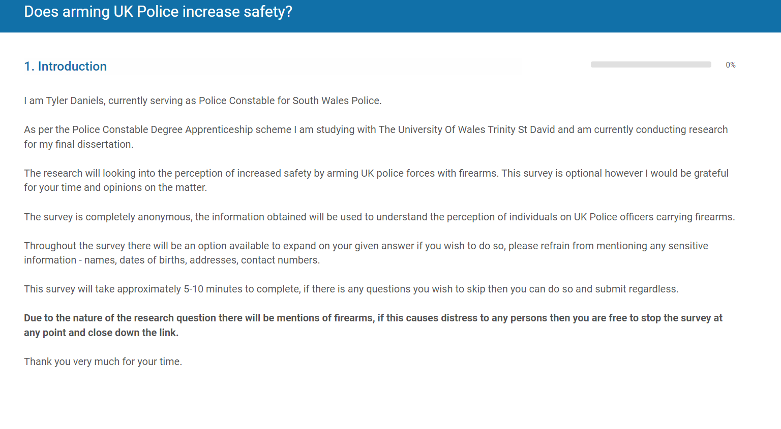
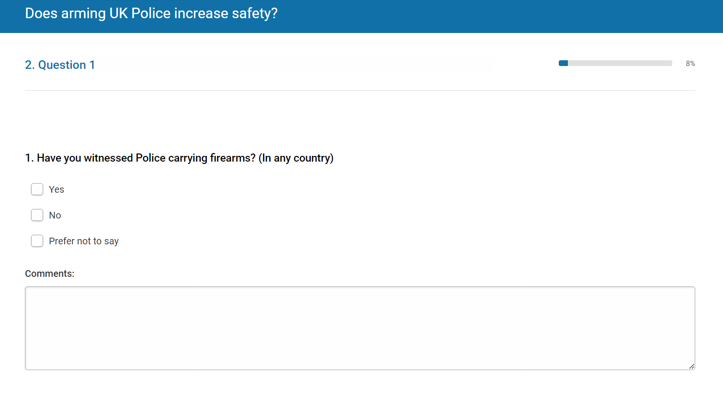

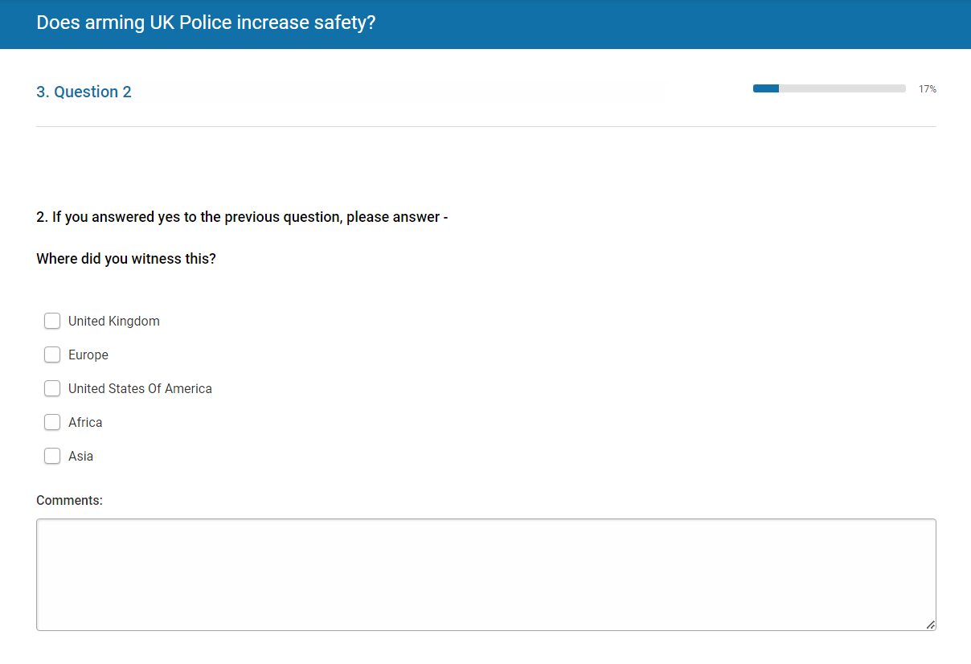
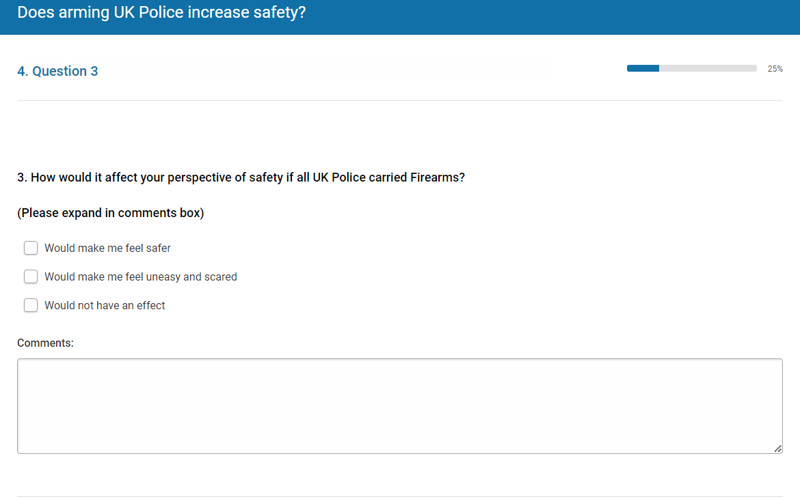
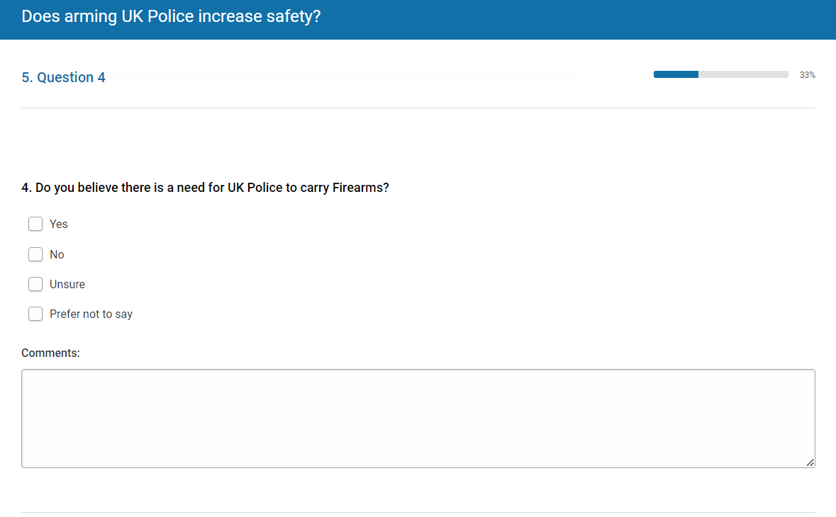
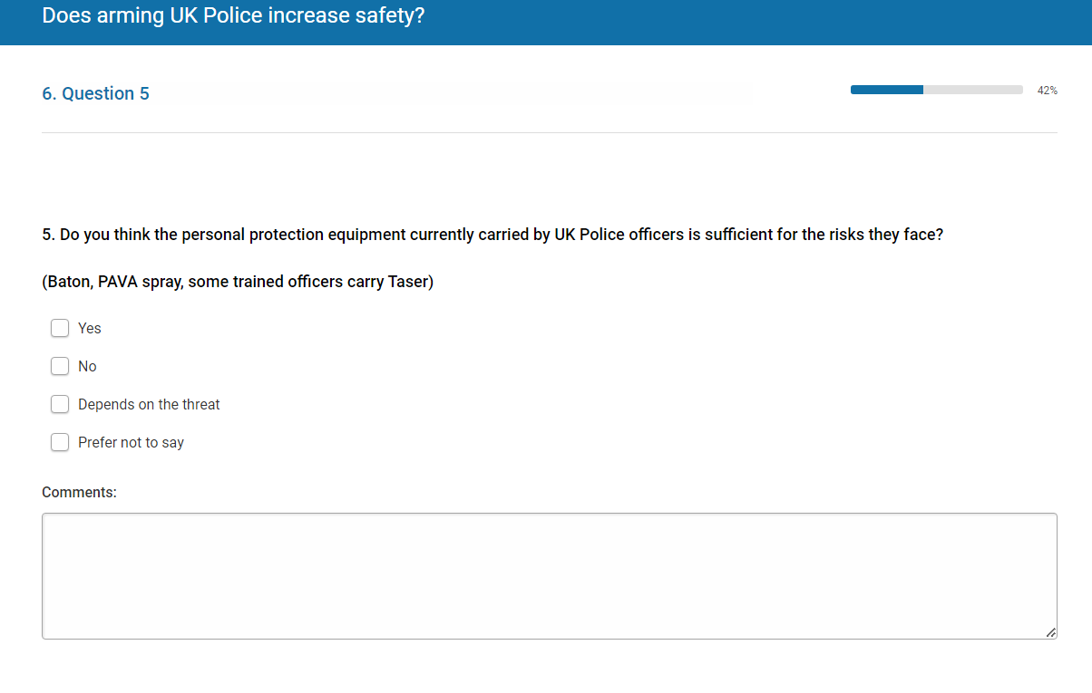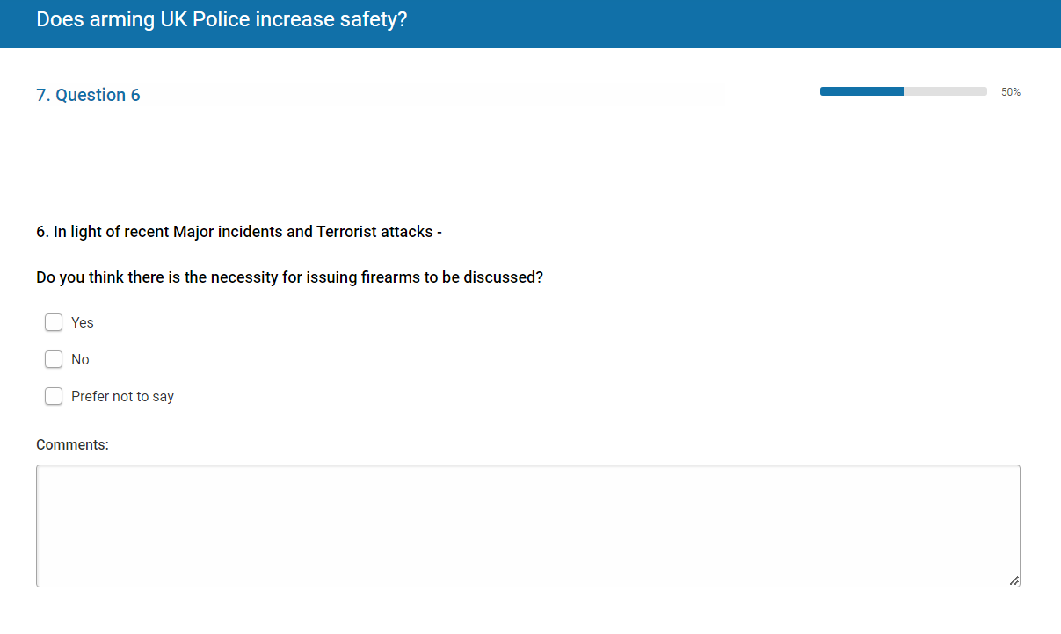
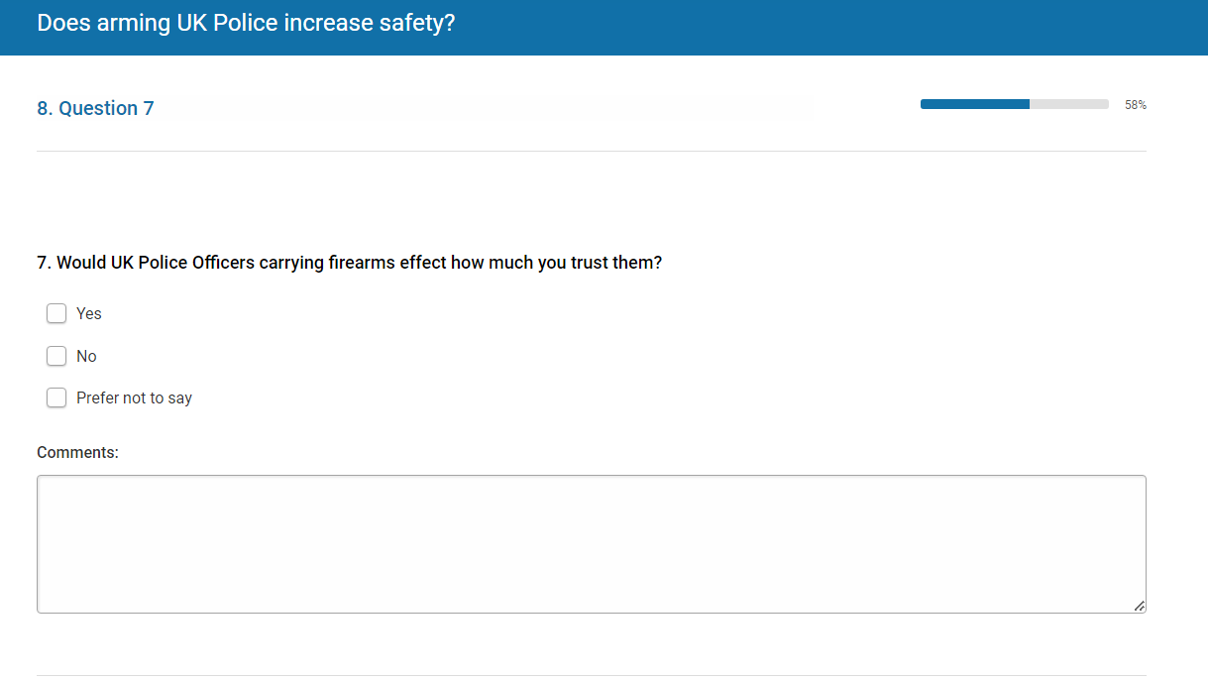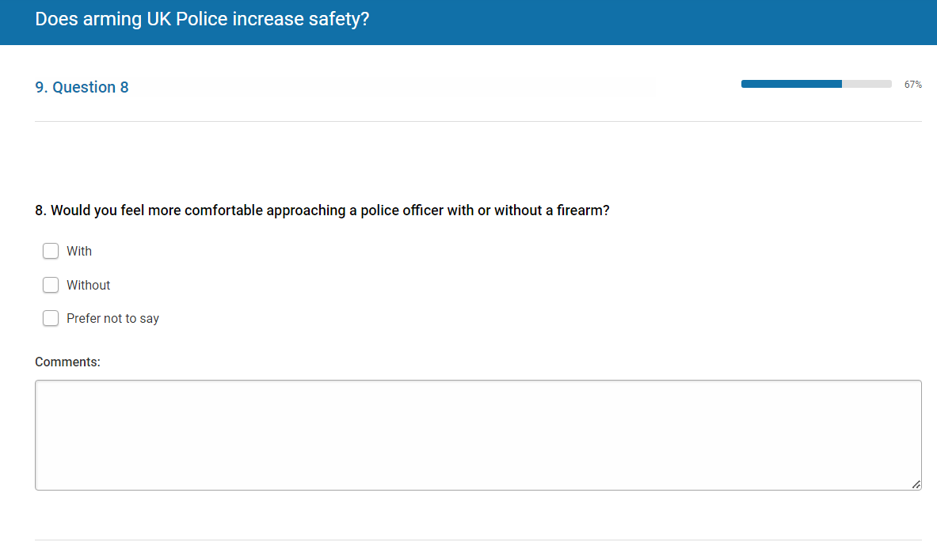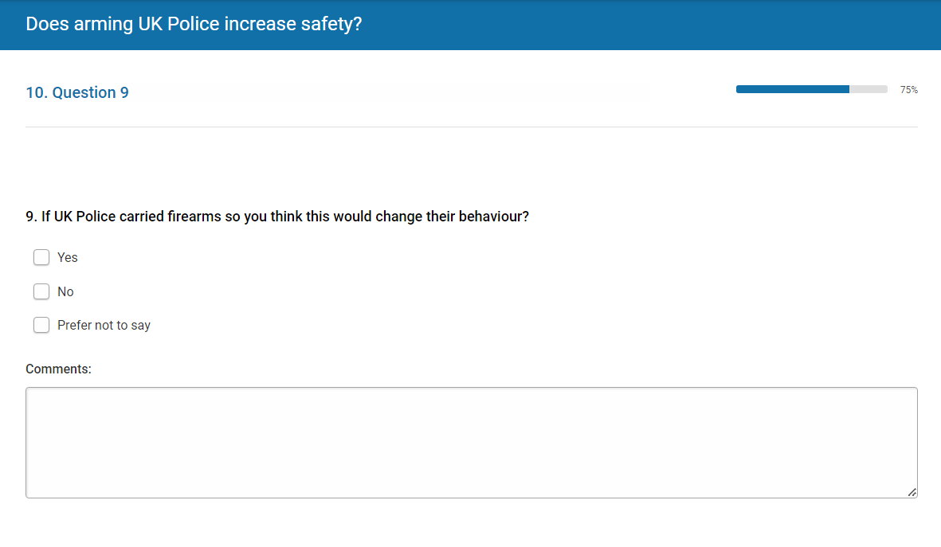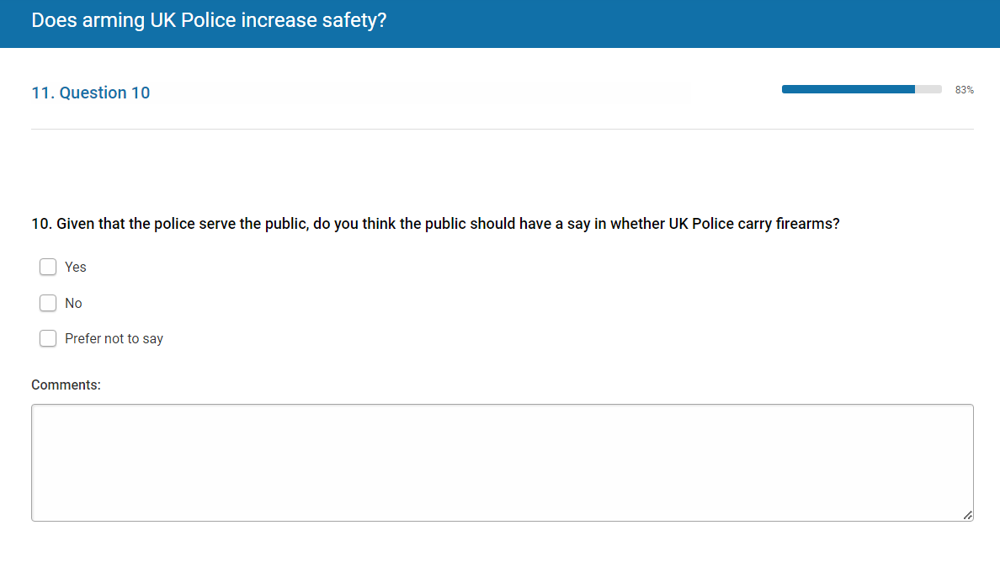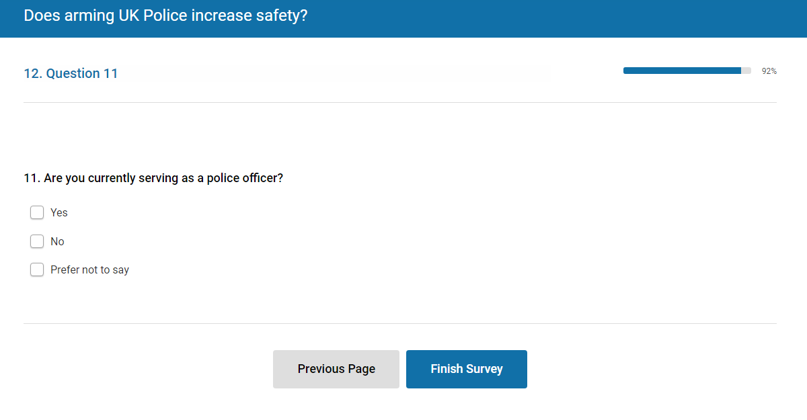

Appendix 2 – Online questionnaire results



