The general game idea was of an arcade space shooter with both on the rails section and free flying sections, some examples of similar games include Starfox [1] and the space battles in Star Wars Battlefront 2 [2]. My game mainly focuses on the free flying aspect for the general gameplay to allow for free movement for the player rather than the ‘on rails’ style of gameplay which would result in the player being confined to a track rather than having free movement throughout the level. This gameplay allowed me to create large open levels that take advantage of the free movement and vast space by including large scenery elements and terrain to fly around and use as cover from enemies. This gameplay was based on the free flying level within the template provided by my tutor with some slight adjustments to gameplay elements to better suit the main ideas I came up with for the game. This allowed me to include larger structures such as big mountains or crystals as well as a large village and science facility, though in a more complete version of this game the levels would require much more detail in the levels to avoid the levels feeling incomplete or barren. The combat of the game consists of multiple weapon types that the player can make use of and having to fly around the levels defeating all the enemies with your weapons while trying to stay alive and out manoeuvre the enemies. The weapons included are a basic energy projectile, a fire projectile that moves slower but is strong, a bomb that shoots a slow projectile that creates an area of effect blast but can only be used five times in one level and a shield that stops all damage aside from collision damage. The game also includes multiple types of enemies, those being, two small fighter ships that chase you down to try and shoot or ram into you and a large carrier ship that remains stationary while shooting you with its built-in turrets. All enemies in a level need to be defeated before moving on to the next level. The game that I created features multiple different levels with unique theming. The themes of these locations were based on cliché level types found in many different types of games but also some that are more unique to my idea this allowed me to create unique and interesting locations to fly around in during gameplay that match the overall theme of my game. The level types included consist of the following: a forest planet, a lava planet, an asteroid field, and a geode planet. These all share the same detail of having some form of glowing crystals somewhere in the level which gives them a connection between each other.
The main target audience is fans of games with similar gameplay such as the two mentioned before in the previous section in addition to other games like No Man’s Sky [3] or Star Wars Squadrons [4]. I’ll also be targeting fans of the genres that I made use of within my game which consist of mainly Sci-Fi with additional fantasy elements mixed into the levels and general gameplay. As for age group, I won’t be aiming at a particular age group; however, the game won’t include any ‘adult’ content such as gore or excessive violence and as such will probably be given a low age rating allowing me to include both a young and old audience. This will allow me to target a young audience for aspects like the basic gameplay and story, while also targeting an older audience that may be more interested in the more complex elements like mastering the gameplay or speed running the game.
The theming I’ve used in my game is a mix of Sci-Fi with fantasy elements. This is mainly shown in the inclusion of glowing crystals in every level which would act as a magical power source for the ships in the game. This led to the inclusion of a glowing crystal on the back part of the player ship that I would’ve made change colour depending on the weapon being used which would represent the magic type of said weapon. If I had more time to work on the game, I would’ve included features such as a mana system that would act as the ammo of the ship as well as different ‘types’ of enemies that would require the player to use their different ‘types’ of weapons to counter the enemies they go up against. This theming would’ve made my game quite unique in comparison to others of the same type due to the focus on magic within a Sci-Fi world rather than a more semi-realistic sci-fi style as well as the focus on weapon and enemy types. The theming also provides a lot of potential for additional levels based on the theme such as a space station themed after a wizard tower or a city planet with unique architecture based around magic. The locations I ended up creating all make use of cliché themes found in other games as they provide a good starting point into creating levels with their own style and feeling and provides a good variety for the game to make every match unique. I expanded upon the themes by using them within the Sci-Fi/Fantasy theming.
I undertook self-directed learning for multiple elements of my game. To start with, I swapped to Blender during the creation of my games models to allow for better work in both the university lecture room as well as from my personal computer at home. But because of this swap I had to learn how to use the tools within Blender at the same level as Maya, as Blender does differ enough from Maya to require me to have to relearn many different aspects that I knew how to do within Maya. To do this, I used some online tutorials as well as learning some techniques while in the process of creating some of my models.
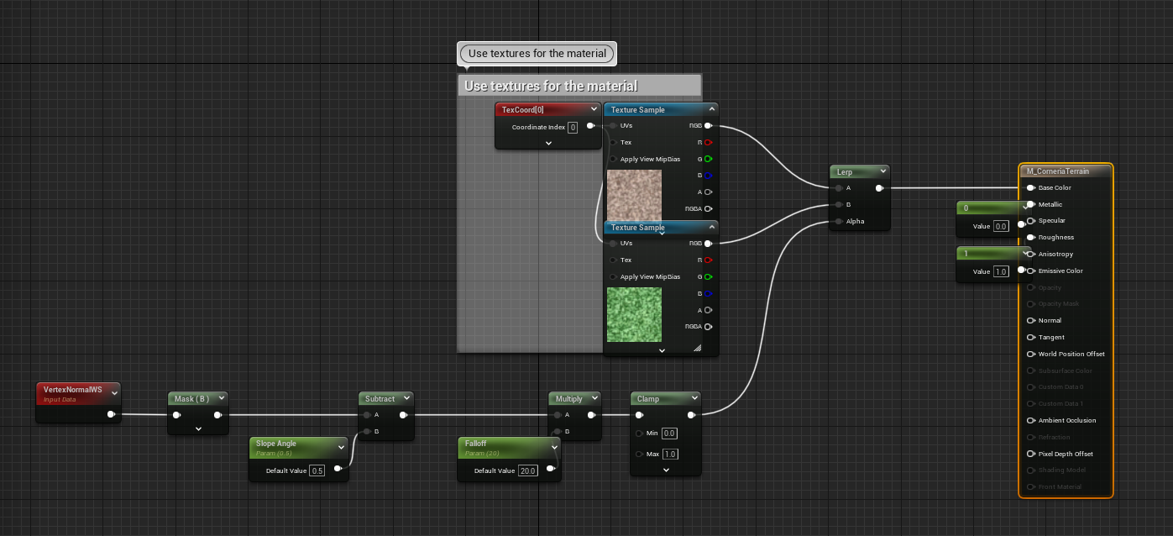
A material included in the template for the ground. I used this as it allowed the texture to change depending on the height of a part of an object. This was useful in creating my terrain.
Another aspect that I had to learn is how to make use of Unreal’s material system as I wanted to use some simple materials for the objects that would end up far away from the player to try and save on space and processing. I did this by using the materials included within the template as well as some online tutorials to create the materials that I needed outside of the materials that I created within substance painter for the ships. Furthermore, I had to learn how to use and modify blueprints in Unreal. I needed to learn this so that I could modify the existing gameplay from the template so that I could adjust the project in a way that would include the features I needed. This required.
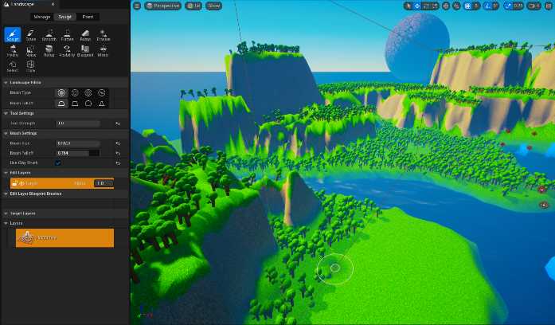
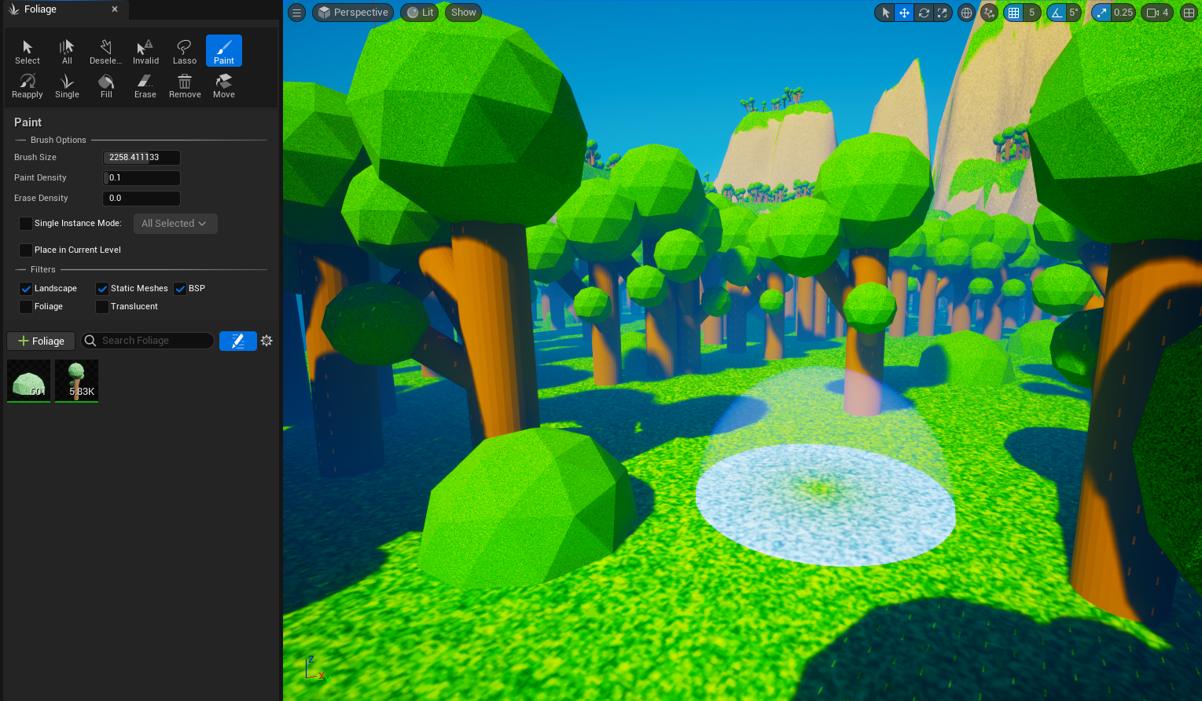
The foliage tool (left) and landscape tool (right) in Unreal.
Finally, I had to learn how to use some of Unreal’s level building tools to create the levels for my game. These tools consisted of the foliage tool and the terrain tool which were both used in all my levels. To use the foliage tool, I had to learn how to add a mesh to the tool to allow me to apply it to the landscape in the way that I wanted. This required me to also learn what the settings do within the tool by changing values until I got the desired result. To use the landscape tool, I had to figure out what each of the brushes do within the tool so that I could create the landscape I wanted for my level. These two tools required less research due to me already understanding them from using them in other places beforehand.
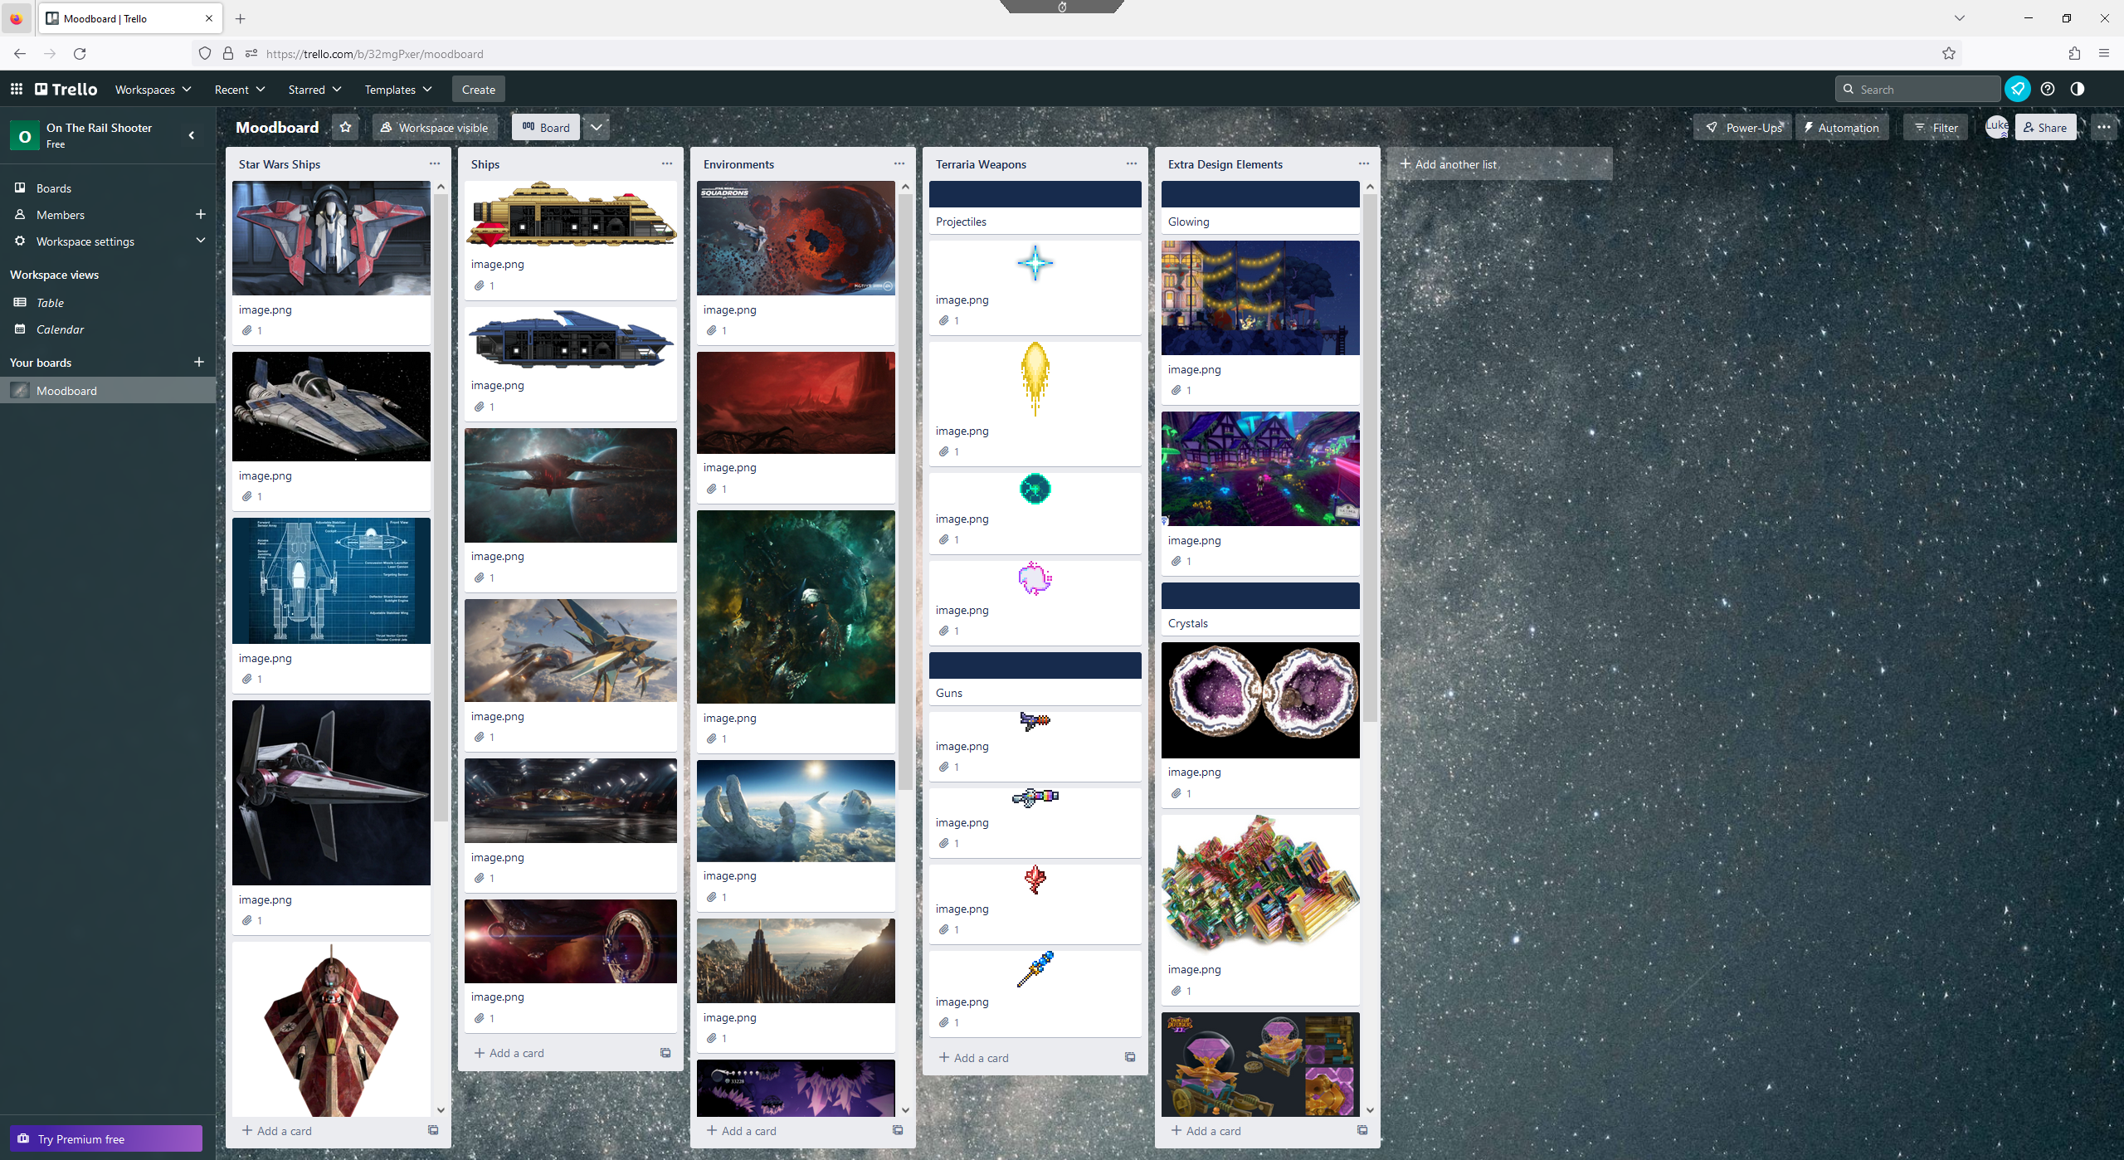
The mood board that I created on the website Trello [5]
During the research stage of my project, I gathered a wide selection of different images from different media to act as inspiration behind the design and theming of the game. This included things such as the style of the ships, the design of the levels, the decoration used within levels and on the ships, the projectiles, etc. This allowed me to better define the feel I wanted to go with for the game. I gathered all these images onto a Trello [5] mood board so I could sort them based on what they were acting as inspiration for. For gameplay, I conducted research by gathering similar games that I had played before to find the aspects of them that create fun and engaging gameplay. For example, I had previously played Star Wars Battlefront 2 [2] before this project so I was able to take the aspects from that game that I enjoyed and apply it to this one. Additionally, I looked into new games that I hadn’t played previously to expand upon the ideas I had for this project. For example, I tried Starfox [1] at the start of the project to get an idea on how that kind of game would work and what elements I would want to incorporate into my project.
The images I gathered were to act as a general inspiration behind the design rather than being outright used within the project. I didn’t model anything after the images due to a vast majority of the images being from other media and I wanted to create something unique compared to them. The games I gathered acted as both an inspiration into potential design choices but also inspiration into gameplay and features I would want to include into my project as well as potentially aspects that I would want to avoid in my project.
When I was gathering this research, I made use of internet databases to allow me to quickly find the relevant images I needed. This allowed me to conduct the necessary research in a quick manner especially considering the research was purely for a general theming idea rather than outright including the research as part of my project. The games I used were gathered by either playing them in my own time or by finding videos related to the necessary elements that I wanted to look into. To do this I used my own equipment to play the games or made use of internet databases to find the relevant videos.
Overall, my project progressed nicely and the research I conducted helped to enhance the project I created due to it complimenting what I required for the project. I was able to learn many new tools as well as good ways to plan a project to allow for adequate completion of the project itself by making use of tools like Gantt charts and asset lists.
[1] Starfox, [Software], Japan, Nintendo, 1993
[2] Star Wars Battlefront 2, [Software], California, Electronic Arts, 2017
[3] No Man’s Sky, [Software], United Kingdom, Hello Games, 2016
[4] Star Wars Squadrons, [Software], California, Electronic Arts, 2020
[5] Atlassian, “Trello”, [Online], Available: https://trello.com/

