Effective Team Work and Communication

NAME: Tache Marian Alexandru
STUDENT NUMBER:2023147
MODULE: BMSW4002
ASSIGNMENT: Efective Team Working and Comunication
LECTURER: Anita Nan

Table of Contents

Introduction 3
Models of communication 3
Shannon and Weaver Communication Model 3
The Schramm Communication Model 4
The SMCR Communication Model 5
Communication Skills 6
Verbal Communication 6
Non-verbal Communication 6
Listening Communication 7
Case Study 7
Conclusion 8
References 9

Introduction
The term "communication" comes from the Latin word communicare, which means "to share" or "to make common." Communication is the act of passing information from one place, person, or organization to another. (Hartley, 2015). Effective communication is essential for enhancing productivity and maintaining strong working relationships at all levels of a business. It isn't only about how well one work with others when it comes to professional communication. It's all about forming bonds, reducing mistakes, and, most importantly, operating as efficiently as possible. Achieving the key management duties of planning, organizing, leading and controlling in their organizations requires managers to have excellent communication skills. For a business to flourish, meet deadlines, and surpass goals, it must have effective communication techniques and relationships. There may be a connection between poor communication and professional issues such as excessive work-life balance and health problems as well as stress and unmet expectations, relationship breakdown, low morale and dissatisfied clients. Using a case study based on my personal working experience, this report will demonstrate how communication difficulties influence the company in general and overcome these difficulties.

Models of communication
The three most relevant theories will be discussed here.

Shannon and Weaver Communication Model
This linear model was developed to help senders and receivers communicate more effectively. They also find factors connected to "Noise" that affect communication (Al-Fedaghi, S., 2012). The concept was born out of a desire to improve technical communication. Later on, it became widely utilized in the communication business. It comprises elements such as information source and transmitter as well as noise as well as channels for a message, receiver, and information destination. It's a five-part transmission model that contains a message generator, a transmitter that converts the message to signals, a channel that adapts the signals for transmission, a receiver that decodes the message from the signal, and a destination where the message arrives. Noise is the sixth ingredient which is a dysfunctional factor: any interference with the message travelling through the channel (such as static on the phone or radio) could cause the signal received to differ from the signal provided. In a telephone, an electrical current flows along a wire, with the transmitter and receiver being telephone handsets. For example, Carl called his assistant and said, "Come here, I want to see you and need help from you." His assistant received just "I want" during his call due to noise (transmission fault). Carl was questioned again by Assistant, "What do you want Thomson?" (feedback). Semantic noise occurs when Carl and his assistant have distinct frames of reference, resulting in a misinterpretation of the message. But after the feedback, they can overcome the problem of misunderstanding.
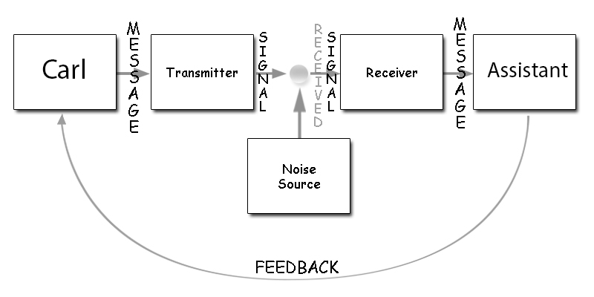

The Schramm Communication Model
The Schramm Communication Model is a cyclical communication model that covers all of the principles of communication. It is a well-known and well-understood method for analyzing and explaining communication. It may be used to find out how two people interact while transferring information, ideas, or views. (Chris Drew, 2021). The above-mentioned Shannon and Weaver Communication Model depicts communication as a linear process in which the roles of sender and receiver are clearly defined. The Schramm communication model, on the other hand, displays a continual circular flow of communication. The sender and recipient aren't always known because this strategy focuses more on the message than on delivering and receiving it. This is primarily due to Schramm's recognition of the ability to send and receive messages to oneself. For example, Olivia decided to contact her closest friend on her way home from work because she hadn't spoken to her in a while. She takes turns informing each other on their weekends, summer plans, and how members of their families are doing. They agree to talk again shortly after they hang up. This example shows their communication will keep moving forward circularly by sending and receiving messages to each other. If we compare the example of ‘Shannon and Weaver Communication Model’ in this model Carl and his assistant’s conversation will not be ended after that one message, they will continue the process and carl will be asked for what he wants any file or something else.
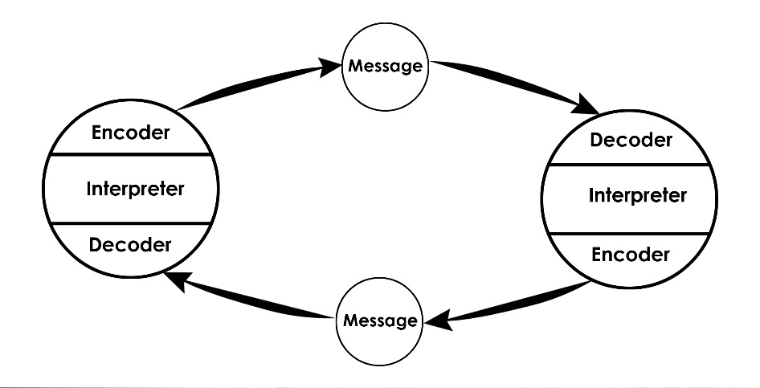
Source: Communication Theory, 2016

The SMCR Communication Model
David Berlo's SMCR Model of Communication shows communication at its most fundamental level. The acronym SMCR stands for Sender, Message, Channel, and Receiver. (JAMES, 2021). The SMCR Model of Communication (1960) by Berlo outlines the several components that make up the basic communication process. Because it focuses on message coding and decoding, this communication tool may be used for more efficient communication. Communication is viewed as a two-way process in the paradigm. It enables the model to be used in a wide range of scenarios. By removing noise or difficulties that produce noise, the idea of noise assists in good communication. This communication paradigm places a strong emphasis on the reaction or response. It is a process, which fundamentally are processes aimed toward certain aims or objectives. According to Berlo, the sender and recipient have a personal relationship. Berlo's theory of communication describes how and why individuals interact with one another. A person cannot reveal his inner ideas to others. As a consequence, an idea must be expressed in words, and material must be created. For example, Carl said to his assistant that the file cabinet was broken. Carl's communication with his assistant is considered the content of the massage, in which he expresses his dissatisfaction with the cabinet scenario. His assistant told him that they could buy a new file cabinet. This shows the breached subject continuing, but with an extra answer revealed by the assistant in the same way as Carl previously by expressing his wants to acquire a new one by replacing the damaged one.

Source: Communication Theory, 2016

Communication Skills
The standard methods of communication are verbal, non-verbal and listening

Verbal Communication
The use of words to exchange information with others is known as verbal communication. As a consequence, it can encompass both oral and written communication (Toylibaevich, 2020). Verbal communication specialists utilize spoken words to communicate a message simply and concisely. An important part of getting a message through is making sure it can be accurately interpreted by the receiver. Excellent verbal communication is essential for maintaining effective business connections. Effective communication increases productivity reduces mistakes and streamlines processes. The message must be succinct and to the point, but complete in every way. Clarity and completeness should not be sacrificed in the pursuit of brevity. Too much talking can lead to misunderstandings and over-communication, while too little talking can result in a lack of understanding and communication. So, simplicity is usually best. Take some time to practice one's delivery. Using examples to add colour to the information, maintaining a relaxed body language, and learning to talk slowly and in a variety of tones are all strategies to improve delivery.

Non-verbal Communication
The use of body language (eye contact, facial expressions, gestures) to communicate information is called nonverbal communication (NVC) (Włodarczak and Heldner, 2017). This technology has the potential to be useful to company owners. Nonverbal communication is crucial in business since it opens up new channels of contact with colleagues, rivals, clients, and future clients. Simple signals such as body language such as posture and voice tones can be used to corroborate what is being stated and to demonstrate consistency and trustworthiness. Diverse meanings can be conveyed by sounds like laughing, throat clearing and humming, in addition to the tone of the speaker's voice and its speed and volume Not to be overlooked are the effects of fragrance and physical contact between speaker and listener on a listener's perceptions. In addition to silence, nonverbal communication also includes the lack of sound. During a face-to-face interaction, silence might indicate incomprehension, if not outright wounded feelings.

Listening Communication
Listening refers to the capacity to accurately hear and interpret communications in the communication process (Bovée, Scribner and Thill, 2011). In any job capacity, being able to listen attentively is essential for effective communication. It is impossible to overestimate the value of listening skills in communication. One will be able to perform better, speak more effectively, understand more, and feel more like a team member if one has excellent listening abilities. Numerous prestigious companies provide their employees with training in listening skills since it is so important. The fact that good listening skills may lead to greater customer satisfaction, increased productivity with fewer errors, and improved information sharing is not unexpected. All of these factors contribute to more creative and imaginative work. Managers and employees who are good listeners will have a stronger working relationship together, according to research.

Case Study
The modern workplace is built on collaboration, and efficient communication among coworkers is essential to that collaboration (Maina, 2015). I can also experience the importance of communication in the workplace. A few years ago, I worked in a restaurant. On the last day of every week our manager, Mr Alice called all the staff for a general meeting. He was great in his verbal communication because many of us understood what he was talking about and what he wants from us. But there were some non-native English speakers. Sometimes they didn’t understand his instructions. His facial expression seemed like he was gloomy or angry. He also didn’t listen to others advice. After his instruction, he guided the meeting. For this reason, the non-native ones couldn’t understand him and often made mistakes in their work. After a few months, a new manager, Mr John, joined the restaurant. I still remember him very well. He always had a smile on his face. He was just a great example of communication skills. He speaks slowly and in various tones while talking with all the staff individually and listened to us if we had any problem. He also gave motivation and clarify all his instructions with us and also kept eye contact. Every one of us was very pleased to work with him. He also kept interpersonal relations with everyone. He had verbal communication skills by maintaining talk slowly and in a variety of tones; non-verbal communication by his smile, postures and gestures; and he was also a great listener. I learn many communication skills from him and later these skills help me a lot in my workplace and personal communication.

Conclusion
Communication is an important aspect of every business. It assists in the settlement of internal and external conflicts. Because it conveys ideas and choices, effective business communication typically aids in boosting corporate efficiency. Besides sending and receiving messages, it requires speaking and listening, sending and receiving communications, and sending and receiving messages. Put your judgment aside and allow answers to arise from the outside when you are listening. Communication is part of the human experience, but it's important to consider how to do it in a constructive way and line with one's obligations and reputation.

References
Al-Fedaghi, S. (2012). A conceptual foundation for the Shannon-Weaver model of communication. International Journal of Soft Computing, 7(1): 12 – 19. [Accessed 29 July 2021].
Bovée, C., Scribner, J. and Thill, J., 2011. Business communication essentials. Toronto: Pearson Canada.
Chris Drew, P., 2021. Osgood-Schramm Model of Communication - Pros & Cons (2021). [online] Helpful Professor. Available at: <https://helpfulprofessor.com/osgood-schramm/> [Accessed 29 July 2021].
Communication Theory. 2016. BERLO’S SMCR MODEL OF COMMUNICATION. [online] Available at: <https://www.communicationtheory.org/berlos-smcr-model-of-communication/> [Accessed 29 July 2021].
Communication Theory. 2016. OSGOOD- SCHRAMM MODEL OF COMMUNICATION. [online] Available at: <https://www.communicationtheory.org/osgood-schramm-model-of-communication/> [Accessed 29 July 2021].
Hartley, P., 2015. Business Communication. Taylor and Francis. [Accessed 29 July 2021].
JAMES, R., 2021. David Berlo&#39;s SMCR Model. [online] Academia.edu. Available at: <https://www.academia.edu/9134901/David_Berlos_SMCR_Model> [Accessed 29 July 2021].
Maina, T., 2015. Instant messaging an effective way of communication in workplace. [online] arXiv.org. Available at: <https://arxiv.org/abs/1310.8489> [Accessed 29 July 2021].
Toylibaevich, K., 2020. Terminological inaccuracy of the terms verbal communication and non-verbal communication in scientific literature. ACADEMICIA: An International Multidisciplinary Research Journal, 10(7), p.453. [Accessed 29 July 2021].
Włodarczak, M. and Heldner, M., 2017. Respiratory Constraints in Verbal and Non-verbal Communication. Frontiers in Psychology, 8. [Accessed 29 July 2021].

