

Business Plan - TIFFINS – HOMEMADE FOOD DELIVERED TO YOUR DESK

Student Name: Nazmin Choudhary
Student Number: 2522124
Programme of Study: Certificate in Higher Education Business Skills for the Workplace
Module Code/Title: LCLM4006 Enterprise and Entrepreneurship
Assessment: Component 1 – Individual Written Business Plan
Lecturer’s Name: Fatima Hashmi
Institution: University of Wales Trinity Saint David

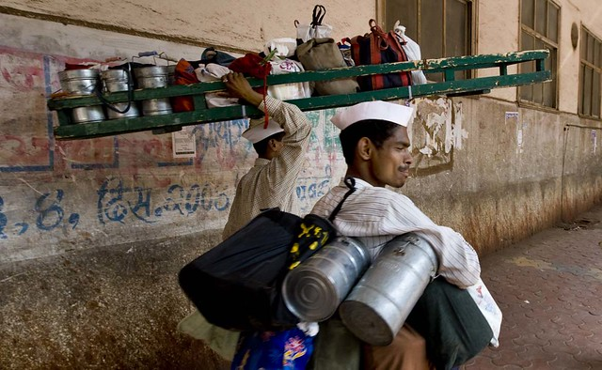
(Two men carry lunch boxes on their heads, n.d.)

Executive Summary
Tiffins is a proposed Birmingham-based workplace lunch service offering freshly prepared homemade meals delivered to customers’ workplaces. Customers will order in advance from a rotating weekly menu, helping them access a convenient alternative to fast food, supermarket meal deals and last-minute takeaways. The initial menu will include familiar dishes such as chicken curry, roast chicken, pasta bake, vegetable biryani and wraps, with vegetarian and vegan choices where practical. Clear ingredients and allergen information will be provided.
The business will start on a small scale as a sole trader, using the founder’s own kitchen only if it meets all applicable food safety and registration requirements. Advance ordering will support demand planning, reduce avoidable food waste and make purchasing more predictable. Tiffins also aim to create flexible paid opportunities for experienced home cooks, retired or semi-retired chefs, homemakers and people returning to employment as demand grows.
The proposed start-up budget is £6,000, funded entirely by the owner’s personal funds. No external loan is planned. The business will test demand through a limited menu and a manageable delivery area before expanding. Financial forecasts are planning assumptions rather than guaranteed outcomes; sales revenue is distinguished from profit, and the cash-flow forecast includes the owner’s capital contribution.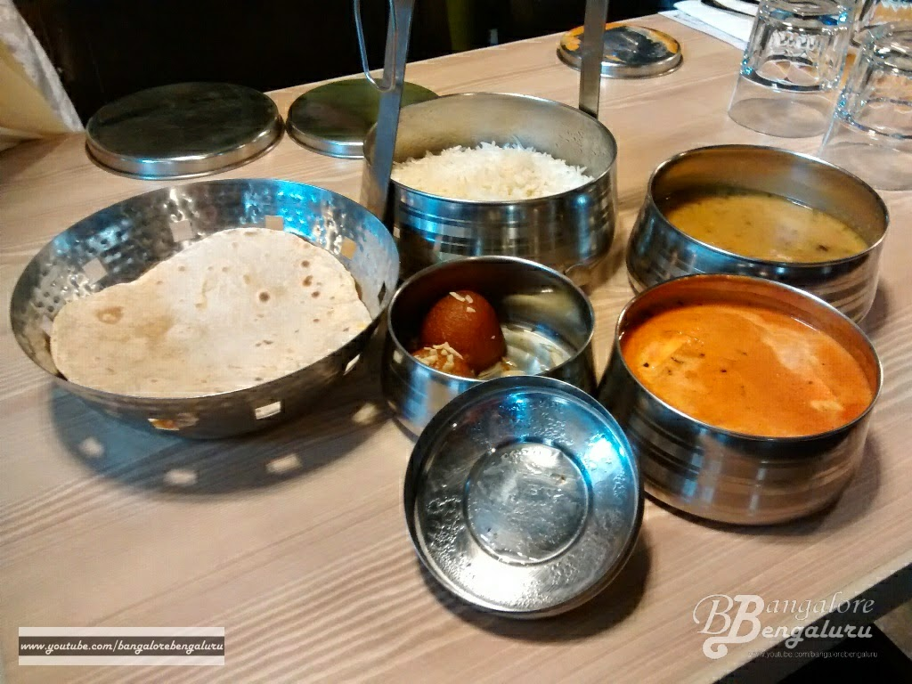
(Indian food in metal bowls on a table, n.d.)

Table of Contents
Page Number
1. Overview of the Business Idea 4
2. Management, Legal Structure and Social/Environmental Value 4-6
3. Market Research: Segmentation, PESTEL and Competition 6-9
4. Marketing Communications 9
5. Financial Plan 9-11
6. Conclusion 11
9. References 12-13

1.Overview of the Business Idea
Tiffins will provide homemade-style lunches prepared in the morning and delivered to workplaces in Birmingham at lunchtime. Customers will choose from a small rotating menu and place advance orders through the business website. Unlike conventional takeaways, Tiffins will focus on planned workplace deliveries, consistent portions, clear allergen information and a limited menu that can be produced efficiently. This responds to research indicating that time constraints influence employee’s lunchtime food choices and use of food outlets (Massey, Brémaud and Saulais, 2021).
The target market is office-based and other workplace customers who have limited time to prepare lunch and want convenient alternatives to fast food, supermarket meal deals and last-minute takeaways. Initial operations will focus on a defined local delivery area and a manageable number of meals per day. Customer feedback, repeat orders and cost per meal will guide decisions about menu choices and future expansion.
Mariotti and Glackin (2016) emphasise the importance of identifying customer needs when developing a small business. Tiffins addresses this need through its rotating menu, advance ordering and direct workplace delivery. Barrow, Barrow and Brown (2021) also highlight the importance of planning operational and financial requirements before business growth
2. Management, Legal Structure and Social/Environmental Value
Management and legal format
Tiffins will initially operate as a sole trader business owned and managed by Nazmin Choudhary. This structure is straightforward to establish and allows direct control (GOV.UK, n.d.). The founder will manage budgeting, menu planning, purchasing, customer communication, marketing, record-keeping and compliance. Extra cooking or delivery support may be added when affordable.
As a sole trader, the owner is personally liable for business debts, making accurate records, insurance and cash management essential. The food business must be registered with the local authority at least 28 days before trading and comply with food
safety, hygiene and allergen requirements (Food Standards Agency, 2026). A home kitchen will be used only if it meets applicable requirements; otherwise, suitable premises will be arranged.
Proposed Management Structure for Tiffins
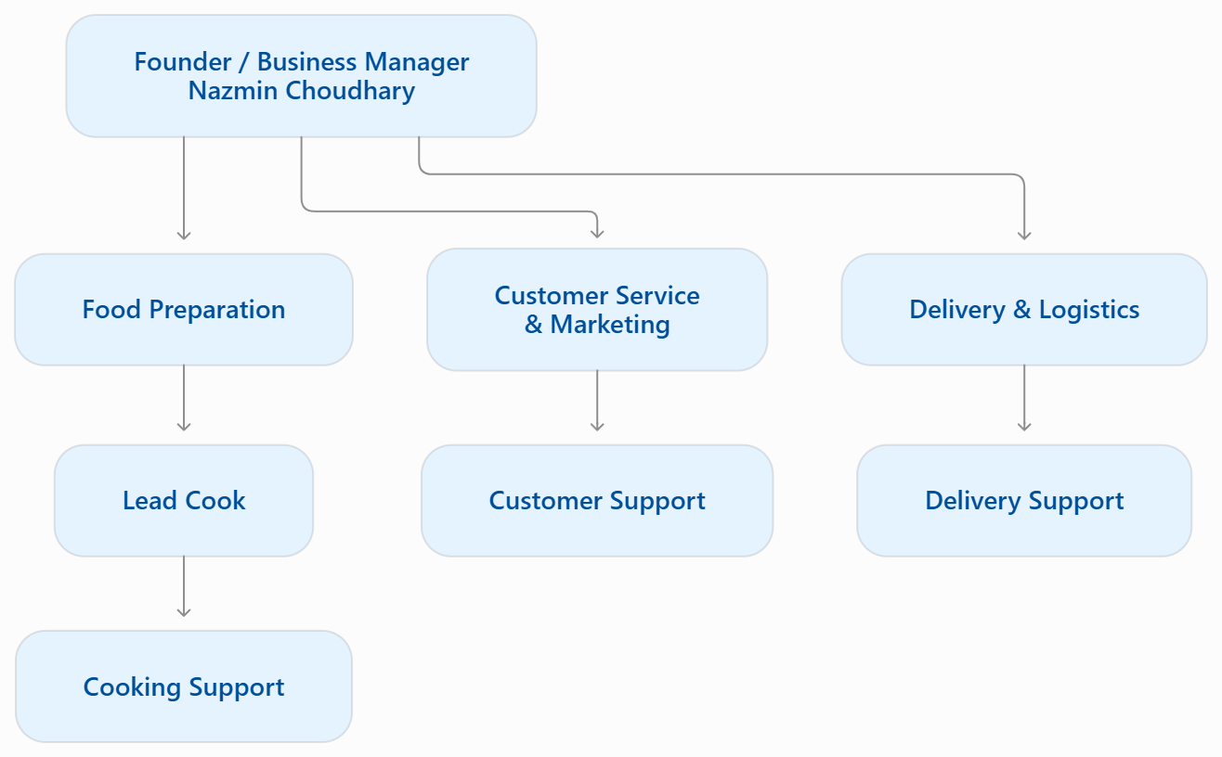
Source: Author’s own illustration (2026).
At launch, the founder will undertake most management and operational duties. Cooking, customer service and delivery support will be added gradually as sales and affordability permit.
Environmental sustainability and community support
Advance orders will help match purchasing and preparation for demand, reducing the risk of unsold meals. A limited menu planned ingredient use and efficient delivery routes may also reduce waste and unnecessary journeys. Packaging will prioritise safety and practicality, using recyclable or lower impact options where suitable. WRAP (2025) highlights the importance of preventing food waste and improving resource efficiency.
Tiffins aim to create flexible paid opportunities for experienced cooks, retired or semi-retired chefs, homemakers and people returning to employment. Potential duties include food preparation, packing, customer support and delivery assistance. Recruitment will depend on demand, affordability, food-safety competence and relevant employment requirements.

3. Market Research: Segmentation, PESTEL and Competition
Target market, customers and segmentation
Tiffins’ primary target market will be office workers in Birmingham who want convenient, affordable, home-style lunches delivered to their workplace. The ideal customers are employees with busy schedules who have limited time to prepare food or leave the office during lunch breaks. Secondary customers may include small businesses ordering meals for staff meetings and teams.
Market segmentation allows Tiffins to divide potential customers into groups with similar needs and purchasing behaviours (Kotler, Keller and Chernev, 2022). Tiffins will use the following segmentation methods:
- Demographic segmentation: Target working adults, particularly employees seeking convenient weekday lunches within an affordable budget. For example, Tiffins will promote individual meals priced at £8.50 to office employees.
- Geographic segmentation: Focus initially on offices and business areas in Birmingham, prioritising workplaces that can be served efficiently. For example, the business will distribute promotional flyers to nearby offices and arrange deliveries to locations within selected delivery zones.
- Psychographic segmentation: Target customers who value home-style food, convenience and varied meal choices. For example, weekly menus will feature familiar dishes alongside vegetarian and vegan options where practical.
- Behavioural segmentation: Focus on customers who regularly purchase lunch at work or prefer ordering meals in advance. For example, Tiffins will encourage repeat purchases through weekly menu updates, advance ordering and promotional offers for returning customers.
These segments will guide Tiffins’ marketing decisions, menu planning and delivery arrangements. Customer feedback, order patterns and repeat-purchase rates will be monitored to identify the most profitable customer groups and refine the service as the business grows.
The table below is concise and gives a practical example for each segmentation method:
Segment | Example of how Tiffins will use it
Demographic | Promote affordable lunches to working adults.
Geographic | Target offices within practical delivery areas in Birmingham.
Psychographic | Advertise home-style meals and varied menu choices.
Behavioural | Encourage advance orders and repeat purchases through weekly menus and offers.

Market Research and PESTEL
Tiffins will survey potential customers about preferred dishes, prices, dietary needs, delivery times and ordering frequency. A tasting trial will test demand. Measures will include daily sales, repeat purchases, feedback, food waste and contribution per meal.
PESTEL factor | Potential impact and response
Political / legal | Tiffins must comply with food business registration, food hygiene, allergen information, tax and relevant employment obligations. Food businesses must register with the local authority at least 28 days before trading and provide legally required allergen information (Food Standards Agency, 2026).
Economic | Rising ingredients, packaging and fuel costs may reduce profit margins, while household budgets may influence customers’ lunch spending. Tiffins should monitor supplier prices, calculate portion costs and review selling prices regularly (Barrow, Barrow and Brown, 2021).
Social | Customers may value convenience, familiar meals and dietary choice. Tiffins should test demand for vegetarian, vegan and other menu options before expanding its range. Understanding customer needs is important when developing an effective business and marketing strategy (Kotler, Keller and Chernev, 2022).
Technological | A simple online ordering and payment system could make ordering more convenient and reduce administration. Tiffins should begin with a low-cost system and protect customer information while developing its digital presence (Kotler, Keller and Chernev, 2022).
Environmental | Food waste and delivery emissions may create environmental challenges. Tiffins can use advanced orders, planned ingredient purchasing, appropriate packaging and efficient delivery routes to reduce avoidable waste and improve resource use (Ciccullo et al., 2022).
Competitive | Supermarkets, cafes, workplace canteens, takeaways and delivery platforms compete for lunch customers. Tiffins can differentiate through home-style meals, advanced ordering and direct workplace delivery. A clear value proposition and an understanding of competitors are important when positioning a new business (Mariotti and Glackin, 2016; Kotler, Keller and Chernev, 2022).

Competition
Competitors include supermarkets, cafes, workplace canteens, takeaways and food-delivery platforms. They may offer speed, familiarity or wider choice. Tiffins cannot compete on scale initially, so it will differentiate through home-style meals, advance ordering, clear allergen information and planned workplace delivery. Risks include low repeat demand, rising costs, delays and food-safety failures. Testing and regular cost reviews will help manage them. Actual sales will guide revisions (Mariotti and Glackin, 2016; Ciccullo et al., 2022).
4.Marketing Communications
Tiffins will use low-cost marketing under the slogan “Homemade Food. Delivered to Your Desk.” Facebook will promote weekly menus, prices and introductory offers, while Instagram will showcase meal photographs and videos. TikTok may feature food preparation and packaging, while LinkedIn could help connect with office managers and local businesses to secure group orders. A simple website or online form will display menus, prices, delivery areas and ordering deadlines. Flyers and tasting sessions may encourage local customers to try the service. Monthly reviews of enquiries, orders, repeat purchases, average order value and customer feedback will measure effectiveness. Customer information will be protected, and claims about health, sustainability or food origin will be evidence-based (Kotler, Keller and Chernev, 2022).

5. Financial Plan

Funding and start-up costs
Tiffins require £6,000 in start-up funding, provided entirely from the owner’s personal funds. This avoids borrowing but requires careful control of personal finances and spending before demand is proven. The figures below are estimates and should be checked against supplier quotations. The contingency reserve is available for unexpected costs and does not need to be spent immediately.

Sales assumptions
The proposed price is £8.50 per meal, based on 20 working days per month. These figures represent revenue, not profit, because costs and tax have not been deducted.
Average meals per day | Meals per month | Monthly sales revenue (£)
10 | 200 | 1,700
20 | 400 | 3,400
25 | 500 | 4,250

The initial planning case is 10 meals per day, generating £1,700 monthly revenue. Higher volumes are scenarios, not guaranteed sales. Before expanding, Tiffins must confirm that each meal covers direct costs and contributes to overheads. Break-even calculations should be updated when actual ingredient, packaging and delivery costs are known.
Start-up Budget
Expense category | Budget (£)
Kitchen equipment / improvements | 800
Initial ingredients | 1,200
Packaging / labels | 350
Website / ordering system | 500
Insurance / compliance | 400
Food hygiene / allergen training | 150
Marketing / tasting | 400
Delivery / transport | 600
Contingency / working capital reserve | 1,600
Total | 6,000

Month 1 Cash-Flow Forecast
This forecast preserves the cash-flow categories and figures supplied in the working draft. It is an illustrative first month forecast and should be updated using confirmed quotes and actual sales.
 | Month 1
Cash In | Amount (£)
Loan – start-up capital | 0
Sales (200 meals × £8.50) | 1,700
Other – owner personal funds | 6,000
Total cash in-flows (A) | 7,700

 | Month1
Cash out-expenses | Amount (£)
Rent | 0
Business rates | 0
Utilities | 100
Insurance | 400
Telephone / internet | 40
Marketing | 400
Vehicle running | 100
Equipment purchase | 800
Postage / printing / stationery | 30
Transport / delivery | 600
Professional fees | 100
Cost of sales – ingredients and packaging | 1,550
Owner wages | 0
Staff wages | 0
Website / online ordering | 500
Food hygiene / allergen training | 150
Total cash out-flows (B) | 4,770
Net cash flow / closing cash before any other movements (A-B) | 2,930
The forecast leaves £2,930 if all listed transactions occur in Month 1. This is not operating profit because it includes the owner’s £6,000 contribution. The £1,600 reserve is not an outflow unless spent. Check that £1,550 cost of sales does not duplicate ingredients and packaging in the start-up budget.
No wages are budgeted initially because the founder will operate the business. A sole trader may take drawings from available funds rather than receive a formal salary. Paid support will be introduced only when demand and cash flow make it affordable.

6.Conclusion
Tiffins offer a focused small business concept built around homemade workplace lunches, advance ordering and local delivery. Starting as a sole trader with £6,000 of personal funding borrowing limits still requires careful cost control, regulatory compliance and realistic demand testing. The business will begin with a limited menu and delivery area, use customer feedback to refine its offer and monitor repeat orders, food waste and contribution per meal. Flexible work opportunities and waste prevention form part of its intended community and environmental value. The next steps are to validate demand, obtain supplier quotations, confirm food-safety requirements and update the cash-flow forecast before trading.

Reference List
Barrow, C., Barrow, P. and Brown, R. (2021) The Business Plan Workbook: A Step-by-Step Guide to Creating and Developing a Successful Business. 10th edn. London: Kogan Page.
Ciccullo, F., Fabbri, M., Abdelkafi, N. and Pero, M. (2022) ‘Exploring the potential of business models for sustainability and big data for food waste reduction’, Journal of Cleaner Production, 340, article 130673. Available at: https://doi.org/10.1016/j.jclepro.2022.130673 (Accessed: 9 October 2026).
Food Standards Agency (2026) Starting a food business. Available at: https://www.gov.uk/guidance/starting-a-food-business (Accessed: 9 October 2026).
GOV.UK (n.d.) Become a sole trader. Available at: https://www.gov.uk/become-sole-trader (Accessed: 9 October 2026).
Indian food in metal bowls on a table. (n.d.). [Photograph] Blogspot.com. Available at https://1.bp.blogspot.com/-zShsQ6gi4QI/U4qVLjBiFDI/AAAAAAAACGQ/dxgH1iWaZwo/s1600/eat+out+-+restaurant+review+-+Tiffin+Box+etc+in+Inorbit+mall,+Bengaluru+city+(INDIA)+-+Ep+104+-+by+BangaloreBengaluru+(44).jpg [Accessed 21 Oct. 2026].
Kotler, P., Keller, K.L. and Chernev, A. (2022) Marketing Management. 16th edn. Harlow: Pearson.
Mariotti, S. and Glackin, C. (2016) Entrepreneurship: Starting and Operating a Small Business. 4th edn. Global edn. Boston: Pearson.
Massey, C., Brémaud, D. and Saulais, L. (2021) ‘Sandwich or long lunch? Lack of time and attendance of food outlets by French workers’, International Journal of Workplace Health Management, 14(2), pp. 164–180. Available at: https://doi.org/10.1108/IJWHM-05-2020-0084.
Two men carry lunch boxes on their heads. (n.d.). [Photograph] Wikimedia Commons. Available at: Mumbai_Dabbawala_or_Tiffin_Wallahs-_200, 000_Tiffin_Boxes_Delivered_Per_Day.jpg (1171×720) Accessed 21 Oct. 2026].
WRAP (2025) A Deep Dive into Household Food Waste in the UK, 2022: Reasons, Patterns, and Opportunities for Change. Available at: https://www.wrap.ngo/resources/report/deep-dive-household-food-waste-uk-2022-reasons-patterns-and-opportunities-change (Accessed: 9 October 2026).

