NAME: Nunzia Lomonaco
STUDENT NUMBER: 2123363
MODULE: LCMB7001
LECTURER: Tushara Balendran
COURSE: Master’s in business administration
SUBMISSION DATE: 28/04/2022

INNOVATIVE MARKETING STRATEGIES FOR


TABLE OF CONTENTS:
- INTRODUCTION 3
- COMPANY BACKGROUND 3
- COMMUNICATION 4
DEFINITION OF COMMUNICATION 4
SHANNON AND WEAVER COMMUNICATION MODEL 4
INTEGRATED MARKETING COMMUNICATION 5

- NEW PROMOTIONAL STRATEGIES 6
ONLINE PROMOTION 6
OFFLINE PROMOTION 7

- BRAND AND BRAND EQUITY 8
BRAND 8 BRAND EQUITY 8
KELLER’S BRAND EQUITY MODEL 9
KELLER’S BRAND EQUITY MODEL RELATED TO ARMANI GROUP 9
ADVANTAGES AND DISADVANTAGES OF KELLER’S BRAND EQUITY MODEL 10

- CUSTOMER JOURNEY 11
STAGES OF CUSTOMER JOURNEY MAP 11

- CUSTOMER TOUCHPOINTS 13
PRE-PURCHASE TOUCHPOINTS 14
PURCHASE TOUCHPOINTS 14
AFTER-PURCHASE TOUCHPOINTS 14

- CUSTOMER JOURNEY MAP 15
STRENGHTS AND WEAKNESSES OF ARMANI CUSTOMER JOURNEY MAP 16

- THE TOTAL ENGAGEMENT MODEL 16

- CONCLUSION AND RECOMMENDATIONS 1

INTRODUCTION:

Most companies turned their attention to the customer experience and regard touchpoints as an essential technique for maximising customer satisfaction. They aim to ensure that their customers are satisfied through the interactions with their product, customer support service, retail staff, and marketing content. But, by looking only at the touchpoints, companies miss delivering the comprehensive experience of purchasing a good; it is only by keeping this essential component in mind that a company can improve its brand performance (Neher, et al., 2016).
This report critically appraises how Armani Group can develop innovative marketing strategies, aimed at increasing brand awareness, improving brand value, as well as managing the customer journey through a variety of communication channels, to ensure that current and future customers' requirements are fulfilled.

COMPANY BACKGROUND

Giorgio Armani is the fashion designer and founder of Armani Group, an Italian company known worldwide for its luxury fashion products.
Armani was the first to tailor the revolutionary women’s jacket which has become the uniform of the new career women, in pursuit of practicality and elegance. Giorgio Armani opened the first store in Milan in 1975 (Vigneri, 2012) and his international success didn't take long to arrive. In 1978 Diane Keaton picked up an Oscar wearing an Armani jacket. In 1980 Armani’s clothes were worn by Richard Gere in "American Gigolo". So, he became a popular designer all over the world (Cantarini, 2020).
In 1981 Giorgio Armani created the Emporio Armani brand with its famous eagle logo, and the Armani Jeans denim line. In 1991, the Armani Exchange fast fashion line.
In 2002 he entrusted his eyewear line to Luxottica and expanded into beauty and Armani Casa, shortly afterwards. In 2004, he further diversified his offer, entering the world of hospitality and catering, the first Armani Hotel in Dubai (Vigneri, 2012). In 2015, Armani inaugurated Armani Silos, a museum of the company (Armani Group, 2022).
Today Armani group is a company with 9.729 employees worldwide, 623 directly managed sales outlets worldwide, 1.594 million euros in economic value generated, 2.000 million euros in assets, 6 industrial sites, 10 brands: Giorgio Armani Prive’, Giorgio Amani, Armani Casa, Emporio Armani, EA7 Emporio Armani, AX Armani Exchange, Giorgio Armani Beauty, Armani Hotels & Resorts, Armani Fiori, Armani Dolci, Food & beverage (Armani, 2021).

COMMUNICATION

DEFINITION OF COMMUNICATION
Communication is a word descendant from the Latin noun 'Communicatio' and the Latin verb Communicare (cum meaning “with”, Commune meaning “to do their duty”). It simply means: to share. Communication is transfer information from one person to another. It is a way to reach others through the transmission of ideas, feelings, thoughts, facts, and values (Newstrom & Keith, 2001)
Communication is an interactive exchange between at least two people, who have the mutual intention and communicative awareness, and who share a certain meaning based on conventional symbolic systems (Watzlawick, et al., 2014).
Communication is the most important process in human society because it allows you to get in touch with others and establish relationships.

SHANNON AND WEAVER’S COMMUNICATION MODEL
In 1949 Claude Shannon and Warren Weaver developed the most well-known and influential formal model of communication. This model is the foundation of most current communication theories, and for this reason, it is sometimes referred to as “the mother of all models” (Chandler & Munday, 2011). The model is based on the concept of "signal transmission" from an information source (sender) to a receiver through a communication channel. The output message is transformed into a signal, transmitted through a channel, received, and decoded by a source. Within this process, there are interferences (noise) at various points, especially on the channel, distortions and degradation of information, and a feedback mechanism (feedback), in which the receiver returns information to the information source (Kotler, et al., 2009).
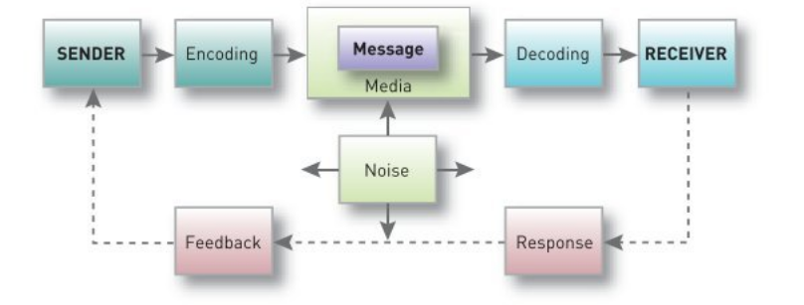
(Kotler, et al., 2009)

This model, related to the marketing process, is to be intended in this way: the sender is the Company or advertiser, and the receiver is the consumer/ target market. The information source sends a message through a channel (website, radio, tv, newspaper, billboards, etc), and the receiver receives and decodes the message. Then, the receiver could give feedback to the sender, positive or negative. But there is another important element to be considered: the noise, something that disturbs the understanding of the message.

INTEGRATED MARKETING COMMUNICATION
Integrated marketing is a management and organisation process that involves all individuals in the analysis, planning, implementation, and control of all marketing communication contacts, media, and communication technologies, targeted at a specific target audience to achieve maximum brand value and coherence. (Pickton & Broderick, 2004).
Changes in methods of marketer and consumer communication, and rapid advancements in communications technology, have had a significant impact on marketing communications. Advertisers are increasingly using a diverse range of more specialised and highly targeted media and contents, such as web, mobile, and social media, to reach smaller client segments, valued with more personalised, interactive messaging.
Marketers are taking their own risks. Aiming to target and catch a large variety of audience, this huge mix of fragmented media and promotional channels result in creating a hotchpotch of communication channels which end up in facing customers confused and unable to understand advertisements, messages, and ultimately stuck in making their own choices (Kotler, et al.,2020).

Companies have used the tool of Integrated Marketing Communications (IMC) to avoid this issue.
The company determines the roles that various promotional methods and marketing content will play, and the level to which each will be used, based on an overarching IMC strategy. This meticulously coordinates promotional operations, as well as the scheduling of key campaigns (Kotler, et al., 2020).

NEW PROMOTIONAL STRATEGIES FOR THE ARMANI GROUP

ONLINE PROMOTION
There is still a gap between the online experience and the in-store experience at Armani group, and this results in an issue during this digital era, where everything is accessed with just one click. Furthermore, this is the era of common people. Experts say that young people are the new unique protagonists of the fashion world, as digital native users, and those who are most likely happy to spend money in excess on ostentation and notoriety. Although Armani group has primarily built its own marketing focus on the young customers, it is missing to reach those customers target by using social media channels, which proved in the last ten years, at least, to be the most powerful channel for the youngers. Below are some ideas for online promotional strategies to improve the digital marketing of Armani:

- Creating a more interactive and attractive website that offers more options like a virtual visit to a physical store, perhaps a sartorial lab.
The website could provide a digital experience showroom for the customers: a client-advisor could show the product in a video call one-to-one with the customer, and give advice, as it is possible to see on the Gucci website, one of the Armani’s competitors.
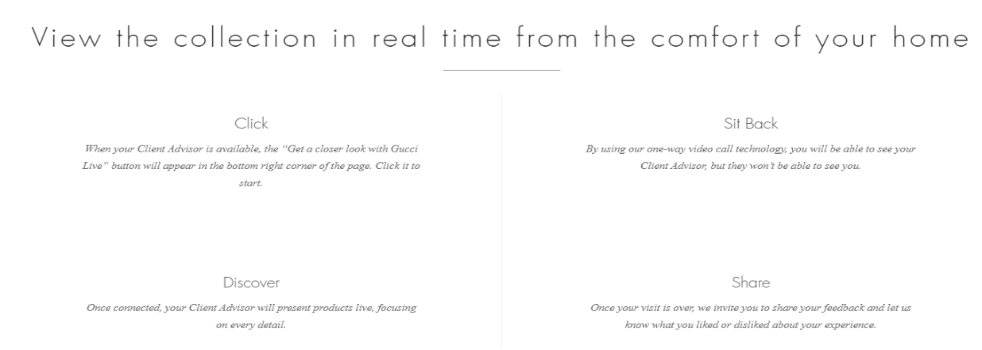

Source: Gucci website

- Armani should make more interesting social media contents: for example, in 2021 Armani just celebrated the 40th anniversary of the Maison, so Armani might have chosen one of its iconic products and shared videos and photos made by users during the event, resulting in direct involvement of consumers.
- Another innovative online strategy could be creating a powerful web application where customers can create a 3D model of their body by uploading full-length photos. So, online simulation of wearing clothes, find the right size and model of clothes. (Metail, 2021).
All of this may create a unique experience for Armani’s customers, giving them the opportunity to evaluate which product fits their own body's characteristics, and it would be enjoyable, as well.

OFFLINE PROMOTION
A luxury product is a high-quality good, sold at a high price; typically purchased by people with a high income. Behind the purchase of a luxury item, there is the search for exclusivity, the desire to feel unique and special. Consequently, a company should try to make the purchase of a luxury item in-store original and extraordinary. Today the new luxury vogue is offline. Below are some innovative offline marketing strategies I would suggest to the Armani group:
- To enhance the exclusivity of its products, Armani might offer selected perfumes exclusively at the brand's stores; for example, more sought-after fragrances could be excluded from online sales, remaining unknown to the general public and thus more niche (a real initiative of Dolce & Gabbana brand) (Dornetti, 2019). The perfumes would be saleable and can be smelt live, making them original and special, maybe with a thank-you message inside the attractive packaging.

- Armani could make the shopping experience in-store, a sensory experience: music, an irresistible scent that pervades the store, the tactile experience of trying an exclusive dress, accompanied by a good glass of wine. Organize special shopping moments during which the customer feels enveloped and satisfied with the situation he lives in. Buying this way could become a unique experience, that leaves an indelible impression on any customer, who is likely shall repeat the experience, and the company will gain their loyalty as a result. The Armani group should also take care of the communication for the invitation to these events: an invitation arriving by post, written by hand on thick paper like old-fashioned letters (Dornetti, 2019).

- Despite the lack of images, statistics show that television and radio remain strategic method of communication. Advertisements on television continue to be an effective approach to introducing a new product.
But newspapers turn out to be the most pervasive, because, in contrast to an advertisement on radio and television, which interrupts the customer's viewing or listening to a program, newspaper advertisement is less annoying (Robbi, 2021).

Armani might come up with a travel-themed advertising campaign, such as a travel 'reportage' for exotic sites across the world that would provide a setting for the company's sartorial apparel or perfumes. The setting should be exotic, maybe by the sea, and depict a state of relaxation that could be warm and enveloping, stimulating the customer's desire to experience that state and subsequently to wear the item promoted. On a psychological level, it is well recognized that the desire for something drives people to get it.

BRAND AND BRAND EQUITY
BRAND

American Marketing Association defines (1960) brand as a name, term, design, symbol, or a combination of these intended to identify and differentiate goods or services of one seller or group of sellers from competitors ( (Keller, et al., 2008). It refers to a business and marketing idea that allows consumers to recognise a specific firm, product, or person. A company's brand is recognized as one of its most valuable and crucial assets. Many businesses are recognized by their brand, meaning that they are often indistinguishable, integrating into one entity (Kopp, 2022). The brand plays an important role in consumer evaluation and, above all, in creating, maintaining and strengthening relationships.
BRAND EQUITY
Brand equity, also known as brand value, depends on consumers' perception of the brand and the relationship they establish with the company, over time. It refers, therefore, to the ability of a brand to drive the choice of purchase, not based on tangible characteristics or the actual quality of the products, but based on recognition, knowledge of the brand and all the associations made with it (Kotler, et al., 2009). Customer-based brand equity occurs when the consumer has a high level of awareness and familiarity with the brand and holds some strong, favourable, and unique brand associations in memory (Keller, et al., 2008).
Companies with a strong brand, and with very positive brand equity, can benefit a lot from brand value because consumers are willing to pay more for that product (with the same characteristics and quality as a competitor) just for the brand value. Apple is an example of a brand with strong brand equity. Even though Apple's products are quite like those of other brands, in terms of features, the company's demand, customer loyalty, and price premium are among the highest in the consumer electronics industry.
Apple is constantly ranked as one of the world's most valuable brands. Brand equity is an intangible resource that expresses the strength and recognition of a particular brand on the market. From a marketing point of view, it is the value that a brand has managed to create both in terms of quality and quantity based on consumer behaviour. It refers, therefore, to the ability of a brand to orient the choices of consumers based on intangible elements rather than tangible characteristics. In a nutshell, the added value that the brand brings to the product. Brand equity is therefore defined as the set of resources linked to the name or symbol that are added to the value that a good or service provides to the customers of a company and the company itself (Azimut, 2020)

KELLER’S BRAND EQUITY MODEL
One of the most important and substantial contributions to the development of brand value theories was by the American professor Kevin Lane Keller. Keller focused his studies on the importance of brand marketing for the success of a company and describes in this Brand resonance model ‘how to create intense, active loyalty relationships with customers’ (Keller, 2013).
The model considers how brand positioning influences what consumers think, feel, and do, as well as how much they resonate or connect with a brand. So, when a company has a strong brand equity, the customers will be more loyal, and they will recommend the products to others. Keller describes his theory how to build a strong relationship with the customer from the ground to the top/apex in a resonance pyramid.
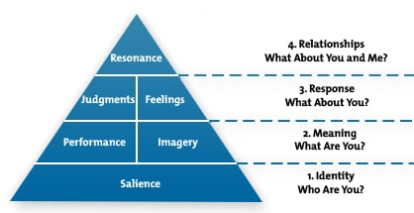

Source: (Keller, 2013)
The resonance pyramid consists of four steps: 1 Brand identity, 2. Brand meaning, 3. Brand responses, 4. Brand relationships. Process consists in moving to the next step, once you have accomplished the previous one, in a way that can be considered successful. This is the core of building a strong brand. (Keller, 2013).
KELLER’S BRAND EQUITY MODEL RELATED TO ARMANI GROUP
- Brand salience: Who are you? It refers to the ease with which customers think of the brand in various situations (Keller, 2009). Armani designed a logo that has become iconic, a symbol of elegance and luxury over time, easily recognizable (Vigneri, 2012). Being an iconic brand produces direct emotional benefits, giving people the impression to be better people, it allows a company to reach the highest level, to build a strong reputation (Holt, 2004). Armani's awareness has expanded thanks to advertisements in fashion magazines and TV, particularly in past decades, making it a desirable brand of elegance. Giorgio Armani created the Emporio Armani magazine in 1988, at the height of his brand's fame and success. The magazine contained fashion articles, stunning photography, and Armani’s philosophy (Tibaldi, 2021).
- Performance/ Imagery: What are you? Brand performance refers to how successfully a product meets the demand of consumers (Keller, 2009): Armani products stand out for their unique style and the selection of raw materials, which takes place in compliance with precise economic, ethical criteria and environmental. In recent years, the Armani Group has focused on sustainability and respect for the environment (Armani, 2021). Brand imagery defines the intangible characteristics of a product, such as how the brand aims to suit clients' psychological or social needs (Keller, 2009). To See or touch a product of Armani immediately evokes elegance, glamour, and style. This helps to satisfy the customer’s need for a product that makes them feel unique.
- Brand Response: What about you? Brand judgments refer to the customers’ ideas and judgments; Brand feelings refer to the emotional feedback of the customers after buying the product (Keller, 2009). Analysing the social media pages of Armani and researching customer feedback, reveals that the feedback is generally positive, the customers highlight the clothing' freshness and appreciate the ability to understand the needs of a woman in her everyday dressing. The response of the customers becomes more enthusiastic for the VIP wearing Armani’s clothing on the red carpet, as well as the collaboration that Armani has always had with movies and actors (Armani Group, 2022). In conclusion, consumers appreciate both the brand's simplicity and the uniqueness brand symbolize.
- Brand relationship: What about you and me? Brand resonance describes the engagement of the customers with the brand, and their synchronicity with the brand (Keller, 2009). Armani has built a loyal relationship with customers by offering an exclusive shopping experience in its boutiques through good customer service. Armani focuses on the fashion market for young people involving stars like Lady Gaga who have an influence on young trends (Armani Group, 2022). Recently, Armani has given great importance to environmental projects such as ‘ACQUA FOR LIFE’ which focuses on universal access to water in areas affected by water scarcity (Armani, 2021). The group has created charity projects in the sports and education sectors to be closer to young people as the ‘Armani Junior Program’ (Armani, 2021), so the company received many awards from environmentalists.

ADVANTAGES AND DISADVANTAGES OF KELLER’S BRAND EQUITY MODEL
The brand equity pyramid of Keller is an important marketing tool to raise the awareness of a company and drive sales to the top (Keller, 2009). To get benefits by applying the model, companies must carry on and accomplish each step before moving on to the next one. If a company can reach the top of the pyramid, brand equity becomes a value to invest in. A brand that knows how to build its own identity, clearly communicate its objectives, and establish a relationship of loyalty with the customer is a reliable and affordable brand.
Investing in a reliable brand means investing in added value. Today Brand Equity is considered an excellent marketing tool and a real asset that can generate profit (Azimut, 2020). The resonance pyramid is a way to identify how marketing communications impact brand equity and establish intense, engaging loyalty connections (Remy, 2021). The pyramid helps companies to achieve success through a gradual path, and once they reach the apex, they get significant advantages such as increased earnings related to higher prices, which they can maintain thanks to the recognised excellence of the brand, and more effective marketing (Remy, 2021). The Pyramid shows some weaknesses; one is highlighted by a study carried out by Kuhn, which revealed that the emotional aspect does not play any role in purchasing some products (e.g., industry and technology sectors).
In this research, the interviewees underlined that they had not felt any emotion during the purchase (Khun & Alpert, 2004). In addition, Keller's Brand Equity Model is simple to apply for organisations that are well-known or have been on the market for a long time, but it is more difficult for entrants. The path to create a brand is lengthy and winding, involving a variety of issues and several efforts (Bhasin, 2019).

CUSTOMER JOURNEY
The customer journey or customer experience commonly refers to a process that a customer or potential customer goes through when they met a company, to satisfy a need or to use one service of a company (Folstad & Kvale, 2018). The increasing focus on customer experience arises because customers now interact with firms through myriad of touchpoints in multiple channels and media. These changes require firms to integrate multiple business functions, involving external partners, in creating and delivering positive customer experiences. The firms should develop a stronger understanding of customer experience and the customer journey in this era of increasingly complex customer behaviour (Lemon & Verhoef, 2016).
Marketing experts have determined the number of fixed key moments (stages) in consumer behaviour, which together form a common thread linking the first approach to a brand, the purchase and turning the customer into a promoter of your products and services.
STAGES OF CUSTOMER JOURNEY
The stages of a customer journey are 5.
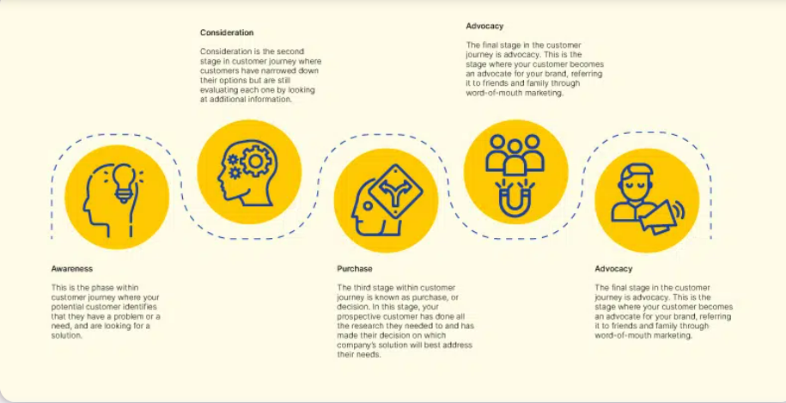

First step: AWARENESS. The consumer becomes aware that he needs a product or service, so he starts to search for information to solve the problem or satisfy a need. Currently, the first source of information for the purchase of a good is the online platform (81% of consumers research online before buying a good) (Zubak, 2017).
Second step: CONSIDERATION. After an initial informative research phase, potential customers make their own considerations. They consider the pros and cons of a product, the price made by a brand and the ones offered by other competitors. They consider all the features of the product and compare the purchase of a product to other solutions (Kotler, et al., 2009).
Third step: DECISION. This is the stage where potential buyers have all the information, and they want to make the right purchase. The customers read reviews of other customers on online surveys and make their decision (97% of customers are influenced by the reviews of other customers) (Zubak, 2017). They are ready to make the purchase.
Fourth step: RETENTION. This is a crucial stage for the company, it should maintain the trust of its customers. Research says that it is easier to maintain the loyalty of an existing customer than to acquire the loyalty of a new customer (Bhasin, 2019).
Fifth step: ADVOCACY. The customer evolves into an active advocate for a brand. The customers say great things about the product and the company because they are satisfied. This is the time of word-of-mouth: satisfied customers refer and recommend the company to their friends and family, and they share information and positive experience. This is the most successful type of promotion for a company (Zubak, 2017).

CUSTOMER TOUCHPOINTS
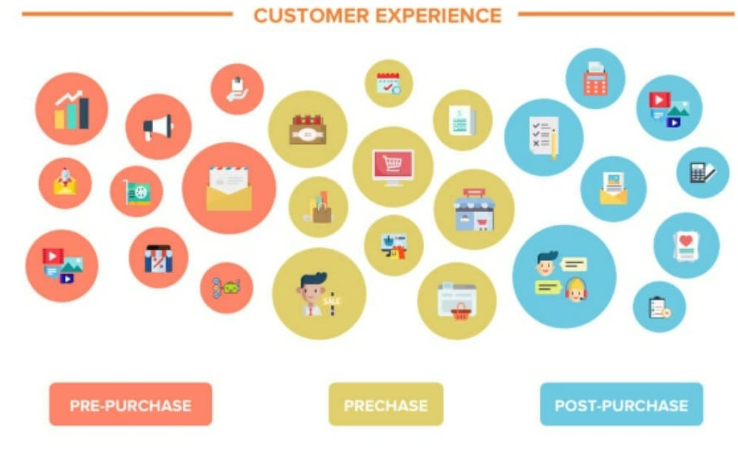
Customer touchpoints are all the interactions between a company and customers that occur throughout the customer journey ( Lemon & Verhoef, 2016). These interactions can take place before, during, or after a customer purchase. Visiting the website and social media pages of the adverted or chosen company, interacting with a customer assistant by phone, email, chat, reading a magazine advertisement or watching a TV advertisement, coming across the brand’s logo: these are all possible touchpoints (Aichner & Gruber, 2017). Consumer experience, from a company perspective, involves many aspects like the quality of customer service, promotion, packaging, functionalities of product and reliability (Meyer, 2007 ). The effectiveness of these interactions has an important impact on how a company or brand is perceived, as well as the customer's propensity to buy and his satisfaction (Aichner & Gruber, 2017). High consumer satisfaction is an important objective of the company; it produces good word-of-mouth, attracts new customers, generates more earnings, and increases the company value (Aichner & Gruber, 2017). Below it is an example of analysis of customer touchpoints between Armani group and a predefined customer.

Source (Penalver, 2020)

PRE-PURCHASE TOUCHPOINTS
Clizia is a 50-year-old woman who has achieved a long-awaited career upgrade. She is delighted, and she wants to make herself a gift for this important moment. She considers a sartorial, classic, and elegant dress. Clizia gets a copy of Vogue magazine and consults the current fashion trends; Armani and Chanel's fashion suggestions capture her interest (1 touchpoint). Then, Clizia visits the official websites of both brands to evaluate their complete clothing line, as well as prices (2 touchpoint). After having evaluated both brands, Clizia decides to purchase an Armani suit, so she submits a request on the Armani official website to find out which store is the closest to her home (3 touchpoints). Clizia has received an email, into which the company enclosed all the information about the closest shops (4 touchpoint).

PURCHASE TOUCHPOINTS
Clizia goes to the Armani store on her day off, she wants to really enjoy the experience (5 touchpoint). Within the shop, a sales assistant exclusively looks after her along the purchasing journey, interacts with courtesy satisfying the customer needs, and makes Clizia feeling comfortable (6 touchpoint). Clizia chooses her dress and purchases it (7 touchpoint). When Clizia has completed her purchase, she has offered the option of activating a loyalty card (8 touchpoint) and subscribing to the newsletter (9 touchpoint) and being updated on special events and promotions.

AFTER-PURCHASE TOUCHPOINTS
After a few weeks, Clizia receives an email from Armani Group, with a invite to an exclusive event: the launch of a new fragrance (10 touchpoints). She is enthusiastic and plans to attend the event (11 touchpoint). During the presentation, participants will have the opportunity to purchase the perfume at a discounted price. Clizia has purchased the perfume and will share the experience with her friends and colleagues, telling them about the VIP who attended the special event and the new fragrance (12 touchpoint).

CUSTOMER JOURNEY MAP
Academic and marketing experts acclaim the Customer journey map as an essential strategic management tool for understanding an organization’s customer experience. The customer journey map is a graphic representation of the sequence of stages through which a customer interacts with the company, during the complex purchasing process (Rosenbaum, et al., 2017). For a better perspective of the Customer Journey map, below is a map of the purchase end-to-end of an Armani dress by a new customer.
CUSTOMER JOURNEY MAP | AWARENESS | DISCOVER | PURCHASE | USE | BOND
WEBSITE |  | 2- Looking for more information and pictures
MAGAZINES | 1-New customer looks at Armani dress
STORE |  |  | 4- Purchase of the dress
SOCIAL MEDIA |  | 3- Looking for customers review
THE PRODUCT |  |  |  | 5- Great quality and design
WEB FORUM |  |  |  |  | 6-Express positive experience
WORD OF MOUTH |  |  |  |  | 7- Satisfaction and sharing good experience with friends and colleagues

The journey starts by discovering an Armani dress in a fashion magazine (1-awareness), then the customer searches on the official company website (2-discover) and on the web forums, looking for reviews of other customers (3-discover). The new customer goes to a store (4-purchase). After months she is still satisfied with the purchase (5- the product) and became the ambassador of the brand on the web (6-bond) e with her friends (7- bond).

STRENGHTS AND WEAKNESSES OF ARMANI CUSTOMER JOURNEY MAP
In the customer journey map of Armani, the strengths are the advertising on magazines, the experience within the store and the quality of the product overtime. Armani has traditionally chosen iconic and artistic pictures to promote his products on magazines. He was a precursor, back in the day, when founded his own magazine in the 1980s to publicize his products and create art (Tibaldi, 2021).
Nowadays, Armani's fascinating photographs continue to be strategic in the most prestigious fashion magazines. As a luxury brand, Armani offers an excellent shopping experience in store, where shop assistants take care of customer and guarantee that all his needs are satisfied. The Armani Group has always prioritised the quality, safety, and authenticity of the products. To that purpose, the company has increased the number of employees committed to this purpose and placed considerable investments for brand protection procedures. Armani intensifies efforts to combat forgery, piracy, and the underground market (Armani Group, 2022). Statistics show that one of the last businesses to join e-commerce was the luxury industry. Online Promotion and sales continue to be a weakness, all around this industry, even though the Armani Group and the Yoox Net-a-Porter Group have partnered to develop new online functionalities available on Armani's e-commerce since 2021 and develop a multi-channel shop (D'amelio, 2020). Armani's website is less appealing than the website of the main competitor, Gucci, which is vibrant in design, easy to use, and piques interest in exploring it. In addition, on Armani’s social media the customer’s comments and engagement are still limited.

THE TOTAL ENGAGEMENT MODEL
Customer engagement means need to create a relationship, a deep connection between a company and its customers that guide over time the purchase decisions, the interactions, the different forms of participation and involvement with the brand. To achieve the aim of customer engagement, the total engagement model focuses on the synergy of many elements such as advertising, services, products, and company culture, which implies involving the company's employees and making them feel like they are a part of a mission or a project (Roberts & Alper, 2010)
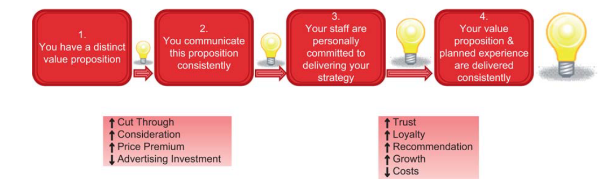
Source: (Roberts & Alper, 2010) the engagement journey
As the image above shows, excellent brand value and efficient communication of the company's values and products are required for reach customer engagement. An essential role is played by the company’s employees who work to develop the company’s strategy and ideas. This is a way to achieve good customer engagement and growth in sales and profits.
In the Armani’s case, the brand's value is recognized worldwide, and the high quality of its products are the factors that guarantee customer loyalty. The shopping experience in store is still a crucial component that must be implemented and constantly enhanced with musical and gastronomic events, VIP and charity events, but also with Premium personalisation to offer something unique to customers. Statistics show that 90 per cent of luxury product purchases take place in stores (Alexander, 2019). Armani, like many other luxury companies, has avoided social media, fearing of degrading its products, but online shopping incomes, and the era of millennials, show that it is necessary to focus on online promotion strategies and to consider strategies seeking customer engagement on social media (Alexander, 2019). Armani still needs to improve communication and digital marketing strategies, to compete with major competitors like Gucci and Louis Vuitton.
CONCLUSION AND RECOMMENDATIONS
This report shows the importance of a variety of marketing tools to improve and fulfil customer needs of a company. First, priority should be given to understand the consumers' needs through the analysis of customers’ touchpoints and the customer journey map, to monitor the complex purchase path of a product, and to improve the map's weaknesses. Then, using integrated marketing communication, develop up with new online and offline marketing strategies. Thanks to Keller's equity model, a company knows how essential is the brand value, and how to assess it. The analysis highlighted how Armani needs to enhance online strategies to increase its visibility and e-commerce profits. As for offline promotion strategies, they are quite strong, especially those related to advertising in magazines. Monitoring the customer journey is essential to improve customer loyalty, and surely Armani must enhance the awareness of its products on online platforms.
RECOMMENDATIONS
Below some recommendations for Armani to improve its marketing strategies and the profits of its business:
- enhancing online platforms, social media, and websites with more interactive contents, as well as additional services, personalized to consumers
- to provide customers with a unique shopping experience in its stores, including sensory experiences
- Organizing more events to promote new or existing products, tie up by celebrities
- Focus on customer service, using and analysing the customer journey map, which is an essential tool for a company that wants to effectively manage its marketing.

References
Chandler , D. & Munday, R., 2011. A dictionary of media and communication. 1 ed. s.l.:Oxford University Press.
Lemon, K. N. & Verhoef, P. C., 2016. Understanding Customer Experience Throughout the Customer Journey. Journal of Marketing, November(Special issue), pp. 70-96.
Rosenbaum , M. S., Otalora , M. L. & Ramirez, G. C., 2017. How to create a realistic customer journey. Business Horizons, 60(1), pp. 143-150.
Aichner, T. & Gruber, B., 2017. Managing Customer Touchpoints and Customer Satisfaction in B2B Mass Customization: A Case Study. International Journal of Industrial Engineering and Management;, 8(3), pp. 131-140.
Alexander, D., 2019. Customer engagement strategy used by luxury brands. [Online]
Available at: https://www.cxnetwork.com/cx-experience/articles/luxury-customer-experience
[Accessed 17 04 2022].
Armani Group, 2022. Giorgio Armani. [Online]
Available at: https://www.instagram.com/giorgioarmani/
[Accessed 08 04 2022].
Armani, 2021. THE ARMANI GROUP AND SUSTAINABILITY 2020, Milan: Armani SPA.
Azimut, 2020. Brand equity. [Online]
Available at: https://azimutdirect.com/en/node/271
[Accessed 08 04 2022].
Bhasin, H., 2019. Keller’s Brand equity Model – CBBE Model by Keller. [Online]
Available at: https://www.marketing91.com/kellers-brand-equity-model/
[Accessed 08 04 2022].
Cantarini, G., 2020. L'OfficielItalia. [Online]
Available at: https://www.lofficielitalia.com/moda/storia-giorgio-armani-stilista-moda-carriera-vita-successi
[Accessed 15 03 2022].
D'amelio, M., 2020. Giorgio Armani spinge sullo shopping multicanale con Next Era. [Online]
Available at: https://www.iodonna.it/moda/news/2020/07/01/giorgio-armani-federico-marchetti-consigliere/
[Accessed 17 04 2022].
Dornetti, L., 2019. Perché il nuovo lusso sarà essere offline. IL sole 24 ore.
Folstad, A. & Kvale, K., 2018. Applying Transactional NPS for Customer Journey Insight: Case Experiences and Lessons Learned. Services Marketing Quarterly, 39(3), pp. 208-224.
Holt, D. B., 2004. How brands become icons: the principles of cultural branding. Harvard: Harvard Business Press.
Keller, K., 2009. Building strong brands in a modern marketing communications. Journal of Marketing Communications, 15(2-3), p. 139–155.
Keller, K. L., 2013. Strategic Brand Management. 4 ed. s.l.:Pearson.
Keller, K. L., Aperia, T. & Georgson, M., 2008. Strategic Brand Management: A European Perspective. s.l.:Financial Times/ Prentice Hall.
Khun, K. & Alpert, F., 2004. Applying Keller’s Brand Equity Model in a B2B Context: Limitations and an Empirical Test. Queensland, ANZMAC.
Kopp, C. M., 2022. Investopedia. [Online]
Available at: https://www.investopedia.com/terms/b/brand.asp
[Accessed 13/03/2022 March 2022].
Kotler, P., Armstrong, G., Harris, L. C. & He, H., 2020. Principles of marketing. Harlow, England: Pearson.
Kotler, P. et al., 2009. Marketing Management. Essex: Pearson Education.
Martel Fashion, 2021. Branding strategy. [Online]
Available at: https://www.martelnyc.com/luxury-fashion/branding-strategy.html
[Accessed 08 04 2022].
Metail, 2021. REDESIGNING DIGITAL FASHION EXPERIENCES. [Online]
Available at: https://metail.com/
[Accessed 10 04 2022].
Meyer, C. a. S. A., 2007 . Understanding customer experience. Harvard business review, Issue February.
Neher, K., Maechler, N. & Park, R., 2016. McKinsey. [Online]
Available at: https://www.mckinsey.com/business-functions/marketing-and-sales/our-insights/from-touchpoints-to-journeys-seeing-the-world-as-customers-do#:~:text=To%20maximize%20customer%20satisfaction%2C%20companies,end%2Dto%2Dend%20journey.
[Accessed 15 03 2022].
Newstrom, J. & Keith, D., 2001. Organizational behaviour: human behaviour at work. s.l.:McGraw-Hill International Editions.
Penalver, P., 2020. Esperienze e touchpoint: customer life cycle. [Online]
Available at: https://www.wearemarketing.com/it/blog/customer-life-cycle-touchpoints-esperienza-cliente.html
[Accessed 13 04 2022].
Pickton, D. & Broderick, A., 2004. Integrated marketing communications. 2 ed. s.l.:Pearson Prentice Hall.
Remy, A., 2021. Ava's impression. [Online]
Available at: https://avaremy.wordpress.com/2013/11/09/brand-equity/
[Accessed 08 04 2022].
Robbi, S., 2021. Strategie di marketing offline: quali sono e quali adottare?. [Online]
Available at: https://www.netstrategy.it/web-marketing/strategie-di-marketing-offline-quali-sono-e-quali-adottare
[Accessed 11 04 2022].
Roberts, C. & Alper, F., 2010. Total customer engagement: designing andaligning key strategic elements to achievegrowth. Journal of Product & Brand Management , 19(3), pp. 198-209.
Tibaldi, S., 2021. Emporio Armani Magazine: la rivista che ha anticipato i tempi. [Online]
Available at: https://www.repubblica.it/moda-e-beauty/foto/2021/09/18/foto/mostra_emporio_armani_anniversario_giorgio_armani_peter_lindbergh-342217140/1/
[Accessed 08 04 2022].
Vigneri, A., 2012. cameramoda. [Online]
Available at: https://www.cameramoda.it/it/associazione/news/914/
[Accessed 17 03 2022].
Watzlawick, P., Janet Beavin Bavelas, J. B. & Don D. Jackson, D. D., 2014. Pragmatics of Human Communication: A Study of Interactional Patterns, Pathologies and Paradoxes. s.l.:WW Norton & Co.
Zubak, J., 2017. Stage of the Customer Journey. [Online]
Available at: https://powerdigitalmarketing.com/blog/how-to-deliver-value-at-every-stage-of-the-customer-journey/#gref
[Accessed 31/03/2022].

