LCBB5001
BUSINESS PLAN: CLEO’S GYM

Ionela Filip-Datcu
Id student :1922490
Lecturer: Vasilios Tavlaridis

Introduction

An overview of the proposed business idea
Cleo’s Gym is a unique fitness club which intends to place a strong focus upon providing an enhancement to the lifestyle of all its members in a friendly, upbeat and an adult oriented atmosphere. With all the latest equipment’s, gymnasium machines, well-educated fitness instructors and best in class personalised services; the fitness club intends to make an impact on the fitness community through its value driven contributions that aligns well with its mission and vision.

Mission and Vision
The mission of the fitness club is to educate its members about the art and discipline behind fitness which is backed up by science to help masses attain a healthy & sustainable lifestyle regime. The vision of the club is to spread awareness about the benefits of fitness in a world full of people committed to an unhealthy lifestyle and thus helping to improve upon ‘self-esteem’.

Service Catalogue
Cleo’s Gym is backed up by both tangible and intangible resources aimed towards creating personalised and customised programmes for its members according to their goals. Members may range from beginners, intermediate and advanced categorised based on their experience. The list of fitness programs will be in accordance with the goals of its clients and will comprise of the following:
Service Programme | Overview
Crash Loss Programme | This programme is aimed towards reducing the body fat percentage of clients.
Crash Gain Programme | This programme will help clients to build muscle with the correct exercise routine and nutrition.
Weight Gain Programme | This programme is tailor made for the hard gainers to gain weight with the correct knowledge of nutrition.
Diet Plans & Charts | The employed nutritionist will make customised diet plans for beginners who are just starting out.
Kangoo Jumps exercise | The Kangoo Jump Exercise instructor will host batches where members will be coached on how to properly perform the jumps along with music to stay fit and loose. on body fat.
Yoga Training Programme | The club has also appointed yoga trainers that will provide yoga and meditation services to clients.
Wellness Course | This course is aimed towards providing the correct knowledge about the fitness industry. This course will consist of instructors teaching beginners about the truth of bodybuilding, the art of calorie counting and bursting the myths about use of performance enhancers.

Personal Expertise & Motives of Entrepreneur
The entrepreneur has a personal hobby and liking towards fitness and loves working out. She personally enjoys cardiovascular exercises, kangoo jumps and lifting weights occasionally with an experience of nearly five years into fitness. In her personal journey of weight loss and dropping body fat percentage, there were several people advising different ways on how to drop weight. The entrepreneur realised that the fitness industry is full of myths especially with respect to exercise, diet, cardiovascular exercises, performance supplements, performance enhancers and steroids. The entrepreneur was convinced that she had to do something for the community in order to educate the beginners about the in’s and out’s of fitness and so educate the masses about the myths of the fitness industry. She always wanted to convert her passion into a profession.

Business Opportunity (Market Gaps)
With the fitness industry leaning towards an aggressive use of performance-enhancing drugs, the market is full of fitness clubs that are promoting and making easy money out of tricking beginners. This is where Cleo’s Gym steps in looking to fill the void in the market and educating the masses about the harsh realities and the core discipline & sheer consistency behind fitness. The club stands by its core values and intends to educate the beginners that ‘Supplements cannot supplement hard work’.

Location and Legal Entity
Cleo’s Gym will be located in the heart of High Street just near to the Ravenside Retail Park which is one of the most principal and prime locations in Erdington at Birmingham in the United Kingdom. Beating one or more affluent regions, Erdington is now recognized as one of the best locations to live in Birmingham area. The entrepreneur will set up the club as a sole trade business considering the scale of operations and easy to set of legal procedures of the same. Furthermore, the entrepreneur intends to retain the entire operational control over the business.

Main Body

SWOT Analysis
The SWOT analysis tool is one of the most popular strategic management tools which can help in identifying the core strengths, weaknesses, opportunities, and threats of a business in an attempt to facilitate internal analysis and making strategic decisions which allows a business to leverage its strengths against its weakness and opportunities for mitigating threats. The individual components of the tool for Cleo’s Gym have been identified and discussed as follows:

Strengths of the Business
There are several sources of strengths concerning the operations of Cleo’s Gym. First and foremost, the core values of the business which encompasses educating the masses about the discipline and consistency behind fitness is what is believed to act as a catalyst to success of the business over the long term. This when coupled with the entrepreneur’s commitment and passion for fitness will help fuel growth. Another source of strength of the business is its location in Erdington which has transitioned into one of the best residing places in all of Birmingham will help in providing clientele to the business. Personalised services, tailor-made custom programs, competitive pricing, well-educated fitness instructors, latest equipment, and a hygienic gymnasium environment all cumulatively add up to be the major points of strength of the business.

Weaknesses of the Business
There are also several inherent weaknesses associated with the proposed venture. The most important source of weakness of the business is that Cleo’s Gym lacks experience. Since the business is just starting out it lacks operational experience. Furthermore, it is the first real time venture of the entrepreneur who also lacks experience of operating a business. Another potential disadvantage of the business is its selected target market. Although Cleo’s Gym is open for one and all it will focus more upon women belonging to the age group 18 years to 32 years.

Opportunities for the Business
There are also several different opportunities that are available for the business and the entrepreneur. There is always an opportunity to expand geographically into other potential locations in Birmingham. Cleo’s Gym can also open a sister concern focusing more upon competitive body building with a different target market all together. Cleo’s Gym can also set up a mini store business involved in selling of different nutritional supplements such as whey protein, pre workouts, protein bars, creatine supplements, mass gainers and much more.

Threats for the Business
One of the most important sources of threat for the business is competitive threat. Birmingham is already host to several popular fitness clubs such as Aesthetic Health and Fitness club, Kaizen Centre, Ultimate Fitness Birmingham and much more. The market is already saturated which will pose a significant competitive threat to Cleo’s Gym. Furthermore, the Covid-19 pandemic has also resulted in people being much more conscious about physical distancing and generally avoiding interactions and overcrowded areas. Additionally, the pandemic has also reduced the economic spending of consumers and has caused a worldwide economic recession.

PEST Analysis
Pest Analysis is another strategic management tool that helps in identifying and analysing the external influences or the macro-environmental influences which may have an impact on the business. The tool comprises a total of four different external forces which in the connection with Cleo’s Gym has been identified as follows:

Political Factors
Before the lockdowns and after Covid-19 pandemic, gyms and fitness clubs have been adversely impacted. The industry is in sheer need of political support and government funding to sustain the adverse impacts of the pandemic. In response, the Government has been proactive and has announced £100 million for supporting the recovery of the industry. Funds have been allocated to a total of 266 local authorities across England for supporting the improvement of gyms and fitness clubs with certainty as a part of the National Leisure Recovery Fund which was set up by the Government in 2020. The UK Government understands the importance of health and fitness thus tending to support the industry in a time of financial difficulties as a part of their commitment to ‘build back fitter’.

Economic Factors
The Covid-19 pandemic has adversely impacted the economy in UK which in turn has materially impacted the performance of the industry resulting in atmosphere of economic uncertainty. The same can also be said about the health & fitness industry which has been impacted the most. Lockdowns are what resulted in the complete gym closure since March 21, 2020. The winter lockdowns in January 2020 for gyms and fitness facilities in UK have caused a combined decrease in £90m worth of revenue each week. The post pandemic return to pre pandemic level of activity and results is a long road to recovery and will potentially result in a long-lasting structural change in the industry.

Social Factors
The outbreak has increased the awareness for health, nutrition and well-being among Brits. The people in the UK are prioritising in being more active than ever before. Live workouts and on-demand workouts have also increased in terms of demand with people also enjoying online fitness classes and working out conveniently from home without having to visit the gym. There has also been an increase in a segment of people preferring dance based cardiovascular workouts such as Kangoo Jumps. All in all, the pandemic has resulted in an increase in the level of interest in exercise, an active lifestyle, and physical activities.

Technological Factors
Technological advancements are a necessity for providing members in fitness clubs access to best-in-class services which can help with service differentiation and attaining a competitive advantage. Periodic upgrades of machines and equipment is mandatory as energy efficient equipment’s can help in decreasing electricity costs but always has a price to pay. Fitness clubs use their introduction of latest and greatest equipment’s to better market their gyms as their marketing strategy for creating new customers. Technological advancements have also allowed for individuals training at home with trainers providing online guidance and classes through their training programs.

Target Market Analysis & Positioning Strategy
Cleo’s Gym will be equipped and staffed with the latest equipment’s and sound training instructors to cater to the needs and expectations of a wide audience. However, the most important segment which the gym would like to target is women in Erdington belonging to the age group of 18 years and 32 years of age. From a psychographic perspective, the target segment is expected to be women individuals who are active, involved in sports, wishing to maintain a healthy lifestyle viewing fitness as a way of life and women primarily looking to cut down on body fat and tone their bodies. Although the gym will also cater to men and aged individuals, the gym through its tailor-made custom programs, kangoo jumps exercise, yoga training and customised diet charts will look to prioritize and focus upon its selected target market.
Cleo’s Gym will position itself in the eyes of its intended target market as a result-oriented training fitness club for enthusiasts who are willing to learn the in and out’s of fitness therefore offering true value to the end consumer in exchange of a competitive and reasonably priced membership fee. The gym will opt for a service differentiation as well as a cost leadership strategy for gaining a competitive advantage and creating new customers in the identified target market segment.

Marketing Plan (Marketing Strategies to reach the Target Market)
Cleo’s Gym looks to capitalize upon marketing for creating a competitive advantage as investing in the correct marketing strategies can help reach the intended target market of the gym which ultimately draws in more members thus maximizing upon revenue and margins. Some of the marketing strategies which the owner will rely upon for reaching the intended target market are discussed as follows:
- Membership Marketing: This is one of the best marketing strategies which can work wonders for any fitness clubs. The budget gym chain Pure Gym in UK have excellently implemented such a strategy which uses referrals for incentivising existing members when it comes to renewals (Wholesale.rdxsports.com, 2021). This can also help facilitate the word-of-mouth strategy.
- Word of Mouth Strategy: This strategy does not even cost a pound as Cleo’s Gym is value driven and will focus upon positioning strategy of differentiation and cost leadership. This also allows existing members to bring in new admissions that helps maximize revenue and build upon a community.
- Digital Marketing: Cleo’s gym also intends to focus upon SEO (search engine optimization) & PPC (pay per click) strategy to target audiences who search and browse for gyms online on the web which helps in getting the word out there. A well optimized website combined with PPC can bring in new leads.
- Social Media Marketing: Ever since the Covid19 pandemic, the increase of social media has rapidly increased. Cleo’s Gym will have official social media handles across different social media platforms such as Instagram, YouTube, and Facebook to market, advertise and interact within the fitness community.
- Influencer Marketing: The social media marketing strategy also gives shape to the influencer marketing strategy which again works wonders for the fitness industry. Cleo’s Gym is also looking to target certain fitness enthusiasts that have significant followers on social media and who can be idealised when it comes to fitness. Getting them to workout in Cleo’s Gym can help draw in numbers. The gym will also offer sponsorships in the long term.
- Traditional Marketing: During the initial stages, Cleo’s Gym will also take advantage of traditional marketing strategies such as flyers, business cards, print advertising & banner advertisements for marketing the service portfolio.

The ‘Four Ps of Marketing’ are price, product, place, and promotion .

Price

In the fitness world consider what you offer in terms of value when developing your pricing plan for your classes and services.

Product

It is very important how you promote your services and attract the proper people to your fitness club. Cleo's Gym has a wide range of products to appeal to a large variety of customers.

Place

Cleo’s Gym is located in Erdington, one of the best places for business as fitness, a great position with a lot of foot traffic will certainly help attract more possibilities through the door.

Promotion
Promotion is a crucial aspect of marketing and an essential part of the marketing mix. Cleo’s gym must promote the best services in terms of their value. Cleo’s Gym will provide a premium service that members will love.

Financial Plan
Based on secondary research, a reasonable estimate can be made with respect to the cost of setting up a fitness gym club. The total cost for setting up Cleo’s Gym is estimated at £80,000 (Startups.co.uk, 2021). The statement for start-up funds has been constructed as follows:
Statement for Start-up Costs for Cleo's Gym
Particulars | £
Total Equipment Cost (Machines, Weights & Equipment’s) | 25,000
Flooring, Walling & Interior Designing | 15,000
Air Conditioning, Fans & Ventilation | 8,000
Furniture Cost | 2,500
Computer Equipment | 3,000
Advance Rent | 15,000
Insurance Expense | 2,000
Marketing & Brochure | 5,000
Miscellaneous Expenses | 2,500
Cash Reserves | 2,000
Total Estimated Start-up Costs for Cleo's Gym: | £80,000

The total estimated start-up costs are most likely to be funded by two different sources of finance which comprises of 70% equity (owner’s contribution) and 30% debt (10% bank loan). The entrepreneur’s own personal investment allows the gearing and financial leverage to be low which reduces the risk of default. Additionally, a bank loan with a 10% per annum finance cost allows the entrepreneur to not invest all the personal savings into the business.

(Estimated Monthly Cash Flows) 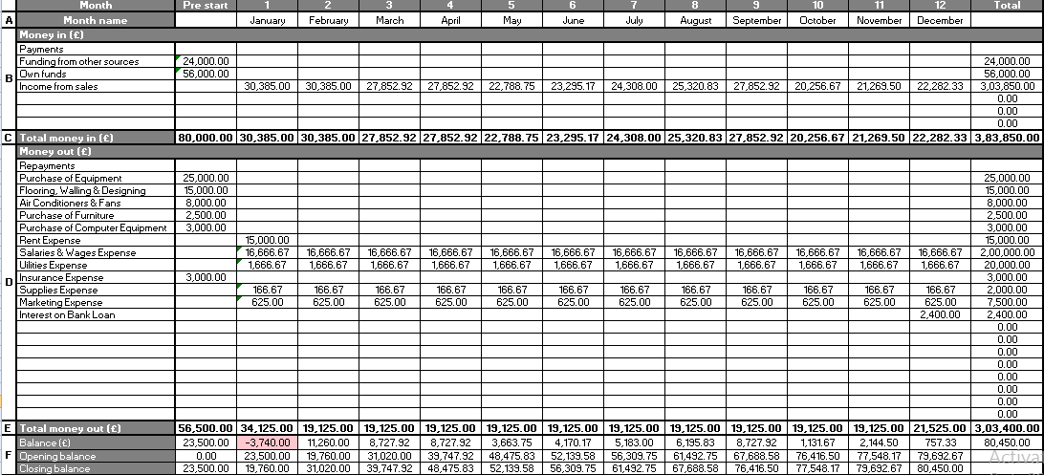
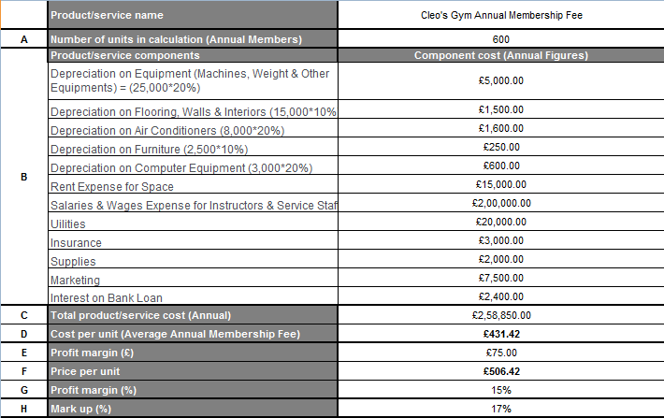
(Costing Related Data)

(Monthly Sales & Cost related data)

References
Economics Observatory, 2021. What does coronavirus mean for the future of sport and fitness clubs? - Economics Observatory. [online] Economics Observatory. Available at: <https://www.economicsobservatory.com/what-does-coronavirus-mean-future-sport-and-fitness-clubs> [Accessed 21 October 2021].
Erdingtonlocal.com, 2021. NEWS: Erdington named one of the ‘best places to live’ in Birmingham by property industry experts -. [online] Erdingtonlocal.com. Available at: <http://www.erdingtonlocal.com/news-erdington-named-one-of-the-best-places-to-live-in-birmingham-by-property-industry-experts/> [Accessed 21 October 2021].
GOV.UK, 2021. Government announces allocation of £100 million to support recovery of leisure centres. [online] GOV.UK. Available at: <https://www.gov.uk/government/news/government-announces-allocation-of-100-million-to-support-recovery-of-leisure-centres> [Accessed 21 October 2021].
Guardian, 2021. Leisure facilities face £90m a week loss under UK winter Covid-19 lockdown. [online] the Guardian. Available at: <https://www.theguardian.com/sport/2021/jan/07/leisure-facilities-face-90m-a-week-loss-under-uk-winter-covid-19-lockdown> [Accessed 21 October 2021].
Hunger, J.D., 2020. Essentials of strategic management.
Lasserre, P., 2017. Global strategic management. Macmillan International Higher Education.
Leisureopportunities.co.uk, 2021. UK gym industry calls for sector-specific government financial support | Leisure Opportunities news. [online] Leisureopportunities.co.uk. Available at: <https://www.leisureopportunities.co.uk/news/Physical-activity-sector-calls-for-a-National-Physical-Activity-Plan-and-financial-protection-as-government-announces-lockdown-3-VAT-reductions-rent-protection-business-rate-relief/346919> [Accessed 21 October 2021].
Men's Health, 2021. New Studies Highlight Covid-19's Impact on Changing Fitness Habits. [online] Men's Health. Available at: <https://www.menshealth.com/uk/health/a35360124/covid-19s-impact-changing-fitness-habits/> [Accessed 21 October 2021].
Startups.co.uk, 2021. How to Start a Gym Business 2021 | Guide by Startups.co.uk. [online] Startups.co.uk. Available at: <https://startups.co.uk/guides/how-to-start-a-gym-business/#:~:text=Starting%20a%20gym%20business%20is,smaller%2C%20like%20a%20fitness%20studio.> [Accessed 21 October 2021].
Wholesale.rdxsports.com, 2021. 10 Marketing Strategies for Gyms and Fitness Clubs. [online] Wholesale.rdxsports.com. Available at: <https://wholesale.rdxsports.com/blog/10-marketing-strategies-for-gyms-and-fitness-clubs> [Accessed 21 October 2021].
https://marketingmix.co.uk/4ps-marketing/[Accessed 30 October 2021]

