
Design Portfolio
System Engineering
ACDA5021
Stan Collins
2022429

11/09/2024

Contents
1. Introduction 4
1.1. The current capability 4
2. Systems engineering 5
2.1. Benefits of systems engineering 6
3. Pre-Design 7
3.1. System Requirements 7
3.2. Rationalised requirements 9
4. Functionality 12
4.1. QFD 1 12
5. Design Concepts 13
5.1. Design choices 14
5.2. Concepts 15
5.3. System Pugh Diagram 16
5.4. QFD 2 18
5.5. System analysis – N² 18
6. Failure Analysis 19
6.1. Failure mode and effects analysis 19
6.2. P diagrams 20
7. Manufacturing considerations 21
8. Reflection 22
8.1. QFD 22
8.2. FMEA 23
9. Conclusion 23
10. References 24
11. Appendix 27
11.1. Requirements 27
11.2. Pairwise comparison 29
11.3. QFD 1: 34
11.4. QFD 2 36
11.5. P diagram WHAT-WHY 37

List of Figures & Tables
Figure 1: US Navy EOD divers 4
Figure 2: A guided missile from the perspective of various specialists [2] 5
Figure 3: Life-Cycle cost impacts from early phase decision making. [5] 6
Figure 4: Stakeholder Influence Map 8
Figure 5: Pairwise comparison matrix. 10
Figure 6: Rationalised requirements for the ROV. 11
Figure 7: System Diagram for the ROV. 12
Figure 8: QD1 functional importance 13
Figure 9: Example of Inspection class ROV described in concept 1 [23] 15
Figure 10: Example of an Inspection-Worl class Hybrid ROV as described in concept 2 [24] 15
Figure 11: Micro-class ROV as described in concept 3 [25] 16
Figure 12: Sub-Sea Crawler ROV as described in concept 4 [26] 16
Figure 13: QFD 2 feature importance 18
Figure 14: N² Diagram for the ROV system 19
Figure 15: Parameter (P) diagram for the ROV 20
Figure 16: Relative control factor importance 21
Figure 17: Relative importance of noise factors 21
Figure 18: The four-phase model of QFD [7] 22

Table 1: I-S model for system requirements 7
Table 2: Refined requirements list 9
Table 3: Functional Means Analysis 14
Table 4: System Pugh Diagram 17
Table 5: Initial requirements list and revisions 27
Table 6: Pairwise comparison Table 29
Table 7: QFD 1 34
Table 8: QFD 2 Table 36
Table 9: Control-Noise Table 37

Introduction
This design portfolio will document the work done to create a design for a remotely operated vehicle (ROV) for Royal Navy underwater operations. Beginning with the user requirements, this report will illustrate the systems engineering approach taken to critically evaluate the options available from a literature review. Multiple design options will be compared, and a preferred design will be explored more thoroughly with manufacturing and process controls considered.

The current capability
In situations where unexploded ordnance cannot be disposed of in any other way, the standard procedure is still to send a person to deal with the threat. Clearance divers are still expected to swim up to a threat with a weapon system, trailing a firing cable behind them, as in Figure 1. This is an extremely dangerous, labour intensive and time-consuming process. ROVs offer the potential to hasten this activity, make it safer by taking the divers out of the water or at least assist divers with sensor packs so those above water can see and assist.
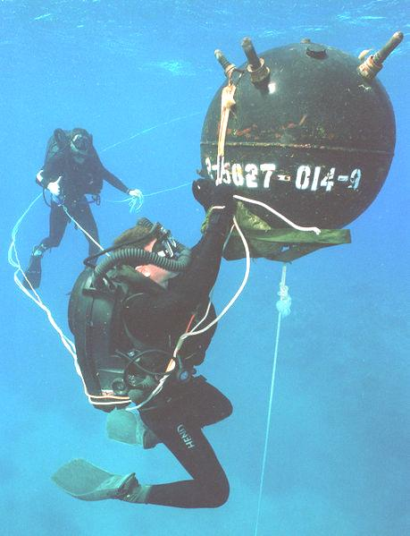
Figure 1: US Navy EOD divers
ROVs are already beginning to be integrated into fleets across the world as inspection vehicles providing additional data during searches [1]. This design portfolio aims to provide a logical evolution of the roll of ROVs in being able to provide additional capability by completing the entire find to fix process.

Systems engineering
Depending on your perspective, systems engineering can be considered a step-by-step process, a design philosophy, a world view, a set of guidelines, project management, risk assessment, a life cycle integration or a defined set of instructions [2]. A commonly accepted definition for all that systems engineering encompasses can be found in the EIA Standard IS-632, which describes it as:
“An interdisciplinary approach that encompasses the entire technical effort, and evolves into and verifies an integrated and life cycle balanced set of system people, products, and process solutions that satisfy customer needs.” [3]
Balance is a critical component of systems engineering, especially as complexity of designs increases. Each element of a design will have its own concept of a best design, as illustrated in Figure 2. The systems engineer needs to have a total view of the system, including internal relationships between sub-systems and the environmental context in which the design will be used.
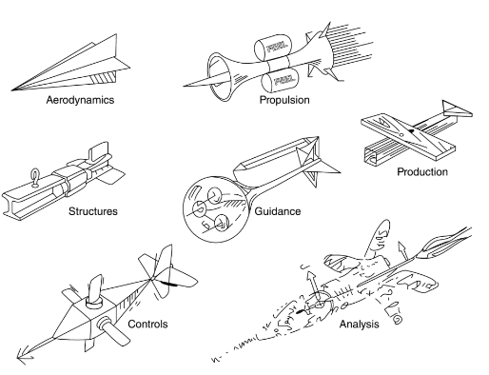
Figure 2: A guided missile from the perspective of various specialists [2]
At its core, systems engineering can be whittled down to several key tenets, which if successfully deployed should result in a successful development. These include (but are not necessarily resisted to:
- Defining the desired outcome from the beginning, and not straying from this goal
- Involving key stakeholders at all stages of design
- Define problem sets before assuming a solution
- Delaying specific technology choices
- Connecting requirements and design choices
- Testing early and often [4]

Benefits of systems engineering
Although the benefits to systems engineering are many, the most tangible benefit is the cost savings. The cost to implement changes to the design, as defined by either dollars or time, drastically increases as the system moves through its life cycle, as illustrated in Figure 3 [5]. By spending time to fully understand the requirements of the system, a systems engineering approach aims to front load the design work to reduce the likelihood of needing changes, limiting cost and delivering a system that meets the needs of the end user.
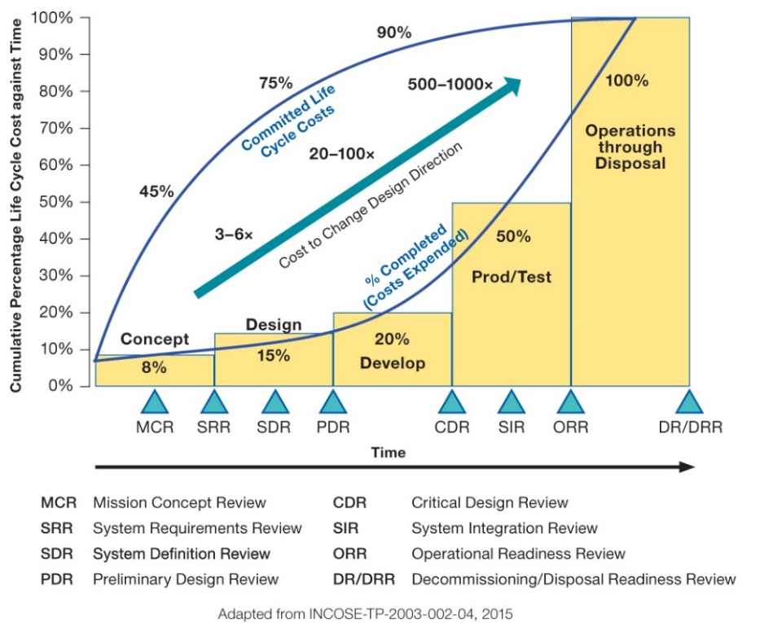
Figure 3: Life-Cycle cost impacts from early phase decision making. [5]
By delaying design choices until the problem to be overcome has been broken down into functions, system engineers avoid limiting their design to what already exists, or obvious choices that may not be the best option. This invites exploration of less ubiquitous options, rather than simply extrapolating from previous designs, and can lead to design breakthroughs or technological advances.
In following systems engineering techniques such as the V – model [6], the designer ensures that the delivered system stays true to initial requirements without the design losing itself with feature creep. It encourages constant checking in and referring to the earlier stages of the design process to make certain that the delivered system meets both the stated and non-stated desires of the customer.
Other benefits from using a systems engineering approach (specifically QFD models) include [7]:
- Development of better products at a price customers are willing to pay
- Customer satisfaction
- Reduced product lead times
- Better communication between teams
- Reductions in engineering changes
- Shorter design cycles
- Lower start-up costs
- Fewer warranty claims

Pre-Design

System Requirements
The brief to design an ROV to replace divers for underwater EOD operations presents a vast number of potential requirements. Given the broad range of activities that comprise a diver’s responsibilities, and the complex nature of ROV design, the first stage of the design process is to narrow the scope of the use-case to a few core fundamentals. These are requirements without which the system would not function. These were identified as:
- ROV must be able to move through the water
- ROV must be waterproof
- ROV must be able to manipulate object in the water
- ROV must be able to ‘see’ underwater
However, this list only represents an element of the actual requirements of the system, what would be described as ‘basic’ requirements in an importance-satisfaction (I-S) model [8]. The model can be seen in Table 1, which is an advancement on the Kano model [9]. What the model highlights is the existence of non-stated requirements, which if not met will result in either a failure in functionality or customer dissatisfaction.
Table 1: I-S model for system requirements
Customer Excitement | High | Expressed | Delight
Customer Excitement | High | Those requirements that are sufficiently important to be verbalised by the customer. | Those requirements that cannot be articulated because the customer does not know they want them, but if provided will surprise and delight.
Customer Excitement | Low | Basic | Assumed
Customer Excitement | Low | Those requirements that are so obvious to the type of system that the customer will not mention them. | Those requirements that while not basic, are taken for granted.
 |  | Low | High
 |  | Customer Satisfaction

To better understand the full breath of the requirements set (and to set the boundaries of what will and won’t be considered in this portfolio), a stakeholder influence map was produced, seen in Figure 4. This better defines those invested in the program and allows for more in-depth investigation into the non-stated requirements.
In terms of ROV functionality, the ROV operators would be considered the key stakeholder. As such, these requirements were more heavily weighted when considering which requirements to drop later in the process. To not become overloaded with requirements, the other stakeholders were largely ignored during this process, but key functional requirements such as safety and survival during transportation were still included.

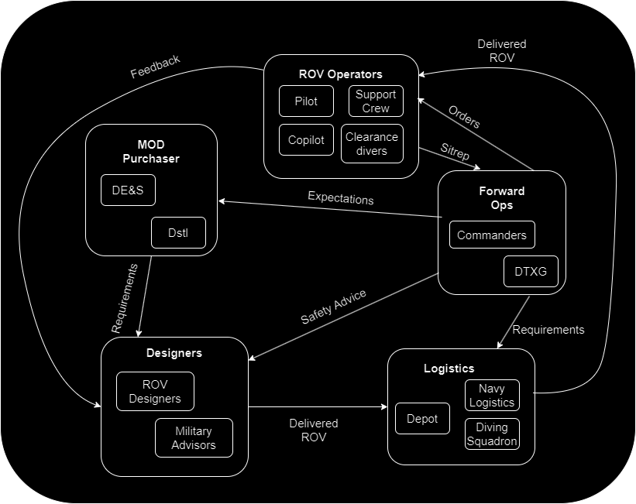
Figure 4: Stakeholder Influence Map
Given the importance of correctly identifying the requirements at the start of the design process [10], the next stage was to conduct a requirement gathering process, following the principles established in the holistic requirements model [11]. From this process, the initial identified requirements for the system were identified (Tabel 5, Appendix). These requirements were identified from research into clearance diver activities, EOD land use robots [12] and extrapolations from the current role of ROVs in the UK Navy, which should meet the expressed and delighted sections of the I-S model.
Even considering all the perspectives largely ignored, this list of 33 requirements presents a logistical challenge if they are to all be included in the QFD process (a table of 33 requirements for a pairwise comparison comprises of over 1000 cells). As such, a review of these requirements was conducted. This was done with the assistance of military advisors and ROV operators to refine the list down to 26, removing repeated requirements, combining similar requirements and taking out non-essentials. The refined list can be seen in Table 2.

Table 2: Refined requirements list
Stakeholder | Requirement
Operator | The operator requires the ROV be manoeuvrable (forward, vertically and laterally) in water in currents of TBC knots
Operator | The operator requires an operational range of at least 1km
Operator | The operator requires minimal latency between user input and ROV manoeuvres (TBC ms latency)
Operator | The operator requires the ROV be usable when out of eyesight
Operator | The operator requires a depth rating of TBC meters
Operator | The operator requires the ROV be capable of holding position when not in use
Operator | The operator requires the ROV be capable of interacting with items/equipment underwater
Operator | The operator requires the ROV have the capacity for the addition of future capability
Operator | The operator requires the ROV be operational in all ocean conditions (Temp, Salinity)
Crew | The crew requires the ROV be able to identify other objects/persons in the water
Crew | The crew requires the ROVs power supply remains isolated from the surrounding water
Crew | The crew requires a way to monitor ROV health/performance during underwater deployment
Crew | The crew requires a way to stop power flow to ROV for retrieval from water
Crew | The crew requires the ROV survive impacts typical to underwater deployments (TBC newtons)
Crew | The crew requires the ROV and control method be waterproof (IP ratings TBC)
Crew | The crew requires lift points on the ROV away from moving parts
MoD | The main customer requires the ROV be cost effective (target cost TBC)
MoD | The main customer requires a minimum development time (TBD)
MoD | The main customer requires the ROV to have a long service life (TBD)
MoD | The main customer requires the ROV to be interoperable with other underwater equipment
MoD | The crew requires the ROV be easily maintained
MoD | The crew requires the ROV be deployable by hand
MoD | The crew requires the ROV and supporting equipment be fully deployable from boat
MoD | The crew requires the ROV have easy training characteristics
Logistics | Logistics require the ROV and supporting equipment to survive vibrations associated with transport in UK military vehicles.
Logistics | Logistics require the ROV survive rough treatment while in storage/transportation (survive small drops/knocks)

Rationalised requirements
Once the list of requirements had been identified, the list had to be ranked in order of importance to correctly assign weight to each requirement. This activity ensures that the allocation of time and effort best matches the needs of the system.
This is done by conducting a pairwise comparison of requirements. This can be conceptualised as a square matrix as in Figure 5 [13], where $m_{ij}$ expresses the relative preference of requirement $R_{i}$ over requirement $R_{j}$.
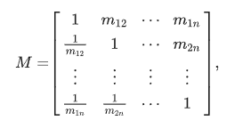
Figure 5: Pairwise comparison matrix.
Scores of 1 to 9 were assigned to each comparison depending on preference, and then normalised to produce the rationalised requirement importance. The values seen in Figure 6 are the relative importance of each requirement.
The requirement that was identified as the most important was the need to stop power flow to the ROV. Additional important requirements were: ROV manoeuvrability, the isolation of the power supply, and the ability to identify persons/objects in the water.
These most important requirements highlight the importance of safety in the design. Putting electronic components into water comes with inherent risk to both the system and other life in the water, so this requirement is naturally the most important.

Figure 6: Rationalised requirements for the ROV.

Functionality
Once the requirements were fully understood, the system as a whole could be investigated. This began with analysis of existing ROVs to build a system map, defining what is and isn’t the ROV for this design, seen in Figure 7. Relevant subsystems were identified as per the requirements. From there, the desired actions of the system can be broken down into action verb functions necessary to achieve the goals of the system. Defining the system this way ensures traceability between design solutions and the functions they achieve [14].
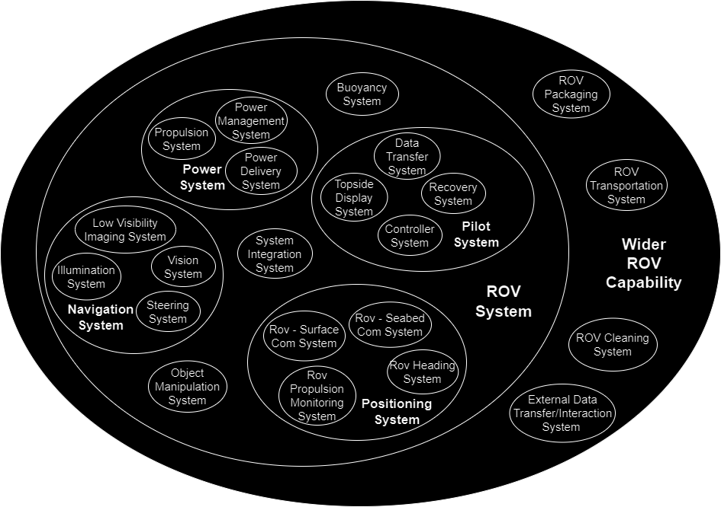
Figure 7: System Diagram for the ROV.

QFD 1
Taking the identified requirements and the basic functionality identified in Figure 7, a simple Quality Function Deployment (QFD) 1 can be produced. QFD 1 or the ‘House of Quality’ turns lists of customer requirements and engineering characteristics into a series of connections, highlighting where each ‘HOW’ meets a ‘WHAT’, outputting the most important elements of the functionality of the system [15].
Taking this system through that process, the resulting graph can be seen in Figure 8. Key functionality identified through the procedure were: provide electrical power, transmit data, display information, generate thrust, and acquire target. As such, these were given the most consideration in the design when moving forward.

Figure 8: QD1 functional importance

Design Concepts
With the key functionality identified, QFD 2 could be conducted. This process matches the functionality to the key parts of the system. To populate that table, the key parts of the system must first be identified.
To develop a generic parts list, a small literature review was conducted into existing ROV technology. This encompassed off the shelf options for achieving each function, and other means from other robotic fields, such as robotic surgery [16], autonomous merchant vessels [17] and land use EOD robots [18] [19] [20]. The means of achieving each function were identified and fed into a functional means analysis, as seen in Table 3.

Design choices
Function means analysis (sometimes referred to as a morphological matrix [21]) compares different means of achieving each function to build concepts. The means suggested cover existing options, advances in technology and slightly less realistic options to fully encapsulate a range of options. A few functions, such as regulate thrust or withstand hydrostatic pressure only have a few options, as there are fewer abstract means available. This is where the limitations of functional means analysis become apparent, as quality of the analysis is dependent on the ideas generated by those conducting the process [22]. The means highlighted green represent the options for the first concept, with the orange options acting as redundancies or backups.
Table 3: Functional Means Analysis

Concepts
Concept 1 (green highlights on Pugh Diagram): Fairly standard inspection class ROV with wired tether. Camera and sonar used for imaging. 3rd party manipulators for interacting with environment. Physical ‘Xbox’ style controller and a Topside console for processing and data evaluation. Pros – similar to current ROV systems. Cons – size limits max operational current conditions.
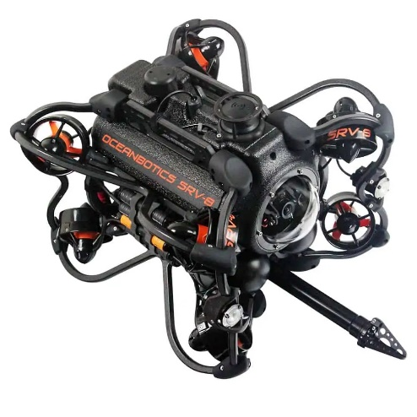
Figure 9: Example of Inspection class ROV described in concept 1 [23]
Concept 2: Larger inspection/work hybrid ROV. The larger body allows for azimuth thrusters, larger INS/navigational equipment, onboard batteries and processing. 3D sonar and expensive 4K cameras are used for imaging, with images being stored on the ROV hard drives to be recovered later. Acoustic links allow for tetherless communication to control the ROV. VR headset/haptic gloves for control of larger ‘arm’ manipulators. Pros – larger size allows for ‘better’ nav equipment and imaging tools, higher depth ratings. Cons – much heavier, higher maintenance, more expensive, longer deployment time
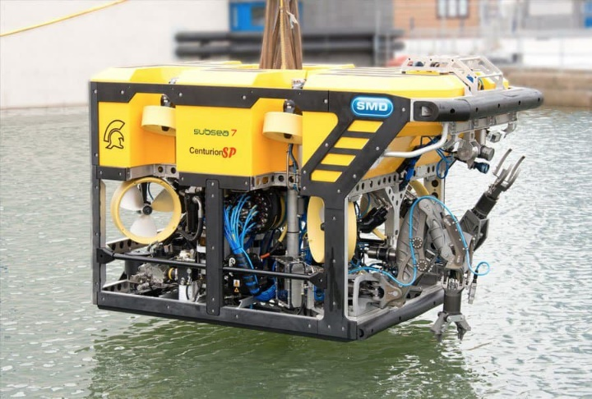
Figure 10: Example of an Inspection-Worl class Hybrid ROV as described in concept 2 [24]
Concept 3: Smaller micro class drone with thrust supplied by waterjet propulsion. Small jaw manipulators, micro cameras and sonar fit inside the small frame. Without larger nav options, Thrust is controlled manually from a phone app. Pros – much cheaper, quicker to develop, easily deployed, easily trained. Cons – reduced thrust capability, size reduces nav/imaging equipment, harder to interact with subsea objects.
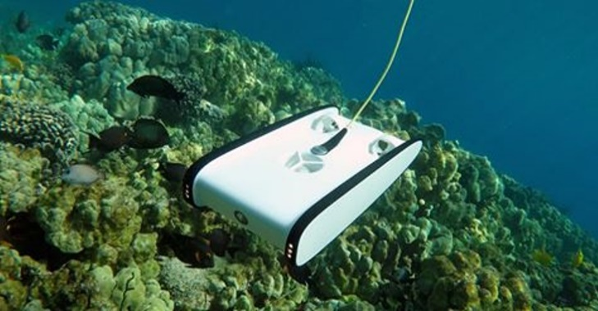
Figure 11: Micro-class ROV as described in concept 3 [25]
Concept 4: Sub-Sea crawler, using treads and thrusters to supplement movement. The treads hold position on seabed, with larger arm manipulators to interact with objects. Wireless communication to the ROV using an above water coms set attached to a float. Pros – operational at low depths/shore conditions, sits on bottom to hold position. Cons – Far less manoeuvrable, heavier, far less useful off the seabed.
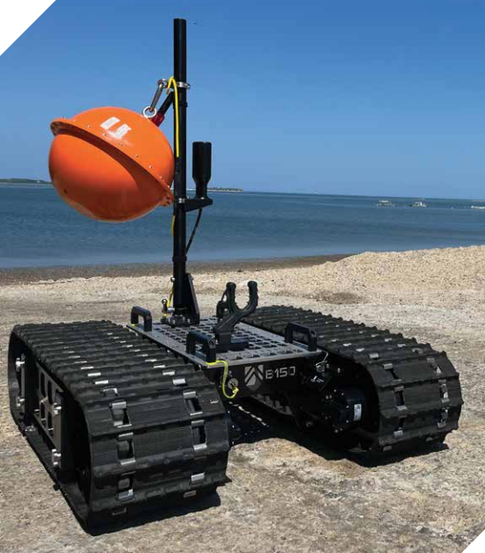
Figure 12: Sub-Sea Crawler ROV as described in concept 4 [26]

System Pugh Diagram
The system Pugh diagram is a comparison device used to choose between different concepts. Each requirement, or WHAT, has its own relative importance as defined by QFD1. Each concept is then judged as per its ability to achieve that requirement when compared to the existing solution, in this case a navy clearance diver. Negative values reflect the concept is worse than the diver, positive values reflect better performance than the diver, and the values reflect how much better or worse the concept is compared to the diver. A zero represents no preference to the diver.
Table 4 finds that the inspection class ROV is the preferred option, just slightly beating out the inspection-work class hybrid concept. The largest negative against that concept was its inability to meet the deployable by hand concept, as the weights of the larger systems often reach 50Kg and over.
Table 4: System Pugh Diagram
WHATs - Customer Requirements | Relative Importance Equal | A diver | Inspection-Work class ROV | Sub-Sea Crawler | Micro-class ROV | Inspection Class ROV
The operator requires the ROV be manoeuvrable (forward, vertically and laterally) in water in currents of TBC knots | 9.76 | 0 | 1 | -2 | -1 | 1
The operator requires an operational range of at least 1km | 5.74 | 0 | 2 | 1 | 0 | 1
The operator requires minimal latency between user input and ROV manoeuvres (TBC ms latency) | 2.18 | 0 | -1 | -1 | -2 | -1
The operator requires the ROV be usable when out of eyesight | 6.52 | 0 | 1 | 1 | 1 | 1
The operator requires a depth rating of TBC meters | 3.83 | 0 | 2 | 1 | -1 | 1
The operator requires the ROV be capable of holding position when not in use | 3.75 | 0 | 2 | 2 | -2 | 2
The operator requires the ROV be capable of interacting with items/equipment underwater | 4.89 | 0 | 0 | 0 | -2 | 0
The operator requires the ROV have the capacity for the addition of future capability | 1.81 | 0 | 2 | 1 | -2 | 1
The operator requires the ROV be operational in all ocean conditions (Temperature, Salinity) | 3.66 | 0 | 1 | 1 | -1 | 1
The crew requires the ROV be able to identify other objects/persons in the water | 9.05 | 0 | 1 | 1 | -1 | 1
The crew requires the ROVs power supply remains isolated from the surrounding water | 9.50 | 0 | 0 | 0 | 0 | 0
The crew requires a way to monitor ROV health/performance during underwater deployment | 3.62 | 0 | 1 | 1 | 1 | 1
The crew requires a way to stop power flow to ROV | 11.21 | 0 | 0 | 0 | 0 | 0
The crew requires the ROV survive impacts typical to underwater deployments (TBC newtons) | 3.46 | 0 | 2 | 1 | 1 | 1
The crew requires the ROV and control method be water proof (IP ratings TBC) | 3.63 | 0 | 0 | 0 | -1 | 0
The crew requires lift points on the ROV away from moving parts | 1.29 | 0 | 1 | 1 | 1 | 1
The main customer requires the ROV be cost effective (target cost TBC) | 0.99 | 0 | -3 | 1 | 2 | 1
The main customer requires a minimum development time (TBD) | 0.54 | 0 | -2 | 0 | 2 | 1
The main customer requires the ROV to have a long service life (TBD) | 1.54 | 0 | 1 | 0 | 0 | 0
The main customer requires the ROV to be interoperable with other underwater equipment | 2.61 | 0 | 2 | 1 | -2 | 1
The crew requires the ROV be easily maintained | 0.96 | 0 | -2 | -1 | 1 | 1
The crew requires the ROV be deployable by hand | 1.44 | 0 | -5 | -2 | 2 | 1
The crew requires the ROV and supporting equipment be fully deployable from boat | 1.82 | 0 | -5 | -1 | 2 | 1
The crew requires the ROV have easy training characteristics | 0.59 | 0 | -2 | 1 | 2 | 1
Logistics require the ROV and supporting equipment to survive vibrations associated with transport in UK military vehicles. | 4.14 | 0 | 1 | 1 | 1 | 1
Logistics require the ROV survive rough treatment while in storage/transportation (survive small drops/knocks) | 1.48 | 0 | 1 | 1 | 1 | 1
Ranking |  | 0 | 57.8 | 28.9 | -28.2 | 68.62

QFD 2
Next stage is to conduct QFD 2. It highlights feature importance to delegate development time, and to better understand the requirements of the system. Sometimes called the ‘Parts Deployment’, this table compares the ‘HOW’ from QFD 1 to the specific parts required to accomplish those tasks. Matching the parts to the functional requirements this way highlights the critical components of the system and can increase understanding of the system for those unfamiliar to the system, as it directly highlights which elements of the system achieve each function [27].

Figure 13: QFD 2 feature importance
Figure 13 shows the relative importance of each feature of the ROV. By far the most important feature is the control console. This makes logical sense, as it is the conduit through which all ROV control is passed. As such, this element of the design is where the most time should be invested to ensure the requirements are met.

System analysis – N²
The N² diagram, Figure 14, highlights the relationships between the subsystems [28]. The N² diagram is a matrix that represents an alternative perspective on a system flow diagram. It also highlights the external inputs and outputs.
A notable undesirable output identified in this process is the excess heat. Normally, this would be addressed by a cooling system, such as a fan or heat sink, but as this system will be operating underwater, the water should act as a coolant. This does mean that the system will only be able to function in limited bursts above water without overheating, this is likely to only happen during maintenance. This potential failure mode will be managed with control measures such as operating condition limits, and evaluated in the failure mode analysis section.
What is notable from the N² diagram is how few components feed into more than one part. The ROV acts similarly to a chain of dominoes, with power and data passing down the chain to the final component, then back the other way. A failure anywhere along this chain would result in a overall failure in the system, and so suggests this ROV design might be ‘frail’ or lacks the ability to continue when one part has a fault. In this way, the tether, power module, coms module and topside console could all be considered critical components.

Failure Analysis
Figure 14: N² Diagram for the ROV system
A dissection of the design’s failings, and how to mitigate against the various failure modes.

Failure mode and effects analysis
Originally pioneered in the aerospace sector in the 1960s [29], Failure mode and effects analysis (FMEA) is a methodology for identifying, evaluating and controlling potential failure points. To analyse the failure modes the potential occurrence (O), severity (S) and detection (D) are all numerically assessed (given a number between 1 and 10), then put through equation 1 to calculate the risk priority number (RPN) [30].
$$\begin{aligned}RPN=O ×S ×D \#\left(1\right)\end{aligned}$$
The higher the RPN of a potential failure, the greater the risk to the overall system. The potential failure modes can be ranked, and actions taken to fix the identified issues with more time/preference taken on those failure modes with the highest RPNs.
Of the 146 failure modes identified and evaluated in this process, the largest risk to the overall system was the input of incorrect navigational data, with an RPN of 224. While having a very low S, due to the nature of dead reckoning it is almost inevitable that GPS position will drift while underwater, producing a very high O. The only mitigation against this is user training to become aware of the issue, and to take corrective action (which may or may not be possible if missions require long stretches without surfacing or extra navigational equipment) and so the D is also quite large.

P diagrams
Taking the identified failure modes from the FMEA, a P-diagram can be assembled to understand how the noise sources are being controlled, which noise sources are the most concerning to the system, and which control methods solve the most issues. The diagram can be expanded to include unintended outputs and functional requirements, but in this case has been kept simple.
Arguably the P diagram covers the same ground as the FMEA, as both diagrams identify both the causes and controls for the various problems.
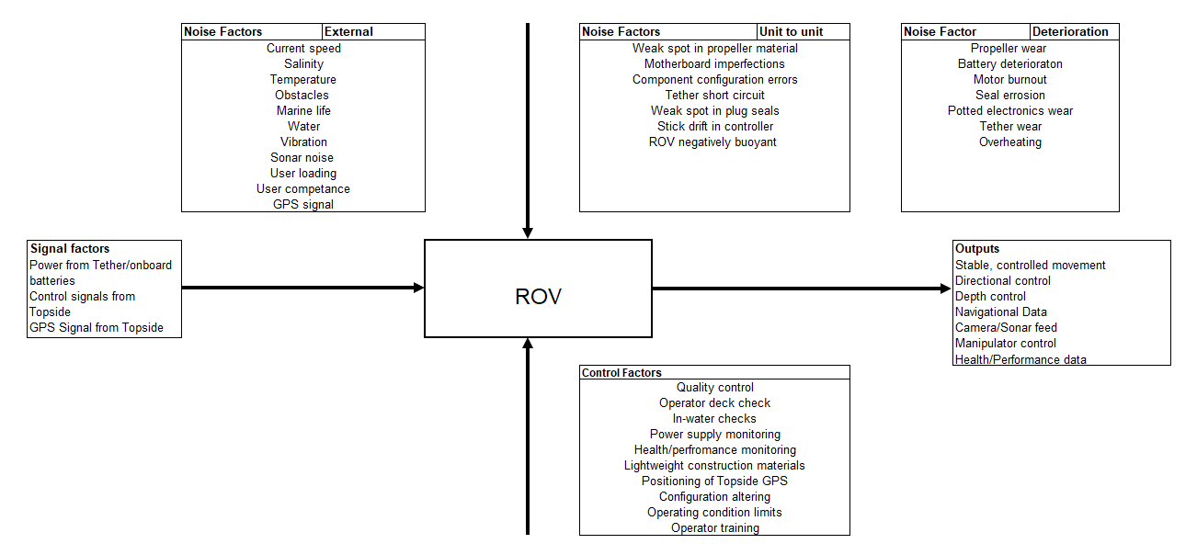
Figure 15: Parameter (P) diagram for the ROV
Taking the identified noise and control factors from Figure 15, a ‘WHAT-WHY’ table can be build (Table 9, Appendix). This compares each noise factor to the control factors and assigns values for the correlation between them. The output of this table is the relative importance of each control factor (Figure 16), and the importance of each noise factor (Figure 17). What these figures highlight is the vital role of health/performance monitoring and quality assurance in mitigating the noise factors prevalent in this system.

Figure 16: Relative control factor importance

Figure 17: Relative importance of noise factors

Manufacturing considerations
The processes the ROV design have been through thus far in this design document encompass only two of the four stages of a QFD, as seen in Figure 18 [7]. Stages 3 and 4 dive into process controls and production methods, two specialisms this report does not have the scope to address with any detail. As such, this section will only allude to the components of the design manufacturing would need to consider thoroughly.
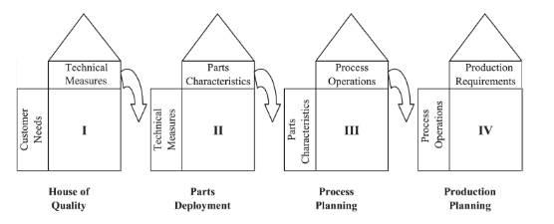
Figure 18: The four-phase model of QFD [7]
Based on the failure analysis for the ROV, a majority of the identified issues could be controlled through tight quality control, such as leaks into the potted electronics and material failure of the thrusters. For proper operational procedure, the buoyancy generated by the float block will need to be consistent, and so tight controls on the float block manufacturing will need needed. Obviously, any electronics on the ROV will need to be potted to avoid contact with water, but this will also need tight manufacturing control.

Reflection
While acknowledging the benefits to conducting a design in this methodology, it is equally important to discuss systems engineering’s limitations, namely that the processes described and conducted in this design document are only as good as the user. The vast majority of this paper was conducted solely by the author, and so the design choices and problem solutions are still coming from a single source, and so are limited by the knowledge of that individual. The functional means analysis and Pugh diagrams are also susceptible to user bias when prescribing numerical values of preference to solutions. As such, these activities would be more valuable as group activities.

QFD
Issues specific to QFD methodology [31]:
- The time required to fully complete QFD charts fully for complex system can be excessive. For this system an initial 33 requirements had to be reduced down to 26, as this made a pairwise comparison table of over 1000 cells (the full 26x26 pairwise comparison can be seen in Table 6, Appendix). This can lead to oversimplifying complex issues for the sake of progressing through the process.
- Customer requirements may be nebulous, especially when designing for numerous customers, or when designing for a market rather than a single customer. It can be difficult to categorize customer demands into specific requirements due to the ambiguous nature of some problem sets.
- It can be difficult to turn ambiguous customer requirements into technical properties
- QFD may not be appropriate for all applications, such as when acting as part of a supply chain, such as the automotive industry.
- QFD is a subjective process, with the assigned values for requirement preference and strength of correlation between requirement and functionality/parts being personal preference.
This is not to say that QFD is a bad process to follow, rather that using it blindly without critical analysis is not a 100% solution for a successful design. As mentioned in section 1, systems engineering is as much a philosophy as a prescriptive method, and so following the tenets of understanding requirements and communication throughout the design process should always improve on designs not including these elements.

FMEA
Based on current available literature, the standard FMEA conducted in this report would be considered rather primitive, with numerous literature reviews published on the identified downsides of this kind of simplistic model of risk assessment [30] [32] [33] [34] [35].
The largest issue surrounding this method is the equation itself, as it does not reflect the nuance of risk management. By only considering O, S & D, the RPN ignores other factors such as cost, quality and other environmental impacts.
The O, S & D values can be difficult to be precisely evaluated, especially at a concept phase without testing. These three factors are taken as equally important, and so a failure mode with a very high severity, low occurrence and moderate detectability (e.g. 9, 3 and 5, making an RPM of 135) may have a lower RPN than a failure mode with all moderate values (5, 6 and 6, making an RPN of 180), even though the higher severity risk requires more attention [30].
Even more fundamental is the RPN calculation, as there is little scientific rationale in calculating RPN as a product of O, S & D [36]. Different combinations of O, S & D can produce the same RPN, but with significantly different risk implications for the user. An RPN of 60 can be produced from 24 different combinations of O, S & D.
Lui at al. [30] gives 10 whole pages on identified issues with the current RPN system, and presents a selection of currently available alternatives, including multi-criteria decision making, mathematical programming, artificial intelligence, cost based models and integrated approaches.

Conclusion
This document summarises the work done to create a concept for an ROV capable to replace divers in EOD operations. While only reaching the concept evaluation phase, it highlights the systems engineering methodology which should be implemented when undergoing such a task. Following this process, this document has turned a set of customer requirements into a detailed concept with its own risk controls in place.
Critical analysis of this process discusses the necessity of evaluating this process rather than blindly following the steps without considering its limitations. Despite the mentioned shortcomings with conducting these processes alone, the proposed design demonstrably meets the requirements laid out at the start of this process.

References

[1] | VideoRay, “U.S. Navy EOD Case Study,” VideoRay LLC, Pottstown, 2014.
[2] | A. Kossiakoff, S. Biemer, S. Seymour and D. Flanigan, Systems Engineering Principles and Practice, John Wiley & sons, 2020.
[3] | EIA, “Process for Engineering a System,” Electronic Industries Alliance, Arlington, 1999.
[4] | C. Shamieh, Systems Engineering for Dummies, Indianapolis: John Wiley & Sons, 2012.
[5] | NASA, “Fundamentals of Systems Engineering,” NASA, 6 Feburary 2019. [Online]. Available: https://www.nasa.gov/reference/2-0-fundamentals-of-systems-engineering/. [Accessed 30 August 2024].
[6] | T. Weilkiens, J. Lamm, S. Roth and M. Walker, “Appendic B: The V-Model,” in Model-Based System Architecture, John Wiley & Sons, 2016, pp. 343-353.
[7] | L. Chan and M. Wu, “Quality function Deployment: A comprehensive Review of Its Concepts and Methods,” Quality Engineering, vol. 15, no. 1, pp. 23-35, 2002.
[8] | C. Yang, “Establishment and applications of the integrated model of service quality measurements,” Managing Service Quality, vol. 13, no. 4, pp. 310-324, 2003.
[9] | C. Yang, “The refined Kano's model and its application,” Total Quality Management & Business Excellence, vol. 16, no. 10, pp. 1127-1137, 2005.
[10] | International Council pn Systems Engineering, “SYSTEMS ENGINEERING HANDBOOK v.3,” INCOSE, 2006.
[11] | S. Burge, “Holistic Requirements Model (HRM),” 2006. [Online]. Available: https://www.burgehugheswalsh.co.uk/Uploaded/1/Documents/HRM-Tool-Box-V1.0.pdf. [Accessed 27 June 2024].
[12] | J. Mamani, P. Pari, D. Vilcapaza, E. Supo, E. Sulla and Y. Silva, “Compilation and Analysis of Requirements for the Design of an Explosive Ordnance Disposal Robot Prototype Applied in UDEX-Arequipa,” in Communications in Computer and information science vol 1420, 2021.
[13] | W. Koczkodaj and J. Szybowski, “Pairwise comparisons simplified,” Applied Mathematics and Computation, vol. 253, pp. 387-394, 2015.
[14] | Department of Defense Systems Management College, Systems Engineering Fundamentals, Fort Belvoir: Defense Aquisition University Press, 2011.
[15] | J. Hauser and D. Clausing, “Havard Business Review,” May 1998. [Online]. Available: https://hbr.org/1988/05/the-house-of-quality. [Accessed 23 June 2024].
[16] | M. Diana and J. Marescaux, “Robotic Surgery,” British Journal of Surgery, vol. 102, no. 2, pp. e15-e28, 2015.
[17] | K. Wrobel, M. Gil and C. Chae, “On the Influence of Human Factors on Safety of Remotely-Controlled Merchant Vessels,” Applied sciences, vol. 11, no. 3, 2020.
[18] | Z. Jiang, Y. Ma, X. Cao, M. Shen, C. Yin, H. Liu, J. Cui, Z. Sun, L. Huang and H. Li, “FC-EODR: Immersive Humanoid Dual-Arm Dexterous Explosive Ordnance Disposal Robot,” Biomimetics, vol. 8, no. 1, 2023.
[19] | Y. Vidal, E. Supo, M. Ccallata, J. Mamani, M. Betancur, B. Pino, P. Pari and E. Sulla, “Analysis and Evaluation of a EOD Robot Prototype,” in IEEE International IOT, Electronics and Mechatronics Conference, Toronto, 2022.
[20] | F. Yang, P. Zhang, Y. Luan, W. Jiao and F. Li, “Design of EOD Robot Based on Hybrid Control of Brain Wave and Remote Network,” in International Conference on Computer Network, Elctronic and Automation, Xi'an, 2022.
[21] | G. Pahl, W. Beitz, J. Feldhusen and K. Grote, Engineering Design: A Systematic Approach, London: Springer, 2007.
[22] | S. Burge, “Functional Means Analysis (FMA),” 2006. [Online]. Available: https://www.burgehugheswalsh.co.uk/Uploaded/1/Documents/FMA-Tool-v1-1.pdf. [Accessed 13 August 2024].
[23] | Oceanbotics, “SRV-8,” Oceanbotics, 2024. [Online]. Available: https://oceanbotics.com/srv-8/#specs-8. [Accessed 2 September 2024].
[24] | Subsea 7, “Remotely Operated Vehicles (ROVs),” Subsea 7, 2024. [Online]. Available: https://irm.subsea7.com/capabilities/assets/rovs. [Accessed 31 August 2024].
[25] | International Institute of Marine Surverying, “Micro ROVs enablers for Marine Surveyors,” International Institute of Marine Surverying, 1 November 2019. [Online]. Available: https://www.iims.org.uk/micro-rovs-enablers-for-marine-surveyors/. [Accessed 2 September 2024].
[26] | Greensea IQ, “Bayonet Surf Zone Robotics,” Greensea IQ, 2024. [Online]. Available: https://greenseaiq.com/products/integrated-systems/bayonet-surf-zone-robotics/. [Accessed 2 September 2024].
[27] | E. Jaiswal, “A Case Study on Quality Function Deployment,” IOSR Journal of Mechanical and Civil Engineering, vol. 3, no. 6, pp. 27-35, 2012.
[28] | S. Burge, “N2 Analysis,” 2011. [Online]. Available: https://www.burgehugheswalsh.co.uk/Uploaded/1/Documents/N2-Analysis-Tool-Draft.pdf. [Accessed 13 August 2024].
[29] | J. Bowles and E. Pelaez, “Fuzzy logic prioritization of failures in a system failure mode, effects, and criticality analysis,” Reliability Engineering and System Safety, vol. 50, pp. 203-213, 1995.
[30] | H. Liu, l. Liu and N. Liu, “Risk evaluation approaches in failure mode and effect analysis: A literature review,” Expert Systems with Applications, vol. 40, no. 2, pp. 828-838, 2013.
[31] | C. Adiano and A. Roth, “Beyond the House of Quality: Dynamic QFD,” Bencemarking: An International Journal, vol. 1, no. 1, pp. 25-37, 1994.
[32] | K. Chang, “Evaluate the orderings of risk for failure problems using a more general RPN methodology,” Microelectronics Reliability, vol. 49, pp. 1586-1596, 2009.
[33] | K. Sharma and S. Srivastava, “Failure Mode and Effect Analysis (FMEA) Implementation: A literature Review,” Journal of Advance Research in Aeronautics and Space Science, vol. 5, no. 1, pp. 1-17, 2018.
[34] | N. Shebl, B. Franklin and N. Barber, “Failure mode and effects analysis outputs: are they valid?,” BMC Health Services Research, vol. 12, p. 150, 2012.
[35] | N. Shebl, B. Franklin and N. Barber, “Is Failure Mode and Effect Analysis Reliable?,” Journal of Patient Safety, vol. 5, no. 2, pp. 86-94, 2009.
[36] | K. Chin, Y. Wang, G. Poon and J. Yang, “Failure mode and effects analysis by data envelopment analysis,” Decision Support Systems, vol. 48, pp. 246-256, 2009.

Appendix

Requirements
Table 5: Initial requirements list and revisions
Requirements | Changes
The operator requires the ROV be manoeuvrable (forward, vertically and laterally) in water in currents of TBC knots
The operator requires an operational range of at least 1km
The operator requires minimal latency between user input and ROV manoeuvres (TBC ms latency)
The operator requires the ROV be usable when out of eyesight
The operator requires a depth rating of TBC meters
The operator requires the ROV be capable of holding position when not in use
The operator requires the ROV be capable of interacting with items/equipment underwater
The operator requires the ROV have the capacity for the addition of future capability
The operator requires the ROV be capable of identifying targets underwater | Repeated requirement
The operator requires the ROV be operational in all ocean conditions (Temperature, Salinity)
The operator requires the ROV be operational in salt and fresh water | Combined with temp to make 1 requirement
The crew requires the ROV be able to identify other objects/persons in the water
The crew requires the ROVs power supply remains isolated from the surrounding water
The crew requires a way to monitor ROV power supply for leaks/faults | Combined with health/performance
The crew requires a way to monitor ROV health/performance during underwater deployment
The crew requires a way to stop power flow to ROV
The crew requires the ROV survive impacts typical to underwater deployments (TBC newtons)
The crew requires the ROV and control method be water proof (IP ratings TBC)
The crew requires lift points on the ROV away from moving parts
The main customer requires the ROV be cost effective (target cost TBC)
The main customer requires a minimum development time (TBD)
The main customer requires the ROV to have a long service life (TBD)
The main customer requires the ROV to be interoperable with other underwater equipment
The main customer requires support package to be cost effective (TBD) | Repeated requirement
The crew requires the ROV be at most a two-person lift (approx. 33kg) | Repeated requirement, better expressed by other req.
The crew requires the ROV be easily maintained
The crew requires the ROV be deployable by hand (approx. 33kg)
The crew requires the ROV and supporting equipment be fully deployable from boat
The crew requires the ROV set-up be easily learnt | Repeated requirement
The crew requires the ROV have easy training characteristics
Logistics require the ROV and supporting equipment to survive vibrations associated with transport in UK military vehicles.
Logistics require the ROV be stored in packaging capable of being stacked | Not needed
Logistics require the ROV survive rough treatment while in storage/transportation (survive small drops/knocks)

Pairwise comparison
Table 6: Pairwise comparison Table
Pairwise comparison of requirements | The operator requires the ROV be manoeuvrable (forward, vertically and laterally) in water in currents of TBC knots | The operator requires an operational range of at least 1km | The operator requires minimal latency between user input and ROV manoeuvres (TBC ms latency) | The operator requires the ROV be usable when out of eye-sight | The operator requires a depth rating of TBC meters | The operator requires the ROV be capable of holding position when not in use | The operator requires the ROV be capable of interacting with items/equipment underwater | The operator requires the ROV have the capacity for the addition of future capability | The operator requires the ROV be operational in all ocean conditions (Temperature & Salinity) | The crew requires the ROV be able to identify other objects/persons in the water | The crew requires the ROVs power supply remains isolated from the surrounding water | The crew requires a way to monitor ROV health/performance during underwater deployment | The crew requires a way to stop power flow to ROV | The crew requires the ROV survive impacts typical to underwater deployments (TBC newtons) | The crew requires the ROV and control method be water proof (IP ratings TBC) | The crew requires lift points on the ROV away from moving parts | The main customer requires the ROV be cost effective (target cost TBC) | The main customer requires a minimum development time (TBD) | The main customer requires the ROV to have a long service life (TBD) | The main customer requires the ROV to be interoperable with other underwater equipment | The crew requires the ROV be easily maintained | The crew requires the ROV be deployable by hand | The crew requires the ROV and supporting equipment be fully deployable from boat | The crew requires the ROV have easy training characteristics | Logistics require the ROV and supporting equipment to survive vibrations associated with transport in UK military vehicles. | Logistics require the ROV survive rough treatment while in storage/transportation (survive small drops/knocks) | Row Product | nth root of row product | Total Normalised
The operator requires the ROV be manoeuvrable (forward, vertically and laterally) in water in currents of TBC knots | 1 | 2 | 5 | 1 | 5 | 2 | 5 | 9 | 5 | 1 | 1 | 2 | 2 | 2 | 2 | 9 | 5 | 9 | 5 | 5 | 9 | 5 | 5 | 9 | 2 | 9 | 1.3286E+14 | 3.49 | 9.76
The operator requires an operational range of at least 1km | 0.5 | 1 | 2 | 1 | 1 | 2 | 1 | 2 | 1 | 0.5 | 1 | 2 | 1 | 2 | 1 | 9 | 5 | 9 | 5 | 2 | 9 | 5 | 2 | 9 | 1 | 5 | 131220000 | 2.05 | 5.74
The operator requires minimal latency between user input and ROV manoeuvres (TBC ms latency) | 0.2 | 0.5 | 1 | 0.2 | 0.2 | 0.5 | 0.5 | 1 | 0.5 | 0.2 | 0.11 | 0.5 | 0.11 | 0.5 | 0.11 | 2 | 5 | 9 | 2 | 1 | 5 | 5 | 2 | 5 | 0.5 | 2 | 0.001497375 | 0.78 | 2.18
The operator requires the ROV be usable when out of eye-sight | 1 | 1 | 5 | 1 | 2 | 2 | 1 | 5 | 1 | 1 | 1 | 2 | 1 | 2 | 1 | 5 | 5 | 9 | 5 | 2 | 9 | 5 | 2 | 9 | 1 | 5 | 3645000000 | 2.33 | 6.52
The operator requires a depth rating of TBC meters | 0.2 | 1 | 5 | 0.5 | 1 | 0.5 | 0.2 | 1 | 1 | 0.2 | 0.2 | 1 | 0.2 | 1 | 1 | 5 | 5 | 9 | 5 | 2 | 9 | 5 | 2 | 9 | 1 | 5 | 3645 | 1.37 | 3.83
The operator requires the ROV be capable of holding position when not in use | 0.5 | 0.5 | 2 | 0.5 | 2 | 1 | 0.5 | 1 | 1 | 0.2 | 0.2 | 1 | 0.2 | 1 | 0.5 | 2 | 5 | 9 | 5 | 2 | 5 | 5 | 2 | 9 | 1 | 5 | 2025 | 1.34 | 3.75
The operator requires the ROV be capable of interacting with items/equipment underwater | 0.2 | 1 | 2 | 1 | 5 | 2 | 1 | 5 | 1 | 0.5 | 0.2 | 1 | 0.5 | 1 | 1 | 5 | 5 | 9 | 2 | 2 | 5 | 5 | 2 | 9 | 1 | 5 | 2025000 | 1.75 | 4.89
The operator requires the ROV have the capacity for the addition of future capability | 0.11 | 0.5 | 1 | 0.2 | 1 | 1 | 0.2 | 1 | 0.5 | 0.11 | 0.5 | 0.5 | 0.11 | 0.5 | 0.2 | 1 | 2 | 5 | 1 | 1 | 2 | 2 | 1 | 5 | 0.2 | 1 | 0.00001331 | 0.65 | 1.81
The operator requires the ROV be operational in all ocean conditions (Temp, Salinity) | 0.2 | 1 | 2 | 1 | 1 | 1 | 1 | 2 | 1 | 0.2 | 0.2 | 1 | 0.2 | 1 | 1 | 2 | 5 | 5 | 5 | 2 | 5 | 2 | 2 | 9 | 1 | 2 | 1152 | 1.31 | 3.66
The crew requires the ROV be able to identify other objects/persons in the water | 1 | 2 | 5 | 1 | 5 | 5 | 2 | 9 | 5 | 1 | 0.5 | 2 | 1 | 2 | 2 | 5 | 5 | 9 | 5 | 5 | 9 | 5 | 5 | 9 | 2 | 9 | 1.84528E+13 | 3.24 | 9.05
The crew requires the ROVs power supply remains isolated from the surrounding water | 1 | 1 | 9 | 1 | 5 | 5 | 5 | 2 | 5 | 2 | 1 | 2 | 1 | 2 | 2 | 9 | 5 | 9 | 5 | 5 | 9 | 5 | 5 | 9 | 2 | 9 | 6.64301E+13 | 3.4 | 9.5
The crew requires a way to monitor ROV health/performance during underwater deployment | 0.5 | 0.5 | 2 | 0.5 | 1 | 1 | 1 | 2 | 1 | 0.5 | 0.5 | 1 | 0.2 | 1 | 1 | 2 | 2 | 5 | 2 | 1 | 5 | 2 | 1 | 9 | 1 | 9 | 810 | 1.29 | 3.62
The crew requires a way to stop power flow to ROV | 0.5 | 1 | 9 | 1 | 5 | 5 | 2 | 9 | 5 | 1 | 1 | 5 | 1 | 2 | 5 | 9 | 5 | 9 | 9 | 9 | 9 | 9 | 9 | 9 | 5 | 9 | 4.90329E+15 | 4.01 | 11.2
The crew requires the ROV survive impacts typical to underwater deployments (TBC newtons) | 0.5 | 0.5 | 2 | 0.5 | 1 | 1 | 1 | 2 | 1 | 0.5 | 0.5 | 1 | 0.5 | 1 | 1 | 2 | 2 | 5 | 2 | 2 | 2 | 1 | 1 | 5 | 1 | 5 | 250 | 1.24 | 3.46
The crew requires the ROV and control method be water proof (IP ratings TBC) | 0.5 | 1 | 9 | 1 | 1 | 2 | 1 | 5 | 1 | 0.5 | 0.5 | 1 | 0.2 | 1 | 1 | 2 | 2 | 2 | 1 | 1 | 1 | 1 | 2 | 5 | 1 | 5 | 900 | 1.3 | 3.63
The crew requires lift points on the ROV away from moving parts | 0.11 | 0.11 | 0.5 | 0.2 | 0.2 | 0.5 | 0.2 | 1 | 0.5 | 0.2 | 0.11 | 0.5 | 0.11 | 0.5 | 0.5 | 1 | 1 | 2 | 0.5 | 0.5 | 1 | 1 | 1 | 5 | 0.2 | 1 | 1.83013E-09 | 0.46 | 1.29
The main customer requires the ROV be cost effective (target cost TBC) | 0.2 | 0.2 | 0.2 | 0.2 | 0.2 | 0.2 | 0.2 | 0.5 | 0.2 | 0.2 | 0.2 | 0.5 | 0.2 | 0.5 | 0.5 | 1 | 1 | 5 | 1 | 0.5 | 0 | 0.5 | 0.5 | 0.5 | 0.11 | 0.2 | 1.76E-12 | 0.35 | 0.99
The main customer requires a minimum development time (TBD) | 0.11 | 0.11 | 0.11 | 0.11 | 0.1 | 0.11 | 0.11 | 0.2 | 0.2 | 0.11 | 0.11 | 0.2 | 0.11 | 0.2 | 0.5 | 1 | 0.2 | 1 | 0.2 | 0.2 | 0 | 0.2 | 0.5 | 0.5 | 0.2 | 0.2 | 3.31999E-19 | 0.19 | 0.54
The main customer requires the ROV to have a long service life (TBD) | 0.2 | 0.2 | 0.5 | 0.2 | 0.2 | 0.2 | 0.5 | 1 | 0.2 | 0.2 | 0.2 | 0.5 | 0.11 | 0.5 | 1 | 2 | 1 | 5 | 1 | 1 | 5 | 1 | 0.5 | 2 | 0.2 | 1 | 0.000000176 | 0.55 | 1.54
The main customer requires the ROV to be interoperable with other underwater equipment | 0.2 | 0.5 | 1 | 0.5 | 0.5 | 0.5 | 0.5 | 1 | 0.5 | 0.2 | 0.2 | 1 | 0.11 | 0.5 | 1 | 2 | 2 | 5 | 1 | 1 | 5 | 5 | 5 | 5 | 1 | 2 | 0.171875 | 0.93 | 2.61
The crew requires the ROV be easily maintained | 0.11 | 0.11 | 0.2 | 0.11 | 0.1 | 0.2 | 0.2 | 0.5 | 0.2 | 0.11 | 0.11 | 0.2 | 0.11 | 0.5 | 1 | 1 | 5 | 5 | 0.2 | 0.2 | 1 | 0.5 | 0.5 | 2 | 0.2 | 0.5 | 7.79487E-13 | 0.34 | 0.96
The crew requires the ROV be deployable by hand | 0.2 | 0.2 | 0.2 | 0.2 | 0.2 | 0.2 | 0.2 | 0.5 | 0.5 | 0.2 | 0.2 | 0.5 | 0.11 | 1 | 1 | 1 | 2 | 5 | 1 | 0.2 | 2 | 1 | 1 | 5 | 0.5 | 0.5 | 3.52E-08 | 0.52 | 1.44
The crew requires the ROV and supporting equipment be fully deployable from boat | 0.2 | 0.5 | 0.5 | 0.5 | 0.5 | 0.5 | 0.5 | 1 | 0.5 | 0.2 | 0.2 | 1 | 0.11 | 1 | 0.5 | 1 | 2 | 2 | 2 | 0.2 | 2 | 1 | 1 | 5 | 0.5 | 0.5 | 0.00001375 | 0.65 | 1.82
The crew requires the ROV have easy training characteristics | 0.11 | 0.11 | 0.2 | 0.11 | 0.1 | 0.11 | 0.11 | 0.2 | 0.11 | 0.11 | 0.11 | 0.11 | 0.11 | 0.2 | 0.2 | 0 | 2 | 2 | 0.5 | 0.2 | 1 | 0.2 | 0.2 | 1 | 0.2 | 0.2 | 2.92159E-18 | 0.21 | 0.59
Logistics require the ROV and supporting equipment to survive vibrations associated with transport in UK military vehicles. | 0.5 | 1 | 2 | 1 | 1 | 1 | 1 | 5 | 1 | 0.5 | 0.5 | 1 | 0.2 | 1 | 1 | 5 | 9 | 5 | 5 | 1 | 5 | 2 | 2 | 5 | 1 | 1 | 28125 | 1.48 | 4.14
Logistics require the ROV survive rough treatment while in storage/transportation (survive small drops/knocks) | 0.11 | 0.2 | 0.5 | 0.2 | 0.2 | 0.2 | 0.2 | 1 | 0.5 | 0.11 | 0.11 | 0.11 | 0.11 | 0.2 | 0.2 | 1 | 5 | 5 | 1 | 0.5 | 2 | 2 | 5 | 5 | 1 | 1 | 6.44204E-08 | 0.53 | 1.48

QFD 1:
Table 7: QFD 1
How | Importance | Generate Thrust | Hold Position | Generate Navigational Data | Acquire Target | Prevent Water Ingress | Manipulate Objects | Transmit Data | Provide Buoyancy | Provide Electrical power | Regulate thrust | Display Information | Translate User Input to ROV Control | Regulate Power Supply | Withstand Hydrostatic Pressure
Requirements
The operator requires the ROV be manoeuvrable (forward, vertically and laterally) in water in currents of TBC knots | 9.76 | 9 | 9 | 1 |  |  |  | 9 | 9 | 9 | 9 | 1 | 1 |  | 1
The operator requires an operational range of at least 1km | 5.74 | 3 | 3 | 3 |  | 1 |  | 9 | 1 | 3 |  |  |  | 1 | 1
The operator requires minimal latency between user input and ROV manoeuvres (TBC ms latency) | 2.18 | 1 |  | 9 | 1 | 3 | 9 | 9 |  | 3 | 3 | 3 | 9
The operator requires the ROV be usable when out of eyesight | 6.52 | 1 | 1 | 9 | 9 |  |  | 9 |  |  |  | 9
The operator requires a depth rating of TBC meters | 3.83 | 3 | 3 | 3 |  | 9 |  |  | 9 |  |  |  |  |  | 9
The operator requires the ROV be capable of holding position when not in use | 3.75 | 9 | 9 | 9 |  |  |  | 3 | 9 | 3 | 9
The operator requires the ROV be capable of interacting with items/equipment underwater | 4.89 | 9 | 9 |  | 9 | 1 | 9 | 3 | 1 | 3 | 3 | 1 | 9
The operator requires the ROV have the capacity for the addition of future capability | 1.81 | 1 |  |  | 3 | 1 | 9 | 9 | 3 | 3 |  | 3 | 3 | 1
The operator requires the ROV be operational in all ocean conditions (Temperature, Salinity) | 3.66 | 9 | 9 |  | 9 | 3 | 1 |  | 9 | 1 |  |  |  |  | 3
The crew requires the ROV be able to identify other objects/persons in the water | 9.05 |  |  |  | 9 |  |  | 1 |  | 1 |  | 9
The crew requires the ROVs power supply remains isolated from the surrounding water | 9.50 |  |  |  |  | 9 |  |  |  | 9 |  |  |  | 9 | 3
The crew requires a way to monitor ROV health/performance during underwater deployment | 3.62 |  |  |  |  |  |  | 3 |  | 1 | 1 | 9 |  | 3
The crew requires a way to stop power flow to ROV | 11.21 |  |  |  |  |  |  |  |  | 9 |  | 1 |  | 9
The crew requires the ROV survive impacts typical to underwater deployments (TBC newtons) | 3.46 | 1 |  | 1 | 1 | 9 | 1 |  |  |  |  |  |  | 1 | 1
The crew requires the ROV and control method be water proof (IP ratings TBC) | 3.63 |  |  |  |  | 9 |  | 3 |  | 3 |  | 9 | 3 | 1 | 9
The crew requires lift points on the ROV away from moving parts | 1.29
The main customer requires the ROV be cost effective (target cost TBC) | 0.99
The main customer requires a minimum development time (TBD) | 0.54
The main customer requires the ROV to have a long service life (TBD) | 1.54
The main customer requires the ROV to be interoperable with other underwater equipment | 2.61 | 1 | 1 | 3 | 3 |  | 9 | 9 | 1 | 3 |  | 9 | 3 | 1
The crew requires the ROV be easily maintained | 0.96 | 1 |  | 1 | 1 | 3 | 1 | 1 |  | 3 |  | 1
The crew requires the ROV be deployable by hand | 1.44 | 1 |  | 1 | 1 |  | 1 | 1 | 1 | 3
The crew requires the ROV and supporting equipment be fully deployable from boat | 1.82 | 1 |  | 1 | 1 |  | 1 | 1 | 1 | 3 |  | 3 | 3
The crew requires the ROV have easy training characteristics | 0.59 | 3 |  | 3 | 3 | 1 | 3 | 3 |  | 1 | 1 | 1 | 3
Logistics require the ROV and supporting equipment to survive vibrations associated with transport in UK military vehicles. | 4.14
Logistics require the ROV survive rough treatment while in storage/transportation (survive small drops/knocks) | 1.48
 |  | 250 | 236 | 168 | 242 | 217 | 116 | 320 | 211 | 378 | 147 | 274 | 105 | 215 | 126

QFD 2
Table 8: QFD 2 Table

P diagram WHAT-WHY
Table 9: Control-Noise Table

