COMMUNITY ENGAGEMENT
A CASE STUDY OF TESCO PLC

GRATIAN BLAGA
STUDENT ID: 1921600
LCBB4002
UWTSD
Table of Contents
Introduction 3
Analysis of the organization 3
Stakeholders engagement 3
Different eras of the organization 4
Use of social media platforms by TESCO PLC 6
Training and development need to deal with Socio-Cultural issue 7
Reasons for giving training on multiculturalism issue 8
Conclusion 8
Recommendations 9
Reference List 10

Introduction
Community engagement is really important for businesses. Business is not only for making a profit, hence it should provide some advantages to the community. It is the responsibility of any organization to stay connected always with the people of the community. The size of the business decides the range of community engagement. Community engagement has different importance and one of the major advantages is, it helps to find out the market requirements, it helps get feedback from its stakeholder, this also helps to create brand awareness in a larger area. All these help an organization to get a competitive advantage in their industry. Nowadays, social media has been used to keep community engagement (Peerooet al., 2015). This report is focused on the biggest retailer in the UK, TESCO PLC. The report will provide some detailed analysis on how Tesco manages its community engagement. There will be some discussion on how the company engages with its stakeholders. Moreover, the report will also present some discussion on the use of social media for community engagement by the organization. Apart from this, there will be another discussion on the required skills knowledge for the employees of the organization. There is another issue that affects community engagement that is the multiculturalism issue, the report will identify those issues in detail and provide recommendations according to that. Finally, the report will end with some useful recommendations which help the organization to get a competitive advantage in the market.

Analysis of the organization
In this section, there will be some detailed discussion on the stakeholder's analysis, different eras of the organization, skills, and knowledge required to be an employee of Tesco PLC, the issue on multiculturalism, and required training to deal with the socio-culture issue.

Stakeholders engagement
Tesco PLC is the biggest grocery supermarket in the United Kingdom. They have done a lot of things to stay connected with their stakeholders all the time. They have several stakeholders such as shareholders, suppliers, customers, and wider society. However, they have considered that customers are their most important stakeholders and they do a lot of things to provide world-class customer satisfaction. They have introduced many technologies to minimize the efforts and minimize the shopping experience. They think that engaging with their stakeholders all over the world is helping them to understand their evolving priorities. The organization does customer research each year to know the customer's requirements, to understand what they thought so the organization can change their services according to their customer needs. The organization is also thinking of its colleagues. They give a lot of priorities to their colleges, they have different levels of college panels from the local level to the global level. The organization takes feedback continuously from its employees and tries to provide the best service in terms of salary, incentives, insurance, and other facilities. Suppliers are their potential stakeholders, the organization maintains an open conversation with their supplier and commits to building trust for partnership. This helps to grow them and Tesco never does cheating with any one of their suppliers. Tesco organizes a supplier survey each year where they take feedback from their employees about their experience on working with Tesco and also they have organized a separate conference with their supplier for sharing best practices to keep fresh the supply chain. The organization is also careful towards its shareholders and analysts. They maintain a continuous open conversation with their shareholders by meeting and they respond quickly to their issues. In annual meetings, all the shareholders have the chance to ask questions to resolve their queries.
Tesco PLC is the biggest supermarket chain in England, at present, the company has more than 460,000 employees all over their world which includes all of its internal stakeholders and almost 20 million customers globally. Therefore, it is not easy to maintain a positive relationship with all stakeholders but Tesco can do that (Xu and Saxton,2019). Social media platforms are the best option in today's world to stay connected with all their employees, shareholders, suppliers, and customers. They have a strong presence on Facebook, the biggest social media platform where Tesco has more than 1.1 million page likes (Peeroo,2019). Apart from this, they use Instagram, Twitter to share information regarding their stores or events. Also, they are using the YouTube platform to keep engaging with their stakeholders especially with their customers, the majority of stakeholders.

Different eras of the organization
The journey of Tesco is not small, rather they just completed their 100th anniversary in 2019. In 1919, when the first World War was just finished, Jack Cohen started a grocery stall. He wanted to reach more people to provide food at an affordable price and at that time, Cohen had only £1 of profit per day. Then in 1924, the brand was named by Tesco and their first own-brand product was Tesco tea (Stanton,2018). Then in 1929, Cohen opened their first shop in North London.
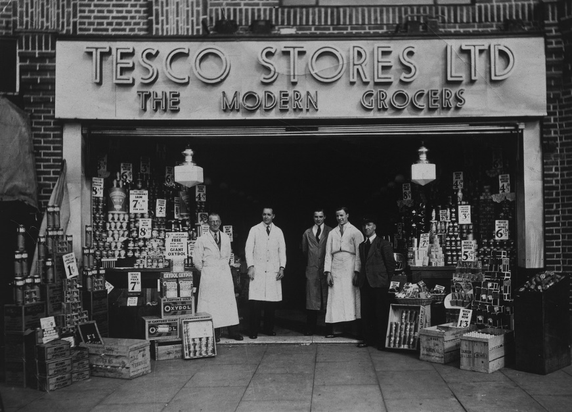
Figure 1: Old Tesco Shop
(Source: tesco.com,2021)
In 1934, the company decided to open its own headquarter and food warehouse. This was the first food warehouse in the UK. Then in the time of World War 2, Cohen gives ration to the poor people. In 1946, another interesting thing happened. Tesco PLC, for the first in the country supermarket, enrolled itself in the British stock exchange with a share price of 25 pence. Then in 1958, Tesco opened their first supermarket in London. Then they have more than 500 stores in the country. Then a huge revolution was done in the late 1970s, in 1978 they introduced to check out service which was beyond the thought of its competitors at that time. They started to provide huge discounts on a lot of products (Godley and Hamilton,2020). Then in 1995, two major things happened. Tesco started to expand their business on an international level for the first time, they started to enter the middle European market. In the same year, they launched their most popular item, the Tesco club card. 5 million cards had been distributed in just one year by them. In the early 2000s, they started digitization. In 2000, they launched their website Tesco. Com for the first time, then they keep on launching different technologies to provide a great customer experience and make the task organized and simpler for their employees.
There are some common skills and knowledge required to be an employee of the Tesco organization. One of the most important skills is communication skills. Excellent communication skills are required to understand the customer's queries, their needs. Apart from this, a huge team working spirit is also required (Erickson et al., 2018). Almost 450,000 employees are working in different locations of the world for Tesco but both of them have strong team working skills as this is a job of customer satisfaction. Employees need to convince and satisfy their customers in any way, for that they cannot do things one-handed. Apart from this, digital skills like computer handling, email checking, data entry via Microsoft Excel, some numeracy skills for cash collection, billing, etc.

Use of social media platforms by TESCO PLC
Nowadays, social media platforms are the best options for maintaining the community engagement program from anywhere in the world. In the UK, almost 45 million people use any kind of social media platform (Dessart,2017). Facebook is the most popular social media platform, and Tesco also knows that. They have different official pages in different names such as Tesco Mobile, Tesco Bank, Tesco Malaysia, Tesco Ireland, etc. Tesco Malaysia has the most profile likes which are more than 1.1 million.
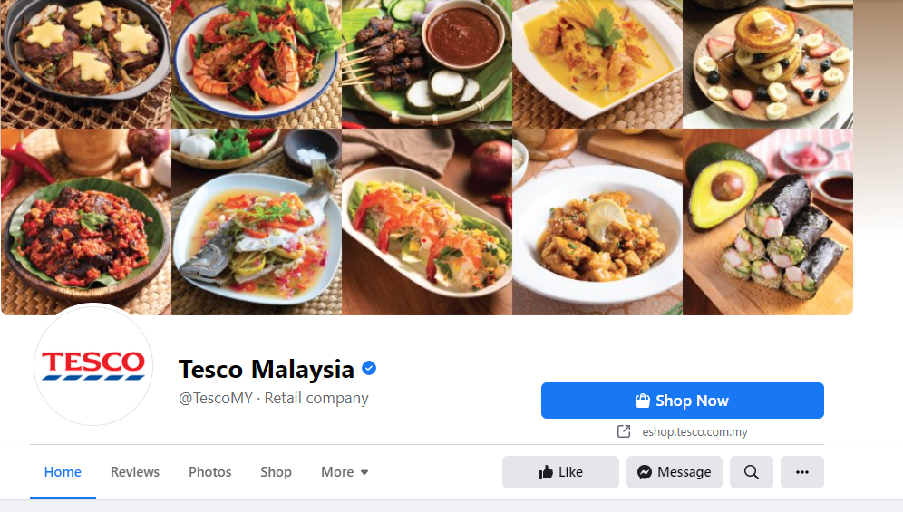
Figure 2: Tesco Malaysia Facebook page
(Source: facebook.com,2021)
Apart from this, around the world, Tesco is connected with its stakeholders which is more than 2 million. On the other hand, the Twitter handle is another important social media platform for continuous monitoring. Tesco has more than 525k active followers on their Twitter handle and gives updates on their Twitter handle. Apart from this, they have shared interesting moments, discounts, news, and some other offerings on their Instagram page where they also have more than 425k active followers. Video engagement is another important weapon nowadays for business organizations.
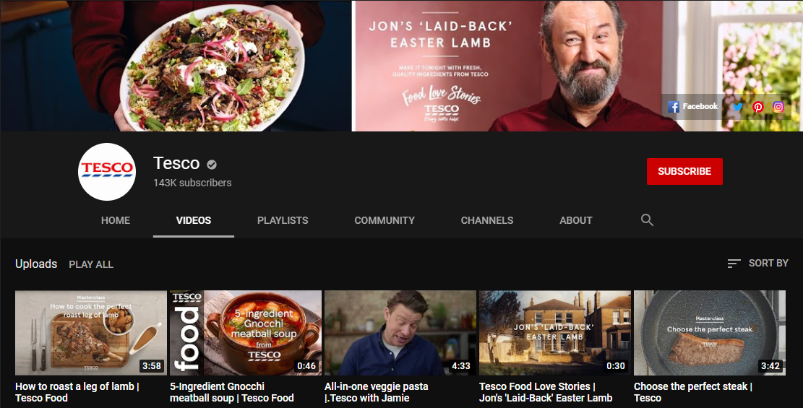
Figure 3: Tesco Official YouTube page
(Source: youtube.com,2021)
Tesco is also not behind this, they used the most popular video-sharing media YouTube for community engagement (Reilly,2015). They have more than 145k subscribers. They give attractive food advertisements, product information via some videos.

Training and development need to deal with Socio-Cultural issue
Community engagement is really important and the reasons are already explained at the beginning of the report. A community is a specific geographic area, anybody who lives in that place or working in that place is the members of that community. Now, in a community, there may be several people who belong to different societies and different cultural backgrounds. Therefore, it is the responsibility of the company to give motivational training where all the employees can learn about the different socio cultures so they can deal with the socio-culture issues (Bulmer and Solomos,2017). Tesco supermarket is for the public and there are no restrictions for any kind of people, so employees need to assure all the customers that Tesco is their shop. There is some specific training needed to handle these situations.
Common culture diversity: In the United Kingdom, there is much diversification of society, culture. Different backgrounds have different cultures and social practices. Employees need to be aware of those so they can come to operate with all types of customers to get their required products.
Employee relationship: Like different background customers, Tesco also has to recruit huge people, but they recruit people as per their talent, knowledge, and working ability but not by cultural background or religion. Therefore, employees should be ready to do their responsibilities as a team. There should not be any conflict between them regarding their culture, religion, or colourism.

Reasons for giving training on multiculturalism issue
This is a serious issue that is already discussed. There are different social and cultural backgrounds people are living in the UK. Many religious people live in the UK. Therefore, employees need to be aware of all kinds of cultural and religious people as they are providing the best customer service. Different cultures or religions have different events, festivals. Therefore, they will come to the supermarket to collect their required products from the event. Employees need to be aware of those things so they can come to operate with them. Also, there may be different terms for one single product due to different cultures. Employees need to ensure they also need to provide the best service (Ashcroft and Bevir,2018). Apart from this, they should be motivated to cooperate and should not judge people by their religion or culture. All have equal responsibilities and equal rights.

Conclusion
This report has been prepared to address the community engagement of TESCO PLC. There are several things discussed in the reports. There is a discussion on how the organization takes care of all of its stakeholders and keeps engaged regularly. They have used social media platforms to keep evolving with them. The report also shows different eras of the organization, how Tesco started its journey and how they grow. Then there is a discussion on the required skill and knowledge to be an employee of the organization. Some common skills and knowledge were noticed in these findings. Apart from this, the report shows how the employees use social media platforms to stay connected with their customers and other internal stakeholders. Finally, the report shows the multiculturalism issue and to deal with such situations which kind of training is required.

Recommendations
- There are several Facebook pages of Tesco, but they should also have one common Facebook page rather than different Facebook pages. It creates confusion among the customers.
- They are not regular on their social media platforms, they posted their last video on YouTube almost one month ago, the same thing is for Facebook, they also have no regular updates.
- Community engagement is less noticed in the case of wider social engagement. Though they are working with some government and non-government organizations to provide help for the poor people. However, the effort is less compared to other big organizations such as Starbucks. Therefore, they can organize some free health check-ups for rural people, or they can provide food in local food banks as this is also a part of community engagement. This initiative will give them an extra competitive advantage.

Reference List
- Ashcroft, R.T. and Bevir, M., 2018. Multiculturalism in contemporary Britain: policy, law and theory.
- Bulmer, M. and Solomos, J. eds., 2017. Multiculturalism, social cohesion and immigration: shifting conceptions in the UK. Routledge.
- Dessart, L., 2017. Social media engagement: a model of antecedents and relational outcomes. Journal of Marketing Management, 33(5-6), pp.375-399.
- Erickson, B., Fausti, S., Clay, D. and Clay, S., 2018. Knowledge, skills, and abilities in the precision agriculture workforce: an industry survey. Natural Sciences Education, 47(1), pp.1-11.
- Godley, A.C. and Hamilton, S., 2020. Different expectations: A comparative history of structure, experience, and strategic alliances in the US and UK poultry sectors, 1920–1990. Strategic Entrepreneurship Journal, 14(1), pp.89-104.
- Lehn, D.V., 2020. Digitalization as “an Agent of Social Change” in a Supermarket Chain: Applying Blumer's Theory of Industrialization in Contemporary Society. Symbolic Interaction, 43(4), pp.637-656.
- Peeroo, S., 2019. Customer-initiated conversations on Facebook pages of Tesco and Walmart. In Information Systems Design and Intelligent Applications (pp. 43-51). Springer, Singapore.
- Peeroo, S., Samy, M. and Jones, B., 2015, December. Customer engagement manifestations on Facebook pages of Tesco and Walmart. In 2015 International conference on computing, communication and security (ICCCS) (pp. 1-8). IEEE.
- Reilly, P., 2015. Every little helps? YouTube, sousveillance and the ‘anti-Tesco’riot in Stokes Croft. New Media & Society, 17(5), pp.755-771.
- Rusavska, V., Batchenko, L., Honchar, L. and Svechkina, A., 2020. Integrative-Innovative Model of Socio-Cultural Activities Managers Training: a Conceptual and Analytical View. Socio-Cultural Management Journal, 3(2), pp.75-106.
- Stanton, J.L., 2018. A brief history of food retail. British Food Journal.
- Xu, W. and Saxton, G.D., 2019. Does stakeholder engagement pay off on social media? A social capital perspective. Nonprofit and Voluntary Sector Quarterly, 48(1), pp.28-49.

