Maisie Tuckett
1802381
BA Illustration
Word Count: 1500 words
Scott L. Smith and Martin Bush
Module ADAD4010

Ways of Perceiving

Throughout this essay, I will explore curation, space and place. I will analyse how creative practitioners look, think, reshape, redesign and understand spaces in which they perform exhibitions. I will primarily explore art-based exhibitions, whether this be photography, paintings, illustrations or fashion and in ‘Part Two’, will explain my personal theories and exploration into my own imagined exhibition.

Part One
Theoretical Perspective

In order to gather knowledge into how artists and exhibitioners curate their desired spaces I visited various exhibitions that are of interest to me and took notes and some photographs to eventually influence my own curation. These exhibitions and shows include Slimbridge WWT Centre in Gloucester, on the outskirts of Bristol; The Glynn Vivian Art Gallery in Swansea town centre; The National Waterfront Museum at Swansea’s harbourside; Leonardo Da Vinci: A Life in Drawing Exhibition at Bristol Museum and Art Gallery and the Great Rotunda at Washington DC’s Capitol Building.

I flew to Washington DC, in August 2018 and was fortunate to see and learn more from the historical buildings I visited and about the American Independence. It provided me with a lot of knowledge about the cultural importance of America’s history and the buildings I saw.
I was fortunate to visit was the Capitol Building which is home to the United States’ Congress. The part I was specifically struck by was the buildings ‘rotunda’ located below the double domes of the building which were built between the years 1855 and 1866. The circular room that houses the Capitol Building’s ‘Great Rotunda’ was the first of the exhibitions that inspired my outlook on constructing one of my own. What drew me to this space was the painting around the domed ceiling called ‘The Apotheosis of Washington’ (Brumidi, 1865) which was completed in 1865 over the course of eleven months and is approximately 180 feet high. The Apotheosis of Washington is a Fresco painting.
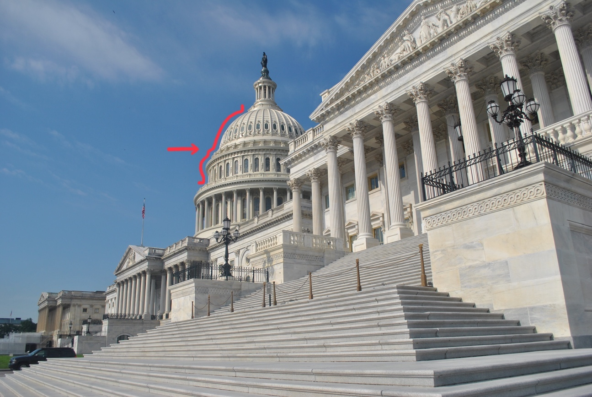
Figure 1. The Capitol Building and where the Great Rotunda is located. Taken by Maisie Tuckett, 2018.

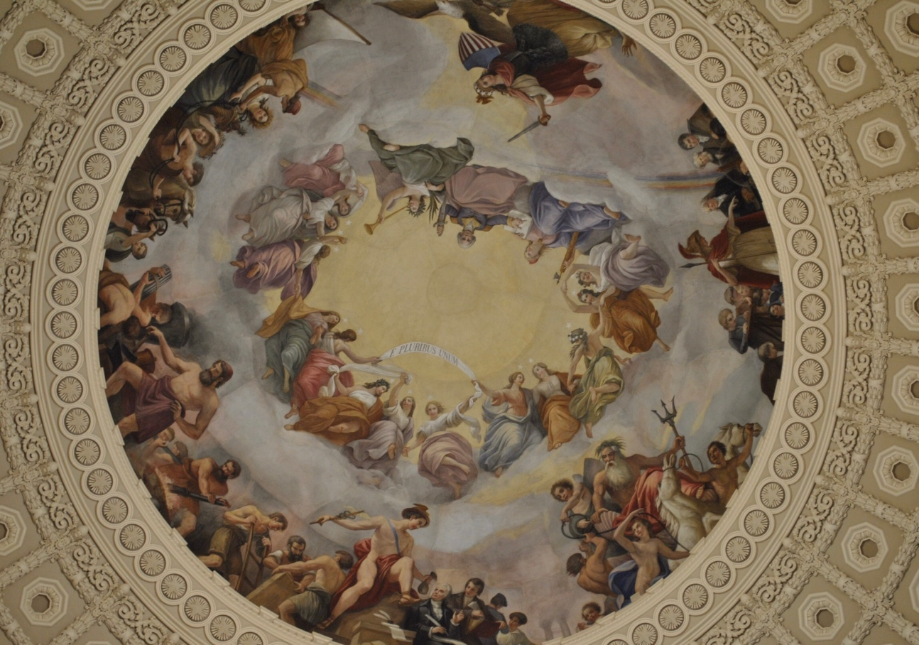
Figure 2. The Apotheosis of Washington, By Costantino Brumidi, 1865 Taken by Maisie Tuckett, 2018.
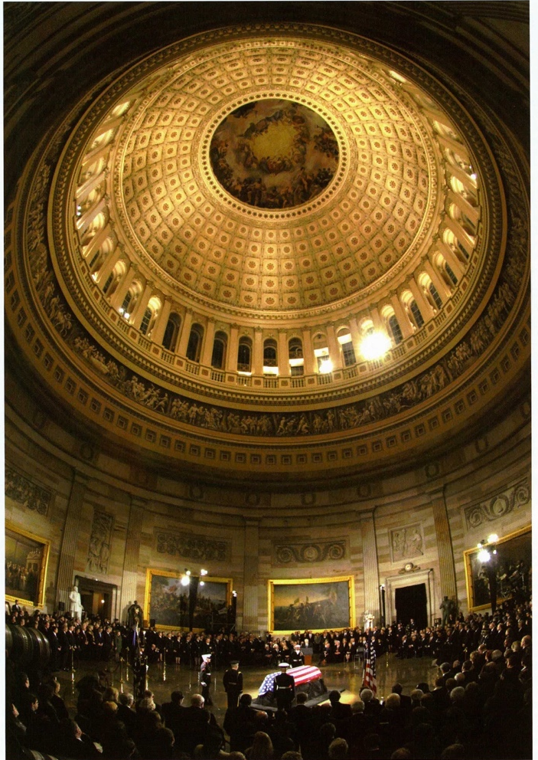

Figure 3. “Overview of the United States Capitol Rotunda” Taken by William D. Moss, 2016.

Figures 1 and 2 are my own photographs demonstrating where the rotunda is located and the Apotheosis of Washington (Brumidi, 1865) itself. Inside the rotunda, there is an exhibit of six statues and eight historical oil paintings. “The first four paintings exhibited were placed between the years 1819 and 1824 which depict scenes of the American Revolution. The later four paintings were placed between 1840 and 1855 and tell the story of exploration and colonialization in America” (Ford, 1994).
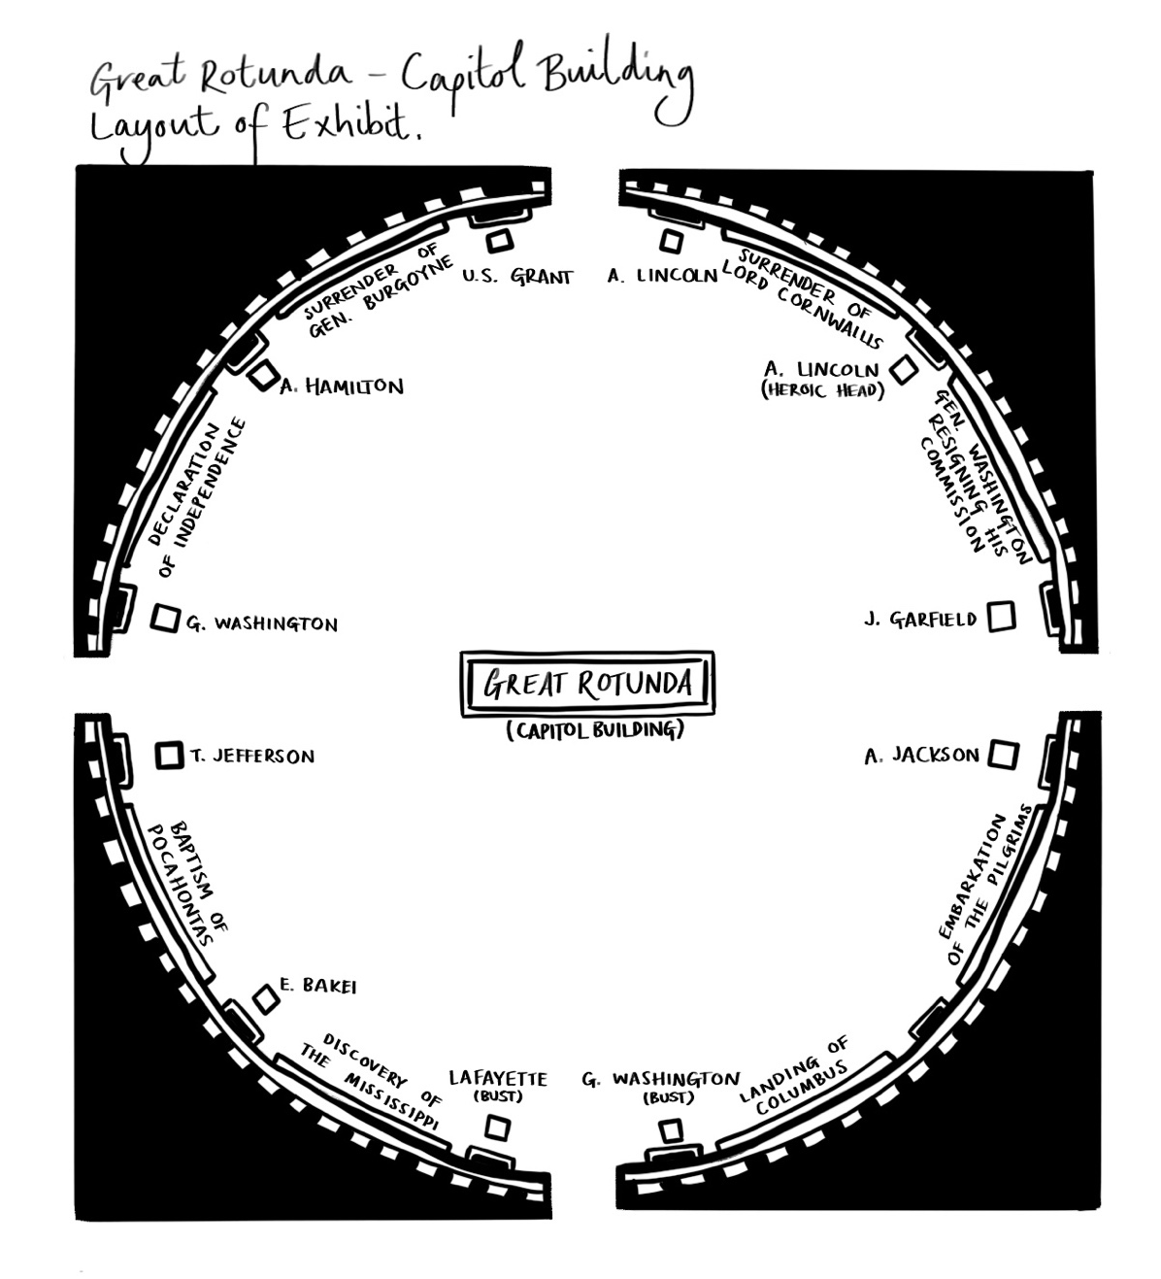

Figure 4. My Diagram of the Great Rotunda and it’s artwork, By Maisie Tuckett 2019.

The rotunda’s exhibition is a permanent one and who’s curator is unknown. Despite this, I believe that the magnificence of the paintings and their placement is unlike any exhibited art work that I have seen and was completely mesmerized by the work as well as the positioning of the paintings which measure at 3.7 by 5.5 metres each. The marbled room is a large 29 metres in diameter and although only fourteen works of art stand in this room, there is a perfect balance between the rich, dark scenes depicted in the paintings and the angelic, delicate statues that stand beside them. The curation of the Rotunda’s exhibit is a work of art in itself, towered over by the Renaissance-like piece that dominates the domed ceiling. The simplicity of the curation for Washington’s Great Rotunda inspires me to let the art work speak for itself and to make sure that I choose a venue that complements the art work that I would like to display, as well as adding to the exhibitions artistic value.

Another exhibition that has influenced my choice of exhibition curation was ‘Leonardo Da Vinci: A Life In Drawing’ at Bristol’s Museum and Art Gallery.
Leonardo Da Vinci is an inspiration of mine because of my interest in Italian Renaissance art so I thought it an ideal exhibition to view to inspire mine. The exhibition was held to mark the 500th year Anniversary of Da Vinci’s death and displayed twelve of his best drawings from the ‘Royal Collection’ which contains his finest artworks.

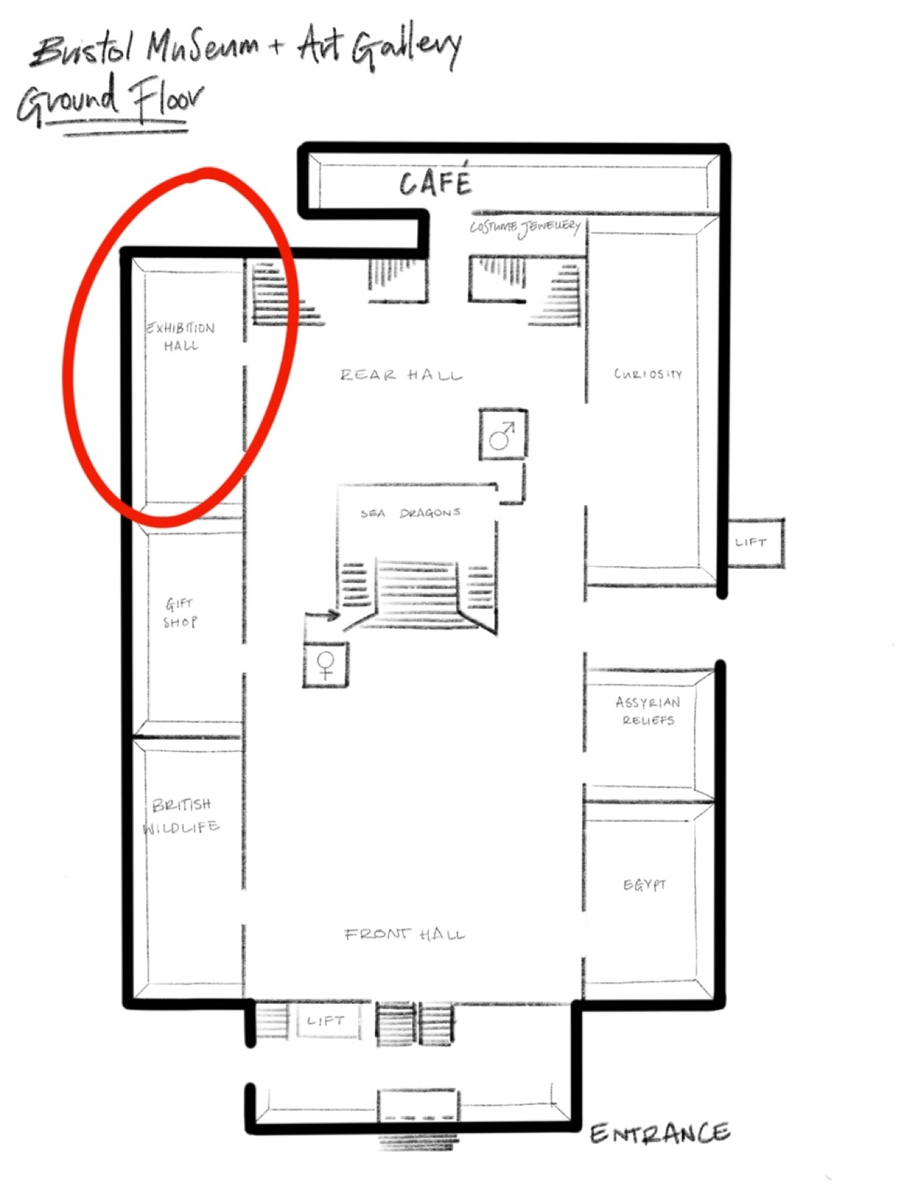
Figure 5. My diagram of Bristol Museum and Art Gallery’s floorplan
with the ‘Exhibition Room’ labelled.

The exhibition represented the variance in drawing materials that Da Vinci used to create his work as well as presenting information on his creative process. Similarly, to the works of art shown in the Great Rotunda, the exhibitions curators let Da Vinci’s work speak themselves despite there being few pieces on show. The exhibition itself left a lot to be desired in terms of curation, however because Da Vinci’s artwork is so undeniably legendary, it brings me to the conclusion that curation really begins with what is being displayed and coming to an understanding on how to curate around the work in order to enhance the exhibit’s focal points.

Part Two
A Critique of my own Imagined Exhibition

Taking aspects from what I have learned from understanding various curations that I have researched and my appreciation for the Italian Renaissance, I decided to make this the pinnacle for my imagined exhibition. I wanted the space and what was being displayed to work as one to become a collective piece of art.
I decided that the art work on display at my exhibition would be a collection of eighteen of my favourite dresses from 2018’s MET Gala by the theme of ‘Heavenly Bodies: Fashion and the Catholic Imagination’. I also researched Andrew Bolton’s exhibition in order to gain more knowledge on creating pieces that replicate fashion that dates back to the 1700’s.

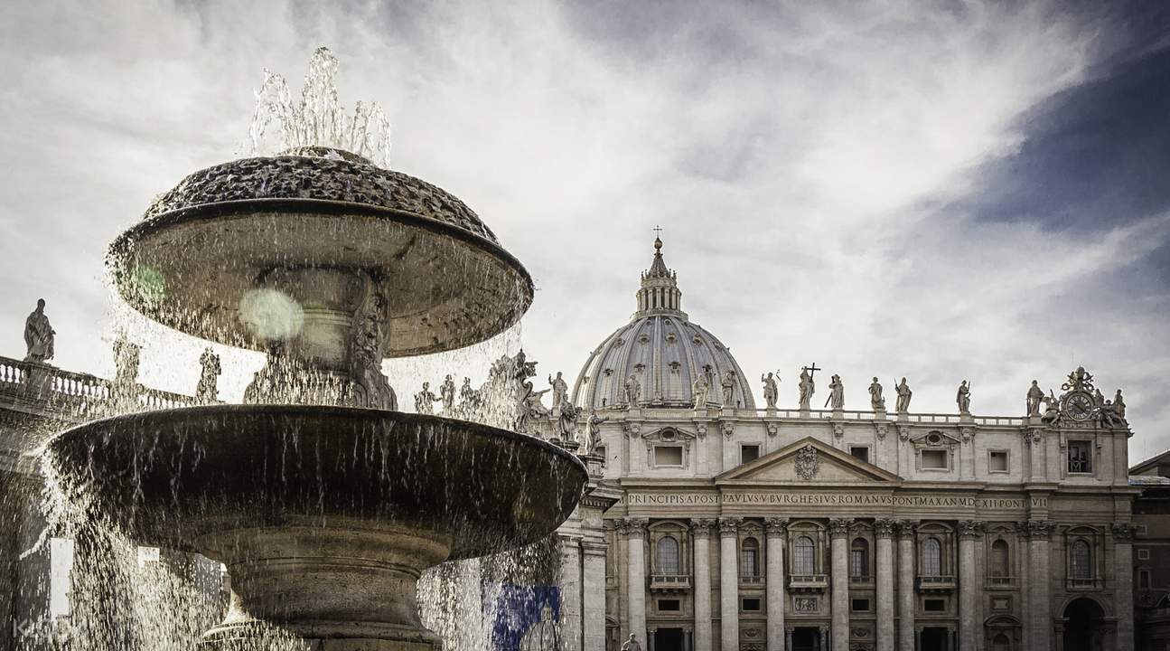
After considering various venues for the exhibition, I took inspiration from the Capitol Building and chose a space that was equally culturally valuable to the art that I will be exhibiting. I chose to house my exhibition in the Sistine Chapel in Vatican City which is part of the Vatican Museums.
Figure 6. Outside view of the Vatican Museums, Sistine Chapel and St. Peters Basilica. Photograph by Klook, date unknown.
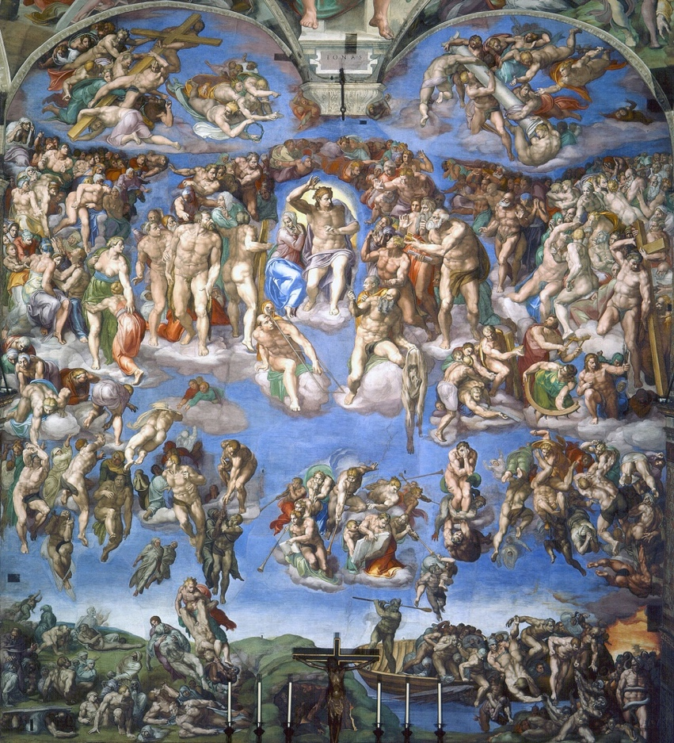

Figure 7. ‘The Last Judgement’ By Michelangelo, 1536-1541. Photographer unknown.
My aim for the exhibition was for the eighteen dresses, ‘The Last Judgement’ (Michelangelo, 1541) and the other surrounding High Renaissance paintings to complement each other to create a scene which encourages peace and appreciation of two art forms that coincide. I considered introducing modern art inspired by the Renaissance era into the exhibition but came to the conclusion to display the dresses only. Taking inspiration from the simplicity of the Leonardo Da Vinci exhibition, and limiting the display to the dresses only, there would be two focal points that worked together to create my show.

The eighteen dresses my exhibition includes is as follows:
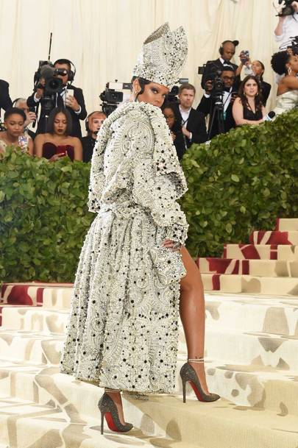

Figure 8. Garment belonging to Maison Margiela by John Galliano

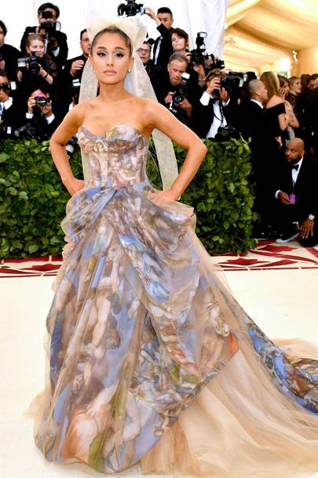

Figure 9. Garment by Vera Wang

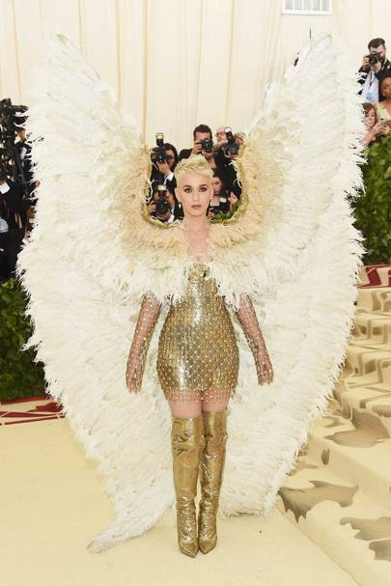

Figure 10. Garment by Versace
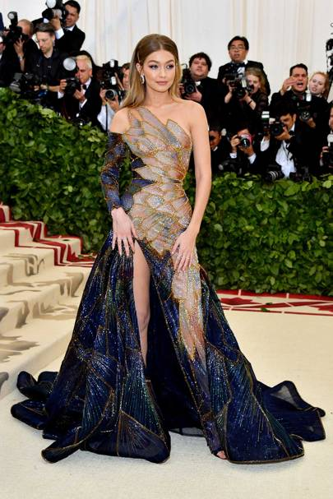

Figure 11. Garment by Versace
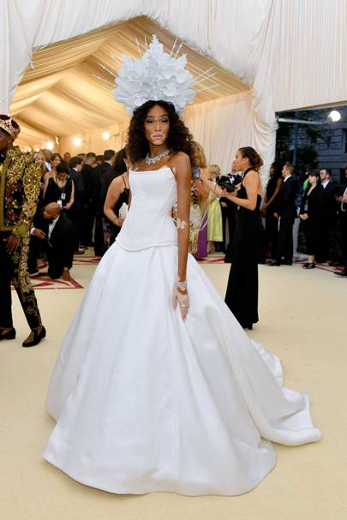

Figure 12. Garment by Tommy Hilfiger

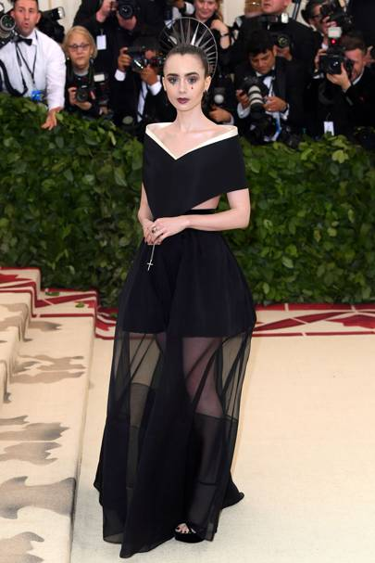
Figure 13. Garment by Givenchy

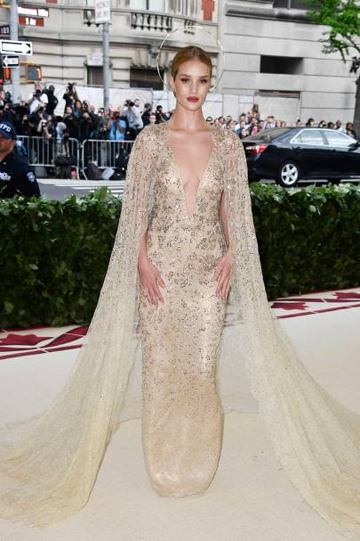
Figure 14. Garment by Ralph Lauren

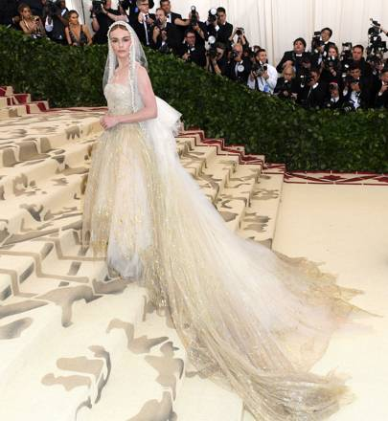
Figure 15. Garment by Oscar de la Renta
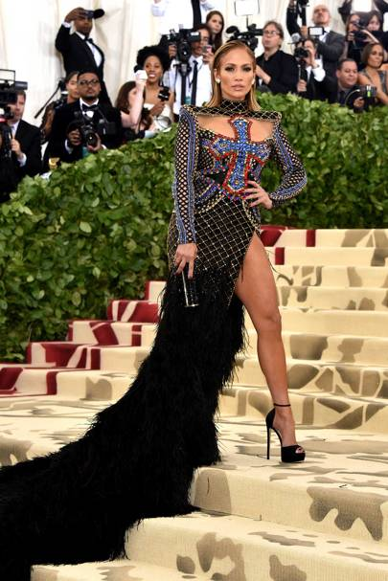
Figure 16. Garment by Balmain
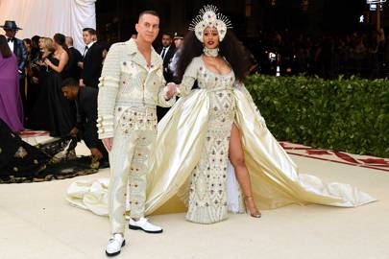
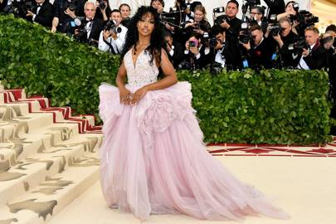
Figure 17. Garment by Versace
Figure 18. Garment (right) by Moschino
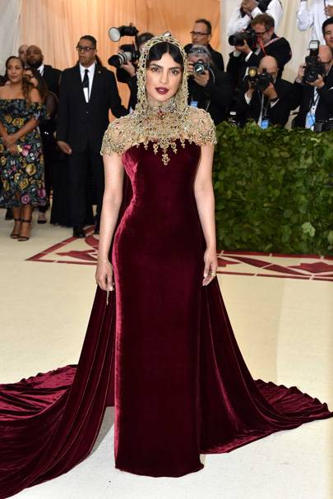
Figure 19. Garment by Ralph Lauren

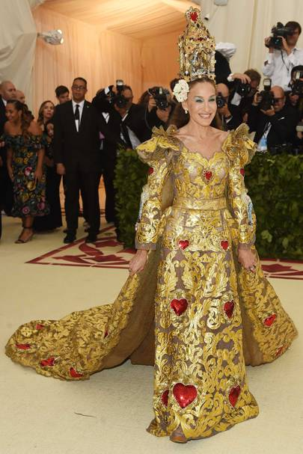
Figure 20. By Dolce and Gabbana

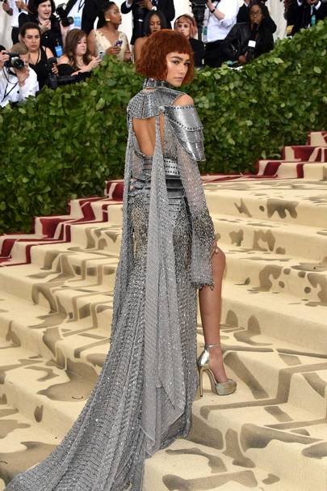
Figure 21. Garment by Versace
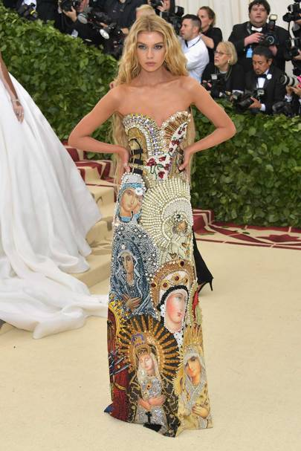
figure 22. Garment by Moschino

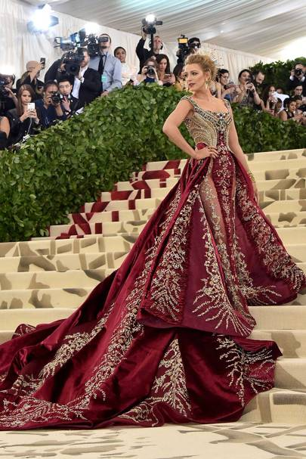
Figure 23. Garment by Versace

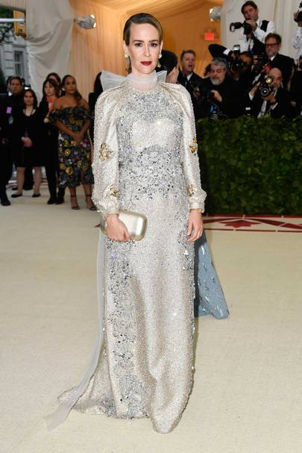
Figure 24. Garment by Prada

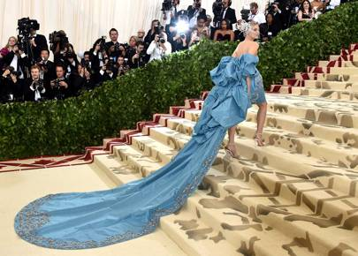
Figure 25. Garment by Prabal Gurung

The eighteen figures above demonstrate the exact garments that appear at my exhibition. These entirely custom-made dresses were created by some of the biggest names in Fashion Design and reflect each designer’s interpretation of the 2018 MET Gala theme.
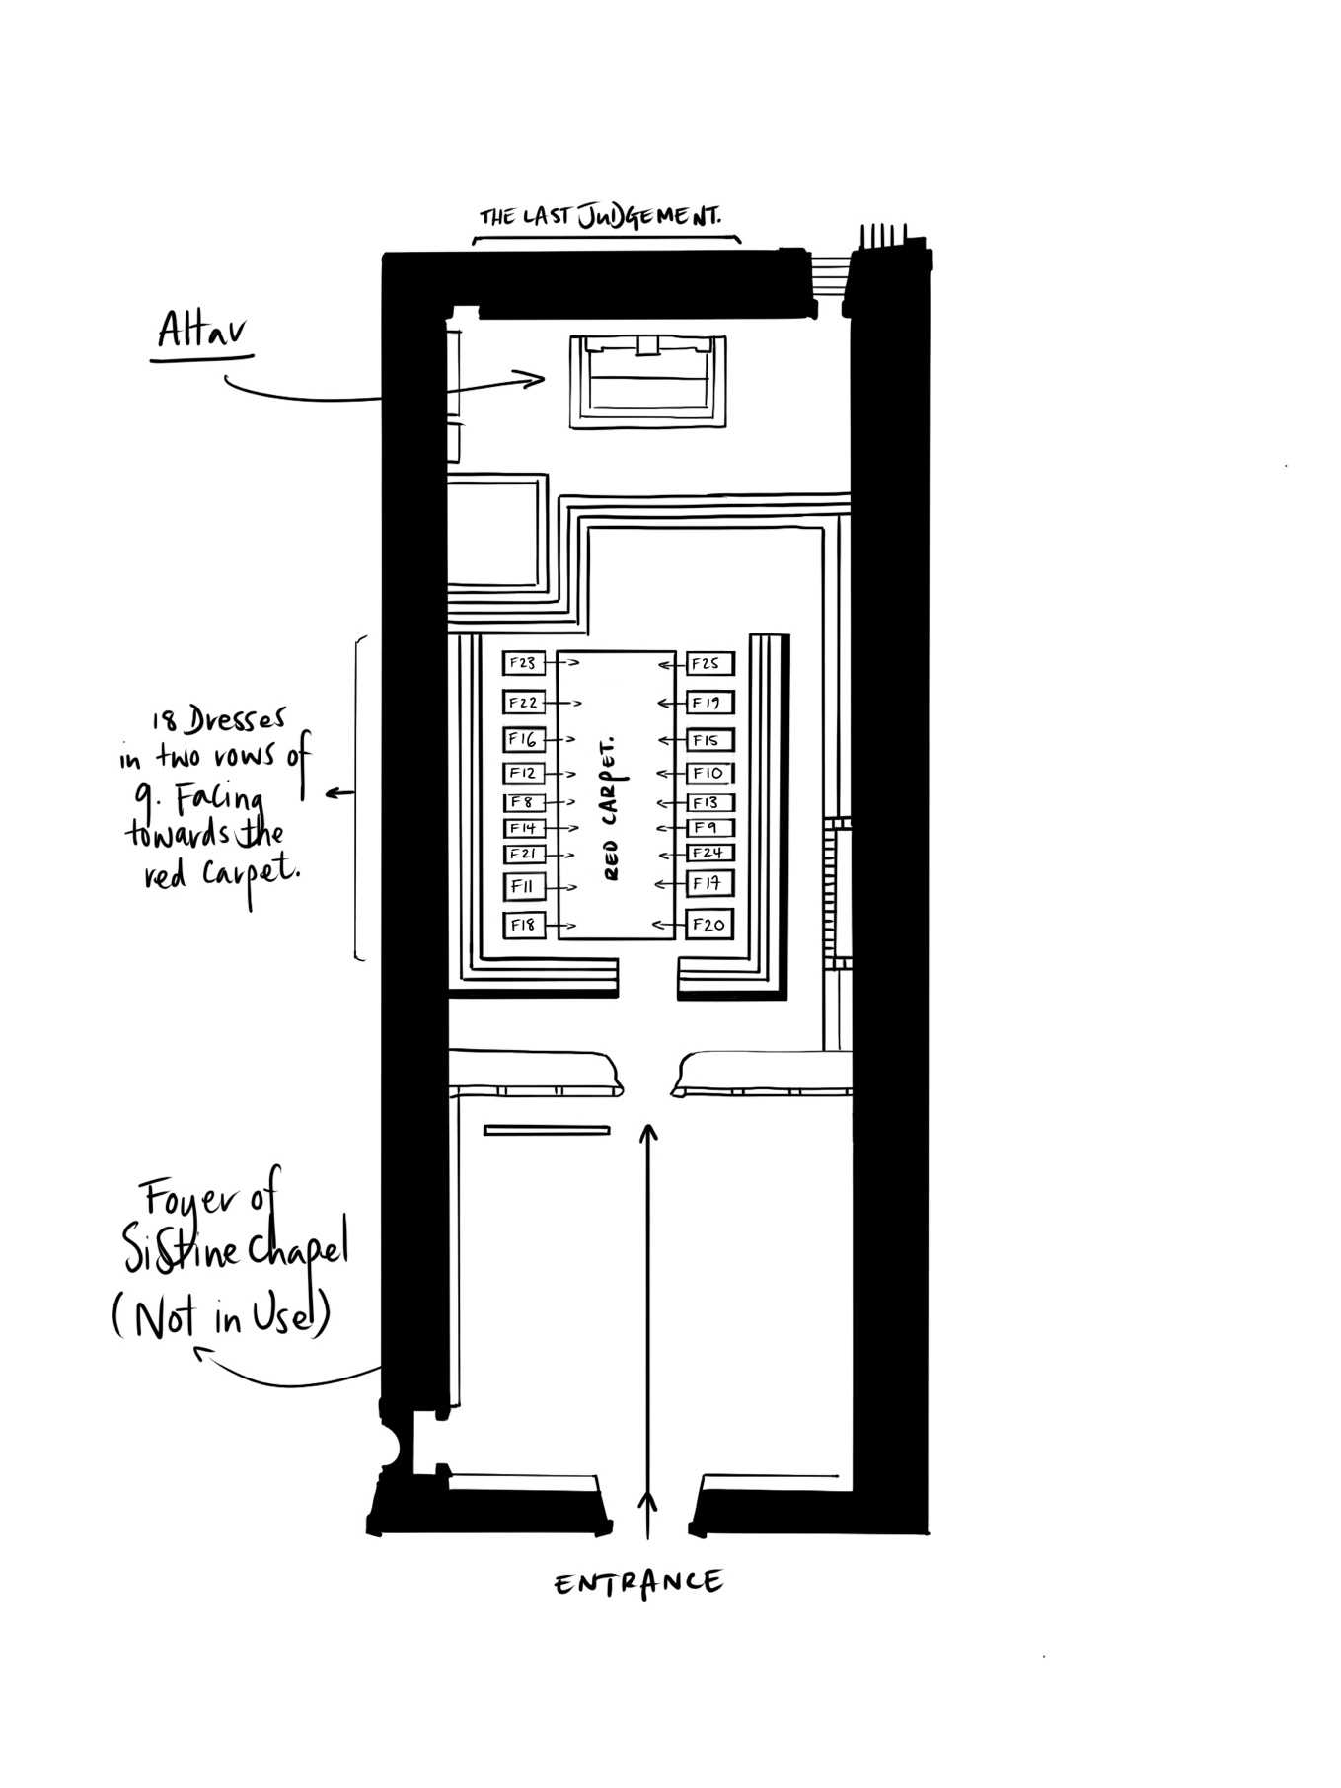
Figure 26. Where the exhibition will take place and where the dresses will be displayed. The dresses correspond with their ‘Figure’ number.

The dresses appear in two rows of nine, either side of the chapel as shown, beside a red carpet, paying homage to the show in which the dresses were created for. The largest dresses appear towards the front or back of the rows as they take up the most space, and the less extravagant ones stay central for aesthetic purposes. The eighteen dresses and the carpet create a path toward the main attraction, ‘The Last Judgement’ (Michelangelo, 1541), as well as the Chapel’s famous altar.
Surrounded by depictions from the bible, the dresses stand behind red rope in order for them to be kept untouched. The chapel is kept silent throughout, in order for the audience to appreciate the joining of art forms as well as being mindful and respectful of the chapel’s history.

I took the most successful aspects from the curation of the two aforementioned exhibitions in the hope to communicate the same objective that these did. The exhibition’s purpose was to create a space in which the architectural beauty of the Sistine Chapel, Italian Renaissance and high fashion were brought together as one collective appreciation of both the historical value and cultural value of this era.

Figure list
Figure 1 – Tuckett, M. (2019). [image].
Figure 2 - Tuckett, M. (2018). [image].
Figure 3 - Moss, W. (2006). Overview of the United States Capitol Rotunda, December 30, 2006. Photograph taken during a memorial service for President Gerald R. Ford.. [image] Available at: https://web-a-ebscohost-com.ezproxy.uwtsd.ac.uk/ehost/pdfviewer/pdfviewer?vid=4&sid=ce6a39b8-22c1-4236-9450-3445ae0feede%40sdc-v-sessmgr02 [Accessed 5 May 2019].
Figure 4 – Tuckett, M. (2019). [image].
Figure 5 - Tuckett, M. (2019). [image].
Figure 6 - Klook (n.d.). Vatican Museums, Sistine Chapel, and St. Peter’s Basilica Tour. [image] Available at: https://www.klook.com/en-AU/activity/2827-vatican-museums-sistine-chapel-st-peters-basilica-rome/ [Accessed 4 May 2019].
Figure 7 - The Last Judgement. (2017). [image] Available at: https://learnodo-newtonic.com/famous-religious-paintings [Accessed 5 May 2019].
Figure 8 - Getty Images (2018). Rihanna wearing Maison Margiela by John Galliano.. [image] Available at: https://www.vogue.co.uk/gallery/met-gala-2018-dresses [Accessed 5 May 2019].
Figure 9 - Getty Images (2018). Ariana Grande wearing Vera Wang.. [image] Available at: https://www.vogue.co.uk/gallery/met-gala-2018-dresses [Accessed 5 May 2019].
Figure 10 - Getty Images (2018). Katy Perry wearing Versace.. [image] Available at: https://www.vogue.co.uk/gallery/met-gala-2018-dresses [Accessed 5 May 2019].
Figure 11 - Getty Images (2018). Gigi Hadid wearing Versace.. [image] Available at: https://www.vogue.co.uk/gallery/met-gala-2018-dresses [Accessed 5 May 2019].
Figure 12 - Getty Images (2018). Winnie Harlow wearing Tommy Hilfiger.. [image] Available at: https://www.vogue.co.uk/gallery/met-gala-2018-dresses [Accessed 5 May 2019].
Figure 13 - Getty Images (2018). Lily Collins wearing Givenchy.. [image] Available at: https://www.vogue.co.uk/gallery/met-gala-2018-dresses [Accessed 5 May 2019].
Figure 14 - Getty Images (2018). Rosie Huntington-Whiteley wearing Ralph Lauren.. [image] Available at: https://www.vogue.co.uk/gallery/met-gala-2018-dresses [Accessed 5 May 2019].
Figure 15 - Getty Images (2018). Kate Bosworth wearing Oscar de la Renta.. [image] Available at: https://www.vogue.co.uk/gallery/met-gala-2018-dresses [Accessed 5 May 2019].
Figure 16 - Getty Images (2018). Jennifer Lopez wearing Balmain.. [image] Available at: https://www.vogue.co.uk/gallery/met-gala-2018-dresses [Accessed 5 May 2019].
Figure 17 - Getty Images (2018). SZA wearing Versace.. [image] Available at: https://www.vogue.co.uk/gallery/met-gala-2018-dresses [Accessed 5 May 2019].
Figure 18 - Getty Images (2018). Cardi B in Moschino.. [image] Available at: https://www.vogue.co.uk/gallery/met-gala-2018-dresses [Accessed 5 May 2019].
Figure 19 - Getty Images (2018). Priyanka Chopra wearing Ralph Lauren.. [image] Available at: https://www.vogue.co.uk/gallery/met-gala-2018-dresses [Accessed 5 May 2019].
Figure 20 - Getty Images (2018). Sarah Jessica Parker wearing Dolce and Gabbana.. [image] Available at: https://www.vogue.co.uk/gallery/met-gala-2018-dresses [Accessed 5 May 2019].
Figure 21 - Getty Images (2018). Zendaya in Versace.. [image] Available at: https://www.vogue.co.uk/gallery/met-gala-2018-dresses [Accessed 5 May 2019].
Figure 22 - Getty Images (2018). Stella Maxwell wearing Moschino.. [image] Available at: https://www.vogue.co.uk/gallery/met-gala-2018-dresses [Accessed 5 May 2019].
Figure 23 - Getty Images (2018). Blake Lively wearing Versace.. [image] Available at: https://www.vogue.co.uk/gallery/met-gala-2018-dresses [Accessed 5 May 2019].
Figure 24 - Getty Images (2018). Sarah Paulson wearing Prada.. [image] Available at: https://www.vogue.co.uk/gallery/met-gala-2018-dresses [Accessed 5 May 2019].
Figure 25 - Getty Images (2018). Diane Kruger wearing Prabal Gurung.. [image] Available at: https://www.vogue.co.uk/gallery/met-gala-2018-dresses [Accessed 5 May 2019].
Figure 26 - Tuckett, M. (2019). [image].

Bibliography
Brumidi, C. (1865). The Apotheosis of George Washington. [Fresco] Washington DC: Capitol Building Rotunda.

Ford, E. (1994). Dome Is Where The Art Is. [online] Washington Post. Available at: https://www.washingtonpost.com/archive/lifestyle/1994/02/18/dome-is-where-the-art-is/d09b5b79-dad0-4516-8445-0c9f091eabc2/?noredirect=on&utm_term=.c3837f1281aa [Accessed 3 May 2019].

Architect of the Capitol. (2017). Apotheosis of Washington. [online] Available at: https://www.aoc.gov/art/other-paintings-and-murals/apotheosis-washington [Accessed 3 May 2019].

Mitnick, B. (2016). Politics and Paintings. [online] 36(2), p.6. Available at: https://web-b-ebscohost-com.ezproxy.uwtsd.ac.uk/ehost/pdfviewer/pdfviewer?vid=4&sid=79fe296c-1a04-4708-be8b-880657abbcfb%40sessionmgr102 [Accessed 5 May 2019].

Fryd, V. (1989). The Italian Presence in the United States Capitol. Italian Presence in American Art 1760 - 1860, [online] p.Chapter 10. Available at: https://web-b-ebscohost-com.ezproxy.uwtsd.ac.uk/ehost/detail/detail?vid=9&sid=79fe296c-1a04-4708-be8b-880657abbcfb%40sessionmgr102&bdata=JnNpdGU9ZWhvc3QtbGl2ZQ%3d%3d#AN=44903013&db=asu [Accessed 5 May 2019].

Leonardo da Vinci: A Life in Drawing - Nationwide. (2019). [video] England: Royal Collection Trust.

Gelb, M. (1998). How to think like Leonardo Da Vinci. [book] New York, N.Y.: Thorsons.

Casely-Hayford, A. (2019). Met Gala 2018 Theme Revealed: “Heavenly Bodies: Fashion and the Catholic Imagination”. [online] Vogue. Available at: https://www.vogue.com/article/met-gala-2018-theme-heavenly-bodies-fashion-and-the-catholic-imagination [Accessed 5 May 2019].

Met Gala 2018 | Heavenly Bodies: Fashion & Catholic Imagination | Art of Style: Andrew Bolton | M2M. (2019). [video] Directed by L. Vreeland.

Anna Wintour's Favorite Outfits From The 2018 Met Gala. (2018). [video] The Late Show with Stephen Colbert.

Michelangelo (1541). The Last Judgement. [Fresco] Vatican City: Sistine Chapel.

