Student Name: Faizan Azam

Student Number 2431939

Module: Introduction to Web and Database Concepts

Module Code: ACCA4023

Lecturer: Sadhana Jha

Assignment Title: HTML & CSS Web Development

Table of Contents
Abstract 1
Introduction 2
Requirements 2
Design Approach 3
Implementation 3
Validation 4
HTML Validation 4
CSS Validation 5
Summary of Validation Issues and Fixes 6
Evaluation 6
Usability 6
Accessibility (WCAG 2.1) 7
Search Engine Optimisation 7
Comparison of Two Websites 7
Conclusion 8
References 9
Appendices 10

Abstract
In this report, the design, development, and evaluation of a responsive site designed using HTML and CSS are discussed as part of a Level 4 web development assessment. The purpose of the site was to create a fake student portfolio, which could be used only for academic purposes and was focused on the ability to show certain principles and standards of web development. The project is dedicated to semantic HTML structure, regular layout, responsive design, and basic accessibility considerations. The report will outline the website's requirements, design strategy, and implementation process. Validation of the HTML and CSS code will then be performed using W3C tools. Lastly, the site is analyzed as being usable, accessible, and search engine optimized.

Introduction
This report presents details on the design, development, and evaluation of a responsive website designed as a Level 4 assessment within HTML and CSS web development. The assignment aims at showing the knowledge of the basics of web standards, concepts, and best practices needed to develop contemporary websites. The site is designed as a fictitious student portfolio, and it has been designed to serve academic purposes only; it is not a reflection of an actual person.
It has been built with HTML5 / CSS3 only, as required in the assessment, without any scripting language or automated web builders. Clean semantic structure, consistent layout, and responsive design have been focused upon to make the site usable on various screen sizes, including mobile devices. Moreover, general search engine optimization principles and accessibility issues have been taken into account to enhance the quality of the site on the whole.
This report will present the specifications of the websites, design strategy, implementation process, and validation outcomes. It is also an analysis of usability, accessibility, and SEO with the backing of academic research and comparison with other existing websites to determine best practices and to determine what is lacking.

Requirements
This website was created to illustrate how the core web development standards and practices can be implemented with the help of HTML and CSS, as per the Level 4 assessment brief requirements. The site has been put together as a fictional student portfolio, which is only academic in nature and not that of a real person. Its main goal is to demonstrate the basic web development principles and not a high level of sophistication.
The website's target market would consist of academic employees evaluating the work and those who have not done any web development before. The site must contain at least three related pages, which comprise a home page, an about page, and a contact page, and they must be linked by a consistent system of navigation. The site should be fully functional and thus capable of operating properly both on desktop and mobile devices.
The site was created according to the brief in hand-coded HTML and CSS without the application of JavaScript or automated website builders. Other non-functional requirements relate to the ability to make the design easy to use, simple accessibility issues, and adherence to accepted web standards to have a well-organized and maintainable design.

Design Approach
The design philosophy of the site was to be simple, clear, and uniform to prove in essence core HTML and CSS rules. The layout of a student portfolio was chosen due to its ability to offer a good format for presenting information, as well as being suitable in terms of academic evaluation. All the pages are designed in the same manner: there is a header, a navigation menu, a body of the main content, and a footer that allows providing a consistent user experience and easy navigation throughout the site.
To aid readability and usability, a low and professional color scheme was selected. The header and footer are dark-colored, and the content sections are light-colored to create a visual distinction between the navigation elements and the main content, thereby reducing eye strain. This contrast makes it friendly and enhances the content comprehension.
The font was a plain, simple, standard sans-serif font to ensure legibility across various browsers and devices. There was a distinction between the headings and the body text in order to give the users a visual hierarchy.
The responsiveness was one of the main design concerns during the development, which was implemented with the help of flexible CSS layouts and media queries.

Implementation
The rollout of the site emphasized the interpretation of the design specifications into a real-world, standards-compliant system in the form of HTML and CSS. To enhance maintainability and readability of the project, a clear and organized file structure was developed. The site is composed of three HTML files, index.html, about.html, and contact.html, and one external stylesheet located in a separate folder in the form of a CSS. Media assets are stored in another images folder to make sure that the content, presentation, and resources are not mixed.
The code of the website is made in HTML, detailing the semantic best practices in order to enhance accessibility and usability. The use of elements like header, nav, main, section, article, and footer throughout all the pages gives a clear outline of the document. All the navigation links are located in a common header so as to be consistent and easy to navigate among the pages. Sectioning elements are used to group content logically, enabling interpretation of the page structure by screen readers and search engines.
Flexbox is adopted to formulate the CSS layout, which is flexible and responsive. Flex containers are also used to display the content sections on a larger screen in a horizontal manner, but to display them on smaller screens in a more natural manner. Padding, margins, and font sizes are used to control spacing, alignment, and visual hierarchy to ensure that it remains clear.
Media queries are used to create a responsive design to make layout behavior change on smaller screens. The content sections on mobile devices appear in a vertical stacking, which makes the content easy to read and use without having to scroll horizontally. Such an implementation shows real-life knowledge of the web standards and a responsive approach suitable for an introductory academic web development project and evaluation.

Validation

HTML Validation
The HTML of the home page (index.html) was checked with the W3C Nu HTML Checker to make sure it complies with the existing web standards and best practices. A warning that was detected during the validation process was that one of the elements of the section did not have an identifying heading. This caution shows that the use of the right elements of headings is necessary to enhance the structure and accessibility of the document, as well as its semantic sense.
The problem was resolved with the help of reviewing the affected section and making sure that appropriate elements of headings were used where necessary. This assisted in enhancing the logical organization of the paper and support accessibility software like screen readers. There were no critical HTML errors as indicated in the validation; the rest of the messages were advisory error messages as opposed to functionality.
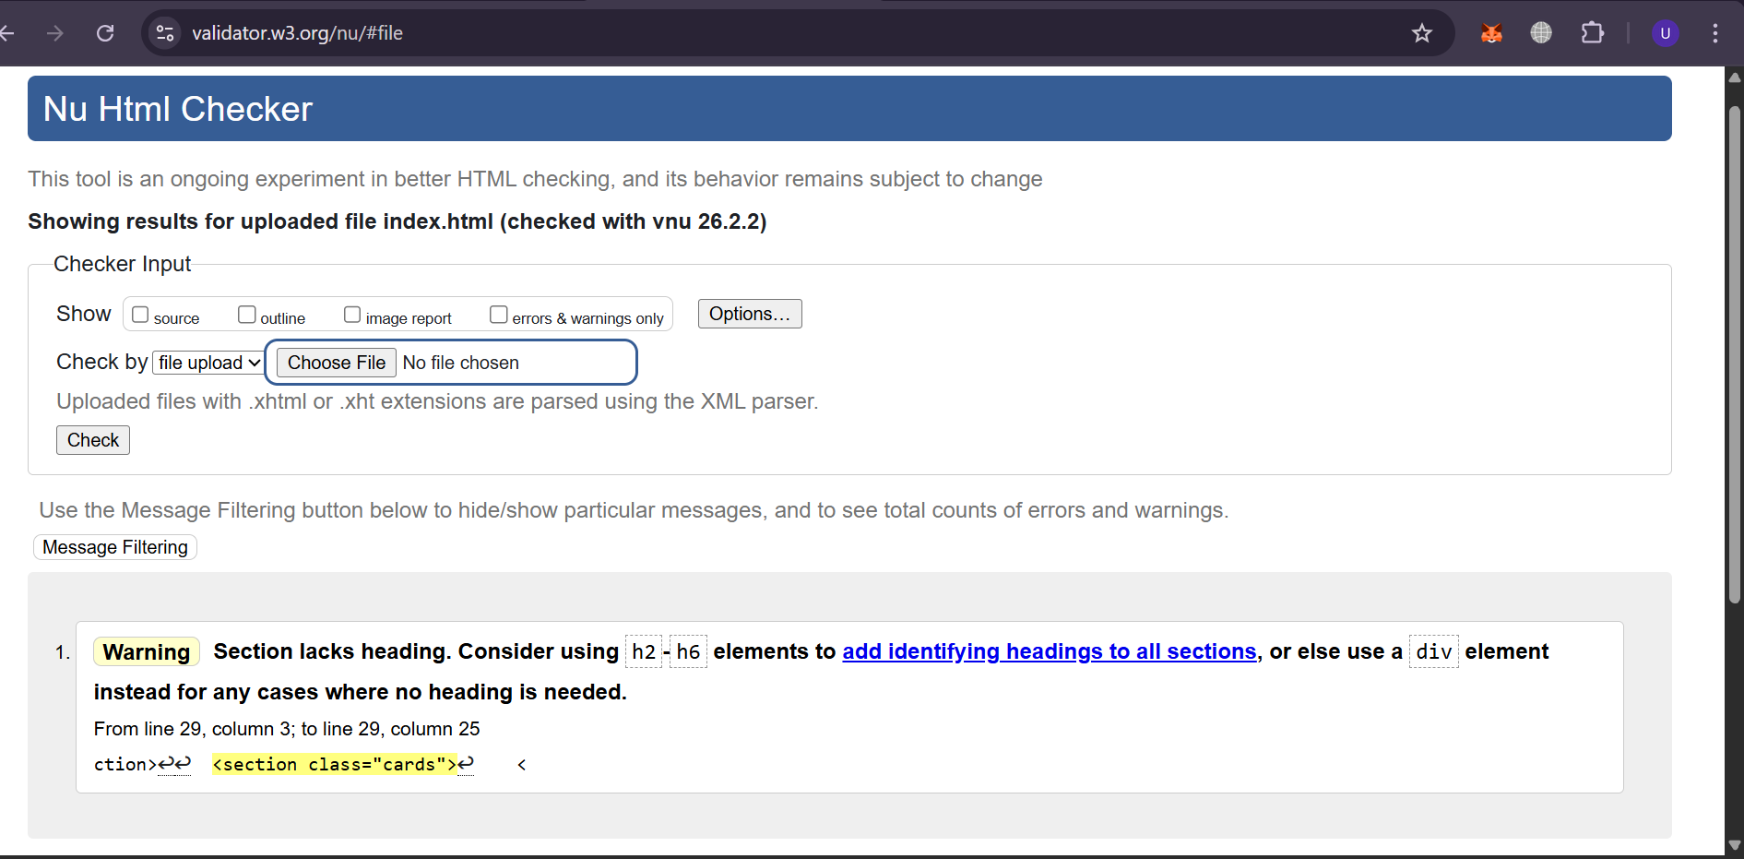
Figure 1 HTML Validation Results (W3C Validator)

CSS Validation
The main stylesheet (style.css) of the website was tested with the W3C CSS Validation Service to make sure that the rules of styling are in compliance with the recognized CSS standards. The validation output of the stylesheet showed that it was able to validate and can be used as CSS Level 3, and no errors were reported. This ensures that the syntax of CSS is proper and compliant with the laid-down standards of layout, typography, and responsiveness.
Lack of CSS errors shows that the current CSS methods, such as flexible designs and media queries, were used properly and uniformly all over the site.

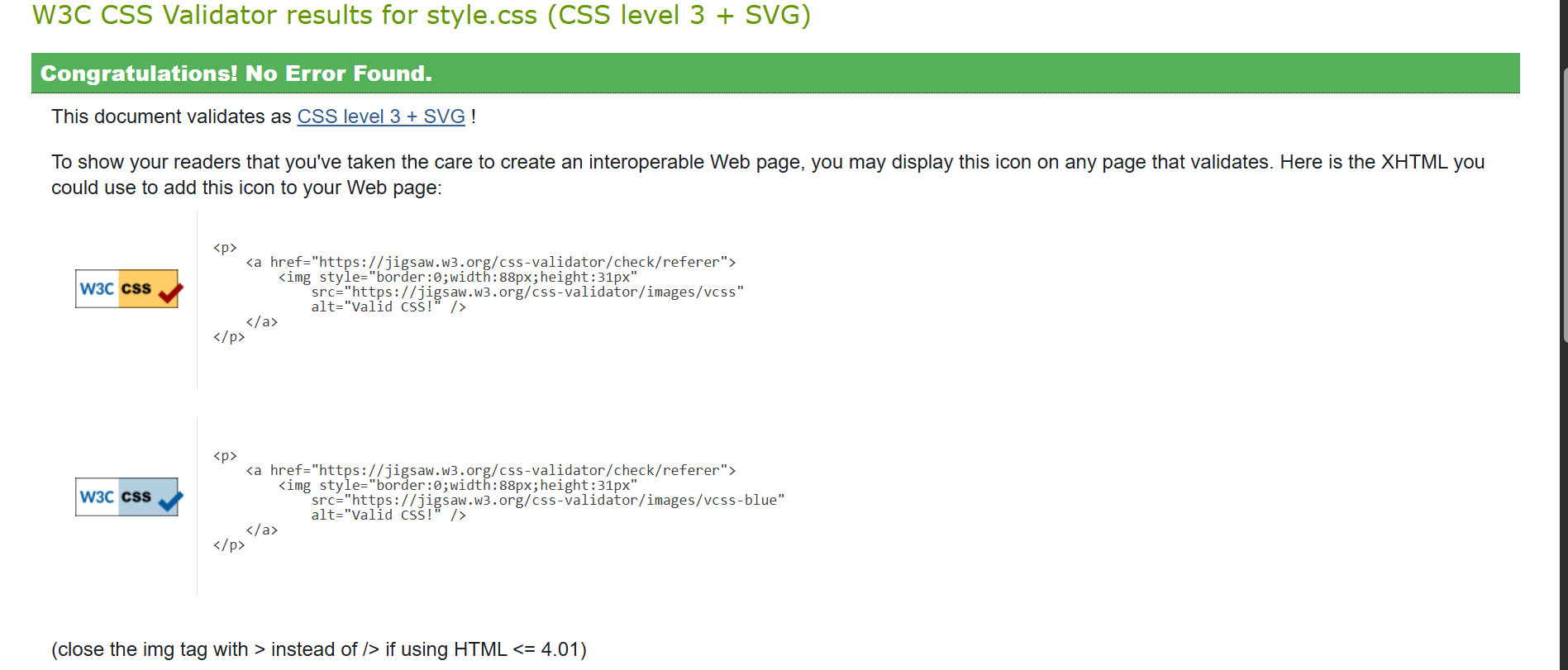
Figure 2 CSS Validation Results (W3C Validator)

Summary of Validation Issues and Fixes
In general, the validation made it possible to confirm that the site is built in accordance with the accepted web standards and best development practices. Cosmetic HTML warnings were checked and corrected to enhance the semantic structure, and the CSS did not have any errors. This was done in order to make sure that the site is trustworthy, available, and befitting an academic web development project.

Evaluation

Usability
The usability of the site was tested based on the navigation, clarity of the layout, and the ease of use in general. The site has a simple and consistent navigation menu, which appears on all the pages, enabling the user to navigate to various sections without getting lost. The layout of the portfolio shows data in a logical sequence and enables users to learn fast the reason behind the existence of the site. Spacing, font size, and visual hierarchy are good enough to promote a good user experience. Information is organized into defined sections, and this minimizes intellectual load and enhances readability. In general, the site illustrates the proper application of the principles of usability that are appropriate in an academic portfolio and an introductory project on web development [1].

Accessibility (WCAG 2.1)
The level of accessibility was assessed in comparison with Web Content Accessibility Guidelines (WCAG) 2.1. A meaningful document structure was provided with the semantic HTML elements of header, nav, main, section, and footer that assistive technologies, including screen readers, can use. Each image has an alternative text to allow users with visual impairment to access the content. Text and background color contrast were taken into account to keep the reading readable, responsive design was developed to keep the content readable on various devices and screens. Although the site has basic accessibility requirements, some additional advancements may be recommended, with the basic accessibility tests being keyboard navigation and a more in-depth accessibility audit based on the specialized tools [2].

Search Engine Optimization
Simple search engine optimization rules were used in order to enhance the discoverability and organization of the site. Page titles were also clear and descriptive to reflect the content on the page, and the heading elements were also used in a logical hierarchy to aid the search engine indexing. Semantic HTML enhances accessibility and search engine optimization by giving sense to the search engines. Image alternative text also enhances searchability. Despite the fact that the site is not to be published publicly, these practices can be viewed as the knowledge of the basic techniques of SEO as applied to the work on a modern web-based application [3].

Comparison of Two Websites
The comparison of two informational websites was chosen to be done by taking the BBC site and the GOV. The UK site is chosen because of its high concentration of usability and accessibility. The BBC site has a rich interface with a lot of content that may at times overload the user's mind. The GOV. The UK site, on the other hand, emphasizes simplicity, easy navigation, and consistency in layout, which makes information easier to find. The accessibility practices are effective on both websites, but the GOV. The UK has a better heading structure and contrast design. In general, GOV. The UK has a more user-friendly experience, especially in terms of ease of use and accessibility; it is the most successful example of best practice [4].

Conclusion

The present project was effectively able to show the creation of a responsive and standards-compliant site in HTML and CSS. The student portfolio site was developed as a fictional site with an aim of fulfilling the assessment criteria as well as addressing the usability, accessibility, and clean structure. In developing the website, major web development concepts like semantic HTML, responsive layout techniques, and web standard validation were utilized. The analysis revealed the significance of usability and simple search engine optimization in the current web design. In general, the project was a useful practical experience during the development and assessment of a simple website and the strengthening of initial skills that would be necessary in further study of web development.

References
[1]
K. V. Vlasenko, S. V. Volkov, I. V. Lovianova, I. V. Sitak, O. O. Chumak, and N. H. Bohdanova, “Exploring usability principles for educational online courses: a case study on an open platform for online education,” Educational Technology Quarterly, vol. 2023, no. 2, pp. 173–187, Jun. 2023, doi: https://doi.org/10.55056/etq.602.
[2]
Bruce, “Accessibility in Web Design - Evaluating Current Practices and Technologies,” Accessibility in Web Design - Evaluating Current Practices and Technologies, Jan. 02, 2025. https://www.academia.edu/download/120580628/Accessibility_in_Web_Design_Evaluating_Current_Practices_and_Technologies.pdf
[3]
F. Alfiana et al., “Apply the Search Engine Optimization (SEO) Method to Determine Website Ranking on Search Engines,” International Journal of Cyber and IT Service Management, vol. 3, no. 1, pp. 65–73, Mar. 2023, doi: https://doi.org/10.34306/ijcitsm.v3i1.126.
[4]
V. Dakulagi, K. H. Yeap, H. Nisar, R. Dakulagi, G. N. Basavaraj, and M. V. Galindo, “An overview of techniques and best practices to create intuitive and user-friendly human-machine interfaces,” Academic Press, 2024, pp. 63–77. doi: https://doi.org/10.1016/B978-0-443-29150-0.00002-0.

Appendices
Appendix A: HTML Code
Index.html
<!doctype html>
<html lang="en">
<head>
<meta charset="utf-8">
<meta name="viewport" content="width=device-width, initial-scale=1">
<title>Student Portfolio</title>
<link rel="stylesheet" href="css/style.css">
</head>
<body>

<header class="header">
<div class="wrap">
<h1 class="name">Alex Student</h1>
<nav class="nav">
<a class="active" href="index.html">Home</a>
<a href="about.html">About</a>
<a href="contact.html">Contact</a>
</nav>
</div>
</header>

<main class="wrap">
<section class="intro">
<img src="images/student.jpg" alt="Portrait of a fictional student" class="profile">
<h2>Web Development Student</h2>
<p>This portfolio website demonstrates the use of HTML and CSS to create a responsive and accessible layout.</p>
</section>

<section class="cards">
<article class="card">
<h3>HTML</h3>
<p>Semantic HTML is used to structure content clearly and correctly.</p>
</article>

<article class="card">
<h3>CSS</h3>
<p>CSS is used for layout, colours, typography, and responsiveness.</p>
</article>

<article class="card">
<h3>Responsive Design</h3>
<p>The layout adapts to different screen sizes for usability.</p>
</article>
</section>
</main>
<footer class="footer">
<div class="wrap">
<p>© 2026 Student Portfolio</p>
</div>
</footer>

About.html
<!doctype html>
<html lang="en">
<head>
<meta charset="utf-8">
<meta name="viewport" content="width=device-width, initial-scale=1">
<title>About | Student Portfolio</title>
<link rel="stylesheet" href="css/style.css">
</head>
<body>

<header class="header">
<div class="wrap">
<h1 class="name">Alex Student</h1>
<nav class="nav">
<a href="index.html">Home</a>
<a class="active" href="about.html">About</a>
<a href="contact.html">Contact</a>
</nav>
</div>
</header>

<main class="wrap">
<section class="page">
<h2>About Me</h2>
<p>I am a fictional student created for an academic assessment to demonstrate core web development principles.</p>

<h3>Education</h3>
<p>Level 4 Computing Student</p>

<h3>Skills</h3>
<ul>
<li>HTML5</li>
<li>CSS3</li>
<li>Responsive Layouts</li>
<li>Accessibility Awareness</li>
</ul>
</section>
</main>

<footer class="footer">
<div class="wrap">
<p>© 2026 Student Portfolio</p>
</div>
</footer>

</body>
</html>

Contact.html
<!doctype html>
<html lang="en">
<head>
<meta charset="utf-8">
<meta name="viewport" content="width=device-width, initial-scale=1">
<title>Contact | Student Portfolio</title>
<link rel="stylesheet" href="css/style.css">
</head>
<body>

<header class="header">
<div class="wrap">
<h1 class="name">Alex Student</h1>
<nav class="nav">
<a href="index.html">Home</a>
<a href="about.html">About</a>
<a class="active" href="contact.html">Contact</a>
</nav>
</div>
</header>

<main class="wrap">
<section class="page">
<h2>Contact</h2>
<p>This contact information is provided for demonstration purposes only.</p>

<div class="card">
<p><strong>Email:</strong> alex.student@email.com</p>
<p><strong>Location:</strong> United Kingdom</p>
</div>
</section>
</main>

<footer class="footer">
<div class="wrap">
<p>© 2026 Student Portfolio</p>
</div>
</footer>

</body>
</html>

Appendix B: CSS Code
*{
box-sizing:border-box;
}

body{
margin:0;
font-family:Arial, sans-serif;
line-height:1.6;
background:#f2f4f7;
color:#111;
}

.wrap{
width:min(1000px,92%);
margin:0 auto;
}

.header{
background:#1e293b;
color:#fff;
}

.name{
margin:0;
padding:18px 0 6px;
font-size:22px;
}
:-ms-keyboard-activ

.nav{
padding-bottom:14px;
}

.nav a{
color:#fff;
text-decoration:none;
margin-right:14px;
padding:6px 10px;
border-radius:6px;
}

.nav a.active{
background:rgba(255,255,255,.18);
}

.intro{
background:#fff;
margin:20px 0;
padding:20px;
border-radius:10px;
text-align:center;
box-shadow:0 2px 10px rgba(0,0,0,.06);
}

.profile{
width:140px;
height:140px;
border-radius:50%;
object-fit:cover;
margin-bottom:12px;
}

.cards{
display:flex;
gap:16px;
margin-bottom:24px;
}

.card{
background:#fff;
padding:16px;
border-radius:10px;
box-shadow:0 2px 10px rgba(0,0,0,.06);
flex:1;
}

.page{
margin:20px 0 24px;
}

.page ul{
margin-left:18px;
}

.footer{
background:#0f172a;
color:#fff;
padding:14px 0;
text-align:center;
}

@media (max-width:768px){
.cards{
flex-direction:column;
}
}

Appendix C: Validation Screenshots

