Student Number: 1601574
Module: Faculty of Education and Communities: Dissertation (ECGE7002P)
Module Lead: Junnine Thomas-Walters
Tutor: Gwilym Siôn ap Gruffudd

MA Education, Faculty of Education and Communities, University of Wales Trinity Saint David, Swansea.

An Exploration into Developing Independent Learners within the Primary School Setting.
31st March 2023

Word count: 15, 000

Contents Page

Title page 1

Contents Page 2-3
Frontispiece and Declaration Form 4
Acknowledgements 5
Abstract 6
Chapter One: Introduction 7
1.1- Overview 7
1.2- Rationale 7
1.3- Aims and Objectives 8
1.4-Hypotheses 9
1.5- Conclusion
Chapter Two: Literature Review 8
2.1-Overview 8
2.2-Historical review 8
2.3- Independence in the new Welsh curriculum 9
2.4- What is independent learning? 11
2.5-Benefits, Opportunities and Limitations of Independent Learning 12
2.6- Conclusion 13
Chapter Three: Methodology 14
3.1-Overview 14
3.2- Adhering to guidelines 14
3.3- Selecting research participants 14
3.4-Selecting research methods 15
3.5- Designing the research methods 15
3.6- Questioning strategies
3.7- Conclusion 16
Chapter Four: Results and Findings 17
4.1-Overview 17
4.2- Context of the study 17
4.3- Pupil interviews 18
4.4- Teacher Interviews 18
4.5- Interpreting and analysing qualitative data 19
4.6-Conclusion 22
Chapter Five: Conclusion 23
5.1- Overview 23
5.2- Conclusion 23
5.3-Informing future practice 23
Reference List 25
Appendix 36
Appendix One- Ethics Form 36
Appendix Two- Parental assent form 37
Appendix Three- Teacher interview schedule 38
Appendix Four- Pupil interview schedule 53
Appendix Five- Working document 54

Frontispiece
This frontispiece is to clarify that except where reference is made, the work and research described throughout this research project is the result of the research carried out by the student (1601574). Also, this research project nor any part of it has been presented, or is currently being submitted in candidature of any award other than for the degree of MA Education at University of Wales Trinity Saint David in Swansea. I declare that I understand that any work I use without reference constitutes as plagiarism, which would lead to the failure of this module.

Declaration Form


Name of the Programme of Study: MA Education

Name of Student (Capital Letters): BETHAN JANE PETTY

DECLARATION

I certify that the whole of this work is the result of my individual effort, and that all sources have been acknowledged.

Signed ............................................................... (Student)

Date 31.03.2023

DECLARATION

I am satisfied that this work is the result of the Student’s effort.

Signed .............................................................. (Lecturer)

Date 31.03.2023

Acknowledgements
Foremost, I wish to mention a special thank you to Gwilym Siôn ap Grufudd, my dissertation research supervisor. Throughout the duration of the research project, Gwilym supported me and provided me with guidance and knowledge. Moreover, the staff at University of Wales Trinity Saint David have helped me over the course of my MA Education and prior to this course my BA Primary Education with QTS, therefore I would like to say a special thank you to everyone at the University. Also, I would like to pay a special mention to my family and friends who have supported and encouraged me throughout my MA Education.

I would like to make reference and thanks to all the participants within the research project, and offer my appreciation to them. Without their insightful responses and valuable contributions, I believe that the results and findings chapter within this research project would not have been as well-informed. As a result of help and support from certain individuals, I believe this research project has been completed to a good standard.

Abstract
Throughout this research project, I investigated the theme of developing independent learners within the primary school setting. The overarching aim of this research project was to explore how children could be encouraged to become independent learners, specifically learners within the Key Stage Two phase. As a result of professional development and personal curiosity, I decided upon this theme which is seemingly fairly predominant within the education sector at present. Moreover, I embodied the role of an action researcher in order to undertake this research project. One of the aims of the project was to gain a range of opinions towards developing independent learners from both teaching staff and the learners themselves. The main research methods utilised throughout the research project were semi-structured interviews. The pupil interviews took the form of group interviews. I interviewed a cross-section of pupils to gain pupils’ insight on the idea of independence and how schools can provide opportunities to encourage independent learning. As a result of utilising these research instruments, I gained qualitative data which I then interpreted and analysed. Within the analysis I was able to identify recurring themes.

Throughout the research project I became more aware of the benefits, limitation and opportunities for independent learning. Undertaking wider reading which informed the literature review chapter enabled me to shape the research project and identify any gaps in the literature base. Also the empirical evidence gathered and discussed within the results and findings chapter, highlighted to me that there was an absence of common understanding based around what independent learning is and how it is developed within the classroom. However, I did discover there are some core strategies and principals that somewhat underpin the concept of independent learning. The primary research I collected aided me to address the overarching title of the research project and comprehend how primary schools could develop independent learners.

Chapter One: Introduction
1.1- Overview
Action research is undertaken to develop or improve professional practice (Newby, 2014). The main objective of this research project is to explore how learners within the primary school sector, specifically within the Key Stage Two phase, can be encourage to develop into independent learners. Furthermore, the research project shall explore the benefits and limitations of independent teaching and learning experiences, and what strategies or opportunities teachers can deploy to encourage their learners to become more independent. This research project shall utilise a deductive approach. Whereby, a deductive approach involves hypotheses being deduced based upon existing literature and theory (Newby, 2014). Then a research strategy shall be designed to conclude and examine the hypotheses. The strategy will consist of utilising research methods to collect empirical primary research (Cohen et al., 2018). The primary research methods shall include semi-structured interviews.

It could be suggested that the want for independent learners is arguably universally agreed upon, however, what is not so agreed upon is what defines an independent learner and the skills that accompanies the independent learner (Bayley and Featherstone, 2011). This research project aims to explore what independent learning is in more depth and seek participants’ perspectives upon what such principles and skills encompass it. Some suggest independent learning can be described as both a process and a goal (Candy, 1991). Arguably, both of which are arguably difficult to measure using research methods. Also, independence can be perceived as being able to do something for oneself (Williams, 2003). There are numerous ways that scholars and theorists have attempted to define independent learning over the years. For purpose of context, I wish to clarify that throughout this research project independent learning refers to managing one’s learning process through active engagement and taking ownership over one’s learning. Throughout the research project, I shall be undertaking the role of an action researcher (Newby, 2014). As both a researcher and class teacher I shall ensure that this power balance is mediated throughout the research project. Action research can be perceived as interpretive research (Cohen et al., 2018).

1.2- Rationale
Independence should be encouraged and fostered throughout the teaching and learning process (Donaldson, 2015). Despite the suggestion that independent learning should be encouraged and fostered, how this is done effectively is less understood. The predominant rationale behind this research project is to gain a better understanding of the nature of independent learning while becoming more aware of how independent learning is encouraged within the primary school sector. With the new Welsh curriculum being fully enrolled within the primary school sector, I believed that this research project would be beneficial and significant to my professional practice. Schön (1991) proposed reflecting in action research model. Whereby, practitioners are encouraged to undertake research in order to reflect upon practice. On conclusion of this research project I aim to utilise data collected to reflect upon my professional practice. In a society that is constantly changing, it is important that independent learners are developed from an early age (Rauber, 2007). Hereby, this could be arguably why independent learning plays a predominant role within school development plans. Some would say that many schools in Wales identify the development of pupils’ independent learning with their school development plan. (Meyer et al., 2008) However, one thing that is unclear is what is meant by independent learning, how it works in practice, or how teachers might best encourage it (Meyer et al., 2018). Currently, developing independent learners is a target on our school development plan. Hence, this was partly a factor of why this topic stimulated my professional curiosity.

Some United Kingdom literature highlights that children cannot become effective independent learners by themselves. Moreover, learners need to be equipped with a positive mindset and learn how to learn effectively, modelled by teachers (Meyer at al., 2008; Paris and Paris, 2001). One aim of the research project is to comprehend whether both teachers and learners acknowledge their role within the independent learning process. Little (1991) suggested that learner and teacher autonomy are interdependent, therefore teachers who aim to encourage independent learners need to reflect upon personal practices. However, some suggest that independent learning can also be perceived as children being engaged and productively employed with a task without hindrance (Gleason, 1979). Hence, why I aim gather practitioners’ opinions upon independent learning.

One aim of educational research is to extend knowledge and understanding in various areas of educational activity (BERA, 2018). One aim of this research project shall be to identify what perspectives and skill drive independent learning. I wish to establish whether there are recurring or potentially interlinked skills that underpin independent learning. One aim is to discover whether there is guidance and necessary strategies available for teachers to deploy that aid children in becoming independent learners. Moreover, I aim to explore benefits, limitations and opportunities for independent learning throughout this research project.

Gilchrist (2018) suggests that action research could be one of the most effective forms of professional development. Action research could be regarded as a form of self-reflective enquiry undertaken by professionals to improve educational practices as well as understanding these practices better and how they are carried out (Kemmis & McTaggart, 1998).

1.3- Aims and Objectives
During my literature review, I aim to discover secondary sources and research that could potentially help me form the basis of my research project. I decided upon the overarching theme of the research project then as a result of wider reading I aim to achieve the research project aims and objectives. To commence this research project, I examined existing literature in order establish the skills, nature and theory related to independent learning, in order to decide upon key themes to explore during my research. Braun and Clarke (2006) discuss the idea of latent themes which delve further and the researcher examines responses and the begins to identify or examine the underlying ideas and conceptualisations. As a researcher, I shall examine the data collected and attempt to discover any latent themes. It became apparent that there were emergent themes that were referred to within several journals and books. The broader skills and principals I decided upon focusing on for the purpose of the research project were: self-regulation, self-efficacy, and the benefits of independent learning .

Arguably, possessing the ability to work and act independently is one of the most important skills that a child can develop (Gershon, 2014). One aim of the research is to discover perceptions on how schools can encourage their pupils to develop into independent learners and equipped to do so effectively. Coulby (1995) suggests that all children should have opportunities to be independent. Hereby, one aim is to examine what opportunities are provided in school to allow children to be independent. Also, I aim to establish whether both pupils and teachers value the opportunities that independent learning provides and whether there are potential benefits and limitations to independent learning. Moreover, Gershon (2014) suggests that to foster to independence everyone needs to adjust their mindsets. Hereby, I aim to explore what participants perception on independent learning. Part of this will research project shall explore what is needed to change attitudes towards independent learning and whether attitudes are generally positive or negative towards independent learning. Also, I aim to explore how strategies and resources, accompanied by the learning environment can impact upon children’s independence. Although it could be argued that practitioners appreciate the importance of independent learning, it is practically challenging given the nature of learners and curriculum demands (Gill and Halim, 2007; Meyer et al., 2008). I aim to explore whether this is the consensus of the participants within this research project or whether their perceptions differ.

Educational researchers need to read around the subject to gain an understanding of theories, principals and ideas before adding to the body of knowledge (Newby, 2014). Although current literature to an extent highlights the nature and theory of independent learning, there is inconsistency with essential themes that surround independent learners. It is evident that there is a great deal of wider reading which attempts to address how teachers can support independent learning or the procedure of acquiring the necessary skills and incorporate them into classroom practice. Moreover, the literature provides a better understanding of what independent learning is, how it could be sustained, and what limitations will have to be overcome in order to have the benefits (Meyer et al., 2008). From observing the wider literature I personally feel that there is more evidence in support of developing independent learners, and it could be suggested that there is less evidence of how to adequately provide opportunities to encourage pupils to become indecent learners. Whereby I aim to add to these gaps in the evidence base by investigating perceptions upon limitations within my research strategy.

1.4- Hypotheses
Sometimes hypothesis drives the research or sometimes the research derives from the hypothesis (Cohen et al., 2018). To an extent, within this research project the hypotheses shall drive the research. One personal hypothesis is that children are often provided with too much support in various ways within the classroom setting and should be given more opportunities that permit them to be more independent. It could be suggested that some children will find learning independently more difficult than others. Another personal hypothesis as a result of wider reading is that sometimes teachers and pupils do not share the same understanding of what independent learning entails. These hypotheses could be proved or disproved as a result of findings within the research methods. Sometimes hypotheses can encourage or lead to bias, moreover, researchers should not undertake research with predetermined bias (BERA, 2018). I will ensure that my hypotheses do not interfere with the research I shall carry out. Moreover, this I shall do this by carefully phrasing my questions and ensuring I do not lead the participants into providing answers that will benefit my research project in the way I would like (Cohen et al., 2018). I aim to utilise empirical evidence, triangulated with wider literature in order to conclude my research project.

Chapter Two: Literature Review
2.1- Overview-
There appears to be a broad range of words to describe independent learning (Meyer et al., 2008). Upon initial observation of the wider literature, it became apparent that a mixture of terminology was utilised to describe an independent learner, including self-directed learners and self-regulated learners. Moreover, some referred to the concept of child-centred education which seemed to draw some parallels with the principles of independent learning. As aforementioned, to reiterate, throughout this research project the main subjects shall be referred to as independent learners. Throughout this chapter, I shall explore how developing independent learners have been prioritised or valued historically in previous curriculums. Then I shall examine any similarities or differences within the modern day curriculum. This literature review mainly focuses upon United Kingdom curricula, more specifically Welsh curriculum, as opposed to global curriculums.

2.2- Historical review
The attitude towards independent learners within schools has been argued by many scholars and various government reports (William, 2003; Gleason, 1979). Moreover, some may suggest that both the government and educational policy-making institutions have asserted their commitment to developing independent learning. However, it could be suggested that current educational policies, including recent initiatives, are conflicted in their impact on the development of children's independent learning (Whitebread et al., 2005). Moreover, some would suggest it is evident that wider reading highlights key policies and initiatives, however, there lacks a clear consistent understanding of the direct impact upon the development of independent learning.

Montessori (1966) discussed the idea of auto-education, whereby children become independent and do not rely on guidance in order to self-construct knowledge. Bruner (1961) suggested that the purpose of education was not to impart knowledge, however, the purpose was to facilitate a child's thinking skills which can then be transferred to a range of situations. Hence, arguably highlighting the importance of independent thinking. It could be suggested that independence has always been predominant within the education sector. The Rumbold Report (DES, 1990) highlighted how independence should be promoted and children encouraged to take responsibility for their learning. In more recent times, Alexander et al. (1992) argued the principals of child-centred education one of which is allowing learners to think for themselves.

Developing and promoting independent learners requires a somewhat new role for teachers, one that opposes traditional transmission of knowledge, and focuses on process-oriented teaching, which ensures that pupils are actively involved in the teaching and learning process (Bolhuis and Voeten, 2001). Some may suggest this takes an interactionist approach to education whereby learners are encouraged to take a leading role within their own learning. Nunan (1994) argued that an issue of redefining teacher roles could potentially more of a barrier than children’s ability to take responsibility for planning, organising, and evaluating their own learning. One implication would be teacher mediating a power balance between their role as leader and permitting their learners to take a more integral role facilitating the teaching and learning process. Hence, potentially why independence has been widely discussed historically, arguably often with a slightly less favourable view than how it is regarded in the current curriculum. It could be suggested that prior curriculums were more constructivist whereby teachers transmit knowledge. However, upon examining historical literature it became apparent that independent learning has always played a factor within previous curriculums. Although within the current curriculum there is a more holistic view whereby pupils are encouraged to take ownership over their own learning.

Some may suggest that the contributing historical and societal forces are an inadequate base for examining independent learning as they seem to cause uncertainty about the intended definitions and suggested activities that are associated with the idea of independent learning (Gleason, 1979). However, I feel previous historical curricula does provide valuable insights into perceptions of independent learning.

2.3- Independence in the new Welsh curriculum
Good teaching and learning encourages children to possess increasing responsibility for their own learning (Donaldson, 2015). One suggestion here is that children should be entrusted with an growing responsibility for their personal progress and direction of their learning. Henceforth, it could be argued that the four purposes of the new Welsh curriculum underpin the essence of independence and are intrinsically interlinked with developing independent learners (Donaldson, 2015). To expand, pupils shall be ambitious and capable learners who are ready to learn throughout their lives and healthy, confident individuals who are ready to lead fulfilling lives as valued members of society (Donaldson, 2015). Upon examining wider literature there was much discussion of the role independent learning plays within developing life-long learners. One principle of the new Welsh curriculum is to excite and inspire children to want to learn and do so independently (Donaldson, 2015). It could be suggested that this principle is shared with most primary school educators. Moreover, how the curriculum becomes exciting and inspiring to the learners, it could be argued is more dependent with the school context. As each school is now encouraged to design a curriculum that is fit for purpose for their school context. This may also contribute to a less common understanding of what independent learning is. On a primary level, it could be argued how the curriculum is inspirational and exciting to learners could be down to practitioners’ pedagogical approach and delivery of lessons. Moreover, it could be argue that how a teacher is expected to encourage children to want to learn independently could occur as a result of intrinsic motivation which is somewhat difficult to measure.

Williams (2003) highlighted some of the practical difficulties of developing independent learners. Which include curriculum constraints and ensuring curriculum coverage. Bullock and Muschamp (2006) suggest that the development of independent learning is, nonetheless, possible under present conditions and is in fact already a growing tendency in primary schools. Moreover, with a curriculum that arguably is designed with the concept of developing independent learners, it could be suggested that this is why it is necessary to encourage and develop independent learners. As aforementioned, how independent learning is fostered, developed and encouraged could vary from school to school. An example of how one school in Wales has developed independent learners included learners setting goals for their work, creating success criteria and assessing their own progress (Estyn, 2020).

2.4-What is independent learning?
Independent learning could be defined as being able learn by one’s self (Williams, 2003). It could be argued that many may perceive this as being the shared and correct definition. In turn this would lead to the view that independent learning means working alone. In contrast, some believe that working alone does not encourage and develop independent learning (Meyer et al., 2008; Mars, 2015). Moreover, Williams (2003) concurs with this suggestion and claims that if a child is isolated in their work without adult stimulation, they will fail to move beyond their Zone of Proximal Development (Vygotsky & Cole, 1978). Whereas through social interaction with peers, learners can sufficiently develop higher mental functions such as thinking and reasoning. Some would suggest that working with more capable others would aid children in becoming an independent learner. However, some may abuse the freedoms of work with peers and this could then contradict or hinder the process of becoming an independent learner.

It could be suggested that becoming an independent learner is a developmental process, with various interlinked changes occurring over time (Mars, 2015). Hence, this concept supports Candy’s (1991) perception on how independence is both a goal and a process. Teachers can provide support for children in their journey towards becoming independent learners (Mars, 2015). Moreover, Gershon (2014) suggested that being able to work independently is one of the most important skills a child can learn and children need to be prepared for a world where adults are not there to provide them with all the answers. Failing to prepare students for this would be doing them a disservice (Gershon, 2014). Thus highlighting the role that teachers can play in developing independent learners. Teachers are arguably in a position where they could either encourage independence or risk extinguishing it forever (Whitebread, 2000). This is somewhat a startling suggestion but arguably merely highlighting how teachers have the capability of fostering independent learning or thus risk undervaluing its importance for pupils’ development.

Creating suitable contexts whereby learners can demonstrate the ability to apply learning independently is an important part of that scaffolding (Donaldson, 2015). Hattie (2012) highlighted the need for teacher to provide children with opportunities for independent practice and apply them in other contexts. Hereby, it could be argued that without children being provided with necessary skills and the ability to revisit those skills, they could fail to become independent learners.

Lockhorst (2010) suggests the role of the classroom teacher is to encourage the development of the competencies necessary for children to work independently. It has been suggested that independent learning could be fostered by providing opportunities and that encourage learner motivation, curiosity, self-belief and self-reliance, and provoking learners’ personal interests (Meyer et al., 2008). However, independent learning does not involve simply giving children more freedom, instead it involves teachers thinking about learning outcomes and learning stages and provides them with ownership over their own learning (Gorman, 1998). Thus highlighting that children need to be made aware of how they can become an effective independent learner prior to achieving the benefits of independent learning.

Pintrich (2000) proposed a theoretical model of self-regulated learning, which emphasises the importance of learners planning, self-monitoring, controlling and evaluating their own learning activities. Moreover, Zimmerman (2002) extended the model by emphasising the importance of motivation within self-regulation, which influences the three phases of self-regulation: forethought, performance and self-reflection. Within Pintrich’s (2000) model there are four phases, within each of these phases there are areas which are, cognitive, motivational/affective, behavioural and contextual. These theoretical models aided me to design my research strategy, enabling me to decide upon key themes or areas to research. Moreover, these theoretical models influenced some of the questions I posed within my pupil interview schedule (Appendix…). In support of these theoretical models is considerable evidence for increased academic performance if learners plan their learning (Meyer et al., 2008). Some may perceive things such a motivation and self-regulation as micro-processes inter-connected with independence.

Autonomy and motivation are arguably central to the notion of independent learning as learners who are motivated to learn, are more able to take ownership of and actively reflect on their learning (Biggs and Tang, 2007; Candy, 1991; Percy and Salter, 1976). Motivated children have a good ability to work independently (Williams, 2003). It could be suggested that every child is different and how they respond or able to to engage independent learning will vary. Some children may benefit from reassurance and therefore will find learning independently a difficult process (Williams, 2003).

It could be suggested that there are varying attempts to define exactly what independent learning is. From exploring wider literature it is evident that different terms describe similar themes and processes, including pupils having an understanding of their learning, being motivated to take responsibility for their learning, and working with teachers to design and structure their learning environment and teaching and learning processes (Meyer et al., 2018).
2.5- Benefits, Opportunities and Limitations of Independent Learning
One challenge of independent learning is that teachers’ perceptions may not correspond to the conceptualisation of independent learning, which arguably has many different interpretations. Some suggest that there are many words associated with independent learning yet they fail to enlighten on what it entails (Gleason 1979). In an attempt to mediate this challenge there needs to be a common understanding. Gershon (2022) highlights the need for a common understanding as this enables a shared definition.

Some may suggest that the suggestion that mindsets need to be adjusted and an adjustment to teachers’ roles may create some limitations towards independent learning. However, this barrier could be overcome through supporting teachers and ensuring that there is a clear comprehension that independent learning does not undermine their role as teachers (Wood and Millichamp, 2000; MacBeath 1993). Another idea that may pose an issue to the implementation of independent learning is that some teachers do not perceive pupils to be capable of becoming independent learners (Wood and Millichamp, 2000; Nunan, 1994). It could be argued that teachers need to be made more aware of just what independent learning entails and how it impacts, but yet does not undermine, their role.

It could be suggested that some children due to factors such as intrinsic motivation and self-belief may feel under-confident in demonstrating independence. Drew (2018) suggests that some children may struggle making decisions as they feel responsible for the decisions they make and therefore are afraid to make the wrong decision. On the other hand, some learners may find it easier to be independent due to internal factors including confidence, but this does not limit only those children in becoming independent learners. Arguably, learners need to be supported and made aware of the advantage in making mistakes and learning from them. The fear of failure could be described as an obstacle to developing independent learners (Gershon, 2014). Dweck (2006) explored the idea of growth mindset which is arguably encouraged in some classrooms at present. It could be suggested that motivation which coincides with growth mindset is a major factor in independent learning. Zimmerman’s theoretical model (2005) highlights the role that self-motivation plays within independent learning.

When a learner discover their own learning resources, decides their own course of action, set goals, then significant learning is maximised (Rogers, 1969). Some would suggested that when provided with opportunities to create success criteria and target set pupils are equipped to become independent learners (Estyn, 2019). This could be beneficial for teachers as pupils play a significant role within the direction of their learning. Moreover, both Pintrich (2002) and Zimmerman (2005) both highlight the importance of taking ownership of learning and target setting within their theoretical models. Percy et al. (1980) highlighted that learners’ independence can develop from various factors including teachers, peers, and methods. However, independent learning can represent a challenge to conventional academic structures and can involve both children and teacher taking risks (Boud, 1988; Brook, Hunt and Hughes, 1994). Which seemingly contradicts certain principals of education and pose difficulty for both teachers and learners.
Gill and Halim (2007) highlighted the importance of independent learning as it helps to ensure children become successful individuals, who are capable of directing their own personal development. Moreover, children should be able to function in an appropriate way in the world, separate from their parents (Lynn, 2008). Some may suggest that both parents and teachers strive for children to develop into independent adults who are capable of working and living independently (Mars, 2015). Hereby, highlighting the important role that education has to play in developing learners who are independent both within and outside the school context. This could be described as am autonomy-dependency axis (Williams, 2003). Some may suggest that due to varying class sizes some children have to be more independent and less reliant on adult support.

Merry (1998) highlighted that children take in information and relate it to what they already know. Constructively building upon their prior knowledge and enabling them to become more independent. It is evident that there is a variety of learning and teaching approaches that could be utilised to help develop children’ independent learning, or provide opportunities for learner autonomy (Graves, 1993; Magin et al., 1993). Moreover, teachers need to be made more aware of these approaches. Some may suggest that there is a somewhat limitation of good practice guidance and examples of initiatives in developing independent learning. Therefore if these limitations were addressed guidance could be generated for schools on how to implement and promote independent learning in their own context (Meyer et al., 2008). One would agree with this statement as upon wider reading it became apparent that although there was much discussion on what independent learning was there lacked evidence of good practice backed up by theory specifically.

However, it is possible to teach in a way that allows room for independence without impacting upon curriculum demands (Gershon, 2022). One of the main challenges is the teachers’ perception that the delivery of the curriculum requires some whole-class teaching approaches, which may restrict the opportunity for independent learning as it is teacher directed rather than fostering pupils’ involvement in and responsibility for their own learning (Meyer at al., 2008). Moreover, Pollard (2000, cited in Bullock and Muschamp, 2006) suggested that whole class teaching may pose a risk and create a barrier for children from a deeper involvement with their learning, thus posing a challenge to independent learning (Reddiford, 1993, cited in Bullock and Muschamp, 2006; Noyes, 2005).

2.6- Chapter conclusion
Throughout the literature review, I gained a better understanding of my research field and was able to discover information that transformed the course of the research project. Often researchers need to undertake observation of the field to understand where to begin (Newby, 2014). This chapter allowed me to identify some core principals that contribute to independence, therefore shaping the research project in a succinct manner and gave me more focus as to what I would proceed to research using primary research methods. The historical review and the perception of independent learners in the current curriculum formed some of my aims and objectives and highlighted to me how even though independence has often been explored by many theorists and priority placed upon developing skills associated with independent learning, there seems to be a conflicting idea of what independent learning actually entails. The literature review ensured that I identify key themes in order to sufficiently address within the research methods.

It could be suggested that long-term goal is for children to be able to make good choices and to take responsibility for their actions even after leaving primary education (Mars, 2015). Moreover, it could be suggested that within prior curriculums there was some degree of focus placed upon developing independent learners. However, within the present curriculum, combined with an ever-changing society there is more of a priority placed upon developing independent learners.

Moreover, some children may misunderstand the notion of independence and somewhat abuse the freedoms that are associated with it (Williams, 2003). This could potentially pose a challenge to teachers. One challenge is that children may resist independent learning or could misuse the freedoms associated with it, this possibly makes the implementation of independent learning difficult (Bates, 1998; Kane, 2004). It could be suggested that it is important for independent learning to be appropriately planned and structured. This involves supporting teachers and adopting a whole-school approach (Williamson, 1995). Within the research methods, I aim to explore pupil and teachers’ perceptions on the idea of independent learning and how the participants can aid or become independent learners. Also, within the research, I aim to explore and the benefits, limitations and opportunities for independent learning.

Chapter Three: Methodology
3.1-Overview
Qualitative research provides understanding of attitudes and intentions (Gonzales et al., 2018). The main purpose of this research project is to gain a better understanding of how to encourage children to become independent learners. The main methods utilised to gather empirical evidence were semi-structured interviews which provided me qualitative data to interpret and explore within the results and findings chapter. Through utilising mainly two methods I could potentially triangulate empirical evidence alongside wider reading discovered within the literature review. Mainly, the questions within the research methods derived from aims and objectives, hypotheses and literature review. I opted to undertake research methods that would gather qualitative data as this would help me achieve my aims by providing descriptive answers that would provide me insights into my research area (Cohen et al., 2018).

Researchers should utilise methods that suit the research they are undertaking (BERA, 2018). Henceforth, throughout this chapter I shall explain how other research methods were examined and considered, then the most suitable research methods were decided upon. Researchers should, within the context of their chosen methods, communicate the extent to which their data collection and analysis techniques, and the inferences to be drawn from their findings, are reliable, valid and generalisable (BERA, 2018). The validity and reliability of the answers from the research project shall be explored within this chapter. Primary research was not undertaken until the ethics form was approved (Appendix …).

3.2- Adhering to Guidelines
Researchers should ensure that all participants in the research comprehend the process in which they are to be engaged, which includes an explanation on why their participation is necessary, and how their responses will be utilised (BERA, 2018). Within the research methods, I explicitly outlined the purpose of the research projects and also explained the research procedure to the participants. Participants were not coerced or deceived and acknowledged that they had the right to withdraw from the research process at any time (BERA, 2018).

Children who are capable of forming their own views should be provided with the right to share these views freely in all matters affecting them (UNICEF, 1989). Some may argue that children may assent to participating in research however they may not fully understand or appreciate the exact nature of their responses (Newby, 2014). Therefore, children should be facilitated to give assent. Researchers working with children need to ensure that children are made to feel at ease and understand the research process before the research begins (University of Wales Trinity Saint David, 2017). With the children participants, I explained the procedure on a more child-friendly level ensuring I covered all the research procedures and I did not commence the research until I understood that the children had assented to their participation.

Some would suggest that due to teachers acting loco parentis, teachers could therefore decide whether a child is capable of participating within a research project. However, this is insufficient and should not permit myself as a teacher to decide whether the should benefit in research that is contributing towards my academic qualification. Alas, this may also accuse me of a power imbalance, utilising my status of a teacher to decide whether children could partake in personal research. Prior to commencement, I ensured obtained parental and carer assent, each participant was provided with a letter explaining the research project (Appendix ..).

Researchers should carry out their research with honesty, trust and respect (University of Wales Trinity Saint David, 2022). Having worked with most of the participants within the research project, to an extent, I have built a mutual relationship based on trust and respect. However, this could accuse me of bias or even conflict of interest due to familiarisation with the participants. This would hinder the validity and reliability of the data collected (Cohen et al., 2018). As an action researcher, one disadvantage is that I was not detached from the research project and therefore considered an insider (Newby, 2014). Further, I ensured that as I was both class teacher and researcher, an issue that had to be overcome was the children perceiving me as an authoritative figure and to move beyond them providing responses they may perceive as being expected (Lewis, 1992; Breakwell et al., 2006). However, in order to avoid bias, I ensured that I explained that the participants’ answers did not have to be what they perceive as the right answers or certainly the answers that I would want to hear, and they would certainly not be used against them.

In order to act ethically, researchers should adhere to Data Protection Act (2018) and adhere to anonymity procedures, participants were informed that the information gathered from the research within they participate, shall remain anonymous. Prior to commencing with the interviews, participants were encouraged to verbally acknowledge that they comprehend that their names shall not be utilised and pseudonyms shall be utilised instead enabling them to be unidentifiable from the data gathered. Also, participants were informed that the data gathered as a result would be stored securely and destroyed in ten years time.

3.3- Selecting research participants
Action research can be perceived as collaborative (Elliott, 1991). Therefore, collaboration through research methods was vital in the outcome of this research project. Sampling is a technique utilised to select a portion of the population to participate within the research project (Hek & Moule, 2006; Newby, 2014). When selecting participants for the pupil interviews, I decided upon interviewing two members of each class within key stage two. Convenience sampling involves choosing a sample of the population from those who the researcher has easy access to (Cohen et al., 2018). One major constraint that impacted upon distributing the research methods with the whole of the key stage two phase was logistical problems. It would have been arguably impractical to interview the whole phase and very time consuming. The pupil group that participated in the research represented a cross-section of pupils, with an even gender split. Represented within the group were a mixture of children including looked after children, free school meal children, basic skills, and more able and talented children. Therefore, I felt as there was a cross-section of children represented, different views would be collated and this would provide me with relevant and sufficient data to analyse. One responsibility of the school council is to feedback to their representative classes. Therefore, within the research project, some members of the school council formed part of the interview group. As a result of this research project, the school council might be encouraged to return to their respective classes and to feedback.

Time and accessibility are two factors that can prevent researches gaining information from the whole population (Cohen et al., 2018). One of the practical issues of interviews is that it can be time-consuming, therefore it is important to implement a time-frame and ensure that the interviews do not run on too long as this may exhaust participants. Consequently, this might mean that participants provide quicker answers in order to complete the interview and hurry the process along. In order to mediate this issue, I ensured that I phrased my questions succinctly in order to collect the data I required awhile minimising an exhausting list of questions, by amalgamating where possible and phrasing them as carefully as possible. Due to the questions being open-ended, this potentially meant that participants despite have thinking time, could deviate and ramble. As to not impact upon children or teachers’ teaching and learning time, I undertook the research during convenient times to the participants, I clarified a timescale in order to make the research project realistic and manageable (Cohen et al., 2018). The teachers who were invited to participate in the research methods work within Key Stage Two and included areas of learning and experience leads and members of the senior leadership team.

Children within key stage two would be in the concrete operational stage, where the goal is logical thought (Piaget, 1961). Hereby, it could be suggested that these children may have a greater understanding of independent learning. Moreover, in somewhat contradiction Piaget’s stages are also based on the idea of children constructing their own cognitive abilities through self-motivated actions and they cannot be directly taught to accomplish tasks beyond their level of cognitive ability (Meyer et al., 2008). Therefore the above suggestion could be incorrect commiserate with pupils’ stage not age. However, Malone and Smith (1996) suggest that intellectual capabilities develop as pupils get older. Within the concrete operation stage, the goal is that stage children can solve things logically within their minds (Piaget, 1961). During Key Stage Two, children will go through various changes in both social, intellectual and emotional development (Sharman et al., 2007). The children participating within the interviews are aged seven to eleven years old. Some advantages of group interview include time saving and collating a wide range of responses quickly (Watts and Ebbutt, 1987; Cohen et al., 2018). I believe it will be beneficial to separate into two group interviews, divided into lower key stage two and upper key stage two. This research study focuses upon Key Stage Two children, hence, why these children were elected to participate in the research in order to achieve the objectives of the research project.

3.4- Selecting research methods
Qualitative data can rely on interpretation (Cohen et al., 2018). Qualitative data provides research with responses from participants which are then open to interpretation. Epistemological assumptions give rise to methodological considerations and are based upon respondents’ views (Cohen et al., 2018). After much consideration, I selected upon utilising individual teacher interviews and pupil group interviews. Group interviewing is often preferred when interviewing children as it encourages interaction (Cohen et al., 2018). Moreover, a group interview can make the children feel more at ease (Greig and Taylor, 1999). Ultimately, after examining other research methods, I decided that the results of interviews would provide a more in-depth understanding of participants’ perceptions and motivations surrounding independent learning (McCombes, 2022). Moreover, interviews can be perceived as naturalistic enquiry which is interlinked with action research (Hammersley and Atkinson, 1983).

Initially at the beginning of this research project, I primarily decided upon two main research methods, whereby I would utilise questionnaires and interviews to gather data. Thus, I selected interviews as the principal research method as interviews provide an opportunity to clarify viewpoints whereas questionnaires do not (Grigg, 2015). However, as the research project developed it became apparent that the interviews would provide me with opportunities to gather responses and viewpoints on independent learning. Questionnaires can provide helpful data however they do not provide critical information that interviews provide (De Groot 2002). After some consideration, I concluded that the questionnaires would provided me with less data that interviews. Hereby, this is why I selected upon utilising interviews (Appendix …). Questionnaires can provide quicker answers which can be easier to analyse, however, it can be difficult to validate the truthfulness. However, having examined some initiatives during wider reading, it became evident that questionnaires had been utilised in many studies regarding developing independent learners (Whitebread et al., 2005). Thus, I found it beneficial to utilise interviews instead.

Another research method that was considered was observations. Observation can be an useful tool for determining if children are capable of being independent and monitoring their progress (Blenkin and Kelly, 1992). Observations can also link into Zimmerman (2002) and Pintrich’s (2005) theoretical models whereby observers could have witnessed potential motivational attitudes and approaches to independent learning. In my opinion, I believed that observations may have benefited this research project, however it could be suggested that observations could lead to subjectivity and bias. Subjective observation bias may result in the observer noting what they may perceive having occurred rather than the phenomena itself (Cohen et al., 2018).

Moreover, another considered research method was focus groups, particularly with the pupil participants. However, after some deliberation, it was decided that group interviews should be undertaken. This was as a result of deciding that focus groups can sometimes miss out important information as sometimes one participant may dominate the conversation, while other participants may feel they cannot share their answers openly (Cohen et al., 2018; Smithson, 2000). Some could suggest that this same occurrence may happen during group interviews. In order to mediate this issue arising during the pupil group interviews, I ensured that I explained that with each question, each participant in turn will have their views listened to and respected.

3.5- Designing the research methods
When designing the research methods, I became aware of unconscious bias. Being mindful of this, I worded some questions carefully as I did not want to let hypotheses deter my participants. Kvale (1996) suggested that interviews can be open to researchers interpretation, and therefore hinder the validity of interviews due to misunderstanding on either the researchers and participants behalf (Cohen et al., 2018). Therefore, I adhered to clarify any views with the participant at the commencement of the interview, in order to validate and clarify their answers prior to analysing them within the results and findings chapter. The interviews were semi-structured, mostly I attempted to not deviate from the main questions but did ask an additional one to clarify a position based upon a particular response.

When designing the research methods I ensured the research methods were participant friendly, awhile ensuring their purpose which was to elicit views from the participant based upon independent learning was not lost. In order to obtain the best answers to aid my research, but being mindful that the research methods could impact upon teacher workload I ensured that the interview questions were succinct but in my opinion worded as to address the aims and objectives of the research project.

3.6- Questioning strategies
The outcome of this research project is to an extent respondent-focused and therefore open-ended questions are preferable as closed-ended questions can lead to bias (Wright and Powell, 2006). When designing my research methods I ensured that my questioning strategies aided me to achieve the aims and objectives of the research project. Moreover, most of the questions I utilised were open-ended which encouraged participants to be more independent as they do not presuppose a single or definite answer (Gershon, 2022). Open-ended question responses can highlight how people can subscribe to different views and the researcher's interest is in exposing these (Newby, 2014). Some would suggest that open-ended questions aid pupils to become more independent as it promotes the idea of independent thinking (Gershon, 2014).

Some perceive interviewing particularly complicated with children participants, including issues such as pitching the questions at the correct level and receiving responses that the children may feel the researcher wants to hear (Cohen et al., 2018; McCormick and James, 1988). On the other hand, interviews are a suitable method when working with children as they allow the researcher to clarify answers and provide specification on questions that may confuse participants. I believed that surveys could be interpreted different to what is intended and this could provide me with incorrect data. Prompts were utilised more with the pupils as it encouraged their deeper thinking and going beyond the surface level.

Open questions have no response ideals imposed upon participants by the researcher and can permit the participants to answer the question in their own words, the answers are valuable as they give a sense of the respondent’s own opinion (Newby, 2014; Meyer at al., 2008). Phrasing questions can be difficult as to not confuse the participant nor word it in a way that would lead participants (Newby, 2014). There is the risk of researchers asking leading questions, which aim to elicit participant responses that will aid their research (Cohen et al., 2018). Careful consideration was undertaken whereby I ensured the questions did not lead the participants into providing answers that will benefit the outcome of this research project. The style of questions I utilised were predominantly conceptual questions which are concerned with eliciting ideas, definitions and reasoning in the subject being studied (Wragg and Brown, 2001). A majority of questions encouraged participants to think upon the purpose of independent learning and what defines it.

Experience questions require participants to elicit and divulge experiences (Patton, 1980; Spradley, 1979). In order to achieve a greater understanding of how the participants feel the new Welsh curriculum aids developing independent learners, I posed some questions that required participants to describe their experience of independent learning and how or if it is interlinked the new curriculum. Some questions involved the participant discussing their experience of independent learning.

Wording can be perceived as significant factor particularly in regards to attitudinal questions (Oppenheim, 1992). As a researcher, I was keen to explore pupil and teacher participants’ attitudes towards independent learning. Their responses would aid me in achieving my aim of exploring a common understanding of what independent learning is and whether they perceive it to be beneficial or not.

Participant voice can play an integral role within interviews (Cohen et al., 2018). As a researcher, I believed that it is necessary to allow the participants to add any further comments as this permits respondents to elicit their own views which they feel may have been omitted within the interview. In relation to this, some teacher participants took the opportunity to further elaborate on some points they had made throughout the interview

3.7- Conclusion
Action research can be perceived as a significant approach for researchers and is participatory and therefore research methods need to be carefully considered (Cohen et al., 2018). I personally selected interviews as they fit my objectives as I sought to gain perspectives on developing independent learners within the primary school setting. Whereas, I felt that other research methods did not suit my research paradigm. I opted to obtain qualitative data over quantitative as I felt that this would provide me with valuable answers to interpret. However, I was mindful in my interpretations. I ensured that I carefully considered my questioning strategies in order to obtain sufficient data, albeit without leading participants into providing answers that they may perceive the researcher wanting. When undertaking the research methods I strived to be honest and open (University of Wales Trinity Saint David, 2017).

Chapter Four: Results and Findings
4.1-Overview
Qualitative analysis involves researchers obtaining different views and opinions and interrupting these (Newby, 2014). Hence why qualitative research can be perceived as an important paradigm for action researchers. Moreover, qualitative research provides a voice to participants and can uncover corresponding attitudes and actions (Cohen et al., 2018). However, this could result in the suggestion that responses uncovered as a result of utilising qualitative research methods can be perceived as subjective (Newby, 2014). Action research is a small scale project out by one researcher (Newby, 2014). Some would argue that becoming an independent learner is a developmental process (Mars, 2015). This research project could have benefited from a longitudinal study as one could witness if the above suggestion is correct. However, some insightful responses and answers discussed during the research project highlighted some interesting perspectives that informed the results and findings chapter.

Triangulation can be defined as the use of two or more methods of data collection (Cohen et al., 2018). Hereby, utilising both pupil and teacher interviews, I was able to draw upon any comparable parallels or key differences. As my research project was small scale approach it was hoped that triangulation of data could be achieved as this would offer a greater insight into the overarching question of the research project. One limitation of action research is lack of rigour (Newby, 2014). I aim to mediate this limitation by ensuring that I am thorough with my analysis.

Children are regarded as the primary source of knowledge about their own views and experiences (Alderson, cited Christensen and James 2004; Docherty and Sandelowski, 1999). Hence, pupil participants could provide some interesting perceptions on their views of becoming independent learners.

4.2- Context of the study
Action research is taken in situ and is participatory (McKernan, 1991) .The research was carried out at a small Catholic school in the South West Wales area. The participants within the research project included ten children and three teachers. Some would suggest that children’s perspectives can sometimes differ to adults’ but can be as equally valid (Newby, 2014) I chose to carry out face to face interviews as this enabled me to explain the research process face to face and clarify any questions the participant may have. The interviews were not recorded and the responses were transcribed onto paper utilising note taking, the answers were then clarified with the participant, and later transcribed onto a word document on a password protected computer (BERA, 2018). Transcription allowed myself as the researcher to detail important aspects and comments as a verbatim record of the interview (Cohen et al., 2018). The instant writing down of the responses allowed myself to clarify viewpoints and ensure that I interpreted the data as the participant had intended.

4.3- Pupil interviews
It is important to discuss with children what it means to be independent in the classroom (Gershon, 2014). The initial question to commence the interview was ‘what does being an independent learner mean to you?’. Responses from this question would instantly highlight if there was a share understanding of what independent learning is. I aimed to establish if the children perceived any particular common themes within independent learning. A majority of the pupils perceived independent learning as working alone. However, one pupil responded that being an independent learning might mean having a little bit of help from either your friends or the teacher. This was insightful as it made me aware of how children need to be made aware that independent learning does not necessarily mean working alone. It is important that practitioners discuss with their class what it means to be an independent learner within the classroom. It could be suggested that whereby practitioners have a better idea about what independent learning entails, pupils are likely to be less certain (Gershon, 2022). As a result of this finding, I believe it would be important for practitioners to share a clear understanding of what independent learning is with their pupils. Some could argue that some pupil participants viewed independence as isolationist where the children work alone. Whereas, a few participants some viewed independence as interactionist (Williams, 2003). Whereby one suggested that effective independent learning comes from working with a friend. Moreover, some would argue that independence meaning working alone is a misconception (Patel, 2022). The differing responses from pupil participants supported my hypothesis of there being a lack of shared definition of what independent learning is.

Additionally, one pupil suggested that being independent is being able to do things automatically and being able to just get on with tasks. Black et al. (2006) also suggest that trust is a significant factor, ensuring consistency, as trust could encourage pupils to become active participants in their own learning process, thus sharing responsibility for their own learning with their teachers. During the group interviews, some pupils mentioned that their teachers provide them with responsibility to decide what strategies or resources to utilise and this aided them to become independent learners. Gershon (2014) suggest that minimising teacher talk can encourage pupils to think for themselves. On the contrary, one pupil suggested that sometimes the teacher explains the task to the class before giving them a chance to work out what the answer may be.

Process questions involve participants attempting to explain a process (Cohen et al., 2018). When asked to provide an example of when they have been an independent learner, pupils shared a range of answers including; ‘problem solving’, ‘working a task out without much help from the teacher’ and ‘thinking of an answer and checking if it is right maybe by using a book to help’. Pintrich (2002) discussed behavioural affects within the theoretical model. I posed the question to children whether they perceived independent learning as a good or bad thing. Nearly all pupils responded that it was good. Although, one participant suggested that sometimes independent learning can be a little bit scary having to work things out by themselves. One pupil added that being an independent learner can set you up for adult life and things like college, work and university. One pupil suggested that it is important to develop the skills now as it may be harder to develop later in adult life. As a researcher, this highlighted that pupils recognise the significance of being independent.

In terms of the new Welsh curriculum (Donaldson, 2015) the pupil participants agreed that the four purposes are interlined with the idea of independent learning. The school council have delivered in-school assemblies based upon the four purposes of the new Welsh curriculum (Donaldson, 2015). Hence, when posed with the question ‘which one of the four purposes links to independent learning the most?’, most pupils stated ‘healthy and confident individuals’ and ‘ambitious and capable learners’. One pupil suggested it was that four purpose because you need to be confident when you are trying your hardest to be independent. Moreover, one suggested it links more with enterprising and creative contributors as when you are being independent you need to be creative and think of your own answers. Furthermore, another participants suggested that it is ambitious and capable contributors that links mostly to independent learning, as you have to believe that you are capable and won’t just have to ask a teacher for help and give tasks a go.

One pupil suggests that sometimes they are encouraged to reflect on their work and correct any mistakes to make it right. However, Gershon (2014) suggest that in order to encourage children to take a more independent approach, practitioners should help their learners recognise failure as an opportunity to learn. One pupil responded with our class teacher tells us to ‘put our thumbs up or down’ to show how well we understand our work. Another suggested at the end of lessons, sometimes the teacher tells them to write what they have learnt in the lesson. Potentially, highlighting how the role that assessment for learning contributes towards independent learning. Zimmerman (2002) highlighted that self-reflection is an important factor of independent learning. One pupil mentioned that their teacher gives them some time to reflect on their work but sometimes the time is not long enough. Gershon (2014) also discusses the important role that self-reflection has upon developing independent learners. Hence, highlighting to me that pupils perceive reflecting upon their progress as an important part of becoming an independent learner.

Some may suggest that when children are participants in their own learning, this leads to increased independence (Bucknall, 2012). One child suggested that when they can make choices in their learning and help to make things like creating success criteria and self-assessment, they are being independent. Galton (1989) analysed the significance of providing children an increased role in decision-making in the classroom, thus giving them responsibility for and ownership of their own learning. When asked to describe things that help them to be an independent learner, the pupil participants described various things such as resources in the classroom, and one pupil responded that there are posters that are around the class that help them remember how to be an independent learner. Some children believed their class teachers encourage them to think for themselves. Moreover, one child suggested that sometimes their class teacher encourages them to help develop the success criteria, but not all the time. This highlighted to me that sometimes pupils are encouraged to play a part in their own learning. Pupils also discussed the idea of pupil voice in response to the question, they suggested that sometimes they are invited to share pupil voice based upon their topic work, thus directing their learning.

4.4- Teacher interviews
The teacher interviews undoubtedly highlighted some similarities with the pupil interviews, such as recognising the benefits of developing independent learners. Some of the answers correlated however some responded did differ. Two of the teachers suggested that working independently means pupils being able to work on their own. One teacher suggested that the necessary conditions for fostering independence included having good motivation, self-belief and not just relying upon the teacher as the ‘font of all knowledge’.

In order to achieve my aim of discovering benefits and limitations of independent learning, I posed the question ‘What do you think are the benefits of having independent learners within your class?’. Pro-offering participants the opportunity to solicit responses and opinions on independent learning. Upon analysis of the data was evident that the teachers that participated in the research, many believed that the benefits outweighed the limitations. However, some identified issues such as presentation not being of a good standard or potentially pupils abusing the freedoms of independent learning.

Risemberg and Zimmerman (1992) discovered that more-able and talented pupils spontaneously use self-regulatory learning strategies more frequently than other pupils. One participating teacher highlighted that more-able pupils may find it easier to be independent learners. Whereas, in contrast, another participating teacher suggested that their more-able pupils lacked the resilience necessary for independence learning, this could have potentially stemmed from home learning whereby they are used to adult support. Moreover, during the interview the teacher added this could be due to lack of motivation or self-esteem. Similarly, Gershon (2014) suggested that fear of failure can hinder pupils ability to become independent learners. This somewhat fear of failure could contribute towards pupils willingness to become effective independent learners. Williams (2003) benefits of independence include children being more socially adept and working to higher standards. Within the pupil interviews a majority of pupils perceived being an independent learner as a good thing, and recognised some benefits which provided myself with some generalisable results. In contrast to this, one teacher suggested that sometimes independence does not always result a positive outcome as sometimes independence needs encouraging and a shift in mindsets. Also, one teacher suggested that some pupils are not capable of being truly independent and there was a lack of resilience within some pupils.

Independence requires adequate resources and minimising teacher talk (Gershon, 2014). Independent learning is aided with effective questioning and dialogue. Moreover, some may argue that teacher instruction is vitally necessary to become an independent learner (Christodoulou, 2014). Additionally, one teacher suggested that they encourage independence by providing the children with their tasks equipped with some resources, along with bare minimum instructions, they then proceed to ask the children what they think the task may involve. Moreover, one teacher highlighted that they feel that open-ended questions and playing dumb by omitting some knowledge can aid independent learning. Gershon (2014) suggests that this tactic encourages pupils to think actively and draw upon their existing knowledge and figure out answers independently. However, some may suggest this could lead to pupils gaining incorrect understanding and this should be exercised with caution. One teach suggested that one limitation of independent learning is that children could create misconceptions or errors, it is important that the teacher monitors the learning of the pupils to ensure that there are no misconceptions or errors in the process strategies the children are using. The participant added that if this is whereby pupils are creating frequent errors or glaring misconception, in this case the teacher will need to intervene again to address these issues. One tactic one teacher participant suggested to encourage independent learning is playing dumb.

Developing independent learners through the teaching and learning process is predominant within the new Welsh curriculum (Donaldson, 2015). I was keen to research whether teacher participants agree or disagree and believe the curriculum leads to developing independent learners. All participants agreed that they believe the new curriculum does place focus upon developing independent learners. However, interestingly, one teacher suggested that as an upper key stage two teacher, possibly the children haven’t had the full effects of the new curriculum and therefore are not as independent, whereas foundation phase are more exposed. Moreover, one participant stated the benefit of independent learning is that teachers can create a somewhat more engaging curriculum particularly with the new freedoms of the Curriculum for Wales (Donaldson 2015), as it encourages the development of children who can think for themselves and have the capacity to set things such as goals and success criteria. One teacher highlighted that the new curriculum enables schools to devise their own curriculum, suitable for their learners and this then provides a great opportunity to further develop pupils independence, teachers can choose topics and areas that interest pupils and which engage them in such a way, so they can work independently.

In order to achieve another objective of this research project, I aimed to identify any strategies or resources practitioners utilise in order to encourage the development of independent learners. One participant highlighted how schools devise their own curriculum, relevant for their learners and school context. Two teachers highlighted the lack of resilience amongst some learners. One suggested teachers could utilise strategies that encourage independent learning such as using a book, using their brain or using a buddy. Similarly, within the group pupil interviews some individuals highlighted how posters with the 5B rules help them comprehend how to be an independent learner.

Moreover, one teacher participant highlighted that one benefit of independent learning is that it allows practitioners to take a step back. One teacher highlighted how having independent learners may allow teachers to take more of a ‘back seat’. Whitebread et al. (2005) claim that the aim of a teacher is to make themselves somewhat redundant enabling pupils to lead learning. On the contrary, another teacher highlighted that one limitation of independent learning is that it can lead to confusion in their own knowledge, sometimes learners’ cognitive abilities aren’t developed fully enough to take in the information or processes, and this in turn can lead to misconceptions that become embedded in their long term memory. However, in contrast to this, one teacher suggested that independent learning enables learning to be a lot more meaningful and therefore it remains in the children longer term memory.

Zimmerman (2005) and Pintrich (2002) both highlighted the importance of self-reflection within independent learning. One teacher suggested that self-assessment allows children to be more independent and have ownership over their own learning. It is believed that self-assessment contributes to independent learning as it helps children enhance the clarity of the learning goals, monitor the learning process, and facilitate reflection (Brown and Harris, 2013, Nicol and McFarlane-Dick, 2006, Panadero and Alonso-Tapia, 2013). Self-assessment is regarded as a strategy whereby children are encouraged to reflect on their learning independently (Gershon, 2014). Moreover, one teacher suggested that independent learning permits them to create a somewhat more engaging curriculum as the learners can think for themselves and have the capacity to set things like goals and success criteria. However, one teacher participant highlighted that sometimes pupils need to be encourage to self-reflect and sometimes with curriculum constraints there is little time to reflect.

There are strategies that practitioners can encourage their children to be independent learners. I was keen to observe what teachers perceived to be relevant techniques. Their answers included good resources and trust. Allowing children to be independent requires acknowledgment of children’s potential for personal responsibility and recognition that varying levels of independence shall be realised when children are trusted and allowed to be independent learners (Williams, 2003). Trusting children to be independent does require some resolve and equipping them with effective strategies and resources.

Some would suggest that some learners seem to instinctively understand how to work independently, but most need to be taught strategies to become effectively independent (Harvey and Chickie-Wolfe, 2007). One teacher suggested that some learners would find it easier to be independent than others, and they would be independent but potentially in their own way. When asked to elaborate upon this, the participant suggested that just as children may have strengths and weaknesses in particular areas, this may also be the case within independent learning.

One pedagogical technique that has been developed to aid independent learning is co-operative group work (Forman and Cazden, 1985), whereby children are involved collaborative activities which encourage them to articulate their own understandings, evaluate their own performance and be reflective upon their progress. Moreover, independent learning can be perceived a children being engaged in a curriculum activity without immediate interpersonal mediation (Gleason, 1979). In contrast to pupil responses, most teachers interviewed mentioned the significant role of peer interaction within independent learning. One teacher highlighted how they utilise a strategy that encourages pupils to learn from their peers, in order to encourage independent learners. The strategy is called think, pair and share and was developed by Lyman (1987). Gershon (2014) suggested that encouraging learners to seek advice from peers can contribute to developing independent learners. In contrast to pupil interviews, most teaching participants recognised the somewhat advantage that peer interactions play within the independent learning process.

In both interviews, participants were asked to think of three words or sentences that they associated with independent learning. Word-association questions can reveal information about the development of particular areas, and this questioning strategy utilised in order to perceive if the participants’ perceptions and experience corresponded with the concept of independent learning through comprehending associated words (Fitzpatrick, 2007; Bahar and Hansell, 2000).

One teacher highlighted how well-organised classrooms aid pupils to become independent learners (Williams, 2003). One aim of this research project was to gain a better understanding of resources and strategies that can aid developing independent learners. One teacher suggested that pupils knowing their classroom well and being aware of where appropriate resources are located can aid them to become more independent. Another discussed the importance of working walls and utilising independent challenge cards. Thus highlighting two particular strategies that practitioners could deploy in order to aid the development of independent learners. Gershon (2014) highlighted various displays that would aid independent learning including literacy-based, fact-based, rule-based, work-based and criteria-based. The relationship between teachers and pupils is an essential element of independent learning, however, it is not solely sufficient (Meyer et al., 2008). Moreover, it could be suggested that the importance of the enabling classroom environment indicates that independent learning does not occur in isolation. However, while many authors have highlighted the importance of an enabling and supportive environment (Bates and Wilson, 2002; Kesten, 1987; Williams, 2003; Gorman, 1998; Alexander et al, 1992; Boekaerts, 1997). However, this concept has often been explored without the theorists identifying what the vital parts of such an environment are (Malone and Smith, 1996; Paris and Paris, 2001; Sharp et al., 2002).

4.5- Interpreting and analysing qualitative data
By interpreting data, researchers can witness any emerging patterns (Newby, 2014). Overall, the teachers’ interviewed had a positive attitude towards independent learning and described the benefits with enthusiasm. However, many teachers had varying opinions on what actually defines an independent learner. Thus highlighting the need for a shared definition in order to create a common understanding. In relation to my hypothesis, the teacher participants had varying definitions of what an independent learner is, which supported my hypothesis. On the contrary, more participants could have been interviewed to disprove or prove this hypothesis. Upon analysis of the data, I sought to discover patterns within the responses. One theme that emerged was a recurrence of the mention of positive role-modelling of motivation and encouraging self-regulation.
All teacher participants mentioned the importance of being a positive role-model for their pupils and modelling a positive mindset and explaining their own thinking process. This correlated with the pedagogical principle reciprocal teaching (Palincsar and Brown, 1984) which involves teachers modelling the teaching of a particular task and then children are then encouraged to teach the activity to their peers. Moreover, another form of instructional practice is self-explanations (Siegler, 2002) which encourages children to provide explanations, and then asks children to give interpretations of their own and an adult's reasoning. One teacher suggested they encourage their pupils to explain a particular task back to them in order to check for understanding or misconceptions. Within the interviews, one pupil explained that sometimes their teacher instructs them what to do with the work or just gives them a particular task and sometimes they have to work it out for themselves.

Independent learners are active and curious (DfES, 2006). One pupil participant highlighted that that independence can develop a sense of curiosity and wanting to know more. Some of the pupils suggested that being independent learners means being curious and taking some risks. One teacher participant suggested that one benefit of independent learning is that children can further develop a sense of curiosity as they are not restricted by the class teacher’s interests and can take their learning in their own direction and at their own pace. Estyn (2019) highlighted that when pupils see value in engaging tasks they become active and curious. Thus highlighting the need for a curriculum that enthuses and engages pupils in order to aid their ability to become independent learners.

Gershon (2014) highlighted the benefit of sharing a common understanding with your class of what independent learning is and the characteristics that coincide with it. One of the aims of the interviews with the school council was to produce a working document containing key words which surround the notion of independent learning. (Appendix ..). This could contribute to a shared, common understanding. The document included subheadings such as ‘motivation' and ‘self-belief’, the data I compiled as a result of the pupil interviews was incorporated into this working document. Although this document was school specific, it was a mutually beneficial activity, that benefited both this research project and my professional practice. One shared idea that both pupil and teacher participants agreed upon was that independent learning prepares pupils for the wider world and encourages them to be independent in other aspects of their life including at home.

4.6- Conclusion
It is my personal belief that the utilised research methods permitted myself to obtain a better understanding of how independent learners can be developed within the primary school setting. Utilising two main research methods suited this research project and permitted me to collect a triangulation of evidence, that was compared with primary research. It could be argued that even though common themes emerged during the data collection, there were varying opinions on what independent learning entails. Hence, this highlights to me that schools could benefit from sharing a common understanding, this could be done through sharing good practise more regularly. Hereby providing schools with a better understanding of how to equip children to develop into independent learners.

Within the interviews, I believe utilising some prompts aided the pupils to assimilate their understanding on independence. In relation to the hypotheses decided upon prior to commencing the research project, some participants’ responses supported the hypothesis that children should be provided with more opportunities to become independent learners. The responses to what is an independent learner varied from each participant, thus highlighting how there appears to be inconsistency in understanding and therefore a share understanding is needed. Moreover, some may suggest that the concept of independent learning could be perceived as subjective and therefore it is likely opinions may vary.

Chapter Five: Conclusion
5.1-Overview
If provided with the right strategies and resources, children have the ability to develop into independent learners. Independent learning benefits children as it provides them with foundations to become life-long learners (Koper and Tattersall, 2004). In a society where lifelong learners are desired, fostering independent learners within primary school setting needs to be prioritised. Motivation which appears to be a driving force, allows a stimulation of lifelong learning (Williams, 2003). Some would argue that teachers need to acknowledge and provide an environment whereby children are motivated to work with an increased independence and therefore are capable of becoming independent (Williams, 2003). Most children are capable of being independent particularly when the expectations are realistic and have been made clear (Cook and Finlayson, 1999). If both pupils are teachers share a common understanding based upon expectations it could benefit the process of developing independent learners.

It could be suggested that children’s independence is perceived as an indication academic quality. Which arguably is paradoxical in nature or contradictory to some points raised within the primary research methods. I perceive developing independent learning as a positive paradigm which seeks to empower children to take responsibility for their own learning and through this to further develop their academic and personal potential. As a result of this research project, I personally believe that all pupils possess the ability to become independent learners. Some would suggest it is an essential part of developing in pupils a self-awareness and self-confidence in order to become autonomous life-long learners.

Though a number of different terms are used to describe independent learning, the concept in its various forms and descriptions has at its core various factors that are important to the learner (Meyer at al., 2008). These factors include self-motivation, self-belief and ownership over learning.

5.2- Conclusion
Meyer et al. (2008) believe that successful independent learning is reliant upon several internal and external factors, which include resilience, self-motivation and self-belief. Independent learning is something that needs to be fostered and encouraged. There are numerous benefits of independent learning which include positive attitudes and self-regulation. As a class teacher I acknowledge that these skills and attributes take time to develop. Arguably, independent learning is a long-term process and can involve significant adjustments to practice and more so, mindsets. However, as an action researcher I recognise that when provided with the suitable learning environment, supportive class based resources and equipped with strategies, children can develop into independent learners. Moreover, practitioners should have the capacity and capability to provide children with opportunities to develop these skills, in order to be come independent learners. This research project has helped change my perception on what I would regard independent learning as. Arguably, I believe that independent learning occurs when a learner has a significant role in choosing their own directions and takes ownership over their learning.

Thus, independent learning goes a lot further than children working on their own, moreover it emerges when children have a significant part in choosing their own direction, discovering their own resources, deciding their own course of action and reflecting on the outcome of that process. Gleason (1979) highlights how resources and learning materials need to be designed in order to maximise efficiency of independent learning. It could be suggested that pupils need to be given the correct freedoms in which to act as independent learners. However, one significant challenge is evolving a balance between too much freedom and too much structure.

In order to address the overarching question of this research project, I have undertaken research on the are of independent learning. Schön (1991) discussed the idea of reflecting on action, as a researcher I have now gained a better understanding of how to develop independent learners within the classroom setting. Furthermore, having interviewed both children and teaching staff, I feel I have reflected upon my professional practice and have gained a better insight of how to develop independent learners within the classroom.
Action research is sometimes perceived as practitioner based research and can be a powerful tool for improvement at local level (McNiff, 1988). The aim of this research project was to mostly benefit a localised group, discovering opinions and perceptions on independent learning within a primary school setting. However the findings can be generalisable and applicable for other primary schools, as the findings discussed throughout the research project highlight some resources and strategies to aid independent learning and the implications and benefits of independent learning. Moreover, at a more national level it could be beneficial to have a shared understanding on principals that interlink with developing independent learning as this would ensure consistency across schools (Whitebread et al., 2005).

5.3- Informing Future Practice
Educational research is often undertaken to improve professional practice (Newby, 2014). The research has been most beneficial for my professional practice. It has shaped my perception on developing independent learners and provided me with some insightful opinions on developing independent learners. The findings as a result of this research project may not only benefit my professional practice but if shared with colleagues could contribute to an improvement of developing independent learners across the school in order to mediate our target on our school development plan. With children living in an ever-changing society, independent learning skills are very important. One could argue that with a desire for education to prepare children for adult life, the need for children to work independently is essential. Helping children to become independent lifelong learners is vital and this research project has been most insightful in developing my practice to aid children become more independent.

Schön (1991) suggested that action research works effectively as it permits practitioners to submit their practice to conscious reflection. As a result of this research project, I reflected upon the results of this research project and aim to implement some strategies that help motivate independent learners. I will ensure that my pupils are equipped with the necessary resources and encouraged to become independent learners. As a school we shall endeavour to ensure pupil care encouraged to develop into independent learners. Some times researchers undertake action research to make a judgement and inform policy (Newby, 2014). Hence, this research has permitted me to comprehend what adjustments could be made a policy level in order to be sufficiently implemented at our school.

Any encouragement of independent learning will need to be supported by a clear and consistent definition. It may also be helpful within the definition to explain the relationship between independent learning, and the corresponding terms and concepts (Meyer at al., 2008; Gershon, 2014). Sharing good practice with pupils and teachers from local primary schools has strengthened pupils’ independence (Estyn, 2020). This quote may suggest that by sharing good practise with cluster peers may ensure consistency. As a result of this research project, I am keen to observe more good practice of developing independent learners.

To conclude the overarching question, in order for effective development of independent learners, there needs to be a consistent approach and a clear understanding of what independent learners are within the primary school sector. Arguably, this could vary from school to school. One result of action research is that it renders results that can be utilised and shared on different levels (McKernan, 1991). However, as a result of this research project I have achieved a better understanding of what independent learning is and how it is regarded within my school, and this shall impact upon my professional practice. I endeavour to share the results of this research project with my colleagues. It is evident that teachers need to equip their learners with the correct resources and foster a positive mindset towards learning independently in order for them to develop into effective independent learners.

Reference List
Alderson, P. (2004) ‘Children as Researchers: The Effects of Participation Rights on Research Methodology’, in Christensen, P. and James, A. Research with Children (pp 241-257) Routledge Falmer: London

Alexander, R., Rose, J., & Woodhead, C. (1992) Curriculum Organisation and Classroom Practice in Primary Schools. London: HMSO.

Ary, D., Cheser Jacobs, L., Sorensen Irvine, C.K. and Walker, D., (2018) Introduction to Research in Education. WHERE: Wadsworth Publishing Co Inc;

Bahar, M. and Hansell, M.H. (2000) The Relationship Between Some Psychological Factors And Their Effect on The Performance of Grid Questions And Word Association Tests. Educational Psychology, 20 (3) (2000), pp. 346-364

Ball, C. (2004) Start Right: The Importance of Early Learning. RSA: London

Bayley,R. & Featherstone, S. (2011) Independent Learning in the Foundation Stage. London: A&C Black Publishers Limited.

Beere, J. (2020). Independent Thinking on Teaching and Learning: Developing Independence and Resilience in All Teachers and Learners (Independent Thinking On... Series). United Kingdom: Crown House Publishing.

Biggs, J. and Tang, C. (2007), Teaching for Quality Learning at University, Society for Research into Higher Education and Open University Press, Buckingham.

Black P., McCormick R., Mary, J. and Pedder, D. (2006). Learning how to learn and assessment for learning: a theoretical inquiry. Research Papers in Education, 21(2), 119-32.

Blenkin, G. and Kelly, V. (1992) Assessment in Early Childhood Education. London: Paul Chapman Publishing.

Bolhuis, S. and Voeten, M.J.M. (2001). Toward self-directed learning in secondary schools: what do teachers do? Teaching and Teacher Education, 17(7), 837-55.

Boud, D. (1988) Developing Student Autonomy in Learning. New York: Kogan Press.

Breakwell, G. M., Hammond, S., Fife-Shaw, C. and Smith, J. A., (2000) Research Methods in Psychology (third edition). London: Sage.

British Educational Research Association (BERA) (2018) Ethical guidelines for educational research (Fourth Edition) [online]. Available at: https://www.bera.ac.uk/publication/ethical-guidelines-for-educational-research-2018-online [Accessed: 21st January 2023].

Brook, I.; Hunt, J. and Hughes, P. (1994) Constraints on Student-Centred learning Practices, In: Gibbs, G. (ed.) 1994. Improving Student Learning: Theory and Practice, Oxford: Oxford Centre for Staff Development.

Braun, V. & Clarke, V. (2006). Using thematic analysis in psychology.Qualitative Research in Psychology, 3, 77-101.
Bryman, A. (2008) Social Research Methods. 3rd ed. Oxford University Press: Oxford

Bucknall, S. (2012) Children as Researchers in Primary Schools: Choice, Voice and Participation. London: Routledge.

Bullock, K. & Muschamp, Y. (2006) Learning about learning in the primary school, Cambridge Journal of Education, 36:1, 49-62, DOI: 10.1080/03057640500491112

Christodolou, D. (2014) Seven Myths About Education. London: Routledge.

Cohen, L., Manion, L., & Morrison, K. (2018). Research Methods in Education (Eighth Edition ed.) New York: Routledge.

Cook, D. and Finlayson, H. (1999) Interactive Children, Communicative Teaching. Birmingham: Open University Press.

Coulby, J. (1995) Behaviour Policy Number Twelve and Guidelines. WILLIAMS BOOK

Creswell, J. W. (2013) Research Design: Qualitative, Quantitative, and Mixed Methods Approaches (4th ed). London: Sage Publications Ltd.

Cullingford, C. (1990) The Nature of Learning. London: Cassell Educational Limited.

DfES (2006) 2020 vision: report of the teaching and learning in 2020 Review Group. Nottingham: Department for Education and Skills.

Dochert, S and Sandelowski, M. (1999) Focus on qualitative methods: interviewing children. Research in Nursing and Health, 22 (2), 177-85

Donaldson, G. (2015) Successful Futures. Cardiff: Crown Copyright.

Drew, C. (2019). Problematising 'student choice' in classrooms. British Journal of Educational Studies, 67(4), 541-555.

Dweck, C. S. (2006). Mindset: The new psychology of success. Random House.

Edwards, R. (ed) (2002) Children, Home and School: Regulation, Autonomy and Connection. London: RoutledgeFarmer.

Elliott, J. (1991) Action Research for Educational Change. Buckingham: Open University Press.

Estyn (2020) Developing pupils’ independence and life skills. [online] Available at: https://www.estyn.gov.wales/effective-practice/developing-pupils-independence-and-life-skills [Accessed on: 14th January 2023]
Estyn (2019) Enabling pupils to become independent learners [online] Available at: https://www.estyn.gov.wales/effective-practice/enabling-pupils-become-independent-learners [Accessed on: 24th January 2023]

Fitzpatrick, T. (2007) ‘Word association patterns: Unpacking the assumptions,’ International Journal of Applied Linguistics 17: 319–31.

Forman, E.A., and Cazden, C.B. (1985) Exploring Vygotskian perspectives in education: the cognitive value of peer interaction, in: J.V.Wertsch (Ed.) Culture, Communication and Cognition: Vygotskian Perspectives, Cambridge: Cambridge University Press.

Galton, M. (1989) Teaching in the Primary School. London: David Fulton Press.

Gershon, M. (2014). How to develop independent learners: Practical ideas and strategies for creating a more independent learning environment. [online] Available at: https://www.tes.com/sites/default/files/tes_strategies_to_develop_independent_learners.pdf [Accessed on: 15th December 2022]

Gilchrist, G. (2018). Practitioner Enquiry. Abingdon: Routledge.

Gill, G. K., & Halim, N. A. (2007). The 'I' in Independent Learning: The Rise of Self-Managing Learners. Reserach Impacts: Proving or Improving. Fremantle: Australian Association for Research in Edication .

Gleason, G. (1967). The theory and nature of independent learning. International Textbook Company.
Gonzales, L., Brown, M.S., Slate, J. R. (2008) Teachers who left the teaching professions: a qualitative understanding. Qualitative Report, 13 (1), 1-11.

Gorman, M. (1998). The 'structured enquiry' is not a contradiction in terms: focused teaching for independent learning. Teaching History, 92, 20-5.

Graham, K. (2003). How can children's independence be promoted and measured in the primary classroom? PhD Thesis, Coventry University in collaboration with University College Worcester .

Graves, N. (ed.) 1993. Learner Managed Learning, Higher Education for Capability.

Greig, A.D. and Taylor, J. (1999) Doing Research with Children. London: Sage.

Grigg, R. (2015) Effective Use of Data and Research Evidence. Cardiff: Welsh Government

Harvey, V.S. & Chickie-Wolfe, L.A. (2007) Fostering Independent Learning: Practical Strategies to Promote Student Success. London: The Guilford Press.

Hattie, J. (2012). Visible Learning for Teachers: Maximizing Impact on Learning. London: Routledge.

Hammersley, M. and Atkinnson, P. (1983) Ethnography: Principles in Practice. London: Routledge.

Johnson, B. & Christensen, L. (2011) Educational Research: quantitative, qualitative and mixed approaches. London: Sage.

Kemmis, S. & McTaggart, R. (1998) The action research planner. Australia: Deak University Press.

Kerlinger, F.N. (1970) Foundations of Behavioural Research. New York: Holt, Rinehart and Winston.

Koper, E.J.R. and Tattersall, C. (2004), Learning Design: A Handbook on Modelling and Delivering
Networked Education, Springer, Heidelberg.

Kvale, S. (1996) Interviews. London: Sage.

Lewis, A. (1992) Group child interviews as a research tool. British Educational Research Journal, 18n(4) 413-21.

Legislation.gov.uk. 2018. Data Protection Act 2018. [online] Available at: <https://www.legislation.gov.uk/ukpga/2018/12/part/2> [Accessed 7 July 2021].

Little, D. (1991). Learner autonomy: definitions, issues and problems. Dublin: Authentic.

Lockhorst, D. (2010). Educational Dialogues and the Fostering of Pupils' Independence: The Practice of Two Teachers. Journal of Curriculum Studies, 41.

Lyman, F. (1987). Think-Pair-Share An Ending Teaching Technique. MAA-CIE Cooperative

MacBeath J (1993). Learning for your self: supported study in Strathclyde schools. Strathclyde: Strathclyde Regional Council.

Magin, D., Nightingale, P., Andresen, L. and Boud, D. 1993. Strategies for Increasing Students’ Independence, SCED, 77, SEDA.

Malone G and Smith D (1996). Learning to learn: developing study skills with pupils who have special educational needs. London: National Association of Special Education Needs.

Mars, H. (2015). Fostering Independence in Children: Tips for Parents. National Association of School Psychologists, 44(3), 28.

McCombes, S. (2022) What Is a Research Methodology? | Steps & Tips. [online] Available at: https://www.scribbr.co.uk/thesis-dissertation/methodology/ [Available at: 25th January 2023]

McCormick, R and James, M. (1988) Curriculum Evaluation in Schools (second edition). London: Croom Helm.

McKernan, J. (1991) Curriculum Action Research. London: Kogan Page.

McNiff, J. (1988) Action Research: Principles and Practice. Basingstoke: Macmillan.

Merry, R. (1998) Successful Children, Successful Teaching. Buckingham: Open University Press.

Meyer, B., Haywood, N. Sachdev, D. and Faraday, S. (2008) What is independent learning and what are the benefits for students? Available at: http://www.curee.co.uk/files/publication/%5Bsite-timestamp%5D/Whatisindependentlearningandwhatarethebenefits.pdf London: Department for Children, Schools and Families Research Report 051 [Accessed on: 5th October 2022]

Montessori, M. (1966) The secret of childhood. Notre Dame, Ind.: Fides Publishers.

Moore, M.G. (1973) Toward a Theory of Independent Learning and Teaching, The Journal of Higher Education, 44:9, 661-679, DOI: 10.1080/00221546.1973.11776906

Murdoch, K., Wilson, J. (2012). Learning for Themselves: Pathways for Thinking and Independent Learning in the Primary Classroom. United Kingdom: Taylor & Francis.

Newby, P. (2014) Research Methods for Education (2nd ed). Abingdon: Routledge.

Nightingale, P. and O’Neil, M. 1994. Achieving Quality learning in Higher Education, London: Kogan Page.

Noyes A (2005). Pupil voices: purpose, power and the possibilities for democratic schooling. British Educational Research Journal, 31(4), 533-40.

Nunan D (1994). Towards autonomous learning: some theoretical, empirical and practical issues. Hong Kong: Hong Kong University Press paper.

Oppenheim, A. N. (1992) Questionnaire Design, Interviewing and Attitude Measurement. London: Heinemann.
Palincsar, A.S., and Brown, A.L. (1984) Reciprocal teaching of comprehension-fostering and comprehension-monitoring activities, Cognition and Instruction 1, 117-75.

Paris A and Paris S (2001). Classroom applications of research on self-regulated learning. Educational Psychologist, 36(2), 89-101.

Patel, H. (2022) How to promote independent learning in the primary classroom. Available at: https://doodlelearning.com/post/promoting-independent-learning-in-the-primary-classroom [Accessed on: 26th January 2023]

Patton, M. Q. (1980) Qualitative Evaluation Methods. Beverly Hills, California: Sage.

Percy, K.; Ramsden, P. and Lewin, J. (1980) Independent Study: Two Examples from English Higher Education. Buckingham: Society for Research into Higher Education.

Percy, K.A. and Salter, F.W. (1976), “Student and staff perceptions and ‘the pursuit of excellence’
in British higher education”, Higher Education, Vol. 5 No. 4, pp. 457-73.

Perry, N. E., & Winne, P. H. (2006). Learning from Learning Kits: gStudy Traces of Students' Self- Regulated Engagements with Computerized Content. Educational Psychology Review, 18, 211- 228.

Piaget, J. (1971) The theory of stages in cognitive development. London: Routledge & Kegan Paul.

Pintrich, P.R. (2000). The role of goal orientation in self-regulated learning. In M. Boekaerts, P.R. Pintrich and M. Zeidner (eds.), Handbook of self-regulation (pp451- 502). San Diego: Academic Press.

Rauber, M. (2007) Noncognitive Skills and Success in Life: The Importance of Motivation and Self- Regulation. Konstanz: Centre for European Economic Research.

Reinders, H. (2010) “Towards a Classroom Pedagogy for Learner Autonomy: A Framework of Independent Language Learning Skills.” The Australian Journal of Teacher Education 35 (5): 40–55. doi:10.14221/ajte.2010v35n5.4.

Risemberg R and Zimmerman BJ (1992). Self-regulated learning in gifted students. Roeper Review, 15(2), 98-101.

Rogers, C. (1969) Freedom to Learn, Merrill.

DES (1990) Starting With Quality. The Rumbold Report of the committee of inquiry into the quality of the educational experiences offered to 3-and 4-year olds. HMSO: London

Schön, D.A. (1991) The Reflective Practitioner: how professionals think in action. London: Temple.

Sharp C, Pocklington K and Weindling D (2002). Study support and the development of the self-regulated learner. Educational Research, 44(1), 29-41.

Siegler, R.S. (2002) Microgenetic studies of self-explanation, in: N. Granott, and J. Parziale, (Eds.) Microdevelopment: transition processes in development and learning, Cambridge: Cambridge University Press.

Smithson, J. (2000) Using an analyzing focus groups: limitations and possibilities. International Journal of Science Research Methodology, 3 (2), 103-19

Spradley, J. P. (1979) The Ethnographic Interview. New York: Holt, Rinehart and Winston.

UNICEF UK. (1989). The United Nations convention on the rights of the child. https://downloads.unicef.org.uk/wp-content/uploads/2010/05/UNCRC_PRESS200910web.pdf?_ga=2.78590034.795419542.1582474737-1972578648.1582474737

University of Wales Trinity Saint David (2022) Research Ethics & Integrity Code of Practice. Available at: https://www.uwtsd.ac.uk/media/uwtsd-website/content-assets/documents/research/REICoP-July-2022.pdf [Accessed on: 2nd October 2022).

Watts, M. and Ebbutt, D. (1987) More than the sum of the parts: research methods in group interviewing. British Educational Research Journal, 13 (1), 25-34
Whitebread, D. (ed.) (2000) The Psychology of Teaching and Learning. London: Routledge/Farmer.

Williams, J. (2003). Promoting independent learning in the primary classroom. Open University.

Wragg, E. C. & Brown, G.A. (2001). Questioning in the Primary School: Vol. New, ed. Routledge.

Wright, R. and Powell, M. B. (2006) Investigate interviews’ perceptions of their difficulty in adhering to open ended questions with child witnesses. International Journal of Police Science and Management, 8 (4), 316-25

Zimmerman, B.J. (2002). Becoming a self-regulated learner: an overview. Theory into Practice, 41(2), 64-72.

Appendix

Appendix One-Ethics Form

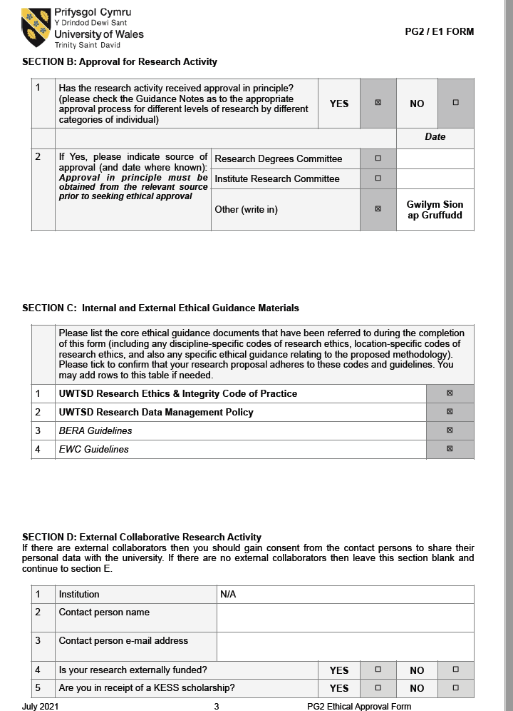

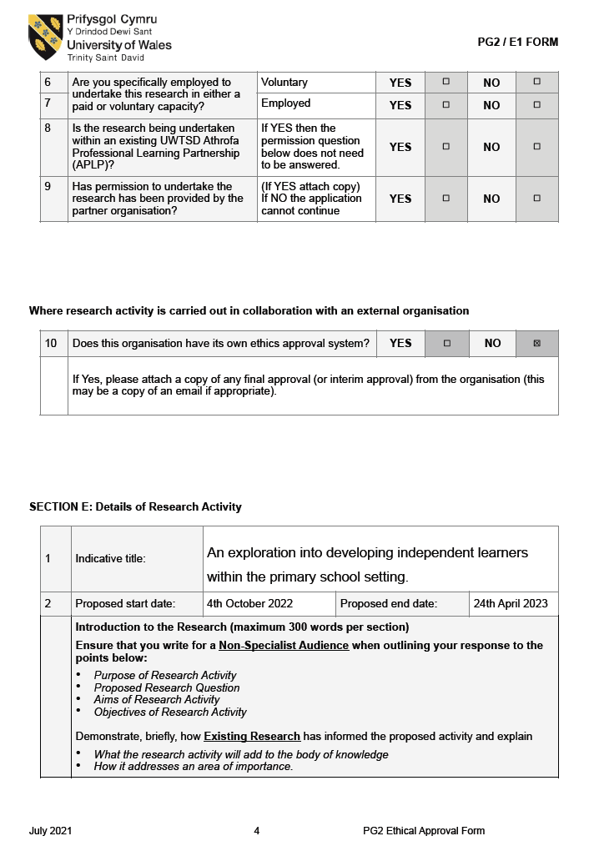

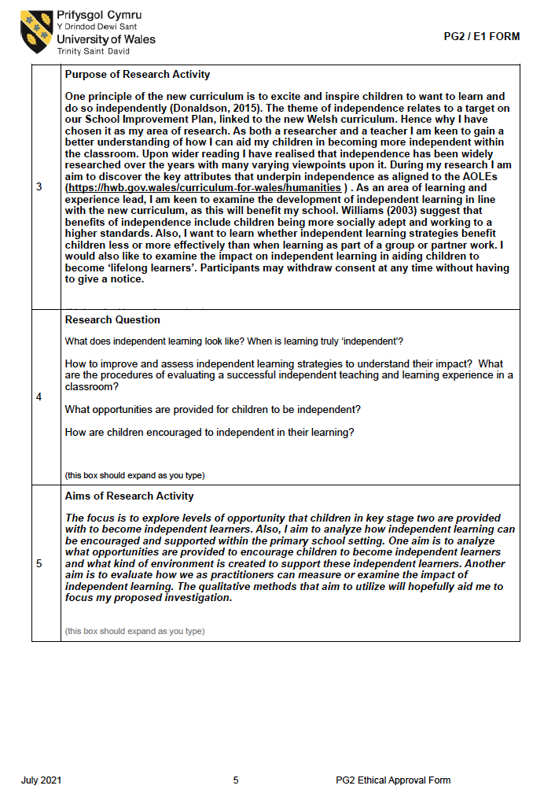

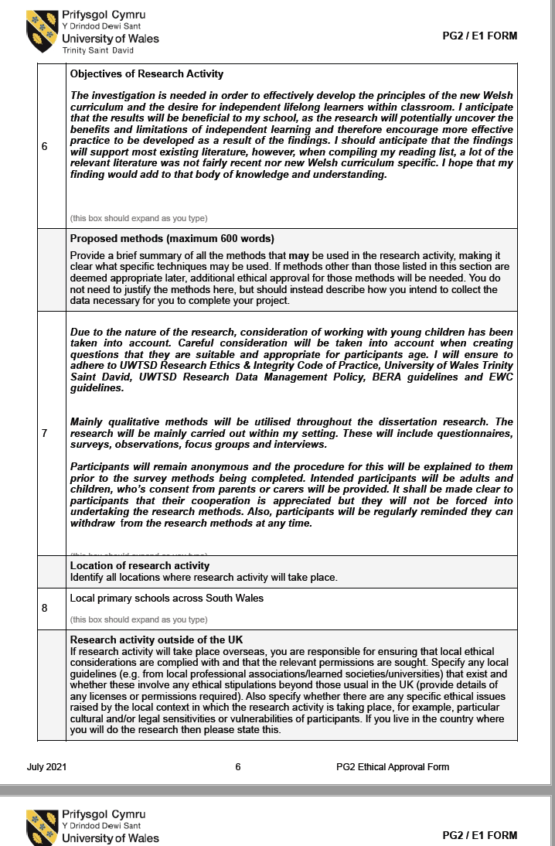

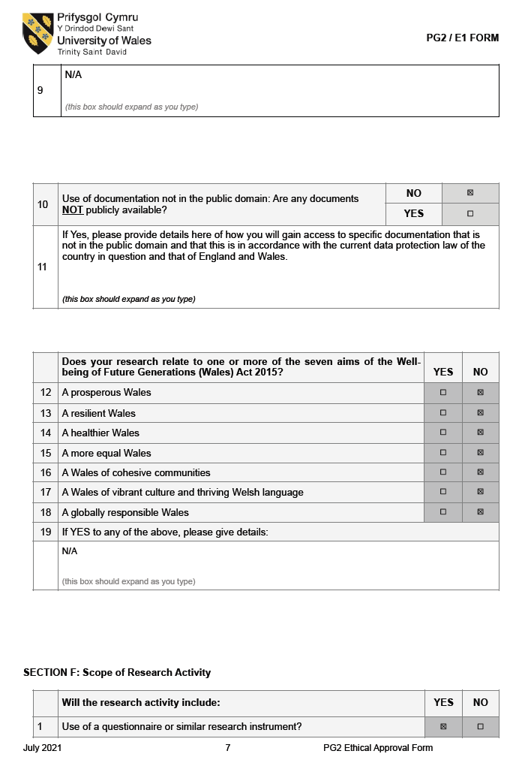

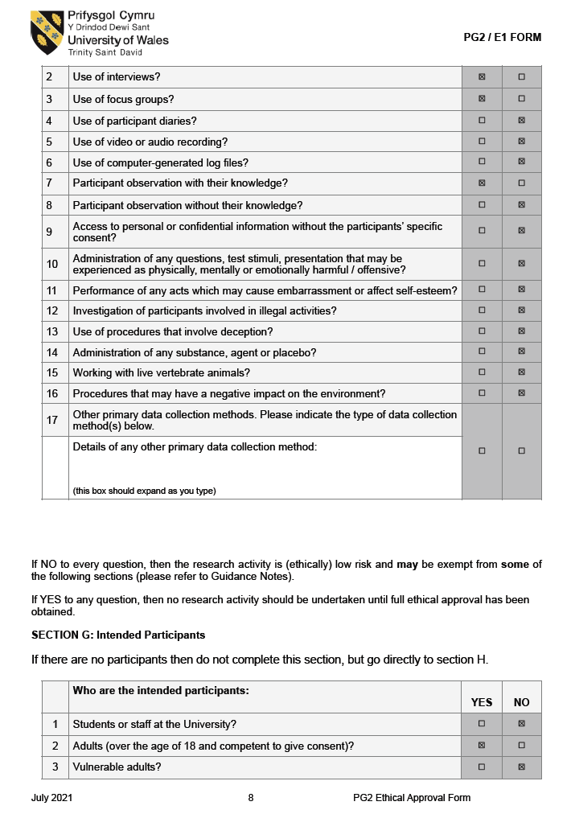

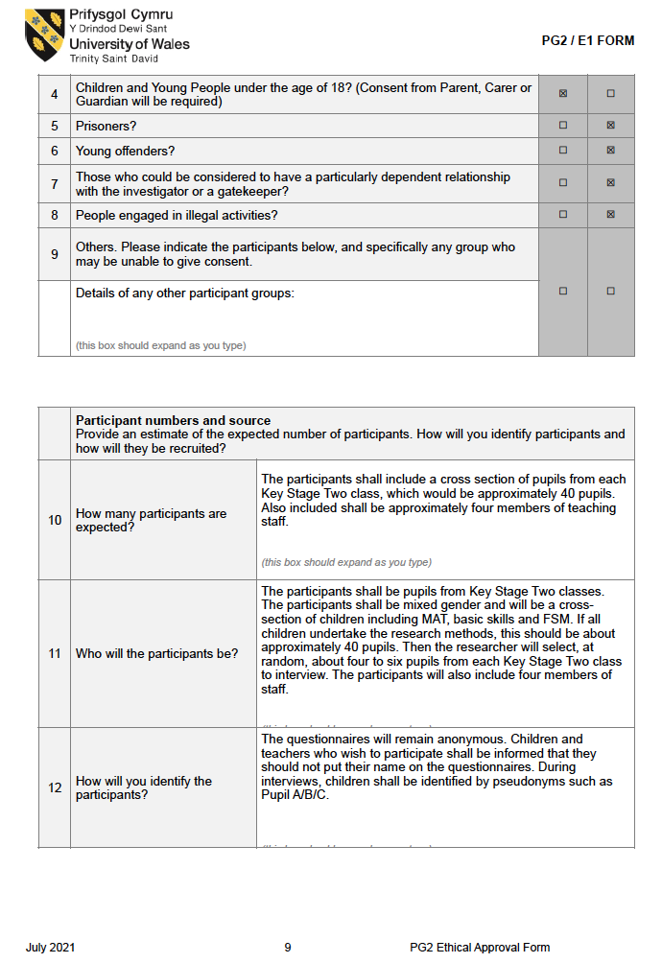

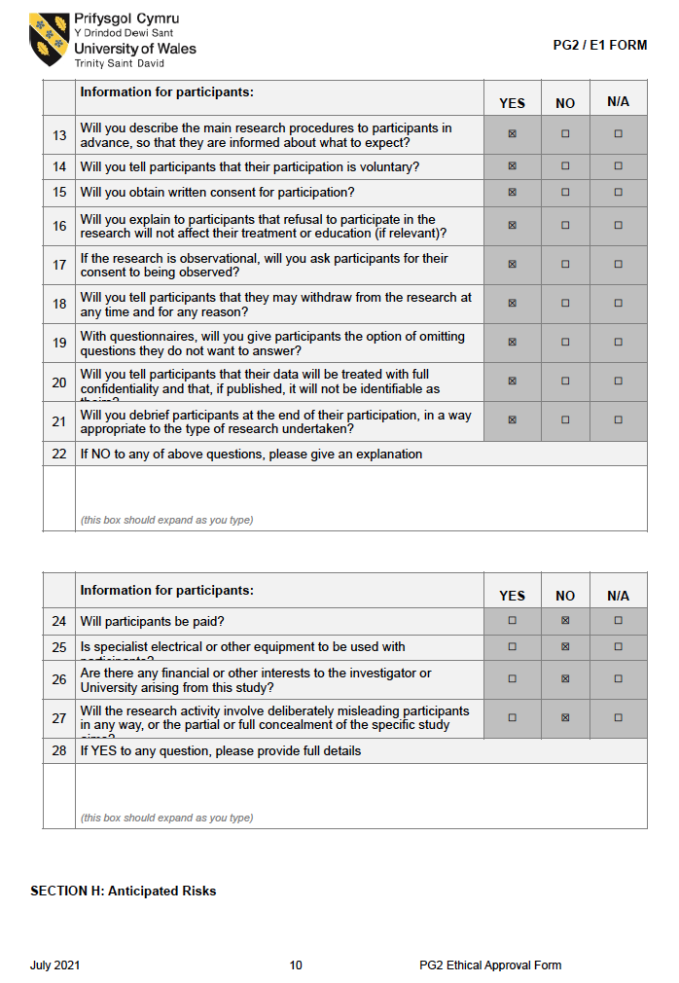

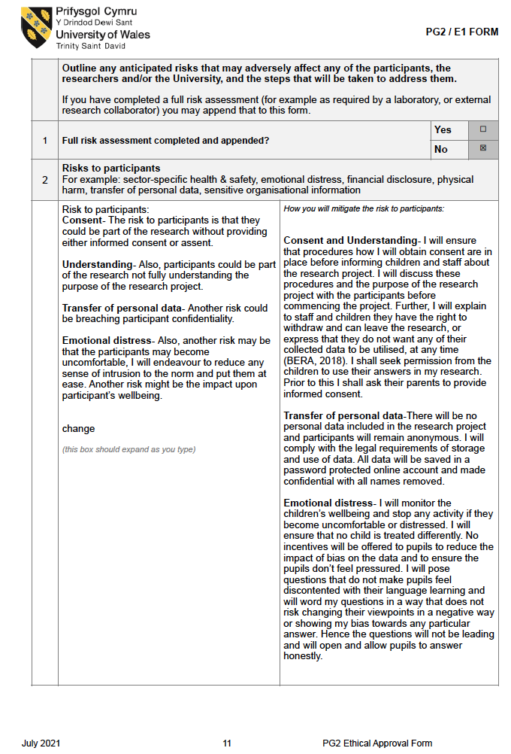

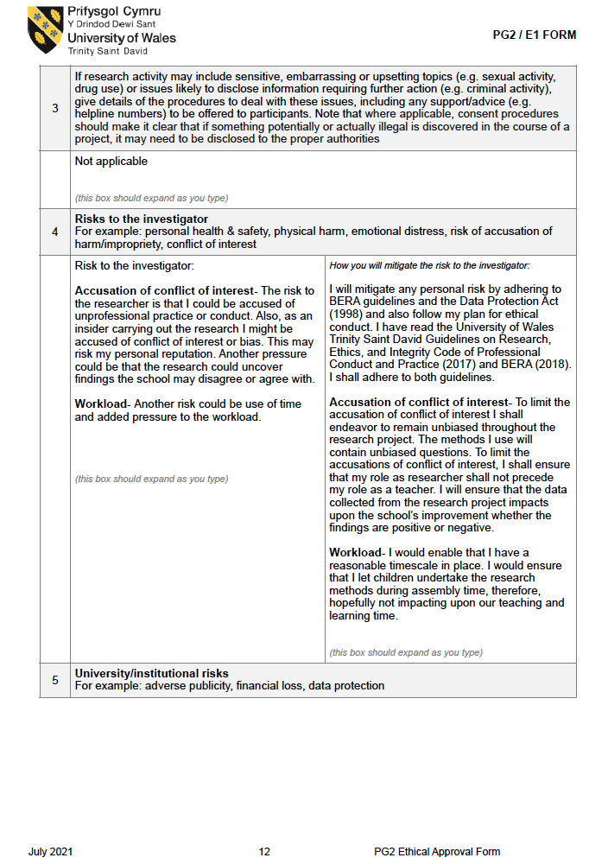

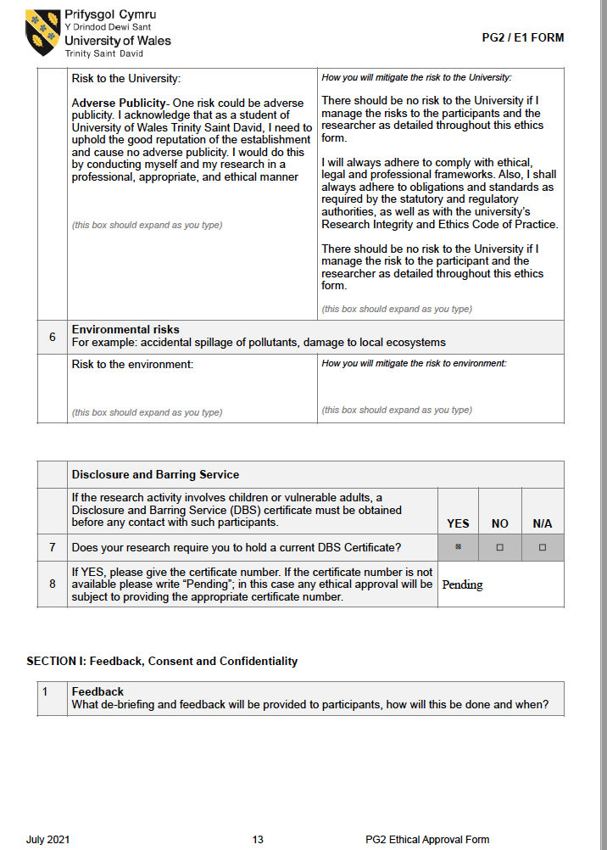

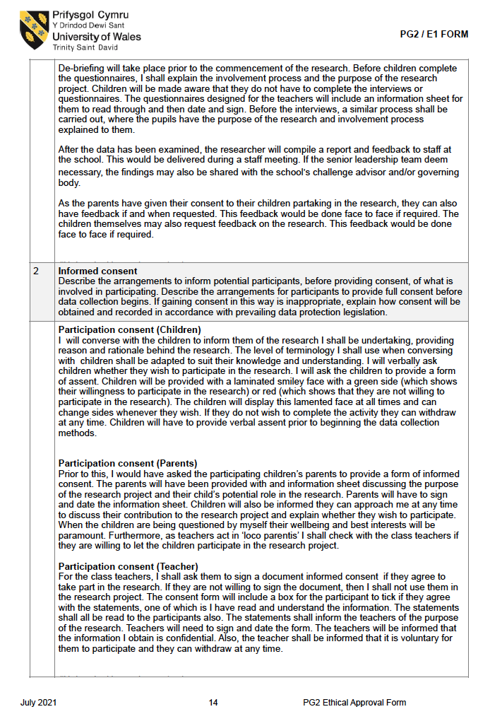

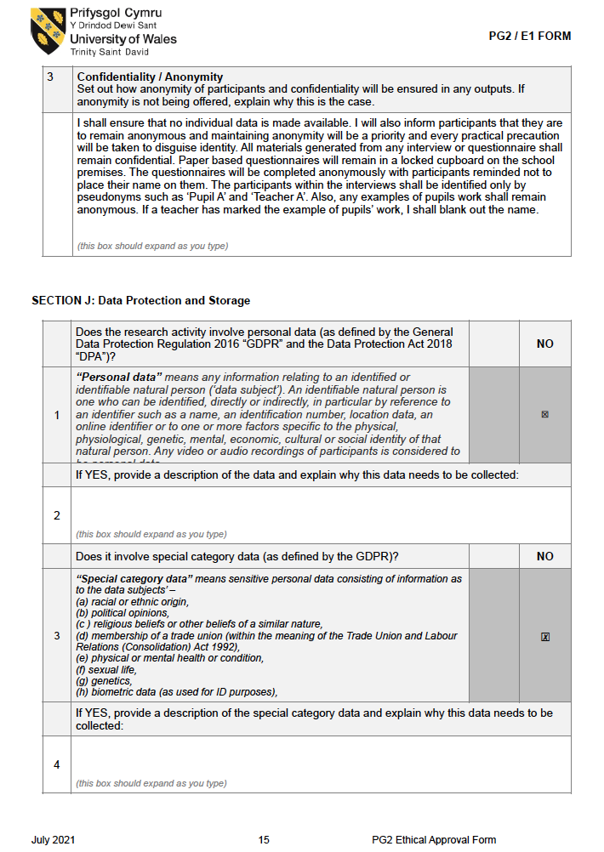

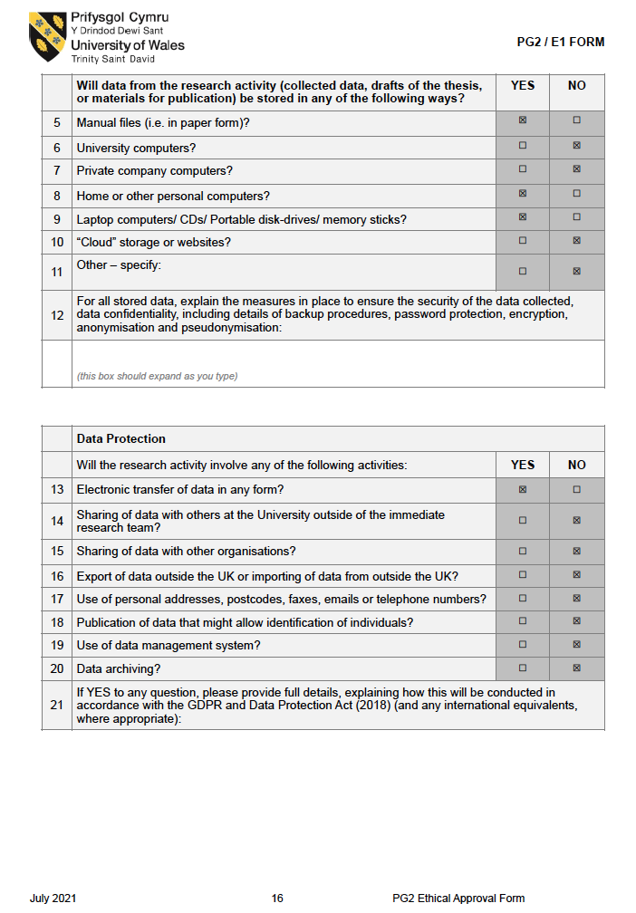

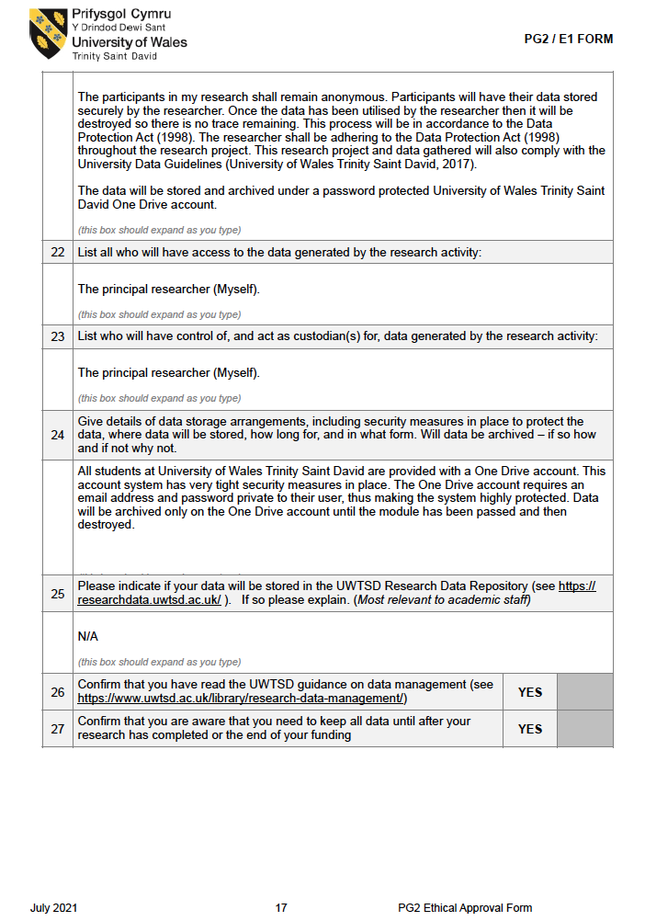

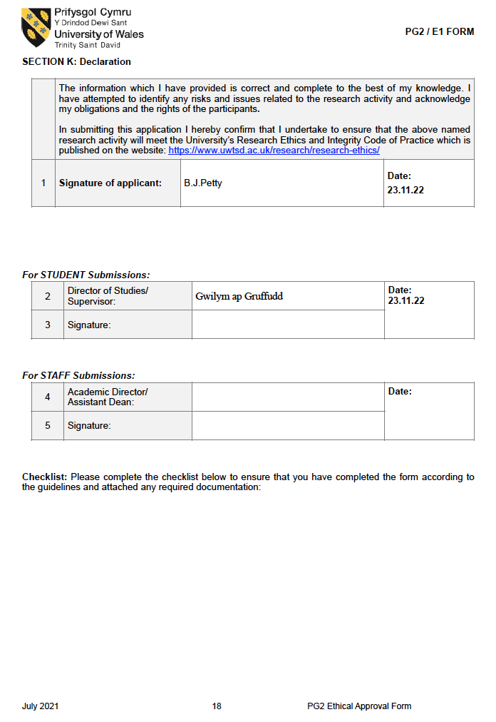
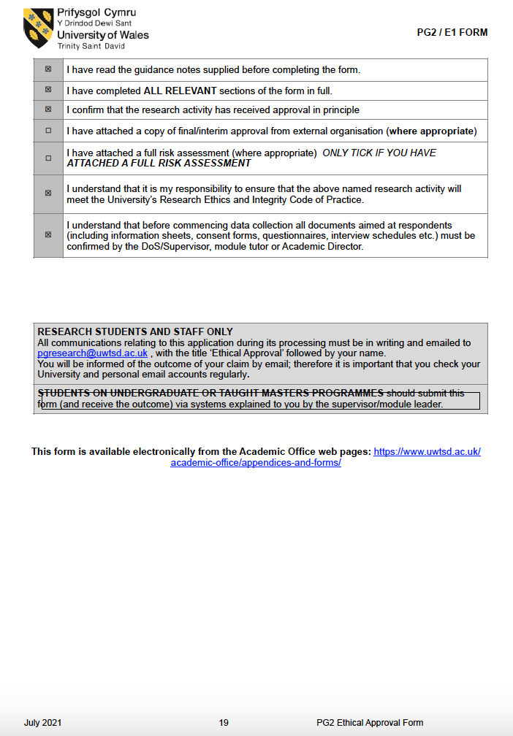

Appendix Two- Parental assent form

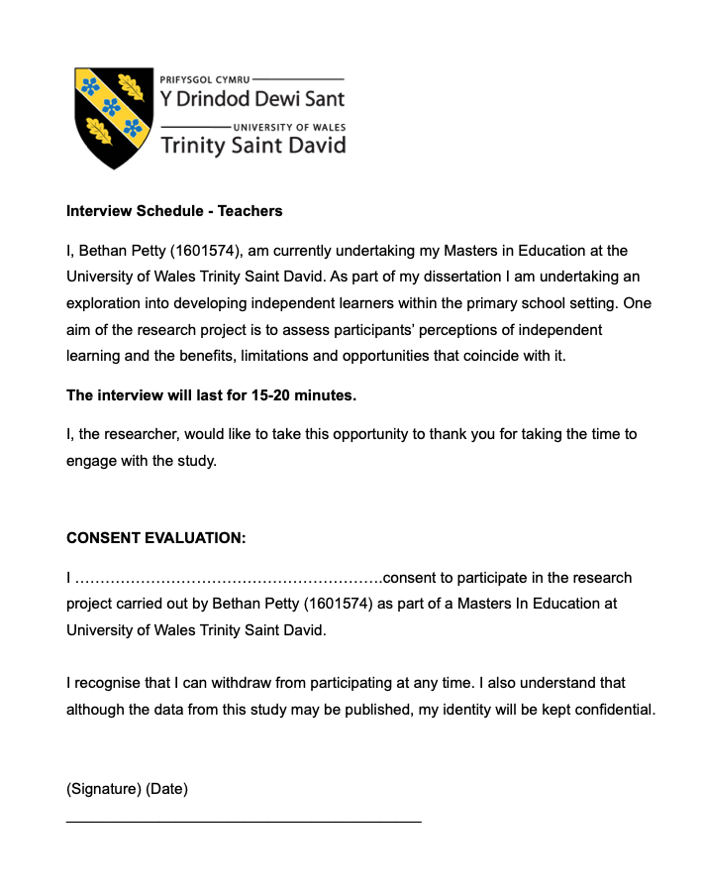
Appendix Three- Teacher interview schedule

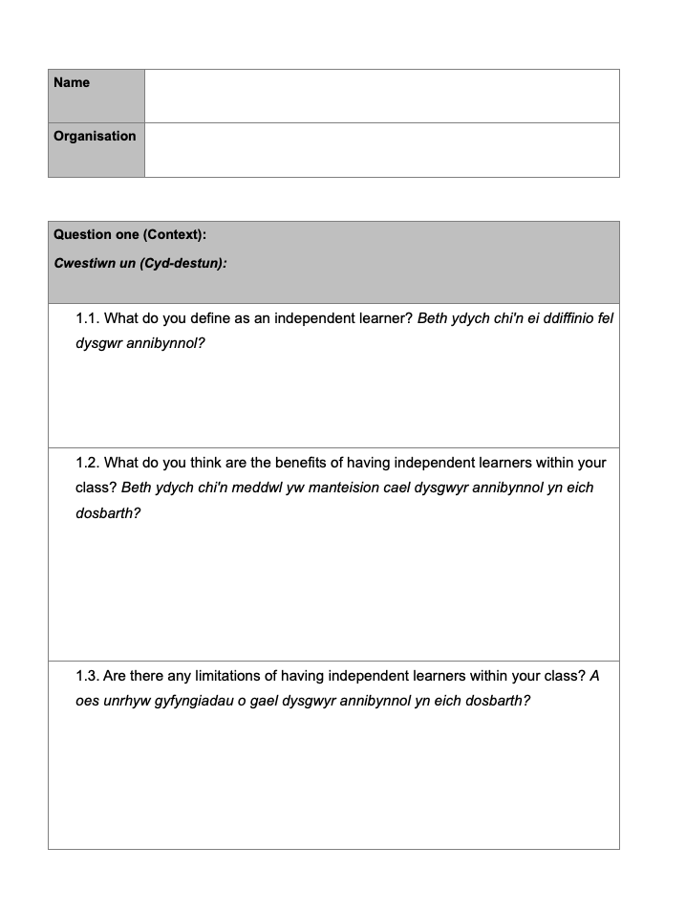

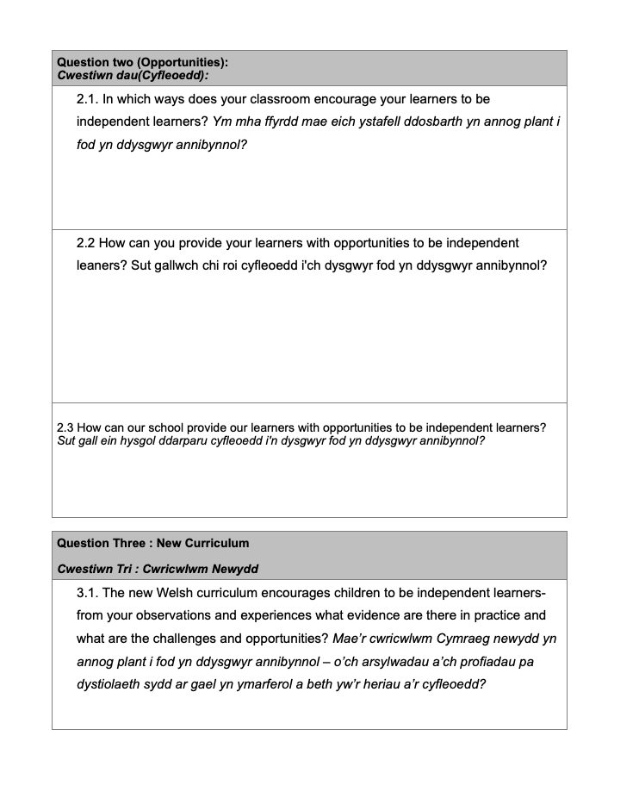

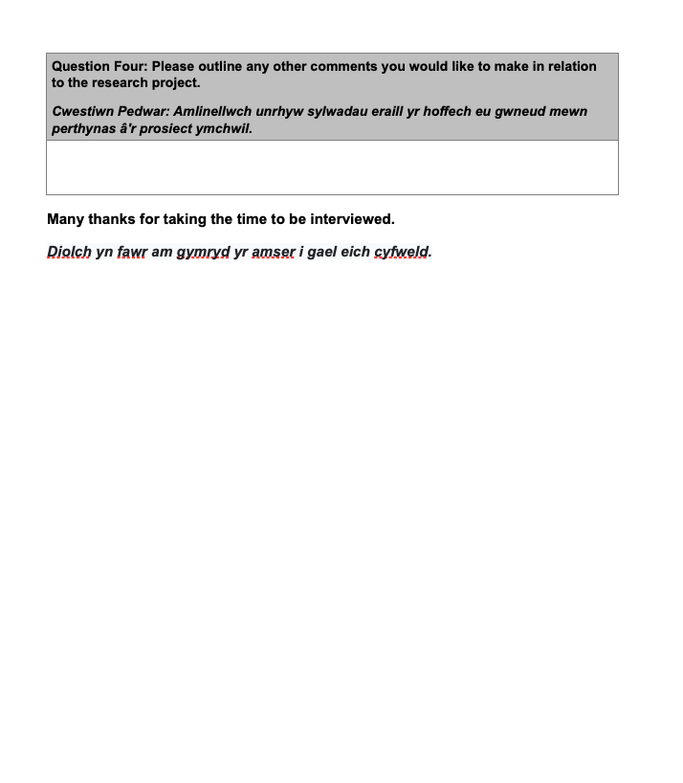

Appendix Four- Pupil interview schedule




