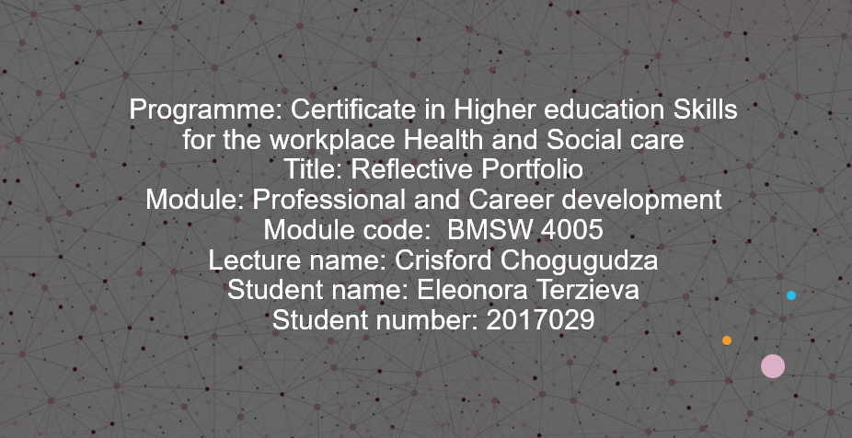

Contents
My skills and competencies 3
How I would assess the learning and development training of my staff 5
How are learning and development needs identified? 5
Common learning and development evaluation methods 5
CPD system 6
Reflective learning 7
What I learnt in the model 7
Who is responsible for promoting mental health in the workplace and community? 8
Learning style 9
References 10

My skills and competencies

It is very important to know your own skills and competencies for the workplace, it is something essential we are prepared for at university, to identify our abilities, and through the continued use of practical strategies, to turn them into polished skills which become our competencies. I will evaluate my own competencies through the use of a personal development plan, and a personality test.
I have chosen to use a personal development plan because it takes into account several aspects of life, according to Taylor and Edge (1997), ‘Dimensions of the PDP include job skills, the wider business, the home and personal life and the wider community.’

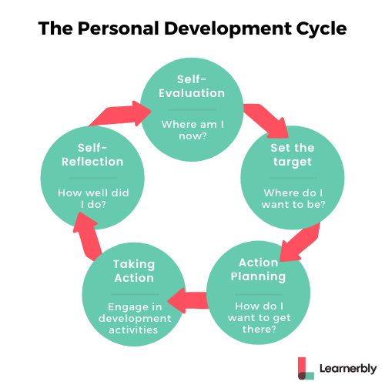

Self-evaluation stage, I am currently quite capable of assimilating new information, and of understanding the social and care needs of vulnerable people, as well as their developmental stages in life.
I want to use this to reach a job in social care, and I plan to undergo relevant training to reach that point.

I will also be using a personality test to help explore my strengths and weaknesses. The result of my test is below, I am classified as a turbulent advocate type of personality.
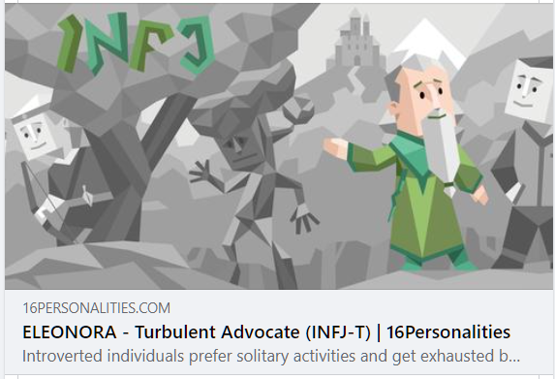
For my skills, according to the results of my test, a social worker job is apt for me. That is because the skills of being passionate and altruistic, fit well with the requirements of the job. Advocates generally stand for what is right and make it their mission to connect with others and make positive differences in their lives.
My strengths include, warmth, honesty, supportiveness, creativeness, and a passionate attitude.
My weaknesses are, a high sensitivity to critics. It’s good to be sensitive to the needs of others but when my values and principles are questioned, I don’t accept it calmly. A violent reaction might ensue and I will feel attacked and withdraw into my bubble.
To improve this issue I need to get a better control over my emotions and wait until I have calmed down before making judgements.
It is also hard for me to know if the people I’m working with are overwhelmed with the workload, and to fix this I plan to do weekly check-ins where we’d discuss how I could better support my team and if there’s any issues we’d need to tackle.

How I would assess the learning and development training of my staff

How are learning and development needs identified?
To identify learning and development needs, we need to be aware of the organisation’s needs and goals, then we can assess our current situation and compare it to our ideal scenario.
To assess this we can use several methods of identification and training, from formal to informal, however ‘formal training is prioritised due to a perceived more tangible demonstrable return on investment’ according to McDowall and Saunders (2010).
Formal methods of assessing this include:
- Collecting the existing data of the organisation’s employees productivity and satisfaction, as well as knowledge.
- Team meetings across different levels
- Questionnaire and surveys gauging the gaps of knowledge and confidence of workers.
- Performance data
Informal methods of assessing include:
- Informal conversations with stakeholders, where discussions of the goals and future of the organization are held.
- Observations, observing the company from the eyes of a worker and/or new hire

Common learning and development evaluation methods
The company’s performance is made up of the efforts and achievements of individual employees, so as a manager I will try to provide to my employees with the tools they need to improve their performance and maximize their potential.
I will set clear expectations for each role, in order to do this I will:
Determine our training and development needs; I must first set clear expectations for each role in our organization. This creates a benchmark for monitoring performance.
I will review the job description when a new position is created or when a significant change is made to an existing role.
I have to remember to respond to minor changes on a regular basis. This makes it easier for me to understand the skills they need to succeed in each role. And this helps identify skill gaps and potential training and development needs.

I will also be monitoring employee performance, instead of traditional employee surveys, I will focus on employee evaluation to encourage honest and open feedback. This will create helpful dialogue about career development and help me identify specific training requirements.
A simple way to do this is to ask employees to rate their job satisfaction and performance and then ask them what would make it better. Also, I will ask them to comment on my current training and development programme and to understand whether it`s supporting their career goals.
It is important to note that the strengths and weaknesses are current or negative, and the opportunities and threats are positive. Performing a SWOT analysis can create a bridge between what the company has achieved so far and the strategic alternatives that are being generated.
According to Piercy and Giles (1989) ‘‘The analysis of Strengths and Weaknesses, and Opportunities and Threats is probably the most common and widely recognised tool for conducting a strategic marketing audit’’, which is why I will be using SWOT to evaluate our developmental needs.

CPD system
‘Effective participation in a technology-based, knowledge society implies an increasing importance for voluntary learning and development’ says Collin, Van der Heijden and Lewis (2012).
Using the CPD management system, is a great way to keep the employees up to date, which is essential in a changing world of work. People’s skills and expertise can quickly become obsolete if not kept up to date, which can impact employee productivity and ultimately profits. The organization can encourage and reward employees, and can easily monitor, manage, and encourage positive behaviour.
I have selected this method because it is all around the year as it is continuous, and works toward ensuring excellence at any moment. It is also holistic and takes into account ever-changing needs and requirements of jobs.
However we have to be careful, Cossham and Fields (2007) warn us that ‘there is a significant gap between the CPD that individuals want, and that which their managers think they should have.’
Many organizations now grant employees CPD days each year (such as annual leave) to hone their skills, and become more competent in their work, and in some cases their own lives. When necessary, workshops and paid training would take place to fill in the gaps of skill and knowledge our organization may have.
Few things affect workplace culture, productivity, and morale more than communication. As a manager, having good communication skills can bring significant short-term and long-term benefits to your business. Effective communicators can motivate teams to achieve more with better results and less misunderstandings.
Communication is essential for everyone in the company. Communication provides employees and managers with the opportunity to express their concerns and ideas in the workplace. Employees who lack communication skills can be dissatisfied because of their colleagues, workplace rules, or with bosses that haven’t heard their thoughts and concerns.

To improve employee communication, as a manager I need to spend time meeting employees in person and explaining what communication is. I don’t have to be a public speaking expert to provide coaching on communication skills to make my employees more effective.
I will invite criticisms and ideas, inform employees that it is okay to express their thoughts and feelings as needed. Use examples to help employees better understand.
Suppose an employee has a way to reduce the time it takes to complete a particular task, employees need to transfer this information to their manager for further discussion.
I would explain the importance of staying calm when communicating. When an employee encounters a problem, he or she should be as calm as possible to address the cause of the problem. Employees need to know that anger and frustration only cause more problems. If you want to get angry, just leave. Communication will be more effective if you choose your language carefully.
Also be frank when communicating with colleagues and bosses. Discuss body language when communicating, we emphasize the importance of body language. Instruct employees to keep eye contact with the person they are talking to, stand upright, and appear relaxed. Explain that body language shows a person’s self-confidence. Give examples of positive and negative body language.

Reflective learning

I will be using Gibbs’ reflective model to illustrate my experience and learning in this module, by stating and describing what I have learnt, evaluating skills I have developed, and concluding how it will help me in the future.

What I learnt in the model
The professional career development module in this course is preparing us for the professional and/or academic challenges that are awaiting after our graduation.
I am learning how to figure out what I want to do with my life, how to investigate techniques and ways to get there, and how to improve my self-promotion and presenting abilities. I am also learning how to behave professionally in today’s environment. This led me to have a better understanding about the relevant laws, rules, ethics, and practises for my chosen career, which is social care, and will help me be a strong applicant in the future.
While completing this module, I am improving my ability to be:
1: Critical, reflect on and develop an appropriate level of professionalism in my chosen career path
2: Develop and test strategies to reach professional development goals, as well as answers to problems that emerge.
3. Improve my professional presenting abilities.
4. Organize my time and knowledge so that I may work independently.
5: Incorporate ethical and professional ideals applicable to my employment and educational route into my professional practices.
In this module I also learnt that if we want to be happier, more influential, better decision makers and more effective leaders, self- awareness is the most important muscle I need to develop. It’s what puts us on track to be the best version of ourselves.
Psychologists Duval and Wicklund (1972) say ‘If you’re highly self-aware, you can objectively evaluate yourself, manage your emotions, align your behaviour with your values, and understand correctly how others perceive you.’
Self-awareness is important to recognise our strengths and weaknesses, and will help me in the future to manage my emotions, accept criticism and consider other people’s point of view.

Who is responsible for promoting mental health in the workplace and community?
I learnt that the set of legal and juridical rules that safeguard every worker throughout their duty is known as labour legislation. This set of rules and regulations ensures that the relationship between the employer and the employee is harmonious and fair.
A good mental health is essential for a person to realise their potential and to cope with daily challenges, work efficiently, and give back to their community. On this premise, individuals, communities, and cultures all around the world can consider mental health promotion, protection, and restoration as critical priorities.
This is affected by the amount of working hours and days we spend at work, a negative emotional state caused by the work environment may cause a mental health disorder. Every workplace should implement interventions and policies that safeguard and promote good mental health.
It is the workplaces responsibility, morally, to ensure a health environment where employees can thrive. It is also required by law that organizations provide basic provisions to help maintain a mentally healthy environment’
We know from Sloane and Mackay (1997) that ‘European Community Law takes precedence over UK law and increasingly dictates legislation changes.’ And employers must follow and comply to this law, and ensure good working conditions.
This will help me in identifying a secure and safe environment to work, and inversely, an unsafe working environment which can then be reported to the relevant bodies.

Learning style

‘Learning depends upon many personal factors and everyone has a distinct learning style’ Montgomery (1996).
I used a learning style test to learn about myself and what works best for me.
According to the learning styles test, my most prominent learning style is tactile (45%), that is to mean that I learn better by doing and touching, generally acting and being practical, making mistakes and understanding why, instead of watching or reading.
I agree with this assessment as various experiences in my life show me that. Sitting in a chair and reading information helps me get an idea of a process or concept but acting it out or practicing something myself is a better way for me to truly understand it and be able to implement it in my life.
That is until we got to the practical lessons, where I could apply my knowledge and solidify it by doing the things I was taught. Learning by trial and error just helps me make the necessary connections in my head of why something must be done the way it is.

References

Collin, K., Van der Heijden, B. and Lewis, P. (2012), ‘‘Continuing professional development’’. International Journal of Training and Development, 16: 155-163. Accessed: 3rd April 2022

Cossham, A. and Fields, A. (2007), “Balancing individuals’’ expectations and organisational requirements for continuing professional development”, Library Review, Vol. 56 No. 7, pp. 573-584. Accessed: 3rd April 2022.

Duval, S. and Wicklund, R. A. (1972) ‘‘A theory of objective self awareness.’’ Academic Press. Accessed: 3rd April 2022.

McDowall, A. and Saunders, M.N.K. (2010), “UK managers’ conceptions of employee training and development”, Journal of European Industrial Training, Vol. 34 No. 7, pp. 609-630. Accessed: 3rd April 2022.

Montgomery, S. (1996). ‘‘Addressing Diverse Learning Styles through the Use of Multimedia’’, University of Michigan. Accessed: 3rd April 2022.

Piercy, N. and Giles, W. (1989), “Making SWOT Analysis Work”, Marketing Intelligence & Planning, Vol. 7 No. 5/6, pp. 5-7. Accessed: April 3rd 2022.

Sloane, P.J. and Mackay, D. (1997), “Employment equity and minority legislation in the UK after two decades: a review”, International Journal of Manpower, Vol. 18 No. 7, pp. 597-626. Accessed: 3rd April 2022.

Taylor, D. and Edge, D. (1997), "Personal development plans: unlocking the future", Career Development International, Vol. 2 No. 1, pp. 21- 23. Accessed on: 3rd April 2022.

