April 4, 2022
Management Economics LCBB5003
University of Wales Trinity Saint David

The COVID19 pandemic influenced all the economies across the world. Using economic policy analysis outline and evaluate the effects on employment and standard of living in the UK with respect to managerial decision-making in organizations (SMEs or large organizations).

Vasilios Tavlaridis

Introduction
The purpose of this essay is to analyze and evaluate the impact of COVID-19 on employment and the standard of living in the UK and how it influences managerial decision-making in organizations.

On January 30, 2020, World Health Organisation confirmed a global emergency because of COVID-19 (it is a disease that causes Severe Acute Respiratory Syndrome Coronavirus 2(SARS-Cov-2). This Coronavirus affected humans in different aspects of healthcare systems globally. The COVID-19 epidemic made the government make decisions on travel restrictions, quarantine, and shut down borders, this decision was to prevent recession and economic crisis. Also, the virus affected many sectors such as primary sectors which are responsible for extracting raw materials which include petroleum, oil, and agriculture, secondary sectors responsible for final products which include manufacturing, and tertiary sectors for all services for example finance and education industries (Nicola et al., 2020).

Options needed to manage uncertainty inflation and deflation

Inflation or deflation will be a topic that will be always questioned in the economy. It is important for business leaders to be ready for uncertainty and they must be prepared for different pricing environments. Also, companies must be prepared for inflation and deflation due to uncertainty, that is why is necessary to adopt good strategies to be in a good position. Firstly, there is a need to monitor and follow changes in inflationary, price changes all the time therefore business leaders need to be prepared for these changes using a strategies control plan to allow them to set prices when uncertainty happens. Secondly, other strategies such as diversification and dimensions include currency exposure, manufacturers, selling destinations, funding sources, and maturities. There is a need to maintain the balance and respect the assets and liabilities duration matching. The diversification will lead to a reduction of risks or instability that can have different results. Lastly, there is a need for companies to be agile, they should be ready for any uncertainty, and changes that may happen in the macroeconomic environment. It is important to continue building a good relationship with suppliers and customers which are advantages and opportunities to keep a strong relationship in challenging times (Steidtmann, Latimore, and Denison, 2011).

Inflation and cost of living
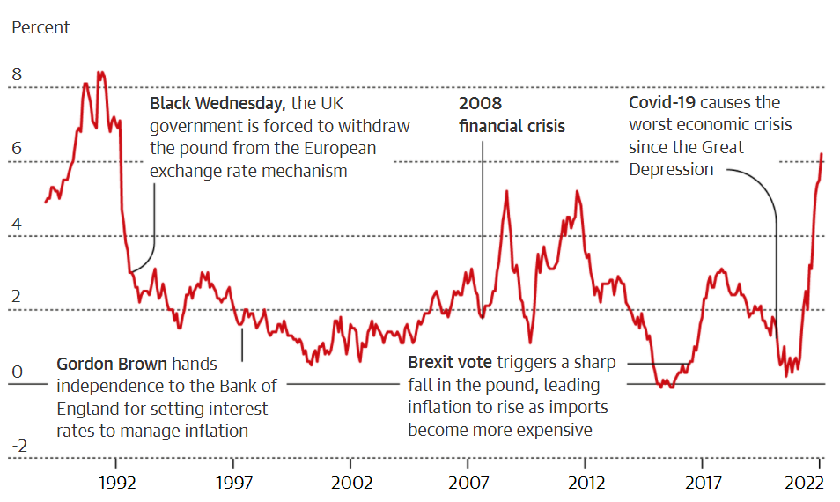
Figure 1: Represents the UK inflation since 1992, which has reached the highest level after COVID19 (Guardian Graphic, 2022).

The UK inflation is considered the highest at 6.2%. Britain’s cost of living was hit by inflation in February which reached 6.2%. In January, the cost of living was 5.5%, diesel and petrol rose, games, toys, and goods please refer to figure 1. The inflation for consumer prices index was higher than 5.9% expected in February by Reuters and UK households will be forced to hold on because the cost of living is rising more. The reason for inflationary hitting the highest record was caused by higher living costs of gas and electricity. The chancellor was advised by the labor and business group about living costs. Chancellor Sunak made a statement about tax and spending on March 23, and what support will be given to households. Rachel Reeves, the shadow chancellor, mentioned the need to check the plans to increase the insurance contributions because it will help workers going through this difficult time on living standards. In 1992 the highest inflation rate for the consumer prices index was 7.1%. In April energy prices will go up because Russia invaded Ukraine. Also, in April inflation will increase to 8% as anticipated by the Bank of England and if the energy price cap continues to increase then inflation should decline (Elliot and Partington, 2022). Refer to figure 2 for inflation
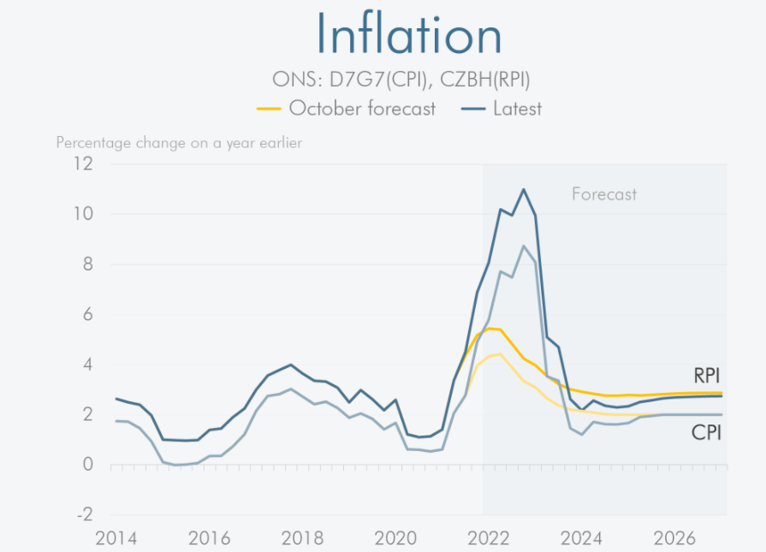
Figure 2: Represents Inflation (Office for Budget Responsibility, 2022).
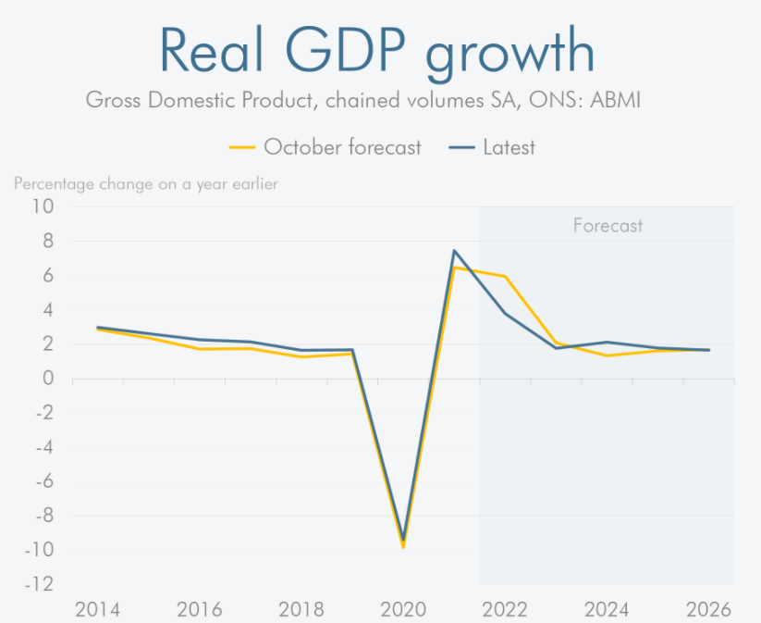
Figure 3: Shows GDP growth over the years (Office for Budget Responsibility, 2022).

Gross Domestic Product

Gross Domestic Product (GDP) predicts the growth and size of the economy and will calculate the value of goods and services produced in the UK as seen in Tables 1 and 2. Table 1 shows the first five regions gross domestic product increased in 2020 and table 2 April to June 2021 increase (Officer of National Statistics, 2021). Refer to figure 3 as GDP.

GDP for all countries and regions of the UK 2020 | From January to March (Q1) 2020 | From April to June  (Quarter 2) 2020 | From July to September  (Quarter 3) 2020 | Oct to Dec  (Q4, 2020)
UK | -2.6% | -18.8 | Increased 16.9% | 0.2%
England | -2.7% | -19.0% | Increased 17.2% | 1.2%
Scotland | -3.3% | -19.1% | Growth 15.8% | 2.3%
Northern Ireland | -1.3% | -13.6% | Increased15.4% | 0.7%
Wales | -1.4% | -15.2 | Increased14.4% | 0.9%
Southwest |  |  | Growth 19.9%
London |  |  | Small growth of 13.3% | Increase 3.1%
West Midlands |  |  | Annual GDP fall 11.3% | 0.3%
East Midlands |  |  |  | 0.8%
Northern Ireland |  |  | - 2.9%
Northwest |  |  | - 4.2%
Table 1: Refer to GDP, UK countries, and regions from January to Dec 2020 (Officer of National Statistics, 2021).

All Countries and regions of the UK, 2021 | January to March  (Q1, 2021) | April to June  (Q2, 2021)
England | Decreased 0.6% | Increased 4.8%
Scotland | Decreased 1.6% | 5.6%
Northern Ireland | Decreased 1.0% | Increased 3.0%
Wales | Decreased 1.7% | Increased 6.2%
East Midland | -1.45
Northeast | -1.3% | Increased 6.9%
Northwest | -1.3% | 4.0%
Southeast | -1.3%
East of England | Increased 0.5% | 4.2%
Table 2: Represent GDP, UK regions, and countries from January to June 2021(Officer of National Statistics, 2021).

Economic Policy Definition

Economic policy is the actions the government sets that control and influence the economy. These policies are used by the government for administration and implementation. The government uses these policies to help in decision-making related to taxation, spending, the supply of money, and how income will be distributed between rich or poor individuals. Economic policy is used in two different methods to evaluate efficiency known as positive and normative economics. The positive economics, it will tell how the policies will be used by the government without saying which outcome is the best. Normative economics will use value judgments to see the economy and economic policies’ performance (CliffsNotes, 2022).

Monetary Policy
The monetary policy reflects inflation and economic analysis used by the monetary policy committee to help make decisions about the interest rate. Monetary policy is the action taken by the central bank or government which will influence the economy. There are two types of monetary policy bank rate-setting the interest rate and quantitative easing (QE). Monetary policy will influence inflation and will be used to meet the target required by the government to maintain inflation at 2%. Monetary policy aims to maintain inflation as lower as possible for benefit of the UK’s economy (Bank of England, 2022).

Fiscal policy

Fiscal policy is the way the government gets money from taxation and how they will spend money which can impact the economy. The government will increase its expenditure, cut tax rates, cut spending, and raise taxes to promote the economy (Hayes, 2020).

Interest Rate

The interest rate is how it will cost borrowing money and how a saver will be rewarded when saving. When a borrower borrows money, it will tell the interest rate they should payback. If they borrow a higher percentage, they will be paid back at a higher rate. For savers, the more they save higher the rate they will receive into their account (Bank of England, 2016).

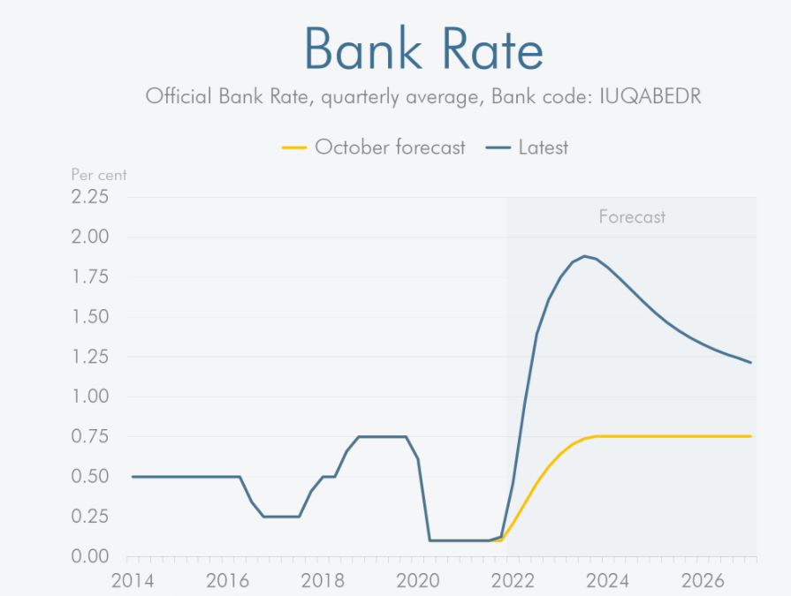
Figure 4: Represent Bank Rate (Office for Budget Responsibility, 2022).

The economic policy regarding COVID-19

COVID-19 impacted the economy hopefully it will not last long. The best way to recover is to deal with COVID19 now through the public health guidelines there is a need to follow the rules on social distance to lower the spread of the virus, therefore introducing restrictions was one of the ways the government found to control the virus. Also, the government must act on economic policy to avoid short-term and long-term economic consequences. To ensure the economy recovers from COVID-19 there are three elements to consider such as mitigation, prevention, and recovery (Mulheirn et al., 2022).
Mitigation – the need to use actions to boost the economy. Fiscal procedures target emergency support to help unemployed households to tackle poverty and health systems (Mulheirn et al., 2022).
Prevention – needed use of prevention on the supply side actions will help maintain workers and the company together and avoid the supply chains to collapse. Companies paying workers’ wages for employment retention schemes will be attainable and loans, grants, and tax breaks for companies to maintain them to not fail in the specific requirement (Mulheirn et al., 2022).
Recovery – for recovery being strong there is a need to use mitigation and prevention. The government must ensure they will continue and be committed to supporting more than necessary. Businesses must be prepared today if they have a strong recovery is good because it will allow them to pay their debt in the future and be prepared to prevent them from insecurity. Mitigation, prevention, and recovery are used to make sure that the economy continues strong as possible. There are unavoidable things, and a pandemic is one of them. Policymakers need to continue to act, use innovation and be vigilant. The economic policy is important because each person in the world will be able to understand these practices and need to follow the responsibilities (Mulheirn et al., 2022).

Economic policy – employment support scheme

The Coronavirus Job Retention Scheme (CJRS) was announced by the government on 20th March 2020, for the Self-Employment Income Support Scheme (SEISS) on 26th March 2020 to support businesses because of the Covid-19 pandemic. The purpose of introducing this financial support was to help individuals as well businesses from Covid-19. These schemes supported millions of employers about 1.2 million during September 2020. Also, guaranteeing 9.6 million jobs add up to £9.3 billion and CJRS £54.5 billion. For SEISS was expected to reach 2.6 million claims on 20th September 2020 equalling £13.4 billion. The Office for Budget Responsibility estimated the SEISS claims would be around £ 15.2 billion in total almost £70 billion. By implementing these schemes government wanted to make the scheme effective. The schemes will be available for people who are eligible as well to avoid error and fraud. The aim was to implement this scheme with a schedule available to support individuals quickly as possible. Also, this scheme allows the government to maintain jobs and people who are on furlough will be able to return to their work again. On the contrary, other people were not able to apply for support and lost their earing as well. This scheme helped the government to mitigate the error and fraud as well as having limited access to this support to prevent error and fraud. Also, the government should inform employees about this scheme because not all employers were eligible to have access to this support (National Audit Office, 2020).

Employment

Labour Force Survey (LFS) is responsible to calculate the number of people in employment in the UK which include people aged 16 and over and people working minimum hour or in the job even temporarily out of work because of sickness or on holiday. Employees and self-employed were reported all together at 99% and considered the two largest categories in employment. Employees and self-employed people are considered the two largest categories in employment. Employees are people that are considered for employment while self-employed have or are not employees and work for their account. People on government support training programs and unpaid family workers are considered minor about 1% of this category for employment (National Audit Office, 2020). Please refer to figure 5 as an example of unemployment and figure 6 as earnings.

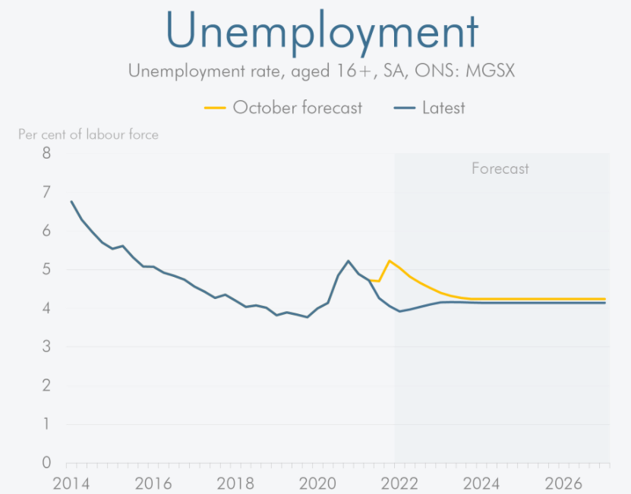
Figure 5: Represents Employment (Office for Budget Responsibility, 2022).

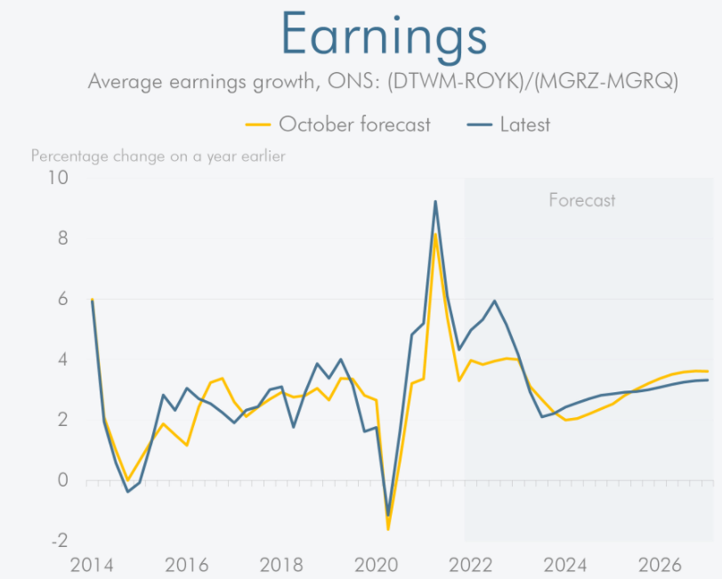
Figure 6: Represents Earnings (Office for Budget Responsibility, 2022).

COVID-19 impacted jobs and businesses

COVID-19 impacted many different jobs and organizations. Businesses were forced to shut down because of restrictions that impacted non-essential businesses as well catering and hospitality and retail were affected too (National Audit Office, 2020).

Labour Market statistics

Labour market statistics will evaluate different types of jobs and works to understand how the economy functions. Also, it is about individuals, their benefits and earnings, and the workforce. A framework was created for labour market statistics which will explain the ideas and relationships that exist between them known as supply and demand. Labour supply will be individuals who are economically inactive or unemployed or employed. The framework will be used for government schemes, employees, and the self-employed. For labour, demand will be employers who need members to care out the work and will benefit members as well. Members that use labour market statistics are economists, teachers, businesses, financial analytics, central and local government, academics researchers, employers’ associations, students, and trade unions. The aim is to be applying these statistics from those groups mentioned above is to help with planning, mentoring, and evaluation of the economy and labour market. Also, for social analysis and to inform people about any government policies regarding older people, jobless householders, women, and young people (Office for National Statistics, 2020).

Social Security System

The purpose of social security is to protect members of the community from any difficulty by taking actions needed for their safety. Also, support them and their dependents with health services and maintenance enough for them to survive. The resources they use are to help members to maintain safety. There are benefit and assistance schemes to support people in need with different types of benefits when they are not in higher income. With the purpose to help those individuals and social security is continuing to protect those individuals of lower-income from hardship (Richardson,2019).

The living standards 2020 in the UK

In May 2020, COVID-19 impacted UK living standards, especially among low and middle-income families and the young. Living standards will be how much families will receive and how they spend those incomes. Living standards were influenced by referendum inflation and post-Brexit. During the Coronavirus, the employment rate was 76.6 percent which left the UK labor market strong. National Living Wage made the pay inequality decline. Between 2017-and 2019 the income for non-pensioner did not grow. Also, between 2016-and 2019 the income decreased for lowest-income families because of Welfare support that was cut in 2015 Between Mach and May 2020 the working hours by employees declined by 17 percent, and the number of employees as well decreased to 574,000. Between February and May 2020, the self-employed said that their pay was reduced. The government launched the Self-employment Income Support Scheme (SEISS) and Coronavirus Job Retention Schemes (CJRS) to support individuals’ incomes. Please refer to figure 7 as an example of income for non-pensioner, figure 13 for lower-income households, and figure 9 for middle-income (Brewer et al., 2020).

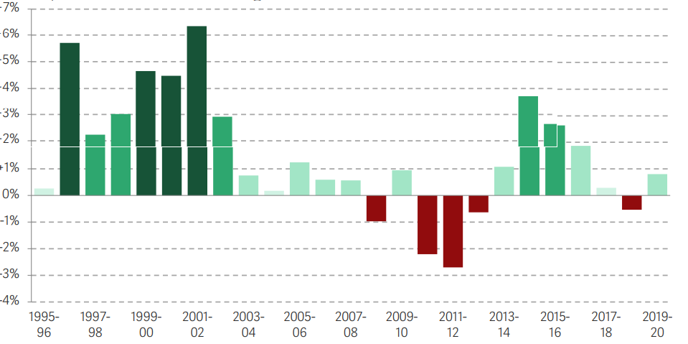
Figure 7: This represents non-pensioner income (Brewer et al.,2020).

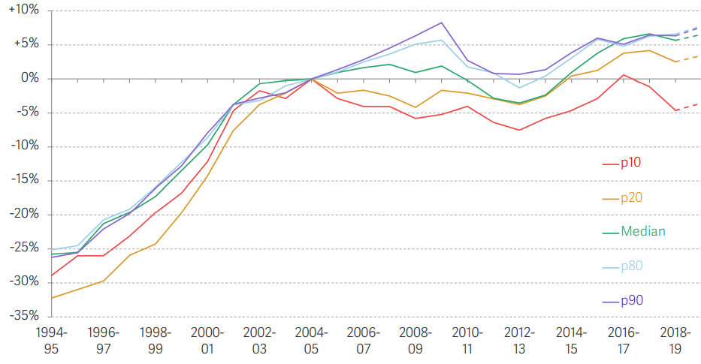
Figure 8: Shows real income for the lowest-income household not higher between 2018-2019 than in 2000-01 (Brewer et al.,2020).

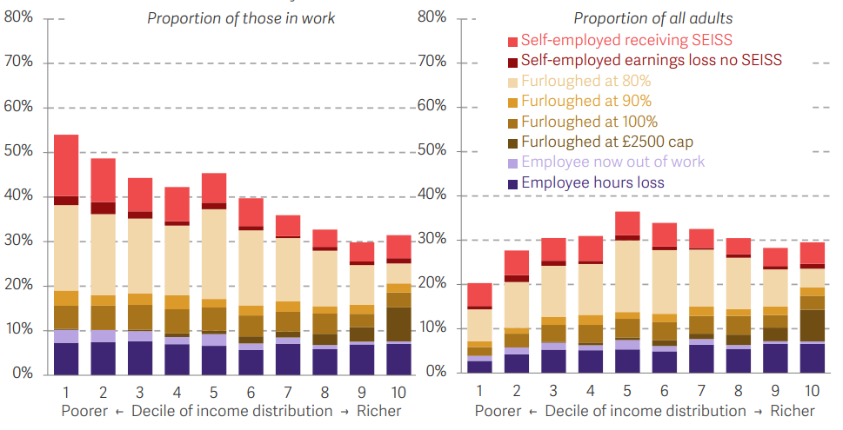
Figure 9: This figure represents middle-income were affected by the economic influence of Coronavirus (Brewer et al.,2020).

Families’ cost of living

Cost of living and families’ assets were affected by 35% lower income, 32% not being able to save, 25% were forced to use their savings to protect for living costs, and 24% used their credit and borrow money as well. The cost of living was increased because of higher prices of, gas, fuel, food, and electricity (Office for National Statistics, 2021).

Price Cap
In April the prices cap will increase by £693 for about 22 million customers. For direct debit customers the price will be £693, they use to pay £1,277 will increase to £1,971 and for pre-payment customers, it will increase £708 they will use to £1,309 will increase to £2,017and (Ofgem, 2022)

The impact of COVID-19 on organizations

COVID-19 impacted businesses over the world because of the lockdown and actions on social distancing. Those actions were to prevent the spread of the virus. Also, those procedures affected many sectors from hospitality, travel and tourism, manufacturing, and the sports industry. The supply chain and lower production were affected by workplace closure. People were concerned about the contagious and they started spending less because their salary was reduced, they worry about being dismissed which can put them to lose jobs and businesses closures. China is known for supplying finished products to many countries and knowing where the virus started. COVID-19 has been an encounter for the global supply chain and many SMEs (Thukral, 2021).

Conclusion

The government uses economic policy to help economic growth because uncertainty happens. Using the economic policy government will improve people’s lives in the world economy. COVID-19 affected the decision-making of living standards and employment. Using economic policies will allow members to make better decisions. The government enforced some measures on restrictions to follow to control the Virus. Also, many businesses were affected by the COVID-19 restriction.

Reference list
Bank of England (2016). What Are Interest Rates? [online] Bankofengland.co.uk. Available at: https://www.bankofengland.co.uk/knowledgebank/what-are-interest-rates [Accessed 1 Apr. 2022].

Bank of England (2022a). Monetary policy. [online] Bankofengland.co.uk. Available at: https://www.bankofengland.co.uk/monetary%20policy [Accessed 29 Mar. 2022].

Bank of England (2022b). Monetary Policy Report - February 2022. [online] www.bankofengland.co.uk. Available at: https://www.bankofengland.co.uk/monetary-policy-report/2022/february-2022 [Accessed 29 Mar. 2022].

Brewer, M., Corlett, A., Handscomb, K., McCurdy, C., and Tomlinson, D. (2020). The Living Standards Audit 2020 • Resolution Foundation. [online] www.resolutionfoudation.org. Available at: https://www.resolutionfoundation.org/publications/the-living-standards-audit-2020/ [Accessed 1 Apr. 2022].

CliffsNotes (2022). Economic Policy. [online] www.cliffsnotes.com. Available at: https://www.cliffsnotes.com/study-guides/economics/introduction/economic-policy?msclkid=6a9ef61db0ea11ec846db5c7571b2954 [Accessed 31 Mar. 2022].

Elliot, L. and Partington, R. (2022). UK inflation hits 6.2%, the highest level in three decades. [online] the Guardian. Available at: https://www.theguardian.com/business/2022/mar/23/uk-inflation-highest-level-in-three-decades [Accessed 24 Mar. 2022].

Guardian Graphic (2022). UK Inflation since 1992.

Hayes, A. (2020). Fiscal Policy vs. Monetary Policy: Pros & Cons. [online] Investopedia. Available at: https://www.investopedia.com/articles/investing/050615/fiscal-vs-monetary-policy-pros-cons.asp [Accessed 2 Apr. 2022].

Mulheirn, I., Browne, J., Wildi, B. and Alvis, S. (2022). Institute for Global Change. [online] Institute for Global Change. Available at: https://institute.global/policy/economic-policy-response-covid-19 [Accessed 26 Mar. 2022].

National Audit Office (2020). Implementing employment support schemes in response to the COVID-19 pandemic - National Audit Office (NAO) Report. [online] National Audit Office. Available at: https://www.nao.org.uk/report/implementing-employment-support-schemes-in-response-to-the-covid-19-pandemic/ [Accessed 30 Mar. 2022].

Nicola, M., Alsafi, Z., Sohrabi, C., Kerwan, A., Al-Jabir, A., Iosifidis, C., Agha, M. and Agha, R. (2020). The Socio-Economic Implications of the Coronavirus and COVID-19 Pandemic: A Review. International Journal of Surgery, [online] 78(78), pp.185–193. Available at: https://www.ncbi.nlm.nih.gov/pmc/articles/PMC7162753/ [Accessed 15 Mar. 2022].

Office for Budget Responsibility (2022). Economic Graphics. Available at: https://obr.uk/hero/spring-statement-uses-fiscal-windfall-to-cushion-historic-hit-to-living-standards/ [Accessed 1 Apr. 2021].

Office for National Statistics (2020). A guide to labour market statistics - Office for National Statistics. [online] www.ons.gov.uk. Available at: https://www.ons.gov.uk/employmentandlabourmarket/peopleinwork/employmentandemployeetypes/methodologies/aguidetolabourmarketstatistics?msclkid=f6e4c185b11211ec863aded349464ad4 [Accessed 31 Mar. 2022].

Office for National Statistics (2021). Coronavirus and the social impacts on Great Britain - Office for National Statistics. [online] www.ons.gov.uk. Available at: https://www.ons.gov.uk/peoplepopulationandcommunity/healthandsocialcare/healthandwellbeing/bulletins/coronavirusandthesocialimpactsongreatbritain/19november2021 [Accessed 2 Apr. 2022].

Officer of National Statistics (2021). GDP, UK regions and countries - Office for National Statistics. [online] www.ons.gov.uk. Available at: https://www.ons.gov.uk/economy/grossdomesticproductgdp/bulletins/gdpukregionsandcountries/julytoseptember2020 [Accessed 2 Apr. 2022].

Ofgem (2022). Price cap to increase by £693 from April. [online] Ofgem. Available at: https://www.ofgem.gov.uk/publications/price-cap-increase-ps693-april?msclkid=312a9d23b1d311ecb2a52fa7413721e3 [Accessed 1 Apr. 2022].

Richardson, J.H. (2019) Economic and Financial Aspects of Social Security: An International Survey. Toronto: University of Toronto Press, doi:10.3138/9781487575533.

Steidtmann, C., Latimore, D. and Denison, E. (2011). The great debate: Inflation, deflation, and the implications for fiscal management. [online] Deloitte Insights. Available at: https://www2.deloitte.com/global/en/insights/deloitte-review/issue-8/the-great-debate-inflation-deflation-and-the-implications-for-financial-management.html [Accessed 23 Mar. 2022].
Thukral, E. (2021). COVID ‐19: Small and medium enterprises’ challenges and responses with creativity, innovation, and entrepreneurship. Strategic Change, 30(2), pp.153–158.

