Create and Safeguard passwords
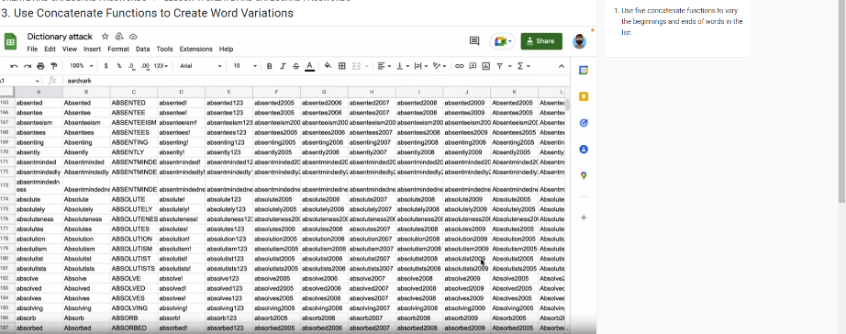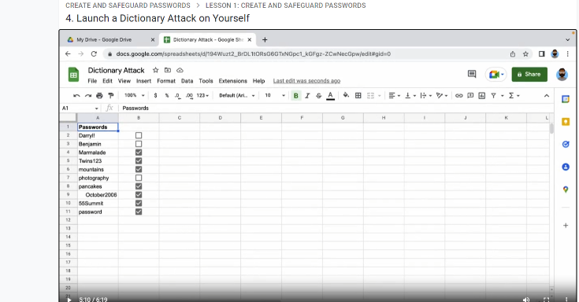
Here, I was assigned to create a spreadsheet of strong passwords, then use a concatenate formula to get the rest of the letters/word in alphabetical order.This enabled me to replace and alter text commandments etc so that it would work and change the rest. There was a special commandment of a table to enable it to be correct and strong due to the action taken.There were ticked checkboxes for the names that are included in the spreadsheet, this was a lot easier to find by filtering.

