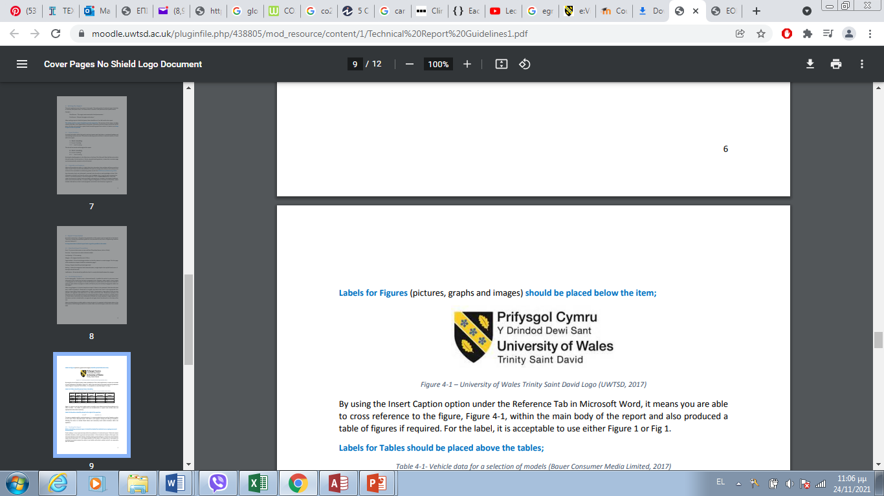
University of Wales, Trinity St. David
School of Engineering

Romylos Frangos

1802755

Automotive engineering

Structural Design and Fluid Analysis
(ACHA6010)

Introduction (need to be paraphrased (maybe) and investigate it again reading wise)

Over the recent decades Computer Aided Engineering tools have become a significant part of the engineering discipline. Not only are they able to assist in the design of the component development but also during the testing stages in order to find the limitations on the stress and strain of the component.
This assessment will talk about the tests that undergo during the simulations of a real word system modelled in a computational environment. At the same time by looking at both structural loading and fatigue life of the component the aim will be improving the structural performance, but to make the assessment as realistic as possible thermal conditions of the component will be tested as due to the material property degradation that would result. In addition, optimizing the mass of the component where is possible. The purpose of this case study is to be used as an example of how CAE can be used in an engineering design tool, while at the same time figuring out what are the limitations of such software, and which is the right approach for it. Based on the finite element analysis (FEA) results from the study will be analyzed and then used to inform the next design until the design targets have set and are met.
The outcome of this assessment is to analyze and evaluate techniques for structural and fluid problems and CAE results alongside with the application of suitable software to investigate engineering structural, fluid problems and cognitive skills in the formulation and analytical solution of a problem within the chosen engineering specialism.
The specific software that will be used in order to validate simulation results is ANSYS. The specific software enables engineers to see how idea will perform against millions of variables and not only that, but it can increase your productivity while decreasing your costs which in today’s world that is very important while marching through the future of engineering technology. Test validation provides physical testing services to validate simulation results and accelerate adoption. ANSYS not only is a finite element modeling package for numerically solving a wide variety of mechanical problems, but these problems include static/dynamic, structural analysis heat transfer and fluid problems which makes it perfect for our case study scenario.

Introduction to ANSYS software:
ANSYS is a general-purpose Finite Element Analysis (FEA) software suite. Finite Element Analysis is a numerical approach for breaking down a large system into extremely small components (of user-defined size) called elements. The software implements and solves equations that govern the behavior of these elements. Creating a complete explanation of how the system works.
The ANSYS Workbench environment is a user-friendly finite element analysis tool that is used in conjunction with CAD systems and/or Design Model. ANSYS Workbench is a software platform for performing structural, thermal, and electromagnetic analyses. The Workbench focuses on attaching existing geometry, configuring the finite element model, solving, and assessing results.

Validation:
For the sake of assessing the suitability of the software it is important to conduct validation testing to measure the accuracy of the output results. That is doable by selecting a suitable text case where an analytical solution can be found based on fundamental principles. Furthermore, completing the analytical version of the case study then replicating the study in ANSYS to compare the results. Henceforth, it is recommended to assess the impact of the mesh sizing on the accuracy of the results by conducting a study to look for a point of mesh independence.

CAD Modeling and Assembly:
In order to make the ANSYS software to be as accurate as possible then the CAD assembly design should also be as realistic as possible as it will have a significant impact on the structural results that will be obtained. In this specific case of assembly, the design contains 5 different components that are suitable for kinematic study.

Kinematic Simulation, Thermal Influence and Structural Analysis:
Kinematic analysis of the assembly should be conducted in ANSYS in order to create a realistic set of loading conditions that the system is probably going to be exposed to. These results should then be fed into a Static Structural study.

Static Analysis:
In both linear and nonlinear static analysis, displacements, stresses, strain, and deformation are calculated under static loading conditions. Plasticity, stress stiffening, big deflection, large strain, hyper elasticity, contact surfaces, and creep are examples of nonlinearities. (Thriveni, 2013)

Methodology (Remember to put a diagram showing start modelling of crankshaft design all components analysis and results and conclusion) which is the fabrication process of the crankshaft
The methodology explains the step-by-step procedure for the test. The modeling of the design crankshaft is modeled using the software solidowkrs, but the analysis of the crankshaft is carried out through ANSYS software for determining the accuracy of the results by conducting a study to look for a point of mesh independence, widely used professionally by industry and universities, it focuses on the field of general CFD calculations.
In order to understand what really is going on during the software is undergoing through thousands of calculations while ensuring that the computational model accurately represents the physics of the real-world system, we need to understand how to validate a computational model. Demonstrating the principles relating to stress/strain calculations and CAE software for ensuring that the computational model accurately represents the physics of the real-world system. ANSYS is a tool to calculate aerodynamic and other fluid dynamics problems and it includes the possibility of resolving the energy equation so that thermal fluid problems such as refrigeration, a common problem in industry with a wide range of possibilities for optimization problems can be solved also (Sola & Ignacio, 2016).

Figure 1, figure 2 and figure 3 below shows the design that was done using the software solidworks, with the help of solidworks designing and creating a crankshaft with a Gudgeon Pin alongside a single connecting road in order to then import them as an assembly (Figure 4) in ANSYS software. By doing that then we can choose a realistic material property for the components and realistic boundary conditions that will be used for the crankshaft where suitable, thermal results would also be applied within the study. This is done since the results from the study can be analysed, then used to inform the next design until the design target have been set and met.

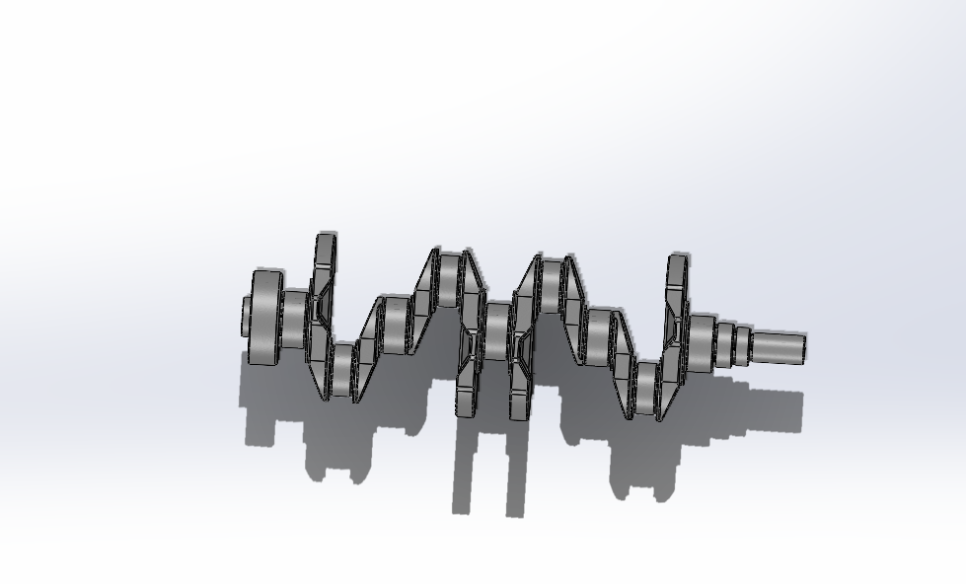
Figure 1: Crankshaft, responsible for the proper operation of the engine and converting a linear motion to a rotational motion.

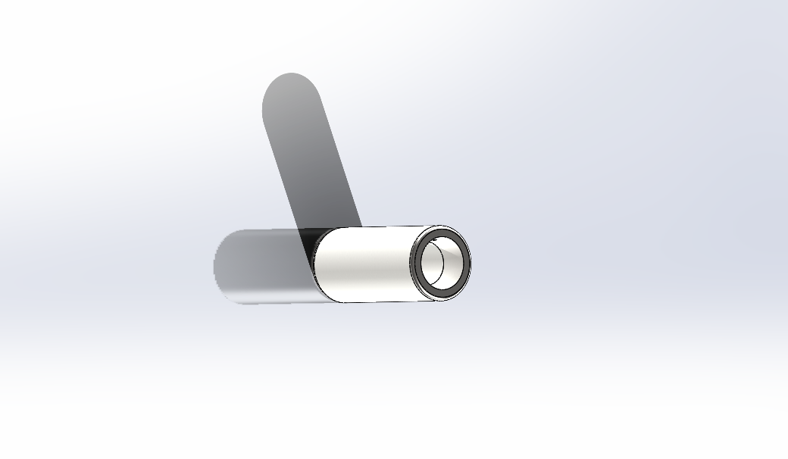
Figure 2: Gudgeon Pin, connects the piston to the connecting rod, and provides a bearing for the connecting rod to pivot upon as the piston moves.

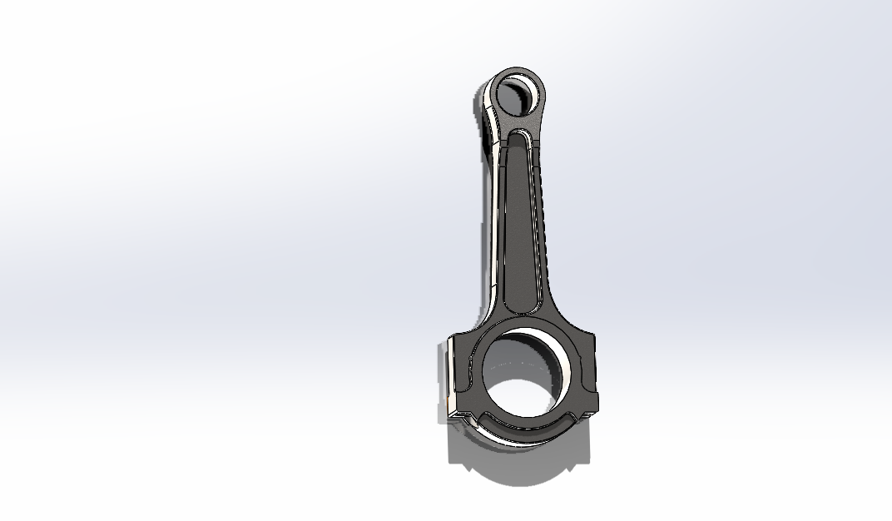
Figure 3: Connecting Road, connects the piston to the crankshaft to transfer combustion pressure to the crankpin.

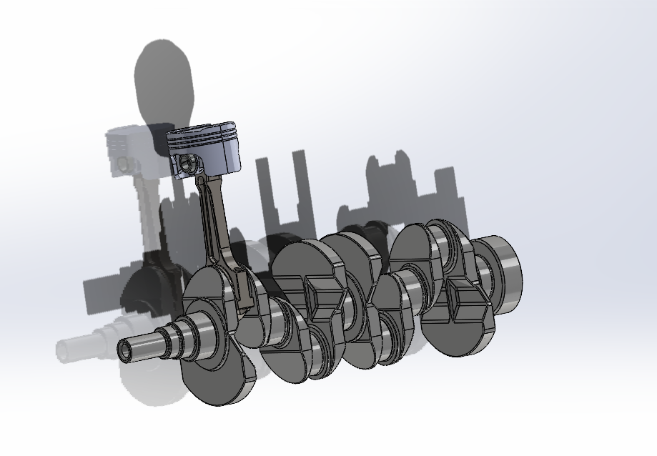
Figure 4: The complete assembly with everything attached as it should be in a normal crankshaft with pistons.

Validation testing
A high-quality mesh is one of the most critical and important factors that need to be considered in order to ensure simulation accuracy and to obtain accurate results from an FEA model. This is why it is very important to check and improve the mesh quality. After design a cantilever beam and Bimetallic beam in solidwokrs it was imported in ANSYS in order to achieve mesh independence. This is a method of investigating whether the simulation results are independence of the underlying mesh or not. It can also be used in order to distinguish whether the solution is independent and that the engineer is achieving the optimal solution time and not enlarging their mesh and solution times. This is done by running a few simulations with different mesh resolution and checking if the results changes. As the tables and the figures shows below the mesh independent was successful since the numbers after a few simulations the numbers would not change. There are a few ways to improve the quality of the mesh and that is by reducing the number of layers meaning that using at least one layer will give the most accurate results, and that is one of the reasons why only one cantilever beam was used in this case. Furthermore, increasing the gap refinement factor will improve the mesh quality significantly, keeping in mind that this value will increase the overall mesh size by a huge number so that means that the software will run through a lot more calculations that it would have done if the number was higher than 1. So ideally, if the software is overloaded it might even crash without evening having wrong variables but just because the software cannot take it at that specific time.
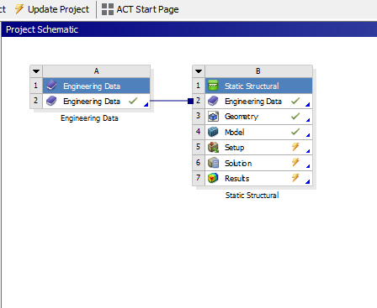Cantilever beam
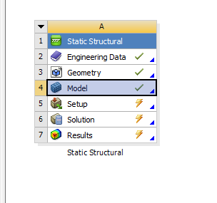Bimetallic beam

Cantilever Beam
Material: | Elastic-plastic
25 | 0.167
20 | 0.167
15 | 0.166
10 | 0.165
5 | 0.164
1 | 0.164

Bimetallic
Material: | Invar | Copper
1 | 1.1234 | 1.1234
0.75 | 1.123 | 1.123
0.5 | 1.1233 | 1.1233
0.25 | 1.1213 | 1.1213
0.1 | 1.1213 | 1.1213

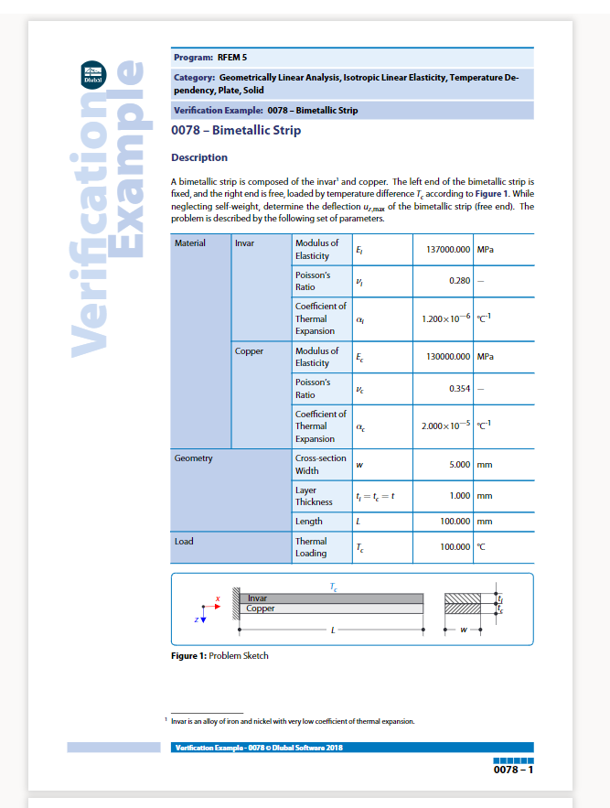
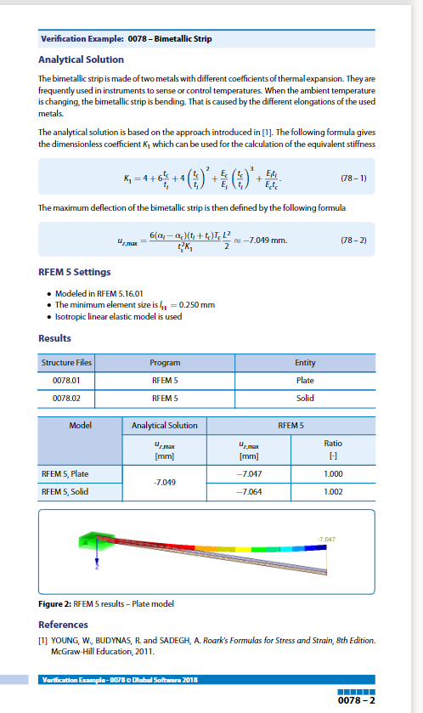
The materials that were chosen for the cantilever beam and the bimetallic beam was given in the reports above as shown. After using the proper values and units in engineering data ANSYS was able to read and insert the specific materials in the software in order for the mesh study to be continued as included below. Also the materials of the beams can be seen in the tables and graphs above. As it is shown, if the original is 7.049 and divide that by 7.123 the results is 0.9896 which is just over 1% over deviation of the analytical report, then by changing the mesh value to 0.25 the result is 1.1213 which again is just 1% over the original deviation. That proves that by changing the number of the mesh value it is possible to get more accurate results every time doing it. The same goes for the cantilever beam which the numbers prove that by reducing the mesh value mesh independence is achievable.

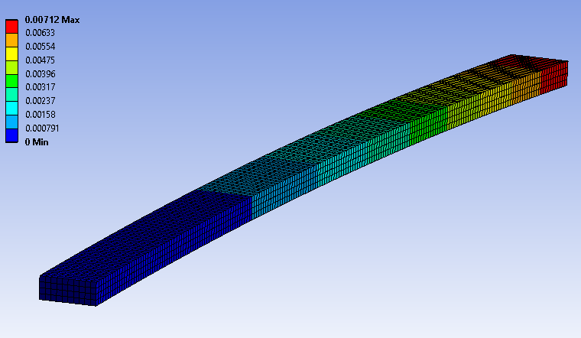

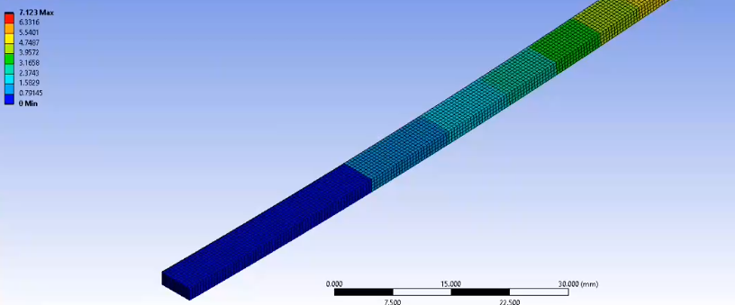

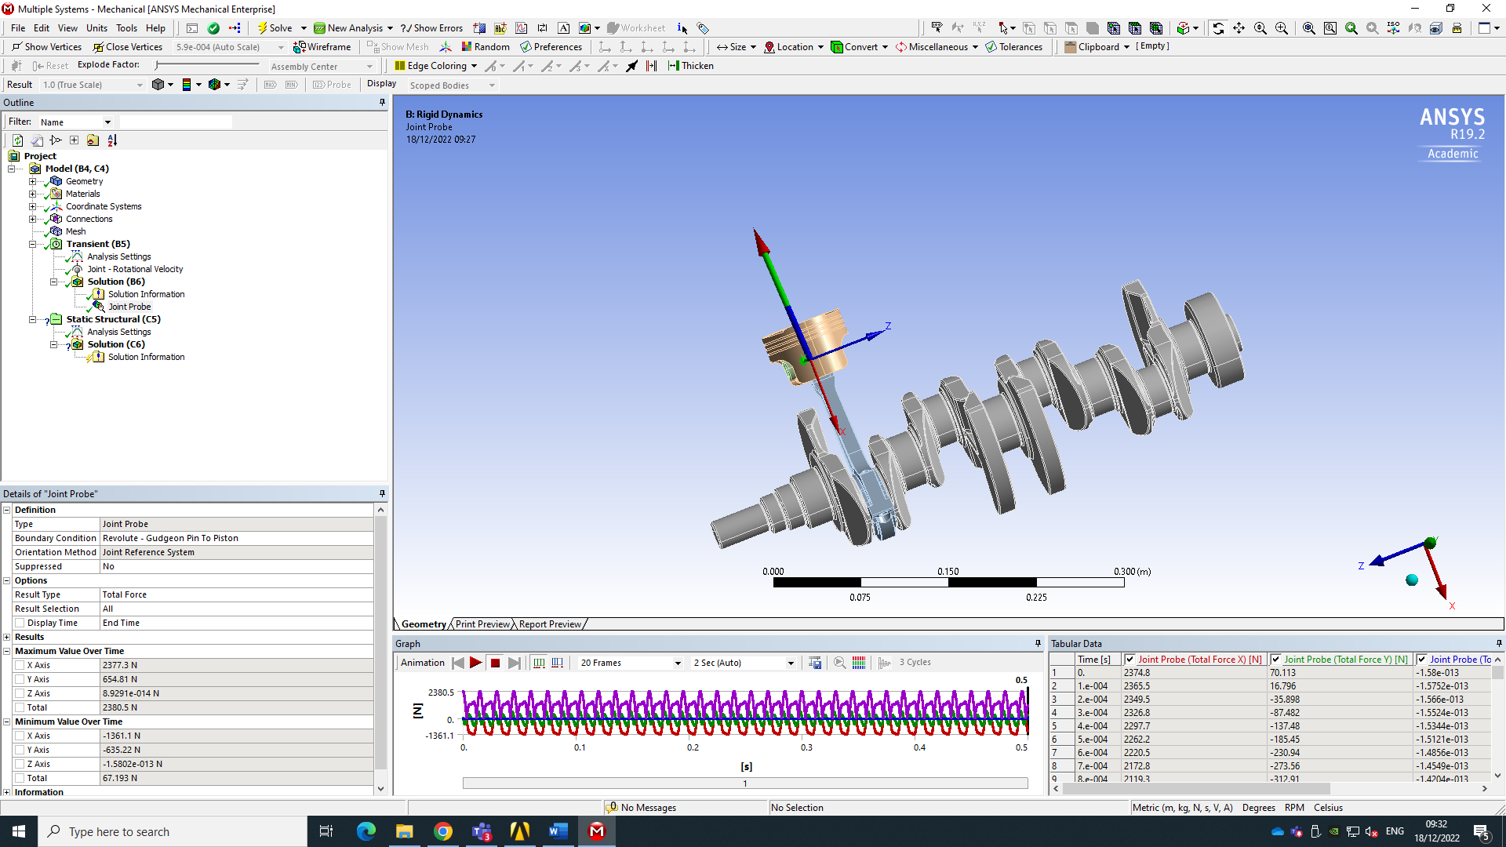

Figure 5

Going forward, to make sure that the design had at least 5 components of materials in order to be ready to be imported in ANSYS. Figure 5 above shows the design after it has successfully been imported to ANSYS and successfully went through the kinematic simulation under realistic conditions. After the kinematic analysis is over then those realistic loading conditions that the system may be exposed to are fed into the Static Structural study. The component has been assessed in a way that is to improve the structural performance while looking at both the structural loadings and the fatigue life. Parallel to that thermal conditions that the component is most likely to go under have been considered due to the material property degradation that would result.

Kinematic simulation, Thermal study, Rigid dynamic study and Structure analysis
After recreating the example with the material of 6061-T, then it was just a case of using different materials to test the same studies for the piston. The two different materials that were used in ANSYS were Aluminium alloy 4032 and Aluminium alloy 6063. These two materials are commonly used in engines and specially pistons for mass productions for the purpose of the properties of the materials. Figure 6 below shows the successful link between all the studies that were done in the three materials that were tested. Firstly, we tested the materials in a Rigid study to calculate the total deformation and the equivalent stress. Static and structural study came next, that means calculated deformation of the materials the analysis and the studies are break down in more detailed later in the report.
Aluminium alloy 4032 had the following deformation as the tables and graphs shown below respectively. After the static structural analysis was done, the next study was the steady-state thermal analysis. Also, below it is shown the following analysis which is the steady-state thermal analysis. In the tables we can see the values of the maximum and minimum deformation, temperature and stress for all the materials that were used. (6061T-6, Aluminium alloy 6063 and Aluminium 4032)

Engineering data:
With the option of engineering data the software is able to access any material that is possible or even create a custom material as long as it has realistic values and uses the software can use it.

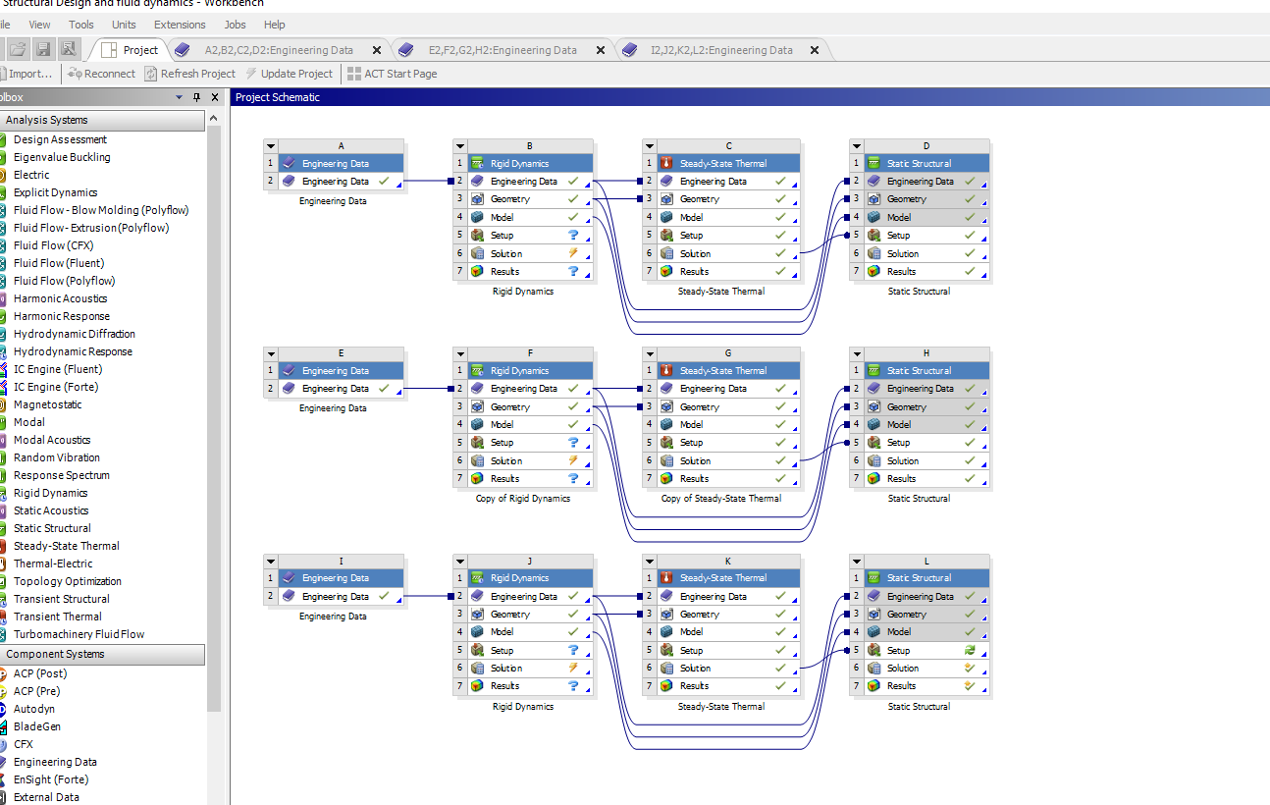

Rigid study:
Because often mechanical systems contain complex assemblies of interconnected parts while undergoing huge overall motion it is defined as a rotation of a body without undergoing any significant internal deformation. The purpose of rigid body study is to provide the ability to analyse any problem in a simple and logical manner in order to be able to apply the basic principles which are understood for solutions.

Material: 6061-T6

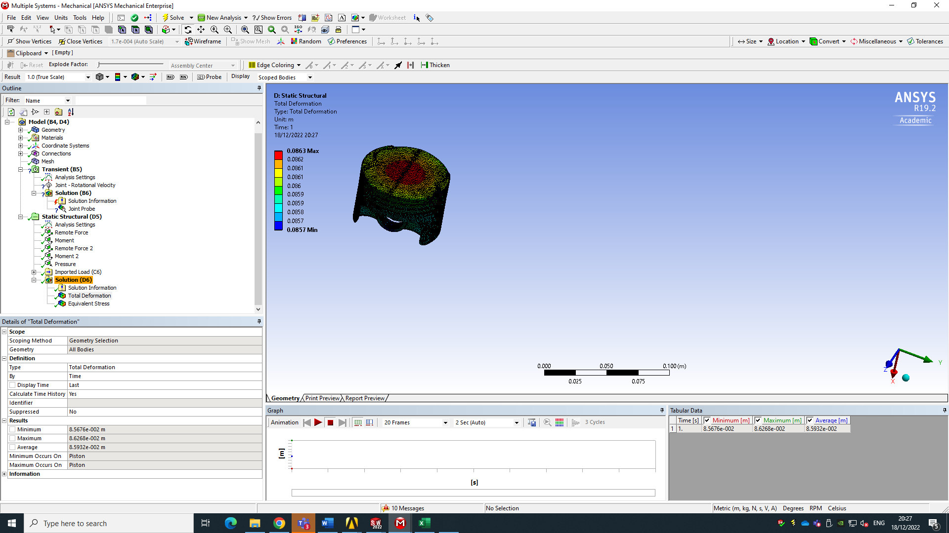

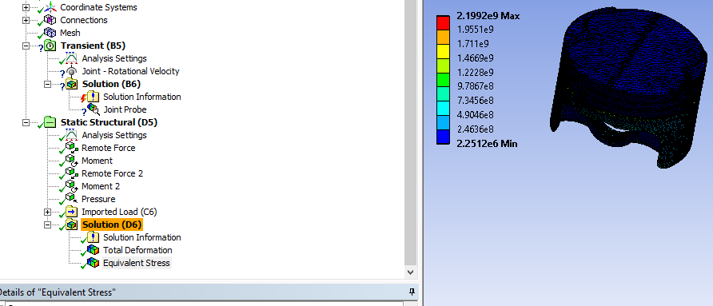

Material: Aluminium alloy 4032

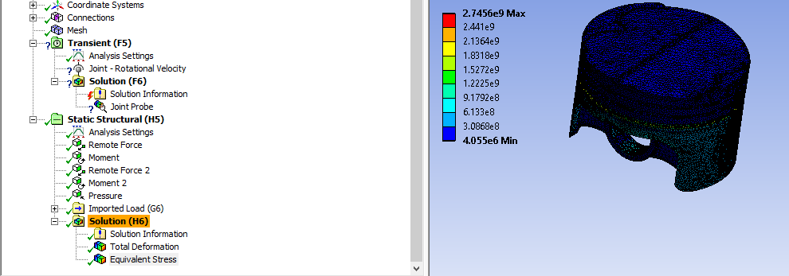

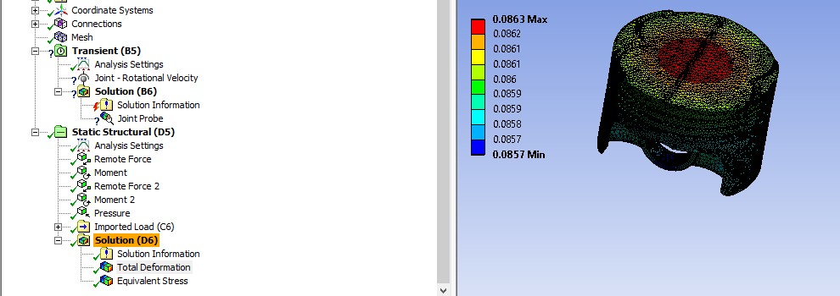

Material: Aluminium alloy 6063

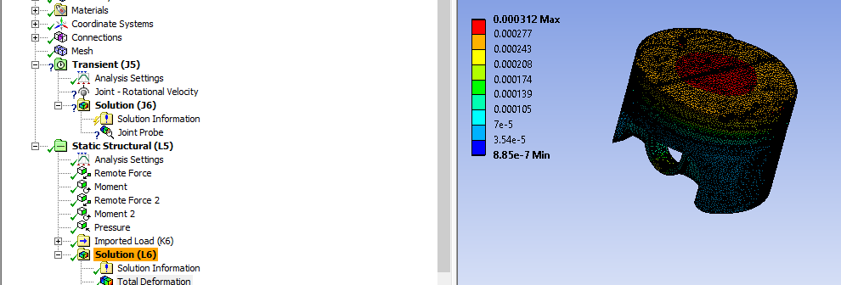
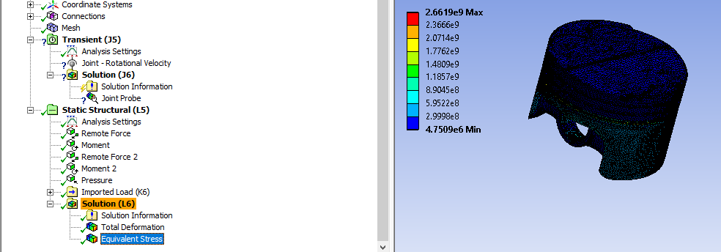

Thermal study:
The thermal study is very straight forward, meaning that it helps engineers to solve the most complex thermal challenges to predict how the designs will perform under specific temperature changes. In our case the thermal study shows the maximum and minimum temperatures of a piston under combustion.

Material: 6061-T6
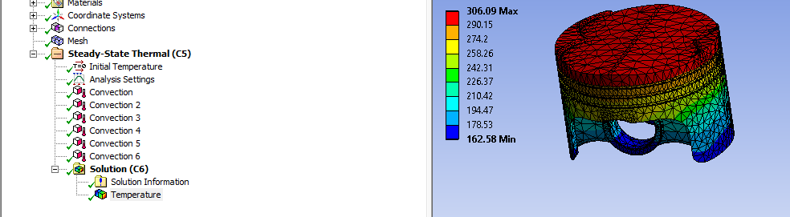

Material: Aluminium alloy 4032

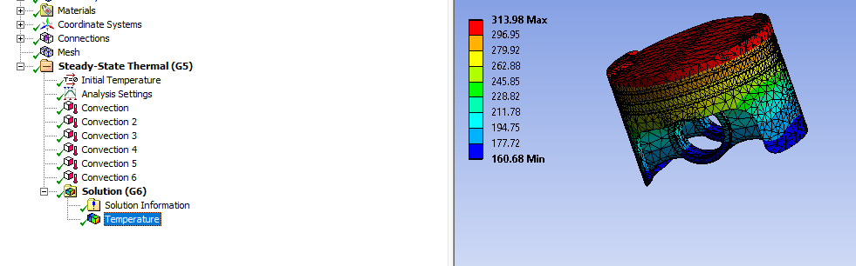

Material: Aluminium alloy 6063

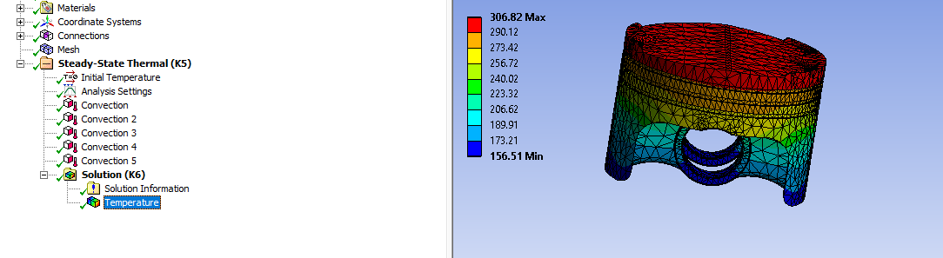

Structure analysis:
Structure analysis calculates stresses and strains as it will be seen below to determine the pistons predicted life using finite element analysis. It enables engineers to again solve complex structural problems in a more efficient and faster way.

Material: 6061-T6

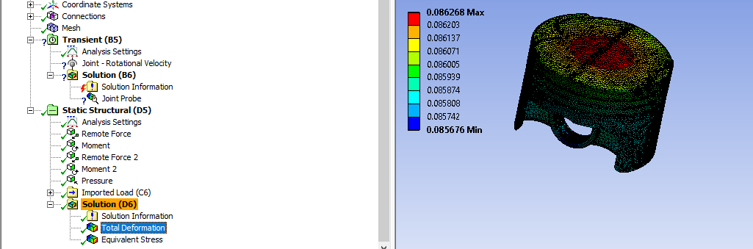

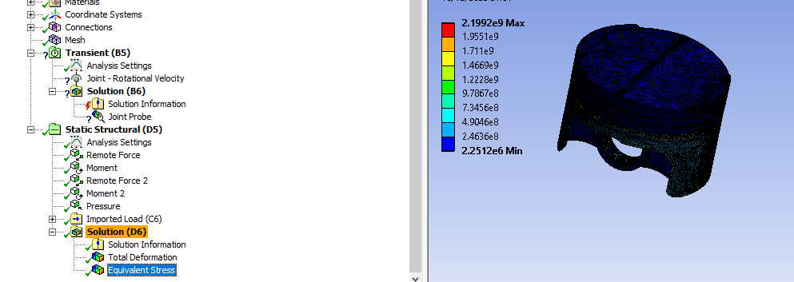

Material: Aluminium alloy 4032
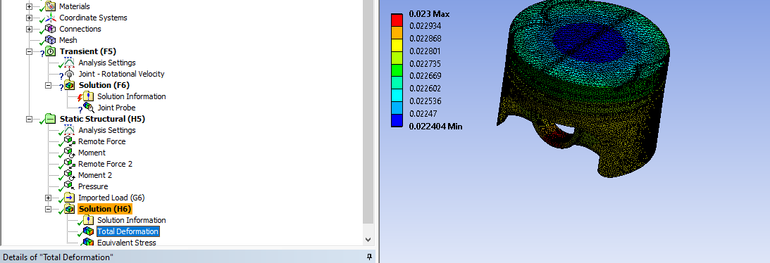

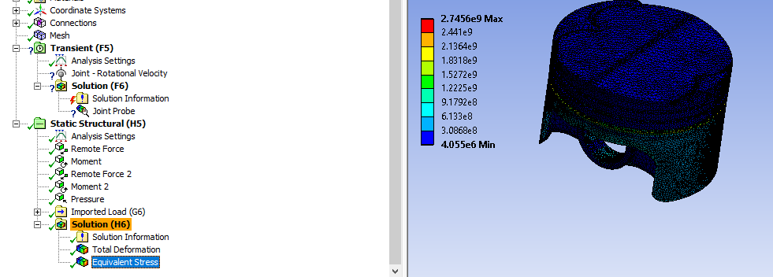

Material: Aluminium alloy 6063

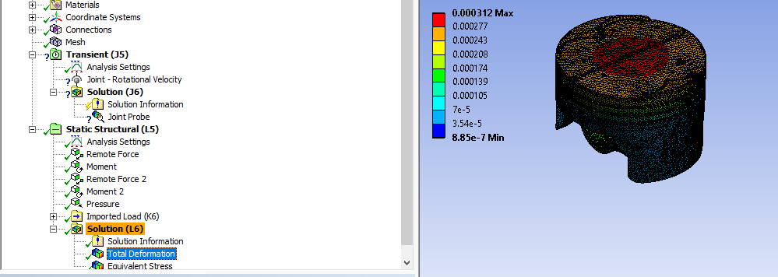

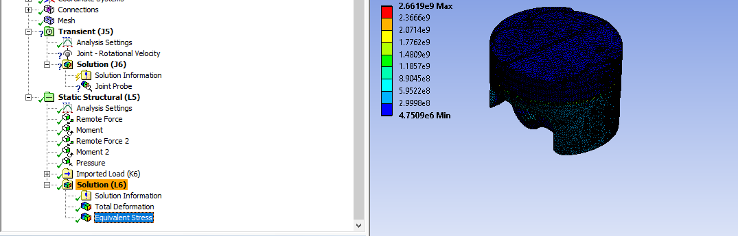

Kinematic simulation:
In order to evaluate how much effect, the impact of a transient loads or even to design potential noise and vibration problem a kinematic simulation must be achieved. Hence, from that simulation it can describe and analyse the motion of the components. Enables accurate analysis of rigid and flexible bodies for evaluation of physical through the analysis of the mechanical system as one. In this case
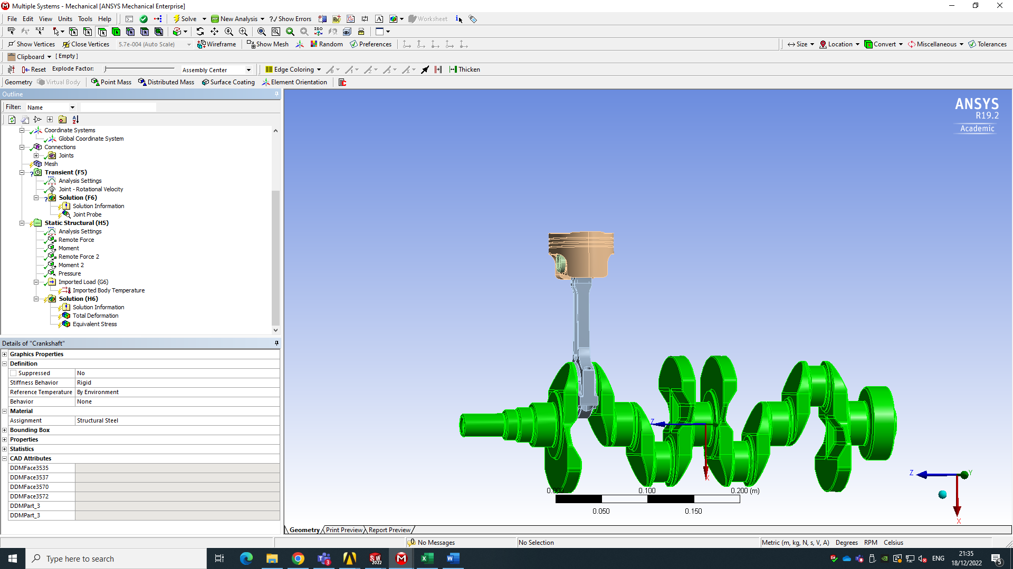
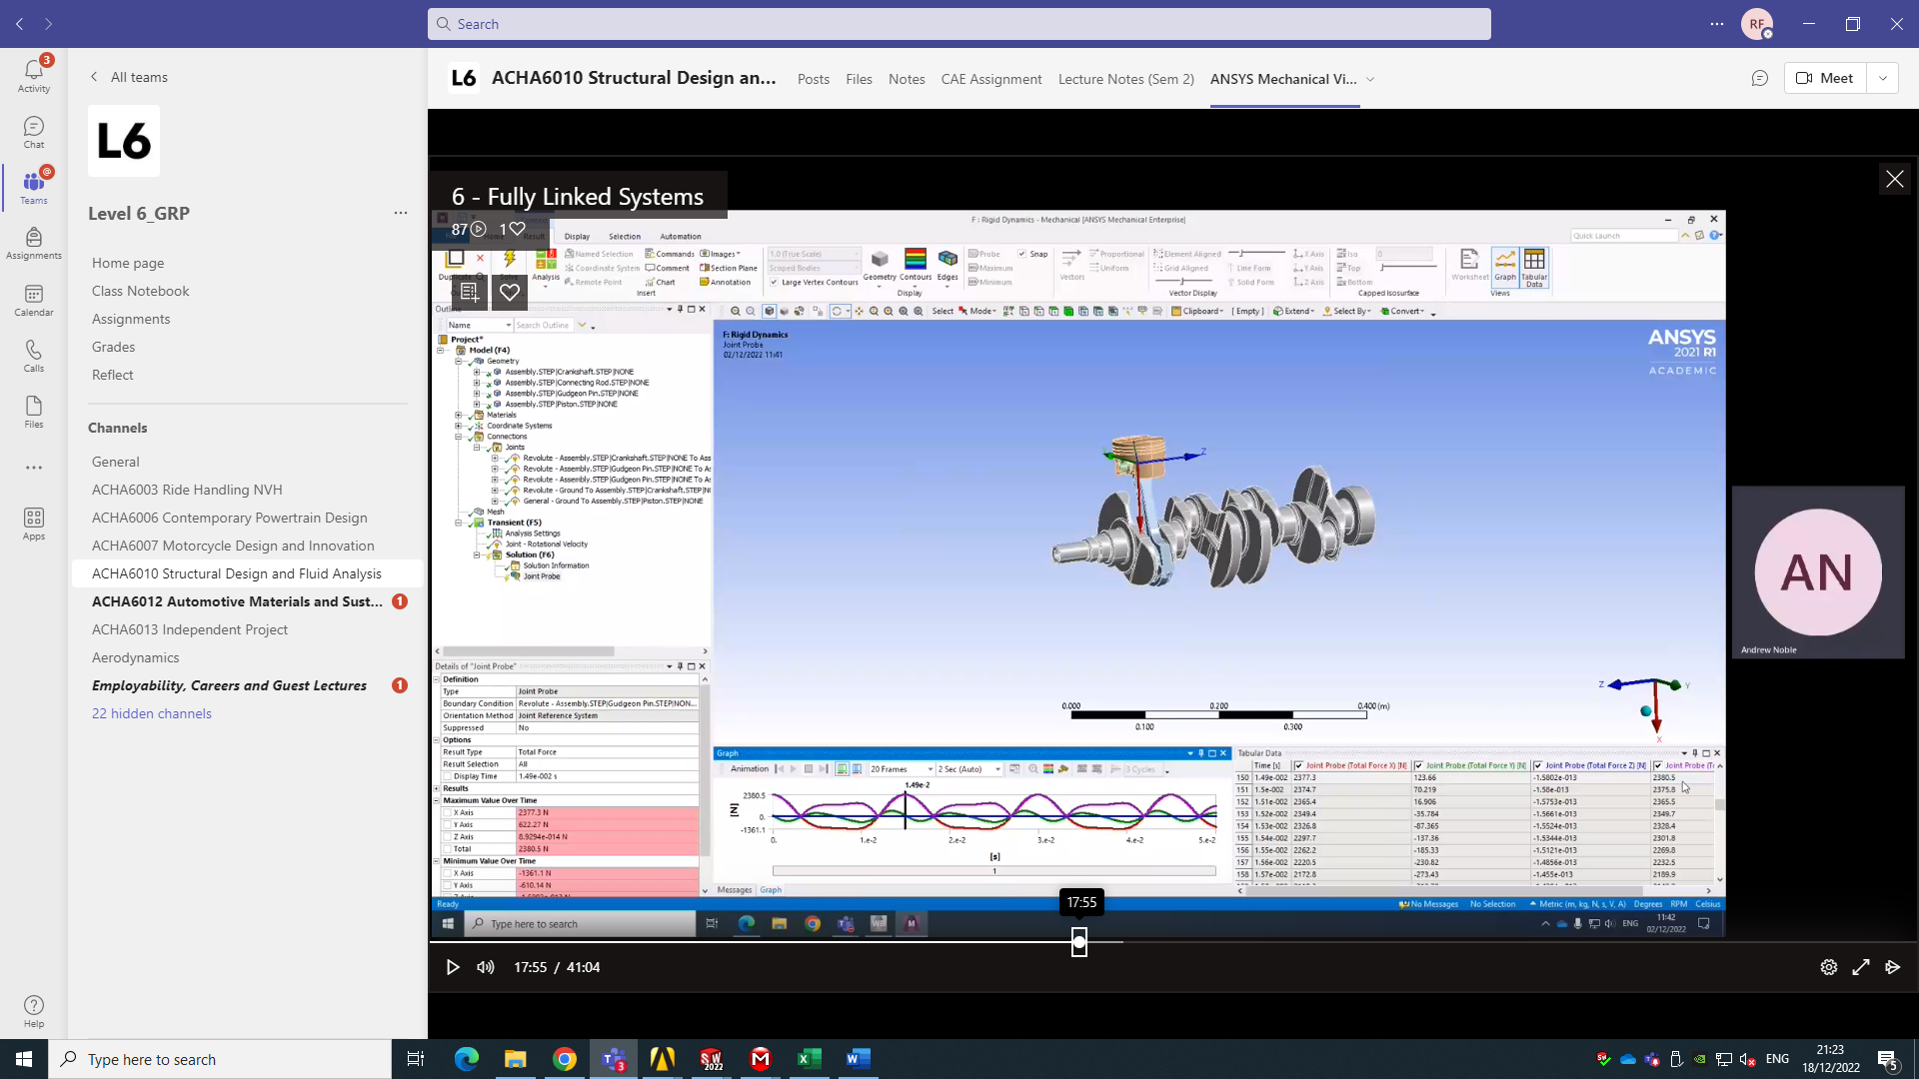

Material: | 6061-T6 | Aluminium alloy cast 6063 | Wrought aluminium 4032
Max. Deformation | 0.0863 | 0.000312 | 0.023
Min Deformation | 0.0857 | 3.54e^-5 | 0.022
Table 1: Maximum and minimum deformation of all three materials.

Graph1: Material 6061-T6, maximum and minimum deformation.

Graph 2: Aluminium alloy 6063 maximum and minimum deformation. Unfortunately the value of the minimum deformation for Aluminium 6063 is very low in comparison to the maximum values that the excel graphs can not show the values.

Graph 3: Aluminium alloy 4032, maximum and minimum deformation.

Material: | 6061-T6 | Aluminium alloy cast 6063 | Wrought aluminium 4032
Max. Temperature | 306 | 307 | 314
Min. Temperature | 163 | 157 | 161

Table 2: Table 2 is showing the maximum and minimum temperature of all three materials.

Graph 4: Showing the maximum and minimum temperature of 6061-T6.

Graph 5: Maximum and minimum temperature of Aluminium 6063.

Graph 6: Maximum and minimum temperature of Aluminium 4032.

Material: | 6061-T6 | Aluminium alloy cast 6063 | Wrought aluminium 4032
Max. Stress | 2.2e^9 | 2.66e^9 | 2.75e^9
Min. Stress | 2.25e^6 | 4.75e^6 | 4.06e^6

Table 3: Lastly table three is showing the maximum and minimum stress that the materials are going through during the analysis.

Figure 6: Successful link between the materials and the different analysis between them.

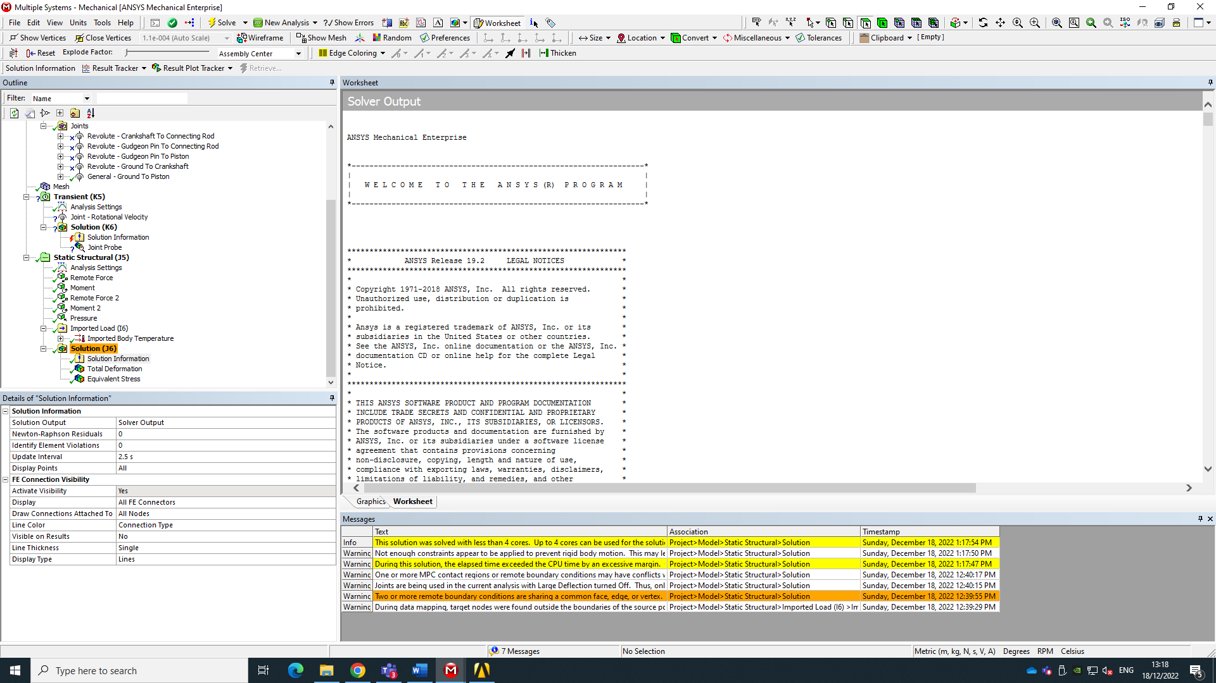

Conclusion
Throughout this report it has been showed that the ANSYS software can be used in order provide engineers of all levels accuracy and flexibility needed to complete intricate projects on time and with the utmost confidence. Furthermore, ANSYS is a finite analysis software that is used to simulate computer models of structure machine components for analysing electronics, toughness elasticity, fluid flow and a lot of other attributes. This assessment simulated a real-world testing system modelled in a computational environment. As shown above it carried out kinematics analysis under realistic operating conditions and then static structural assessment of one component within the assembly. This case study can be uses as an example of how CAE tools can be used in an engineering design process, with of course the limitations it comes with. Such as that the ANSYS software is only available by subscription either monthly or annually. Furthermore, this report is intended to assess the understanding of CAE process and limitations as well as the practical implementation of such tools.

