Sam Lamprey (2203378)

Electronics 2 assignment-ACDA6001
Critical evaluation of Braun’s multiplier and Wallace tree multiplier using VHDL

Electronics 2 assignment
Introduction
This report covers multipliers and their importance in electronic system. It focuses on two main type of multiplier design which are the Brauns and Wallace multipliers specifically 8x8 multipliers for both designs. The two designs will be compared and analysed to determine which method is more efficient and which one is faster using simulations to provide data used for the analysis. The designs were created using the vivado software using the VHDL programming language. The report will also contain background information on multiplier techniques and the current developments with them as well as the advantages and applications of them.

Literature review
There are different types of multipliers that can be used but this report focuses on multipliers using logic gates. These types of [1] “multipliers are usually placed in two different categories which are array and tree multipliers.” An array multiplier works by using an [2] “array of half and full adders to multiply two binary numbers”. The advantages of using an array multiplier are that they are [3] “easy to design and they are easily scalable” which means that they can be used for small and large multiplications depending on the size of the design. One disadvantage of array multipliers is that they have long delays between the inputs and outputs when compared to other methods. They also consume more power than other methods due to them taking longer compute. Another disadvantage is that they can take up a large space which means that they could be less versatile than other designs when using a lot of multipliers in a small space. An example of an array multiplier would be a serial array multiplier which uses adders in series to get a larger output. There are also parallel array multipliers which use adders in parallel instead of series which improves the speed of the multiplier but also adds to the complexity meaning that it is harder to implement the design.
There are lots of current developments in multiplier most of which focus on improving the speed and power consumption of the design. Both of these can be done in different ways for example the speed can be improved by optimizing the algorithm that is used for a design such as booths algorithm. One way that power consumption could be reduced is by reducing the number of partial products produced which will also help with the speed of the system.
The other category of multipliers is tree multipliers which the most common design for is the Wallace tree multiplier. The Wallace tree multiplier has two main benefits over other designs which are that it has a [4] “quick processing time and has low power requirements.” The Wallace tree multiplier works by using AND gates to multiply two factors together and then uses the outputs of the gates to input into half and full adders. It does this in parallel which improves the speed of the design but also adds complexity to the design. The biggest disadvantage of the Wallace tree multiplier is that [5] “it is very irregular” which complicates the design especially when trying to minimize the size of the design. Another benefit of the Wallace tree multiplier is that when increasing the size of the design the number of adders directly correlates to the number of inputs. This make the Wallace tree useful when multiplying large numbers as the design can be easily scaled up. Wallace tree multipliers are commonly used for high speed and lower power mathematical applications such as signal processing which requires high speed to reduce latency and microprocessors which also require high speed operation.
Another type of multiplier is a booth algorithm multiplier which like the Wallace and array multipliers has advantages and disadvantages. The first advantage being that [6] “it optimizes the multiplication of the binary numbers which reduces the number of additions needed”. Booth’s algorithm is also faster than other traditional methods due to it only having a few steps. This also means that the hardware design will be simple and will have a small footprint when compared to other designs. [7] “A disadvantage of using booths algorithm is that it only works for signed binary values” which may make it not suitable for some applications. It also requires more power than other methods specifically when multiplying larger numbers. Booth’s algorithm is used for multiple different applications such as in computer processors and [8] “hardware designs as it has a reduced complexity which is important when space is limited.”
The Dadda multiplier is another type of multiplier that is used for binary multiplication. Like the Wallace the Dadda multiplier uses both full and half adders as well as AND gates to achieve the multiplication. [9] “When compared the Wallace tree design the Dadda multiplier is slightly faster and requires less gates”. [10] “The main disadvantage of the Dadda multiplier when compared to the Wallace tree is that it does a minimum amount of partial product reduction at the early stages” which leads to this reduction happening all throughout the design. The Dadda multiplier is also more complex than the Wallace tree which can make it harder to design. Dadda multipliers are commonly used for similar applications to Wallace trees such as digital signal processing and in [11] “hardware such as CPUs specifically in the ALU.”
The final type of multiplier that will be discussed in this report is the Brauns multiplier also known as a carry save array multiplier. Like the previous multipliers that were discussed it is a parallel multiplier which uses AND gates and adders in a parallel array to achieve multiplication of two binary values. Unlike the Booths multiplier a Brauns multiplier uses unsigned binary values which means that the multiplier only works with [12] “nonnegative values “due to the bits being the same value whether positive or not. The benefits of the Brauns multiplier are similar to the other designs mentioned in this report, it is fast and has a low power consumption. It also has a relatively simple structure which makes it easy to implement and has a reduced size compared to more complex multiplier designs. The biggest disadvantage of the Brauns multiplier is that [13] “when the number in binary inputs is increased the number of components increases quadratically which makes it inefficient for multiplying larger values.”
The hardware that these multipliers can used with are called FPGAs or field programable gate arrays. An FPGA is a [14] "reprogrammable integrated circuit” that can be used for various tasks that require complex computation. Due to FPGAs being reprogrammable they can be used for many different applications with the most common being [15]” digital signal processing where FPGAs are used for video and audio processing as well as wireless communication”. There are many different ways to program an FPGA but all of the languages usually used to program them are HDLs or hardware description languages. [16] “One of the most common languages used is VHDL” which is short for very high-speed integrated circuit hardware description language. When creating a program in VHDL it is important to consider timing delays which there are two types. [17] “Transport delay which simulates delay caused by a wire and inertial delay which is the delay caused by analog ports.” These delays are important when creating a simulation of the system as they would be present in a physical system. These delays also help to compare the performance of different designs using the simulations.

Design process
When designing a multiplier there are a few key things that need to be considered to ensure that the design is optimal. The first of these things that needs to be considered is the speed of the design which is important for many reasons. The first thing that the speed of the design will affect is how efficient the design is because the faster that the design is the less time is needed to complete the task which will reduce the overall power consumption thus increasing the efficiency. The faster that the multiplier can calculate also means that the performance of the system will be better meaning that more operations can be carried out in a smaller period of time.
Another important factor to think about when designing a multiplier is the size that it will take up which is important especially when the multiplier will be used in a system with a limited amount of space such as and ALU which will use multiple adders to compute different things at the same time such as in CPUs.
One of the first features of the design that needs to considered is the type of multiplier that will be used for example a Brauns multiplier or a Wallace multiplier both of which have their advantages and disadvantages that will affect the performance of the system. This would be the theory behind the design which then could be used to create the circuit schematic. If either of these designs were chosen, then they would both include multiple AND gates, full and half adders. The AND gates would be used to create partial products which will then be reduced using the full and half adders until the final product is produced. The full and half adders reduce the products by combining the products that are inputted into them [17] “using an add and shift algorithm” which replicates multiplication and once all of the inputs have been added you get the output. The number of adders and the way that are connected to one another will directly affect the speed and efficiency of the multiplier. This will also affect the power consumption and the size of the multiplier which is also an important factor and is one of the advantages and disadvantages of the Brauns and Wallace multiplier designs. A block diagram of both the Brauns and Wallace tree multiplier was created as shown in figure 2 and 19. These diagrams showed that both designs are fairly compact but the Wallace would be slightly smaller.
Once a block diagram for the multiplier design has been created a program needs to made so that the device and work. To do this and FPGA was used to carry out the functions as they are highly versatile. The program language used to create the program was VHDL which is known for its high speed which made it suitable for a multiplier application. The program was written using the Vivado software which also allowed for a synthesis and implementation of the design to be created so that analysis on the two designs could be carried out.

System flow chart
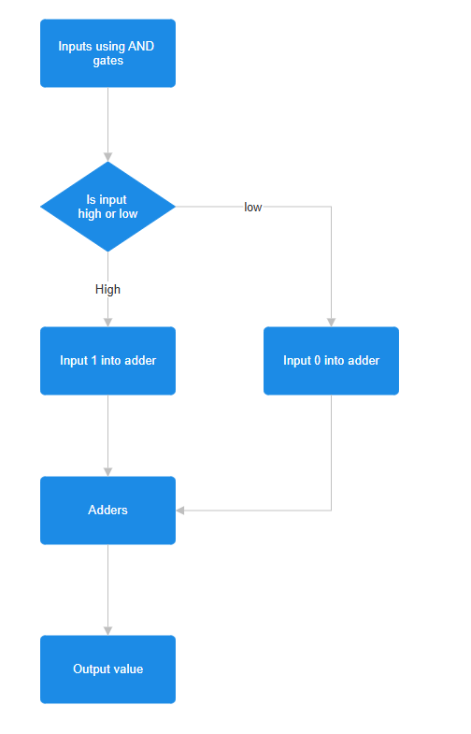
Figure 1
Brauns block diagram
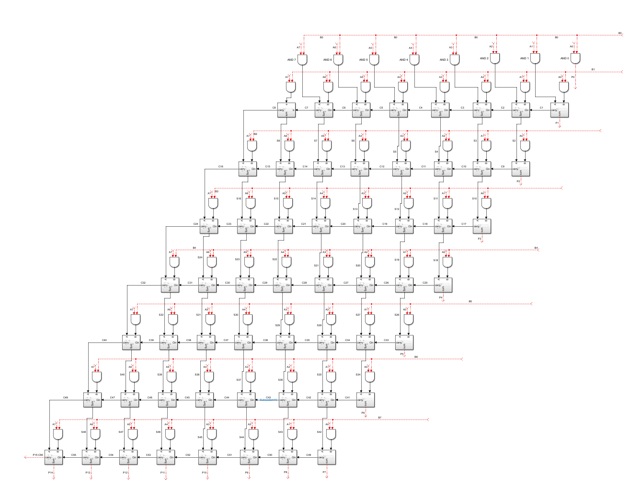
Figure 2
Brauns Longest delay path
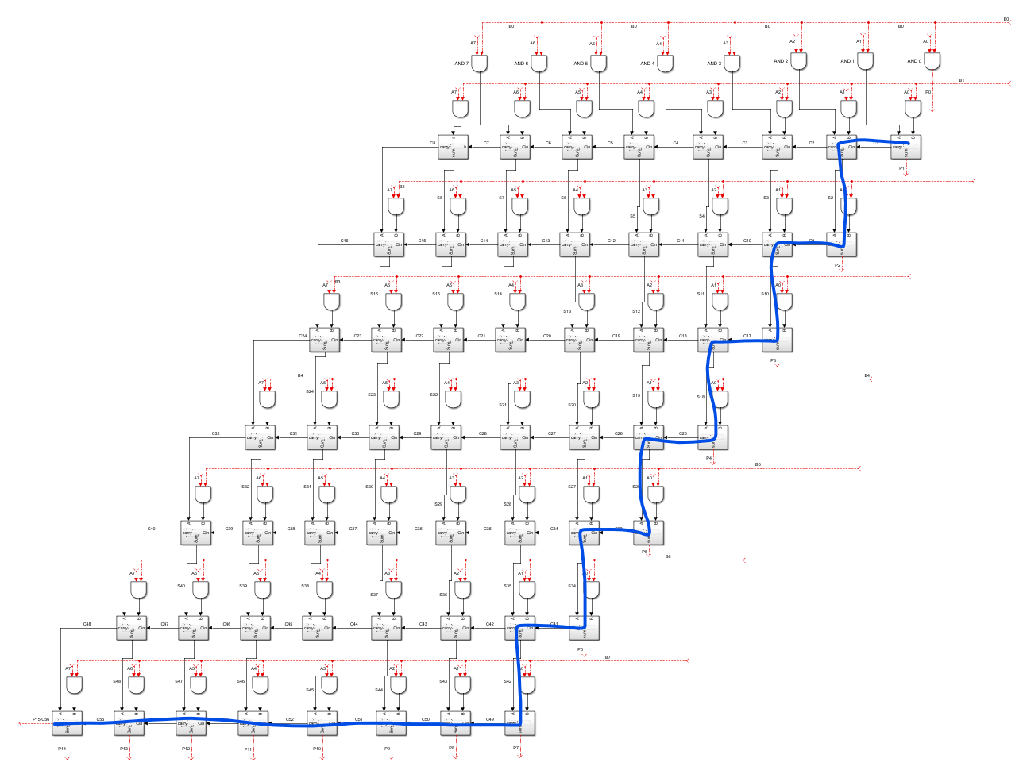
Figure 3
Brauns multiplier samples
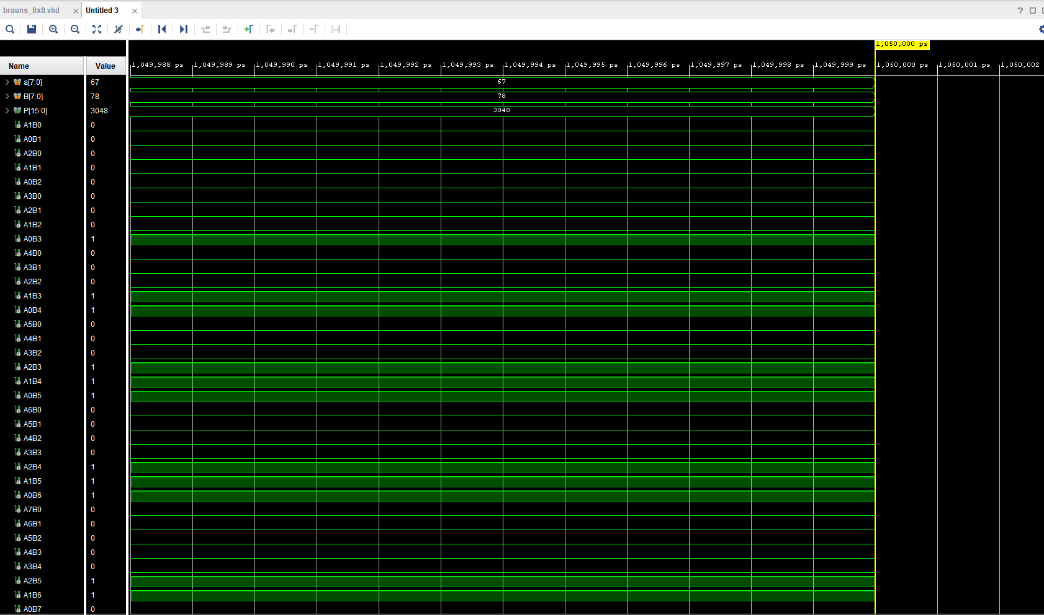
Figure 4

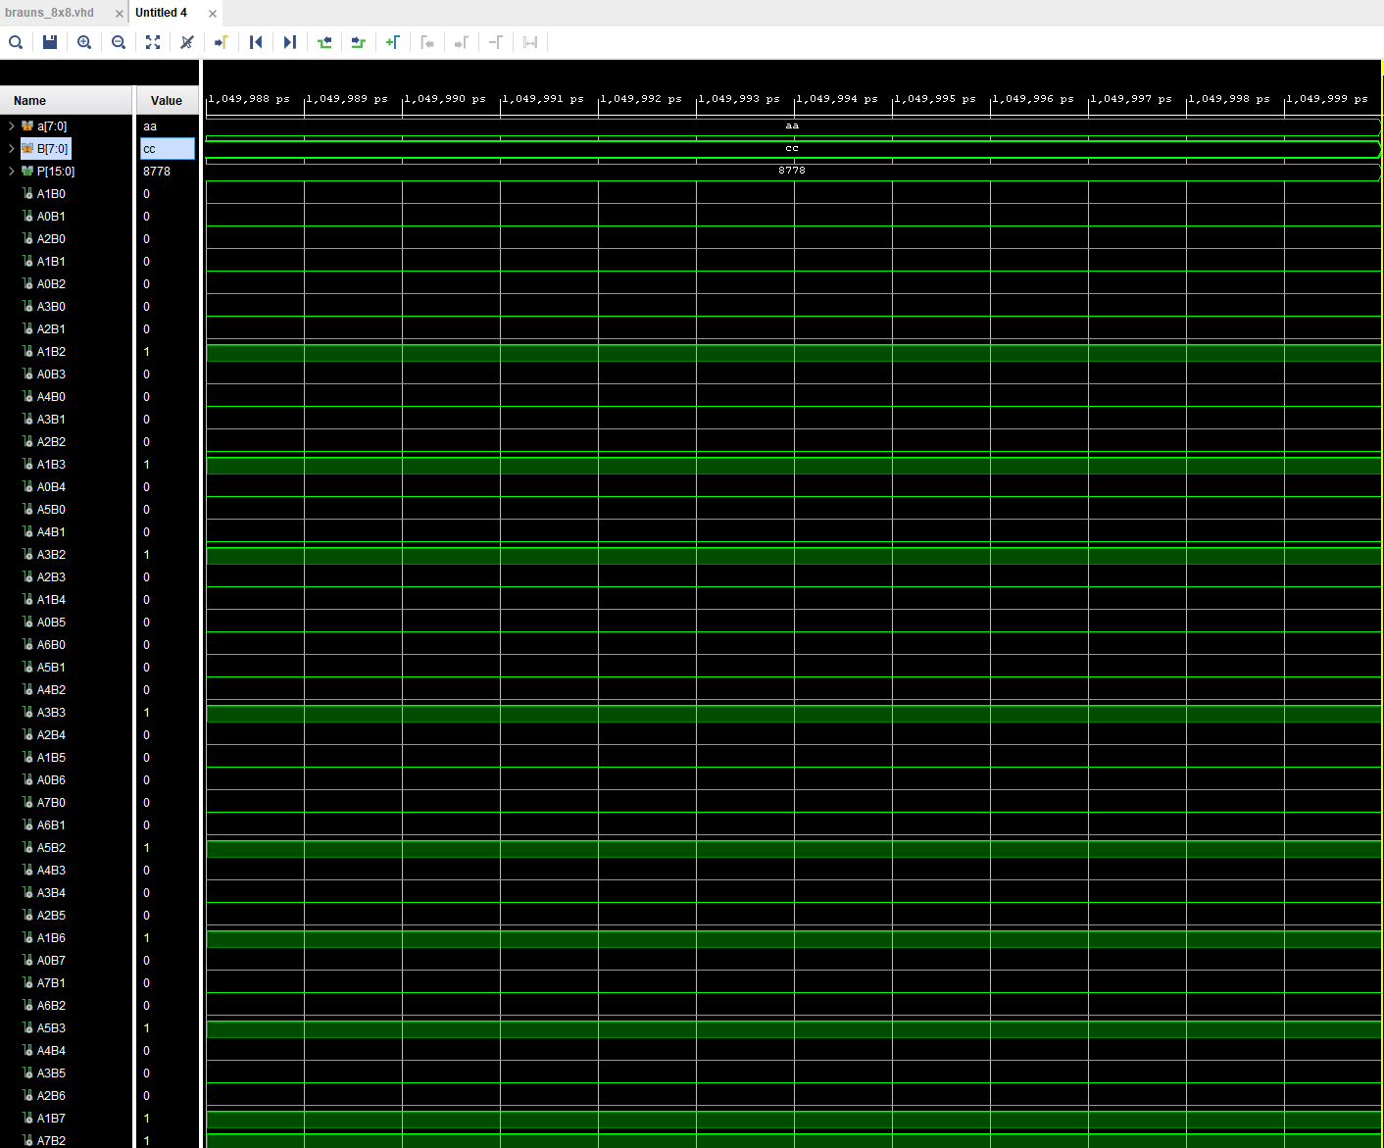
Figure 5
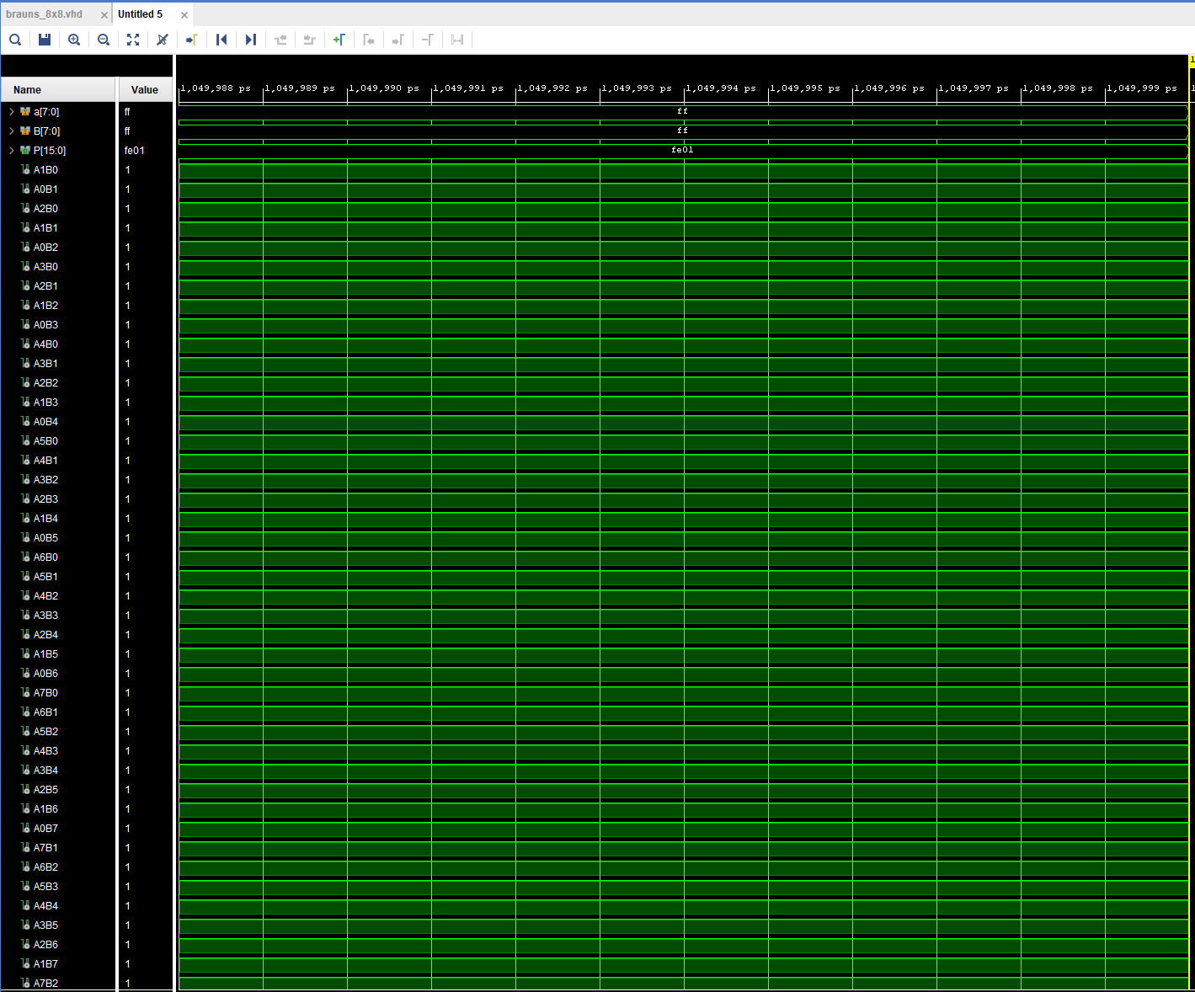
Figure 6
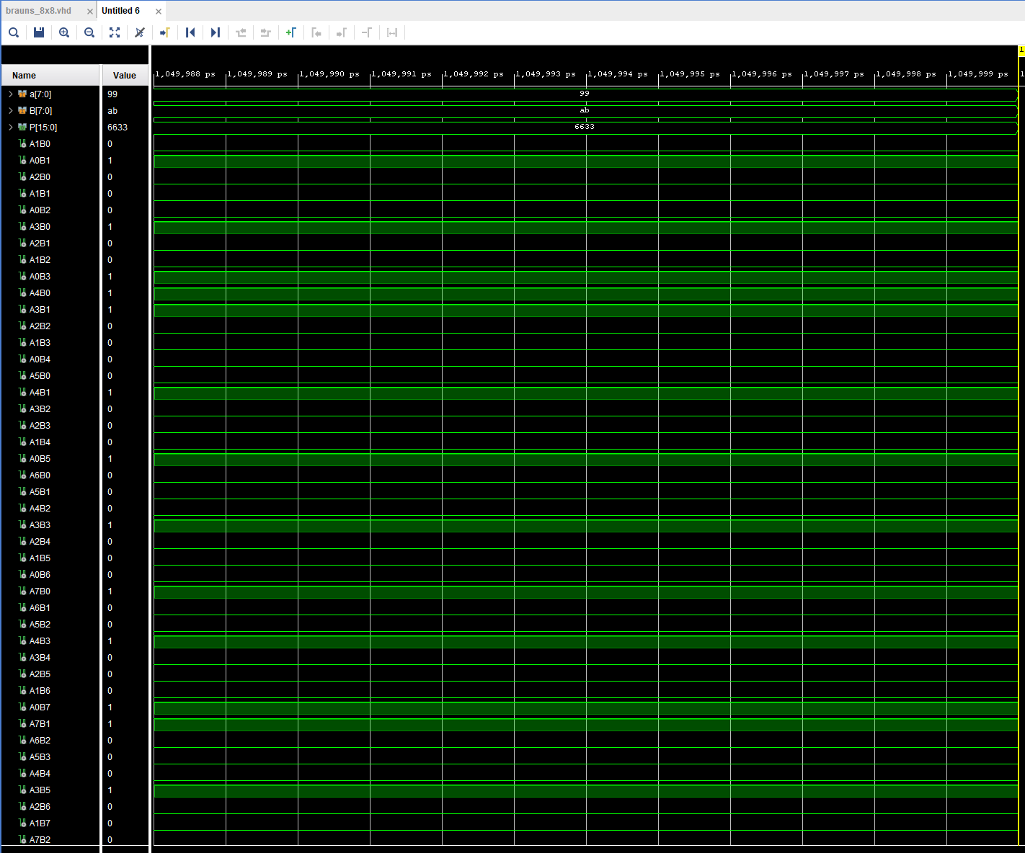
Figure 7
Brauns RTL design
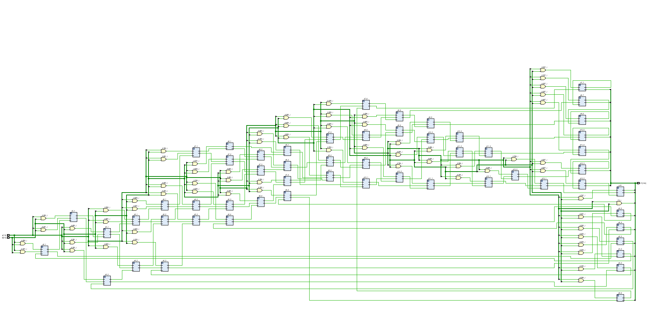
Figure 8
Brauns implementation schematic
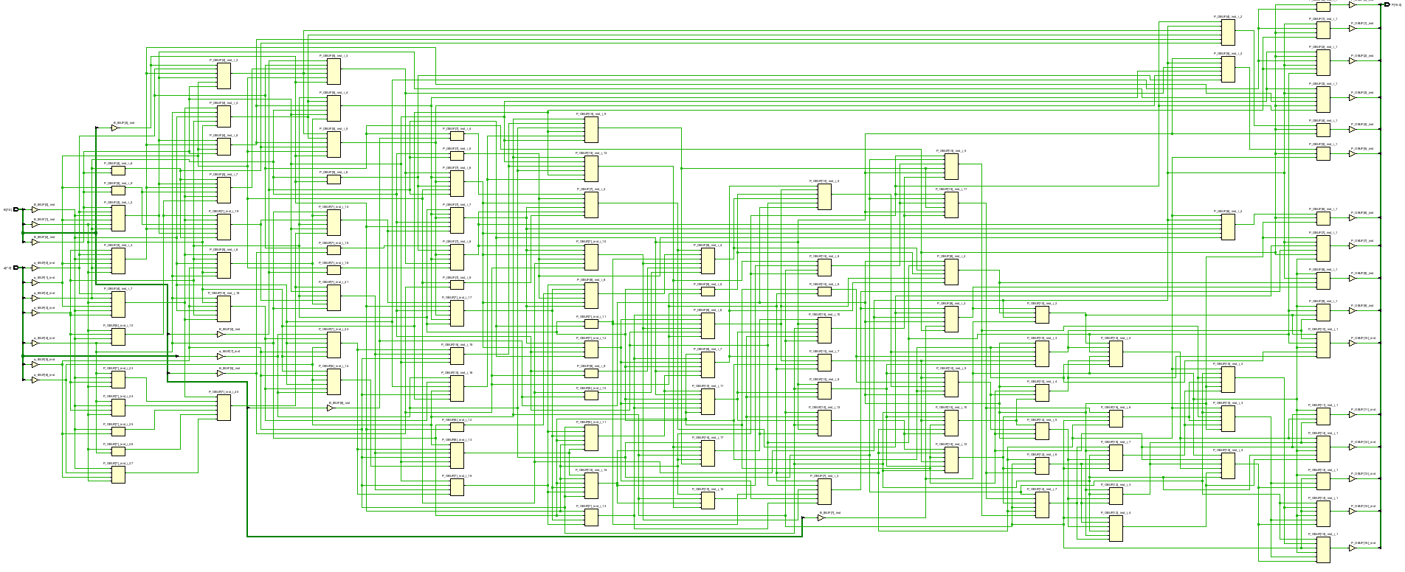
Figure 9

Brauns device
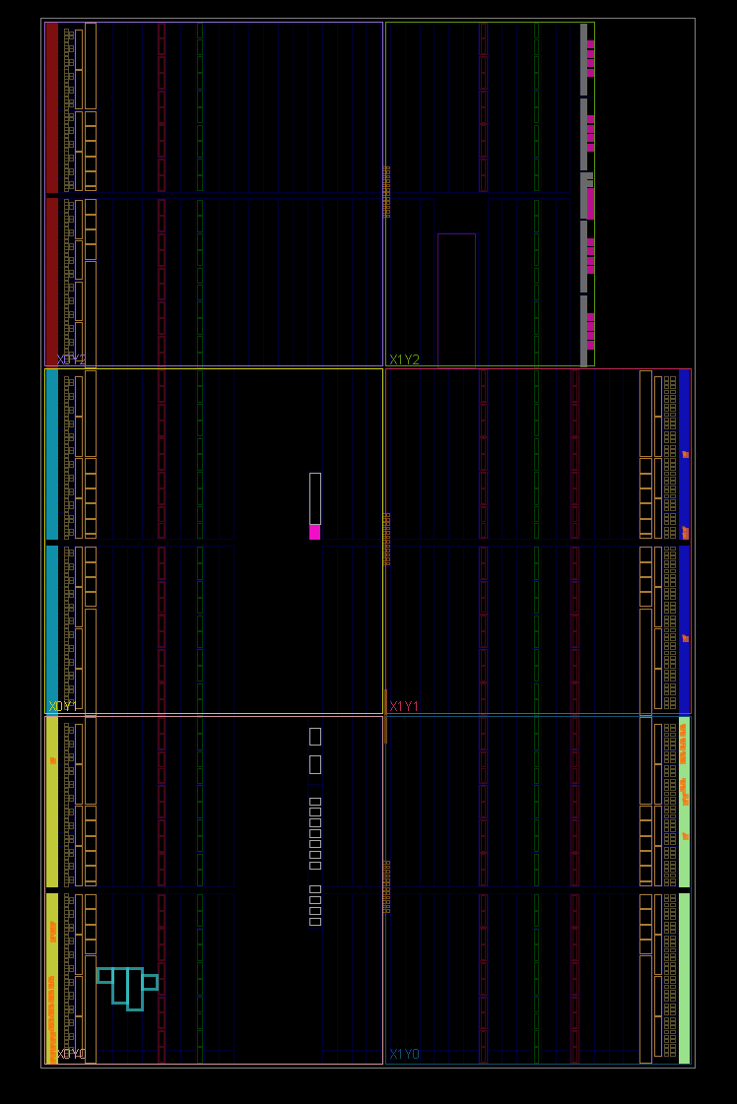
Figure 10
Brauns I/O planning
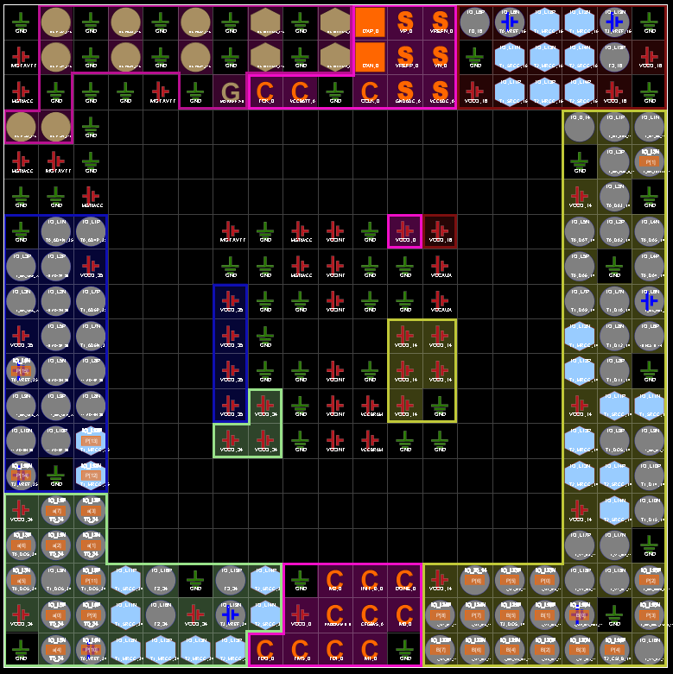
Figure 11

Brauns timing constraints
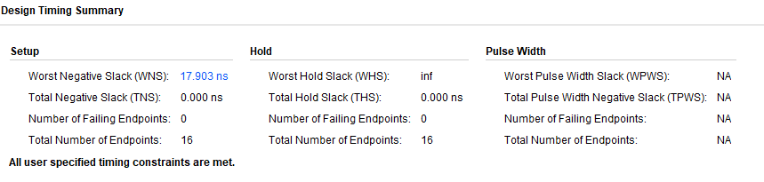
Figure 12
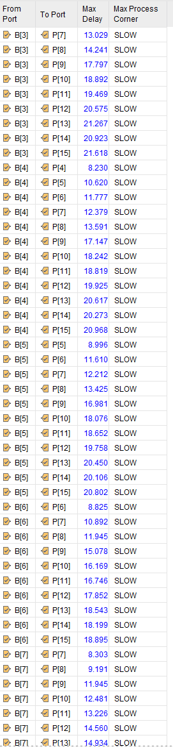
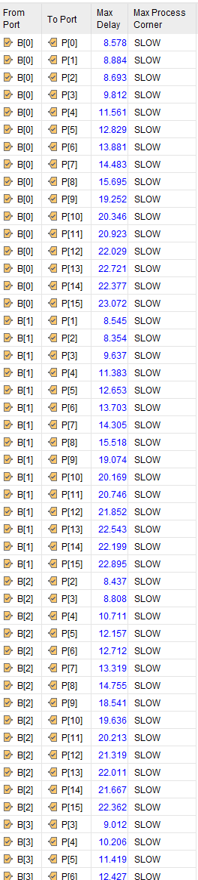
Figure 13 Figure 14
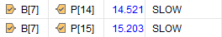
Figure 15
Brauns report utilization

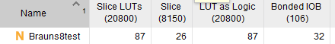
Figure 16

Brauns power report
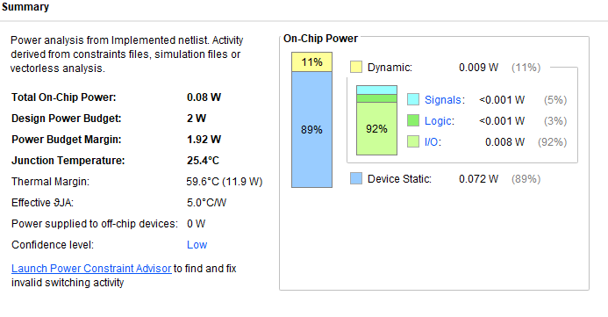
Figure 17
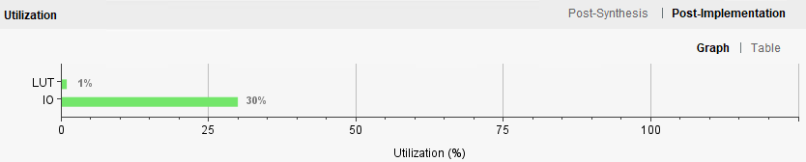
Figure 18

Wallace block diagram
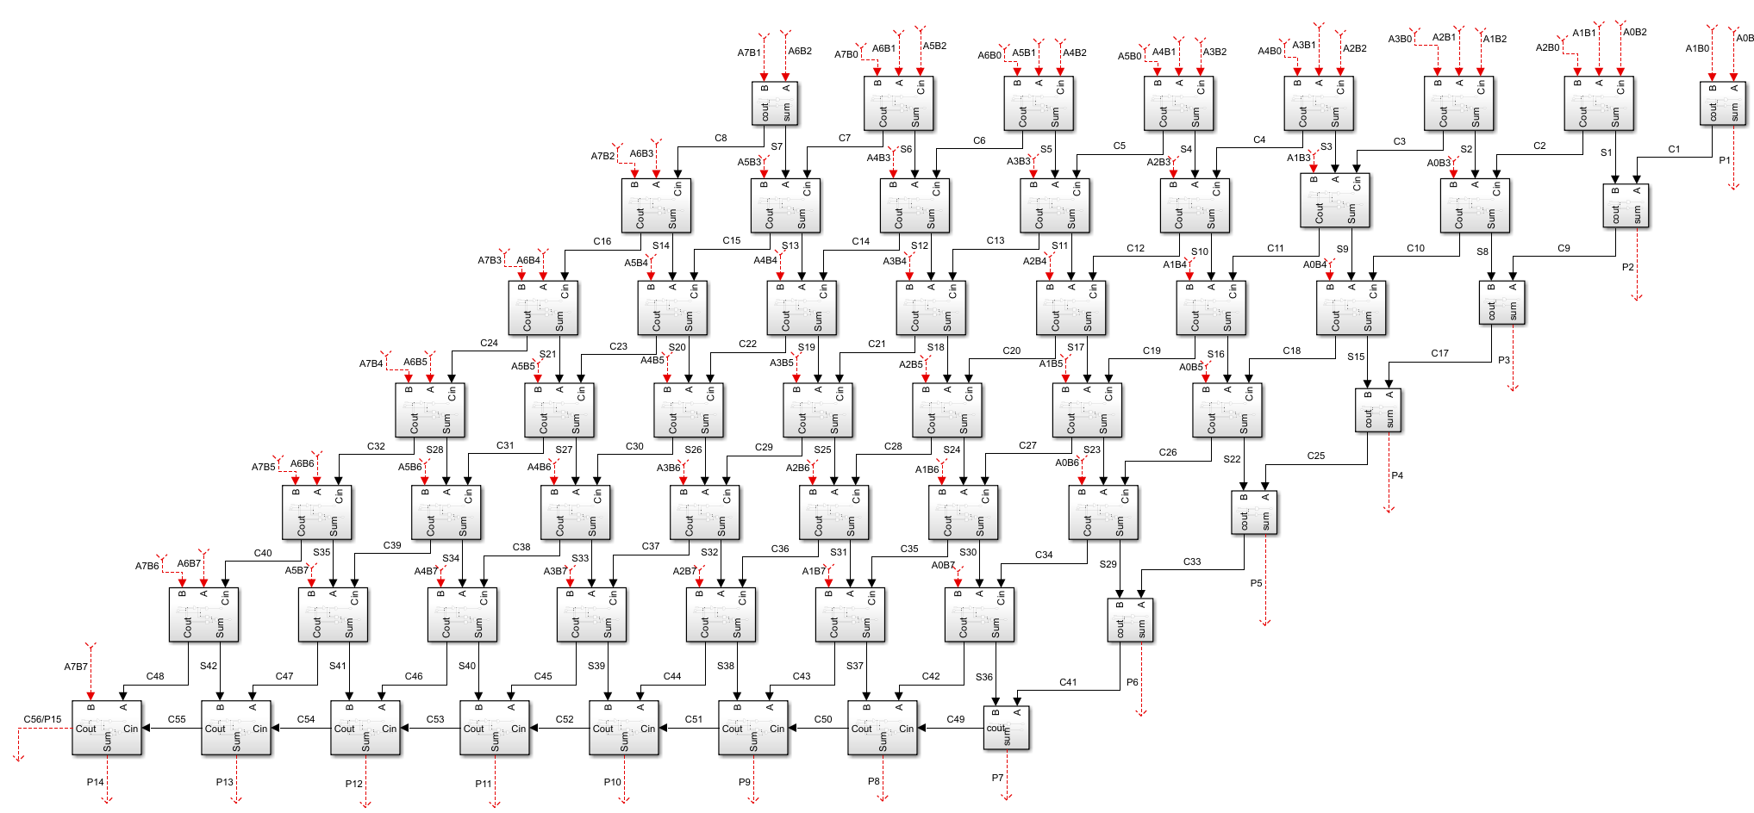
Figure 19
Wallace longest delay
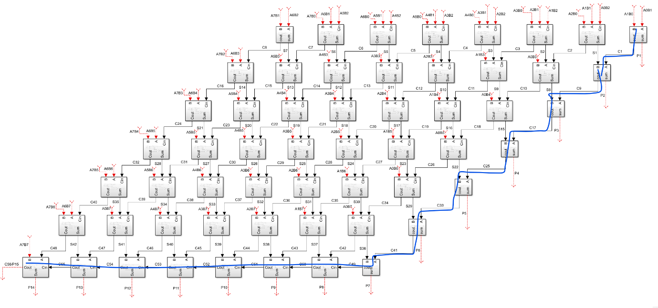
Figure 20

Wallace multiplier samples
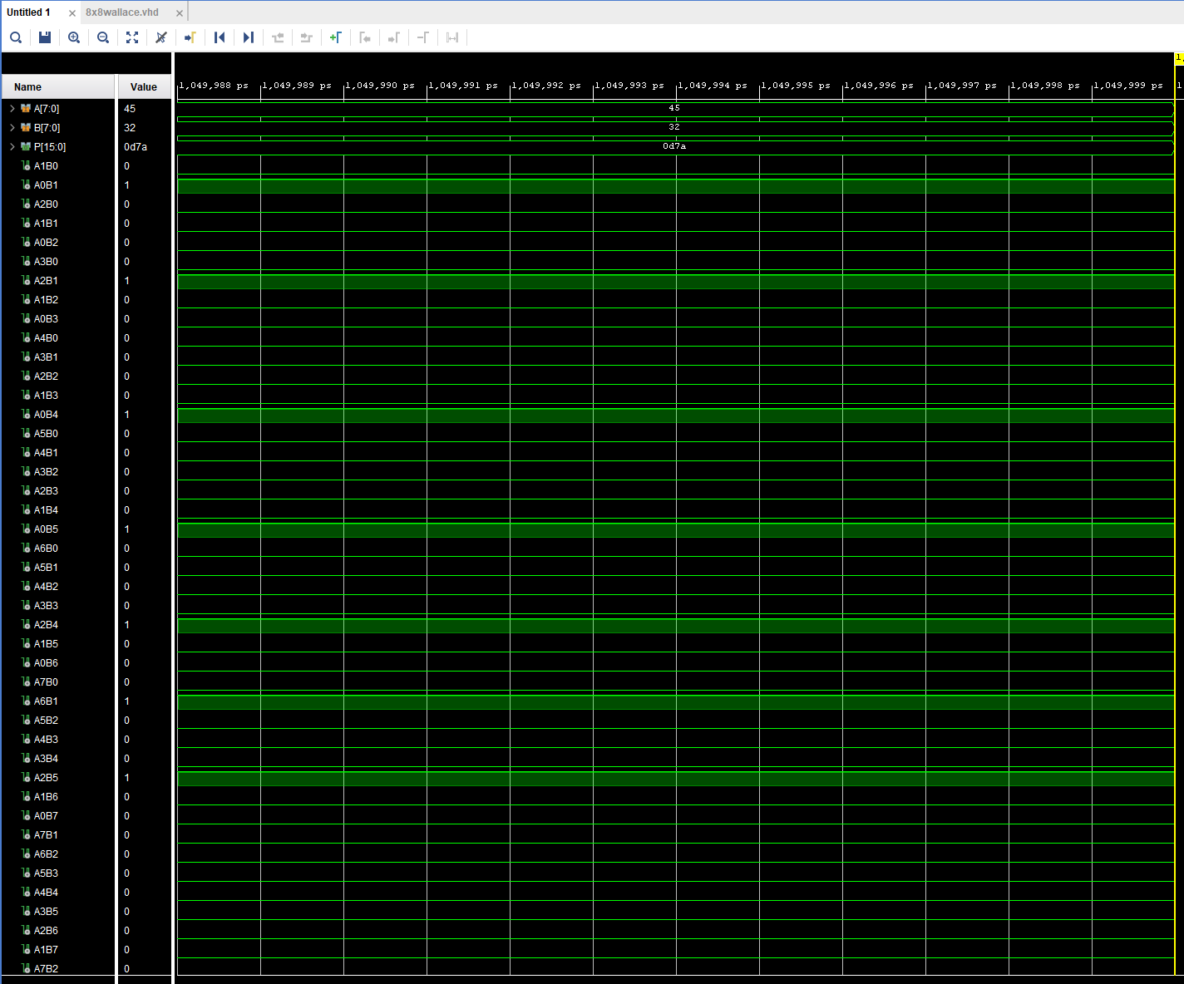
Figure 21
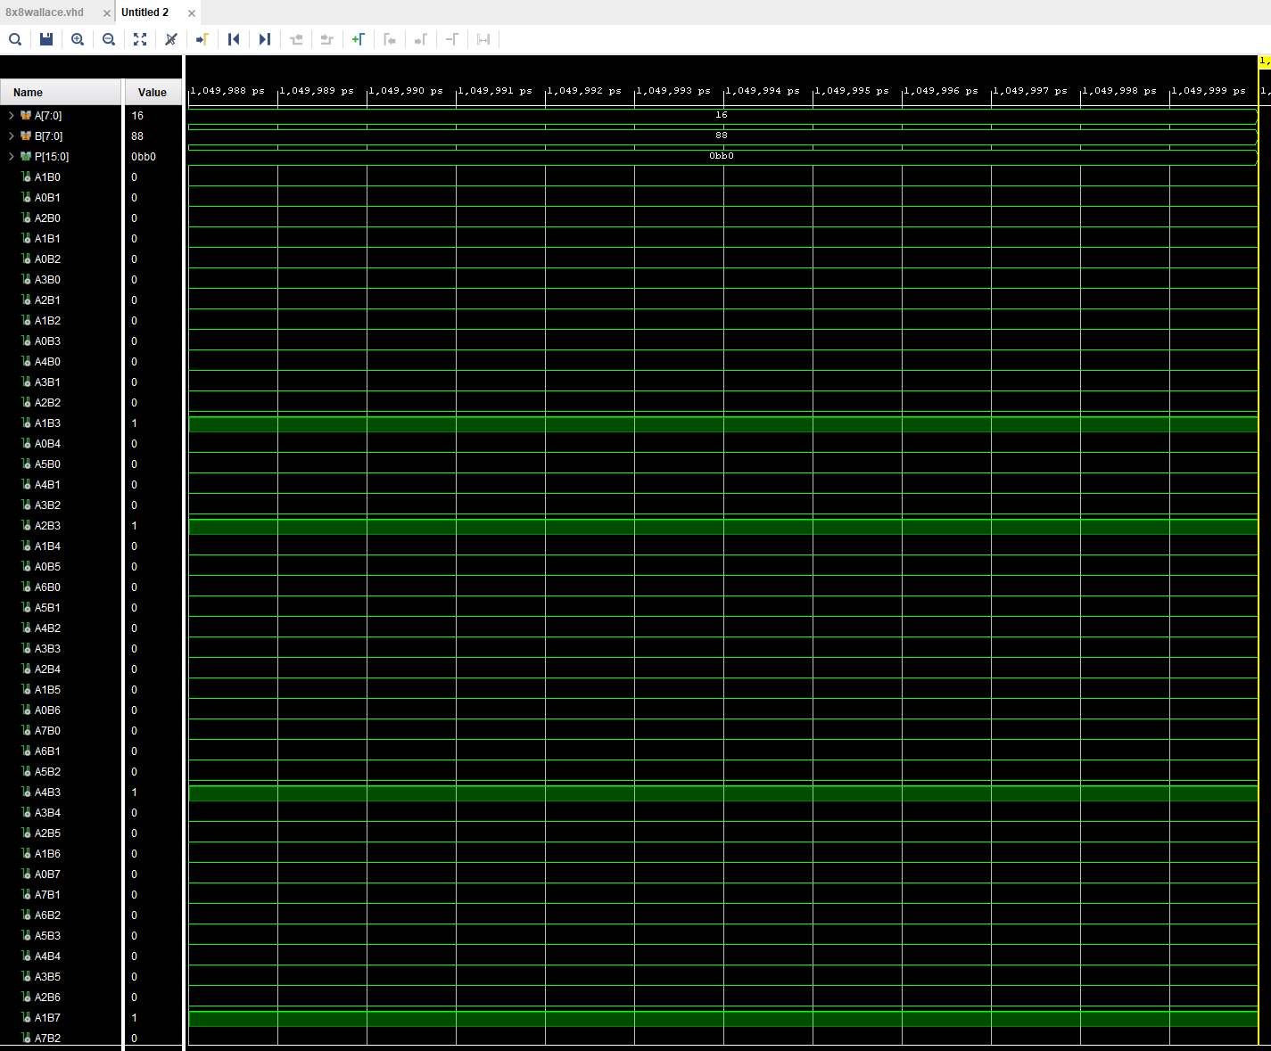
Figure 22
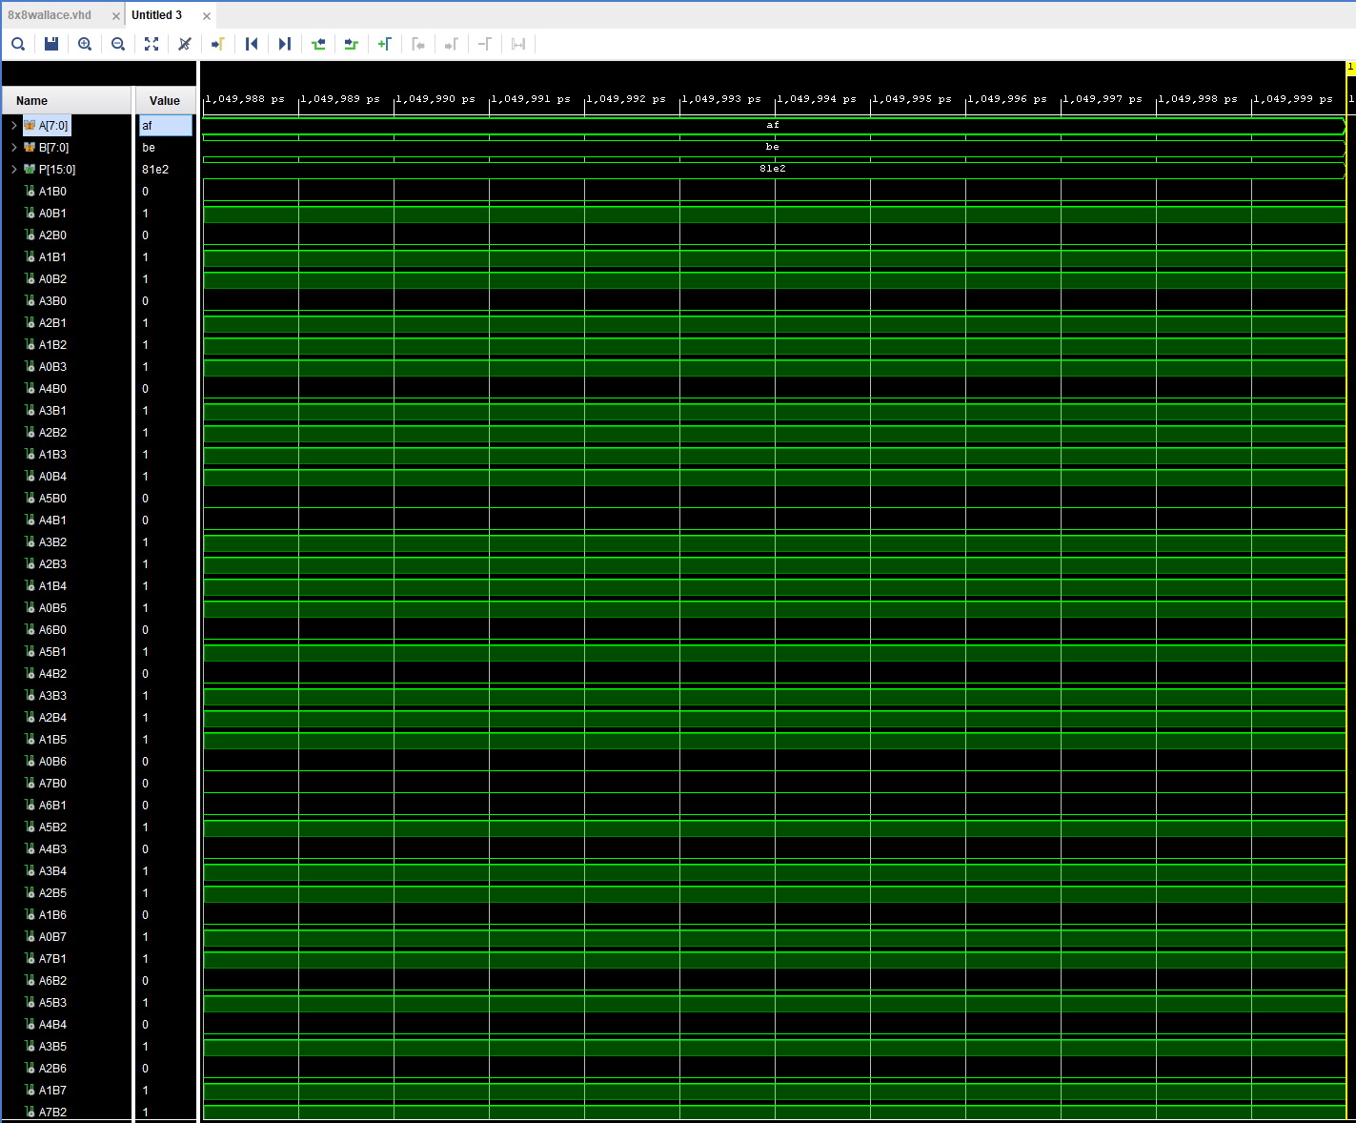
Figure 23
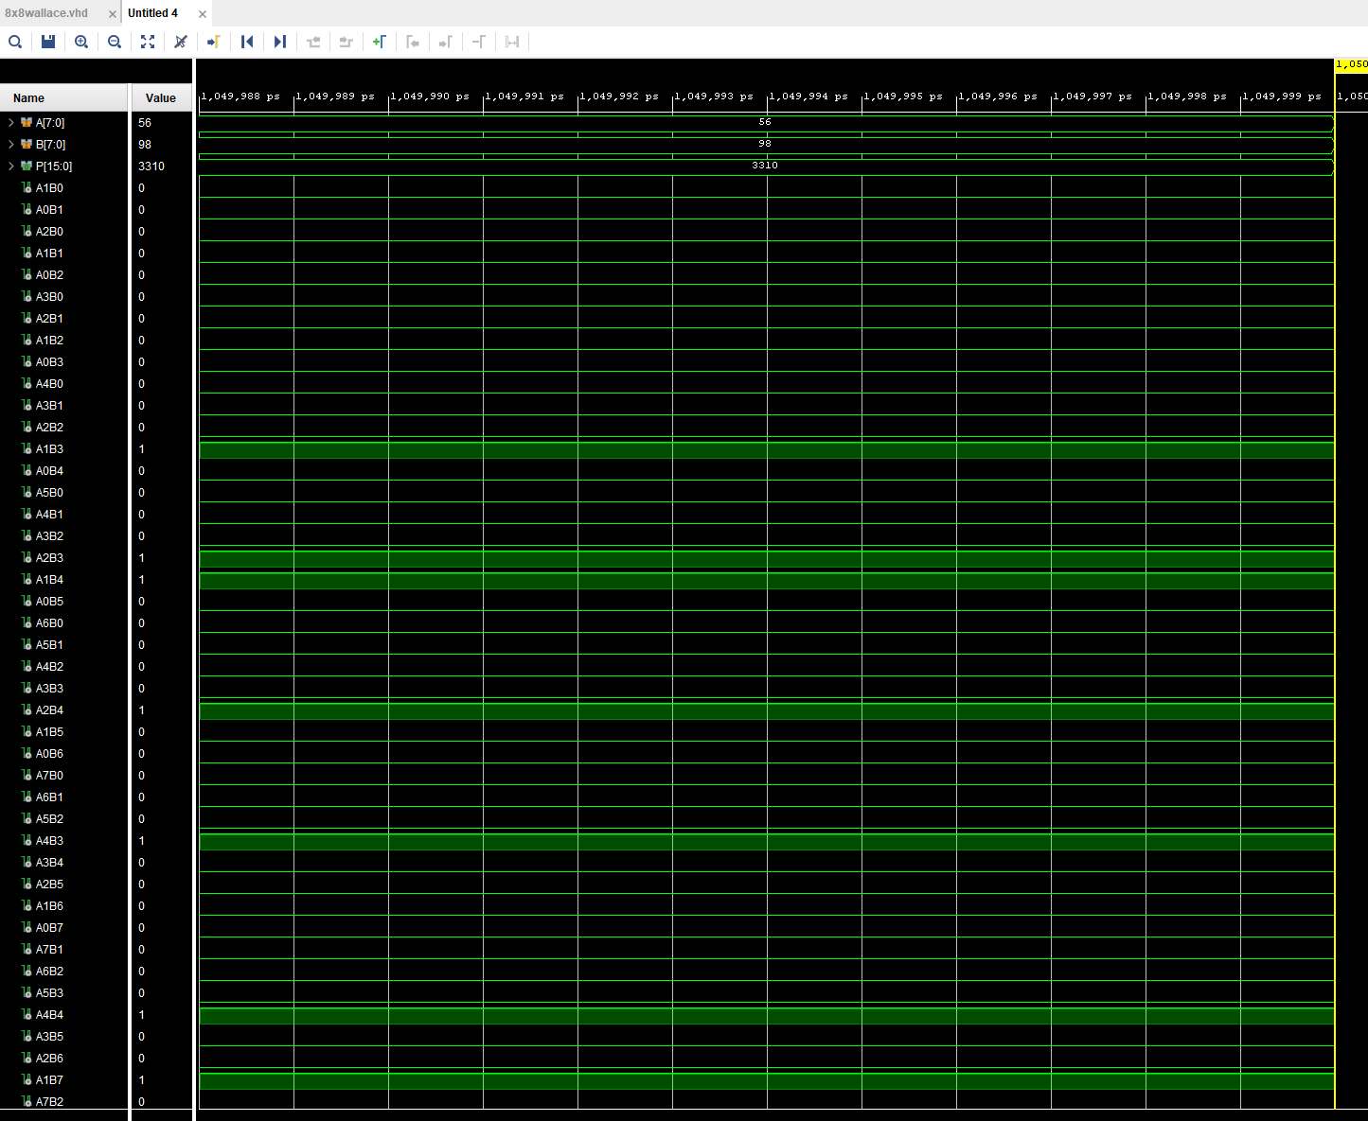
Figure 24
Wallace RTL design
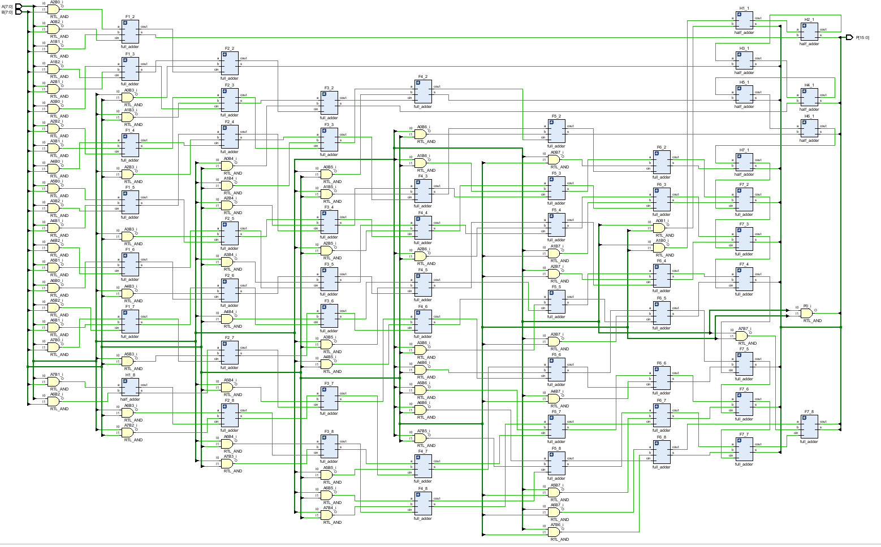
Figure 25
Wallace implementation schematic
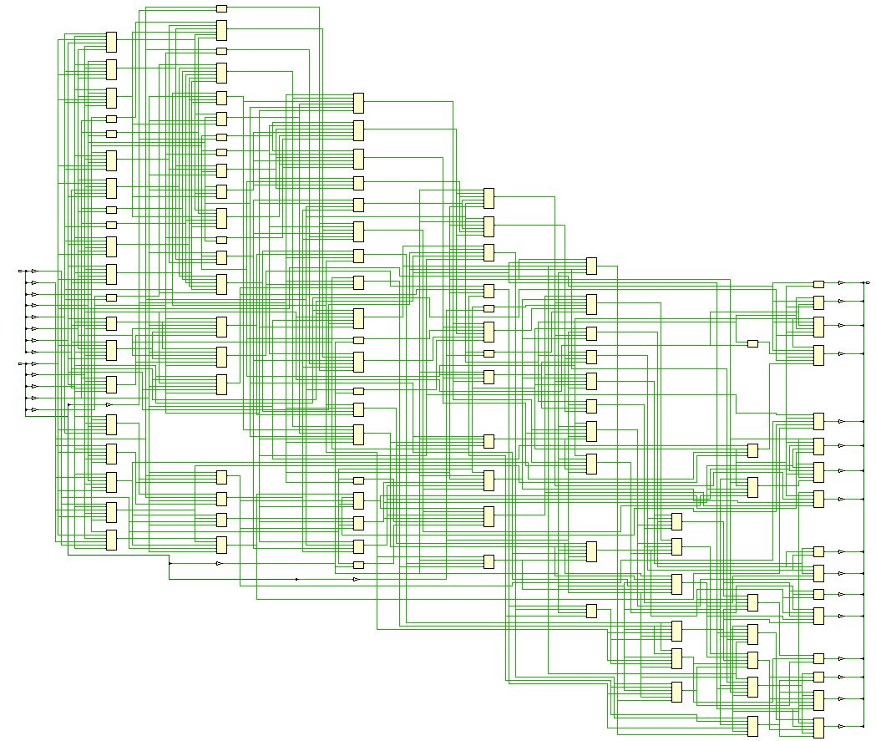
Figure 26
Wallace device
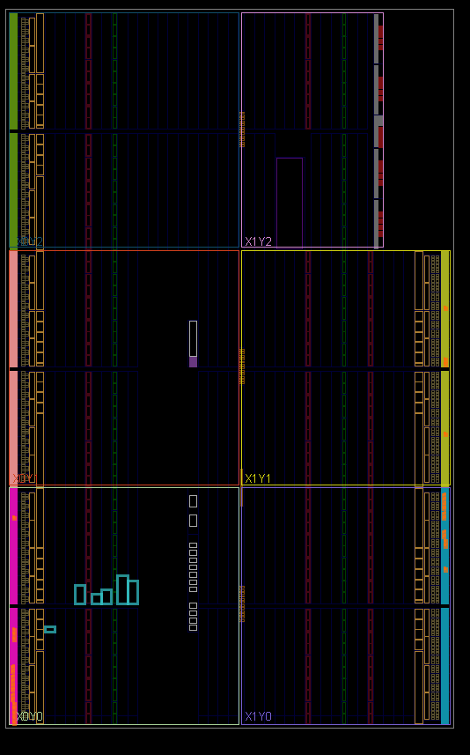
Figure 27
Wallace I/O planning
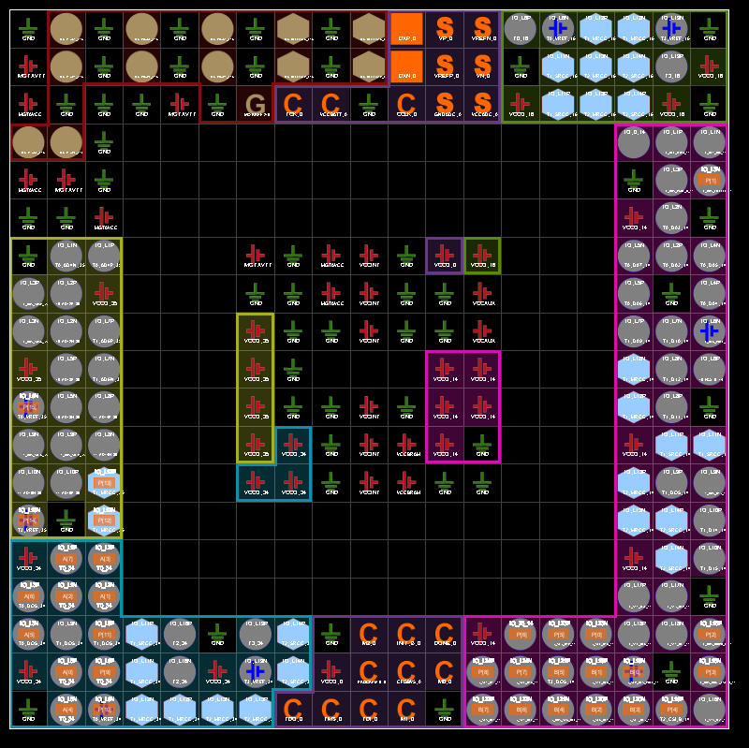
Figure 28

Wallace timing constraints
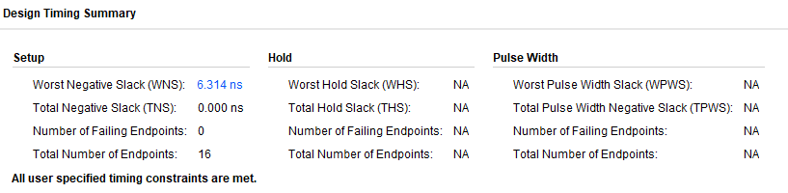
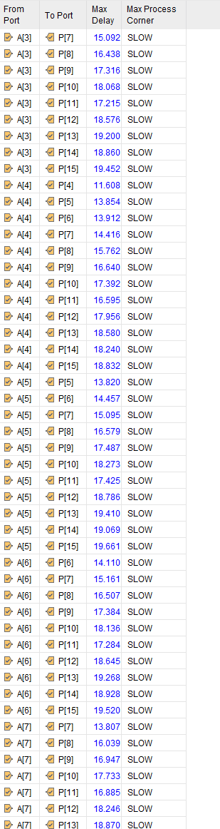
Figure 29
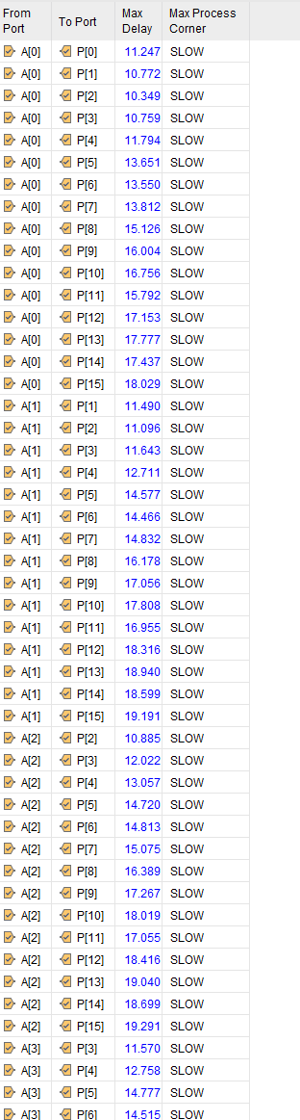
Figure 30 Figure 31
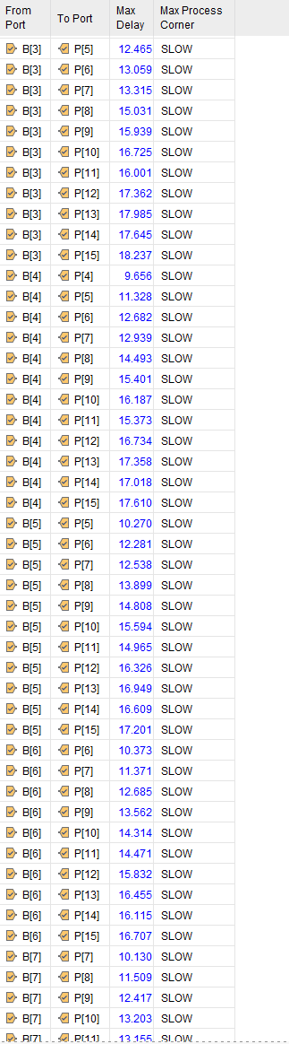
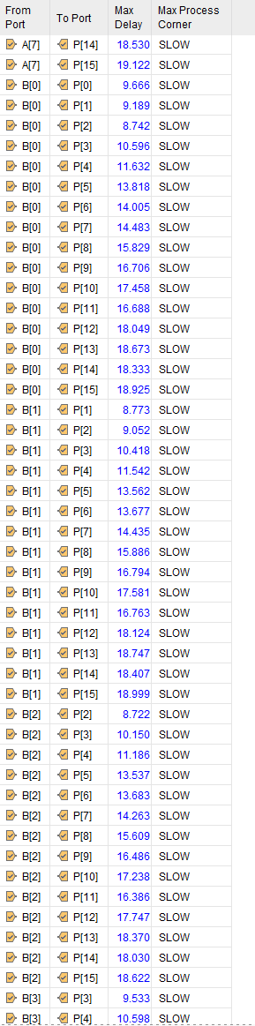
Figure 32 Figure 33
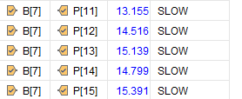
Figure 34

Wallace utilization report
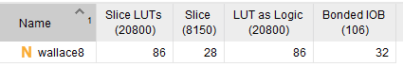
Figure 35
Wallace power report
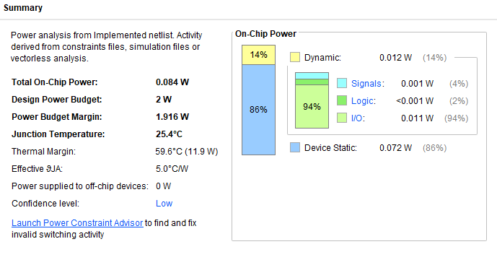
Figure 36
Figure 37

Brauns hardware test
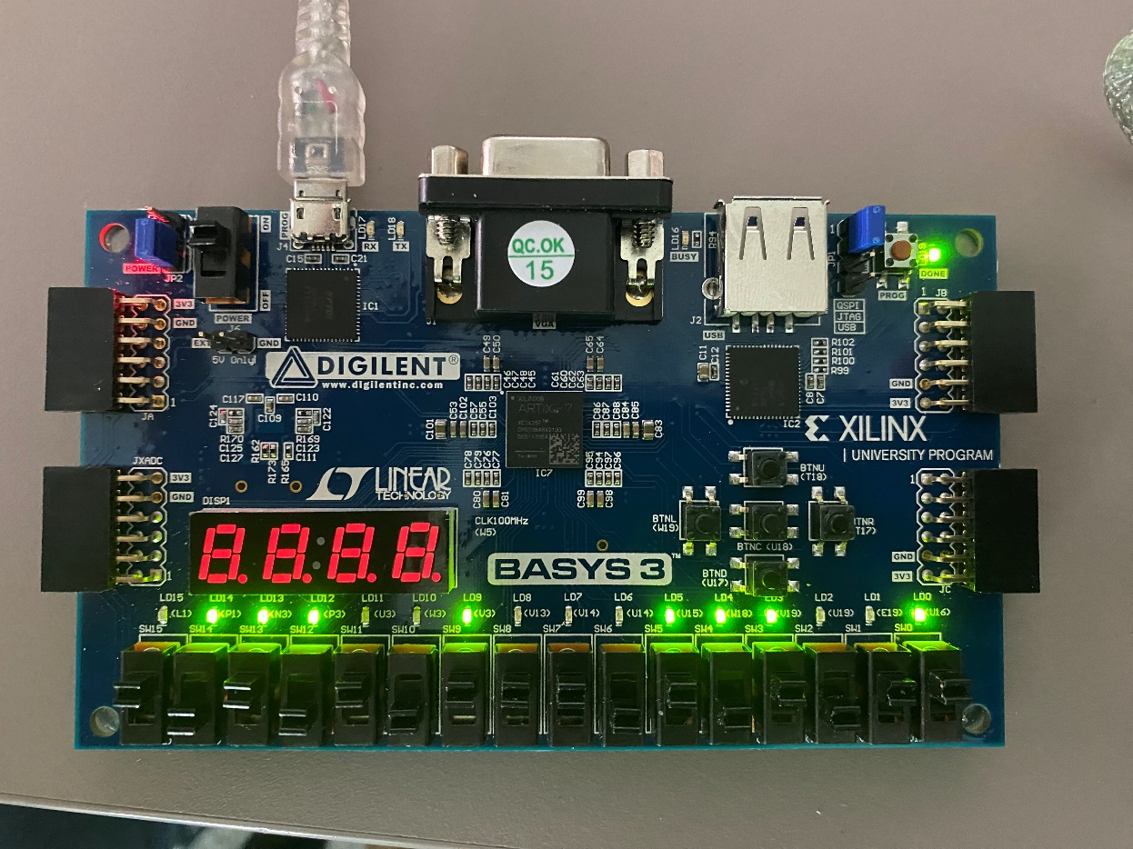
Figure 38

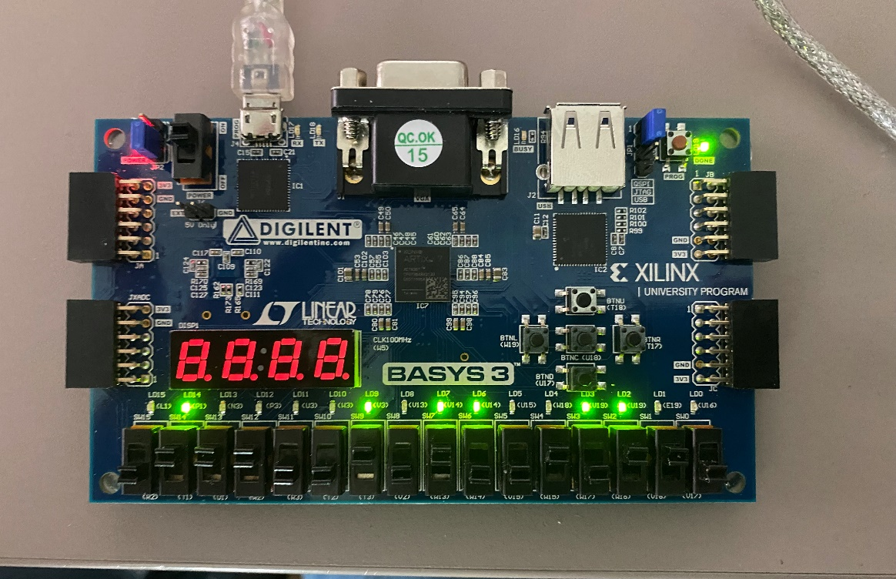
Figure 39

Wallace hardware test
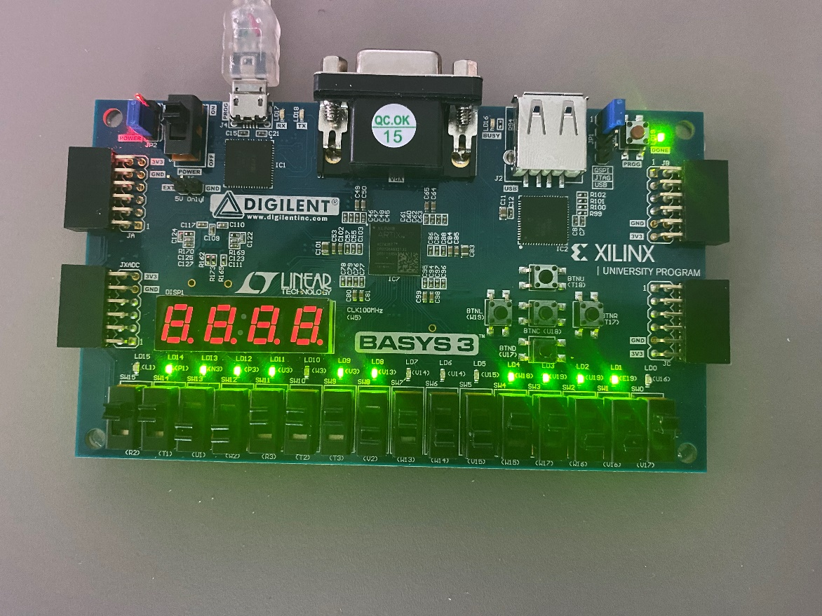
Figure 40
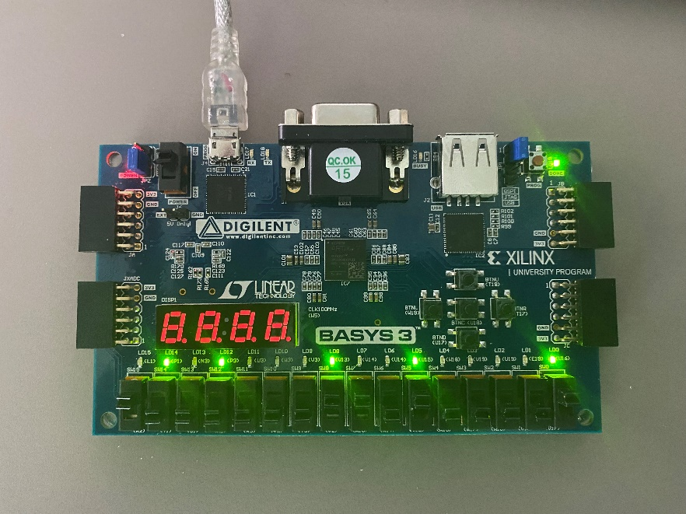
Figure 41

Comparison of Brauns and Wallace
Timings
Before the timings were selected for the simulation they were calculated manually using the longest possible delay of the design as seen in figure 3 and figure 20. These where calculated to be 41ns for Brauns taking into account that an adder was presumed to take 2ns and an AND gate was presumed to be 1ns. The same timings for the adders and AND gates where used to calculate the maximum delay for the Wallace tree multiplier which was calculated to be 29ns. These delays where then defined in the constraints file of the program which where then used to generate results using the simulation of the design.
When looking at the timings of the Brauns and Wallace design simulations it is clear that the Wallace is faster than the Brauns by a significant amount. When both are using the same delay values the Brauns design has a worst negative slack(WNS) of 18.903ns. This means that the timings in the design has enough time to complete each task due to the value being positive because is the WNS is negative then the timings set have failed. When the Wallace was tested using the same timings the simulation results showed that it had a WNS of 6.314ns which means that when compared to the results of the Brauns the Wallace more closely follows the timings constraints set.
This could be due to many different factors but is most likely caused by the way in which the two different methods reduce the number partial products. This will be due to the placement of the adders and how they are connected to one another. The shortest path between the adders is also shorter in the Wallace design but this difference wouldn’t be the only cause of the difference in speed between the two. It could also be caused by a delay in the input and output pins of the device. When comparing the results of the pin delays in figures 13, 14 and 15 for Brauns and figures 30,31,32,33 and 34 for the Wallace it is clear that the maximum delay of the pins is longer in the Brauns design. This could also be caused by many different factors the most likely being the longer path between the inputs and the outputs. For the Wallace the longest pin delay can be seen in figure 31 which was 19.661ns which occurred between pin A5 and P15. When look at the Wallace block diagram in figure 20 the longest route doesn’t have an input of pin A5 so this results would likely be caused by variance in the pins in the FPGA. The longest delay for a pin in the Brauns simulation was 23.072ns between B0 and P15 which is a larger maximum delay than in the Wallace and unlike the Wallace B0 to P15 does follow the longest path of adders. However when looking at the results it is also clear that there are more pins with a longer delay in the Brauns as there 27 total pins with a larger delay than the largest delay in the Wallace design. When looking at the shortest delay of both designs the Brauns does have the shortest delay at 8.23ns whereas the shortest delay in the Wallace is 8.722ns which occurs between pins B2 and P2 which is the shortest path between an input and output.

Power utilization and LUTs
Both designs were given a power budget of 2w which they both work within. When comparing the power usage of both design seen in figure 17 and figure 36 they are very similar to one another but the Wallace design used slightly more power. This will be due to the same number of adders being used in each design as well as the same input and output pins. Most of the power used by both of the designs is from the state device which would be the adder and logic gates in the design. The Wallace does use more power for the I/O pins and for dynamic power but this value would be negligible in a real life implementation due to tolerances. However due to the higher speed of the Wallace it would be more efficient than the Brauns as it would be able to carry out more tasks in the same amount of time. The number of LUTs or look up tables needed for both designs was also similar as shown in figure 16 and 35.

Further improvements
There are a few ways that both the Brauns and Wallace multipliers could be improved. One way would be to use [19] “hybrid full adder circuits” which would improve the power delay. The Wallace tree multiplier can also be integrated with a Booths multiplier which would help [20] “improve power consumption and delay in the design” by reducing the partial products earlier. To improve the Brauns multiplier [21] “high speed parallel prefix adders could be used which would improve the power efficiency and space usage of the design.” Implementing these improvements would require more analysis to be carried out to ensure that they have a positive effect on the designs performance.

Conclusions
Overall this report shows that both the Brauns and Wallace tree multiplier have their own advantages and disadvantages when compared against one another. Particularly the speed, power usage and size of both designs. But after analysing both designs the Wallace does seem to perform better when talking about the speed of the design. However the Wallace is more complex to design than the Brauns but it does also require less space but does use slightly more power. After researching developments in multipliers it is also clear that both designs could be improved in all areas but this would require further testing and analysis.
To conclude this report was successful in showing the differences between the Brauns and Wallace multipliers using simulations using vivado to create data that could then be analysed to come to a conclusion on the benefits of both designs. The research in the report also showed that further improvements could be made to both designs to improve both the efficiency and speed.

Appendix
Brauns VHDL program
library IEEE;
use IEEE.STD_LOGIC_1164.ALL;
use IEEE.STD_LOGIC_arith.ALL;
use IEEE.STD_LOGIC_unsigned.ALL;

-- Uncomment the following library declaration if using
-- arithmetic functions with Signed or Unsigned values
--use IEEE.NUMERIC_STD.ALL;

-- Uncomment the following library declaration if instantiating
-- any Xilinx leaf cells in this code.
--library UNISIM;
--use UNISIM.VComponents.all;

entity Brauns8test is
Port (a : in std_logic_vector (7 downto 0);
B : in std_logic_vector (7 downto 0);
P : out std_logic_vector (15 downto 0));
end Brauns8test;

architecture Gate_level of Brauns8test is

signal A1B0 : std_logic;
signal A0B1 : std_logic;
signal A2B0 : std_logic;
signal A1B1 : std_logic;
signal A0B2 : std_logic;
signal A3B0 : std_logic;
signal A2B1 : std_logic;
signal A1B2 : std_logic;
signal A0B3 : std_logic;
signal A4B0 : std_logic;
signal A3B1 : std_logic;
signal A2B2 : std_logic;
signal A1B3 : std_logic;
signal A0B4 : std_logic;
signal A5B0 : std_logic;
signal A4B1 : std_logic;
signal A3B2 : std_logic;
signal A2B3 : std_logic;
signal A1B4 : std_logic;
signal A0B5 : std_logic;
signal A6B0 : std_logic;
signal A5B1 : std_logic;
signal A4B2 : std_logic;
signal A3B3 : std_logic;
signal A2B4 : std_logic;
signal A1B5 : std_logic;
signal A0B6 : std_logic;
signal A7B0 : std_logic;
signal A6B1 : std_logic;
signal A5B2 : std_logic;
signal A4B3 : std_logic;
signal A3B4 : std_logic;
signal A2B5 : std_logic;
signal A1B6 : std_logic;
signal A0B7 : std_logic;
signal A7B1 : std_logic;
signal A6B2 : std_logic;
signal A5B3 : std_logic;
signal A4B4 : std_logic;
signal A3B5 : std_logic;
signal A2B6 : std_logic;
signal A1B7 : std_logic;
signal A7B2 : std_logic;
signal A6B3 : std_logic;
signal A5B4 : std_logic;
signal A4B5 : std_logic;
signal A3B6 : std_logic;
signal A2B7 : std_logic;
signal A7B3 : std_logic;
signal A6B4 : std_logic;
signal A5B5 : std_logic;
signal A4B6 : std_logic;
signal A3B7 : std_logic;
signal A7B4 : std_logic;
signal A6B5 : std_logic;
signal A5B6 : std_logic;
signal A4B7 : std_logic;
signal A7B5 : std_logic;
signal A6B6 : std_logic;
signal A5B7 : std_logic;
signal A7B6 : std_logic;
signal A6B7 : std_logic;
signal A7B7 : std_logic;

signal c1 : std_logic;---P2
signal s2 : std_logic;

signal c2 : std_logic;--p3
signal s3 : std_logic;
signal c9 : std_logic;
signal s10 : std_logic;

signal c3 : std_logic;--p4
signal s4 : std_logic;
signal c10 : std_logic;
signal s11 : std_logic;
signal c17 : std_logic;
signal s18 : std_logic;

signal c4 : std_logic;--p5
signal s5 : std_logic;
signal c11 : std_logic;
signal s12 : std_logic;
signal c18 : std_logic;
signal s19 : std_logic;
signal c25 : std_logic;
signal s26 : std_logic;

signal c5 : std_logic;--p6
signal s6 : std_logic;
signal c12 : std_logic;
signal s13 : std_logic;
signal c19 : std_logic;
signal s20 : std_logic;
signal c26 : std_logic;
signal s27 : std_logic;
signal c33 :std_logic;
signal s34 : std_logic;

signal c6 : std_logic;--p7
signal s7 : std_logic;
signal c13 : std_logic;
signal s14 : std_logic;
signal c20 : std_logic;
signal s21 : std_logic;
signal c27 : std_logic;
signal s28 : std_logic;
signal c34 : std_logic;
signal s35 : std_logic;
signal c41 : std_logic;
signal s42 : std_logic;

signal c7 : std_logic;--p8
signal s8 : std_logic;
signal c14 : std_logic;
signal s15 : std_logic;
signal c21 : std_logic;
signal s22 : std_logic;
signal c28 : std_logic;
signal s29 : std_logic;
signal c35 : std_logic;
signal s36 : std_logic;
signal c42 : std_logic;
signal s43 : std_logic;
signal c49 : std_logic;

signal c8 : std_logic;--p9
signal c15 : std_logic;
signal s16 : std_logic;
signal c22 : std_logic;
signal s23 : std_logic;
signal c29 : std_logic;
signal s30 : std_logic;
signal c36 : std_logic;
signal s37 : std_logic;
signal c43 : std_logic;
signal s44 : std_logic;
signal c50 : std_logic;

signal c16 : std_logic;--p10
signal c23 : std_logic;
signal s24 : std_logic;
signal c30 : std_logic;
signal s31 : std_logic;
signal c37 : std_logic;
signal s38 : std_logic;
signal c44 : std_logic;
signal s45 : std_logic;
signal c51 : std_logic;

signal c24 : std_logic;--p11
signal c31 : std_logic;
signal s32 : std_logic;
signal c38 : std_logic;
signal s39 : std_logic;
signal c45 : std_logic;
signal s46 : std_logic;
signal c52 : std_logic;

signal c32 : std_logic;--p12
signal c39 : std_logic;
signal s40 : std_logic;
signal c46 : std_logic;
signal s47 : std_logic;
signal c53 : std_logic;

signal c40 : std_logic;--p13
signal c47 : std_logic;
signal s48 : std_logic;
signal c54 : std_logic;

signal c48 : std_logic;--p14
signal c55 : std_logic;

signal c56 : std_logic;--p15

component full_adder
port (A : in std_logic;
b : in std_logic;
cin : in std_logic;
s : out std_logic;
cout : out std_logic);
end component;

component half_adder
port (a : in std_logic;
b : in std_logic;
s : out std_logic;
cout : out std_logic);
end component;

begin

A1B0 <= A(1) and B(0);
A0B1 <= A(0) and B(1);
A2B0 <= A(2) and B(0);
A1B1 <= A(1) and B(1);
A0B2 <= A(0) and B(2);
A3B0 <= A(3) and B(0);
A2B1 <= A(2) and B(1);
A1B2 <= A(1) and B(2);
A0B3 <= A(0) and B(3);
A4B0 <= A(4) and B(0);
A3B1 <= A(3) and B(1);
A2B2 <= A(2) and B(2);
A1B3 <= A(1) and B(3);
A0B4 <= A(0) and B(4);
A5B0 <= A(5) and B(0);
A4B1 <= A(4) and B(1);
A3B2 <= A(3) and B(2);
A2B3 <= A(2) and B(3);
A1B4 <= A(1) and B(4);
A0B5 <= A(0) and B(5);
A6B0 <= A(6) and B(0);
A5B1 <= A(5) and B(1);
A4B2 <= A(4) and B(2);
A3B3 <= A(3) and B(3);
A2B4 <= A(2) and B(4);
A1B5 <= A(1) and B(5);
A0B6 <= A(0) and B(6);
A7B0 <= A(7) and B(0);
A6B1 <= A(6) and B(1);
A5B2 <= A(5) and B(2);
A4B3 <= A(4) and B(3);
A3B4 <= A(3) and B(4);
A2B5 <= A(2) and B(5);
A1B6 <= A(1) and B(6);
A0B7 <= A(0) and B(7);
A7B1 <= A(7) and B(1);
A6B2 <= A(6) and B(2);
A5B3 <= A(5) and B(3);
A4B4 <= A(4) and B(4);
A3B5 <= A(3) and B(5);
A2B6 <= A(2) and B(6);
A1B7 <= A(1) and B(7);
A7B2 <= A(7) and B(2);
A6B3 <= A(6) and B(3);
A5B4 <= A(5) and B(4);
A4B5 <= A(4) and B(5);
A3B6 <= A(3) and B(6);
A2B7 <= A(2) and B(7);
A7B3 <= A(7) and B(3);
A6B4 <= A(6) and B(4);
A5B5 <= A(5) and B(5);
A4B6 <= A(4) and B(6);
A3B7 <= A(3) and B(7);
A7B4 <= A(7) and B(4);
A6B5 <= A(6) and B(5);
A5B6 <= A(5) and B(6);
A4B7 <= A(4) and B(7);
A7B5 <= A(7) and B(5);
A6B6 <= A(6) and B(6);
A5B7 <= A(5) and B(7);
A7B6 <= A(7) and B(6);
A6B7 <= A(6) and B(7);
A7B7 <= A(7) and B(7);

p0 : P(0) <=A(0) and b(0) ;

p1_0 : half_adder port map (A=>a1B0 , b=> a0b1 , s=> p(1), cout=>c1);

p2_1 : full_adder port map (A=>A2b0 , b=>a1b1, cin=>c1, s=>s2, cout=>c2);
p2_2 : half_adder port map(a=>a0b2 , b=>s2, s=>p(2), cout=>c9);

p3_1 : full_adder port map (a=>a3b0, b=>a2b1, cin=>c2, s=>s3, cout=>c3);
p3_2 : full_adder port map (a=>a1b2, b=>s3, cin=>c9, s=>s10, cout=>c10);
p3_3 : half_adder port map(a=>a0b3 , b=>s10, s=>p(3), cout=>c17);

p4_1 : full_adder port map (a=>a4b0, b=>a3b1, cin=>c3, s=>s4, cout=>c4);
p4_2 : full_adder port map (a=>a2b2, b=>s4, cin=>c10, s=>s11, cout=>c11);
p4_3 : full_adder port map (a=>a1b3, b=>s11, cin=>c17, s=>s18, cout=>c18);
p4_4 : half_adder port map(a=>a0b4 , b=>s18, s=>p(4), cout=>c25);

p5_1 : full_adder port map (a=>a5b0, b=>a4b1, cin=>c4, s=>s5, cout=>c5);
p5_2 : full_adder port map (a=>a3b2, b=>s5, cin=>c11, s=>s12, cout=>c12);
p5_3 : full_adder port map (a=>a2b3, b=>s12, cin=>c18, s=>s19, cout=>c19);
p5_4 : full_adder port map (a=>a1b4, b=>s19, cin=>c25, s=>s26, cout=>c26);
p5_5 : half_adder port map(a=>a0b5 , b=>s26, s=>p(5), cout=>c33);

p6_1 : full_adder port map (a=>a6b0, b=>a5b1, cin=>c5, s=>s6, cout=>c6);
p6_2 : full_adder port map (a=>a4b2, b=>s6, cin=>c12, s=>s13, cout=>c13);
p6_3 : full_adder port map (a=>a3b3, b=>s13, cin=>c19, s=>s20, cout=>c20);
p6_4 : full_adder port map (a=>a2b4, b=>s20, cin=>c26, s=>s27, cout=>c27);
p6_5 : full_adder port map (a=>a1b5, b=>s27, cin=>c33, s=>s34, cout=>c34);
p6_6 : half_adder port map(a=>a0b6 , b=>s34, s=>p(6), cout=>c41);

p7_1 : full_adder port map (a=>a7b0, b=>a6b1, cin=>c6, s=>s7, cout=>c7);
p7_2 : full_adder port map (a=>a5b2, b=>s7, cin=>c13, s=>s14, cout=>c14);
p7_3 : full_adder port map (a=>a4b3, b=>s14, cin=>c20, s=>s21, cout=>c21);
p7_4 : full_adder port map (a=>a3b4, b=>s21, cin=>c27, s=>s28, cout=>c28);
p7_5 : full_adder port map (a=>a2b5, b=>s28, cin=>c34, s=>s35, cout=>c35);
p7_6 : full_adder port map (a=>a1b6, b=>s35, cin=>c41, s=>s42, cout=>c42);
p7_7 : half_adder port map(a=>a0b7 , b=>s42, s=>p(7), cout=>c49);

p8_1 : half_adder port map (a=>a7b1, b=>c7,s=>s8, cout=>c8);
p8_2 : full_adder port map (a=>a6b2, b=>s8, cin=>c14, s=>s15, cout=>c15);
p8_3 : full_adder port map (a=>a5b3, b=>s15, cin=>c21, s=>s22, cout=>c22);
p8_4 : full_adder port map (a=>a4b4, b=>s22, cin=>c28, s=>s29, cout=>c29);
p8_5 : full_adder port map (a=>a3b5, b=>s29, cin=>c35, s=>s36, cout=>c36);
p8_6 : full_adder port map (a=>a2b6, b=>s36, cin=>c42, s=>s43, cout=>c43);
p8_7 : full_adder port map (a=>a1b7, b=>s43, cin=>c49, s=>p(8),cout=>c50);

p9_1 : full_adder port map (a=>a7b2, b=>c8, cin=>c15, s=>s16, cout=>c16);
p9_2 : full_adder port map (a=>a6b3, b=>s16, cin=>c22, s=>s23, cout=>c23);
p9_3 : full_adder port map (a=>a5b4, b=>s23, cin=>c29, s=>s30, cout=>c30);
p9_4 : full_adder port map (a=>a4b5, b=>s30, cin=>c36, s=>s37, cout=>c37);
p9_5 : full_adder port map (a=>a3b6, b=>s37, cin=>c43, s=>s44, cout=>c44);
p9_6 : full_adder port map (a=>a2b7, b=>s44, cin=>c50, s=>p(9),cout=>c51);

p10_1 : full_adder port map (a=>a7b3, b=>c16, cin=>c23, s=>s24, cout=>c24);
p10_2 : full_adder port map (a=>a6b4, b=>s24, cin=>c30, s=>s31, cout=>c31);
p10_3 : full_adder port map (a=>a5b5, b=>s31, cin=>c37, s=>s38, cout=>c38);
p10_4 : full_adder port map (a=>a4b6, b=>s38, cin=>c44, s=>s45, cout=>c45);
p10_5 : full_adder port map (a=>a3b7, b=>s45, cin=>c51, s=>p(10),cout=>c52);

p11_1 : full_adder port map (a=>a7b4, b=>c24, cin=>c31, s=>s32, cout=>c32);
p11_2 : full_adder port map (a=>a6b5, b=>s32, cin=>c38, s=>s39, cout=>c39);
p11_3 : full_adder port map (a=>a5b6, b=>s39, cin=>c45, s=>s46, cout=>c46);
p11_4 : full_adder port map (a=>a4b7, b=>s46, cin=>c52, s=>p(11),cout=>c53);

p12_1 : full_adder port map (a=>a7b5, b=>c32, cin=>c39, s=>s40, cout=>c40);
p12_2 : full_adder port map (a=>a6b6, b=>s40, cin=>c46, s=>s47, cout=>c47);
p12_3 : full_adder port map (a=>a5b7, b=>s47, cin=>c53, s=>p(12),cout=>c54);

p13_1 : full_adder port map (a=>a7b6, b=>c40, cin=>c47, s=>s48, cout=>c48);
p13_2 : full_adder port map (a=>a6b7, b=>s48, cin=>c54, s=>p(13),cout=>c55);

p14 : full_adder port map (a=>a7b7, b=>c48, cin=>c55, s=>p(14),cout=>c56);

p15 : p(15)<= c56;

end Gate_level;
Wallace VHDL program
library IEEE;
use IEEE.STD_LOGIC_1164.ALL;
use IEEE.STD_LOGIC_arith.ALL;
use IEEE.STD_LOGIC_unsigned.ALL;

-- Uncomment the following library declaration if using
-- arithmetic functions with Signed or Unsigned values
--use IEEE.NUMERIC_STD.ALL;

-- Uncomment the following library declaration if instantiating
-- any Xilinx leaf cells in this code.
--library UNISIM;
--use UNISIM.VComponents.all;

entity wallace8 is
Port ( A : in STD_LOGIC_VECTOR (7 downto 0);
B : in STD_LOGIC_VECTOR (7 downto 0);
P : out STD_LOGIC_VECTOR (15 downto 0));
end wallace8;

architecture gate_level of wallace8 is

component Full_adder is
Port ( A : in STD_LOGIC;
B : in STD_LOGIC;
Cin : in STD_LOGIC;
Cout : out STD_LOGIC;
S : out STD_LOGIC);
end component;

component Half_adder is
Port ( A : in STD_LOGIC;
B : in STD_LOGIC;
S : out STD_LOGIC;
Cout : out STD_LOGIC);
end component;

signal A1B0 : std_logic;
signal A0B1 : std_logic;
signal A2B0 : std_logic;
signal A1B1 : std_logic;
signal A0B2 : std_logic;
signal A3B0 : std_logic;
signal A2B1 : std_logic;
signal A1B2 : std_logic;
signal A0B3 : std_logic;
signal A4B0 : std_logic;
signal A3B1 : std_logic;
signal A2B2 : std_logic;
signal A1B3 : std_logic;
signal A0B4 : std_logic;
signal A5B0 : std_logic;
signal A4B1 : std_logic;
signal A3B2 : std_logic;
signal A2B3 : std_logic;
signal A1B4 : std_logic;
signal A0B5 : std_logic;
signal A6B0 : std_logic;
signal A5B1 : std_logic;
signal A4B2 : std_logic;
signal A3B3 : std_logic;
signal A2B4 : std_logic;
signal A1B5 : std_logic;
signal A0B6 : std_logic;
signal A7B0 : std_logic;
signal A6B1 : std_logic;
signal A5B2 : std_logic;
signal A4B3 : std_logic;
signal A3B4 : std_logic;
signal A2B5 : std_logic;
signal A1B6 : std_logic;
signal A0B7 : std_logic;
signal A7B1 : std_logic;
signal A6B2 : std_logic;
signal A5B3 : std_logic;
signal A4B4 : std_logic;
signal A3B5 : std_logic;
signal A2B6 : std_logic;
signal A1B7 : std_logic;
signal A7B2 : std_logic;
signal A6B3 : std_logic;
signal A5B4 : std_logic;
signal A4B5 : std_logic;
signal A3B6 : std_logic;
signal A2B7 : std_logic;
signal A7B3 : std_logic;
signal A6B4 : std_logic;
signal A5B5 : std_logic;
signal A4B6 : std_logic;
signal A3B7 : std_logic;
signal A7B4 : std_logic;
signal A6B5 : std_logic;
signal A5B6 : std_logic;
signal A4B7 : std_logic;
signal A7B5 : std_logic;
signal A6B6 : std_logic;
signal A5B7 : std_logic;
signal A7B6 : std_logic;
signal A6B7 : std_logic;
signal A7B7 : std_logic;

signal c1 : std_logic; --p2
signal s1 : std_logic;

signal c2 : std_logic; --p3
signal s2 : std_logic;
signal c9 : std_logic;
signal s8 : std_logic;

signal c3 : std_logic; --p4
signal s3 : std_logic;
signal c10 : std_logic;
signal s9 : std_logic;
signal c17 : std_logic;
signal s15 : std_logic;

signal c4 : std_logic; --p5
signal s4 : std_logic;
signal c11 : std_logic;
signal s10 : std_logic;
signal c18 : std_logic;
signal s16 : std_logic;
signal c25 : std_logic;
signal s22 : std_logic;

signal c5 : std_logic; --p6
signal s5 : std_logic;
signal c12 : std_logic;
signal s11 : std_logic;
signal c19 : std_logic;
signal s17 : std_logic;
signal c26 : std_logic;
signal s23 : std_logic;
signal c33 : std_logic;
signal s29 : std_logic;

signal c6 : std_logic; --p7
signal s6 : std_logic;
signal c13 : std_logic;
signal s12 : std_logic;
signal c20 : std_logic;
signal s18 : std_logic;
signal c27 : std_logic;
signal s24 : std_logic;
signal c34 : std_logic;
signal s30 : std_logic;
signal c41 : std_logic;
signal s36 : std_logic;

signal c7 : std_logic; --p8
signal s7 : std_logic;
signal c14 : std_logic;
signal s13 : std_logic;
signal c21 : std_logic;
signal s19 : std_logic;
signal c28 : std_logic;
signal s25 : std_logic;
signal c35 : std_logic;
signal s31 : std_logic;
signal c42 : std_logic;
signal s37 : std_logic;
signal c49 : std_logic;

signal c8 : std_logic; --p9
signal c15 : std_logic;
signal s14 : std_logic;
signal c22 : std_logic;
signal s20 : std_logic;
signal c29 : std_logic;
signal s26 : std_logic;
signal c36 : std_logic;
signal s32 : std_logic;
signal c43 : std_logic;
signal s38 : std_logic;
signal c50 : std_logic;

signal c16 : std_logic; --p10
signal c23 : std_logic;
signal s21 : std_logic;
signal c30 : std_logic;
signal s27 : std_logic;
signal c37 : std_logic;
signal s33 : std_logic;
signal c44 : std_logic;
signal s39 : std_logic;
signal c51 : std_logic;

signal c24 : std_logic; --p11
signal c31 : std_logic;
signal s28 : std_logic;
signal c38 : std_logic;
signal s34 : std_logic;
signal c45 : std_logic;
signal s40 : std_logic;
signal c52 : std_logic;

signal c32 : std_logic; --p12
signal c39 : std_logic;
signal s35 : std_logic;
signal c46 : std_logic;
signal s41 : std_logic;
signal c53 : std_logic;

signal c40 : std_logic; --p13
signal c47 : std_logic;
signal s42 : std_logic;
signal c54 : std_logic;

signal c48 : std_logic; --p14
signal c55 : std_logic;

signal c56 : std_logic;--p15

begin

A1B0 <= A(1) and B(0);
A0B1 <= A(0) and B(1);
A2B0 <= A(2) and B(0);
A1B1 <= A(1) and B(1);
A0B2 <= A(0) and B(2);
A3B0 <= A(3) and B(0);
A2B1 <= A(2) and B(1);
A1B2 <= A(1) and B(2);
A0B3 <= A(0) and B(3);
A4B0 <= A(4) and B(0);
A3B1 <= A(3) and B(1);
A2B2 <= A(2) and B(2);
A1B3 <= A(1) and B(3);
A0B4 <= A(0) and B(4);
A5B0 <= A(5) and B(0);
A4B1 <= A(4) and B(1);
A3B2 <= A(3) and B(2);
A2B3 <= A(2) and B(3);
A1B4 <= A(1) and B(4);
A0B5 <= A(0) and B(5);
A6B0 <= A(6) and B(0);
A5B1 <= A(5) and B(1);
A4B2 <= A(4) and B(2);
A3B3 <= A(3) and B(3);
A2B4 <= A(2) and B(4);
A1B5 <= A(1) and B(5);
A0B6 <= A(0) and B(6);
A7B0 <= A(7) and B(0);
A6B1 <= A(6) and B(1);
A5B2 <= A(5) and B(2);
A4B3 <= A(4) and B(3);
A3B4 <= A(3) and B(4);
A2B5 <= A(2) and B(5);
A1B6 <= A(1) and B(6);
A0B7 <= A(0) and B(7);
A7B1 <= A(7) and B(1);
A6B2 <= A(6) and B(2);
A5B3 <= A(5) and B(3);
A4B4 <= A(4) and B(4);
A3B5 <= A(3) and B(5);
A2B6 <= A(2) and B(6);
A1B7 <= A(1) and B(7);
A7B2 <= A(7) and B(2);
A6B3 <= A(6) and B(3);
A5B4 <= A(5) and B(4);
A4B5 <= A(4) and B(5);
A3B6 <= A(3) and B(6);
A2B7 <= A(2) and B(7);
A7B3 <= A(7) and B(3);
A6B4 <= A(6) and B(4);
A5B5 <= A(5) and B(5);
A4B6 <= A(4) and B(6);
A3B7 <= A(3) and B(7);
A7B4 <= A(7) and B(4);
A6B5 <= A(6) and B(5);
A5B6 <= A(5) and B(6);
A4B7 <= A(4) and B(7);
A7B5 <= A(7) and B(5);
A6B6 <= A(6) and B(6);
A5B7 <= A(5) and B(7);
A7B6 <= A(7) and B(6);
A6B7 <= A(6) and B(7);
A7B7 <= A(7) and B(7);

p0 : P(0) <=A(0) and b(0) ;

H1_1 : Half_adder port map(A=>A1B0,B=>A0B1,S=>P(1),Cout=>C1);
F1_2 : Full_adder port map(A=>A2B0,B=>A1B1,Cin=>A0B2,S=>S1,Cout=>C2);
F1_3 : Full_adder port map(A=>A3B0,B=>A2B1,Cin=>A1B2,S=>S2,Cout=>C3);
F1_4 : Full_adder port map(A=>A4B0,B=>A3B1,Cin=>A2B2,S=>S3,Cout=>C4);
F1_5 : Full_adder port map(A=>A5B0,B=>A4B1,Cin=>A3B2,S=>S4,Cout=>C5);
F1_6 : Full_adder port map(A=>A6B0,B=>A5B1,Cin=>A4B2,S=>S5,Cout=>C6);
F1_7 : Full_adder port map(A=>A7B0,B=>A6B1,Cin=>A5B2,S=>S6,Cout=>C7);
H1_8 : Half_adder port map(A=>A7B1,B=>A6B2,S=>s7,Cout=>C8);

H2_1 : Half_adder port map(A=>c1,B=>s1,S=>p(2),Cout=>C9);
F2_2 : Full_adder port map(A=>s2,B=>A0B3,Cin=>c2,S=>S8,Cout=>C10);
F2_3 : Full_adder port map(A=>s3,B=>A1B3,Cin=>c3,S=>S9,Cout=>C11);
F2_4 : Full_adder port map(A=>s4,B=>A2B3,Cin=>c4,S=>S10,Cout=>C12);
F2_5 : Full_adder port map(A=>s5,B=>A3B3,Cin=>c5,S=>S11,Cout=>C13);
F2_6 : Full_adder port map(A=>s6,B=>A4B3,Cin=>c6,S=>S12,Cout=>C14);
F2_7 : Full_adder port map(A=>s7,B=>A5B3,Cin=>c7,S=>S13,Cout=>C15);
F2_8 : Full_adder port map(A=>A6B3,B=>A7B2,Cin=>c8,S=>S14,Cout=>C16);

H3_1 : Half_adder port map(A=>c9,B=>s8,S=>p(3),Cout=>C17);
F3_2 : Full_adder port map(A=>s9,B=>A0B4,Cin=>c10,S=>S15,Cout=>C18);
F3_3 : Full_adder port map(A=>s10,B=>A1B4,Cin=>c11,S=>S16,Cout=>C19);
F3_4 : Full_adder port map(A=>s11,B=>A2B4,Cin=>c12,S=>S17,Cout=>C20);
F3_5 : Full_adder port map(A=>s12,B=>A3B4,Cin=>c13,S=>S18,Cout=>C21);
F3_6 : Full_adder port map(A=>s13,B=>A4B4,Cin=>c14,S=>S19,Cout=>C22);
F3_7 : Full_adder port map(A=>s14,B=>A5B4,Cin=>c15,S=>S20,Cout=>C23);
F3_8 : Full_adder port map(A=>A6B4,B=>A7B3,Cin=>c16,S=>S21,Cout=>C24);

H4_1 : Half_adder port map(A=>c17,B=>s15,S=>p(4),Cout=>C25);
F4_2 : Full_adder port map(A=>s16,B=>A0B5,Cin=>c18,S=>S22,Cout=>C26);
F4_3 : Full_adder port map(A=>s17,B=>A1B5,Cin=>c19,S=>S23,Cout=>C27);
F4_4 : Full_adder port map(A=>s18,B=>A2B5,Cin=>c20,S=>S24,Cout=>C28);
F4_5 : Full_adder port map(A=>s19,B=>A3B5,Cin=>c21,S=>S25,Cout=>C29);
F4_6 : Full_adder port map(A=>s20,B=>A4B5,Cin=>c22,S=>S26,Cout=>C30);
F4_7 : Full_adder port map(A=>s21,B=>A5B5,Cin=>c23,S=>S27,Cout=>C31);
F4_8 : Full_adder port map(A=>A6B5,B=>A7B4,Cin=>c24,S=>S28,Cout=>C32);

H5_1 : Half_adder port map(A=>c25,B=>s22,S=>p(5),Cout=>C33);
F5_2 : Full_adder port map(A=>s23,B=>A0B6,Cin=>c26,S=>S29,Cout=>C34);
F5_3 : Full_adder port map(A=>s24,B=>A1B6,Cin=>c27,S=>S30,Cout=>C35);
F5_4 : Full_adder port map(A=>s25,B=>A2B6,Cin=>c28,S=>S31,Cout=>C36);
F5_5 : Full_adder port map(A=>s26,B=>A3B6,Cin=>c29,S=>S32,Cout=>C37);
F5_6 : Full_adder port map(A=>s27,B=>A4B6,Cin=>c30,S=>S33,Cout=>C38);
F5_7 : Full_adder port map(A=>s28,B=>A5B6,Cin=>c31,S=>S34,Cout=>C39);
F5_8 : Full_adder port map(A=>A6B6,B=>A7B5,Cin=>c32,S=>S35,Cout=>C40);

H6_1 : Half_adder port map(A=>c33,B=>s29,S=>p(6),Cout=>c41);
F6_2 : Full_adder port map(A=>s30,B=>A0B7,Cin=>c34,S=>S36,Cout=>C42);
F6_3 : Full_adder port map(A=>s31,B=>A1B7,Cin=>c35,S=>S37,Cout=>C43);
F6_4 : Full_adder port map(A=>s32,B=>A2B7,Cin=>c36,S=>S38,Cout=>C44);
F6_5 : Full_adder port map(A=>s33,B=>A3B7,Cin=>c37,S=>S39,Cout=>C45);
F6_6 : Full_adder port map(A=>s34,B=>A4B7,Cin=>c38,S=>S40,Cout=>C46);
F6_7 : Full_adder port map(A=>s35,B=>A5B7,Cin=>c39,S=>S41,Cout=>C47);
F6_8 : Full_adder port map(A=>A6B7,B=>A7B6,Cin=>c40,S=>S42,Cout=>C48);

H7_1 : Half_adder port map(A=>c41,B=>s36,S=>p(7),Cout=>c49);
F7_2 : Full_adder port map(A=>c42,B=>s37,Cin=>c49,S=>p(8),Cout=>C50);
F7_3 : Full_adder port map(A=>c43,B=>s38,Cin=>c50,S=>p(9),Cout=>C51);
F7_4 : Full_adder port map(A=>c44,B=>s39,Cin=>c51,S=>p(10),Cout=>C52);
F7_5 : Full_adder port map(A=>c45,B=>s40,Cin=>c52,S=>p(11),Cout=>C53);
F7_6 : Full_adder port map(A=>c46,B=>s41,Cin=>c53,S=>p(12),Cout=>C54);
F7_7 : Full_adder port map(A=>c47,B=>s42,Cin=>c54,S=>p(13),Cout=>C55);
F7_8 : Full_adder port map(A=>c48,B=>A7B7,Cin=>c55,S=>p(14),Cout=>c56);

p15 : p(15)<= c56;

end gate_level;

Reference list
[1]
M. H. Sulieman, M. Mahmoud, R. Raafat, and G. Reda, “Design and Simulation of a Nanoscale Threshold-Logic Multiplier,” TEM Journal, pp. 333–338, May 2019, doi: https://doi.org/10.18421/tem82-03.
[2]
“[Solved] An array multiplier is used to find the product of a 3-bit n,” Testbook, 2024. https://testbook.com/question-answer/an-array-multiplier-is-used-to-find-the-product-of--5fc79896e739351a316d150d
[3]
vlsiverify, “Array Multiplier - VLSI Verify,” VLSI Verify, Dec. 11, 2022. https://vlsiverify.com/verilog/verilog-codes/array-multiplier/
[4]
S. Balaji, C. Gowda, A. Chethan, and D. Gowda, “Issue 7 www.jetir.org (ISSN-2349-5162),” JETIR2207528 Journal of Emerging Technologies and Innovative Research, vol. 9, 2022, [Online]. Available: https://www.jetir.org/papers/JETIR2207528.pdf
[5]
A. Ghalyan and V. Kadyan, Available: https://core.ac.uk/download/pdf/229654706.pdf
[6]
“Booth’s Multiplication Algorithm in Computer Organization,” Ccbp.in, 2025. https://www.ccbp.in/blog/articles/booth-multiplication-algorithm-in-computer-organization
[7]
“Computer Organization | Booth’s Algorithm,” GeeksforGeeks, Mar. 29, 2018. https://www.geeksforgeeks.org/computer-organization-booths-algorithm/
[8]
“Booth’s Multiplication Algorithm in Computer Organization,” Ccbp.in, 2025. https://www.ccbp.in/blog/articles/booth-multiplication-algorithm-in-computer-organization
[9]
“Dadda multiplier | Semantic Scholar,” Semanticscholar.org, 2018. https://www.semanticscholar.org/topic/Dadda-multiplier/408571
[10]
W. J. Townsend, E. E. Swartzlander Jr., and J. A. Abraham, “A comparison of Dadda and Wallace multiplier delays,” NASA ADS, vol. 5205, pp. 552–560, Dec. 2003, doi: https://doi.org/10.1117/12.507012.
[11]
N. Rambabu, V. Krishna, S. Vasavi, K. Biyabani, and Prasad, “Low Power 16×16 Bit Multiplier Design using Dadda Algorithm of the Creative Commons Attribution License (CC BY 4.0),” International Journal of Trend in Scientific Research and Development, vol. 7, no. 2, pp. 1–17, 2023, [Online]. Available: https://www.ijtsrd.com/papers/ijtsrd53897.pdf
[12]
“Product Documentation - NI,” Ni.com, 2024. https://www.ni.com/docs/en-US/bundle/labview/page/unsigned-integers.html
[13]
B. Chennaiah, M. Omnamasivaya, V. Hemanth, M. Suresh, and C. Harika, “International Journal of Research Performance Analysis of Different Multipliers,” 2018.
[14]
911EDA N. Desk, “Guide to FPGA Design: Basics to Advanced Techniques,” 911EDA, Sep. 08, 2023. https://www.911eda.com/articles/fpga-design-guide/
[15]
admin_mirabilis, “(FPGA) Field Programmable Gate Array Application,” Mirabilis Design, Nov. 01, 2023. https://www.mirabilisdesign.com/working-applications-of-fpga/
[16]
“FPGA Programming - Introduction Guide to HDL,” CodiLime, Aug. 03, 2022. https://codilime.com/blog/fpga-programming/
[17]
“VHDL Delay Type Modeling,” Surf-VHDL, Jul. 09, 2015. https://surf-vhdl.com/vhdl-syntax-web-course-surf-vhdl/vhdl-delay-type-modeling/.
[18]
B. Chennaiah, M. Omnamasivaya, V. Hemanth, M. Suresh, and C. Harika, “International Journal of Research Performance Analysis of Different Multipliers,” 2018.
[19]
S. Naga Leela, B. Manisha, P. Bharath, and E. Praneeth, “Design of Wallace tree multiplier circuit using high performance and low power full adder,” doi: https://doi.org/10.1051/e3sconf/202339101025.
[20]
“Design and Evaluation of An Approximate WallaceBooth Multiplier,” www.ece.ualberta.ca. https://www.ece.ualberta.ca/~jhan8/publications/Wallace-BoothMultipliersFinal.pdf
[21]
Kiran V and M. Savi, “A Novel Approach to Braun Multiplier Design Utilizing High-Speed Parallel Prefix Adder for Low Power Applications,” pp. 1–6, Nov. 2023, doi: https://doi.org/10.1109/csitss60515.2023.10334119.

