Problem Solving and Decision Making in Workplace
Tsvetelina Viktoria Tsvetanova
SN1907859

PROBLEM SOLVING AND DECISION MAKING
BMSW4004
NADEEM MIRZA

University of Wales Trinity Saint David
London

26/8/2020

Table of content

Introduction 3
Methodology 3
Problem description 4
Identification 5
Idea generation 5
Evaluation 6
Implementation 7
Conclusion 8
References 9
Apendix 10

Introduction
People tend to say that just one bad apple can spoil the whole bunch. In this study I will present a “bad apple employee”. According to Wittbrodt (May 2014), one inefficient employee could cost, not only economically to the business, but may have a negative influence on the rest of the team members as a result of a series of underperformance factors. She says that bad performance of just one employee could cost reduction of the productivity to 30-40% of the overall business performance. That is why team leaders must be monitoring frequently the level of the overall and individual performance and in case of deficiency they have to react immediately.
In this report I will cover the case study and the influence of the bad performance of an employee and it will be focusing on what the causes of the complex problem are and how it makes the employee ineffective. Later, I will present possible scenarios of addressing the problem by using identifying tools, subsequently problem-solving methods and finally how to apply them in the implementation process.
For that purpose, I will use my personal experience from a previous workplace. Then, I will move on to the problem-solving process. To do this more effectively I will use the following steps.

Methodology
Because of the nature of the problem, I decided to follow a rational approach to the problem solving and decision-making procedure. Rekha (2012) points out that it is very important to overcome the problem with drastic decisions and targeted actions. Therefore, using the rational problem-solving technique makes you feel more confident, have more self-esteem and empowers you to go forward with your goals justifying your efforts. First, I will identify the complex problem and analyze it by using a problem identifying tool. To identify and analyze the bad performance of the employee I will use the fish bone tool. That will help me do analytical thinking by breaking down the problem to components and analyzing them one by one. This method will help discover all the causes of the problem and move towards the solution more effectively.
Then comes the generation of ideas. This step includes the problem-solving solutions. I will come up with several ideas and contributing factors for each of the problem components and suggest potential solutions suitable to each of them. At this point I will use the brainstorming tool. The next step is the evaluation of the suggestions. The evaluation will be analyzed and supported by PESTLE and SWOT analysis. The brainstorming tool will be suitable in this case as well. These tools will help the evaluation process in depth. I will be able to identify important potential effects and impacts of the decision-making process and go further and apply the problem-solving process. Depending on the nature of the components, the decision making, and problem-solving process could be done using the rational or creative approach.
It is evident that at the moment, some changes need to take place in order to go further with the problem-solving process. At this point the most suitable model is ADKAR model. Risk analysis will be done, and the final decision will be made.
The last step is the implementation process. This is the point that I will apply the most suitable solution to each one of the components which caused the problem of ineffective performance in the first place. Following the procedure mentioned above, the resulting decision will be the easiest to implement and less harmful for every stake holder and the organization itself.
When a problem in the workplace arises, it is very important to use the essential tools and techniques to identify and solve it (Smart, 2020). She mentions that by using the right problem-solving methods, it will be very helpful, and it will make your team more effective and productive.

Problem description
In my previous workplace as a warehouse operative, I used to have the position of shift supervisor on the picking- scanning process. I used to manage 3 leaders. One of them had known that an employee was underperforming and as a result the processing of each lory needed a lot of rework and that influenced the whole department. This means delays and low quality in the entire work. I asked the team member to explain the reasons for him not being efficient. From the discussion, I reached a conclusion. This problem was complex, consisting of several components.
- The belt line was going too fast. As a result, he was not able to pick all the parcels and, in the end, he had to do a lot of rework. The device he used to handle was not updated and there was a failure in the scanning process.
- The colleague at the front was not placing the parcels in the right order and the person was not able to see the barcodes in time, and as a result he missed a lot of them.
- There was a big quantity of parcels with wrong bar-codes which caused delays.
- The picking and scanning are too much work to be done just from one person. This causes many parcels to be left behind and then much work has to be done all over again.
- The music in the warehouse was too loud and he was not able to concentrate.
The impact of all those components was harmful for the whole process, the rest of the workers, the department in general and also affected some other departments as well. For example, the sorting and loading departments.

Identification
At this point I applied the Fishbone method to identify and address the cause of the problem.
The Ishikawa diagram or Fishbone method according to Pearson (2020), was discovered and implemented by Karou Ishikawa at the shipyards of Kawasaki in 1960 with great success. But this was not the first time this tool was used. It has been well-known since the 1920. Today this method is still relevant, as she mentions, because of its validity and influence.
You can find the analytical Fishbone diagram according to this report in the appendix of the paper.
In this case, there were 5 components. Machinery, people, measurement, materials and environment.

Idea generation
Provided that the problem was complex and needed an immediate solution, I decided to go further using the brainstorming technique to evaluate the situation by using analytical thinking, find one or more solutions and choose the more relevant for each of the components. Concluding with the identification of the complex problem, the management team had the information and facts to go further with the brainstorming process and idea generation.
The first component was the machinery. The speed of the belt line and the outdated device. For the belt line, we come up with two suggestions. Locating more people to support the process or slow down the speed of the belt line. The lack of the device had just one solution. To assign the job to a leader who will be responsible to audit, control and update all devices before each shift. As a result of that, there will be no more deficiencies.
The second component was the human, an underperforming colleague. The worker explained his performance and came to the conclusion that he had the same issue. The speed of the belt line and many parcels with errors. It was obvious that if we made the right decisions, we would correct both components.
The third component was the materials, parcels with errors. The result of that was confusion, wasted time and more missing parcels. At this point, the management team realized that the problems of the components are connected and the decision that should be taken must be suitable and relevant for each of them separately and all together. The solution for this problem was only one. To place a worker in the front of the belt line, who will check all barcodes with a scanning device and remove all the wrong ones from the belt.

The next component was the measurement. The employee says that the quantity of the parcels was too high. It was too much for just one person to do the picking and scanning. In this case, there were two solutions as well. Reducing the speed of the belt or placing more workers.
And the final component was the environment. The shift was taking place during the night hours. Consequently, one of the supervisors decided to play music from the control panel with the purpose of keeping the workers awake and motivating them. But eventually the volume was too high. As a result, the employee was distracted and was not able to focus on his job. In this case, there was just one solution. Reducing the volume of the music.

Evaluation
The most suitable tool for the evaluation in this occasion is SWOT analysis. According to Parsons (2018), this instrument is very simple to be used but still very powerful. He continues saying that no matter what kind of business you manage, this tool is very helpful for the effectiveness and the precision of the strategy you intend to apply. The most common presentation of the SWOT is in two-by-two web or table analysis. It consists of four elements. Strength, Weakness, Opportunity and Threat.
The table of the SWOT analysis can be found in the appendix of this report. Analyzing the problem using this method, the management team came up with the following findings: the relevant solution for the most components of the problem was reducing the speed of the belt line. The choice of placing more workers according to the SWOT was more expensive with a high level of ineffectiveness risk. Auditing the devices, placing barcode controllers and reducing the volume of the music. At this point, our team was facing the next step of the evaluation process.
Risk analysis should be done before developing a plan for the implementation of the solutions. Risk analysis is a mandatory process with the purpose of avoiding negative impact in the future as a result of the current decision. According to Hayes (2019) risk analysis starts with addressing what could go wrong. Subsequently, investigating the potential event capable of creating problems and estimate the impact of the event if it eventually takes place. Hayes claims with an impressive statement that risk analysis is more art than science.
However, there is still the hazard of not efficient performance by the employee. To avoid any mistakes by reducing the speed of the belt line, the management team decided to motivate the employee. Decreasing the speed, auditing the devices and removing the errors should have as a result no parcels left behind. Which means saving time from doing the same work again. This saved time will be distributed to the whole sector as a break to get some rest and have the ability to finish the shift less tired. Studying all facts and using the correct methods and tools, the decision was made.
At this point, it was the right time to apply the last tool to make sure that this decision is not harmful or against any political, legal or any other factors. For this purpose, I apply the theory of the PESTEL analysis. According to the Oxford college of marketing PESTEL is a fundamental tool to identify the external factors that a business is facing. If the plan of the organization is not relevant to some of the PESTEL components, the result of the implementation could be harmful in many ways. The analytical PESTEL table is located in the Apendix.

Implementation
It is obvious that some changes needed to be made and make the applications to the team. To make sure that the changes will be accepted positively and avoid problems with the management team, I got the help of the ADKAR model. According to Mulder (2014) this tool has the purpose of identifying the reason why changes are difficult and how to minimize the risk of failure. Following the five steps of the model, I communicated my decision with all stake holders.
- Awareness
Analyzing the problem of our employee and the consequences of his ineffectiveness, I created a need for changes in the whole department.
- Desire
To welcome the changing process and support from all parties, I give them the motivation.
- Knowledge
All employees were informed for their new responsibilities, goals and how exactly the whole procedure must be done.
- Ability
All parties agreed with the new rules and roles because they were presented as something that they already were doing but differently.
- Reinforcement
I made clear that there is no turning back to the old procedure because it was harmful for the stuff and the department in general.
To make sure that the whole process will go on and the workers will follow the new rules, minimizing the possibility that the problem would rise again, the leader monitored the process step by step and gave reports in short periods of time in the form of small breaths.

Conclusion
The problem solving and decision-making process was successful. The overall review shows that when a problem occurs in the workplace, such measures should be taken immediately. By studying the factors and using the right tools, nothing could go wrong.

References

Hayes, A, 2020. How Risk Analysis Works. [online] Available at: <https://www.investopedia.com/terms/r/risk-analysis.asp> [Accessed 26 August2020].

Mudler, P, What Is The ADKAR Model Of Change By Jeff Hiatt (Prosci) | Toolshero. [online] Available at: <https://www.toolshero.com/change-management/adkar-model/> [Accessed 26 August 2020].

Oxford College of Marketing Blog. 2020. What Is A PESTEL Analysis? - Oxford College Of Marketing Blog. [online] Available at: <https://blog.oxfordcollegeofmarketing.com/2016/06/30/pestel-analysis/#:~:text=A%20PESTEL%20analysis%20is%20an,can%20be%20added%20(e.g.%20Ethical) oxford> [Accessed 26 August 2020].

Parsons, N, 2020. What Is A SWOT Analysis, And How To Do It Right (With Examples). [online] LivePlan Blog. Available at: <https://www.liveplan.com/blog/what-is-a-swot-analysis-and-how-to-do-it-right-with-examples> [Accessed 26 August 2020].

Pearson, S, 2020. Definition – What Is A Fishbone Diagram? [online] Available at: <https://tallyfy.com/definition-fishbone-diagram/#:~:text=The%20fishbone%20diagram%20or%20Ishikawa,problem%20feeding%20into%20the%20spine.> [Accessed 26 August 2020].

Rekha, S, 2020. Technique Of Rational Problem Solving | Cognitive Healing. [online] Available at: <https://www.cognitivehealing.com/personal-growth/technique-of-problem-solving/> [Accessed 26 August 2020].
Smart, J, 2020. [online] Available at: <https://www.sessionlab.com/blog/problem-solving-techniques/> [Accessed 26 August 2020].

Wittbrodt, S, 2020. How Much Does A Bad Employee Cost My Business? | Kinesis. [online] Available at: <https://www.kinesisinc.com/how-much-does-a-bad-employee-cost-my-business> [Accessed 26 August 2020]

Apendix
SWOT Analysis
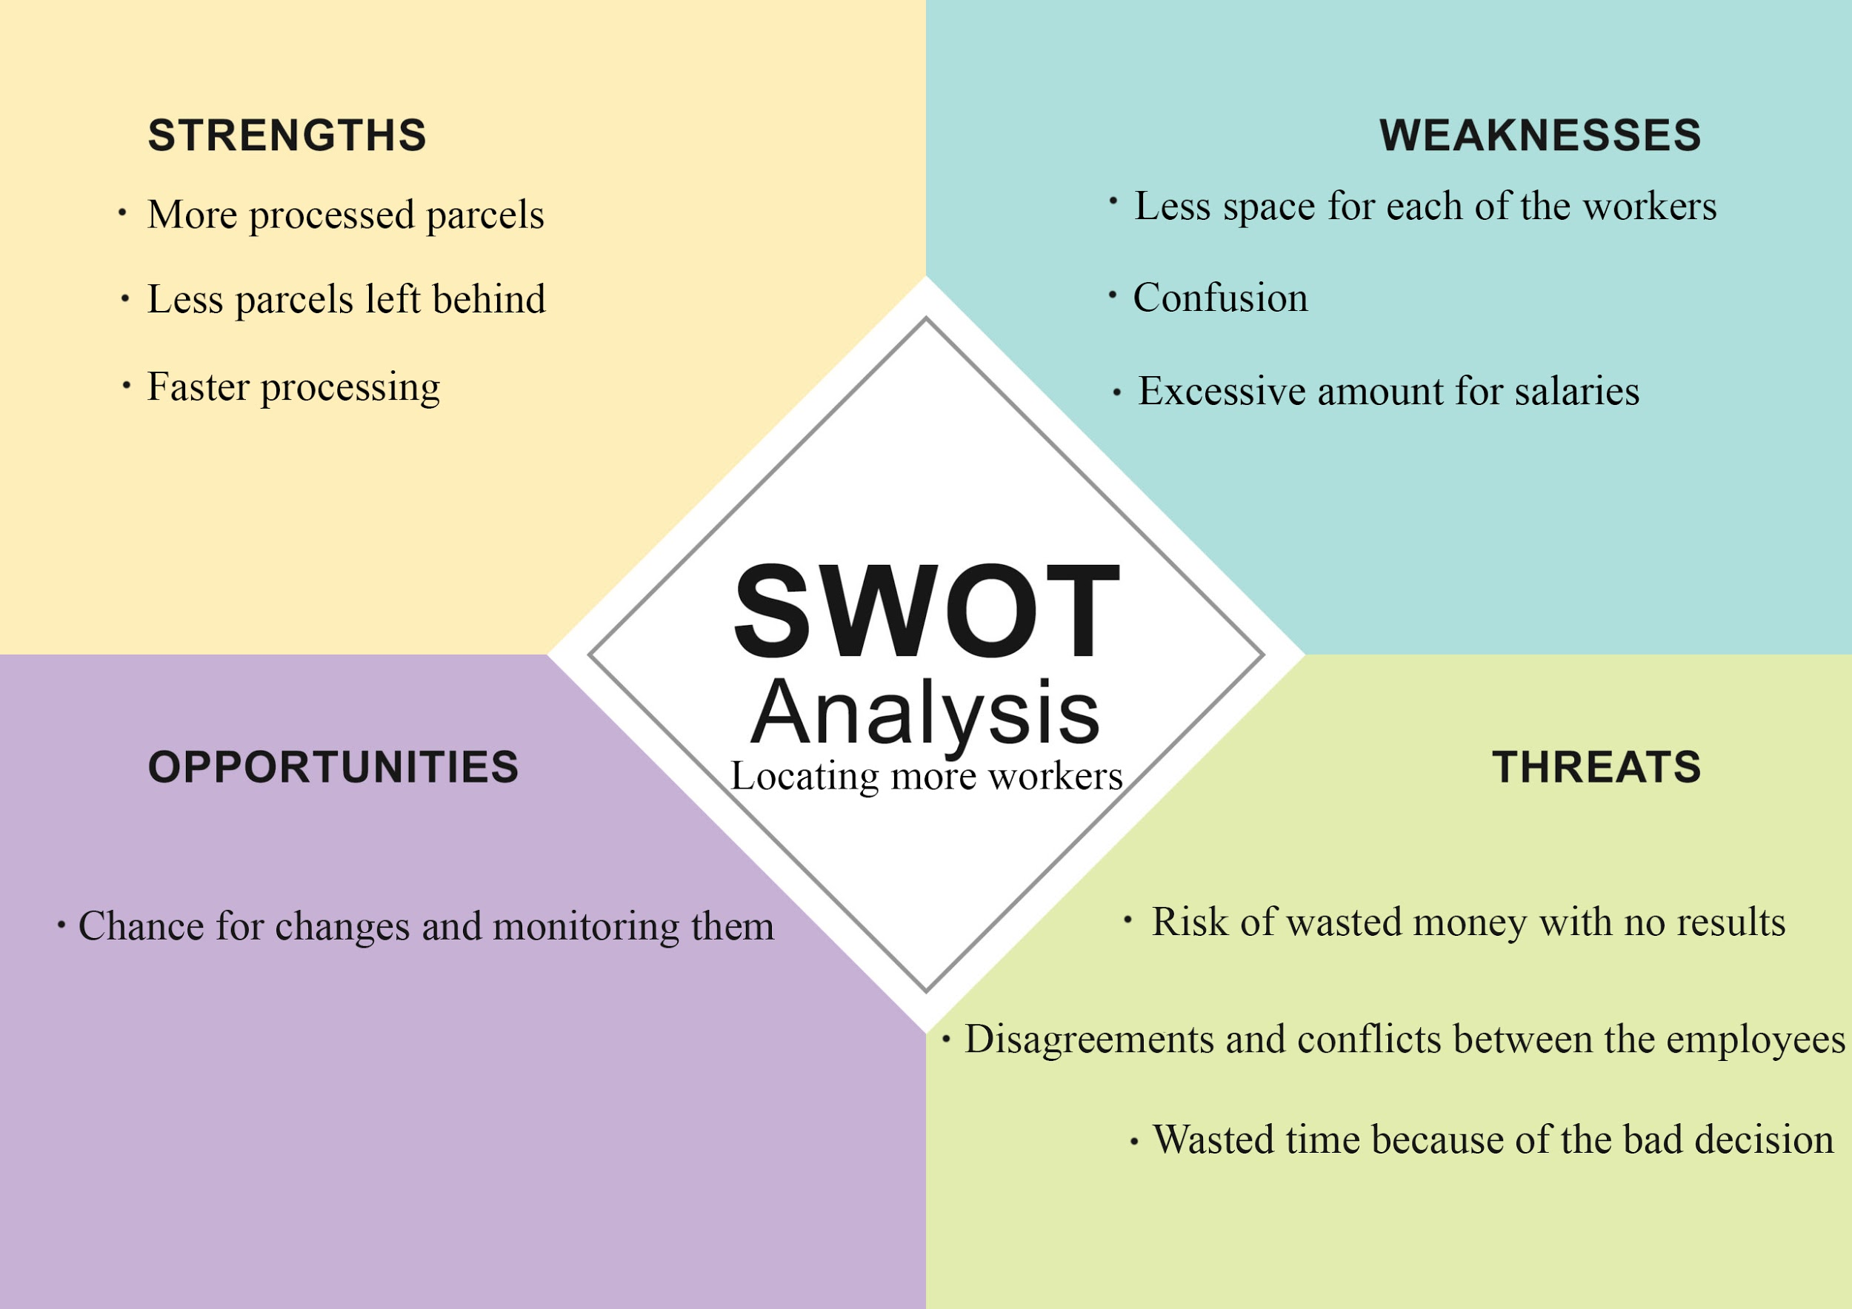
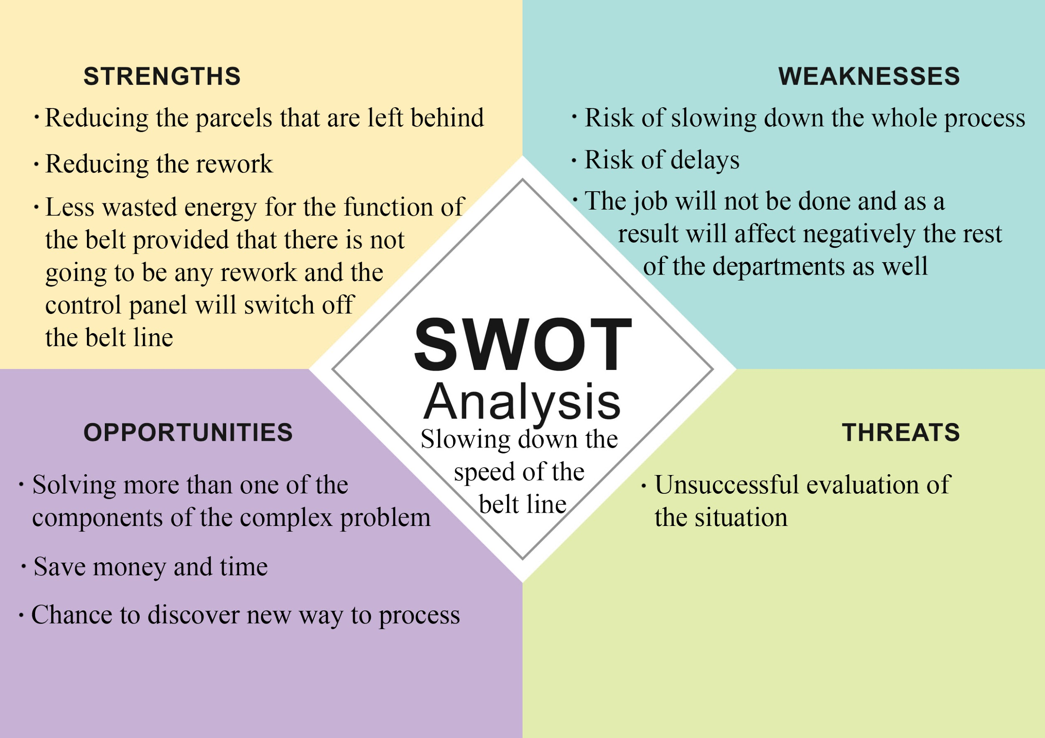
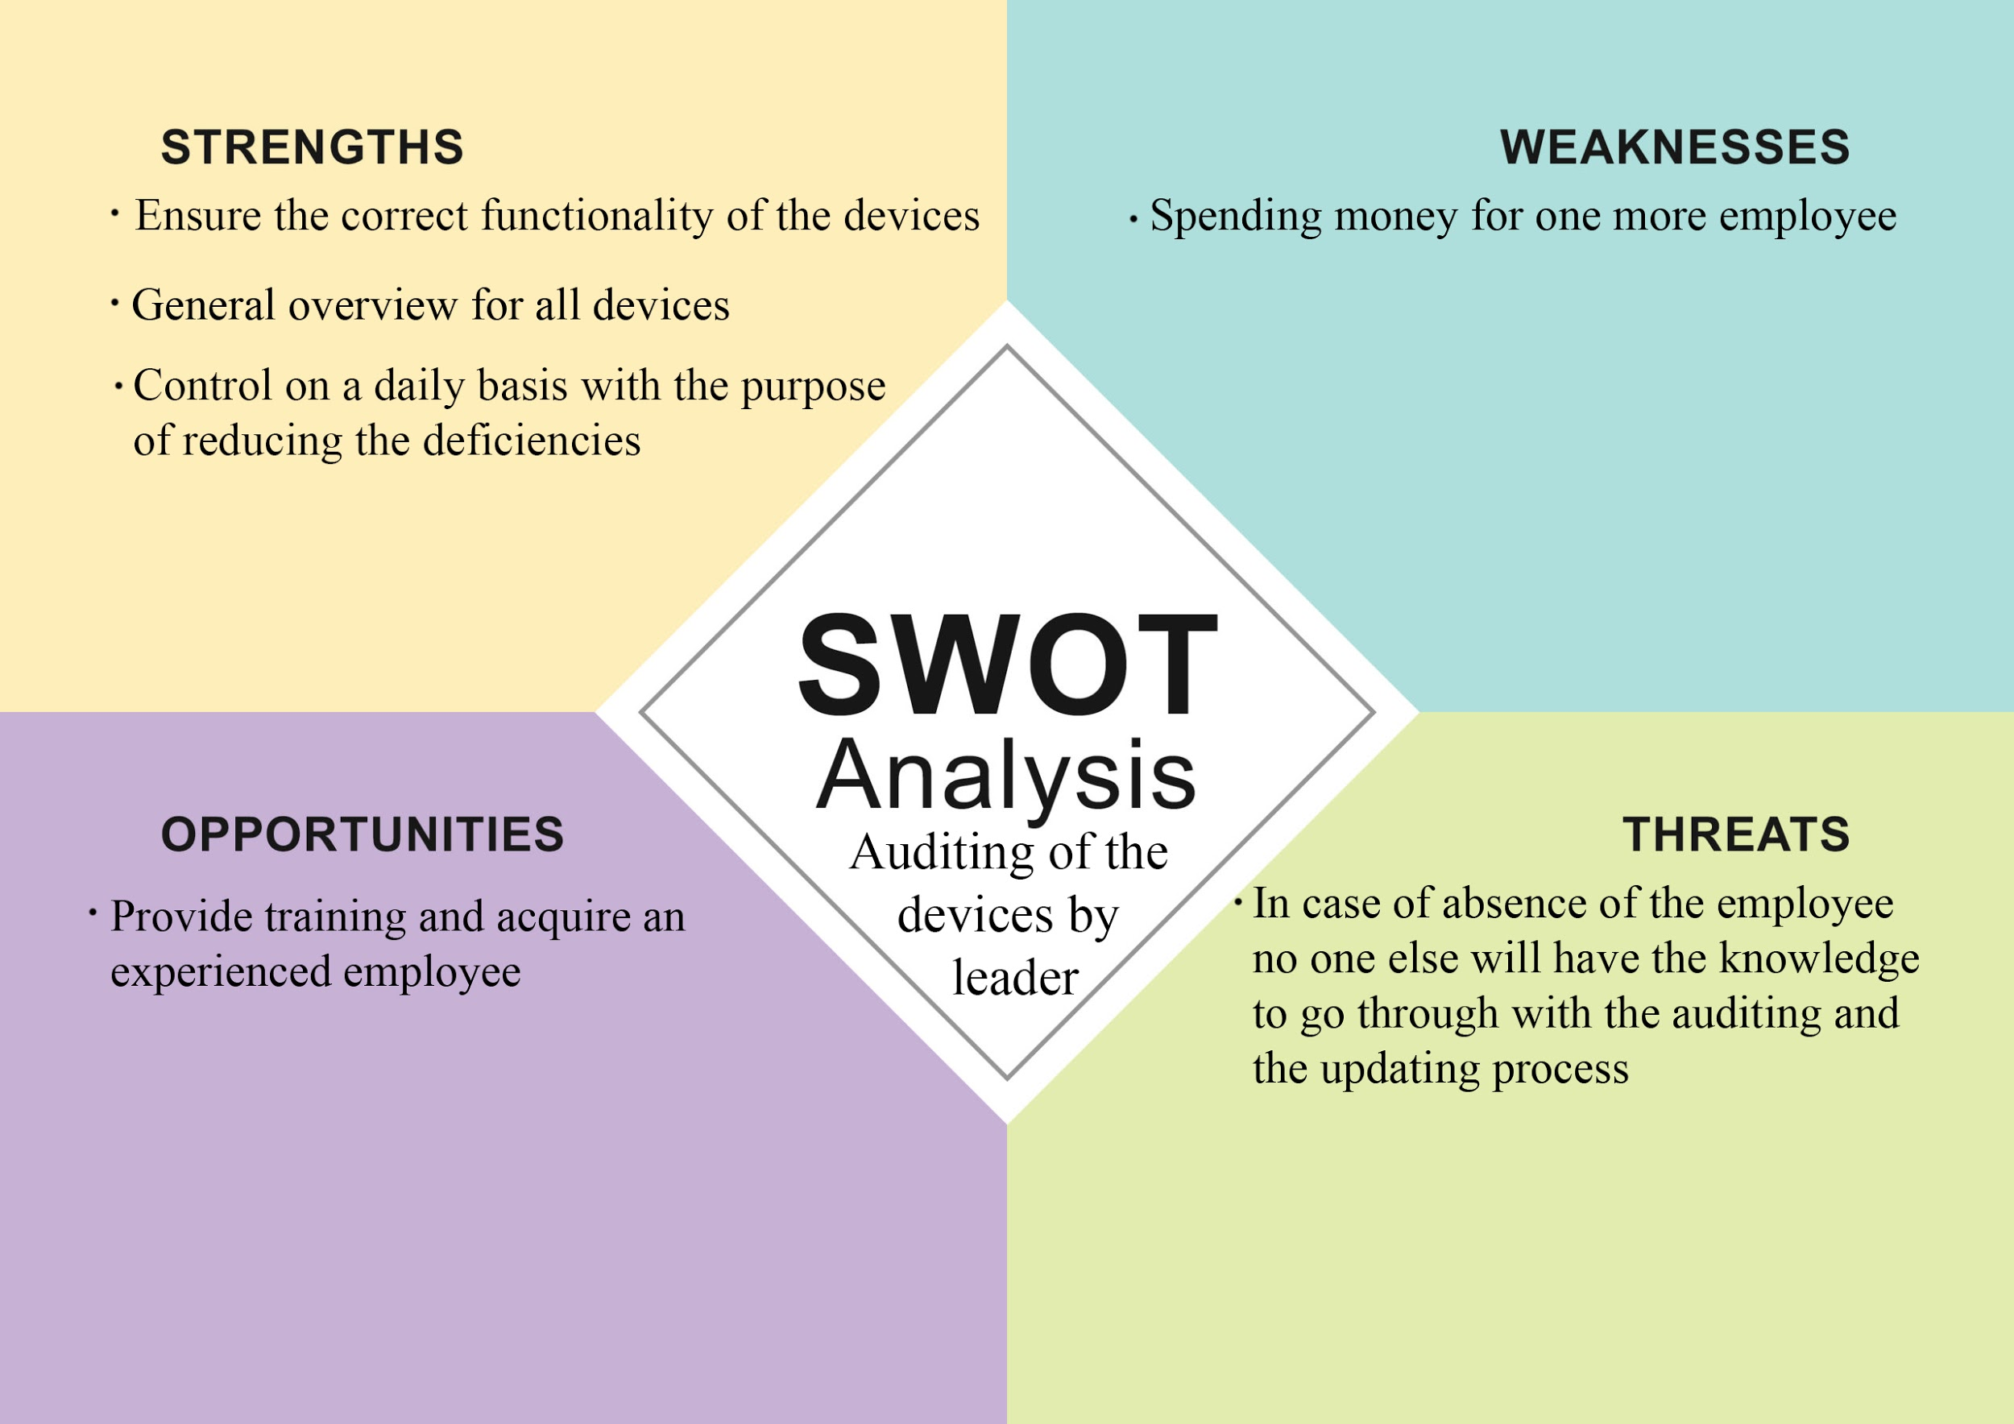
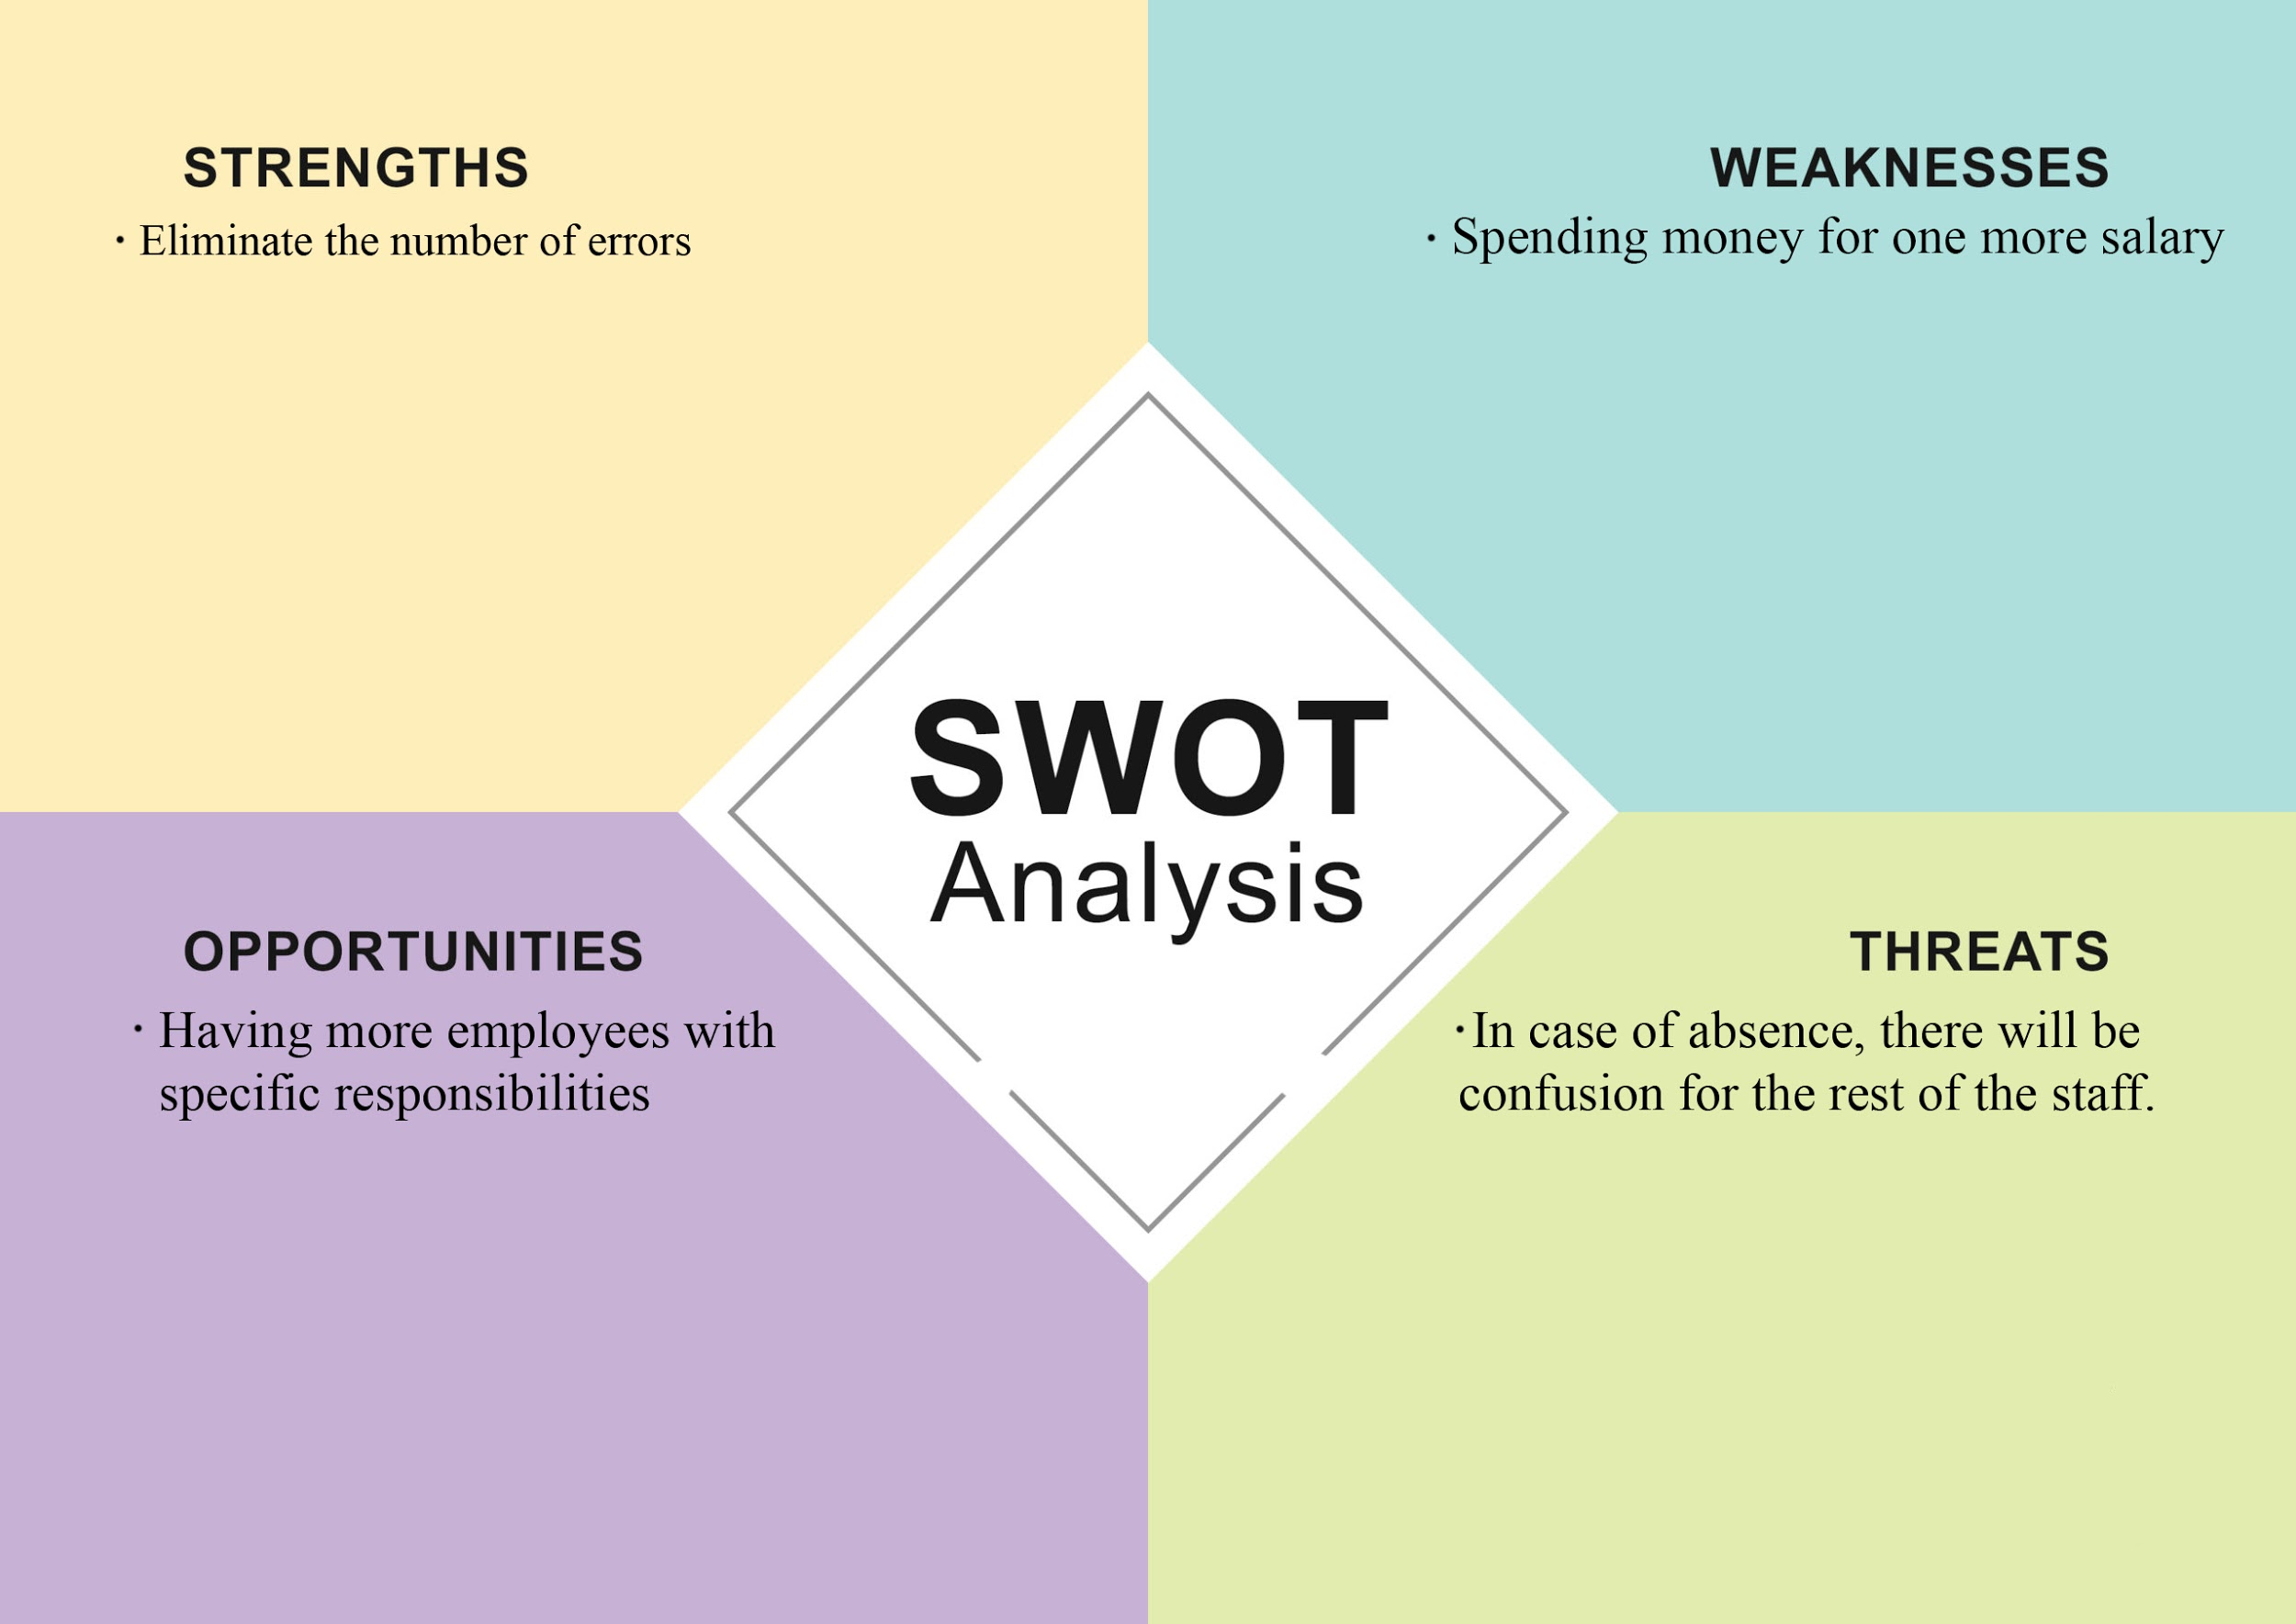

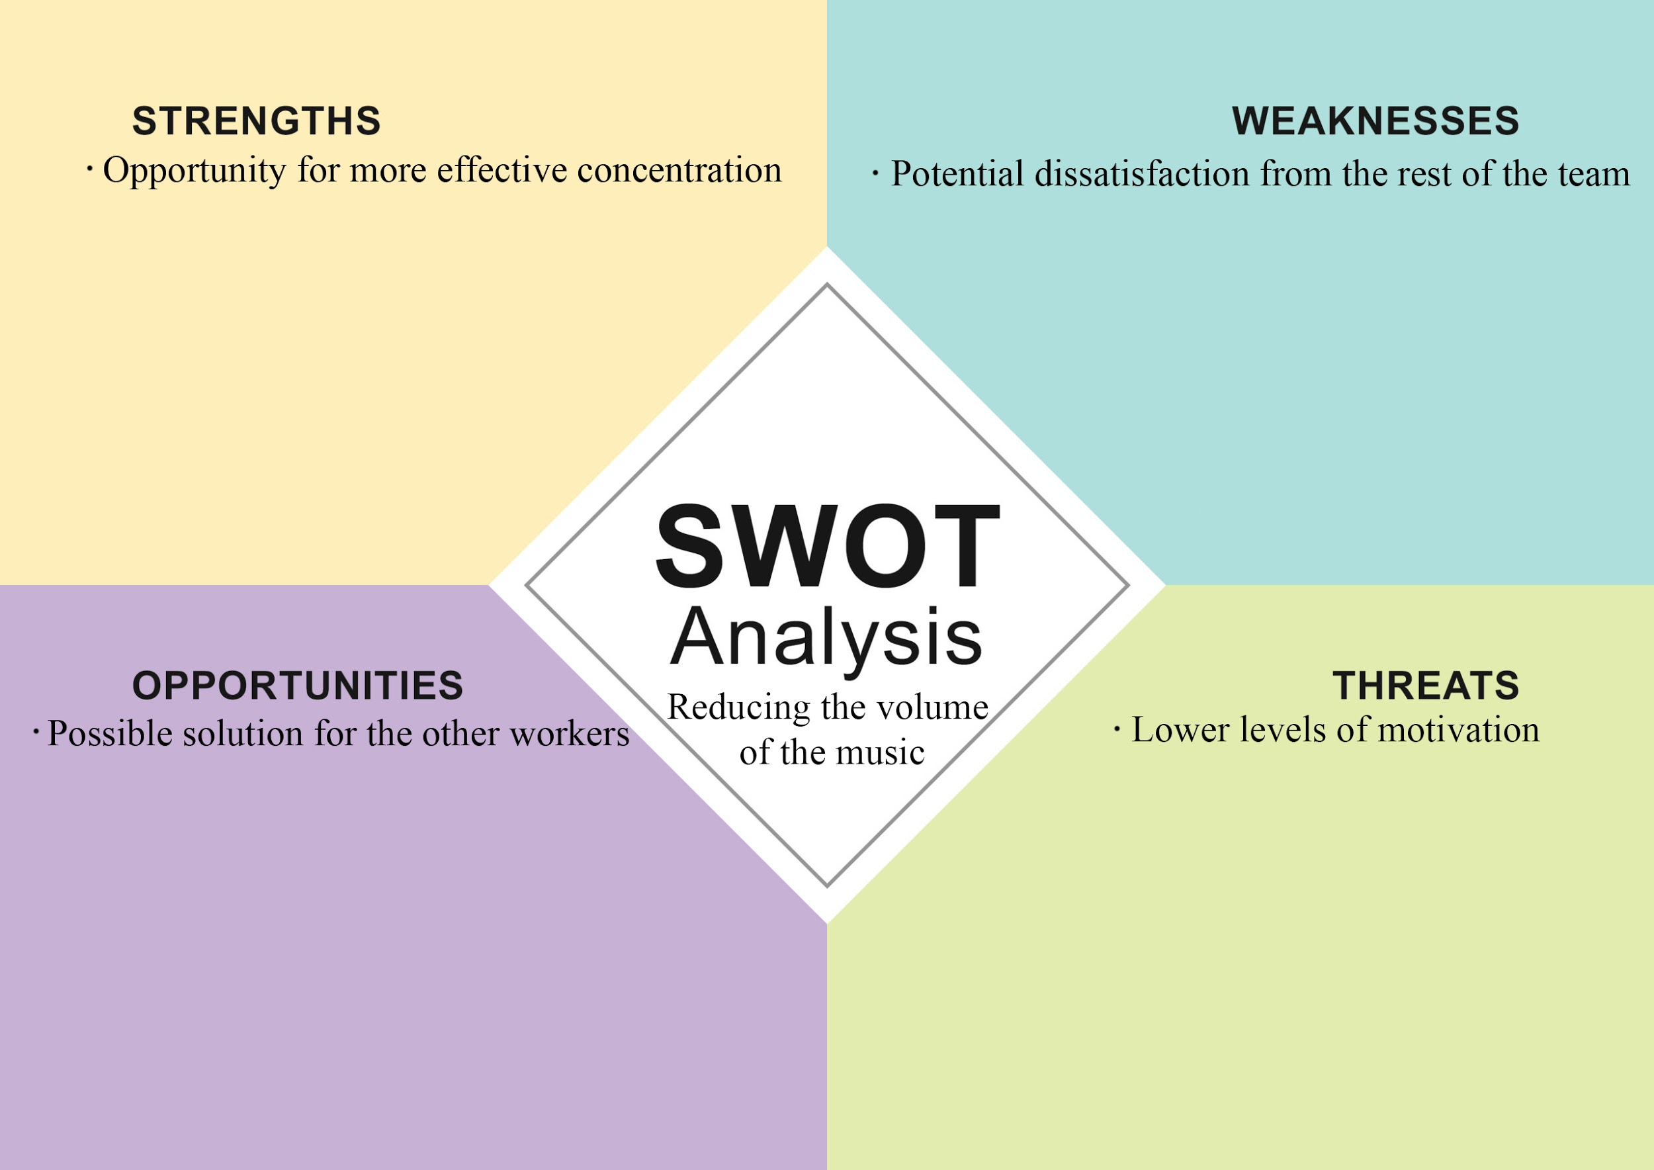

Fishbone Analysis
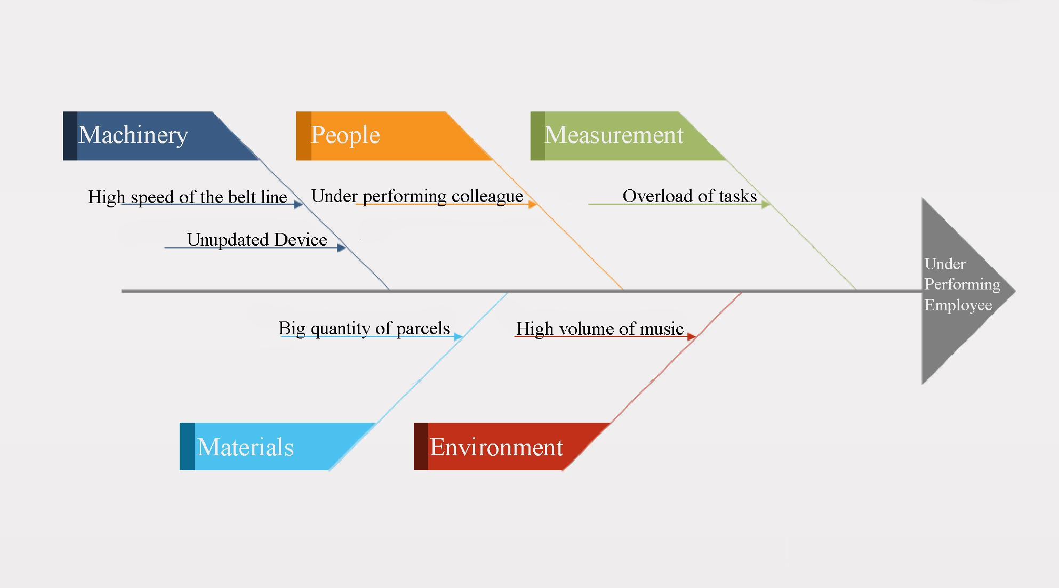

PESTEL Analysis

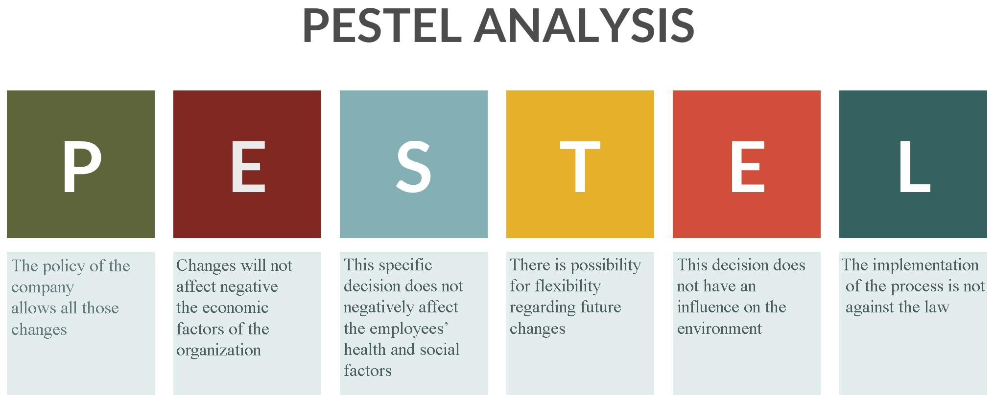

ADKAR Model
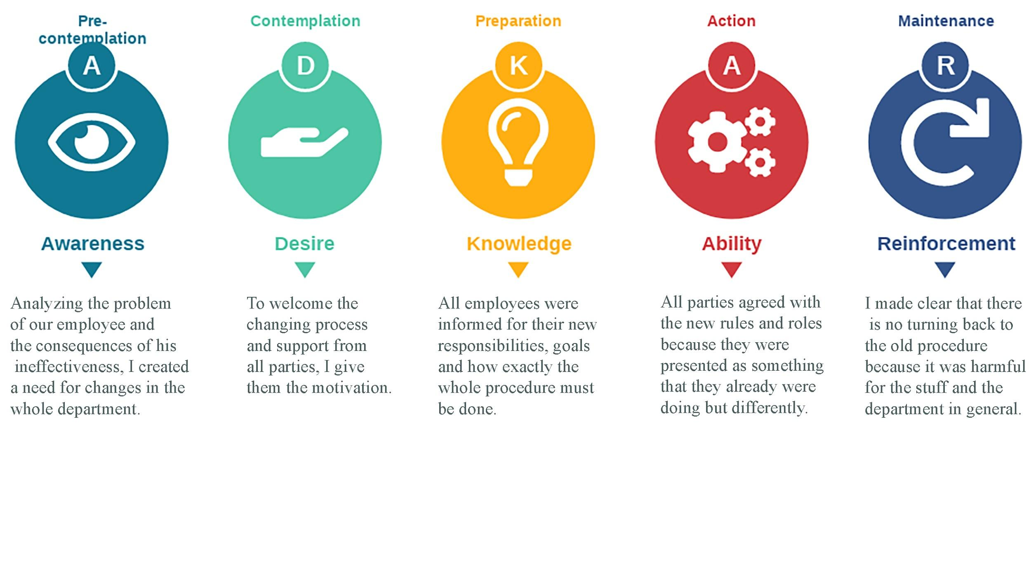

Role play questions
Hello Norbert. I have known that you are unsatisfied for some reason. You have some kind of problem.
N. Yes. I feel disappointed and have lost interest of my job. I feel like I do great effort for no reason. My work is meaningless.
V. May I ask you the reason for that? Why do you feel that way and what is happening to make you feel that way?
N. First of all, the belt line is going to fast as a result I miss many parcels. I am getting tired very fast because I try to work fast but at the end I have to do a lot of rework as well and I am getting more tired for no reason. My effort is for nothing.
And second, my colleague in the front does not sort the parcels correctly as a result I can not see the barcodes in time. Some of them I can not see at all and I miss more parcels.

