
Ethical assessment of management theories in response to a complaint
In addition to a focus on mainstream and critical management theories; with recommendations made to the organisation (Uber)

November 11, 2022
2003955
Tom Pendlebery

Executive Summary –

Contents –

Executive Summary
Introduction – Page 3
- 1.1 – The purpose of the report
- 1.2 – Background on Uber
- 1.3 - The complaint

Management theories and ethical considerations (Main Body)
- What is management - page 4/5/6
- Critical and mainstream theories of management – Page 6/7/8
- Scientific management – Page 8/9
Conclusion – page 10
Recommendations – Page 11
References – Page 12/14

Introduction –
1.1 – The purpose of the report
The purpose of this report is to investigate a complaint made on functional areas within the organisation Uber, through ethical assessments and an overview of the management theories in place a number of recommendations will be outlined as possible solutions. Furthermore, the report aims to provide solutions to the complaint that was made in addition too exploring the differentiation between critical and mainstream theories. The depth to which the critical and mainstream theories will be evaluated is to help shape positive conclusions.
1.2 – Background on Uber
Uber is a platform that provides an affordable transport service and as an extension, food delivery service too (Uber, 2022). The organisations mission statement under ethics and integrity states that they are to serve as trusted business partners and will guide conduct of all employees (Uber, 2022). The global success of Uber and the strong autocratic leadership style at the high points of management justify the choice of the case study as the contemporary issue the business faced opens a discussion into the effectiveness of certain management styles.

1.3 - The complaint
A report has been received that functional areas within Uber’s management structure are not being performed to modern ethical values. In particular, the drivers working for Uber are not considered as employees, instead contractors, as a result employment benefits do not apply to the drivers; benefits including health insurance and sick pay. The complaint specifically questions if this is an ethical way of treating people who not only work for Uber but represent the brand; Over more, it questions whether management are considering ethics when implementing theories affecting stakeholders and ideology surrounding whether Uber look past the basic accumulation of profits and consider how people lower down the hierarchy ‘ought’ to be treated.
3.

Management theories and ethical considerations (Main body) –
- What is management -
Management in its simplest form, is described by Drucker (1963) as an ongoing process of efficiency and effectiveness. Meanwhile Fayol (1949) defines management with five key ideologies; to forecast, organise, command, co-ordinate and control. In a modern context, Fayol’s ideas are more easily applied to organisations as it clearly outlines specific areas within management unlike Drucker’s whose ideas are still relevant to hyper profit-driven organisations, but overall are too broad and don’t account for modernised more human based organisations. Management theories have developed based on the ideas and concept of good and bad management within organisations; Uber’s management has been criticized largely by its own employees because of the tall autocratic corporate structure in place (BBC, 2021). Cellar, et al (2001) defines an autocratic leadership style as one where leaders independently make important business decisions with minimal to no participation from any other parties. This specific style is an attractive type of management for many as it enables management to generate exactly what they want by communicating this to employees, the lack of employee involvement reduces time spent on decisions and does not take away from the power of people higher up the corporate structure (Dolly, 2018).

However, the idea of an authoritative management style in context to modern day businesses can be seen as outdated (Janse, 2018). Employees can become demotivated as their involvement in decisions is minimised begging the question to whether certain aspects of the autocratic management style are too controlling and potentially unethical; making Fayol’s (1949) ideas of a positive controlling style less relevant to current business eco-systems. The issue Uber is facing concerning whether people who work for the organisation should be entitled to sick pay and basic health insurance could have potentially stemmed from the lack of communication channels from base employees to those higher up in the business.
4.
As Mayo (2001) states, a company is unlikely to survive long-term in a market where human capital is not seen as the businesses key factor to prolonged success. In context, the worldwide access to social media platforms has given people an insight into how businesses such as Uber are run, allowing the public to determine the companies value of human capital. Over more, potential new employees will know what kind of business is being run and this will impact their decision to apply for a certain role; a strong autocratic management viewpoint may deter an ambitious demographic from recruitment.

On the other hand, a democratic management style would offer a more inclusive structure where employees could have communicated their views and a solution put in place. In addition, decision making acts as one of the most important factors (Sharma, 2013) therefore the involvement of the people impacted by the decisions is likely to improve employee productivity and reduce staff turnover. An example of an effective use of the democratic management style is within Google; the inclusive management structure has solidified Google within a highly innovative and competitive market place. According to (Smithson, 2018) the company promotes product development from all sectors allowing any employee to contribute if desired, this freedom to contribute positively effects work ethic because staff feel like they are making a significant difference. Considering Google’s approach to management in an ethical context, the idea that anyone can have a platform to voice their ideas creates a flat structured business and a sense of equality amongst the hierarchy to achieve a common goal. The traditional bureaucratic structure of public sectors is becoming more flexible and this has implied large amounts of cooperation between all three of the sectors (Snellman, 2015). This has been an important factor as the government have led by example and has demonstrated that ethics is a huge part of consumer and employee satisfaction; private sector businesses such as Google attract people because of their strong ethical values that progress a positive ethnically diverse community.

5.
Uber’s structure means issues are difficult to reach those who can make significant change. Drivers, as they are considered ‘contractors’ don’t receive any employee benefits such as basic health insurance, and paid sick leave (Bauguss, 2022). Uber, as an employer don’t have any legal obligation to confide in any of these benefits, however, the consideration that they ought to look after the stakeholders who keep the functional side of the business running. In line with what Ford (2010) says “A business that makes nothing but money is a poor kind of business”. Uber in this instance is seen to choose profits over employment satisfaction deterring future people from working for them potentially. The philanthropic nature (Carroll, 1991) seen by businesses of similar success presents the question to whether Uber are acting ethically to the degree claimed. Corporate social responsibility is the idea that businesses voluntarily integrate environmental and social aspects within operations, much of which won’t directly impact the business however positively affect those around them. Uber, not showing any real positive impacts although claiming to, stating they encourage all employees to “Stand up and speak up” (Uber, 2022) contemplates the idea to whether there has been manipulation for financial gain.

Critical and mainstream theories of management –

Critical theories of management is an attempt to emancipate forms off oppression within business structures that lead to power imbalances between social classes, furthermore, the motivation behind the theory is to eliminate the unconscious knowledge of the oppression upon the employees (Visser, 2010). A more narrowed standpoint stems from the Marxist philosopher Horkheimer’s ideas on what the terms for critical theory should be. The term Marxist originating from the views of Marx (1847) who stated that economies form foundations to which society elements are based (Real, 2015). Horkheimer (1937) suggested, in a normative fashion, that critical theory’s purpose was to be used to transform society away from injustice and hierarchal power domination. The idea was to guide a future where ethics would be presented as a key element to success for organisations.
6.
The ideology surrounding original critical theories of management is outdated, however provides important ethical considerations in a modern-day context. The most important being the distribution of power from the tall structured organisations such as Uber, and providing employees with a voice to distinguish their viewpoints. Ethically speaking, critical theories of management justify its importance as it challenges capitalism where management fails to create an ethical and fair culture amongst private profit-driven organisations. Applying critical management theory to Uber, the structure of the business is built on a profit focus foundation where the main attention is the bottom line, the complaint that employees have made would positively reflect Horkheimer (1937) as part of an ethical movement to eradicate strong social injustice within unbalanced business structure. The injustice between management and employees within autocratic businesses, like Uber, reinforces the importance of base critical structure because it is difficult to incorporate human elements into centralised objectives, suggesting a more complex response to the issue/complaint.
Mainstream theories of management –
In opposition, mainstream management described by (Visser, 2010), suggests that there is a definitive solution between management and employees where by both parties are satisfied, alternatively the concept of a ‘win – win’ presents mainstream management theory at a base level. Visser, (2010) states that control is a key factor through all processes within relevant organisations, upon the reasoning that it reduces the chance of unpredictability allowing for the continued ownership of control. Considering McGregor’s (1960) managerial theory, employees in this context are largely deemed theory x staff because of the hands-off approach they establish when working (Kopelman, 2008). Mainstream theories of management demonstrate traditional industrial mindsets, however, contextualised to modern day, there is an ethical demand to provide both opportunities for those who want a solitary and controlled work experience (theory x), and for employees who demand a more trusted and impactful experience (theory y). Both management styles maintain positives within mainstream management, though not utilising an employee’s full potential may lead to lack of productivity.
7.
Applying Parkinson’s theory, work given to employees that may not present a challenge will cause a prolonged time extension upon which the task is completed negatively impacting progression (Brannon, 1999).
Scientific Management -
Scientific management theory began during the twentieth century where a lack of labourers led to a reduced productivity within manufacturing industries at the time (Paramboor, 2016). Creating an obvious issue, this conceptualised the idea from which a standard body of principles was drawn up to tackle poor productivity (Taylor, 1911). In addition, Taylor (1911) describes a negative trouble between people of management and those of labour; issues on both sides and a lack of motivation for labourers, led to wage-incentive determination where employees were rewarded for productivity. In many ways the idea of Taylorism formed a foundation for ethical structure between management and staff before entering a time of strict bureaucratic structure. Weber (1947) describes bureaucratic management as a systematic method to establish a set of rules while enforcing the hierarchy of command. This would in theory improve efficiency and any nature of favouritism amongst organisations can be avoided (Swedberg, 2005).

Bureaucracy is evident in Uber externally with the law, however, considering the complaint where by drivers are not seen as employees creates a potentially unethical standpoint. As workers are seen as independent contractors not employees (BBC, 2021) they are not eligible for a number of insurances that benefit them. Uber avoiding the classification of having their drivers as employees saves them capital at the expense of their quality of life. The lack of support to Uber’s ‘contractors’ creates an argument that the drivers are external and as an extension, apart of the external environment; therefore, demonstrates elements of a closed system (Kapsali, 2009) due to failure of interaction. Over more, applying Maslow’s hierarchy of needs demonstrates the failure of Uber to supply employees with health and financial security creates a barrier to achieving creativity and problem solving under the umbrella of self-actualisation (Maslow, 1943).
8.
In contradiction, the profit-driven nature of Uber demands in no sense that they should provide basic human rights to what the organisation considers as contractors. However, considering a moral standpoint, Uber have a duty that they ought to provide these basic employment benefits as although will come at a financial burden may positively improve the company’s reputation adding longer term value against short term financial gain (Origgi, 2018).

In addition, Taylor (1911) states a lack of structural incentive for employees leads to poor productivity, and in context to modern day organisations, Uber may benefit from implementing ethical ideologies into a more centralised bureaucratic management style. Ethical values were considered at a time of Industrialisation and bureaucracy movement which solidified the importance of how stakeholders and in particular employees should be treated, providing limited excuses to Uber as to why they are not able to provide basic employee benefits in response to high productivity.

9.
Conclusion –
In conclusion, the management style that Uber has been using since its establishment (autocratic) has become outdated and in multiple ways unethical with regards to its stakeholders. In particular, the contractors/employees that compile the grounds of the operations at Uber are not granted basic health and sick pay; this is where the complaint into the ethical standpoint of management within Uber stemmed from. A large majority of why Uber drivers are having to complain publicly is because of the complex and tall autocratic structure that is engrained within Uber. As discussed under an ethical consideration of the current and other management styles, it is believed that if a more democratic management style was introduced then Uber would not have faced such social issues within the organisation. Furthermore, Uber did not act philanthropically, not only negatively affecting their drivers, but reputation as a whole, detracting potential new employees from wanting to join.
In addition, the comparison between mainstream and critical theories of management concluded that Uber would benefit largely from implementing critical theories of management into their operations. The consideration for employees to have their say and to positively impact the business, acting upon theory y narratives, could ascend the organisation quicker than treating every employee as a more theory x based. In conclusion their needs to be consideration for both theory x and y employees within critical because to not do so would suggest an unethical practice within the industry.
The complaint received by Uber was justified and provided an insight into how the contemporary issue raised can be combatted going forward to expand the companies internal and external values. The philanthropic nature potential within uber gives an insight into how unethical they have been but stems a potential for good ethical practice going forward.

10.
Recommendations –
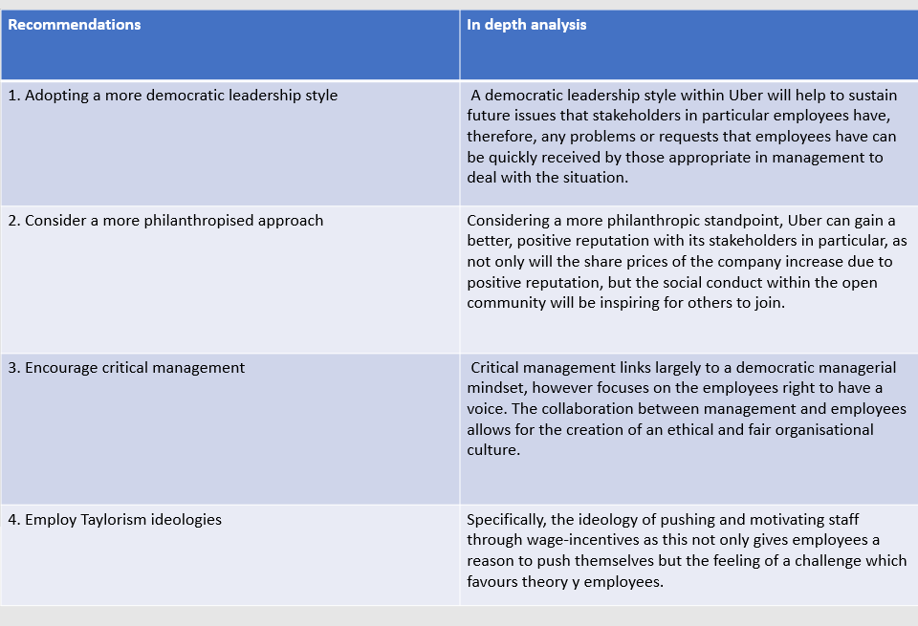
This table includes the recommendations to the complaint concerning poor management within Uber and a lack of basic rights for contractors/employees.

11.
References –
BBC. (2021). Uber drivers are workers not self-employed, Supreme Court rules. [Online]. BBC. Last Updated: 19th February 2021. Available at: https://www.bbc.co.uk/news/business-56123668 [Accessed 3 November 2022].
Bauguss. (2022). Why Are Uber Drivers Independent Contractors. [Online]. SPIRIT CREATIONS BY RITA. Last Updated: 19 April 2022. Available at: https://spiritcreationsbyrita.com/2022/04/19/why-are-uber-drivers-independent-contractors/ [Accessed 4 November 2022].
Brannon, Hershberger, Brock. (1999). Timeless demonstrations of Parkinson's first law. [Online]. Research Gate. Last Updated: April 1999. Available at: https://www.researchgate.net/publication/11189704_Timeless_demonstrations_of_Parkinson's_first_law [Accessed 10 November 2022].
Carroll, (1991). The pyramid of corporate social responsibility: toward the moral management of organizational stakeholders. Business Horizons, 34(4),39–48.
Cellar, D.F., Sidle, S., Goudy, K., O'Brien, D. 2001. Effects of leader style, leader sex, and
subordinate personality on leader evaluations and future subordinate motivation.

Dolly, Okpokwasili. (2018). IMPACT OF AUTOCRATIC LEADERSHIP STYLE ON JOB PERFORMANCE OF SUBORDINATES IN ACADEMIC LIBRARIES IN PORT HARCOURT, RIVERS. International Journal of Research Granthaalayah. 6(10), pp.213-215. [Online]. Available at: https://www.researchgate.net/publication/332321338_IMPACT_OF_AUTOCRATIC_LEADERSHIP_STYLE_ON_JOB_PERF [Accessed 3 November 2022].
Drucker, P. F. (1963). Managing for Business Effectiveness. Harvard Business Review. Accessed from:
https://hbr.org/1963/05/managing-for-business-effectiveness (Accessed: 27/10/2022).

Fayol. (1949). General and industrial management. Mansfield Centre: Martino Publishing

Ford. (2010). A business that makes nothing but money is a poor kind of business.. Motor Age. 2010, p.2.

Horkheimer, (1937) Traditional and critical theory. In M. Horkheimer, Critical theory: Selected essays. (pp. 188-243).

Janse, B. (2018). Authoritarian Leadership. Retrieved from Tools Hero:
https://www.toolshero.com/leadership/authoritarian-leadership/ accessed September 20, 2018).

Kapsali. (2009). Comparing the application of Closed and Open Systems approaches in innovation project management. [Online]. Research Gate. Last Updated: January 2009. Available at: https://www.researchgate.net/publication/236260388_Comparing_the_application_of_Closed_and_Open_Syst [Accessed 8 November 2022].

12.
Kopelman, Prottas, Davis. (2008). Douglas McGregor's Theory X and Y: Toward a Construct-valid Measure*. Journal of managerial issues. 20(2), pp.255-271. [Online]. Available at: https://www.researchgate.net/publication/280114317_Douglas_McGregor's_Theory_X_and_Y_Toward_a_Constr [Accessed 10 November 2022].

Marx, Engels, (1847). The Communist Manifesto, Charles H. Kerr &Company, E.Ohio Street, Chicago, Illinois

Maslow, A. H. (1943). A theory of human motivation. Psychological Review, 50(4), 370-96.

Mayo, (2001). The Human Value of the Enterprise: Valuing People as Assets –
Monitoring, Measuring, Managing. Nicolas Brealey, London.

Mcgregor. (1960). The Human Side of Enterprise. New York: McGraw-Hill.

Origgi. (2018). Reputation: What It Is and Why It Matters. New Jersey: Princeton University Press. pp.1-61.

Paramboor, Musah, Al-Hudawi. (2016). Scientific Management Theory: a Critical Review from Islamic Theories of Administration. [Online]. Research Gate. Last Updated: October 2016. Available at: https://www.researchgate.net/publication/308802710_Scientific_Management_Theory_a_Critical_Review_fr [Accessed 7 November 2022].

Real. (2015). Analysis of the Marxist Philosophy. [Online]. academia. Last Updated: March 16, 2015. Available at: https://www.academia.edu/11562971/Analysis_of_the_Marxist_Philosophy [Accessed 8 November 2022].

Sharma, Singh. (2013). A Study on the Democratic Style of Leadership. INTERNATIONAL JOURNAL OF MANAGEMENT & INFORMATION TECHNOLOGY. 3(2), pp.54-55. [Online]. Available at: https://www.researchgate.net/publication/331082855_A_Study_on_the_Democratic_Style_of_Leadership [Accessed 3 November 2022].

Smithson. (2018). Google’s Organizational Structure & Its Characteristics (An Analysis). [Online]. Panmore Institute. Last Updated: SEPTEMBER 8, 2018. Available at: https://panmore.com/google-organizational-structure-characteristics-analysis [Accessed 4 November 2022].

Snellman. (2015). Ethics Management: How to Achieve Ethical Organizations and Management? [Online]. Research Gate. Last Updated: December 2015. Available at: https://www.researchgate.net/publication/287151217_Ethics_Management_How_to_Achieve_Ethical_Organiza [Accessed 4 November 2022].

Swedberg, Agewal, (2005). The Max Weber Dictionary: Key Words and Central Concepts. California: Stanford University Press

Taylor. (1911). The Principles of Scientific Management. .: Harper & Brothers. p.90.

13.
Uber. (2022). Ethics and integrity. [Online]. Uber.com. Last Updated: 2022. Available at: https://www.uber.com/gb/en/about/integrity/#:~:text=Ethics%20and%20integrity,culture%20of%20ethical% [Accessed 8 November 2022].

Visser. (2010). Critical management studies and “mainstream” organization science. International Journal of Organizational Analysis. 18(4), pp.466-475. [Online]. Available at: https://moodle.uwtsd.ac.uk/pluginfile.php/432839/mod_resource/content/0/Critical%20Management%20Stud [Accessed 8 November 2022].

Weber. (1947). The Theory Of Social And Economic Organization. New York: Oxford University Press.

Management,” p. 90, 1911.

14.

