BMSW7001
Developing People in Organisations

DEVELOPING A LEADERSHIP STRATEGY

Student Name: Ancuta Elena Gidoiu
Student number: 1905822

Table of Contents
Executive Summary 3
Introduction and Scope 3
Analysis 5
Development of leadership strategy 5
Objectives that will be achieved 6
Implementing the change 6
Benefits and challenges of the change for Bupa 8
Recommendations 8
Conclusion 11
Reference list 12

Executive Summary
Leadership strategy can be depicted as an important aspect that further allows the implementation of a guided approach for the company (Armstrong, 2016, p.10). Bupa as a care home situated in the UK is dedicated to providing standard care to patients. In the case of Bupa, the company needed to implement a democratic leadership strategy that further allows driving inclusion and diversity within the organisation. This study further sheds light on the change management situation that is further analysed by using Kotter's 3-stage model for effective management of change. In addition to this, it can be showed that the study further sheds light on the restructuring of the selection and recruitment process in the UK.

Introduction and Scope
Leadership strategy is a pivotal aspect of an organisation that further delivers a guided approach towards achieving different objectives and goals of the organisation along with the belief in continuing development (Armstrong and Taylor, 2020, p.15). Also, inclusive strategies are a pivotal aspect for a company as it allows them to increase the trust and commitment of employees which creates a positive impact on the business. In this study, the leadership strategy for Bupa UK, a specialised care home in the UK. The organisation offers a diverse range of care services which range from dementia to Parkinson's disease. The benefits of the nursing home further include services such as the treatment of wounds to post-operative care.
In addition to this, the organisation assists with care for the funded individual through different programs such as NHS continuing care. Bupa is also known for its 24-hour service for patients along with providing cleaning as well as laundry services. As illustrated in a recent study, it can be depicted that 74.4 percent of individuals have accepted they have received good quality care whereas 8.5% of individuals have rated their care outstanding (Michas, 2021).
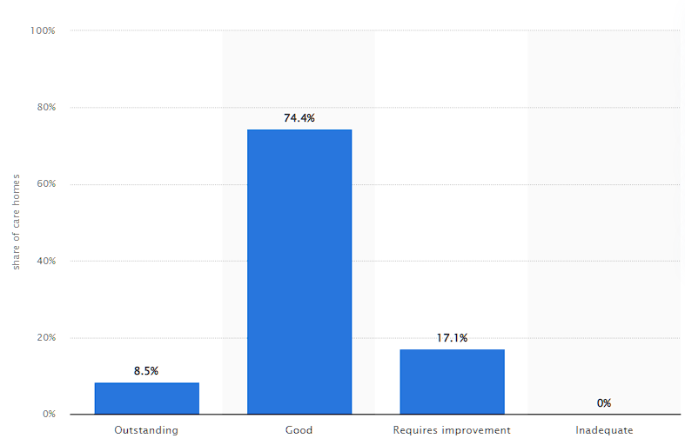
Figure 1: Service quality of Bupa UK
(Source: Michas, 2021)
In this report, a leadership strategy for the selected company will be developed that further allows them to develop a diverse workforce that provides multiple benefits such as the creation of an environment that accepts along with reducing harassment.
External environment analysis: UK is a culturally diverse country that promotes the inclusion factor. The UK government implements a “Diversity and inclusion strategy” from 2020 to 2024 that further promotes diversity within the country and allows companies to develop a diverse workforce within the country (Gov.uk, 2020). Understanding of the UK government the necessity of diversity and inclusion further can drive inclusion strategy and diversity hiring within the organisation.
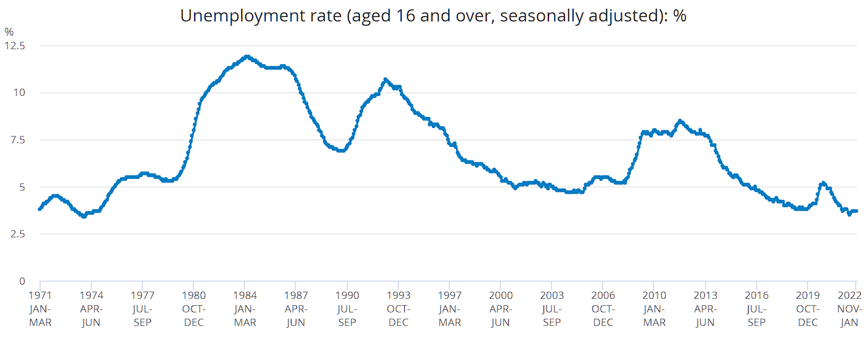
Figure 2: Unemployment in the UK
(Source: ONS, 2023)
As per a recent report, it can be described that the unemployment rate in the UK has achieved 3.5% which further illustrates significant improvement compared to the previous year. Alternatively, it can be illustrated that the employment rate within the country is 75% in the current fiscal year which has a positive impact on the hiring process (Ons.gov.uk, 2023). On the other hand, it can be depicted that rising inflation further can have a direct impact on the hiring process. As per the recent report, it can be described that the annual inflation rate in the UK has increased from 5.3% to 5.7% further having a direct impact on the economic stability of the country (Ons.gov.uk, 2023a). It can have a major impact on the company's ability to allocate a budget for diversity hiring.
As per recent report states, the shortage of skilled workers can be observed in the UK labour market as the skilled worker shortage lies between 12.9% to 15.4% (Devine and Buchanan, 2023). It further creates an opportunity for the company to carry out a hiring process to increase the diversity aspect of the company. As a recent study suggests, that in the fiscal year 2022, the vacancy within the country was 3.9 out of 100, further reflecting significant demand (Devine and Buchanan, 2023). Technology is another considerable factor as an implementation of AI technology can create a direct impact on the hiring of companies, as it streamlines the onboarding process and improves employee experience (Dattner et al., 2019). The UK government enacts the "equality act" to increase the diversity scenario in the country. So, organisations must track changes within the tanks so that a leadership strategy could be considered that further has a positive impact on the hiring approaches of companies.

Analysis

Development of leadership strategy
This section of the following report sheds on the leadership strategy development that further allows Bupa to increase motivation for diversity. It can be illustrated that leaders play a major role in the context of developing a diverse workforce (Homan et al. 2020, p.1101). So, leaders who realise the importance of diversity and inclusion can create a diverse workforce by developing a culture that further has multiple benefits in terms of problem-solving and overall productivity of an organisation. Increasing diversity within the workplace can be described as a difficult job to carry out when it comes to dealing with different implicit as well as explicit prejudices (Lee et al. 2021, p.1526). In addition to this, it can be described that it further comprises a longer timescale along with proper planning and excess cost that determines its effectiveness in terms of implementation.
As per Daniel Goleman, six different styles of leadership are generally present which are “coercive, authoritative, affiliative, democratic, pacesetting and coaching” leadership (Goleman, 2019, p.1). Moreover, it can be described that, in the context of the promotion of diversity as well as inclusion, leaders need to have inclusive characteristics that further allow them to include team members in decision-making as well as empower employees. As commented by Wilson, (2020, p.731), democratic leadership focuses on three distinct factors that are collaboration, engagement and creativity. In the context of Bupa care home, the Democratic leadership can develop an environment that further allows them to develop stronger employee trust and productivity that enhances the productivity of employees.

Objectives that will be achieved
This section of the following report sheds light on the objectives that will be achieved. Moreover, to develop a more diverse working environment, it is required to increase diversity at the top level. BUPA UK has seven male leaders whereas four females are in the CIO role (Bupa.co.uk, 2021). It further reflects a change in a leadership role to increase the number of female employees in management.

Implementing the change
So, a structural reformation will lead to a change in working procedure as it will allow the organisation to shift its focus to inclusive decision-making. To implement the selected strategy in Bupa, Lewis's Change Management model is taken into consideration and sheds light on three factors such as “Freeze”, “change” and “refreeze” (Cone and Unni, 2020, p.1711). In the case of the Bupa, a technological aspect is also an important factor as it can streamline the hiring process and allows them to create a pool of employees. So, in the case of a freeze option, currently, the executive leadership team of Bupa is focused on creating a quality care hub for all the needs of the patient.
Furthermore, it can be illustrated that Democratic leadership can play a pivotal role in the context of healthcare. So, for restructuring purposes, the change in the working process is the change needed to convey to the employees so that they can get accustomed to the new procedure (Häyry, 2021, p.42). In the new process, to promote diversity within the workplace, it is required to renovate the hiring process, and the company has to allocate a significant amount of budget in context to diversity hiring. Here, technology comes into play as the company needed to implement a monitoring system that further sources the diverse talent from the UK market. Moreover, technology further allows streamlining communication with the candidate and the use of modern-day technologies and social media applications such as WhatsApp to stay connected with potential employees (Barr and Dowding, 2022). So, the change in the hiring process must be communicated to the hiring managers of the company so that they can undertake the new process. There may be confusion arising from different levels that might resist the stated change. Here, incentives and rewards can be implemented by the organisation so that a welcoming space can be created for the newly joined employee which further has a positive impact on employee retention. The primary motivation behind the change will be implementation and diversity throughout the workforce. As per the recent study, it can be depicted that there is a provision of change within employee growth. As studies suggest more than 42% of employees want appropriate health and wellness benefits from Bupa that further motivate them in working in their current roles, which further reflects demand among employees in case of changing economic environment of the UK (Businesswire.com, 2022). Additionally, the higher management of the company needed to understand the change in the process of hiring, for this reason, a team meeting can be arranged to discuss the following matter.
Furthermore, the need or the pull for the change development is required so that an urgency within the employee to adopt the change can be initiated. For this reason, rewards and motivation can be used. The next step is implementing the change, the hiring process change is not sufficient as the creation of policy regarding the promotion of diversity practices can allow Bupa to implement different training programs for the existing employees so that they develop an understanding of workplace diversity. The next step, in the change implementation process, sheds light on giving appropriate resources. Providing opportunities to employees in the context of self-development along with an allocation of financial resources allows for effective implementation. Along with this, team development is another important aspect when it comes to the development of an effective team.
Additionally, it can be described that the line managers of Bupa can employ a “Mentorship Program”, which can allow them to provide a development opportunity for the employees as this one-to-one mentorship program can allow employees to ask questions and solve their queries that further have a positive impact on the productivity of employees (Green, Tripp and Hoffman, 2020, p.71). This not only allows the development of motivated employees but also helps the executive team of Bupa to implement democratic leadership within the organisation. The final stage of the change process includes a refreezing stage, which further sheds light on sustaining the change situation within the organisation. For this, the leaders of the selected nursing organisation needed to allow individuals to make their own decisions while accepting responsibility for what they do. This fosters a setting in which varied perspectives can be heard and each individual gets a chance to share their thoughts and opinions. Additionally, it can be depicted that celebrating diversity as well as recognising the benefit it provides to the organisation is necessary (Fang et al. 2019, p.1803). They promote an open and respectful atmosphere in which everyone can feel secure to be themselves while bringing their complete self to the job.

Benefits and challenges of the change for Bupa
This section of the following study sheds light on the benefits and drawbacks that the change brings to the organisation. Besides this, the primary drawback that the Bupa can face is resolving conflicts regarding the change. Moreover, it can be described that the cost of diversity hiring further can increase the operation cost (Caillier, 2020, p.918). The existing problem such as the rising demand for employees. As per change benefits are concerned, it can be described that there are multiple benefits it can provide, as increasing the total number of female employees in leadership will allow BUPA UK to reduce employee conflicts. Besides this, the following leadership promotes an inclusive environment that further allows them to include employees in decision-making and further allows them to develop a motivated workforce. To ensure the success of the change, there are multiple KPIs that can be considered which are as follows:
- Promotional figures
- Selection figures
- Pay comparisons.
- Employee retention
- Employee engagement.

Recommendations
This section of the following report sheds light on the recommendations that can be followed by the company to implement the following change along with an analysis of cost. The recommendations are as follows:
Recommendations 1: development of digital HRM and restructuring hiring: In order to create a diverse workplace, there is a need for technological implementation. For this, it is recommended that the company employ different AI-based Human resource management software needed to implement within the company. In simpler terms, the digitisation of the hiring process includes automated steps that can carry out different processes in an effective manner. Besides, it can be illustrated that the automated process can hire employees as per workforce requirements with a thorough analysis of the skills and capabilities (Budhwar et al. 2022, p.1065). So, it comprises two distinct costs that are further related to the hiring process such as the implementation of proper technology and hiring cost.
Particulars | Cost
Cost of the HR system: £7.57 for a person, so if 100 users are onboarded within the company, the cost will be 100 users will be £607 (Peoplehr.com, 2022). | £7284
Internal recruitment cost | £200-£5,000
External requirement cost:  - Fees of job board: £149 for Glassdoor and £130 for Monster (Glassdoor.co.uk, 2020).  - Background checking service: £301.5 | £450 to £430

Table 1: Cost of hiring
(Source: Self-developed)
As per analysis, it can be painted that three aspects drive the cost of the hiring process. Besides this, it can be showed that digital HR system implementation requires a considerable amount of cost which further increases due to additional factors such as implementation and training. Moreover, it can be described that the cost further can be divided into two types that are internal and external factors that range from posting on job boards as well as agencies further driving overall cost. Better technology enables organisations to establish a favourable recruiting and onboarding procedure for new workers, giving them essential documents and training remotely while also providing them with access to the appropriate communication channels (Blom, Kazeroony and Du Plessis, 2019). This remotely available paperwork can include information about the company's diversity and inclusion practices as well as contact information in case the employee needs extra assistance or reassurance. Good relationships early in the career of a worker indicate that the business has an open and welcoming culture.
Recommendation 2: Setting up KPIs to monitor: setting up different KPIs can allow Bupa to understand the success of the implementation of the new style of leadership. In addition to this, it can be depicted that the effectiveness of the strategy can be understood by analysing different performance-related as well as employee-related KPIs (McCance et al. 2020, p.1443). Moreover, it is recommended to the company to implement measures such as "NPS score”, “Turnover Rate”, as well as “employee satisfaction index” which can be depicted as an effective measure that allows them to understand the effectiveness of their considered process. Along with this, it can be illustrated that analysing employee productivity and their engagement with their work further depicts the success of the change process.
Recommendation 3: Implementing communication channels: The primary drawback of the proposed leadership style within the organisation is a hindrance in communication. In order to reduce conflicts or streamline communication, different communication channels can be implemented by Bupa that further reduce the chance of possible conflicts (Kovaitė et al., 2020, p.171). Along with this, it can be depicted that implemented technologies such as Microsoft Teams or Google Meet can be a viable option that further allows them to stay connected with the employees and guide them towards a collaborative as well as connected environment.

Conclusion
Zeroing down on the above study, it can be depicted that leadership is an important aspect of companies that can promote diversity and an inclusive mindset. From the above report, it can be depicted that democratic leadership will be as a viable option for Bupa care homes that increases diversity within the organisation. In addition to this, it can be depicted that Bupa needed to restructure the hiring process with the help of technology. Likewise, it can be shown that employing employee training related to diversity and inclusion can allow the company to develop an inclusive workforce. Reward and motivation for the HR management team can allow the company to increase their motivation which further drives their productivity in the context of recruitment and selection. In addition to this, it can be depicted that employing technologies within the recruitment process can allow streamlined communication and provide a concrete experience for employees.

Reference list
Armstrong, M. and Taylor, S., (2020). Armstrong's handbook of human resource management practice. London: Kogan Page Publishers.
Armstrong, M., (2016). Armstrong's handbook of management and leadership for HR: Developing effective people skills for better leadership and management. London: Kogan Page Publishers.
Barr, J. and Dowding, L., (2022). Leadership in health care. Newcastle upon Tyne: Sage.
Blom, T., Kazeroony, H. and Du Plessis, Y., (2019). The role of electronic human resource management in diverse workforce efficiency. SA Journal of Human Resource Management, 17(1), pp.1-12. DOI: https://doi.org/10.4102/sajhrm.v17i0.1118
Budhwar, P., Malik, A., De Silva, M.T. and Thevisuthan, P., (2022). Artificial intelligence–challenges and opportunities for international HRM: a review and research agenda. The InTernaTIonal Journal of human resource managemenT, 33(6), pp.1065-1097. DOI: https://doi.org/10.1080/09585192.2022.2035161.
Bupa.co.uk. (2021). Our leaders. Available at: https://www.bupa.co.uk/about-bupa-uk/our-leaders#:~:text=Carlos%20Jaureguizar&text=Carlos%20became%20CEO%20of%20Bupa,in%20Spain%2C%20Sanitas%20in%202006. [Accessed 27 Apr. 2023]
Businesswire.com (2022). Bupa: Demand for Workplace Benefits Soars During Fast-Changing Economic Climate. Available at: https://www.businesswire.com/news/home/20220928005580/en/Bupa-Demand-for-Workplace-Benefits-Soars-During-Fast-Changing-Economic-Climate [Accessed 9 Apr. 2023].
Caillier, J.G., (2020). Testing the influence of autocratic leadership, democratic leadership, and public service motivation on citizen ratings of an agency head’s performance. Public Performance & Management Review, 43(4), pp.918-941. DOI: https://doi.org/10.1080/15309576.2020.1730919.
Cone, C. and Unni, E., (2020). Achieving consensus using a modified Delphi Technique embedded in Lewin's change management model designed to improve faculty satisfaction in a pharmacy school. Research in Social and Administrative Pharmacy, 16(12), pp.1711-1717. DOI: https://doi.org/10.1016/j.sapharm.2020.02.007.
Dattner, B., Chamorro-Premuzic, T., Buchband, R. and Schettler, L. (2019). The Legal and Ethical Implications of Using AI in Hiring. Available at: https://egn.com/dk/wp-content/uploads/sites/3/2020/06/The-legal-and-ethical-implications-of-using-AI-in-Hiring.pdf.
Devine, B.F. and Buchanan, I. (2023). Skills and labour shortages. Available at: https://commonslibrary.parliament.uk/research-briefings/cdp-2023-0001/ [Accessed 9 Apr. 2023].
Fang, Y.C., Chen, J.Y., Wang, M.J. and Chen, C.Y., (2019). The impact of inclusive leadership on employees’ innovative behaviors: the mediation of psychological capital. Frontiers in psychology, 10, p.1803. DOI: https://doi.org/10.3389/fpsyg.2019.01803.
Glassdoor.co.uk (2020). How Much It Costs To Post A Job Online - Glassdoor for Employers. Available at: https://www.glassdoor.co.uk/employers/blog/much-costs-post-job-online/ [Accessed 9 Apr. 2023].
Goleman, D., (2019). The emotionally intelligent leader. Brighton: Harvard Business Press.
Gov.uk (2020). Equality, Diversity and Inclusion Strategy 2020 to 2024. Available at: https://www.gov.uk/government/publications/cma-diversity-and-inclusion-strategy-2020-to-2024/equality-diversity-and-inclusion-strategy-2020-to-2024 [Accessed 9 Apr. 2023].
Green, W.M., Tripp, H. and Hoffman, A., 2020. Integrating critical consciousness in health professions education through leadership education and mentoring. New Directions for Adult and Continuing Education, 2020(167-168), pp.71-81. DOI: https://doi.org/10.1002/ace.20399/.
Häyry, M., (2021). The COVID-19 pandemic: Healthcare crisis leadership as ethics communication. Cambridge Quarterly of Healthcare Ethics, 30(1), pp.42-50. DOI: https://doi.org/10.1017/S0963180120000444.
Homan, A.C., Gündemir, S., Buengeler, C. and van Kleef, G.A., (2020). Leading diversity: Towards a theory of functional leadership in diverse teams. Journal of Applied Psychology, 105(10), p.1101. DOI: http://dx.doi.org/10.1037/apl0000482.
Kovaitė, K., Šūmakaris, P. and Stankevičienė, J., (2020). Digital communication channels in Industry 4.0 implementation: The role of internal communication. Management: Journal of Contemporary Management Issues, 25(1), pp.171-191. DOI: https://doi.org/10.30924/mjcmi.25.1.10
Lee, Y., Tao, W., Li, J.Y.Q. and Sun, R., (2021). Enhancing employees’ knowledge sharing through diversity-oriented leadership and strategic internal communication during the COVID-19 outbreak. Journal of Knowledge Management, 25(6), pp.1526-1549. DOI: http://dx.doi.org/10.1108/JKM-06-2020-0483.
McCance, T., Dickson, C.A., Daly, L., Boomer, C.A., Brown, D., Lynch, B., MacArthur, J., Mountain, K. and McCormack, B., (2020). Implementing person‐centred key performance indicators to strengthen leadership in community nursing: A feasibility study. Journal of Nursing Management, 28(6), pp.1443-1452. DOI: 10.1111/jonm.13107.
Michas, F. (2021). Bupa: quality of care in UK care homes (2021). Available at: https://www.statista.com/statistics/1240137/level-of-care-quality-of-bupa-care-homes-in-the-united-kingdom/ [Accessed 9 Apr. 2023].
ONS (2023). Unemployment Rate (aged 16 and over, Seasonally adjusted) - Office for National Statistics. Available at: https://www.ons.gov.uk/employmentandlabourmarket/peoplenotinwork/unemployment/timeseries/mgsx/lms [Accessed 9 Apr. 2023].
Ons.gov.uk (2023). Employment in the UK - Office for National Statistics. Available at: https://www.ons.gov.uk/employmentandlabourmarket/peopleinwork/employmentandemployeetypes/bulletins/employmentintheuk/march2023 [Accessed 9 Apr. 2023].
Ons.gov.uk (2023a). Consumer price inflation, UK - Office for National Statistics. Available at: https://www.ons.gov.uk/economy/inflationandpriceindices/bulletins/consumerpriceinflation/february2023#:~:text=a%20year%20earlier.- [Accessed 9 Apr. 2023].
Peoplehr.com (2022). How Much Does a HR System Cost in 2023? | People HR. Available at: https://www.peoplehr.com/en-gb/resources/blog/how-much-does-a-hr-system-cost-in-2023/ [Accessed 9 Apr. 2023].
Wilson, D.E., (2020). Moving toward democratic-transformational leadership in academic libraries. Library Management, 41(8/9), pp.731-744. DOI: https://doi.org/10.1108/LM-03-2020-0044.

