

The Social Model of Disability: A Critical Framework for Person-Centred Care

Student Name: Ana Raquel Sousa
Student ID: 2414272
Programme: BSc (Hons)
Module: Principles of Health and Social Care Practice
Module code: BMHP5016
Lecturer: DR Itse Olaoye

Table of Contents
Introduction 3
Critical Discussion of the Social Model 3
Application in UK Policy and Practice 5
Recommendations and Conclusion 7
Recommendations 7
1. Mandatory Training Co-Delivered by Disabled People 7
2. A National Fund for Reasonable Adjustments 7
3. Stronger Investment in Independent Advocacy 7
Conclusion 7
Reference 8

Introduction
The Social Model of Disability is one of the most influential ideas in modern health and social care. In simple terms, it argues that people are not disabled because of their medical conditions, but because of the barriers created by society. These barriers may be physical, such as steps outside a GP surgery, or they may be social and attitudinal, such as low expectations, stigma, or discriminatory behaviour. This approach contrasts strongly with the Medical Model of Disability, which views disability mainly as a problem inside the person—something to be treated, cured, or managed by professionals. While the Medical Model focuses on diagnosis and impairment, the Social Model places responsibility on society to remove obstacles and support full participation.
This essay will argue that the Social Model plays a vital role in shaping person-centred care because it encourages dignity, choice, and independence. It shifts attention away from “fixing” the person and towards changing environments, systems, and attitudes. However, putting it into practice can be challenging. Issues such as long-standing professional habits, limited funding, and complex support needs mean that many UK services still fall short of the model’s ideals. Although the principles are widely recognised in policy and law, real-world implementation remains inconsistent.
To explore this argument, the essay will first examine the origins and ideas of the Social Model, including its strengths and criticisms. It will then analyse how the model appears in UK policy and front-line practice today. Finally, it will offer practical recommendations for strengthening its influence across health and social care.

Critical Discussion of the Social Model
The Social Model of Disability emerged in the 1970s through the activism of disabled people who were frustrated with the limited and medicalised ways society viewed them. One of the most important groups behind this shift was the Union of the Physically Impaired Against Segregation (UPIAS). Their 1976 statement distinguished clearly between impairment—a physical or mental condition—and disability, which they defined as the restrictions imposed by a society organised for non-disabled people (Oliver, 1990). This was a radical rethinking of disability. Instead of individuals being seen as ‘deficient’, the model argued that social systems should change to be more inclusive.
The academic Mike Oliver helped to develop and promote the model, describing disability not as a tragedy but as a form of social oppression (Oliver, 1990; 2013). This perspective aligned disability with other civil rights struggles, positioning it as a political issue rather than a purely medical one. It also matched the experiences of many disabled people who felt that their biggest difficulties came not from their conditions but from inaccessible environments, exclusion from work, and negative attitudes.
A key strength of the Social Model is its clear distinction between impairment and disability. For instance, a person who uses a wheelchair may have an impairment that affects mobility. However, they are only disabled if a building does not have a lift or ramp. In this sense, disability is created by poor planning, inflexible services, and discriminatory structures. This clarity is useful not only for theory but for practical service design because it directs attention to removing barriers rather than locating the problem in the individual.
This approach sits comfortably with person-centred care. Person-centred care focuses on seeing the whole person, respecting their preferences, and supporting autonomy. The Social Model strengthens this approach by encouraging professionals to consider how their own practices may limit choice or independence. By emphasising strengths and aspirations, it avoids the deficit-focused thinking that sometimes arises from the Medical Model (Shakespeare, 2006). Instead of asking, “What is wrong with this person?”, practitioners are encouraged to ask, “What barriers can we remove to help this person do what they want to do?” This shift supports self-determination, empowerment, and partnership working—all core elements of person-centred care.
However, the Social Model has faced several criticisms. One common argument is that it does not sufficiently acknowledge the reality of pain, fatigue, or other difficulties that come with many impairments. Crow (1996), writing from her own lived experience, explained that ignoring impairment risks silencing parts of disabled people’s lives. For her, both impairment and social barriers shape everyday experience. Another criticism is that the model can be overly idealistic. Thomas (2004) argues that while removing barriers is important, it is not always possible to eliminate all disabling factors, especially for people with complex or fluctuating conditions. For example, a ramp can provide access, but it may not address cognitive or sensory impairments that require different types of support.
There are also concerns about how rigid interpretations of the model may limit understanding. Some critics feel that by focusing mainly on external barriers, the model does not fully explain the complex relationship between body, society, and identity. This is especially relevant to people with long-term mental health conditions or learning disabilities, where support needs may be high and not easily resolved by removing environmental barriers.
Despite these criticisms, many scholars have defended the Social Model by clarifying that impairment and disability do not need to be seen as separate (Shakespeare, 2006; Watson, 2012). They argue that acknowledging impairment does not undermine the model’s central message: that social exclusion, not the body, is the main cause of inequality. This more balanced view, sometimes called the ‘interactive’ or ‘relational’ model, builds on the Social Model while also recognising personal experiences of impairment.
Overall, the Social Model remains a powerful tool for promoting rights and person-centred practice. Its ability to challenge discriminatory attitudes, shape legislation, and empower disabled people gives it lasting relevance. However, its limitations remind practitioners that no single model can fully capture the complex realities of disability. A flexible, reflective approach is needed—one that values the Social Model’s insights while remaining sensitive to individual experiences.

Application in UK Policy and Practice
Having explored the theory, it is now crucial to examine how the Social Model appears in UK policy and everyday practice. Over the past two decades, its principles have influenced major legislation, though the extent to which this has transformed real experiences is mixed.
One of the clearest examples of the Social Model shaping policy is the Equality Act 2010. This law requires employers, education providers, and public bodies to make “reasonable adjustments” so that disabled people are not placed at a substantial disadvantage. The duty applies to physical environments, workplace practices, and communication formats. The very idea of a “reasonable adjustment” reflects Social Model thinking because it recognises that social structures must change to accommodate diverse needs (EHRC, 2011). Another important policy is the Care Act 2014, which emphasises wellbeing, independence, and personal choice. Personal budgets are intended to give people more control over their support, enabling them to decide what best meets their needs (HM Government, 2014). This aligns strongly with the Social Model’s emphasis on autonomy and rights.
The model can also be seen in local policies promoting inclusive education, accessible housing, and community participation. National charities such as Scope and the British Association of Social Workers advocate for Social Model-informed services, arguing that good practice requires both barrier removal and respect for lived experience (Scope, 2019).
In practice, many health and social care settings try to apply these principles through person-centred planning, multi-agency work, and co-produced services where disabled people help design and evaluate support. Advocacy groups also use the model to support individuals to challenge discrimination and secure adjustments in education, healthcare, and employment.
However, despite strong policy foundations, significant challenges limit the full implementation of the Social Model. One major issue is the persistent gap between what policy promises and what services deliver. Research shows that disabled people continue to face employment discrimination, inaccessible public transport, and long waits for adaptations (Pearson, 2017). Many buildings in the UK remain difficult to access, and some councils have long delays in providing home adaptations.
Funding is a major factor. Since the 2010 austerity measures, local authorities have faced substantial budget reductions. Social care funding has struggled to keep pace with rising demand, making it difficult for councils to invest in barrier removal, staff training, or innovative accessible services (Lymbery, 2018). Without sufficient resources, the Social Model’s ambitions become difficult to realise.
Another barrier is the persistence of medical model thinking among some professionals. Many health and social care workers are trained primarily in clinical approaches, which can unintentionally position disabled people as passive recipients of care. Changing long-established attitudes requires time, reflective practice, and better training. This challenge is not only about knowledge but also about workplace culture and power relationships.
A further issue arises when attempting to apply the Social Model to people with complex or high support needs. For individuals with profound learning disabilities, dementia, or multiple conditions, simply removing barriers is not enough. They require significant personal support to stay safe and well (MENCAP, 2022). Although the Social Model acknowledges this, it still struggles to fully explain the experiences of those who rely heavily on others for daily support. Practitioners must interpret the model flexibly, ensuring that independence is promoted wherever possible but not at the expense of wellbeing.
Administrative and policy complexity adds another layer of difficulty. Navigating assessments, funding streams, and legal entitlements can be overwhelming for both professionals and service users. When systems are confusing, rights can become meaningless in practice.
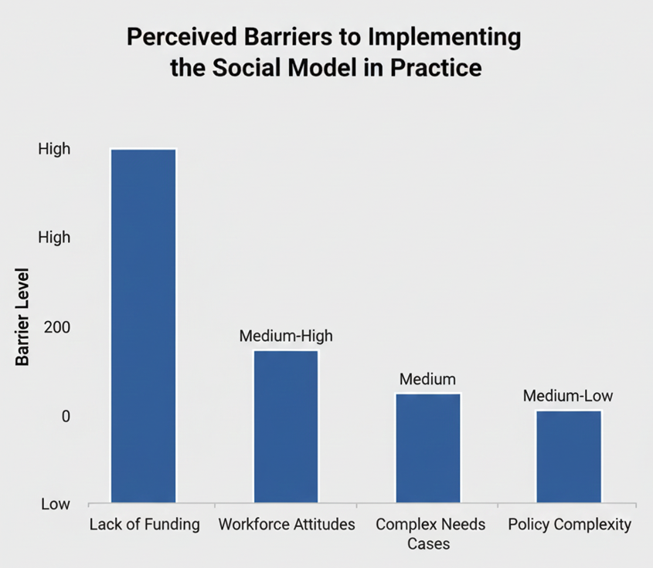This visual summary highlights the main challenges discussed and shows why implementation often falls short of the model’s intentions.

Recommendations and Conclusion

Recommendations
To strengthen the Social Model’s impact in health and social care, three practical steps are suggested:
1. Mandatory Training Co-Delivered by Disabled People
All health and social care staff should receive compulsory training on the Social Model, human rights, and inclusive practice. Crucially, this training should be co-designed and co-delivered by disabled people themselves. Hearing real experiences can challenge assumptions and encourage more reflective practice. Embedding this training at undergraduate level and in ongoing professional development would help shift the culture away from a purely medical perspective.

2. A National Fund for Reasonable Adjustments
Government should create a dedicated national fund specifically for accessibility and reasonable adjustments. This would prevent local councils, GP surgeries, and small employers from having to cover costs from already overstretched budgets. A ring-fenced fund would ensure that the duty to remove barriers is not limited by postcode or financial pressure.

3. Stronger Investment in Independent Advocacy
Advocacy services play a critical role in helping disabled people understand their rights, challenge poor decisions, and take part in care planning. Increasing funding for advocacy would ensure that more individuals can benefit from entitlement under the Care Act 2014 and Equality Act 2010. Strengthening advocacy also supports person-centred care by amplifying the individual’s voice.

Conclusion
The Social Model of Disability has transformed the way disability is understood in the UK. By distinguishing between impairment and the disabling barriers created by society, it provides a powerful foundation for person-centred care. It encourages practitioners to focus on autonomy, rights, and barrier removal rather than attempting to “fix” individuals. However, the challenge lies in translating this vision into everyday practice. Funding cuts, outdated attitudes, and complex support needs all contribute to a gap between policy and lived experience.
This essay has argued that while the Social Model remains essential, further action is needed to make its principles a reality. With better training, stronger funding structures, and improved advocacy, the UK can move closer to a society where disabled people are fully included, respected, and empowered. The long-term goal is not only better services but a more inclusive culture—one in which every person has the opportunity to participate equally.

Reference
Barnes, C. and Mercer, G. (2010) Exploring Disability. 2nd edn. Cambridge: Polity Press.
Crow, L. (1996) ‘Including All of Our Lives: Renewing the Social Model of Disability’, in Morris, J. (ed.) Encounters with Strangers, London: Women’s Press, pp. 206–226.
Department for Work and Pensions (2013) Fulfilling Potential: Building a Deeper Understanding of Disability in the UK. London: HMSO.
Equality and Human Rights Commission (2011) Equality Act 2010: Guidance on Reasonable Adjustments. London: EHRC.
HM Government (2014) Care Act 2014. London: The Stationery Office.
Lymbery, M. (2018) ‘Austerity, Personalisation and the Future of Social Care’, British Journal of Social Work, 48(3), pp. 772–789.
MENCAP (2022) Supporting People with Profound and Multiple Learning Disabilities. London: MENCAP.
Oliver, M. (1990) The Politics of Disablement. Basingstoke: Macmillan.
Oliver, M. (2013) ‘The Social Model of Disability: Thirty Years On’, Disability & Society, 28(7), pp. 1024–1026.
Pearson, C. (2017) ‘Austerity, Welfare Reform and Disabled People’, Social Policy & Society, 16(2), pp. 1–13.
Scope (2019) The Disability Perception Gap. London: Scope.
Shakespeare, T. (2006) Disability Rights and Wrongs. Abingdon: Routledge.
Shakespeare, T. and Watson, N. (2012) ‘The Social Model of Disability: An Outdated Ideology?’, Research in Social Science and Disability, 2(1), pp. 9–28.
Thomas, C. (2004) ‘How is Disability Understood?’, Disability & Society, 19(6), pp. 569–583.
UPIAS (Union of the Physically Impaired Against Segregation) (1976) Fundamental Principles of Disability. London: UPIAS.

