Assignment title: Comparison of Corinthia Hotels and Ibis Hotels

Student name: Gabriela Zosllei

Student number: 2133167

Module code: BMIH5007

Module title: Financial management

Lecturer name: Tristan Hawkins

Contents
Introduction 3
Total revenue 3
Market Position 5
Growth Protentional 6
Swot analysis of Corinthia Hotel 6
Swot analysis Ibis hotel 7
Bowman's Strategy Clock 9
Financial Commitment to CSR 11
Conclusion and Recommendation 12
references 13
Appendix 16

Introduction
The success of the business and organization is based on the important role of financial management. There is greater importance on principles of fundamental financial management so that they could be enabled to manage their profitability in the proper way. This report is based on making a comparison between two different companies that are leading the hotel industry and the companies included in this comparison include the Ibis Hotel and Corinthia Hotel Group (Mosteanu and Faccia, 2020).
The spirit of Corinthia is inspired by family traditions which have been passed down through generations, starting with the Pisani family in Malta who set up a chain of hotels called Corinthia in 1962. As if they were old friends, the Pisani family loves to look after and greet visitors. They promote and support each other to ensure that their hotel staff around the world can have a pleasant, inspirational working experience. In its role as a hotel company, it places a premium on discreet, sincere service, by raising the status of master artisans in the hospitality sector, and appreciates sincerity, passion, accuracy, and comprehension (Corinthia, n.d.).
Ibis is owned by Accor, and it is one popular French hotel brand. It was established and created in 1974 and it became the megabrand of the economy of Accor in 2011 based on Ibis Budget and rebranding of Ibis Styles from all the Etap Hôtel and Seasons. Under this brand, there were 1,218 hotels now working according to a report in December 2019 and across 70 countries it is serving people with a total number of 159,180 rooms (Referenceforbusiness, n.d.)

Total revenue

 | Corinthia |  |  | Ibis
 | 2020 | 2021 | 2022 | 2020 | 2021 | 2022
Revenue | 91,909 | 129,266 | 238,207 | 1,621 | 2,204 | 4,224
Revenue growth Percentage | - | 40.67% | 84.46% | - | 36.11% | 91.42%
Based on the consideration of a 95% increase on an annual basis in the hotel segment €238.2 million was the revenue of Corinthia in 2022. In 2019, the overall revenue was sustaining at 89%. A further improvement is forecasted in our performance in the prospect of looking forward and results in 2019 are close to this (Annual Report, 2022). For the year 2021 revenue reported by the Group was standing at €129.3 million and it in comparison to 2019 was just under half.
According to results in 2021, €26.5 million was considered as the operating results before fair value and depreciation versus in 2020 when it was just under €4 million. The turnaround in this regard was considered to be €30 million.
In terms of speed of recovery within IHI, the best results have been noted in hotel operations in London and Malta. Results revealed €18.5 million as the value of gross operating profit in the case of Corinthia in London, and it was considered a remarkable turnaround based on which easier restrictions made at an earlier level are reflected in the UK and with the local British market's good reputation has enjoyed by the brand. The sale of the Penthouse had been also closed by the company in 2021 in London and it had done for £30 million (Cocks, 2022).
In comparison to Q3 2021 an increase of 83% has occurred in the revenue of Ibis Hotel that has been reported to be €1,149 million in Q3 2022. In breaking down this figure it is reported 80% in the case of Hotel Assets & Other and an 84% increase for Hotel Services. The like-for-like increase was 9% in the context of the revenue in Q3 2019 for providing a comparison with RevPAR. Consolidation of Ennismore was a key reason behind the changes in the scope of consolidation based on €14 million contribution (Press, 2022). In the case of Hotel Services €3,194 million in revenue has been generated which was 89% for like-for-like. A solid recovery in business has been reflected by this. The revenue identified and reported in the case of M&F was standing at €1,052 million and this was up 93% like-for-like

Market Position

 | Corinthia Hotel |  |  | Ibis Hotel
EPS % | 2020 | 2021 | 2022 | 2020 | 2021 | 2022
Year Over Year | — | -10.00 | -38.89 | — | — | 631.58
3-Year Average | — | — |  | — | -70.76 | -3.57
5-Year Average | — | 108.91 |  | — | -26.40 | -0.14
10-Year Average | -3.02 | -4.42 |  | — | 4.70 | —
A decline has been reported in both 2021 and 2022 in the case of the EPS of Corinthia Hotel and in this way, over the year some challenges are faced in growing and maintaining earnings. An increase on the other hand was experienced by Ibis Hotel in 2021 and 2022 in EPS so during this period improvement was significant.
The analysis of Corinthia Hotel's performance has been limited because of the absence of data for the five years. However, a modestly negative trend has been reported for 10-year average growth in the case of Corinthia Hotel where EPS reduction is showing.
There is mixed average growth noted for 5 years in the case of Ibis Hotel where in 2021 a significant level of increase was reported but in 2022 a significant decline was reported. Over the medium term, a volatile performance is shown in this way. A positive trend is indicated by the 10-year average growth in the case of Ibis Hotel where from 2020 to 2021 an increase is reported in EPS.

Growth Protentional

Swot analysis of Corinthia Hotel
- Strengths:
- Corinthia Hotel is often associated with excellent customer service, providing a high standard of accommodation and amenities.
- In addition to accommodations, Corinthia offers a range of services including spa facilities, fine dining, and event hosting, adding to its appeal.
- The Corinthia Hotel is known for its upscale and luxurious brand image, drawing on high-end clientele, and it has a presence in key international locations, which increases its global reach and brand recognition.
- In buildings with historical significance, several Corinthia hotels are located, giving the brand a distinctive and attractive appearance (Kadirova, 2022).
Weaknesses:
- Higher operating costs could result because of maintaining a luxurious brand image and in this way, the profit margin of the company can be affected.
- It is noted that high end market is primarily targeted by Corinthia and in this way, its customer base is limited especially during economic difficulties.
- Fluctuations that are occurring in the tourism industry are one factor based on which the performance of hotels can be impacted so it has become vulnerable to geopolitical and economic uncertainties.
- There is the high level of competition exists in the luxury hotel industry so less efficiency than others will lose market share (Tan et al., 2021)
Opportunities:
- New revenue streams can be gained by the business based on focusing on the expansion of the business into new emerging markets.
- The overall satisfaction of customers can be increased based on the implementation of advanced technology for increasing the efficiency of operations and personalizing guest experiences.
- The reach of the hotel and attraction of new customers can be gained by the hotel based on creating partnerships with travel agencies, airlines, or other luxury brands.
- health-focused travelers and environmentally conscious individuals could be attracted by the company based on alignment with sustainability and wellness trends.
Threats:
- The travel and hospitality sector can be significantly affected by events such as pandemics or global crises.
- Luxury hotels are vulnerable to economic downturns because customers will be less inclined to spend on their own.
- Political turmoil and geopolitical instability in strategic areas may lead to operational disruptions and reputational damage.
- Due to its greater reliance on technology, the hotel is at risk of cyber security risks that could damage guest data and trust.
- A risk could be changing consumer tastes or the growing number of alternative accommodation options, like Airbnb (Ye et al., 2022).

Swot analysis Ibis hotel
Strengths
- Due to its location in commercial places, the Ibis Hotel is easily accessible to guests.
- A global network of Ibis hotels is strong.
- Based on offering 15 15-minute satisfaction guarantee program, quality is maintained in all services.
- By offering economical prices, the brand is offering comfort and value to customers.
- 24-hour kitchen and bar services are also offered by the hotel.
- ISO certification has been gained by the Ibis (Kozhukhіvska et al., 2022)
Weaknesses
- To design proofroomsin economical rates there will be a need for advice from experts and this will have high operational costs.
- There are substantial costs will be incurred in the development and evolving sleep solutions of Good Night by involvement of experts.
- Individual travelers are mainly targeted by the Ibis hotel and there is no wider channel of distribution used by the hotel so enough groups could not be attracted.

Opportunities
- Having the capacity to emerge in new segments and new markets.
- The alliance could be formed by the Ibis Hotel with the local level competitors.
- ibis Hotel can also focus on integration with suppliers (Jones and Comfort, 2021)
Threats
- Both at the local and international levels an increase has been noted in a number of budget hotels which is one threat.
- Sustainability could be a threat because of the increasing level of competition at the global level.
- The functioning in the longer run could be affected because of the regulatory forces and bargaining power of suppliers at the international level (Mrowinska, 2020).

Bowman's Strategy Clock
In prospects of Bowman's Strategy Clock, there are eight various strategic options have been included which are presented below:
Strategic Option | Corinthia Hotel | Ibis Hotel
Low Price/Low Value: | Focus has been maintained by Corinthia Hotel on delivering higher value and standard to customers, so it is not positioning as low value provider. | Budget-friendly accommodation services are offered by Ibis Hotel without the addition of significant value-added services, so it is positioned on the "Low Price/Low Value" end of Bowman's Strategy Clock
Low Price: | Based on price it is noted Corinthia Hotel is not in competition with budget hotels in the market. The luxury segment is the main focus of Corinthia Hotel | Based on affordability and cost efficiency it is noted that Ibis Hotel is competing in the market. In terms of pricing, it is not a competition with Corinthia Hotel
Hybrid: | A hybrid strategy is used by Corinthia Hotel and unique and high-quality experiences are provided by focusing on cost leadership and differentiation strategies. | A hybrid strategy is also used by Ibis Hotel where some elements of differentiation are incorporated such as central city location and smart rooms (Saqib, 2021).
Differentiation: | In the strategy of Corinthia Hotel, one key element is called differentiation. The provision of unique and memorable experiences is a key factor in its popularity. | Cost leadership is the primary focus of Ibis Hotel, but some differentiation is added based on the hybrid approach
Focused Differentiation: | Specific properties and brands are retained by Corinthia Hotel that are targeting niche markets within the luxury segment. They are allowed to cater to different types of high-end customers (Weston and Nnadi, 2023). | Focused differentiation is not focused by Ibis Hotel, but some focus is given on differentiation by a sub-brand "Hub by Ibis Hotel"
Increased Price/Standard Value: | Premium services and options are offered by Corinthia Hotel which means the price is higher than other brands. | Significant increase in prices is not involved in the strategy of Ibis Hotel and in the budget hotel segment, they remain cost competitive.
Increased Price/Low Value: | A strategy of increasing prices based on lower value is not followed by Corinthia Hotel. Exceptional value is focused on being provided by it to customers. | For increasing prices, a reputation gained by Ibis Hotel perspective of offering low-value services
Low Value: | Corinthia Hotel is not positioned in the market as one low-value provider because high standards of quality are focused and so prices are higher. | Ibis Hotel is also not positioned as one low-value provider in the market, but the provision of budget-friendly and basic accommodation is its key focus (Chathoth and Köseoglu, 2020).

Financial Commitment to CSR
Robust CSR identifications are considered and focused on by the collection of luxury hotels Corinthia Hotels in the world. Corinthia Hotels has improved the quality of life for students and teachers at Buwambo Primary School in Uganda by constructing a gender-sensitive toilet block with washrooms, which was one kind of tank for storage of water with a capacity of 8,000-gallon so that it can be ensured that during the season safe drinking water is used. Students may not take classes because of taking water from wells (Hohnholz, 2018).
Corinthia Hotels is approaching CSR initiatives with an ever more optimistic, pragmatic attitude as well as working alongside both national and international infrastructure. Their commitment to enhancing not only their organization but also the quality of life for their employees and the wider community is unwavering and sustained. PERFECTING ENERGY EFFICIENCY works to reduce their energy use in an effort to lessen their carbon impact, and they have so far seen notable progress in this regard (Alatawi et al., 2023).
The Corinthia hotels' diligent attempts to cut back on fuel and water usage, as well as their involvement in international activities like Earth Hour, greatly contribute to the global movement to conserve the environment. More locally and particularly, the Corinthia Hotel St George's Bay collaborates with other five-star hotels in Malta to clean and tidy St. George's Bay's seabed (GreenGuest, n.d.).
The well-known network of budget-friendly hotels, Ibis, has also started on sustainable travel. They have set specific sustainability targets to reduce waste, save resources and minimize their carbon footprint as part of the Whitbread PLC group (Ibis, n.d.). Community involvement is also highlighted, with the Ibis Hotel participating in several activities such as charity fundraising and support for local projects, which are particularly concerned with homelessness and education. Ethical labor standards and human rights guaranteeing that workers are treated fairly and with dignity at work underpin their corporate principles. The Whitbread Foundation, the parent company of the Ibis Hotel, is the driving force behind charitable initiatives aimed at supporting charities and local communities. Clearly, in line with its brand values and changing customer expectations, the Ibis Hotel allocates resources to sustainability, community involvement and social impact through Whitbread plc even though specific CSR commitments cannot be publicly disclosed (Press, 2016).

Conclusion and Recommendation
In summary, the hotel corporations of Ibis and Corinthia show innovative planning and monetary profiles. In the Hotel Corinthia, the prime focus is on distinction and luxury, confronting the challenging situation of revenue. On the other hand, Ibis Hotel pursues an approach of cost-efficient strategies with a prime focus on revenue profit. Both the Hotel Sector of Ibis and Corinthia stress to invest in CSR initiatives while stressing the development of society and investing in sustainability respectively. The business corporation of Corinthia must put focus on cost-efficient approaches while it is important for Ibis Hotel to regulate and balance differentiation and cost leadership in the working culture.

references
Alatawi, I.A., Ntim, C.G., Zras, A. and Elmagrhi, M.H., 2023. CSR, financial and non-financial performance in the tourism sector: A systematic literature review and future research agenda. International Review of Financial Analysis, p.102734.
Annual Report, 2022. International Hotel Investments p.l.c. Annual Report & Financial Statements31 December 2022. [Online] Available at: https://www.corinthiagroup.com/wp-content/uploads/2023/04/ihi.html#:~:text=2022%20Revenue%20was%20at%20%E2%82%AC,closer%20to%20the%202019%20results [Accessed 2 Feb 2024].
Chathoth, P. and Köseoglu, M.A., 2020. Strategic Management for Hospitality and Tourism. Strategic Management in the International Hospitality and Tourism Industry; Routledge: London, UK, 18, pp.33-52.
Cocks, P., 2022. Corinthia to target 4-star space under new brand to be launched by 2023. [Online] Available at: https://www.businesstoday.com.mt/business/business/1849/corinthia_to_target_4star_space_under_new_brand_to_be_launched_by_2023 [Accessed 02 Feb 2024].
Corinthia, n.d.. WE ARE CORINTHIA. [Online] Available at: https://www.corinthia.com/en-gb/our-story/ [Accessed 19 Jan 2024].
GreenGuest, n.d.. Corinthia Hotels. [Online] Available at: chrome-extension://efaidnbmnnnibpcajpcglclefindmkaj/https://greenguest.files.wordpress.com/2019/03/hu_01_corinthia.docx.pdf [Accessed 19 Jan 2024].
Hohnholz, L., 2018. Corinthia Hotels’ diverse CSR initiatives in 2018 have positive impact on sustainable tourism. [Online] Available at: https://eturbonews.com/corinthia-hotels-diverse-csr-initiatives-in-2018-have-positive-impact-on-sustainable-tourism [Accessed 19 Jan 2024].
Ibis, n.d.. OUR KEY ACHIEVEMENTS. [Online] Available at: https://ibis.accor.com/sustainable-development/index.en.shtml [Accessed 19 Jan 2024].
Jones, P. and Comfort, D., 2021. Modern slavery statements and leading UK hotel companies. Athens Journal of Tourism, 8(3), pp.147-162.
Kadirova, D.X., 2022. Lexical Features of Terms Related to Tourism and Technology in English and Uzbek. Journal of Positive School Psychology, pp.5675-5683.
Kozhukhіvska, R., Sakovska, О., Maslovata, S., Dluhoborskа, L. and Chuchmii, I., 2022, June. Managing innovation in tourism and hospitality industry: International experience. In AIP Conference Proceedings (Vol. 2413, No. 1). AIP Publishing.
Mosteanu, N.R. and Faccia, A., 2020. Digital systems and new challenges of financial management–FinTech, XBRL, blockchain and cryptocurrencies. Quality–Access to Success, 21(174), pp.159-166.
Mrowinska, J., 2020. Financial Performance Analysis of major hotel chains in Poland, Finland, and United Kingdom during 2017-2019.
Press, 2016. AccorHotels takes its corporate responsibility to the next level with bold new CSR commitments looking. [Online] Available at: https://press.accor.com/accorhotels-takes-its-corporate-responsibility-to-the-next-level-with-bold-new-csr-commitments-looking/?lang=en [Accessed 19 Jan 2024]. Press, 2022. Third-quarter 2022 revenue of €1,149 million up 83% like-for-like. [Online] Available at: https://press.accor.com/third-quarter-2022-revenue-of-e1149-millionup-83-like-for-like/?lang=en [Accessed 02 Feb 2024].
Referenceforbusiness, n.d.. Accor S.A. - Company Profile, Information, Business Description, History, Background Information on Accor S.A.. [Online] Available at: https://www.referenceforbusiness.com/history2/68/Accor-S-A.html [Accessed 19 Jan 2024].
Saqib, N., 2021. Positioning strategies: a literature review. Journal of Cardiovascular Disease Research, 2545.
Tan, Y., Jamshidi, A., Hadi-Vencheh, A. and Wanke, P., 2021. Hotel performance in the UK: the role of information entropy in a novel slack-based data envelopment analysis. Entropy, 23(2), p.184.
Weston, P. and Nnadi, M., 2023. Evaluation of strategic and financial variables of corporate sustainability and ESG policies on corporate finance performance. Journal of Sustainable Finance & Investment, 13(2), pp.1058-1074.
Ye, F., Xia, Q., Zhang, M., Zhan, Y. and Li, Y., 2022. Harvesting online reviews to identify the competitor set in a service business: evidence from the hotel industry. Journal of Service Research, 25(2), pp.301-327.

Appendix – Corinthia Hotel
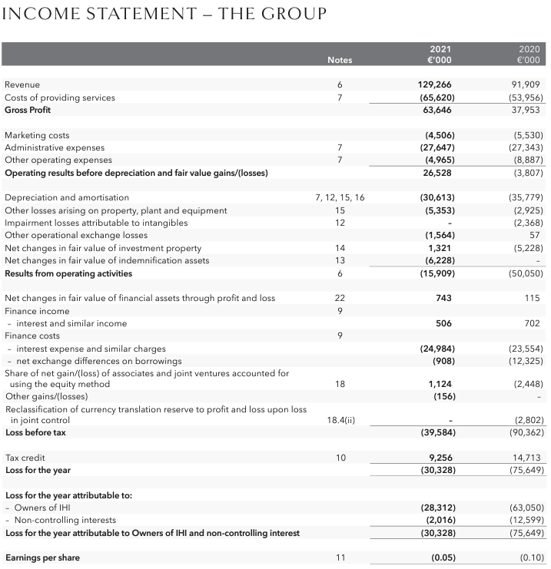
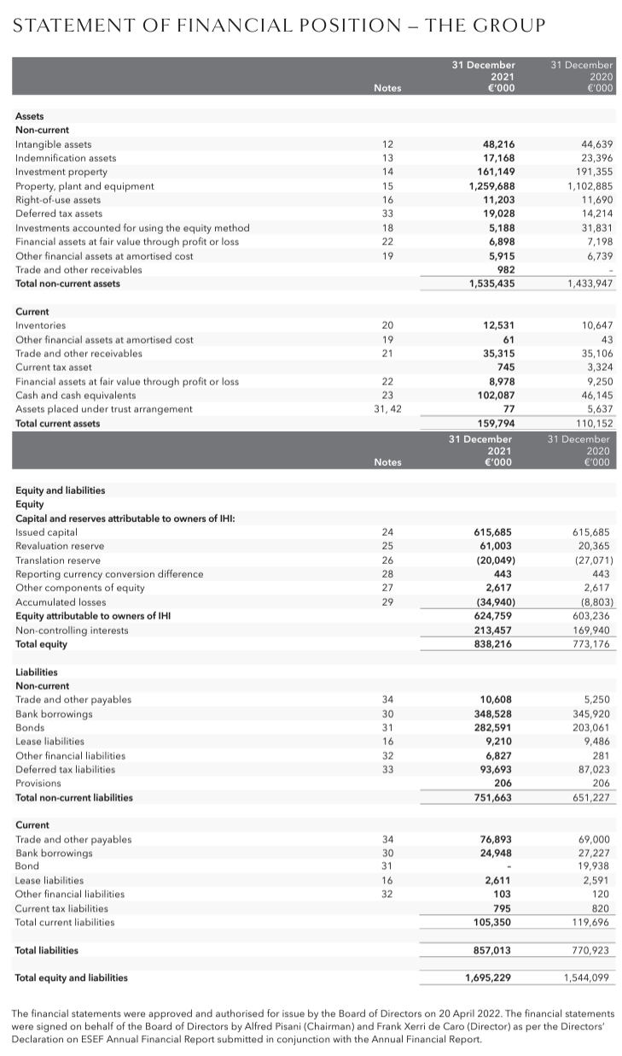
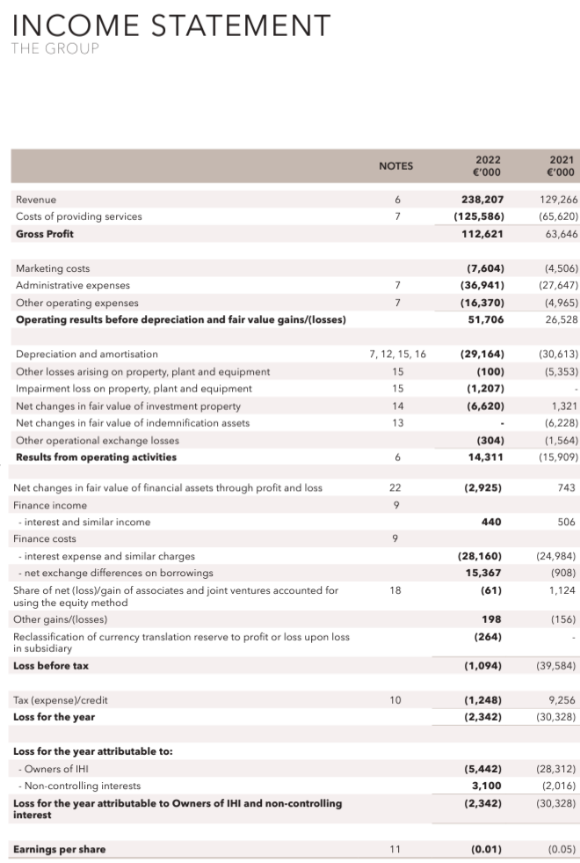
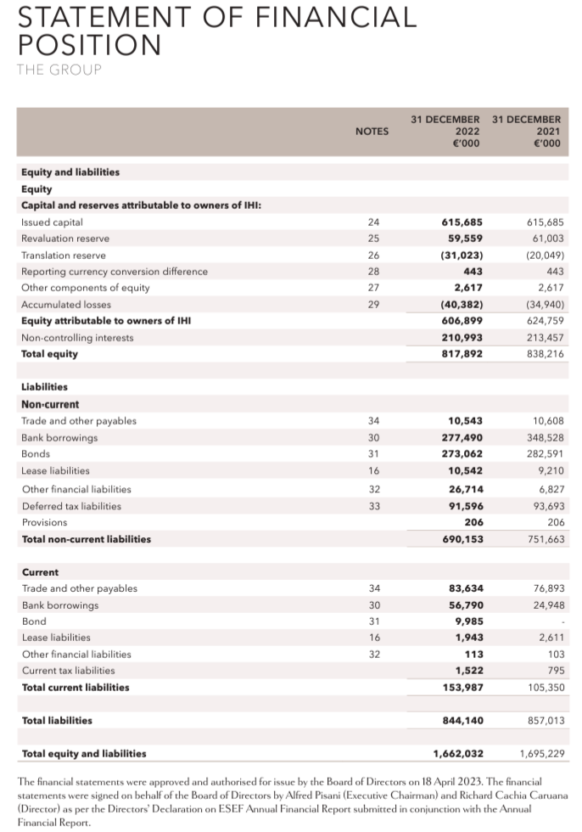

Appendix – Ibis Hotel


