Corporate Social Responsibility Report

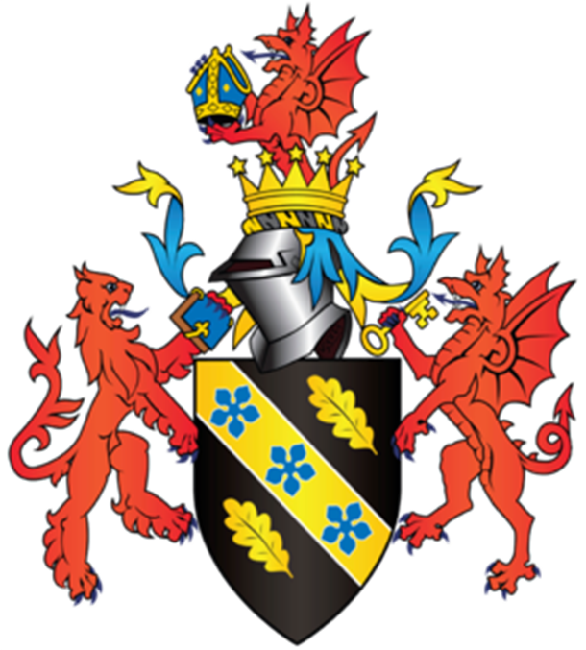

Module Name: Management Ethics
Student Name: Ella Williams
Student Number: 1707424

Table of Contents

- Executive Summary………………………………………………………………………………………..3
- Introduction…………………………………………………………………………………………………4-7
2.1 Report Remit
2.2 Background on Tesco
2.3 What is Corporate Social Responsibility?
3. Main Findings……………………………………………………………………………………………….8-9
3.1 Model of Corporate Social Responsibility
4. Conclusion………………………………………………………………………………………………………10
5. Recommendations………………………………………………………………………………………….10
6. References…………………………………………………………………………………………………11-12

List of Figures

Figure 2.2.1: Tesco’s Stakeholder Mapping……………………………………….………………….……......6
Figure 2.2.2: Tesco’s Mendelow Grid……………………………………………………………………………….6
Figure 3.1.3: Carroll's CSR Pyramid……………………………………………….…………………………………8

- Executive Summary
This report gives the reader an inside on how Tesco sold horsemeat to customers who thought was beef as it was cheaper for them and they knew they would make a profit. Also, throughout this report the stakeholder and shareholder theories, Mendelows grid and Carroll CSR Pyramid, to explain the unethical situation.
The purpose of this report is to show the reader how organisations only think about making profit or how one stakeholder can affect the other stakeholders within the organisation as whole. It shows how people can be very selfish working within the business industry.
The reader will find as they go through the report that Tesco say they will do a lot of things to meet their CSR requirements in their previous years CSR reports. However, this unethical scandal just proves organisations seem to say things and not mean them.
This report will conclude stating how even the biggest organisations will try and do anything just to make more profit. However, the reader will find Tesco do want to move on from this and gain their customers trust back so I would recommend the organisation to purchase meet from local farms as they will know exactly where the meat is from and know it is genuine.

- Introduction

  - Report Remit
This report seeks to analyse the horsemeat scandal in 2013, with special reference to Tesco. Further it seeks to embed CSR concepts to the issues involved.

  - Background on Tesco
Tesco was founded 99 years ago by a man called Jack Cohen. Tesco now owns 6,966 stores located around the world (Statista, 2018).
However, 14th January 2013, the Food Safety Authority of Ireland tested what was supposed to be frozen beef burgers sold by Tesco but came back as 29% horse (Lawrence, 2013). Tesco apologised straightaway saying, “We and our supplier have let you down and we apologise” and all products were removed from the shelves immediately (BBC-News, 2013).
Months after the horsemeat scandal over 100 UK butchers in the UK noticed their beef burger sales increasing to 30% (UK-Farming, 2013). This benefits local farmers and it would bring more money to the area. Five years on, organisations are now monitoring their supply chain better so this does not happen again (Levitt, 2016).

2.3 What is Corporate Social Responsibility?
Corporate Social Responsibility (CSR) looks at the relationship between corporations and societies which they work in (Chandler, 2006). This includes economical, ethical, legal, and generous expectations that organisations must undertake due to society (Buchholtz, 2009). CSR is socially responsible for their own organisation, stakeholders and the public, who are all interested in the organisation’s operations.
In Tesco’s (2016) CSR report Tesco state how they were going to create more jobs for people in local communities in their new stores and trading around the world. However, they do not state how jobs will be lost due to local shops closing as they will not be able to compete. Between 1997 – 2002, 13 thousand specialist stores have closed due to large stores like Tesco opening (Earth, 2004). However, Tesco seem to do a lot of charity work to cover up their unethical past, so people only hear about the good things.
The two main positions will be evaluated and applied in this report.
Friedman’s shareholder theory states how every business only has the responsibility to increase their profits, where they are legally obligated to do as they please in 1960 – 1970’s (Friedman, 1970). This promotes social responsibility to society, as if you increase profits in an organisation it would benefit the local community in that economy.
However, Edward Freeman believes laws have been put into place due to society limiting its sustainability. This proves Friedman’s theory is false as he exaggerates how there are no moral hazards or economic problems from only thinking about profits. Freeman created the theory after he recognised the important elements of CSR in the world we live in today. However, even the world’s largest organisations state how they follow CSR, but their actions fail to live up to their words. Freeman believed that a stakeholder can affect or be affected by actions of a business (Admin, 2013).
This theory is true as Tesco meat suppliers affected other stakeholders due to selling horse meat instead of beef.

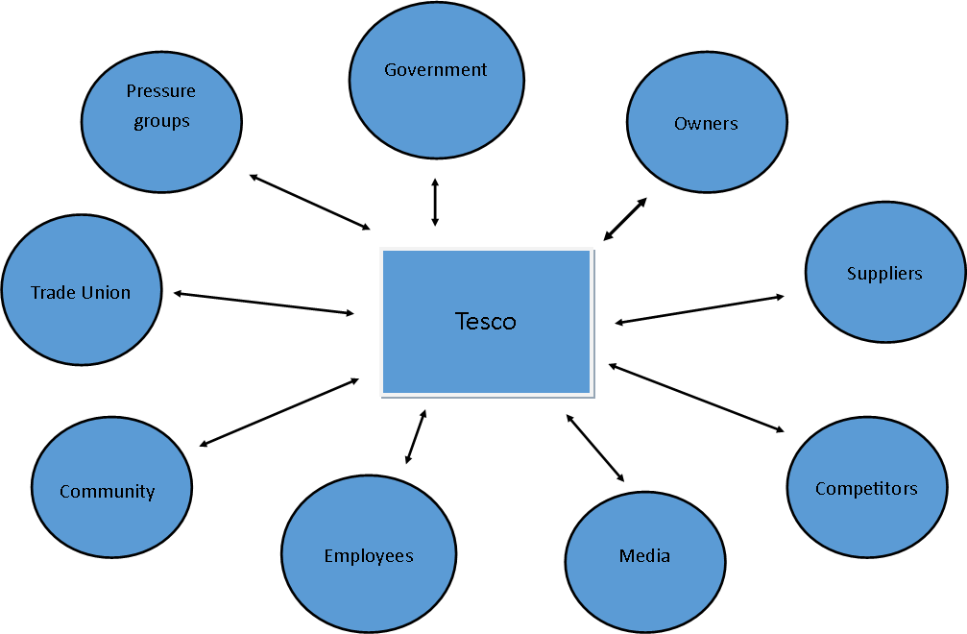
Figure 2.2.1: Tesco’s Stakeholder Mapping

Within the horsemeat scandal Tesco blames the “beef” supplier for the scandal and no longer work alongside the supplier due to “breach of trust” (Hodge, 2013). Tesco have stated how they have “been listening” and “rebuilding trust is one of their strategic priorities” (Tesco, 2015).

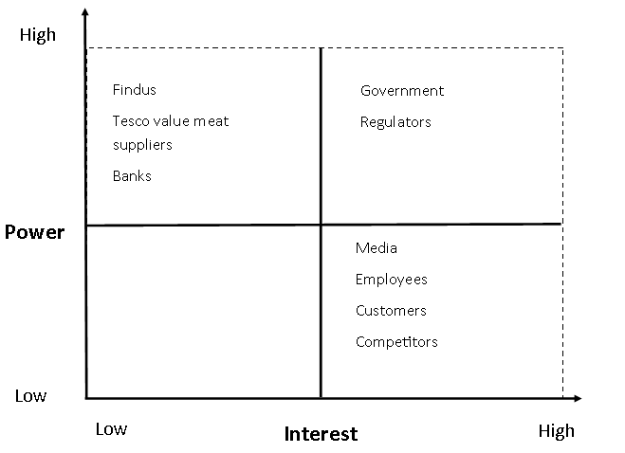
Figure 2.2.2: Tesco’s Mendelow Grid

Figure 2.2.2 is model that organisations use to recognise the key stakeholders, and what relationship they have with them.
The first box holds the stakeholders who have high power, but low interest so organisations must keep them satisfied. For example, Tesco a brand called Findus in their superstores which contained 100% horsemeat. Findus knew exactly what they were doing and said they, “did not believe it was a food safety issue” (2013). Although, the Act states under section 14 how you are not to sell food that is not of the nature, substance or quality of the product demanded by the buyer (Food-Standards-Agency, 2018). Just one supplier effected the organisation and had an impact on other stakeholders.
The government and regulators would be in the box for high interest and high power as the organisations must follow the laws and regulations put in place, so the regulators will want to investigate the matter. The scandal has brought to light how the government have not made a contingency plan for future scandals (Lawrence, 2014). However, the Government stated they would make one by the year 2015, but the contingency plan was published in 2016 (Government, 2016).
The low impact and interest box are left blank as there was no stakeholder who had a low impact and interest because of how serious this scandal was.
Lastly, within the high interest, low power box holds the media, employees and customers of the organisation. The media would have no power over the scandal but would have a high interest as they would want to know what has happened, to get it published fast. Consumers were impacted a lot as they’ll now be cautious of what they purchase, as Tesco was supposed to be a dependable supermarket. Also, employees were affected as the scandal was out of the blue and they had nothing to do with it, and their jobs may have been lost due to UK sales dropping by 43% (Lymbery, 2018). Competitors may also be affected as Tesco was not the only supermarket to have their products brought to light as Lidl, Iceland and Aldi also had horse meat in their products. This meant they all had to regain consumer trust.

- Main Findings

  - Model of Corporate Social Responsibility
Freeman’s theory identifies Carroll’s model of CSR as they both states how organisations will gain profit and respect society and the environment if they follow the laws.
In 1983, Carroll said “Corporate social responsibility involves the conduct of a business so that it is economically profitable, law abiding, ethical, and socially supportive” (Dudovskiy, 2012).
Carroll illustrates in figure 3.1.1 steps that society requires and desires.

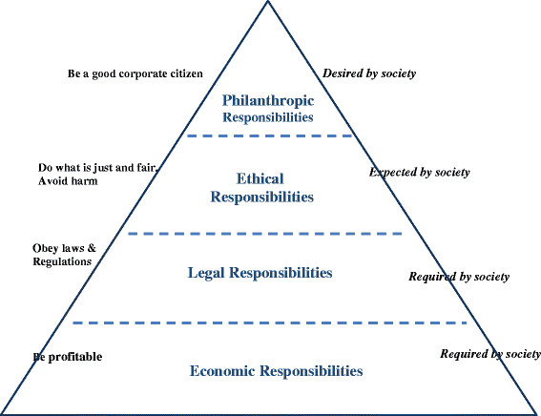
Figure 3.1.3: Carroll's CSR Pyramid

Carroll’s economic responsibility is to be more profitable as it is required by society, agreeing with Friedman. Tesco did not meet this responsibility as they were not profitable during the horsemeat scandal. In the 2013 CSR Report, Tesco state “We need to demonstrate that our products are safe, sourced to the highest standards and are honestly labelled” (Tesco, 2013). Tesco did not live up to their statement as their meat was not safe, up to standards or honestly labelled, which lead to losing £300m of their market value (Fletcher, 2013). However, Tesco have now completed 1,500 tests on their own meat ranges and have found new suppliers since the scandal (Jefferies, 2013).
Carroll also believe organisations have the right to obey laws and regulations, when Friedman believes that businesspeople should not worry about the impacts they are making, if they are making profit (Carroll, 2016). Tesco did not meet this responsibility as they did not obey laws and regulations of the general food law. Section 14 and 15 of the Food Safety Act 1990 were breached (Food-Standards-Agency, 2018).
Ethical responsibilities are expected of organisations by society and should be easy to maintain when following the law. However, organisations may think they can get away with being unethical, but the truth always comes out. In this case it was found Tesco did not follow the law. This had a huge impact on society, customers, employees and communities. Although, Tesco have changed this now and use local farmers as they will know they would be supplied 100% fresh beef, and this would support local farmers, bringing money to the area; benefiting everyone.
Lastly, philanthropic responsibilities are also required by society as business’ need to give back to society by ethical voluntary activities (Carroll, 2016). During the scandal Tesco did not meet this responsibility as Tesco did not improve quality of life for employees, the local community, or society overall (Andrew Crane, 2010). However, Tesco appears to hide all the unethical practices they have done by indorsing all the moral practices they do like supporting local communities through fundraising events, although they also effect local communities too. Tesco have donated £55 million to different charities, as well as fundraising £37.9 million (Dudovskiv, 2016).

- Conclusion
To conclude, organisations must follow each responsibility put in place on the CSR models, otherwise they will struggle to be ethical. It has been proven within this report that even the largest organisations do not always follow the policies put in place, which then have a huge effect on their organisation, stakeholders and market value like it did for Tesco.

- Recommendations
For Tesco to avoid this from happening again I would recommend a few solutions such as obey the laws and regulations put in place, especially the Food Safety Act 1990 as it had a huge impact on the organisation and their stakeholders. If Tesco obeyed the laws they would not have gone through this bad experience, losing customers and employees trust and £30m off the value of the supermarket.
Also, I would recommend Tesco’s to use local meat suppliers. This would help gain consumers trust back and benefit local farmers, bringing money to the area.
Lastly, I would recommend Tesco to improve their communication with their suppliers. This would help Tesco make a strong relationship with all their suppliers and trust them more.

References

Admin, C. (2013, July 16). Shareholder & Stakeholder Theories Of Corporate Governance . Retrieved from Corplaw : http://www.corplaw.ie/blog/bid/317212/Shareholder-Stakeholder-Theories-Of-Corporate-Governance
Andrew Crane, D. M. (2010). Understanding Business Ethics. In D. M. Andrew Crane, Business Ethics: Managing Corporate Citizenship and Sustainability in the Age of Globalisation (p. 54).
BBC-News. (2013, January 17). Horsemeat in Tesco burgers prompts apology in UK papers. Retrieved from BBC : https://www.bbc.co.uk/news/uk-21054688
Buchholtz, A. B. (2009). In A. B. Buchholtz, Business and Society: Ethics, Sustainability, and Stakeholder Management (p. 44).
Carroll, A. B. (2016). Carroll's pyramid of CSR: taking another look. Retrieved from International Journal of Corprate Social Responsibility : https://pdfs.semanticscholar.org/7e34/9825b55bebc98ef813f86608a53824d6edbe.pdf
Chandler, W. B. (2006). Strategic Corporate Social Responsibility. USA.
Dudovskiv, J. (2016, May 24). Tesco CSR Overview. Retrieved from Research Methodology: https://research-methodology.net/tesco-csr-overview/
Dudovskiy, J. (2012, October 25). Carroll’s CSR Pyramid and its applications to small and medium sized businesses. Retrieved from Research Methodology: https://research-methodology.net/carrolls-csr-pyramid-and-its-applications-to-small-and-medium-sized-businesses/
Earth, F. o. (2004). Every Little Hurts: Why Tesco needs to be tamed. Friends of the Earth.
Fletcher, N. (2013, January 2013). Horse meat scandal wipes £300m off Tesco's market value . Retrieved from The Guardian: https://www.theguardian.com/business/marketforceslive/2013/jan/16/horse-meat-tesco-market-value-shares
Food-Standards-Agency. (2018, January 23). General food law. Retrieved from Food Standards Agency: https://www.food.gov.uk/business-guidance/general-food-law
Friedman, M. (1970). The Social Responsibility of Business is to Increase its Profits. The New York Times Magazine, 1.
Government, W. (2016). Welsh Government Contingency Plan for Exotic Animal Diseases. Welsh Government .
Hodge, K. (2013, January 30). Horsemear scandal: Tesco drops burger meat supplier after 'breach of trust'. Retrieved from Independent : https://www.independent.co.uk/news/uk/home-news/horsemeat-scandal-tesco-drops-burger-meat-supplier-after-breach-of-trust-8472183.html
Jefferies, T. (2013, June 5). Tesco suffers sales hit from horsemeat scandal as revamp sees it get rid of 'unprofitable' electronic gadgets. Retrieved from This is money : https://www.thisismoney.co.uk/money/markets/article-2336179/Tesco-sales-fall-horsemeat-scandal-hits-convenience-food-business.html
Lawrence, F. (2013, May 10). Horsemeat scandal: timeline. Retrieved from The Guardian : https://www.theguardian.com/uk/2013/may/10/horsemeat-scandal-timeline-investigation
Lawrence, F. (2014, September 4). Horsemeat scandal report calls for urgent and comprehensive reforms . Retrieved from The guardian: https://www.theguardian.com/uk-news/2014/sep/04/horsemeat-scandal-report-urgent-comprehensive-reforms
Levitt, T. (2016, January 7). Three years on from the horsemeat scandal: 3 lessons we have learned . Retrieved from The Guardian: https://www.theguardian.com/sustainable-business/2016/jan/07/horsemeat-scandal-food-safety-uk-criminal-networks-supermarkets
Lymbery, P. (2018). Horsemeat Scandal - Lessons Learned? Retrieved from Ciwf: https://www.ciwf.org.uk/philip-lymbery/blog/2015/01/horsemeat-scandal-two-years-on-lessons-learned
Statista. (2018). Tesco's number of stores worldwide from 2008 to 2018. Retrieved from Statista: https://www.statista.com/statistics/238667/tesco-plc-number-of-outlets-worldwide/
Tesco. (2013). Tesco and Society Report. Tesco PLC.
Tesco. (2015). Our approach. Retrieved from Tesco PLC: https://www.tescoplc.com/media/1069/tesco_cr15_corporateresponsibilityupdate2015.pdf
Tesco. (2016, November). An update on our Corportate Responsibility commuitments. Retrieved from Tesco PLC: https://www.tescoplc.com/media/391787/corporate-responsibility-update_nov-2016-final.pdf
UK-Farming. (2013, February 9). Local butchers see trade increase amid horse meat scandal. Retrieved from Farming UK: https://www.farminguk.com/news/Local-butchers-see-trade-increase-amid-horsemeat-scandal_24964.html

