Name: Ceri Dacey______________________________

Student Number: 2415538_______________________
__________________________________________________________

WORKSHEET 1a – TESTING (Using Variables)

- Original code:
[Copy and paste your original code from Moodle into this box. Do not change it.]

print("Please enter your surname:")
surname = str(input())

print("Please enter your Car registration:")
car_Reg = str(input())

flag = 0
while flag == 0:
try:
userAge = int(input("Please enter your age: "))
except ValueError:
print("This is not a number, try again")
else:
flag = 1

flag = 0
while flag == 0:
try:
lecHours = float(input("Please enter how many hours per week you have of lectures: "))
except ValueError:
print("This is not a number, try again")
else:
flag = 1

- Code Testing

For each test below, run your code and enter the values provided. Provide a screenshot of the programme running. Did the programme behave correctly or did it do something unexpected? Fill in a box for each test below. You should present 14 separate boxes, 1 for each test. (Note: the first box is provided as a template)

Surname:
- Enter JONES
- Leave blank
- Enter 123

Car registration:
- Enter CN66RBU
- Leave blank
- Enter BG56345DFE (ie too long for a UK car registration number)

Current age
- Enter 34
- Enter 150
- Enter -4
- Enter a letter

Hours per week of lectures
- Enter 12
- Enter 15.5
- Enter -4
- Enter 150 (ie longer than the maximum possible hours that the University is open in a week)

Test:
Surname i. Enter JONES

Screenshot(s) of output:
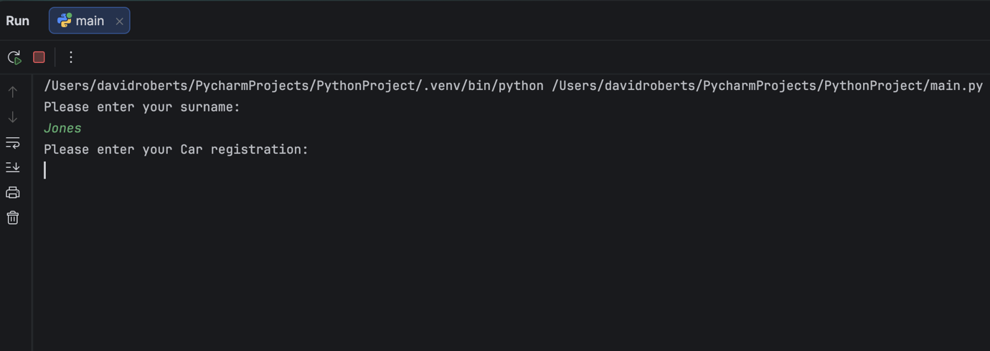
Result: Did the programme behave as expected ie syntactically and logically correct?
Yes, the programme accepted the name and moved on to the next question.

Test:
Surname ii Leave blank

Screenshot(s) of output:
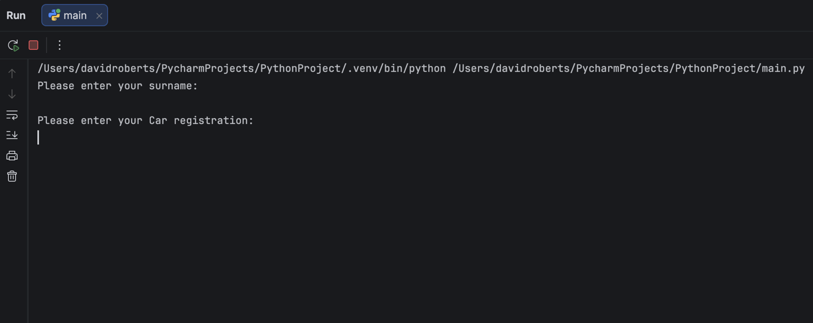
Result: Did the programme behave as expected ie syntactically and logically correct?
No, a name was not entered before moving on to the next question. Validation was not included.

Test:
Surname, enter 123
Screenshot(s) of output:
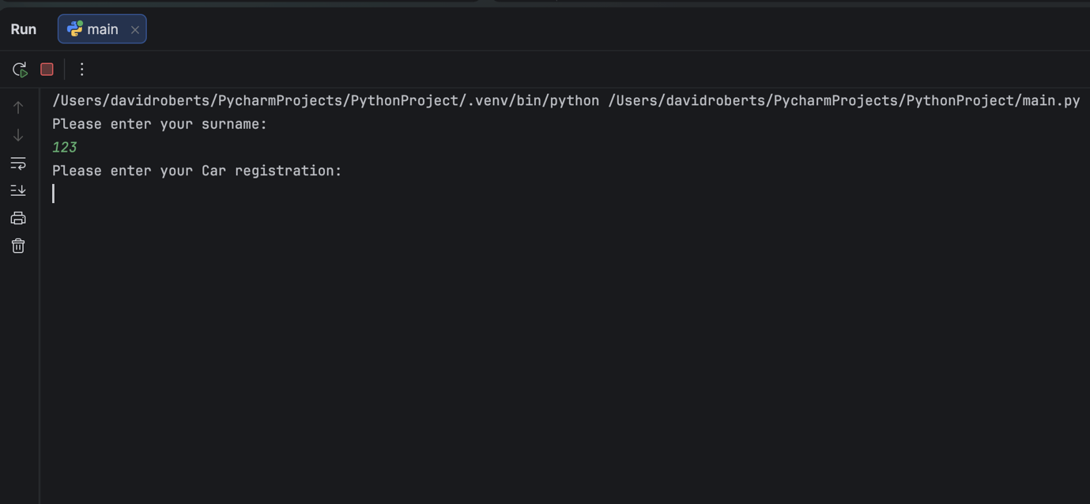
Result: Did the programme behave as expected ie syntactically and logically correct?
No, the programme accepted a number as a name. It needs further validation.

Test:
Car registration, Enter CN66RBU
Screenshot(s) of output:
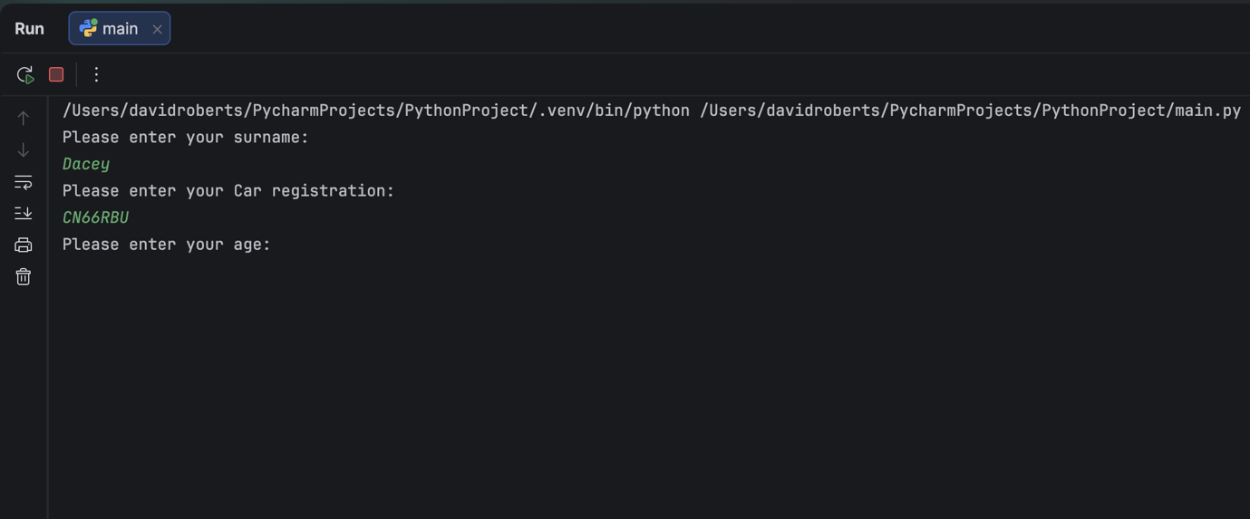
Result: Did the programme behave as expected ie syntactically and logically correct?
Yes, the car registration was accepted and the program moved on to the next question.

Test:
Car registration, Leave Blank
Screenshot(s) of output:
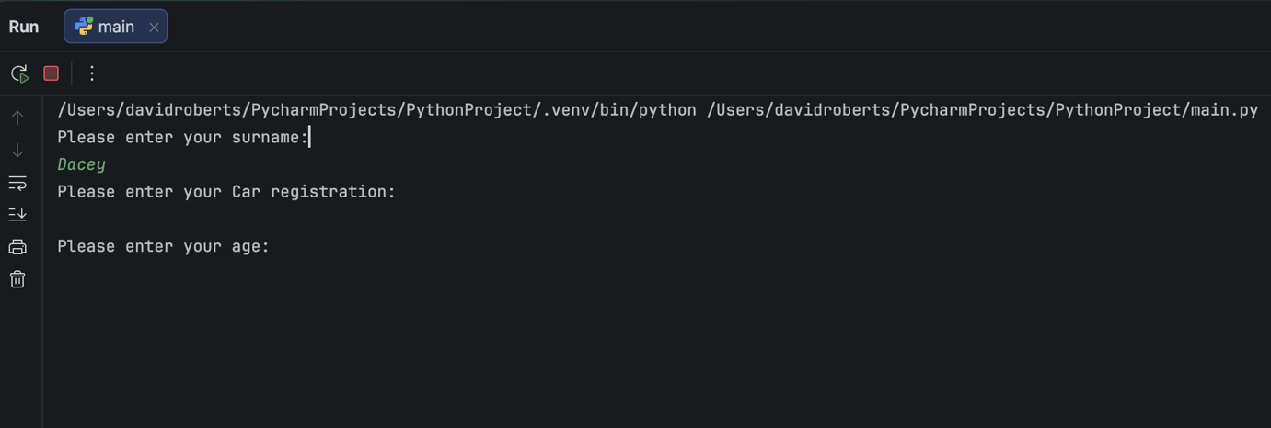
Result: Did the programme behave as expected ie syntactically and logically correct?
No, the program accepted a blank answer and instead of prompting the user again for a car registration it went onto the next question. Validation needed.

Test:
Car Registration, BG56345DFE
Screenshot(s) of output:
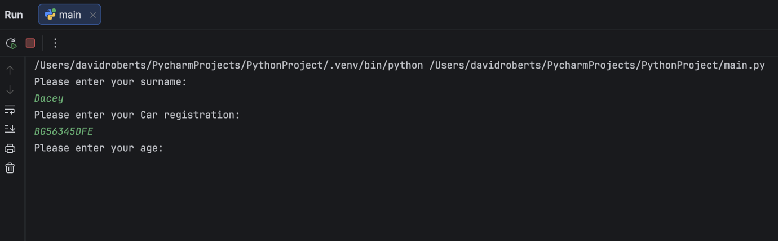
Result: Did the programme behave as expected ie syntactically and logically correct?
No, the program accepted a car registration number that is too long. Validation required.

Test:
Age, 34
Screenshot(s) of output:
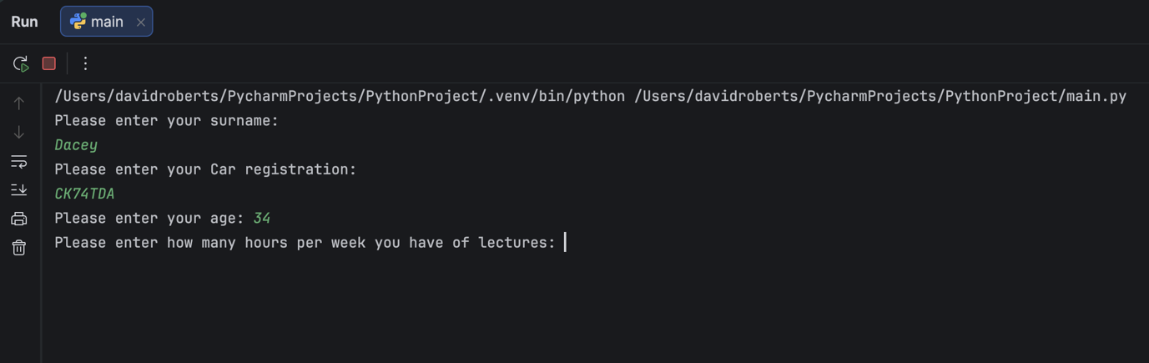
Result: Did the programme behave as expected ie syntactically and logically correct?
Yes, the age was accepted and the program went on to the next question.

Test:
Age, 150
Screenshot(s) of output:
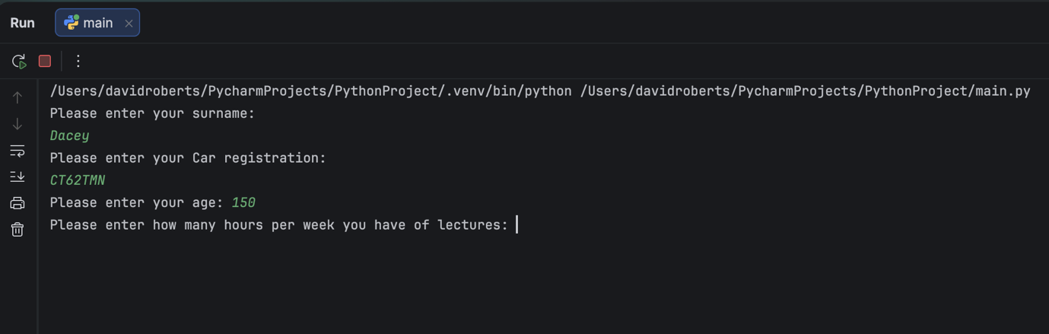
Result: Did the programme behave as expected ie syntactically and logically correct?
No, the program accepted 150 as an appropriate age (the longest someone has lived for is 122 years.) Validation is needed to make sure answers larger than that wont be accepted.

Test:
Age, -4
Screenshot(s) of output:
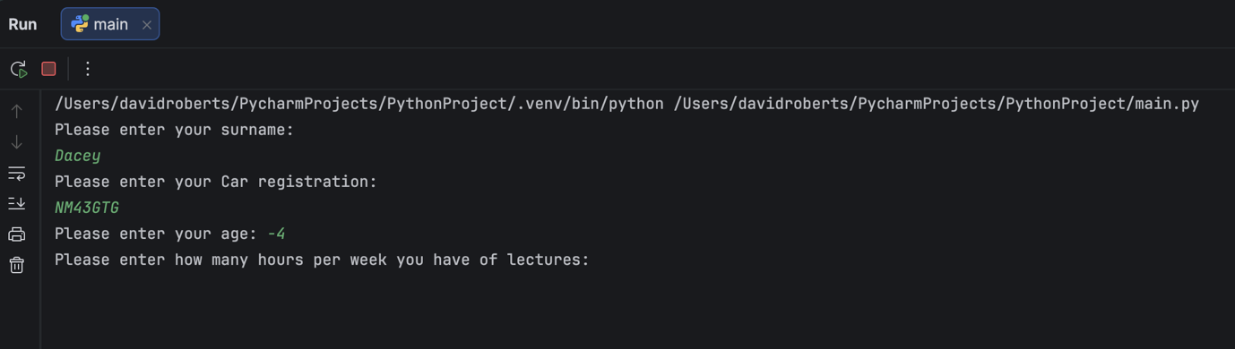
Result: Did the programme behave as expected ie syntactically and logically correct?
No, -4 is not a possible age. Validation needed to make sure people can’t enter an inappropriate number.

Test:
Age, Enter a letter
Screenshot(s) of output:
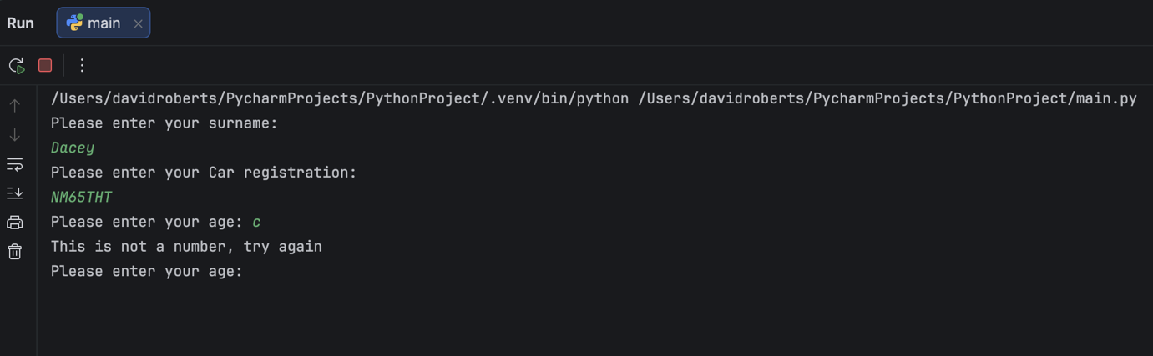
Result: Did the programme behave as expected ie syntactically and logically correct?
Yes, the program recognised that ‘c’ is not a number and therefore prompted the user to try again.

Test:
Hours per week, 12
Screenshot(s) of output:
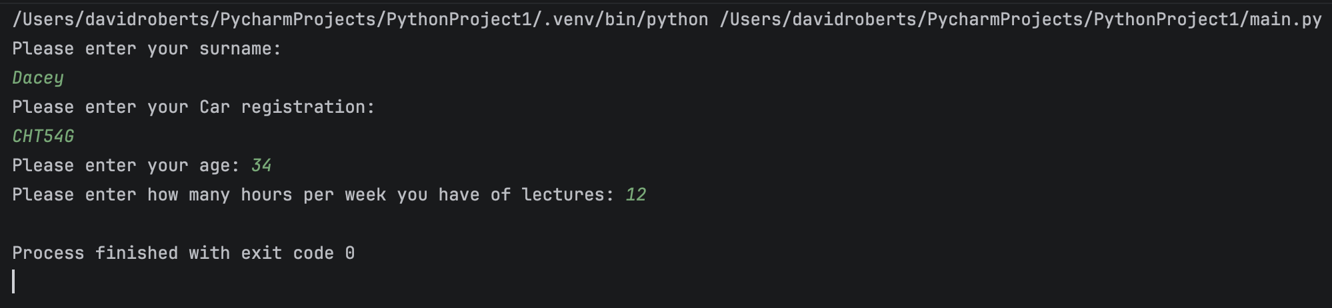
Result: Did the programme behave as expected ie syntactically and logically correct?
Yes, the program accepted the answer and finished.

Test:
Hours, 12.5
Screenshot(s) of output:
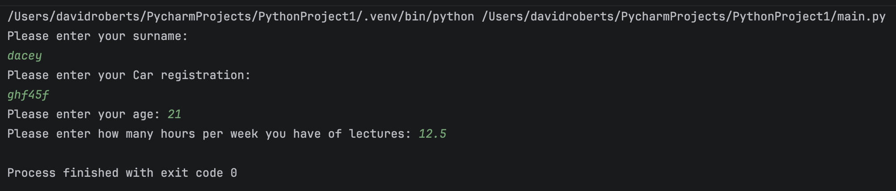
Result: Did the programme behave as expected ie syntactically and logically correct?
No, lectures are meant to be whole hours/numbers and therefore a decimal shouldn’t be accepted. Validation required.

Test:
Hours, -4
Screenshot(s) of output:
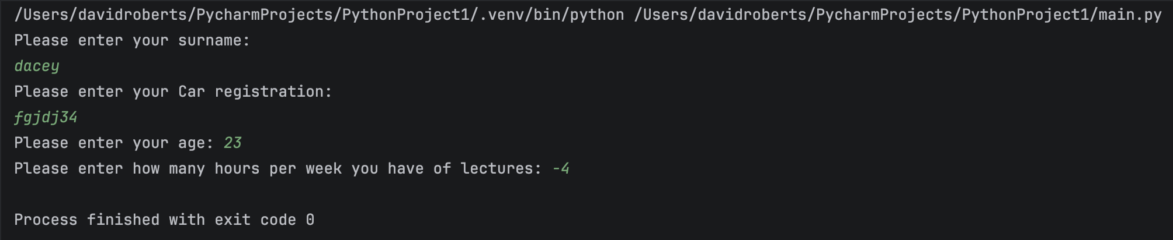
Result: Did the programme behave as expected ie syntactically and logically correct?
No, it is not possible to have -4 hours of lectures. Negative numbers should not be accepted. Validation required.

Test:
Hours, 150
Screenshot(s) of output:
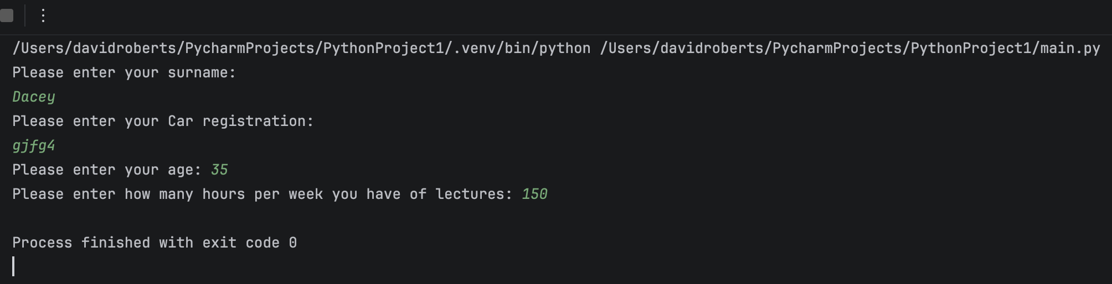
Result: Did the programme behave as expected ie syntactically and logically correct?
No, the program should not accept 150 as an answer as it is longer than the possible weekly hours of lectures. Validation needed.

- Consider the results of the above tests and revisit your original code in order to address any tests that failed. (Note: you may not be able to solve all of the problems that were encountered, but solve as many as you can.)

Paste your full revised code here :

[Copy and paste your full revised code here – note, do not use a screenshot]
while True:
surname = input("Please enter your surname: ")
if surname == "":
print("Surname cannot be empty. Try again. ")
elif any(char.isdigit() for char in surname):
print("Surname cannot contain numbers. Try again.")
else:
break
while True:
car_Reg = input("Please enter your car registration number: ")
if len(car_Reg) <= 7:
break
else:
print("Your car registration number must be 7 characters or fewer")
flag = 0
while flag == 0:
try:
userAge = int(input("Please enter your age: "))
except ValueError:
print("This is not a number, try again")
else:
if 0 < userAge <120:
flag = 1
else:
print("Your age must be between 1 and 119")
flag = 0
while flag == 0:
try:
lec_Hours = int(input("Please enter how many hours per week you have of lectures: "))
except ValueError:
print("This is not a valid number, try again")
else:
if 0 < lec_Hours <70:
flag = 1
else:
print("You must enter a number between 0 and 70")

