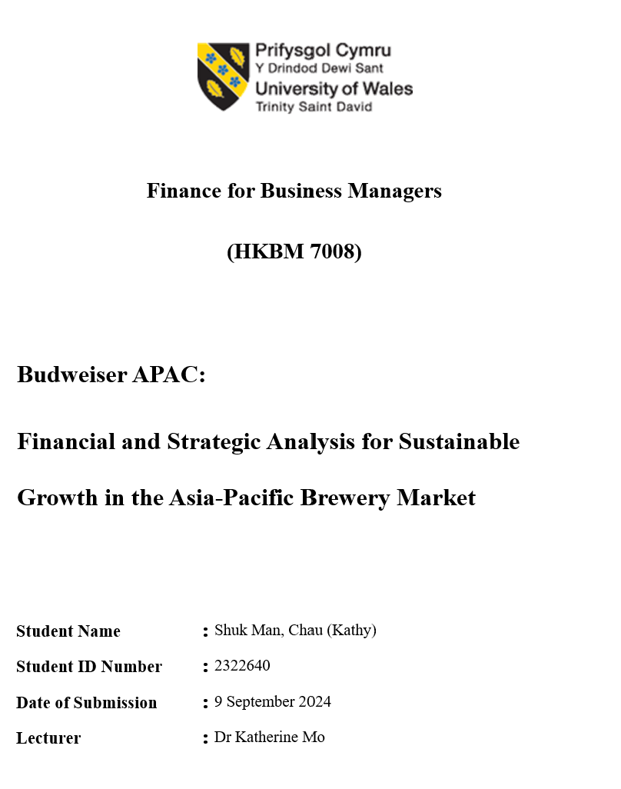

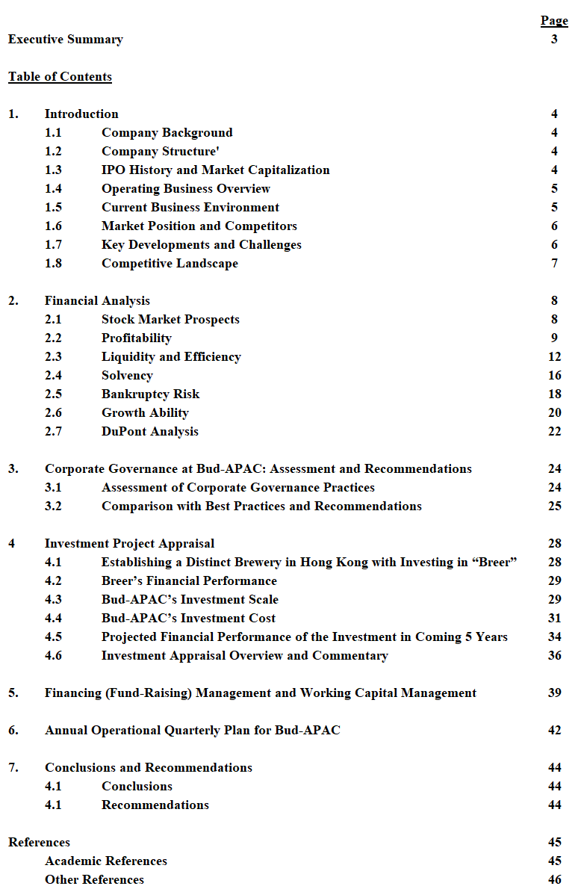
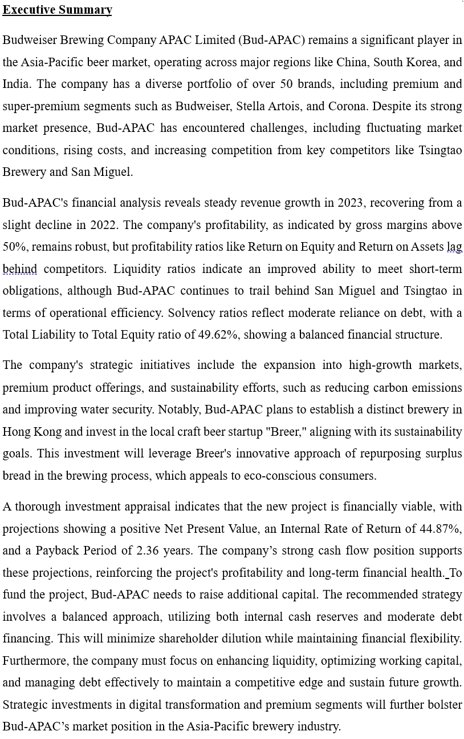
- Introduction
This section provides an overview of Budweiser Brewing Company APAC Limited ("Bud-APAC") and the key aspects of its operations, business environment, and market positioning, setting the foundation for the subsequent analysis.

  - Company Background
Bud-APAC is a leading brewery in the Asia-Pacific region and a subsidiary of Anheuser-Busch InBev. The company boasts a portfolio of over 50 brands, including Budweiser, Stella Artois, and Corona. Its operations primarily span China, South Korea, India, and other key Asian markets (Budweiser APAC Annual Report, 2023). Listed on the Hong Kong Stock Exchange (HKEX) under stock code 01876.HK in September 2019 (HKEX, 2024), Bud-APAC has focused on expanding its footprint by capitalizing on the growing demand for premium and super-premium beer segments in the region.

  - Company Structure
Bud-APAC’s governance framework follows the HKEX’s Corporate Governance Code, emphasising on transparency, risk management, and accountability (Bud-APAC, 2023). The company’s Board of Directors is comprised of both executive and non-executive directors, ensuring independent oversight. Several functional committees play a pivotal role in shaping the company’s governance framework, ensuring the alignment of strategic objectives with effective risk management and regulatory compliance (HKEX, 2024). Bud-APAC's organizational structure supports its operations across diverse markets, enabling localized decision-making while adhering to overarching corporate policies.

  - IPO History and Market Capitalization
Bud-APAC’s initial public offering (IPO) in September 2019 raised approximately HKD39.2 billion, marking one of the largest IPOs of the year (Kung, 2019). The company initially had a market capitalization of HKD545.5 billion, underscoring investor optimism. However, fluctuating market conditions have reduced its market value to HKD112.19 billion as of September 2024 (CompaniesMarketCap, 2024). This shift highlights the volatility in the global beer market, as Bud-APAC navigates rising costs and regulatory pressures.
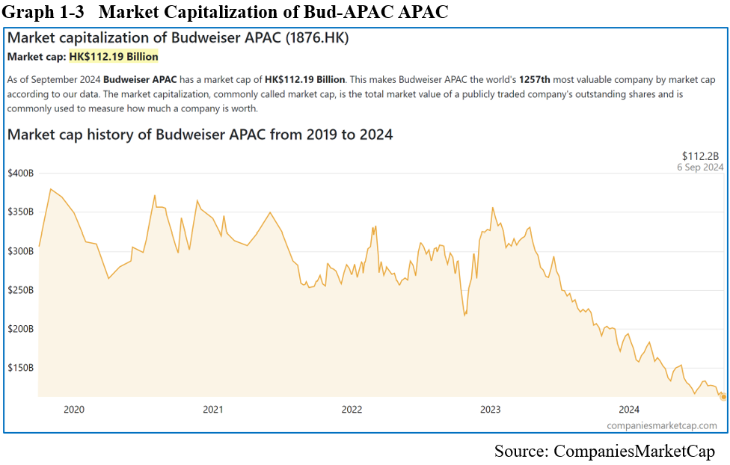

  - Operating Business Overview
Bud-APAC is engaged in beer manufacturing and distribution, serving a wide range of consumers with products categorized into premium, core-plus, core, and value beer segments (Bud-APAC, 2023). Premium brands like Budweiser and Stella Artois are vital to the company’s growth strategy, aligning with evolving consumer preferences for higher-quality beer. Bud-APAC's major markets are China, South Korea, and India, with China generating a substantial portion of its revenue (Bud-APAC, 2023). The company has also embraced digital transformation, partnering with platforms like "BEES" and investing in direct-to-consumer sales channels (McKee, 2023).

  - Current Business Environment
Bud-APAC operates in a dynamic and competitive environment marked by changing consumer preferences, economic factors, and regulatory challenges. In recent years, consumers have increasingly shifted toward premium beers, driven by higher disposable incomes and a desire for healthier lifestyles (Data Bridge, 2021). The company has faced regulatory scrutiny in areas such as alcohol advertising and environmental sustainability (Olajire, 2021), prompting it to adopt greener production methods, including carbon emissions reduction and water-saving technologies (Bud-APAC, 2023). Furthermore, digital transformation has reshaped consumer goods markets, with Bud-APAC enhancing its e-commerce presence and digital marketing strategies to capture younger consumers (Thackray & Piazza, 2024).

  - Market Position and Competitors
Bud-APAC faces fierce competition from regional players, most notably Tsingtao Brewery in China and San Miguel Brewery in the Philippines. While Tsingtao dominates the mass-market beer segment and is expanding into the premium space (Tsingtao Brewery, 2023), Bud-APAC differentiates itself by prioritizing premium and super-premium segments. In contrast, San Miguel holds a significant position in Southeast Asia's value beer market (San Miguel Brewery, 2023). Despite the competition, Bud-APAC maintains a strong foothold in the premium market, a lucrative segment that aligns with shifting consumer preferences.

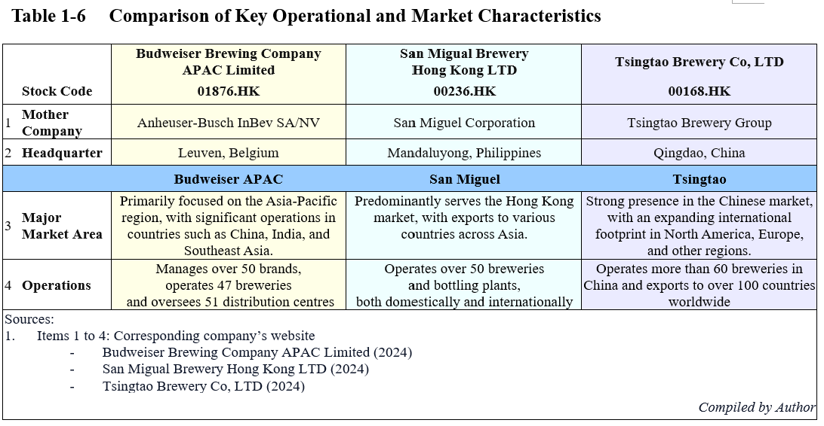

  - Key Developments and Challenges
Bud-APAC has committed to achieving net-zero carbon emissions by 2040, a key development in its sustainability strategy (Bud-APAC, 2023). However, rising operational costs and evolving regulations pose ongoing challenges for the company. Moreover, competition in the premium segment continues to intensify, requiring Bud-APAC to remain innovative and cost-efficient. Additionally, the shift toward digital and e-commerce channels offers both opportunities and challenges, as the company invests in technological advancements to keep pace with consumer expectations.

  - Competitive Landscape
Within the Asia-Pacific premium beer market, Bud-APAC competes primarily with Tsingtao Brewery (00168.HK) and San Miguel Brewery (00236.HK), both of which are key players in the region (UBS, 2023). Tsingtao is rapidly expanding its premium segment, while San Miguel dominates the value beer market in Southeast Asia. Despite differing strategies, Bud-APAC remains competitive due to its premium focus and well-established brand portfolio. A comprehensive financial analysis, which follows in Section 2, further evaluates Bud-APAC’s performance in comparison to these competitors.

- Financial Analysis
This section examines Bud-APAC's financial performance relative to competitors San Miguel and Tsingtao, focusing on key metrics like profitability, liquidity, efficiency, solvency, and growth potential over the past three years. A comparison of financial ratios and industry benchmarks highlights Bud-APAC’s strengths and areas for improvement.

  - Stock Market Prospects
Bud-APAC’s stock performance, assessed alongside competitors, indicates shifts in investor confidence.
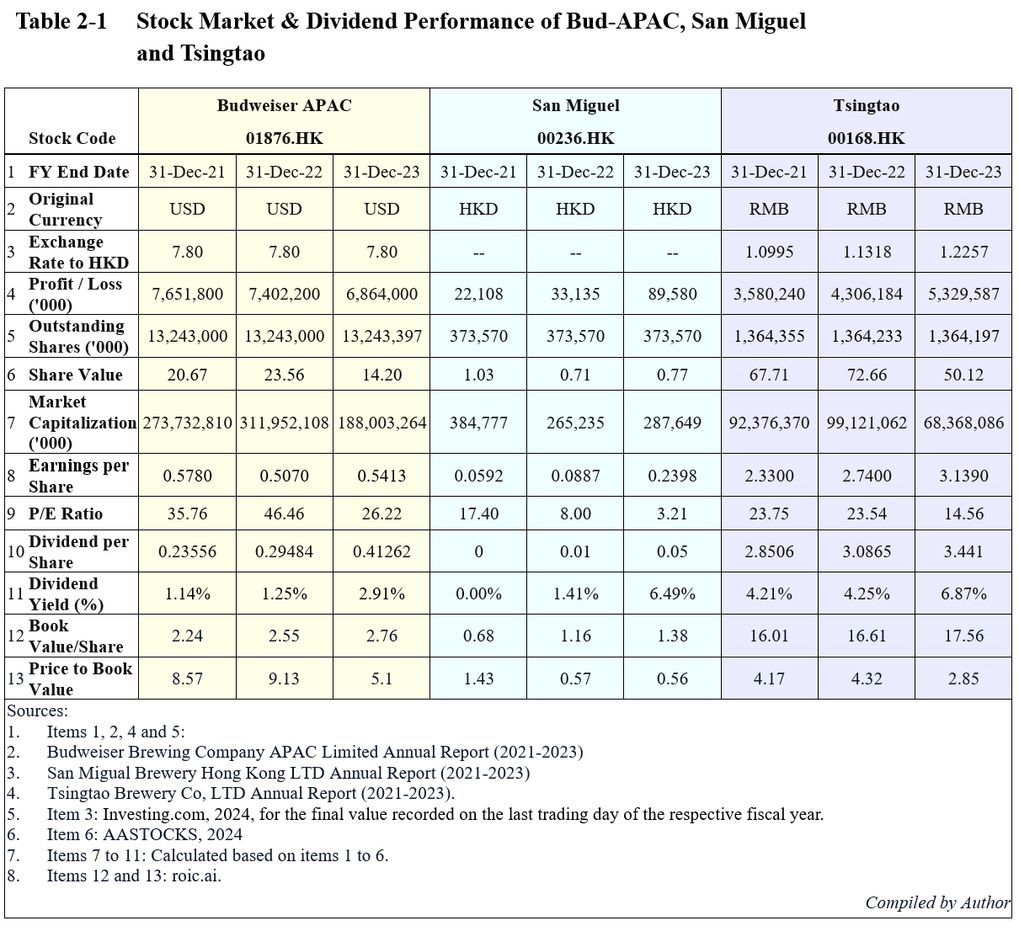

- Market Confidence
Bud-APAC shows consistent profitability but its P/E ratio declined in 2023, suggesting lower market confidence or an undervaluation. San Miguel's low P/E signals undervaluation, while Tsingtao maintains profitability with a moderate P/E.

- Dividend Yield
Bud-APAC’s 2023 dividend yield surged, making it appealing to income investors. San Miguel’s yield grew but remains below Tsingtao’s.

- Valuation
Bud-APAC has a high price-to-book ratio, indicating that investors are paying a premium for its assets. Tsingtao, in contrast, is closer to a balanced valuation with a strong book value, making it attractive for value-focused investors.

- Growth Outlook
Tsingtao seems to be the most consistent performer in terms of maintaining a steady growth trajectory, whereas Bud-APAC appears to be experiencing fluctuations in market capitalization.

In summary, Tsingtao shows consistent growth, San Miguel is undervalued, and Bud-APAC faces investor confidence challenges but offers potential as a dividend stock.

  - Profitability
This section analyzes Bud-APAC's profitability, comparing key earnings and margin ratios with key competitors.
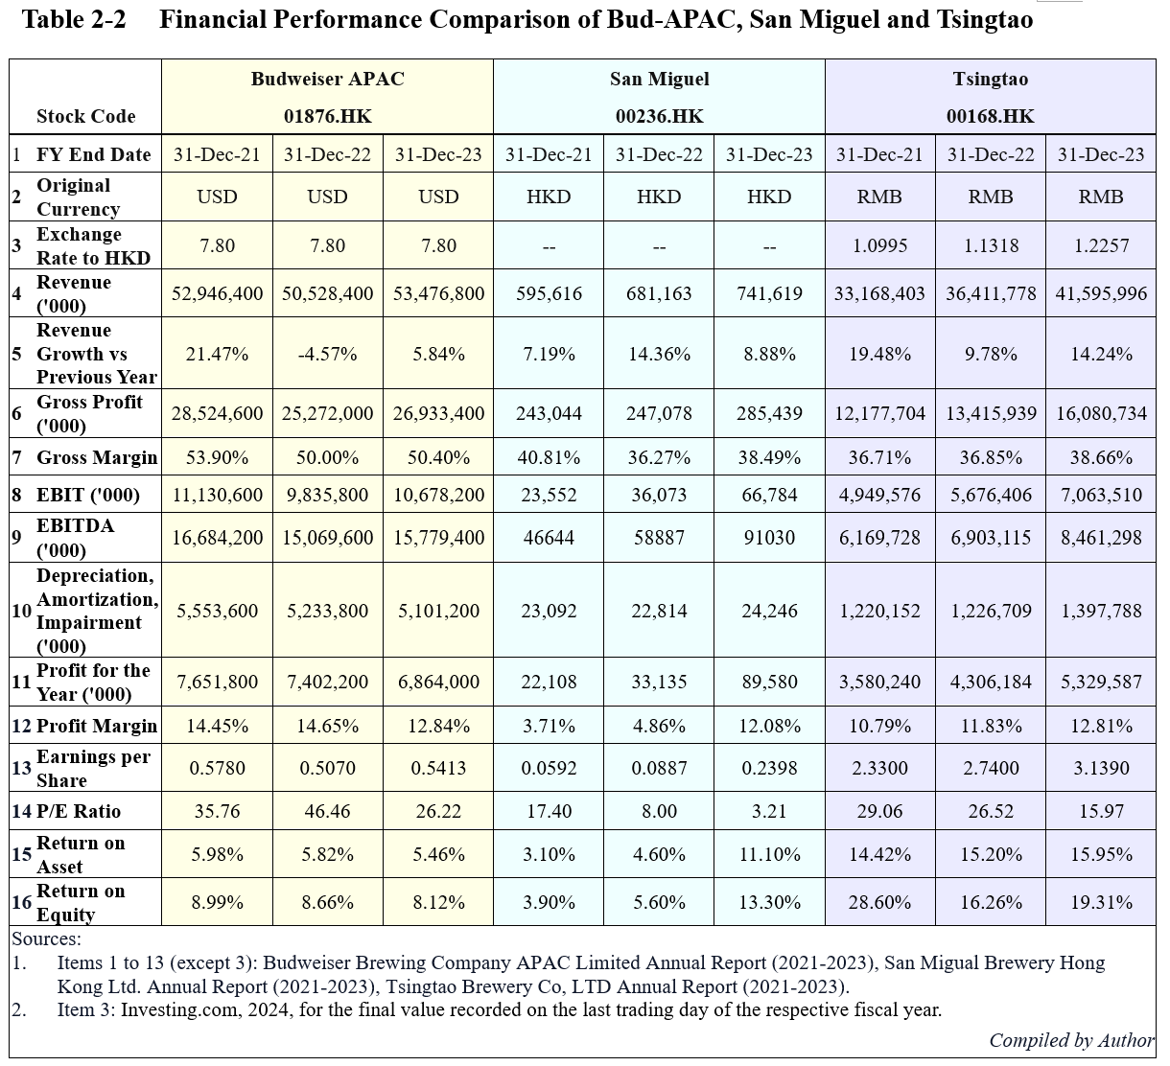
- Sales Revenue and Margins Comparison
Bud-APAC's revenue increased by 5.84% in 2023, following a 4.57% decline in 2022, yet remains below 2021 levels. Its gross margins, though above 50%, fell slightly from 53.90% in 2021, reflecting cost pressures. A solid gross margin is essential for long-term profitability (Brigham and Ehrhardt, 2021). Meanwhile, Bud-APAC’s profit margin dropped to 12.84%, in contrast to the steady profit growth of San Miguel and Tsingtao.

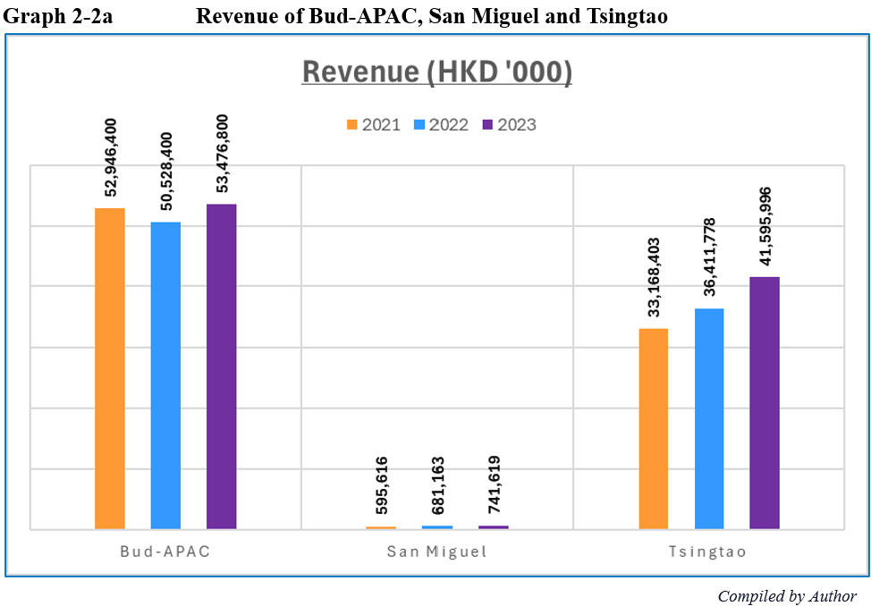
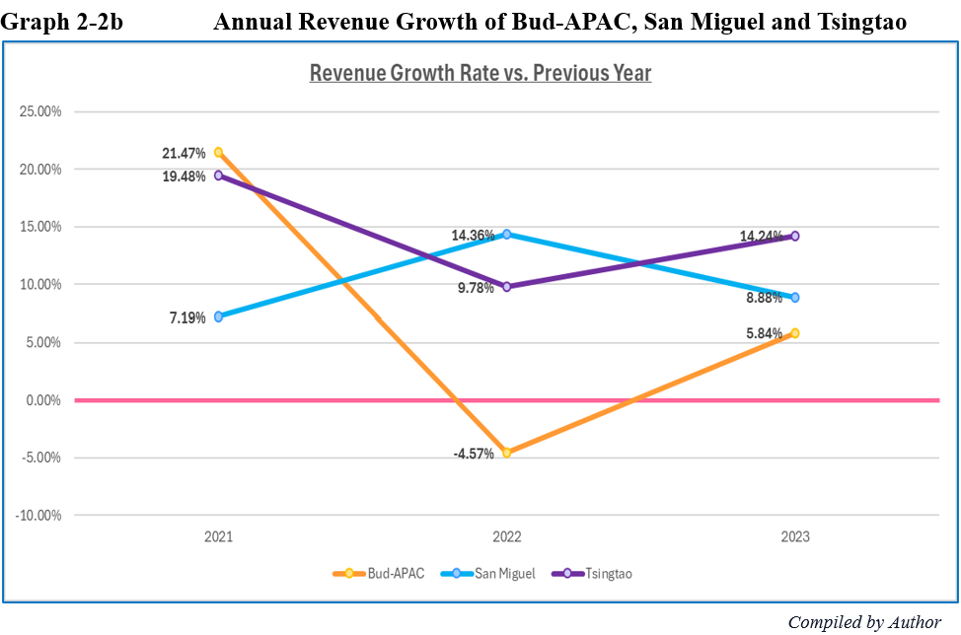
- P/E Ratio
Bud-APAC’s high P/E ratio of 26.22 suggests investor optimism, but it may signal overvaluation if earnings growth does not meet expectations (Ross et al., 2020). Tsingtao’s P/E of 15.97 and San Miguel’s 3.21 reflect more conservative valuations, especially given Tsingtao’s stronger revenue and profit growth. This disparity highlights differing market perceptions of future growth.

- ROA and ROE
Bud-APAC’s return on assets (ROA) in 2023 was 5.46%, trailing Tsingtao’s 15.95%, indicating that Tsingtao generates profit more effectively from its assets. Similarly, Bud-APAC’s return on equity (ROE) at 8.12% is below Tsingtao's 19.31%, signaling that Tsingtao creates more value for shareholders. Strong ROE is key for shareholder returns (Berk and DeMarzo, 2020), and Bud-APAC’s weaker performance suggests inefficiencies in capital utilization.

In conclusion, while Bud-APAC maintains solid margins, its financial performance lags behind competitors, requiring a focus on operational efficiency and cost management to improve profitability.

  - Liquidity and Efficiency
Liquidity and efficiency ratios are essential tools for assessing a company's financial health and operational performance. Liquidity ratios measure a company's ability to meet its short-term obligations (Brigham and Houston, 2019) while Efficiency ratios evaluate how effectively a company manages its assets (Brigham and Ehrhardt, 2017). Both sets of metrics offer a comprehensive view of a company's liquidity and efficiency, aiding investors and analysts in making informed decisions.
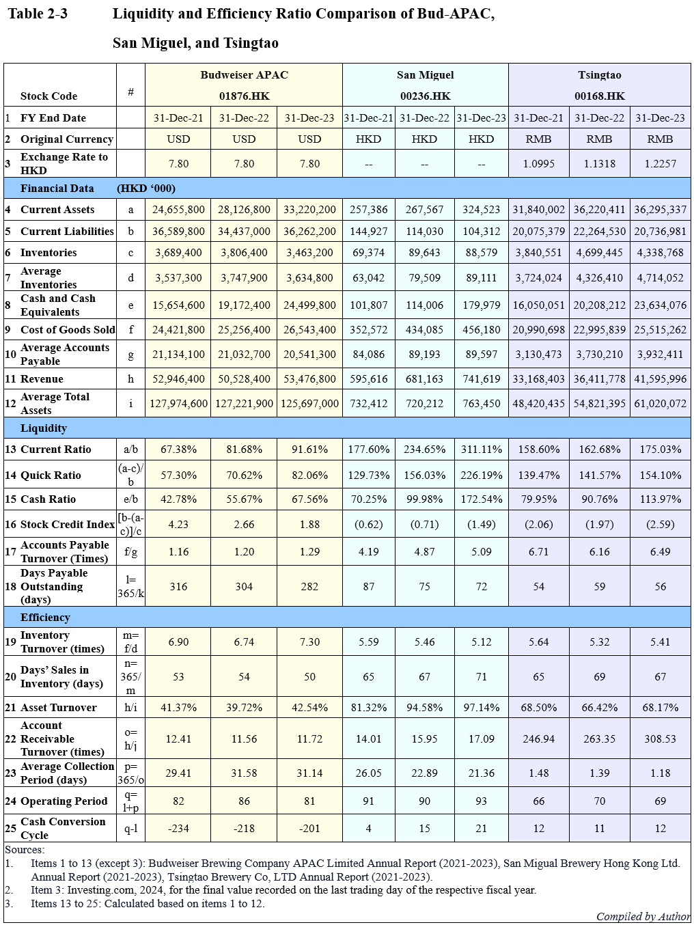

- Current Ratio
Bud-APAC’s current ratio rose from 67.38% in 2021 to 91.61% in 2023, indicating improved ability to meet short-term liabilities. San Miguel’s higher current ratio of 311.11% suggests excess liquidity, potentially signalling inefficiencies, while Tsingtao’s steady 175% reflects a more balanced approach to liquidity management (Brigham & Ehrhardt, 2020).

- Quick Ratio
Bud-APAC’s quick ratio improved to 82.06% in 2023, though it remains lower than San Miguel and Tsingtao, which suggests a stronger liquidity position. A high quick ratio indicates a company’s ability to meet short-term obligations without relying on inventories, crucial during economic uncertainty (Westerfield & Jaffe, 2016; Ross et al., 2021).

- Cash Ratio
Bud-APAC’s cash ratio increased to 67.56% by 2023, reflecting improved cash reserves, though it still trails Tsingtao’s 113.97% and San Miguel’s 172.54%. While higher cash reserves provide a buffer against short-term liabilities, excessive reserves can indicate inefficient resource allocation (Gitman & Zutter, 2015; Damodaran, 2021).

- Stock Credit Index
Bud-APAC’s declining index, from 4.23 to 1.88, reflects reduced liquidity buffers over time. San Miguel and Tsingtao show negative values, suggesting potential liquidity risks with liabilities exceeding current assets, even when inventories are included.

- Accounts Payable Turnover
Bud-APAC’s accounts payable turnover of 1.29 in 2023 indicates slower payments to suppliers compared to Tsingtao’s faster 6.49. While delayed payments may enhance liquidity, they risk supplier dissatisfaction (Higgins, 2016; Damodaran, 2021).

- Days Payable Outstanding (DPO)
Bud-APAC’s higher DPO suggests slower payments to suppliers, which can improve short-term liquidity but potentially strain vendor relationships. Tsingtao’s lower DPO indicates more efficient payment practices (Gitman & Zutter, 2021).

- Inventory Turnover
Bud-APAC’s improved inventory turnover ratio of 7.30 in 2023 indicates better stock management, compared to Tsingtao’s slower 5.41. Higher turnover is usually linked to better operational efficiency (Brigham & Ehrhardt, 2017; Ross et al., 2021).

- Days’ Sales in Inventory
Bud-APAC reduced its days’ sales in inventory from 53 to 50 days, suggesting faster inventory clearance, whereas Tsingtao’s increased to 67 days, signalling potential overstocking (Brigham & Ehrhardt, 2020).

- Asset Turnover
Bud-APAC’s asset turnover of 42.54% shows improved efficiency, though it still lags behind San Miguel’s 97.14% and Tsingtao’s 68.17%, indicating that competitors use their assets more efficiently to generate sales (Westerfield & Jaffe, 2016; Ross et al., 2021).

- Accounts Receivable Turnover
Bud-APAC’s lower accounts receivable turnover reflects slower collections compared to Tsingtao, which could impact liquidity and cash flow (Atrill & McLaney, 2021).

- Average Collection Period
Bud-APAC’s increasing collection period signals slower customer payments, extending its cash cycle and affecting liquidity, while Tsingtao’s shorter collection period indicates better cash conversion efficiency (Petersen & Rajan, 2017).

- Operating Period
Bud-APAC’s shorter operating period reflects faster inventory turnover and operational efficiency, though Tsingtao continues to lead in inventory management (Hillier et al., 2021). Effective inventory turnover directly supports liquidity (Gitman & Zutter, 2021).

- Cash Conversion Cycle
Bud-APAC’s negative CCC indicates that it receives payments from customers before paying suppliers, improving liquidity. However, this strategy should be carefully managed to avoid harming supplier relationships (Deloof, 2003; Lazaridis & Tryfonidis, 2006). In contrast, competitors with positive CCCs may need external funding to bridge their working capital needs (Deloof, 2003).

In conclusion, while Bud-APAC has made strides in improving liquidity and operational efficiency, it still lags behind competitors like Tsingtao and San Miguel in key areas. Continued focus on asset utilization and efficient cash management will be essential to maintain competitiveness.

  - Solvency
Solvency measures a company’s ability to meet long-term financial obligations, ensuring its assets exceed liabilities for sustained operations (Scherer & Stahl, 2021). It is a critical measure of financial health, indicating whether a company’s assets exceed its liabilities.
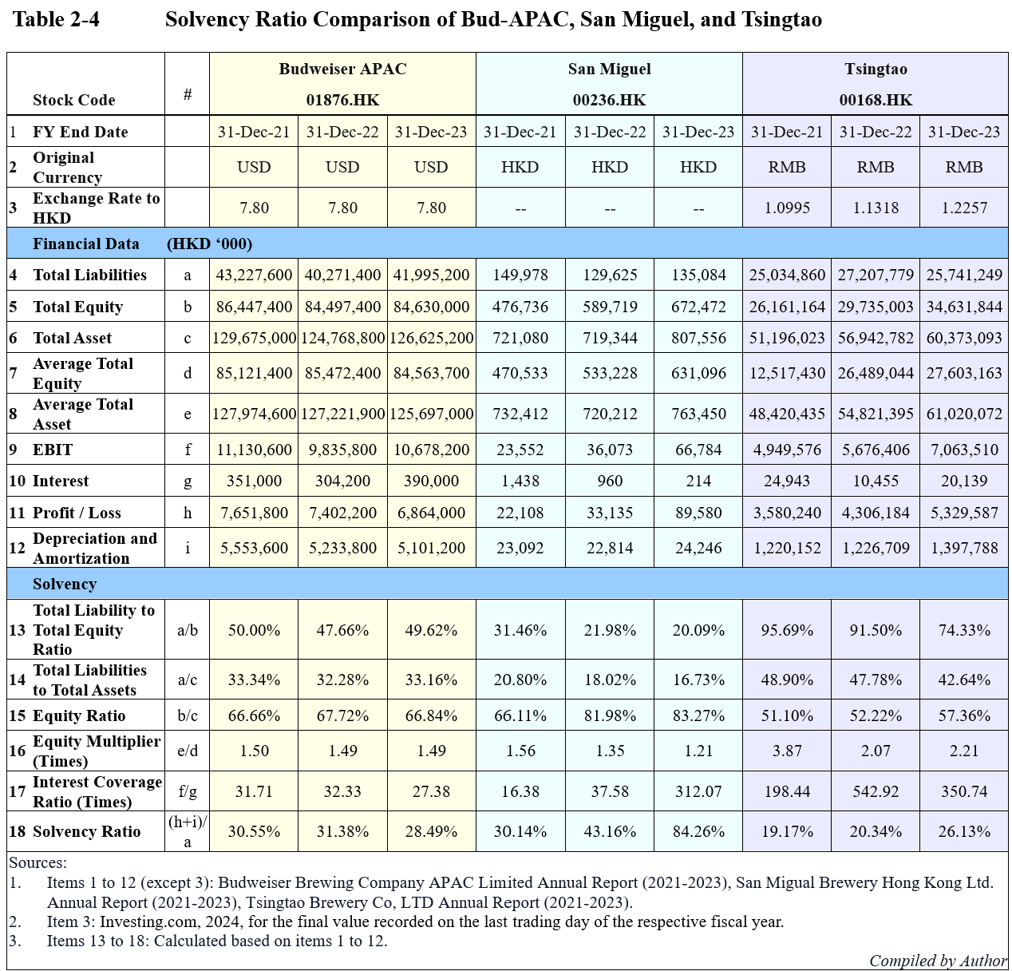

- Total Liability to Total Equity Ratio
Bud-APAC’s 2023 ratio of 49.62% shows a balanced but relatively high reliance on debt compared to equity. San Miguel’s lower ratio of 20.09% reflects a more conservative financial approach, while Tsingtao’s 74.33% indicates higher leverage and risk (Hillier et al., 2020).

- Total Liability to Total Asset Ratio
Bud-APAC’s 33.16% shows strong financial health with low debt reliance, while San Miguel’s 16.73% is even more conservative. Tsingtao’s 42.64% suggests greater debt use, signalling higher financial risk (Brealey et al., 2018).
- Equity Ratio
Bud-APAC’s 66.84% equity ratio in 2023 highlights a strong financial structure, with equity as the main funding source. San Miguel’s 83.27% reflects an even lower risk profile, while Tsingtao’s 57.36% shows a higher reliance on debt (Megginson, Smart, & Graham, 2010).

- Equity Multiplier
Bud-APAC’s equity multiplier of 1.49 shows moderate leverage, indicating assets are mostly funded by equity. San Miguel’s 1.21 shows minimal debt use, while Tsingtao’s 2.21 indicates higher leverage and risk (Bodie et al., 2019).

- Interest Coverage Ratio
Bud-APAC’s ratio of 27.38 in 2023 suggests a healthy ability to cover interest payments, though Tsingtao’s 350.74 and San Miguel’s 312.07 indicate even stronger positions (Hillier et al., 2020).

- Solvency Ratio
The solvency ratio, which compares a company’s net income plus depreciation to total liabilities, reveals its ability to meet long-term obligations. Bud-APAC’s 28.49% solvency ratio reflects moderate long-term financial health, while San Miguel’s 84.26% demonstrates superior solvency. Tsingtao’s 26.13% indicates slightly weaker solvency (Berk & DeMarzo, 2020).

This analysis underscores Bud-APAC’s moderate solvency, comparing it with the stronger financial positions of San Miguel and Tsingtao.

  - Bankruptcy Risk
Bankruptcy risk refers to the likelihood that a company will be unable to meet its financial obligations, potentially leading to insolvency. The Altman Z-score introduced in 1968 (Altman, 1968) is a key tool for assessing this risk, combining various financial ratios to predict a firm's financial health (Altman & Hotchkiss, 2010). A Z-score above 3 suggests a low risk of bankruptcy, making it particularly useful in industries like brewing, where financial stability can fluctuate due to capital expenditures and competition (Brown & Taylor, 2022).
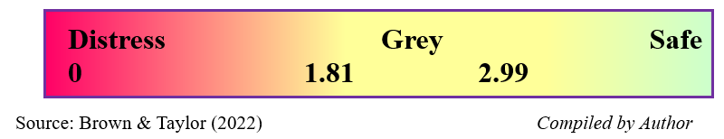
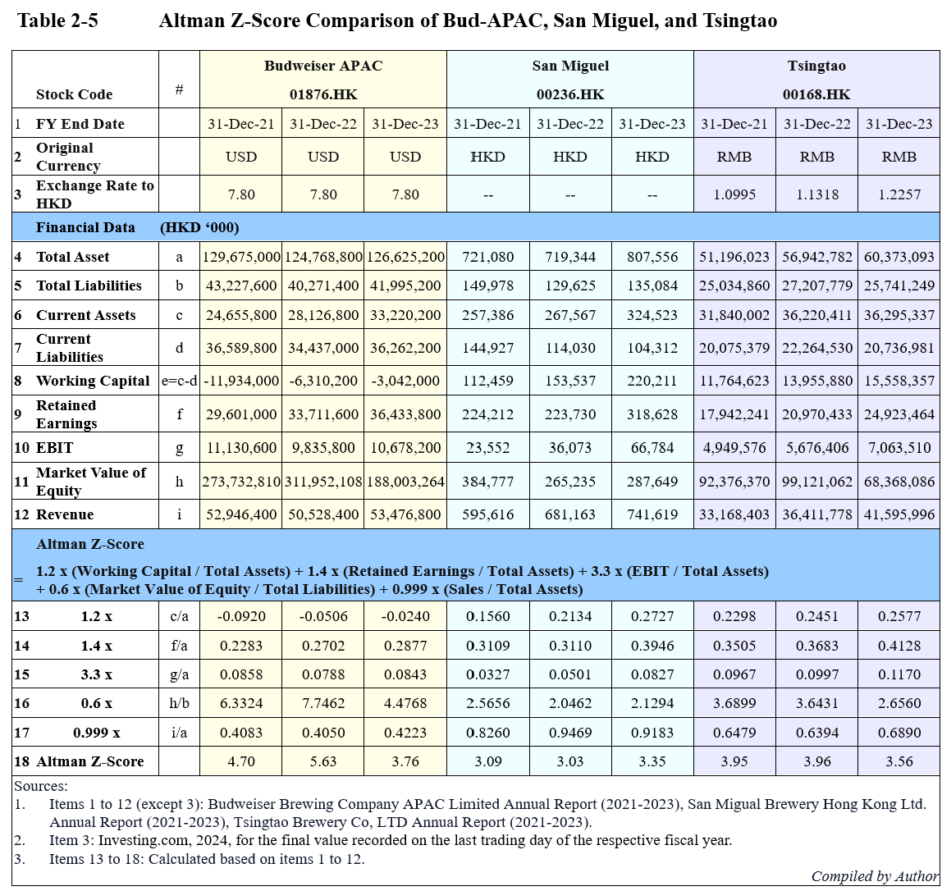

In 2023, Bud-APAC’s Z-Score of 3.76 places it in the safe zone, indicating strong financial health and low bankruptcy risk. This is supported by its high equity ratio and stable EBIT/Total Assets. San Miguel’s Z-Score of 3.35, though also in the safe zone, reflects its higher debt reliance, making it more vulnerable to market changes. Tsingtao’s Z-Score of 3.56 shows a similarly low risk, with strong retained earnings and stable working capital performance contributing to its long-term sustainability.
Overall, Bud-APAC, San Miguel, and Tsingtao all demonstrate moderate to low bankruptcy risk, supported by their operational performance and robust equity positions.
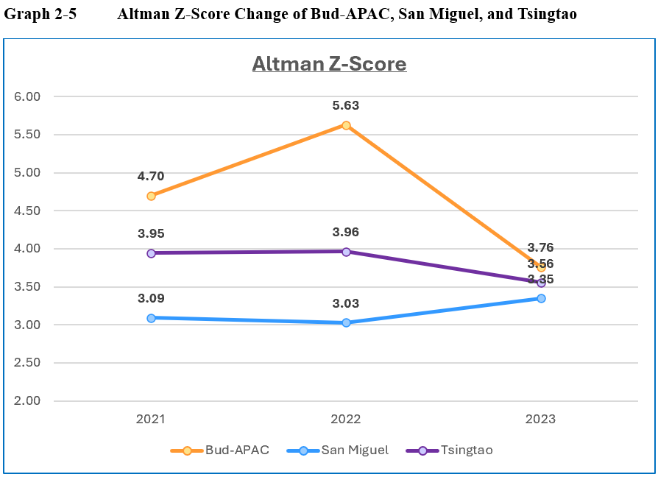

  - Growth Ability
Growth ability reflects a company's capacity to expand operations, increase revenue, and improve profitability through organic growth or reinvestment of retained earnings (Helfert, 2001).
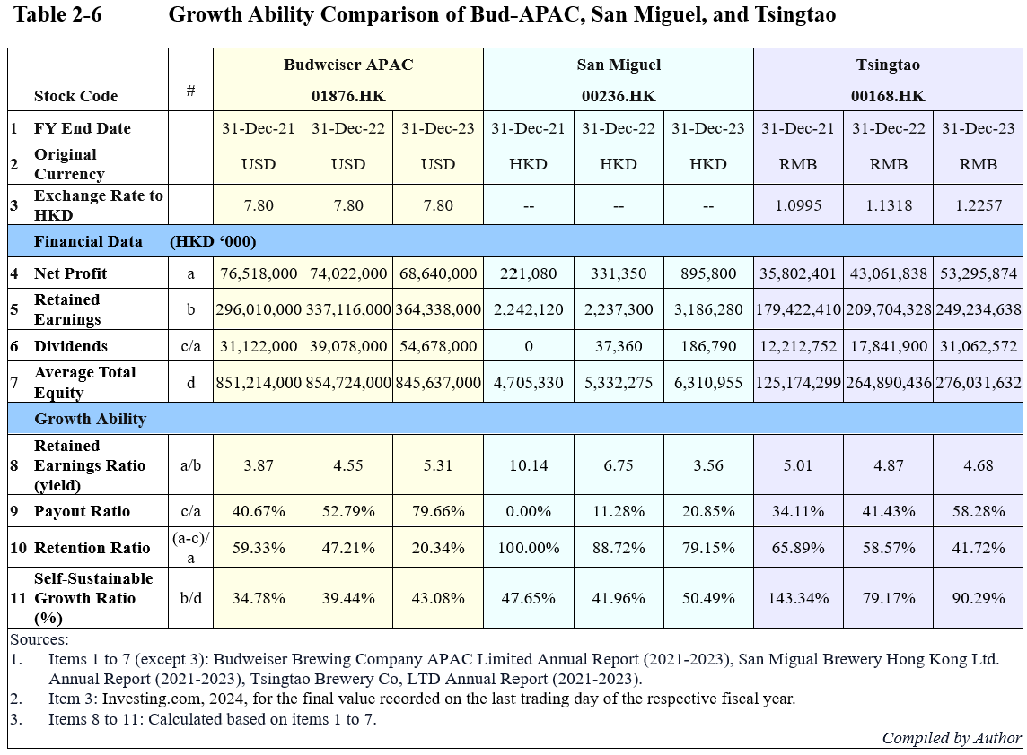

- Retained Earnings Ratio
Bud-APAC’s retained earnings ratio rose from 3.87 in 2021 to 5.31 in 2023, indicating an accumulation of earnings for reinvestment. San Miguel’s ratio fluctuated, peaking at 10.14 in 2021 but falling significantly by 2023. Tsingtao’s ratio remained relatively stable. Bud-APAC’s rising retained earnings suggest potential for reinvesting in growth opportunities (Atrill, 2021).

- Payout Ratio
Bud-APAC’s payout ratio jumped from 40.67% in 2021 to 79.66% in 2023, indicating an increased focus on dividend distribution. Similarly, Tsingtao's payout ratio has grown, while San Miguel consistently maintained lower payout ratios, distributing no dividends in 2021. High payout ratios may limit a company’s ability to reinvest, hindering future growth potential (Penman, 2021).

- Retention Ratio
Bud-APAC’s retention ratio declined sharply from 59.33% in 2021 to 20.34% in 2023, reflecting a shift toward profit distribution rather than reinvestment. Tsingtao showed a similar decline, while San Miguel maintained a higher retention ratio, signaling a stronger focus on growth (Brigham & Ehrhardt, 2021).

- Self-Sustainable Growth Ratio
Bud-APAC’s self-sustainable growth ratio increased from 34.78% in 2021 to 43.08% in 2023, indicating improved capacity for growth without external financing. Tsingtao led with the highest self-sustainable growth, while San Miguel showed volatility but improvement. Bud-APAC’s rising ratio is promising, but its declining retention may limit future organic growth without external funding (Ross, Westerfield, & Jordan, 2021).

In summary, Bud-APAC shows growth potential, but increasing dividend payouts and lower retained earnings could restrict long-term growth unless supported by external financing. (Ross, Westerfield, & Jordan, 2021).

  - DuPont Analysis
The DuPont Analysis is a framework used to assess the key drivers of Return on Equity (ROE) by breaking it down into three components: profit margin, asset turnover, and equity multiplier. It offers a more detailed perspective on the financial performance of a company, helping to identify the strengths and weaknesses that contribute to overall profitability (Bodie, Kane, & Marcus, 2021). The DuPont analysis for Bud-APAC and its competitors can be found in Table 2-7 and illustrated in Graph 2-7.

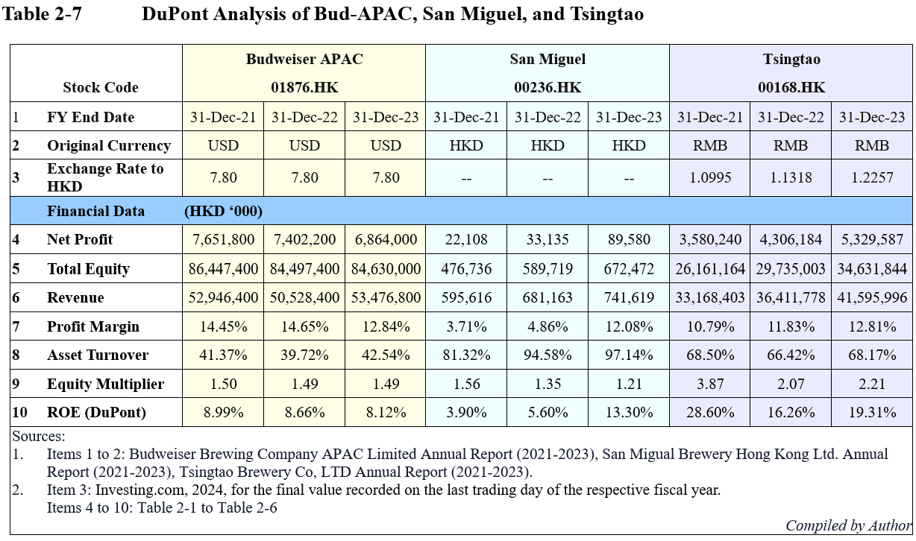
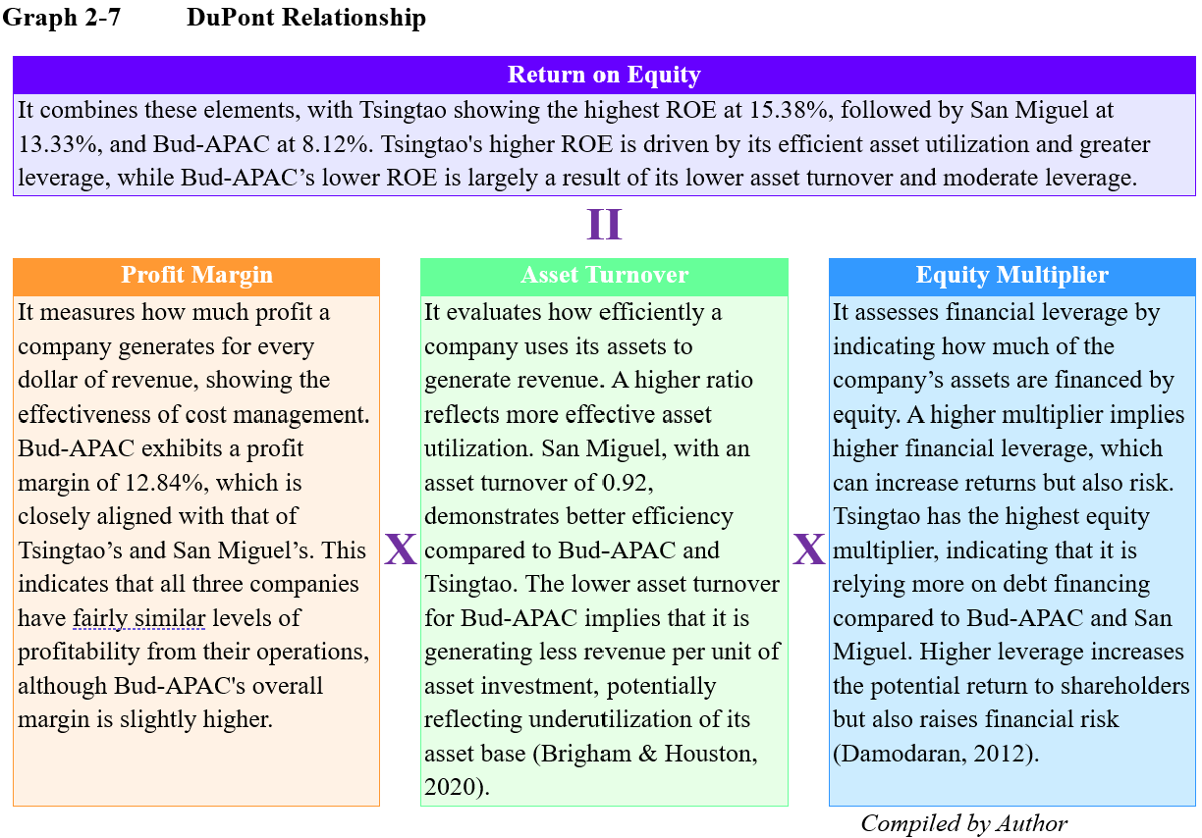

- Corporate Governance at Bud-APAC: Assessment and Recommendations
Bud-APAC has demonstrated a strong commitment to corporate governance, as evidenced by its recognition in the 2023 Corporate Governance and Environmental, Social, and Governance (ESG) Awards by the Hong Kong Corporate Governance Excellence Awards. The company won both the Awards of Excellence in Corporate Governance and the Awards of Excellence in ESG, highlighting its dedication to transparency, accountability, and sustainable business practices (Corporate Governance & ESG Awards, 2023)

  - Assessment of Corporate Governance Practices
The assessment is done based on the following dimensions:

- Compliance with HKEX Corporate Governance Code
Bud-APAC's corporate governance framework aligns with the principles set out in the Hong Kong Stock Exchange (HKEX) Corporate Governance Code (HKEX, 2023). The company's 2023 Annual Report states that it has complied with all applicable code provisions throughout the reporting period (Bud-APAC Annual Report, 2023, p. 23).

- Board Composition and Diversity
The Board of Directors comprises seven members: one Executive Director and six Non-executive Directors, of whom three are Independent Non-executive Directors (INEDs), accounting for over one-third of the Board (Bud-APAC Annual Report, 2023, p. 27). The Board Diversity Policy emphasizes a balance of skills, experience, and diversity of perspectives (Bud-APAC Annual Report, 2023, p. 33).

- Board Committees and Management-Level Committees
The Board delegates authority and functions to the Board Committees and other management-level committees as appropriate to effectively manage and carry out the Group’s daily business operations as shown in Figure 3-1.

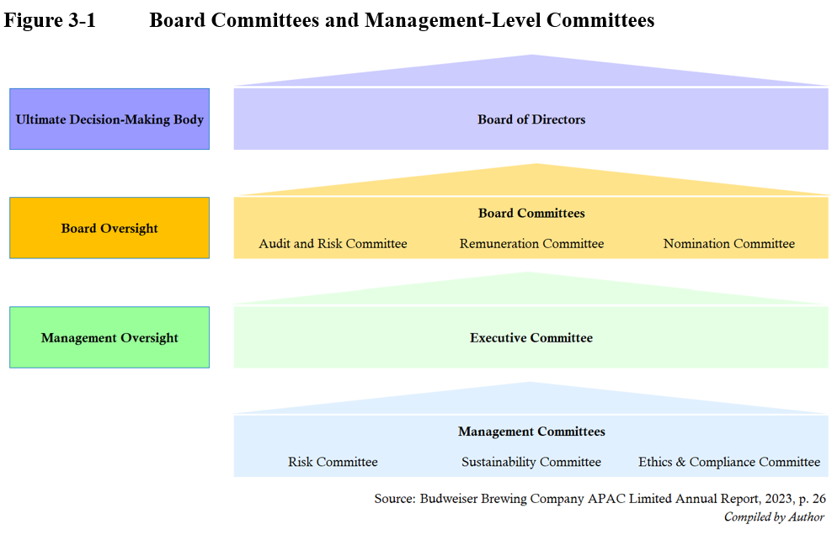
- Internal Control System and Risk Management
Bud-APAC has established an internal control system and risk management framework overseen by the Audit and Risk Committee (Bud-APAC Annual Report, 2023, p. 25). The company conducts regular reviews of the effectiveness of its risk management and internal control systems in compliance with the HKEX Corporate Governance Code (Bud-APAC Annual Report, 2023, p. 54).

- ESG Initiatives
The company has made significant progress towards its 2025 Sustainability Goals, with initiatives in climate action, water stewardship, circular packaging, and sustainable agriculture (Bud-APAC Annual Report, 2023, p. 19). Bud-APAC has received an 'A-' rating in Climate Change and an 'A' rating in Water Security from CDP, reflecting its commitment to environmental sustainability (Bud-APAC Annual Report, 2023, p. 19).

  - Comparison with Best Practices and Recommendations
While Bud-APAC has robust corporate governance practices, comparing them with best practices from industry leaders and academic insights can identify areas for further enhancement. Further details are provided in Table 3-2.
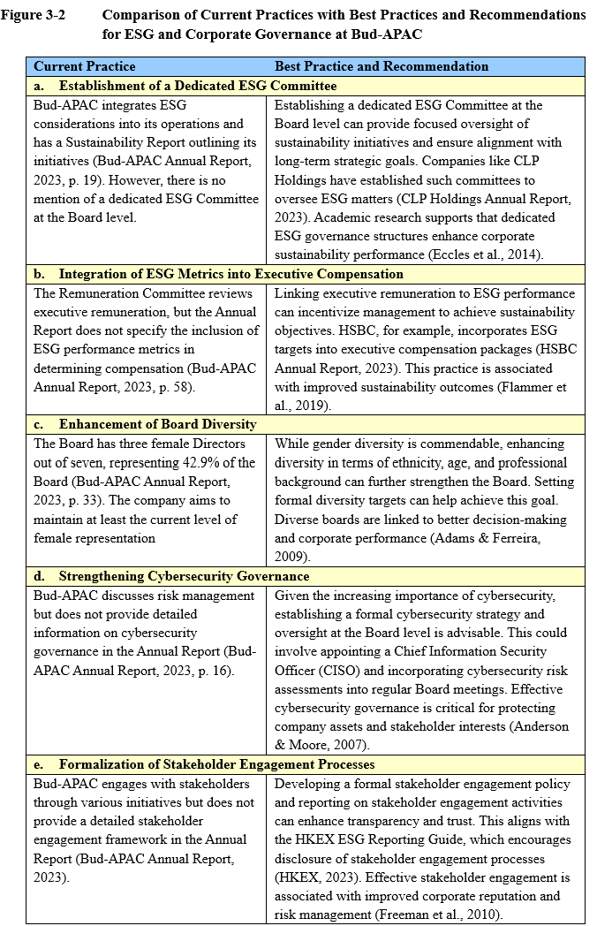

Bud-APAC has established strong corporate governance practices, complying with HKEX guidelines and receiving industry recognition. By implementing the above recommendations, the company can further enhance its governance framework, aligning with best practices and academic insights to support sustainable growth and long-term value creation.

- Investment Project Appraisal
This section will present a potential investment project to Bud-APAC and conduct an appraisal process to evaluate its feasibility. The investment for this project should not exceed 5% of the sales revenue for the fiscal year 2023, which amounts to USD6,856 million. Using an exchange rate of 7.8 HKD to 1 USD, the budget is estimated at approximately HKD 2,673.84 million.

  - Establishing a Distinct Brewery in Hong Kong with Investing in “Breer”
San Miguel’s success as the only international brand with a brewery in Hong Kong highlights the benefits of local production. Bud-APAC can strengthen its presence by establishing its own brewery, enhancing product freshness and catering to local preferences. Additionally, Bud-APAC can further differentiate itself by investing in the local craft beer startup, “Breer”. This investment aligns with sustainability efforts, as Breer repurposes surplus bread, reducing waste and appealing to eco-conscious consumers.

Beer traditionally comprises malted barley, hops, yeast, and water (American Homebrewers Association, 2024). Breer innovatively replaces malted barley with surplus bread, provided at No COST (Nowakowski, 2024). Though Breer has not yet secured external funding, it has raised over HKD7 million through competitions without sacrificing equity (Vlight, 2024). Despite limited public financial data due to its private status, the investment in Breer aligns with Bud-APAC’s sustainability goals and offers potential for positive returns based on public interviews with its cofounder (Jacob, 2023).

This dual approach strengthens Bud-APAC’s market position and brand image in Hong Kong.
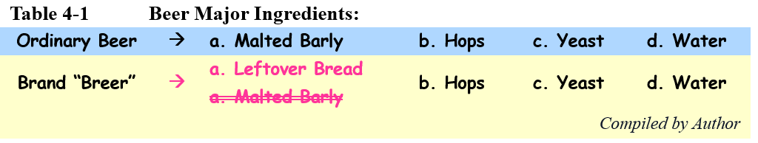

  - Breer’s Financial Performance
Founded in 2021, Breer achieved a total revenue of HK$2.5 million during its initial two years. Notably, in 2023, the company’s revenue surged to HK$1.8 million (Jacob, 2023). Based on this limited data and assuming consistent growth rates and profit margins, we can refer to the projection in Table 4-2. The table illustrates a high profit margin, implying that the investment is worthwhile for Bud-APAC to explore further.
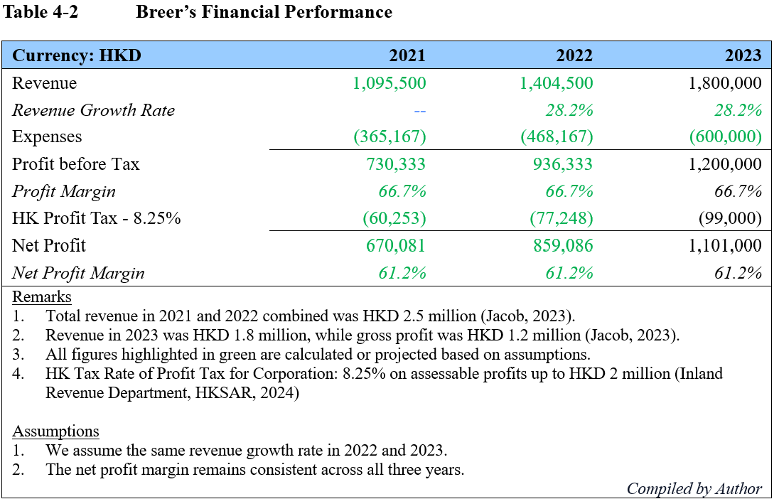

  - Bud-APAC’s Investment Scale
In determining Bud-APAC’s investment scale, the operational scale of San Miguel’s brewery in Hong Kong and Breer’s current operations provide valuable benchmarks.

San Miguel's Yuen Long facility, with a daily production capacity of 1.2 million cans (EDigest, 2018), serves as a reference for Bud-APAC if it chooses to establish its own brewery. However, Breer, a craft beer with distinctive flavours, does not require the same large-scale production as mass-produced beer. Bud-APAC could aim for an initial production target of 600,000 cans per day, about half of San Miguel’s output, allowing for flexibility while maintaining quality.

Breer currently operates on a smaller scale, producing up to 60,000 liters annually through contract breweries, using surplus bread from local restaurants and bakeries (C, 2023). Given a standard can holds 330ml, Bud-APAC’s target production scale is approximately 1,200 times that of Breer’s current output. This calculation informs the initial investment scale and allows for future expansion based on demand and market conditions.
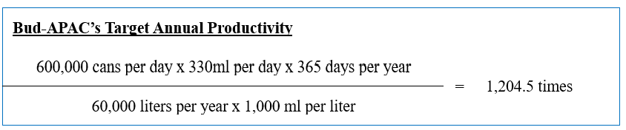

The investment scale of 1,200 times Breer’s current production is detailed in Table 4-3. This initial production projection is based on the assumption that Bud-APAC adopts Breer's business model of operating without its own brewery. A more detailed projection that includes the establishment of Bud-APAC’s own production facility is presented in the forthcoming Section 4.5.

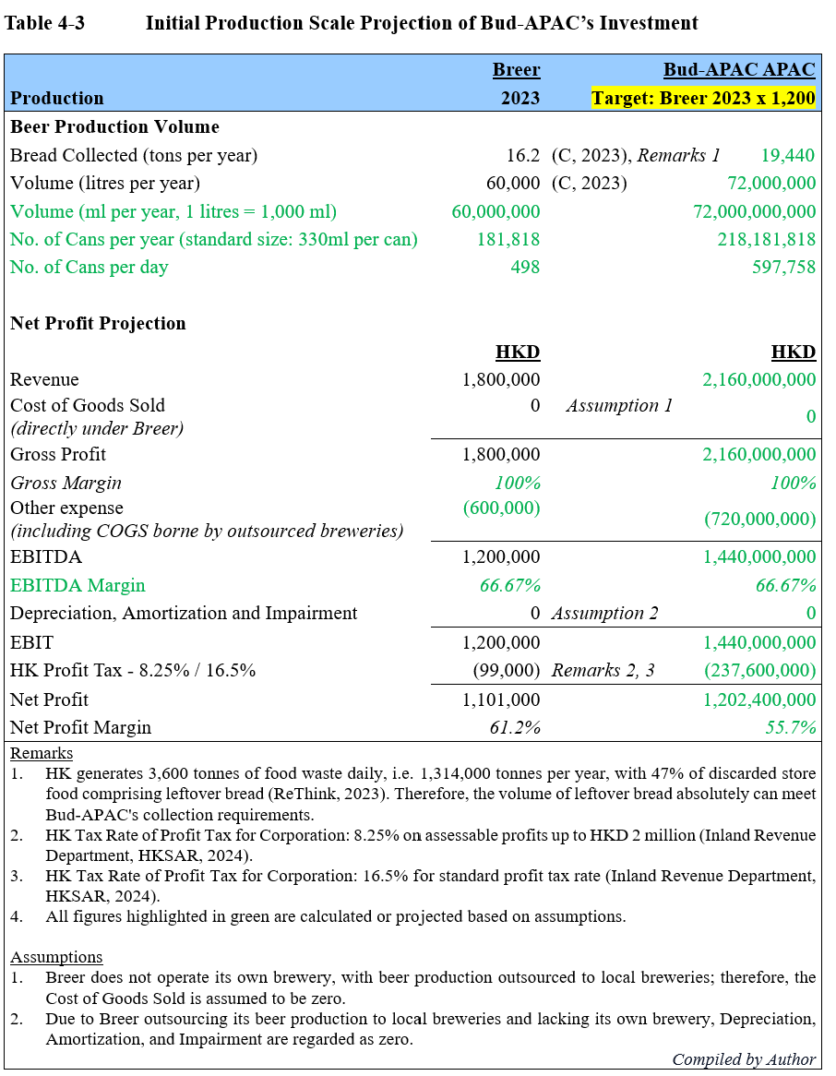

  - Bud-APAC’s Investment Cost
Bud-APAC’s plan to establish its own plant for the “Bread to Beer” initiative takes inspiration from San Miguel, the only international brewing company with a large-scale production brewery in Hong Kong. San Miguel’s Yuen Long plant, spanning 400,000 square feet, was built in 1996 with an investment of HKD1.3 billion for construction, machinery, and equipment (EDigest, 2018). Using this as a benchmark, Bud-APAC’s investment cost will be broken down into two main components: land acquisition and construction, including machinery and equipment.

- Land
With an initial production scale at half of San Miguel’s plant and an anticipated annual growth rate of 5.84% over the next four years to reach maximum capacity, Bud-APAC’s new facility will require 250,000 square feet of land.
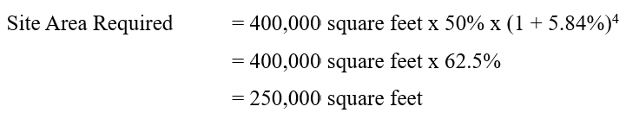

In January 2024, the Hong Kong Special Administrative Region (HKSAR) Government announced an industrial park site in Yuen Long, with an estimated price of HKD 2,500 per square foot, totalling HKD625 million for Bud-APAC’s land acquisition (Qi, 2024).

- Construction, Machinery and Equipment
San Miguel’s capital expenditure, adjusted for inflation (see Graph 4-4) and Bud-APAC’s investment scale, along with the anticipated growth, serve as key references for Bud-APAC’s project. The projected cost for construction, including machinery and equipment, is approximately HKD1,272.01 million, assuming the investment commences in 2025. Since Bud-APAC’s 2023 Annual Report does not specify asset allocation, San Miguel’s cost distribution from its 2023 Annual Report has been used to estimate the breakdown, detailed in Table 4-4.
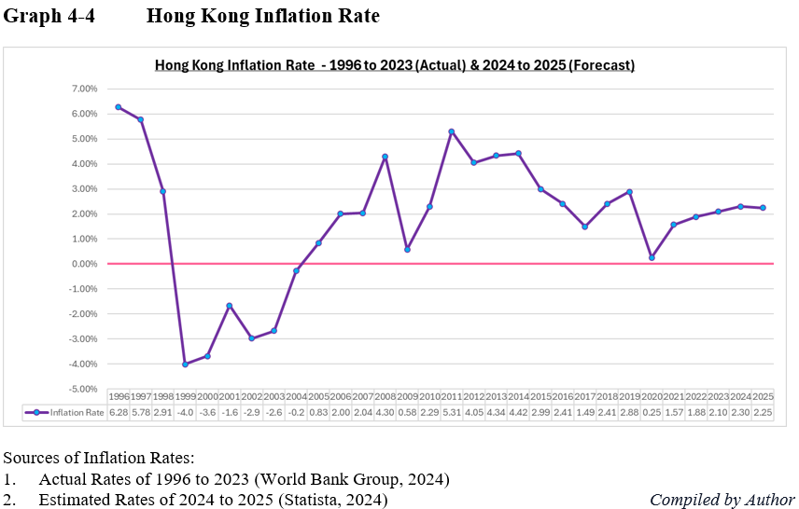

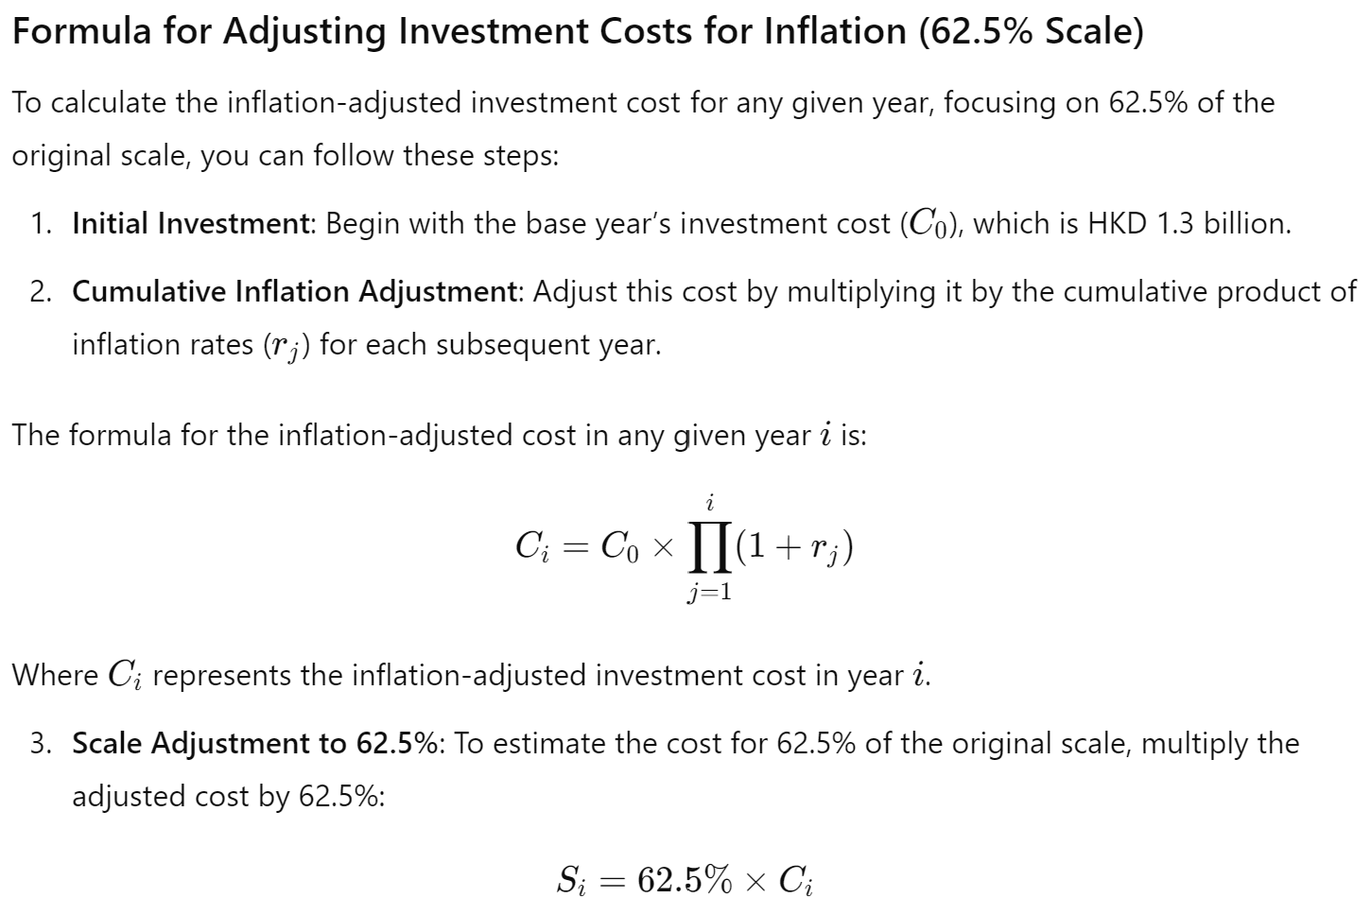
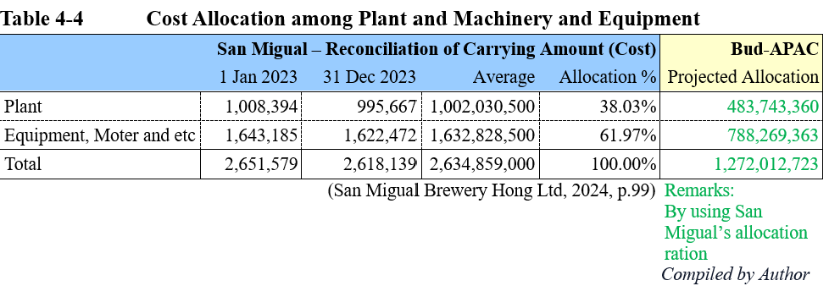

- Total Investment Cost
The total estimated investment for Bud-APAC’s project is HKD1,897.01 million, which includes HKD625 million for land and HKD1,272.01 million for construction, machinery, and equipment. This represents about 70.95% of the total budget of HKD2,673.84 million. As the estimated cost falls within the allocated budget, the investment appraisal process can proceed.

  - Projected Financial Performance of the Investment in Coming 5 Years
This section will forecast the financial performance of the investment plan over the next five years.

- Business Model Framework
Bud-APAC’s business model will differ from Breer's, as it plans to establish its own brewery rather than relying on third-party production. Future growth will be projected based on Bud-APAC’s 2023 revenue growth rate of 5.84%, rather than Breer’s rapid first-year expansion. Since Breer is not publicly listed, it is assumed that the net profit shown in Table 4-2 represents the cofounder’s earnings. To foster collaboration, Bud-APAC will offer 5% of its revenue, nearly 100 times the cofounder’s current earnings, as a licensing fee and remuneration, inviting the cofounder to serve as Project Director.

Additionally, given the larger scale of Bud-APAC’s operations compared to Breer's, increased Marketing and Promotion expenses, projected at 17.52% of revenue, will be required to drive growth, aligning with Bud-APAC’s 2023 marketing expense ratio. To strengthen corporate social responsibility, Bud-APAC will also donate 5% of its EBIT on behalf of bread donors, as the surplus bread used in production is collected at no cost.

- Net Profit Projections
According to Table 4-5a, the investment plan's projected net profit margins are approximately 32% over the next five years, significantly higher than Bud-APAC’s recent margins, which were below 20%. This highlights the strong potential profitability of the new business model and investment strategy.

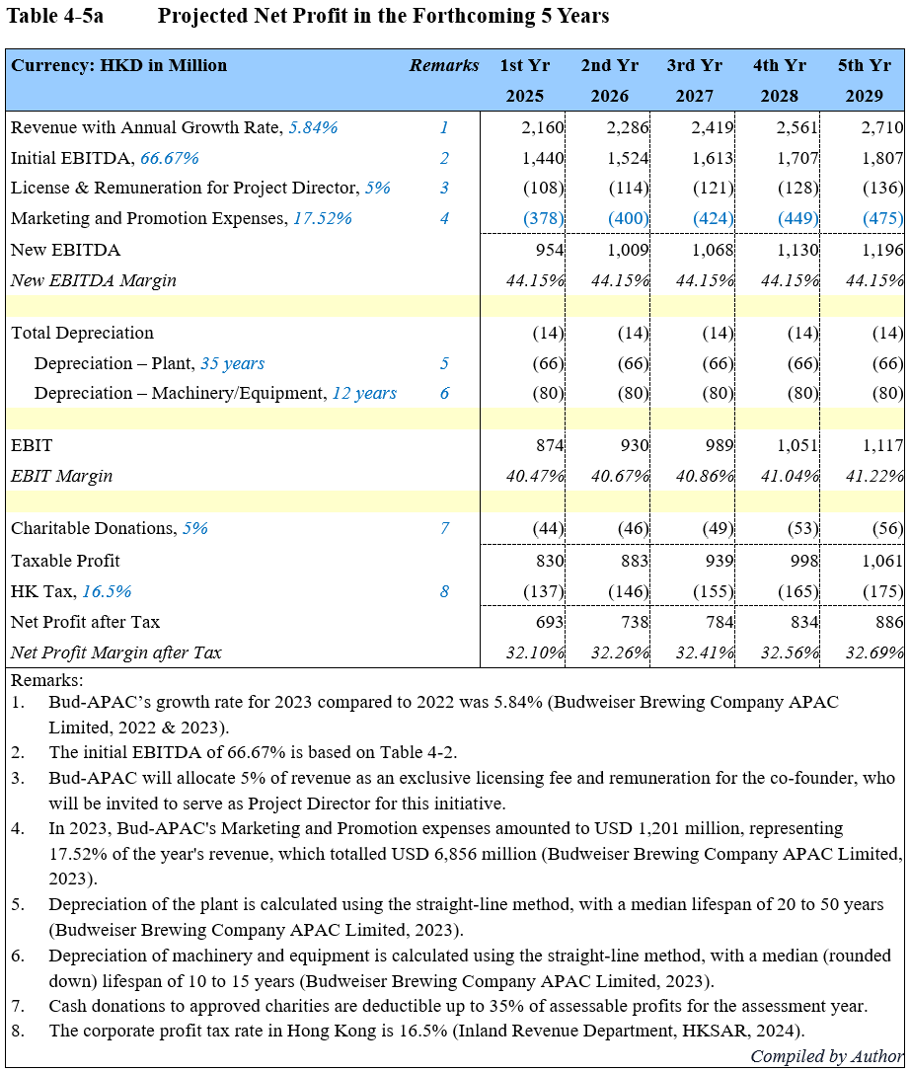

- Cash Flow Estimation in the Forthcoming 5 Years
Cash flow projections indicate a positive trajectory, with increasing cash flow over the five-year period. The initial year shows negative cash flow due to upfront costs, but a recovery and growth are expected in subsequent years. This optimistic outlook suggests the investment will generate strong returns, supported by sound cash flow management and operational efficiency.

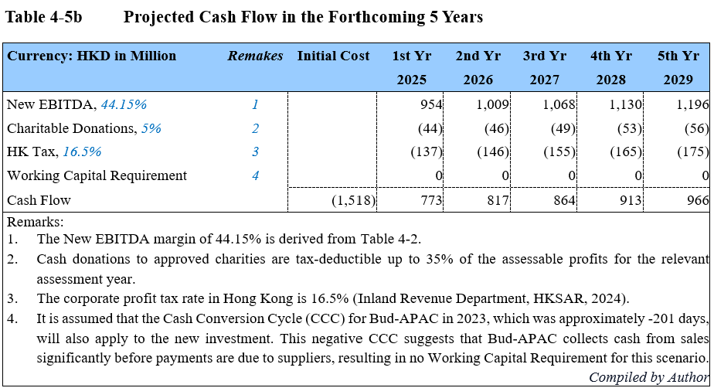

  - Investment Appraisal Overview and Commentary
This investment appraisal uses several financial metrics to assess the project’s viability, including Net Present Value (NPV), Internal Rate of Return (IRR), Accounting Rate of Return (ARR), and Payback Period (PBP). NPV evaluates the project’s value by discounting future cash flows (Damodaran, 2021), while IRR measures the discount rate that brings the NPV to zero, indicating the expected return (Penman, 2021). ARR compares the average profit to the initial investment, and PBP assesses the time needed to recover the initial investment (Megginson et al., 2010).

Comments
The appraisal demonstrates strong project performance, with positive cash flow over the 12-year period. The IRR improves annually, reaching 44.87% in the final year, well above the WACC of 7.04%, indicating significant profitability. ARR also shows steady growth, reflecting increased profitability as the project matures (Gitman & Zutter, 2021). The consistently positive NPV confirms that the project generates value exceeding the cost of capital (Bodie et al., 2019). Additionally, the Payback Period of approximately 2.36 years (2 years and 5 months) suggests a swift recovery of the initial investment, further supporting the project's financial strength. Overall, these metrics indicate a highly profitable and attractive investment.
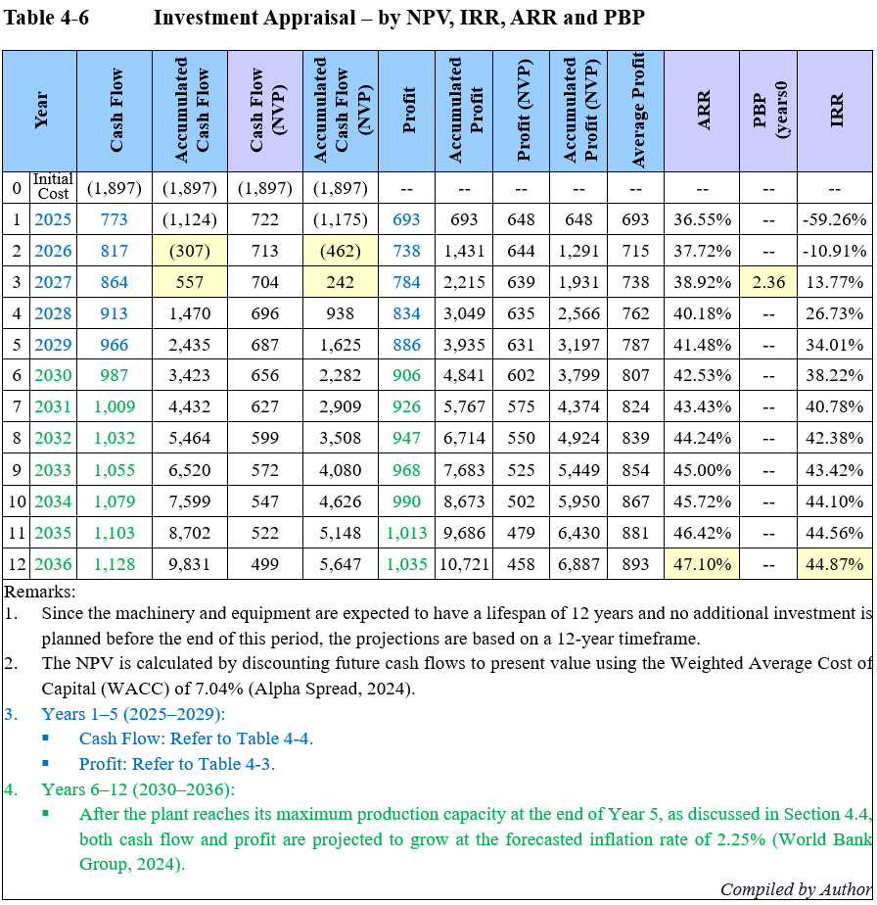

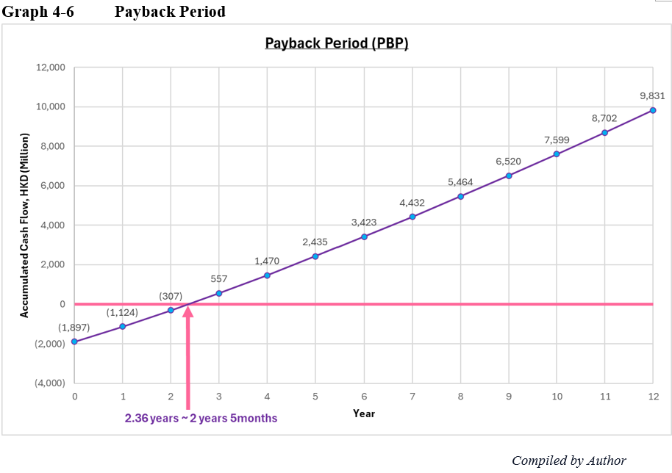

- Financing (Fund-Raising) Management and Working Capital Management
Bud-APAC needs to raise additional funds equivalent to 3% of its total assets, amounting to HKD 3,798.76 million, to finance a new project. As estimated in Section 4, only 50% of this amount, or HKD 1,897.01 million, will be needed as the initial cost, leaving a 50% buffer for further expansion or other investments. The company has several options to raise these funds: equity financing, debt financing, selling non-core assets, or utilizing internal cash reserves. Each option has its own set of advantages and disadvantages, particularly in terms of its impact on the company's financial ratios and overall financial health.

  - Equity Financing
Equity financing involves issuing new shares to raise capital, which strengthens the balance sheet by increasing equity and improving the equity ratio. However, it dilutes existing shareholders’ ownership and may lower earnings per share (EPS). Issuing equity can also be costly and time-consuming due to regulatory requirements. Despite these drawbacks, equity financing does not require repayment, which helps maintain cash flow and avoids interest expenses, protecting profit margins. This option is ideal for companies seeking to reduce leverage and avoid additional debt. Bud-APAC could consider equity financing if it wants to maintain a low debt burden.

  - Debt Financing
It allows Bud-APAC to raise funds without diluting ownership, as the company retains full control. Interest payments on debt are tax-deductible, lowering the overall cost of borrowing. However, taking on additional debt increases liabilities, which could negatively impact the debt-to-equity ratio and interest coverage ratio. Regular interest payments might also strain cash flow during slower revenue periods. Nonetheless, with a strong operating cash flow of HKD 24.5 billion in FY23, Bud-APAC is well-positioned to handle additional debt, provided the borrowing terms are favourable. This option leverages the company’s robust cash flow without affecting its equity structure.

  - Sale of Non-Core Assets
Selling non-core assets provides an immediate cash infusion without incurring debt or issuing equity. This method can improve operational focus by eliminating non-essential assets. However, selling assets could reduce future revenue streams if those assets contribute to income generation. The immediate benefit is an increase in liquidity and a potential boost to liquidity ratios, such as the current ratio. Careful consideration is needed to ensure that the sale of assets does not compromise long-term operational capacity.

  - Utilizing Internal Cash Reserves
It is a conservative option that avoids external costs such as interest or dividends. It also retains full control over the company’s capital structure. However, depleting cash reserves may limit the company’s ability to handle unforeseen expenses or pursue other strategic opportunities. This approach impacts liquidity ratios, like the quick ratio, but it avoids increasing liabilities or diluting equity. If Bud-APAC has sufficient cash reserves, this method could be a low-risk way to finance the project.

  - Recommended Approach
Considering these factors, the recommended strategy for Bud-APAC is to leverage a mix of internal cash reserves and a moderate level of debt financing. This approach balances the need for additional capital with the goal of maintaining financial flexibility, while also minimizing the potential adverse effects on the company's financial ratios. Bud-APAC's robust operating cash flow suggests that the company is well-positioned to service additional debt comfortably, while utilizing internal reserves helps reduce interest expenses and avoid shareholder dilution. Research by Ghosh and Jain (2021) supports the importance of maintaining an optimal mix of debt and equity to preserve financial flexibility and minimize the cost of capital. Additionally, Zhang and Liu (2022) highlight that internal financing can reduce the adverse selection costs associated with external financing, especially in volatile markets. Anderson and Reeb (2020) further emphasize the significance of liquidity preservation through effective cash management, particularly during large capital investments. This combined strategy allows Bud-APAC to fund its projects effectively while ensuring long-term financial stability. Continuous monitoring of cash flows and key financial ratios will be essential to ensure that the company remains within safe operational limits.

- Annual Operational Quarterly Plan for Bud-APAC
Table 6-1 outlines Bud-APAC’s annual operational plan, focusing on key financial and operational priorities for the upcoming 12 months. These priorities include improving liquidity management, optimizing costs, and pursuing strategic growth initiatives. Key actions involve enhancing liquidity ratios, optimizing working capital, managing debt restructuring, and strengthening equity financing options. Additionally, the plan highlights assessing growth opportunities, with a focus on sustainability investments and digital transformation to support long-term financial stability and operational efficiency throughout 2025.
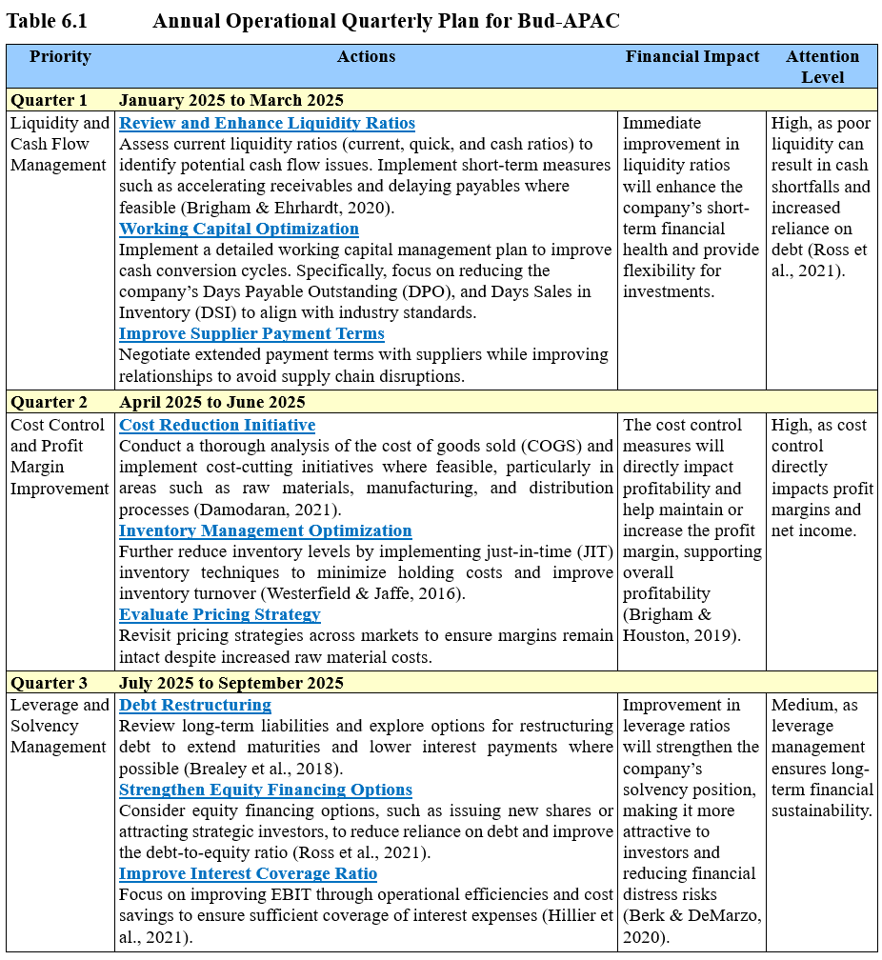

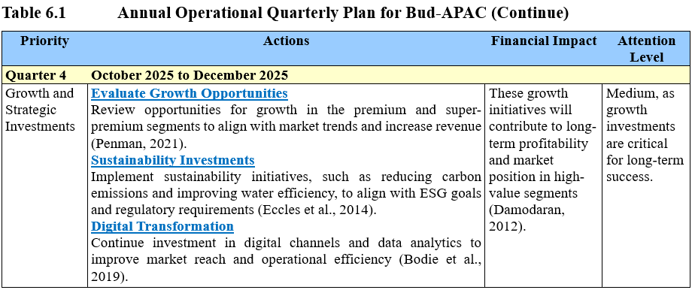

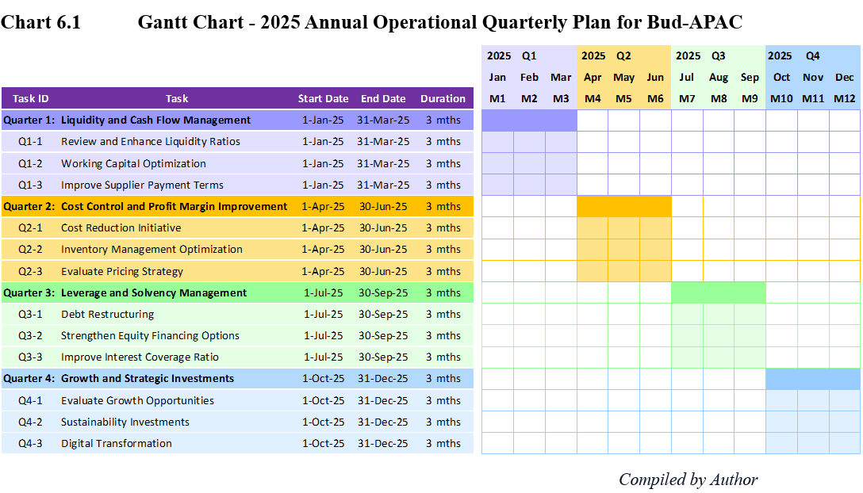

Bud-APAC's financial position is stable, but there is a need for improvements in liquidity, profitability, and leverage. Prioritizing the optimization of working capital, effective cost control, and prudent debt management will enhance both short- and long-term financial resilience. Investing strategically in high-growth sectors and sustainability initiatives aligns with regulatory expectations and market trends (Ghosh & Jain, 2021). By addressing these key areas, Bud-APAC can maintain a competitive edge and foster sustainable growth in an increasingly competitive and challenging market environment (Zhang & Liu, 2022).

- Conclusion and Recommendations
This section highlights the main findings and offers strategic recommendations to strengthen Bud-APAC's position in the Asia-Pacific brewery market. These insights are intended to inform future marketing strategies and drive sustainable growth.

  - Conclusions
Bud-APAC maintains a stable position in the Asia-Pacific beer market but must improve liquidity, cost control, and debt management to strengthen resilience. Its focus on premium segments, sustainability, and digital transformation supports future growth, but rising competition, regulatory pressures, and increased costs remain key challenges. Proactive working capital management and financial flexibility are essential for sustaining profitability.

  - Recommendations
Bud-APAC should pursue a balanced financing approach, combining internal cash reserves with moderate debt to maintain liquidity while minimizing leverage and shareholder dilution. Expanding in high-growth markets like China and South Korea through premium offerings and sustainability initiatives will enhance competitiveness and meet evolving consumer demands (Ghosh & Jain, 2021). Additionally, improving operational efficiency, controlling costs, and closely monitoring cash flow will ensure long-term growth and market leadership in a challenging environment (Zhang & Liu, 2022).



