User Experience Design

(M6X01111)

Luke Rees

Word Count: 2,188

Contents
Introduction 3
UX Comparison 3
Main Menu 3
Almanac 5
Zen Garden 5
Plant Select 7
During Level 7
Extra Modes 8
Shop 9
Options 9
Final Comparison 10
References 10

Introduction
The two apps chosen for this report are Plants vs Zombies [1] and its sequel Plants vs Zombies 2 [2]. These apps were chosen as they both contain similar UX design ideas, but they approach these ideas in different ways that change the UX found in them. For this report the versions of the games used will be the version of Plants vs Zombies found on Steam and the version of Plants vs Zombies 2 found the iPhone app store. Each of these apps will have been analysed based on the version found on 23/10/2023 in case of any major update to either apps.

UX Comparison
In this section, each screen type shared between the two games will be analysed based on how well they work in comparison to the other. Improvements to each of the game’s UI will be suggested after the comparison to improve the overall user experience for the games.

Main Menu
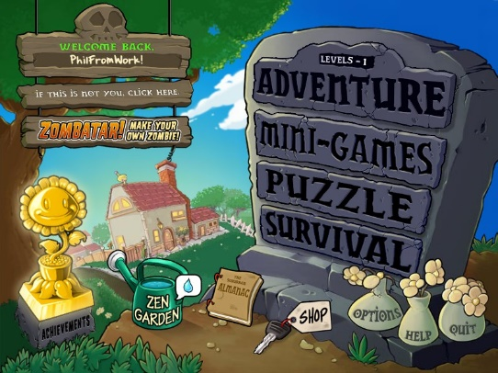
PvZ’s main menu consists of one screen. The largest buttons on the screen lead to the main mode as well as the three extra modes. The size of these buttons clearly tells the user where the main gameplay can be found. The adventure button also has additional text to show what level the user is on.
The buttons on the bottom right consist of options, help, and quit. These are each a vital component of the menu but don’t lead to gameplay which is reflected in how the menu presents them. The four buttons to the left of them lead to side sections, these being achievements, zen garden, almanac, and shop each being represented as something from that section.
The top right buttons are used for file options like the avatar and the active file.
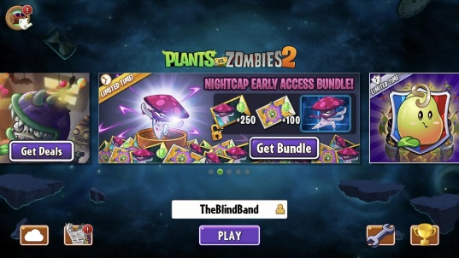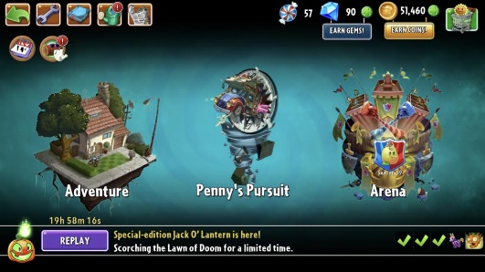
PvZ 2’s main menu contains two screens.
The first screen acts mainly as a news page. The middle section consists of recent news about the game such as current events or shop bundles. This is the first thing you see when opening the game.
The bottom right contains the options and achievements buttons. Bottom left contains cloud saves and news and updates buttons. These all-use icons rather than text to identify them.
The middle buttons contain the users and the play button, pressing play leads you to the second menu which is used to access the different gameplay modes.
The three main buttons on this screen are used to access the main gameplay as well as the extra modes. The bottom bar is for the daily level and displays the daily streak as well as the daily level’s general theme.
The top of the screen has buttons for various sections.
Going from the left there are buttons for Back, Calendar, Options, Almanac, Travel Log, Zen Garden, News, Currencies, and the in-game shop. These are also clearly indicated by icons as well as a number to show how much of each currency you have.

The main difference between the main menus is how much more is contained within PvZ 2’s main menu compared to the first game. However, the additions only serve to add clutter to the screens.
  - Level Select
For PvZ, the main menu also acts as the level select screen as clicking on the adventure button sends you to next level. This saves on additional screens; however, the game may have benefited from a level select screen to allow the user to choose which level they want to play.
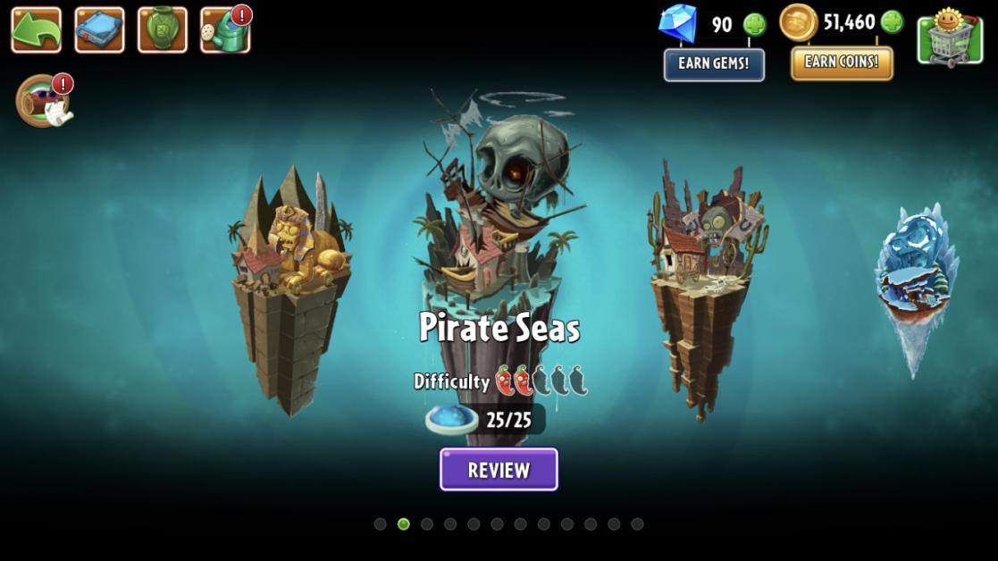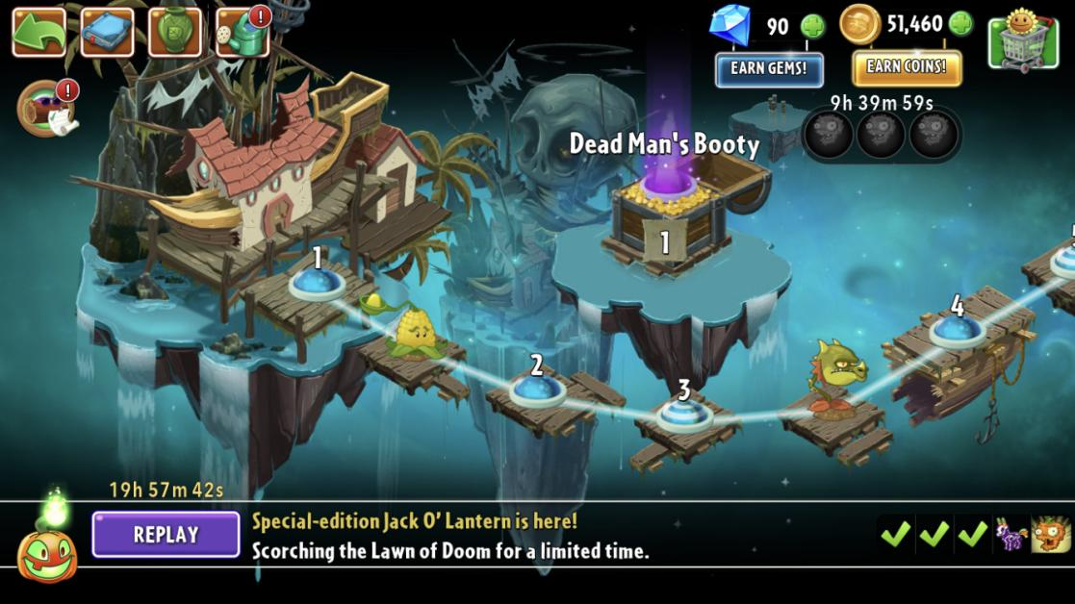
PvZ 2 has two screens for level select. The first is a world select where you can get a general overview of the worlds with information such as difficulty and what’s contained within them.
The second is a level select where you are given a line of levels within a world that unlock in a set order as well as having items along this line that show any unlockable that are contained within the world. There’s a visual indicator on the level nodes are used to quickly show levels with a gimmick to them.
These two screens keep the surrounding buttons from the second main menu screen.

PvZ 2 has the better level select screen as it allows the user to replay any level they wish rather than being sent to the next level in the sequence as well as allowing you to see what kind of level you’re playing before you go into it.

Almanac
The Almanac in both apps is used as a character and enemy viewer.
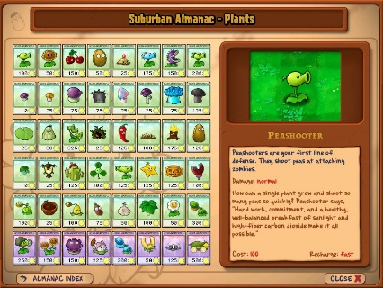
PvZ’s almanac consists of two screens for characters and enemies. These give a brief overview of what’s selected going over the important information as well as a brief description for personality.
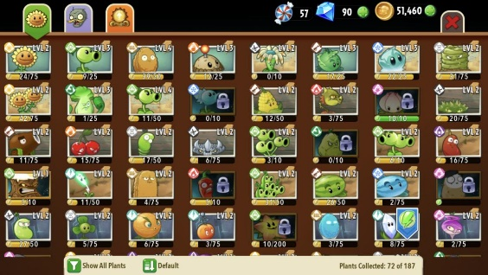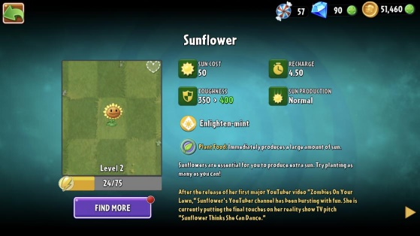
PvZ 2’s almanac contains the same information as PvZ but with additional information. This information is mainly about the level up system but there’s also information about character categories which are used to search and filter characters. There is also a section for unlockable items within the game.

Both versions of this page accomplish their goal of providing the user with all the necessary information that you’d need to get. The only notable issue is the clutter on PvZ 2’s screen.

Zen Garden
The zen garden allows the user to grow plant pots found during gameplay.
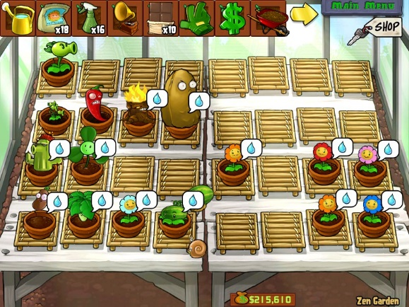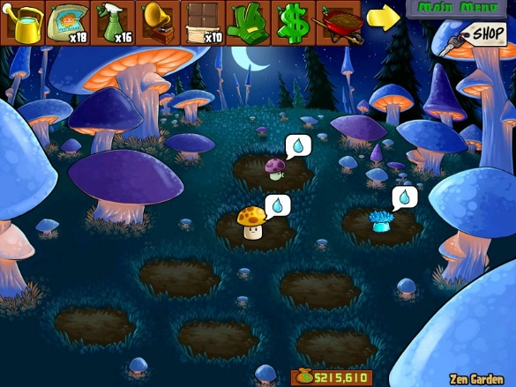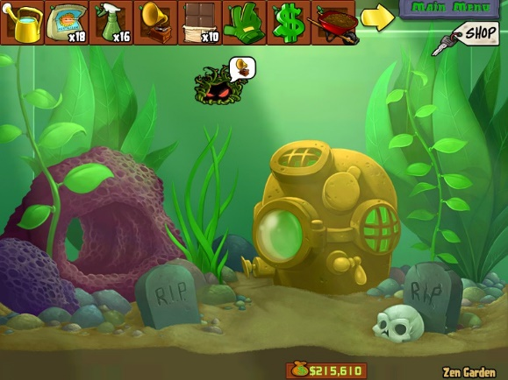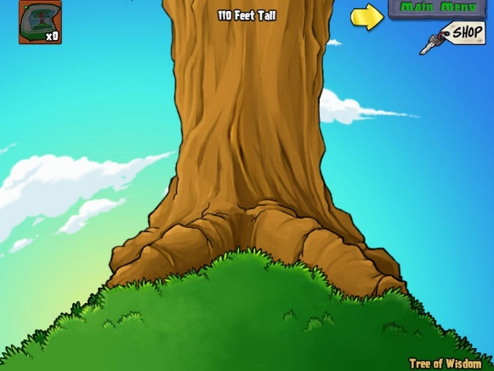
PvZ’s zen garden is very basic in its functionality. It’s used as a way for the user to earn money for shop by collecting and growing plants.
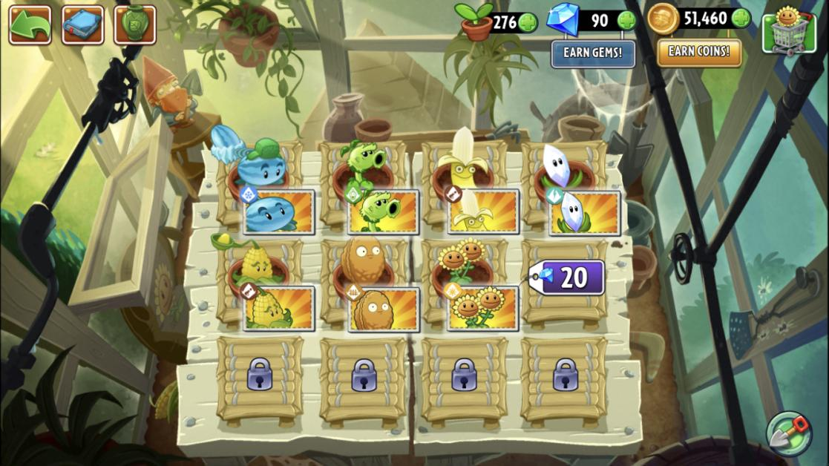
PvZ 2’s zen garden also allows the user to earn coins however it also gives the user a benefit during gameplay by allowing the user to power up different characters by growing them in the zen garden.

PvZ 2 has the better zen garden of the two in comparison as it’s simpler and has a direct usage for gameplay. PvZ’s zen garden only allows the user to collect plants and earn money which makes it less directly useful to the user.

Plant Select
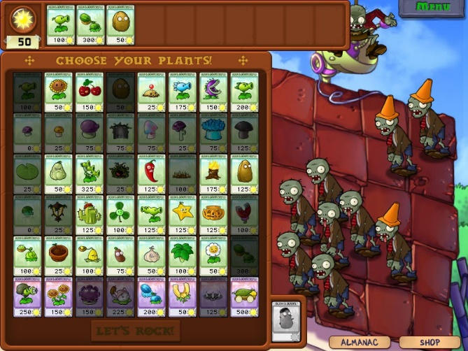
PvZ’s plant select screen contains a box with all the plants on one screen highlighted differently based on their status for the current level. It also has buttons for the almanac and shop to allow the user quick access if needed.
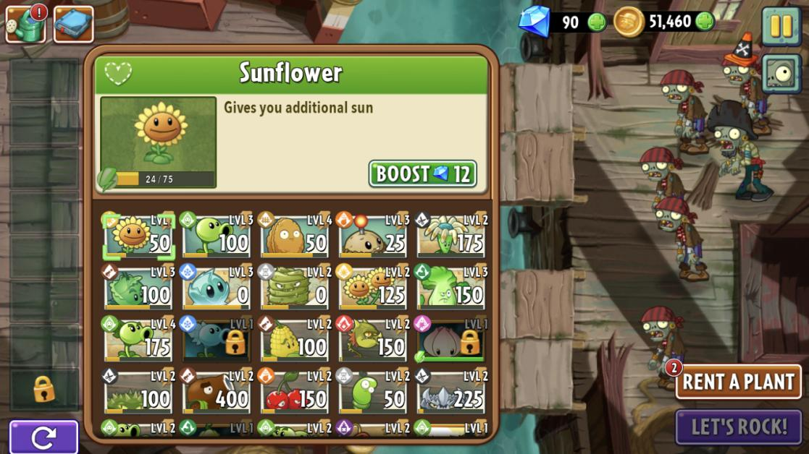
PvZ 2’s plant select screen is like PvZ, however, it contains additional features such as a reload button, zen garden button and a section for the currencies due to them having a direct use in gameplay.
Both screens serve the intended purpose. However, PvZ 2 has a more cluttered screen compared to the first due to the additional features contained on it that may generally go unused by the user.

During Level
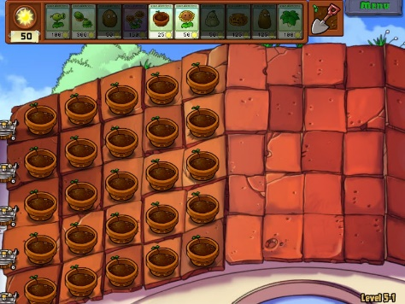
This is PvZ’s screen while in a level. The top bar contains the chosen plants as well as the amount of sun you have and the shovel for removing plants. On the top right is a menu button which is used to bring up the pause menu. On the bottom right is text showing the level you are playing as well as a bar that shows the level progress. The rest of the screen is used for gameplay aside from when you collect money.
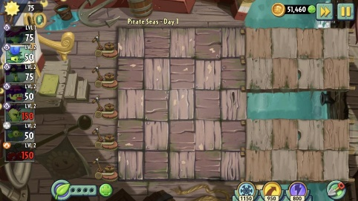
This is PvZ 2’s screen while in a level. It has similar sections to PvZ; however, they are reorganised to better suit the platform. The plants you selected are now horizontal on the left which was done to suit the platform the game is on; however, the shovel has been made smaller which is harder to press compared to what PvZ had. The progress bar and level number was moved to the top. The pause button is in the same place, but it has two different sections next to it being the ‘fast forward’ and the number of coins you have. There are two new sections on the bottom being plant food and power ups, which are both used during gameplay.

Both screens are fit for the purpose they serve, and they also have some consideration for the device that they are on to make the user experience smoother. However, PvZ 2 is still the more cluttered of the two apps as it has a few extra buttons that can go unused by the user and some aspects are not fully fit for the platform it’s on.

Extra Modes
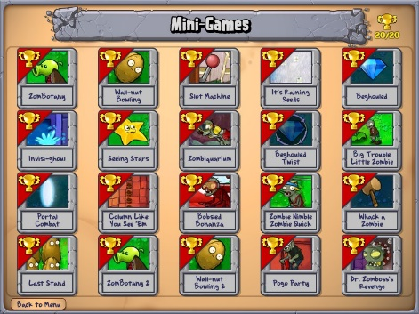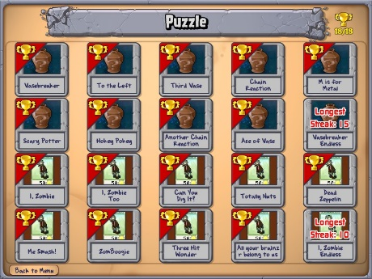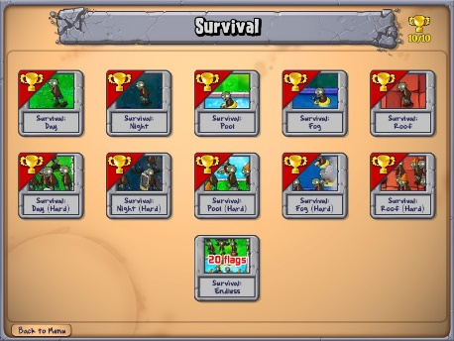
PvZ has three extra modes, these being Mini-Games, Puzzle and Survival. Each of these modes use the same style for selecting a level. This consists of all the levels laid out in order with a trophy count at the top to show how many have been completed.
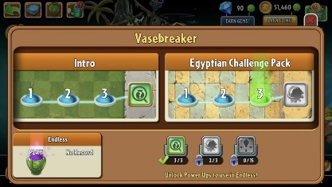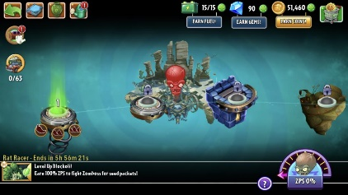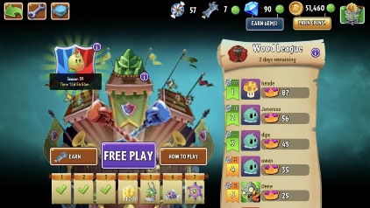
PvZ 2 also has three additional modes, these being Vase breaker, Penny’s Pursuit and Arena.
Each mode makes use of a slightly different screen. Vase breaker is a smaller version of the level select with three levels per world type. Penny’s Pursuit also resembles the level select screen but with less levels and additions like an energy bar and a boss charge bar. Arena is the most unique of the three. It contains a leader board, win streak rewards and buttons to enter a match. It also has two unique currencies.
PvZ’s extra modes are a lot easier to understand as they all share the same layout. PvZ 2’s extra modes, while all interesting, only add to the clutter that the game suffers from. This is made worse by two of the modes having unique currencies that only relate to that mode rather than giving more uses to the existing ones.

Shop
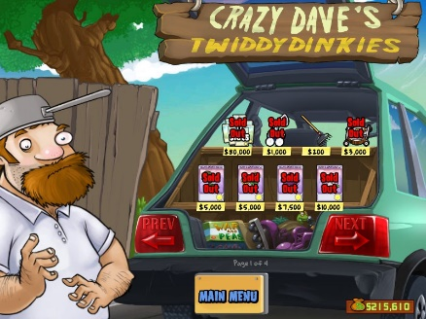
PvZ’s shop is simple, it gives a couple of items that can be bought for the in-game. These items are then used in either the main gameplay or the zen garden.
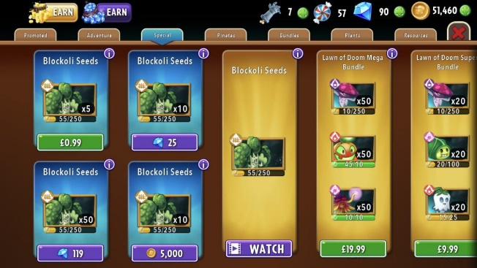
PvZ 2’s shop has a few different sections. Each of these sections displays a selection of items that can be bought for in game currency or for real money. These items consist of similar items to PvZ, but with the addition of the new currencies and seed packets that are then used in different modes.

PvZ’s shop is a lot clearer and understandable especially in terms of what you’re getting when you buy an item. In comparison, PvZ 2’s shop has a lot of different items in it for a variety of prices, this leads to a very confusing shop where the value of each item is hard to understand and as such makes it difficult to justify buying anything.

Options
  - 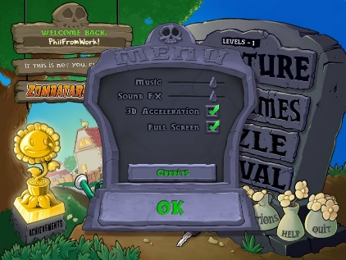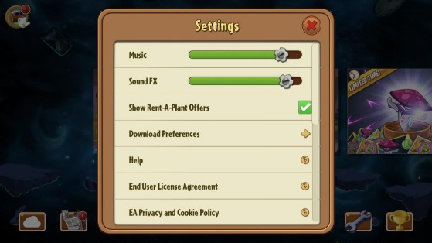
The option screen on both games serves its basic purpose of providing easy access to any options you may what to change. The main difference is that PvZ 2 has extra options relating to the online features of the app.

Final Comparison
To conclude, both apps use a lot of similar ideas in their UX design because one being a direct sequel to the other. The main differences in UX design are found in the layouts and the approach to in game currency.
The layout of the screens is different between the games due to the platforms they are on. PvZ is on the computer which makes reaching certain buttons easier due to the use of a mouse. This also means a lot of the menus are laid out in the centre of the screen as that’s what would be directly in front of the player. To compare, PvZ 2 is on phones, this means that using a mouse isn’t an option and as such the screens need to be laid out to account for how someone would hold a phone. This leads to the layout being focused mostly on the sides as that’s the easier place to reach when holding a phone or tablet.
The final major difference is both games approach to in game purchases. PvZ only has a small shop that purely uses in game currency, which leads to that currency not playing a big part in the games design and only popping up where needed. PvZ 2 has a bigger focus on microtransactions as such the game makes heavier use on in game currencies wherever it can justify making the player more likely to want to buy the currency. This has the adverse effect, however, of making the game a lot more cluttered and harder to understand due to having a lot of different abilities and items that could be purchased.
For these reasons, PvZ has the better UX design as it is a lot simpler and easier to understand in comparison to PvZ 2.
To improve upon PvZ 2’s UX the clutter needs to be removed on many of the different screens. This will help clarify to the player the important aspects of the screens and remove unnecessary options or features. For example, the currency found on many of the screens should be removed as it isn’t needed on some screens such as the main menu and level select. Another example would be decreasing the focus on microtransactions in the game. This would allow many features to be adjusted for better clarity for example the whole shop could have a rework to make it clearer what you’re getting when you buy an item it would also allow the removal of unnecessary aspects such as the rent a plant button or plant power ups from the zen garden for example.

References
[1] Plants Vs Zombies. [SOFTWARE], Seattle: PopCap Games, 2009.
[2] Plants Vs Zombies 2. [SOFTWARE], California: Electronic Arts, 2013.

