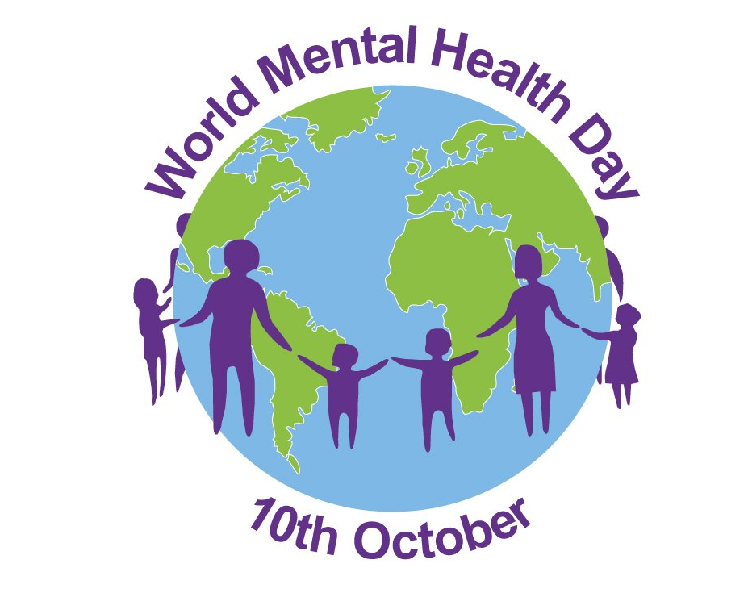

Viktoria Koleva
2028456
Professional career development

What are the five social impact of mental illness on people who suffer from the condition? To what extent do you agree or disagree?

Introduction
In my case study I will explain about the five social impact of mental illness on people and how they can change our life in the future, our goals, dreams. Everyone can have a lot of pluses, if take care for the mental health.

Definition
According to the World Health Organization, “mental health” means a pure and simple state of well-being in which a person realizes his potential, can cope with normal stress in life, can work productively and contribute to the effective functioning of the community.
As well the “mental health” can be defined like different condition of our emotional, psychological, and social well-being.
Recent statistics show that more than 6,000 people die each year from suicide in the UK and having a long-term mental health problem can reduce life expectancy by up to 21 years due to related physical health problems.

The five social impact of mental health

1. Stigma - Stigma can be defined as the negation of a characteristic or personal trait that is considered to be or is actually a defect. Unfortunately, negative attitudes and beliefs towards people with mental illness are common. Most people are reluctant to share this problem because they are afraid of being rejected or rejected by society.

2. Social isolation - Studies show that some people who worry about their health generally feel more lonely, depressed and anxious. Which makes them want to isolate themselves from the world. This, in turn, exacerbates the problem. Yes I am agree.

3. Discrimination - Discrimination arises from the fear of sharing with others that my mental problem, the fear that others will not understand us and the shame that you have rejected the group, family, community. Yes I am agree

4. Unemployment and poverty - It is constantly established that unemployment - lack of work and active job search - has a negative impact on a number of health outcomes. It has been proven that the health consequences of unemployment increase with duration - for mental health and life satisfaction, as well as for physical health. Yes I am agree, but that situation can be change, it is up to us and what choice we will to do – To find work or just to waiting.

5. Poor education - Higher levels of education are associated with better mental health. Educated people have more choices and thus more control over their lives and better security. Low education is associated with a lack of sense of control and resilience and fear for the future. I agree that education gives you more opportunities and the right choices in life and focuses you on the real and significant things in life

Conclusion

We have good mental health when we can deal with stressors, indulge in relationships with our loved ones, to contribute to the community in which we live and to work to achieve our goals. The choices are in our hands.

