BA International Hotel Management

BMIH5007 Financial Management for the Hotel Industry

Business Report - Comparison of Two Hospitality Organisations

Student Name: Catalina Simona Ianos
Student ID:2232322

Module Leader: Tristan Hawkins

I acknowledge that I have used (https://app.grammarly.com/) for checking and correcting grammatical and syntax errors in my work for ensuring grammatical accuracy on February 20, 2025.
I confirm that I have not presented any AI-generated text as my own work. I confirm I have copies to my drafts, notes and other resources I used before and the after the use of AI tools which I may be asked to provide in evidence.

Executive Summary
This report compares Shangri-La Hotels and Premier Inn Hotels' financial performance, overall revenue, marketplace position, growth opportunity, and economic investment in Corporate Social Responsibility (CSR).
Shangri-La, a luxury hospitality group, exhibited robust top-line restoration, growing in high-margin segments and investing in premium experiences and sustainability programs. Premier Inn, the largest value-for-money branded UK hotel group, posted sustained top-line growth, with cost efficiencies and selective expansion, most prominently in Germany, driving performance.
The analysis reveals opportunities for growth in terms of geographic expansion, digital transformation, and revenue diversification. Shangri-La must invest in wellness tourism and branded residential apartments, while Premier Inn needs to fully leverage its Accelerating Growth Plan (AGP) and broaden its corporate partnerships.
For both companies, strengthening customer contact and sustainability is necessary to be competitive. By advancing these statements, Premier Inn and Shangri-La can offset profit, establish dominance in the trade environment, and operate profitability for years to come in a continually evolving global hospitality market.

Contents
Executive Summary 2
Introduction 4
Analysis of Shangri-La Hotels 4
Revenue of Shangri-La Hotels 4
Market Position of Shangri-La Hotels 5
Growth Potential of Shangri-La Hotel 6
Financial Commitment to CSR of Shangri-La Hotels 6
Analysis of Premier Inn Hotels 7
Revenue of Premier Inn Hotels 7
Market Position of Premier Inn Hotels 7
Growth Potential of Premier Inn Hotels 8
Financial Commitment to CSR of Premier Inn Hotel 9
Conclusion 10
Recommendations for Shangri-La Hotels and Premier Inn Hotels 10
References 12

List of Figures
Figure 1: Revenue of Shangri-La Hotels 4
Figure 2: Locations of Shangri-La Hotels 5
Figure 3: Market Position of Premier Inn Hotel 8
Figure 4: Premier Inn's Financial Commitment to CSR 9
List of Tables
Table 1: Recommendations for Shangri-La and Premier Inn Hotels 11

Introduction
The hospitality industry is a cutthroat ecosystem where financial management is highly crucial to scale and sustainability. The following analysis report will comparatively analyse two hotel groups, Shangri-La Hotels and Premier Inn Hotels, under one of the vital segments of the economy, which is the overall hotel chain, market position, potential growth, and the investment level made in Corporate Social Responsibility (CSR). This report will analyse these various factors in the hope of identifying the strengths, weaknesses and opportunities of each hotel group, thus providing sound, logical recommendations to maximise financial performance and viability in the long term.

Analysis of Shangri-La Hotels
Shangri-La Hotels is a luxurious hospitality group based in Hong Kong named Shangri-La Asia Limited. Established in 1971, the group has become international, with over 100 hotels under its management and proprietorship in Asia, the Middle East, Europe, and North America (Shangri-La Group, 2021). With a commitment towards offering high-class experiences, its flagship hotels, such as Shangri-La Hotels, Kerry Hotels, JEN Hotels, and Traders Hotels, offer high-class experiences, with a strong commitment towards sustainability and innovation, combining environmentally friendly programs, high-class amenities, and personalised service, and a pioneer in high-class hotels (Financial Times, 2024).

Revenue of Shangri-La Hotels
Shangri-La Hotels delivered a strong financial performance in 2023, with consolidated revenue rising 46.5% to USD 2.14 billion, fueled by the reopening of borders in Mainland China and Hong Kong (Shangri-La, 2023).
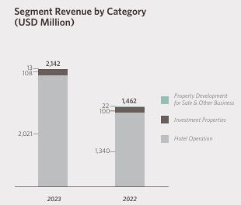
Figure 1: Revenue of Shangri-La Hotels
Source: (Shangri-La, 2023)
EBITDA for the group increased 199.4% to USD 522.2 million, with cost efficiencies and renewed activity in business. Owners' profit increased to USD 184.1 million, reversing 2022’s loss of USD 158.5 million. Revenue per available room (RevPAR) increased 69% to USD 108, fueled by heightened occupancy (62%) and strong demand in key source markets (Oh, 2024). Hotel operations continued to dominate in revenue, generating USD 1.93 billion, supplemented with earnings in investment property and ventures. Shangri-La's balance sheet showed solidity, with net assets valued at USD 5.22 billion, free cash flow becoming positive at USD 145 million, and dividend payments reinstated (He, 2024). Overall, the group maximised the complete restoration of worldwide travel with strong profitability and operational efficiency.

Market Position of Shangri-La Hotels
Shangri-La Hotels holds a strong position as a high-class hospitality brand, with a presence in over 100 hotels in Asia, the Middle East, Europe, and North America. The figure below shows the global locations of Shangri-La Hotels-
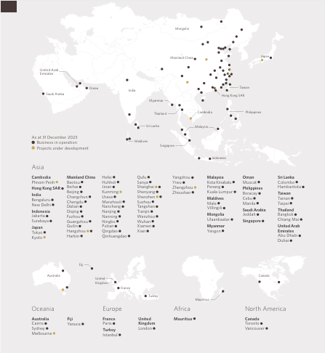
Figure 2: Locations of Shangri-La Hotels
Source: (Shangri-La, 2023)
It is a high-class, high-presence brand with offerings for high-value visitors, high-value corporates, and high-net-worth persons. In 2023, its market recovered substantially, with a strong demand for tourism following pandemic-related restrictions in both Mainland China and Hong Kong (Luxrally Travel, 2023). Shangri-La's brand value remains strong, with various accolades, including "Best Luxury Hotel Brand in Asia-Pacific" and "Best Business Hotel Brand in the World." It also leverages its portfolio diversity, including its presence in Shangri-La Hotels and Resorts, Kerry Hotels, JEN by Shangri-La, and Traders Hotels, with offerings for a range of segments of its target visitors (Hospitality Net, 2023). In addition, its high-value presence in key city and resort locations strengthens its competitive edge even further. With a re-designed reward scheme for its visitors (Shangri-La Circle) and a strong orientation towards personalised experiences, its visitor engagement and retention have continued to build, and its position as a top-class luxury hotel brand continues unchallenged.

Growth Potential of Shangri-La Hotel
Shangri-La Hotels has strong expansion potential through expansion, market restoration, and technological transformation. In 2023, its 46.5% earnings expansion, partially supported by Hong Kong and Mainland China, indicates high demand for high-end tourism. Expansion in its key regions, including China, Southeast Asia, the Middle East, and Europe, through new hotels such as JEN Shenzhen Qianhai and Shangri-La Nanshan, Shenzhen, constitutes its expansion drive (Shangri-La, 2024). In addition, its property development commitment generates long-term sources of earnings.
Shangri-La's investment in technology transformation and reengineering its Shangri-La Circle reward scheme have strengthened customer relationships and direct bookings. The corporation's emphasis on sustainability programs, such as environmentally responsible hospitality, is in harmony with shifting consumption behaviour, creating new opportunities in the marketplace (Jenny, 2023). Economic uncertainty, high interest rates, and global trends in tourism could become a challenge. Despite that, substantial brand value, investments in a planned manner, and a commitment to providing a memorable customer experience have positioned the corporation for long-term expansion, particularly in high-priority tourism destinations.

Financial Commitment to CSR of Shangri-La Hotels
Shangri-La Hotels reflects a strong financial dedication to Corporate Social Responsibility (CSR) through community, environment conservation, and sustainability programs. The "Stay, Savour, and Shine" ESG model incorporates sustainability in its hotel operations to minimise its impact on the environment and its social contribution. In 2023, Shangri-La participated actively in green programs such as beach cleaning, farm tours, Eco parks tours, and conservation of endangered species, with over 2,300 guests and employees participating. Besides, the group sponsored events, such as World Oceans Day and Earth Day, to conserve marine life and environmentally friendly food procurement (Shangri-La Group, 2023). Shangri-La also prioritises social responsibility, providing 300 makeshift accommodations for quake victims in Turkey through employee contribution and corporation matching. It also advocates for programs for kids' development, benefiting 3,800 children through educational seminars and meal programs. All its CSR programs and investments in sustainability say a lot about a long-term commitment to responsible ethics in business. Not only will these enhance its reputation, but such actions will also resonate with the emerging demand for responsible and environmentally friendly hospitality.

Analysis of Premier Inn Hotels
Premier Inn, part of Whitbread PLC, is the UK's largest branded hotel, with 85,000-plus rooms in 850 hotels. It is growing strong in Germany, with 59 hotels and an ambition to become a budget hotel brand of preference. It is a value-for-money model, offering high-quality accommodations at competitive prices, with its expansion ongoing, a pipeline of 7,000 new rooms, and long-term ambition for 125,000 UK and Ireland rooms, with its vertically integrated model, operational efficiency, and cost controls, and a uniformed guests' experience (Premier Inn, 2024).

Revenue of Premier Inn Hotels
Premier Inn Hotels, a subsidiary of Whitbread PLC, delivered strong financial performance in 2023/24, with 13% growth in statutory revenue to £2.96 billion, supported by strong demand in UK and German operations. Adjusted profit before taxes increased 36% to £561 million, supported by increased occupancy, pricing, and cost savings (MarketScreener, 2024). UK operations continued to drive growth, with accommodation sales growing 12%, with a strong performance in regions (+10%) and particularly in London (+17%). Premium revPAR increased to £5.95, supported by Premier Inn’s UK leadership position in its marketplace (Whitbread Plc., 2024). Premier Inn reduced its adjusted loss before taxes to £36 million in Germany by improving operational efficiency during ongoing expansion. Returns to shareholders totalled £756 million, including dividends and buy-backs. The group maintained a strong balance sheet with a net debt of £298 million, supported to fund new hotels and operational improvements (Whitbread, 2024). Overall, Premier Inn delivered strong profitability and resilience, positioning for long-term growth.

Market Position of Premier Inn Hotels
Premier Inn holds a dominant position in its marketplace. It is the UK's largest branded hotel chain, with over 85,000 rooms in 850 hotels (Statista, 2023).
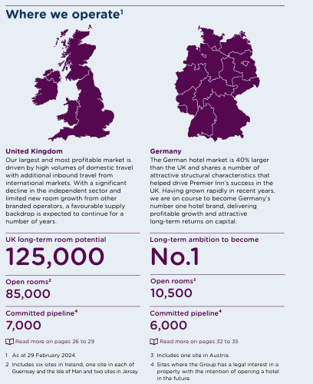
Figure 3: Market Position of Premier Inn Hotel
Source: (Whitbread, 2024)
It attracts price-conscious leisure and business guests, offering high-value, value-for-money accommodation with a firm, well-established brand name. Premier Inn continues to outpace UK midscale and economy (M&E) hotels, with its RevPAR premium rising to £5.95, underpinned by its head position in its marketplace. The brand has a consistent value proposition for guests, with direct bookings, effective pricing, and high occupancies, most prominently in London (+17%) and regions (+10%). Premier Inn is expanding rapidly in Germany, a 40% larger hospitality marketplace than in the UK, with 59 hotels trading and 34 in development (Bown, 2024). It will target its UK success through free-standing conversions and new builds, with a long-term objective of becoming Germany’s largest budget accommodation group. With continued investments in technology, service, and environment, Premier Inn will maintain its competitive position in both nations, securing long-term expansion and marketplace leadership.

Growth Potential of Premier Inn Hotels
Premier Inn possesses strong growth potential, supported through expansion in a considered manner, strong demand in its markets, and operational efficiencies. It will develop its room base in the UK from 85,000 to at least 97,000 in 2028/29, with a long-term target of 125,000 rooms. The Accelerating Growth Plan (AGP) will free 3,500 additional rooms by converting underperforming branded restaurants into adjacent hotels, maximising the use of accommodation, and driving increased profitability. Its vertically integrated model helps it manage its cost base and maintain high occupancy, underpinned by its position of market leadership (O’Neill, 2024). In Germany, Premier Inn is growing in a 40% larger marketplace than in the UK, with 59 trading hotels and 34 in development. It aims to become Germany’s leading budget hotel brand, with its strong value offering and awareness-raising marketing activity (Gollasch, 2024). Having initially incurred losses, its German operations have delivered increased profitability, with a target to break even in 2024. With a strong balance sheet, its transformation through technology, and its drive for sustainability, Premier Inn is well-placed for long-term growth and increased shareholder value.

Financial Commitment to CSR of Premier Inn Hotel
Through its holding group, Whitbread PLC, Premier Inn reflects a strong financial dedication to Corporate Social Responsibility (CSR) under its "Force for Good" sustainability scheme.
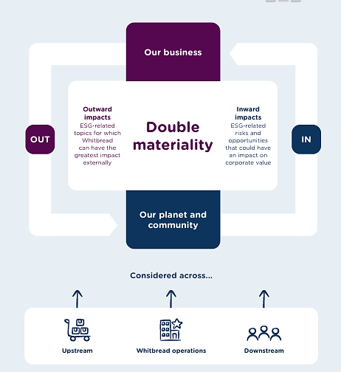
Figure 4: Premier Inn's Financial Commitment to CSR
Source: (Whitbread, 2024)
The company spends significant sums on reducing its carbon footprint, conserving water, and contributing to local communities. In 2023/24, Premier Inn saw its first all-electric hotel in Swindon, a significant move towards its target of net-zero carbon operations. The group has reduced operational carbon emissions by 54.9% since 2016/17 and continues working towards Scope 1 and 2 net zero in 2040. Besides, Premier Inn is socially responsible, raising £24 million for Great Ormond Street Hospital Children's Charity. It even gave over 50,000 items of bedding and 2,000 mattresses for use in supporting humanitarian work in Ukraine (Premier Inn Hotels, 2024). The group is actively reducing water use, with a 10.1% fall per sleeper since 2019/20, and distributing over 259,000 meals to food charities. By infusing its model for its business with consideration for its impact, Premier Inn ties its financial success with ethical and environmentally responsible behaviour, strengthening its position as a responsible corporate player.

Conclusion
This report analysed financial management at both Shangri-La Hotels and Premier Inn Hotels, including revenue performance, marketplace position, opportunity for growth, and CSR commitment. Shangri-La is distinguished in high-class hospitality, high-value experiences, and programs for sustainability, and Premier Inn is distinguished in budget hotels with operational efficiency and expansion in a strong position in Germany. There is an opportunity for both companies to diversify sources of revenue, expand in a planned manner, and enhance customer relations. Adhering to proposed strategies can consolidate financial performance, preserve a competitive edge, and yield long-term expansion in a transforming hospitality industry.

Recommendations for Shangri-La Hotels and Premier Inn Hotels
Based on the analysis above, Shangri-La and Premier Inn Hotel can improve several areas. Some places that both the hotels can focus on are the areas of growth and revenue diversification. The recommendation for improvement is given below in the table-
Hotel Group | Opportunities for Growth | Revenue Diversification
Shangri-La Hotels | Expand in High-Growth Markets: Continue expanding in China, Southeast Asia, and the Middle East, countries with increased demand for high-end tourism (Walker and Walker, 2020). | Luxury Residential and Branded Experiences: Expand revenue sources through branded residential, serviced apartments, and high-end experiences.
Shangri-La Hotels | Enhance Digital and Loyalty Programs: Invest in technology-enabled experiences and extend Shangri-La Circle for deeper customer engagements. | MICE (Meetings, Incentives, Conferences, and Exhibitions) Growth: Capitalise on premium and business events to generate non-room revenue (Tranter, Stuart-Hill and Parker, 2014).
Shangri-La Hotels | Sustainability Initiatives: Increase investment in environmentally friendly property and operations to draw in environmentally responsible visitors | Wellness and Culinary Tourism: Develop spa retreats, wellness stays, and culinary experiences to draw more guests.
Premier Inn Hotels | German Market Expansion: Continue hotel purchases and new development to position Premier Inn as Germany's best value-for-money budget brand (Chen et al., 2021). | Diversify Beyond UK Market: Expand into high-potential European and Asian markets, leveraging Premier Inn’s value positioning.
Premier Inn Hotels | Accelerating Growth Plan (AGP): Convert underperforming branded restaurants into bedrooms to maximise capacity. | Food and Beverage Growth: Strengthen integrated restaurant offerings, breakfast options, and delivery alliances to drive non-room revenue (Walker and Walker, 2020).
Premier Inn Hotels | Technology and Automation: Invest in AI-facilitated dynamic pricing and electronic checking processes to save expenses and enhance efficiency (Ruel and Njoku, 2020). | Corporate Partnerships: Develop business packages and extended stays to win over corporation guests and drive room occupancy.
Table 1: Recommendations for Shangri-La and Premier Inn Hotels
Source: (Self-made)

References
Brown, C. (2024) Premier Inn progress in Germany, THP News. Available at: https://tophotel.news/premier-inn-progresses-in-germany/ (Accessed: 4 February 2025).
Chen, M.-H. et al. (2021) ‘Modelling a green supply chain in the hotel industry: An evolutionary game theory approach’, International Journal of Hospitality Management, 92, p. 102716.
Financial Times (2024) Shangri-La Hotel PCL, SHANG: SET profile - FT.com, markets.ft.com. Available at: https://markets.ft.com/data/equities/tearsheet/profile?s=SHANG:SET (Accessed: 4 February 2025).
Gollasch, G. (2024) Premier Inn says brand strength is unparalleled as it looks to expand its digital footprint, Marketing Week. Available at: https://www.marketingweek.com/premier-inn-digital/ (Accessed: 4 February 2025).
He, K. (2024) Shangri-La Returned to Profit in 2023 with 47% Revenue Jump, Mingtiandi. Available at: https://www.mingtiandi.com/real-estate/finance/shangri-la-returned-to-profit-in-2023-as-revenue-jumped-47-on-travel-recovery/ (Accessed: 5 February 2025).
Hospitality Net (2023) Shangri-La by Shangri-La, Hospitality Net. Available at: https://www.hospitalitynet.org/brand/23000140/shangri-la.html (Accessed: 5 February 2025).
Jenny, M. (2023) Shangri-La Group reveals luxury hospitality shifts for 2023, Globetrender. Available at: https://globetrender.com/2023/01/23/shangri-la-group-reveals-luxury-hospitality-shifts-2023/ (Accessed: 5 February 2025).
Luxrally Travel (2023) Shangri-La Group, LuxRally Travel. Available at: https://www.luxrallytravel.com/hotel-groups/shangri-la-group (Accessed: 5 February 2025).
MarketScreener (2024) Whitbread: Annual Report and Accounts 2023, MarketScreener. Available at: https://www.marketscreener.com/quote/stock/WHITBREAD-PLC-4006657/news/Whitbread-Annual-Report-and-Accounts-2023-46736580/ (Accessed: 7 February 2025).
O’Neill, S. (2024) Premier Inn to Grow Hotel Room Count by 25% Before 2030, Skift. Available at: https://skift.com/2024/04/30/premier-inn-to-grow-hotel-room-count-by-25-before-2030/ (Accessed: 7 February 2025).
Oh, T. (2024) Shangri-La Asia returns to black in FY2023 with US$184.1 million net profit, The Business Times. Available at: https://www.businesstimes.com.sg/companies-markets/shangri-la-asia-returns-black-fy2023-us-184.1-million-net-profit (Accessed: 7February 2025).
Premier Inn (2024) Why We are Premier, www.premierinn.com. Available at: https://www.premierinn.com/gb/en/why.html (Accessed: 7 February 2025).
Premier Inn Hotels (2024) The Economic and Social Impact of Premier Inn Hotels. Premier Inn Hotels. Available at: https://cdn.whitbread.co.uk/media/2023/08/The-economic-and-social-impact-of-Premier-Inn-hotels.pdf (Accessed: 7 February 2025).
Ruel, H. and Njoku, E. (2020) ‘AI Redefining the Hospitality Industry’, Journal of Tourism Futures, 7(1), pp. 53–66.
Shangri-La (2023) Shangri-La Annual Report, shangri-la.com. Shangri-La Group. Available at: https://sitecore-cd.shangri-la.com/-/media/Project/Shangri-La-Group/Investor/Files/Public-Disclosures/Latest-Top-Publications/2023_Annual_Report_E.pdf (Accessed: 8 February 2025).
Shangri-La (2024) Shangri-La Group Breaks Ground on New Development Project in Dalian, Shangri-la.com. Available at: https://www.shangri-la.com/group/media/media_post?post=Dec23_Dalian (Accessed: 8 February 2025).
Shangri-La Group (2021) Corporate Profile, Shangri-la.com. Available at: https://www.shangri-la.com/group/investors/corporate-profile (Accessed: 8 February 2025).
Shangri-La Group (2023) Environmental, Social and Corporate Governance | Shangri-La Experiences, Experiences. Available at: https://www.shangrilaexperiences.com/community-and-social-impact (Accessed: 8 February 2025).
Statista (2023) Premier Inn hotel numbers 2012-2023 Statistic, Statista. Available at: https://www.statista.com/statistics/739855/whitbread-premier-inn-hotels/ (Accessed: 8 February 2025).
Tranter, K.A., Stuart-Hill, T. and Parker, J. (2014) An introduction to revenue management for the hospitality industry: principles and practices for the real world. Harlow: Pearson Education.
Walker, J.R. and Walker, J.T. (2020) Introduction to hospitality. Harlow: Pearson.
Whitbread (2024) Annual Report, Whitbread. Whitbread. Available at: https://cdn.whitbread.co.uk/media/2024/05/Whitbread-PLC-Annual-Report-and-Accounts-2023_Single_pages-1.pdf (Accessed: 18 February 2025).
Whitbread Plc. (2024) FY23 Results Premier Inn UK drives significant profit uplift versus FY22 and FY20 Strength of operating model underpins long-term growth opportunities in UK and Germany Increased dividend plus £300m share buy-back in H1 FY24. Available at: https://cdn.whitbread.co.uk/media/2023/04/Final-FY23-RNS-Final-Combined.pdf (Accessed: 18 February 2025).

