Cascading Style Sheets (CSS)

Objectives
The aim of this lab exercise is to help you practice using CSS.

Exercise

Instructions
You are to try and add some CSS styles to create a web page that looks similar to the image shown in Figure 1: Screenshot of styled index page (see last page).
- Add a CSS (stylesheet) file to your project and link this to the index.html and attributions.html pages. I have already added the links to the external third-party stylesheets for you.
- Style you header section
  - Set a background colour for your header
  - Style the logo and main menu sections
- Style the Jumbotron
  - Set background image to adult-adventure-auto-2409681.jpg (or you can use another image - make sure the image is suitable for a background and you do not end up with a pixelated image)
  - Set its height to at least 300px and position the background centrally.
- Style the Main Section
  - I have added a class attribute to each of the featured categories called shopping_category. You can use this as a selector.
  - Set each of the images under the shopping category to float left the following size:
    - Width: 50%
    - Height: auto (the height will scale automatically based on the width)
  - Remember to set the parent element of the images to overflow: auto because of the floats added to the image.
  - Style each of the nav menus in each of the shopping categories (you may need to add a class attribute to help you style them).
    - Remove the bullet points
    - Change the link text colour and remove the underline
    - Add a hover effect for the links
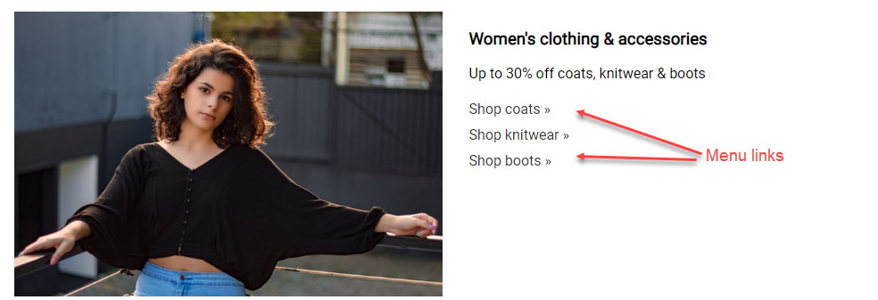
- Style the footer section
  - Change the footer background colour and space things out a bit
  - Style the nav menu links
    - Space them out a bit
    - Change the link text colour and remove the underline
    - Add a hover effect for the links
  - Centre the content

Demo Screenshot

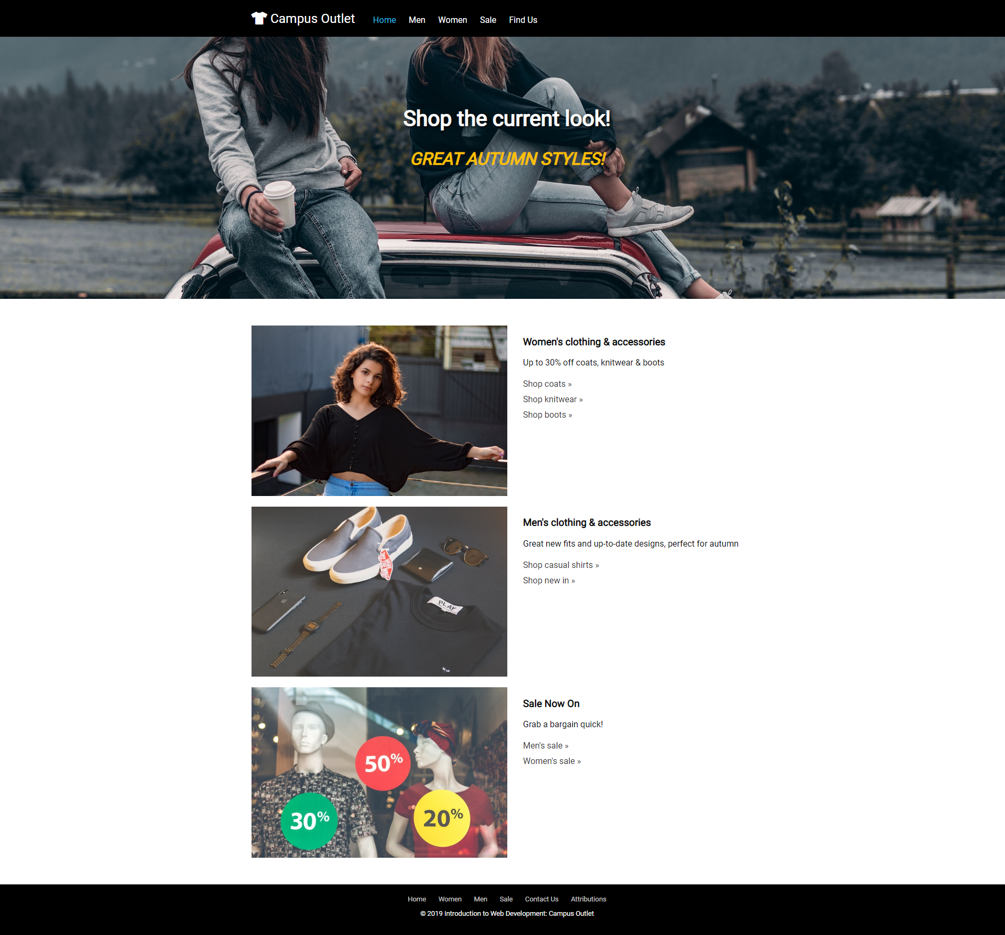
Figure 1: Screenshot of styled index page

