Name: Ash Toner

Student Number: 2514500
__________________________________________________________

WORKSHEET 1 – TESTING (Using Variables)

- Original code:
def check_not_null(value_entered):
if value_entered == "":
print("You must enter a value, cannot leave this blank")
raise ValueError

def check_valid_age(number_entered):
if number_entered <= 0:
print("Age cannot be a negative number.")
raise ValueError
elif number_entered >= 130:
print("Invalid age, number is too high.")
raise ValueError

try:
surnameInput = input("Enter your surname: ")
check_not_null(surnameInput)

ageInput = int(input("Enter your Age: "))
check_not_null(ageInput)
check_valid_age(ageInput)

if ageInput >= 16:
NINumberInput = input("Enter your National Insurance Number: ") # NINumber = National Insurance Number
check_not_null(NINumberInput)

# length check for National Insurance Number, is always 7
if len(NINumberInput) != 7:
print(f"National Insurance Number should be 7 characters long, you entered {len(NINumberInput)} character(s).")
raise ValueError
else:
print("You are not old enough for a National Insurance Number")

workingHoursPerWeekInput = float(input("How many hours do you work per week "))
check_not_null(workingHoursPerWeekInput)

except ValueError:
print("ERROR: What you entered is invalid. Please enter a valid input.")

- Code Testing

For each test below, run your code and enter the values provided. Present a screenshot of the programme running. Did the programme behave correctly or did it do something unexpected, and if so, why?

Surname:
- Enter JONES
- Leave blank
- Enter A
- Enter 123

National Insurance Number:
- Enter PE534121B
- Leave blank
- Enter AB11223344556677 (ie too long for National Insurance number format)
- Enter 22PE4088A (ie wrong format)

Age
- Enter 34
- Enter 150
- Enter -4
- Enter a letter

Number of working hours per week:
- Enter 37.5
- Enter 150
- Enter 0
- Enter -2

Fill in a box for each test above. You should present 16 separate boxes, 1 for each test. (Note: the first two boxes are provided as a template)

Surname
Test: Surname i. Enter JONES
Screenshot(s) of output:
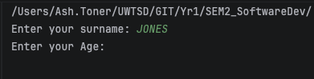

Result: Did the programme behave as expected ie syntactically and logically correct?
YES
Validation for surname includes being not null, to my knowledge “JONES” is a valid input that is not null and so the program continued.

Test: Surname ii. Leave blank
Screenshot(s) of output:
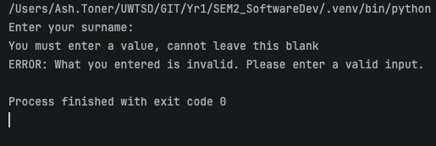

Result: Did the programme behave as expected ie syntactically and logically correct?
YES
Surname was left blank; it failed the validation (null checking) and so the user was alerted and the program stopped.

Null checking function called:
def check_not_null(value_entered):

Test: Surname iii. Enter A
Screenshot(s) of output:
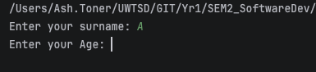
Result: Did the programme behave as expected ie syntactically and logically correct?
YES
This test is a bit of a grey area because legally it is possible to have a surname that is one letter long, it’s very rare, but legal. In my opinion validating against this would be unfair to those who genuinely have one letter surnames and so I deemed this a valid input, and it passed the test.

Test: Surname iv. Enter 123
Screenshot(s) of output:
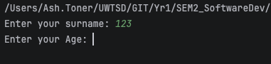
Result: Did the programme behave as expected ie syntactically and logically correct?
NO
123 is an invalid surname as legally you are not allowed any special characters except “ ‘ “, so this test fails. I should have added validation to see if the input contained numbers.

National Insurance Number
Test: National Insurance Number i. Enter PE534121B
Screenshot(s) of output:
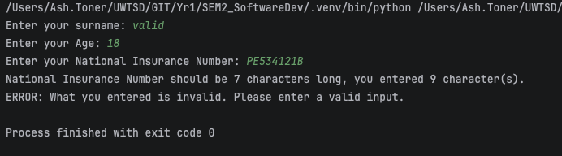
Result: Did the programme behave as expected ie syntactically and logically correct?
NO
When validating this input, I made an error with the correct length. I set the correct length to 7 instead of 9, probably down to poor googling skills. My code throws an error if the length is not 7:
if len(NINumberInput) != 7:
Changing this number to 9 would solve this issue and make the program correct but for this reason the test fails.

Test: National Insurance Number ii. Leave blank
Screenshot(s) of output:
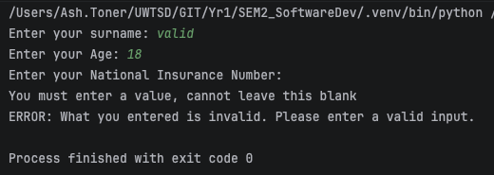
Result: Did the programme behave as expected ie syntactically and logically correct?
YES
National Insurance Number was left blank; it failed the validation (null checking) and so the user was alerted and the program stopped.

Test: : National Insurance Number iii. Enter AB11223344556677 (too long)
Screenshot(s) of output:
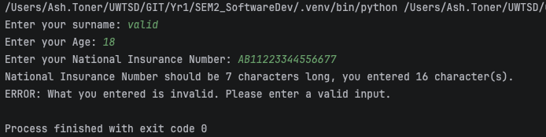
Result: Did the programme behave as expected ie syntactically and logically correct?
YES
Ignoring the fact that I got the correct length wrong in my error message, this behaves correctly. Length checking validation fails as it should and outputs for many characters you inputted back to the user to make it easier for them to diagnose why their input was wrong.

Test: National Insurance Number iv. Enter 22PE4088A (wrong format)
Screenshot(s) of output:
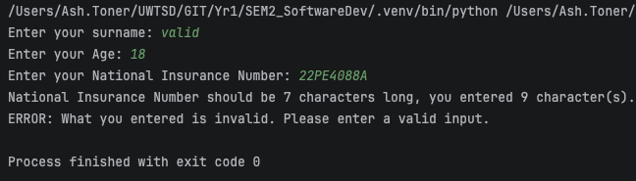
Result: Did the programme behave as expected ie syntactically and logically correct?
NO
This test for an invalid format failed but not for the reason it should have. It failed again because I incorrectly set the correct length to 7 in my length checking. However, if this was correctly set to 9 my program only checks for length, so this would have gone through incorrectly as a valid input.

To fix this I could try implementing a regular expression (if available in python) or do some research in to in built functions to help with this problem. If there are none available, I could try splitting up the input into an array and checking to see if the data types match what are expected for each character. Will see what conclusion I come to in the improvements, if improving on this is within my ability.

Age
Test: Age i. Enter 34
Screenshot(s) of output:
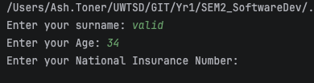
Result: Did the programme behave as expected ie syntactically and logically correct?
YES
I validated age in 2 functions; the null checking used on all inputs and a function called:
def check_valid_age(number_entered):
which checks if the value entered is more than or equal to 0 (because 0 is a valid age in my opinion) and under 131. Since the age is not null and between 0 and 130 inclusively, it passes.

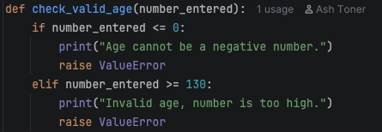
(Ignore my name next to the code, it’s all stored in GitHub)

Test: Age ii. Enter 150
Screenshot(s) of output:
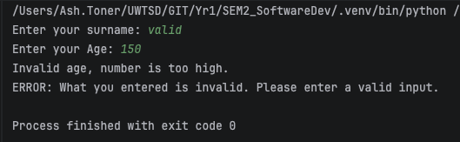
Result: Did the programme behave as expected ie syntactically and logically correct?
YES
Again, 150 is not null and is over 131 so fails the validation I mentioned previously and passes the test.

Test: Age iii. Enter -4
Screenshot(s) of output:
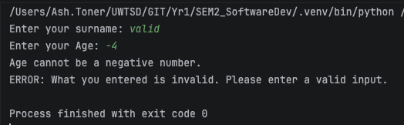
Result: Did the programme behave as expected ie syntactically and logically correct?
YES
Any negative ages inputted will fail the validation of the input being over 0, so this failed the validation and passed the test.

Test: Age iv. Enter a letter
Screenshot(s) of output:
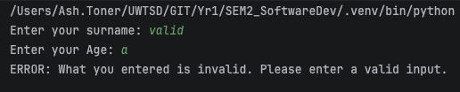
Result: Did the programme behave as expected ie syntactically and logically correct?
YES
This error is caught differently, since a letter can’t be parsed as a number using int(), this automatically throws a ValueError in python. To handle this, the error is caught (as this code is called in a try except block) and that is the error message that gets printed out. This is a caught error and inputs a message back to the user and so passes the test.

Working Hours
Test: Working Hours i. Enter 37.5
Screenshot(s) of output:
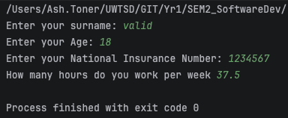
Result: Did the programme behave as expected ie syntactically and logically correct?
YES
The only validation I have on this input is null checking and error handling for parsing it as a floating-point number. As 37.5 is not null and a floating-point number, it passes the test.

Test: Working Hours ii. Enter 150
Screenshot(s) of output:
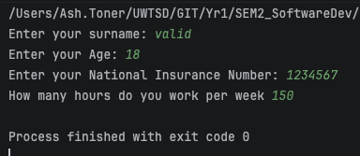
Result: Did the programme behave as expected ie syntactically and logically correct?
NO
As I said previously, the only criteria this input has to meet is being a valid floating-point number and not being null. 150 is both of those things but realistically is way too high to be valid. There are only 168 hours in a week so working these many hours is way over the legal weekly total of 48 (set by the UK GOV). Even though this result is syntactically valid, it fails the test.

Test: Working Hours iii. Enter 0
Screenshot(s) of output:
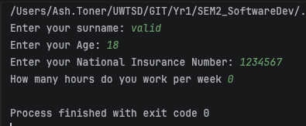
Result: Did the programme behave as expected ie syntactically and logically correct?
YES
0 is both not null and a valid floating-point number as so passes the validation. Even though this question is about hours worked and the input is less than 1, I think 0 is still a valid input as someone may not be working or may have not worked at all for a week, so this passes the test.

Test: Working Hours iv. Enter -2
Screenshot(s) of output:
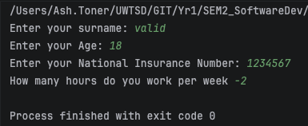
Result: Did the programme behave as expected ie syntactically and logically correct?
NO
-2 is again not null and also a valid floating-point number and so passes the validation. -2 however is not a valid input and therefore this test does not pass. I should add validation to make sure this number is more than or equal to 0.

- Consider the results of the above tests and revisit your code in order to solve the problems. (Note: you may not be able to solve all of them, but solve as many as you can.)

What I did:
- Added validation to cover all points mentioned in this testing.
- Used while loops to give the user another chance to input the right data into the program instead of terminating the program
- Program will not finish until it has successful inputs

Surname:
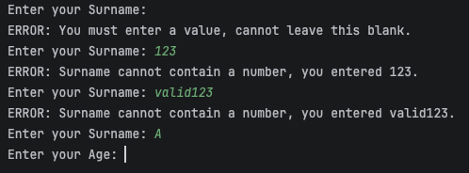
- Checks a value is entered
- checks value doesn’t contain a number
- Accepts strings with 1 letter or less

Age:
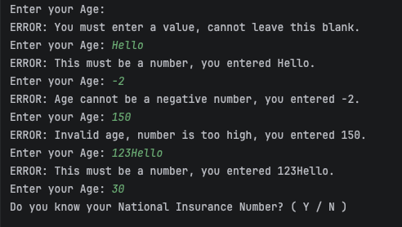
- Checks a value is entered
- Checks it can be converted to a type int
- Checks age is between 0 and 130 (inclusive)
- Accepts only integers between 0 and 130 (inclusive)

NINumber:

No
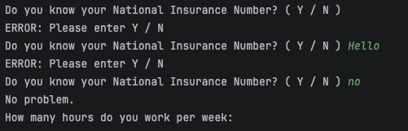
- Null checking
- Works for no, NO, No, nO, n, N
- All Yes / No inputs have validation so you can only enter Y, yes, N, no (capital letters too)
- Program carries on

Yes
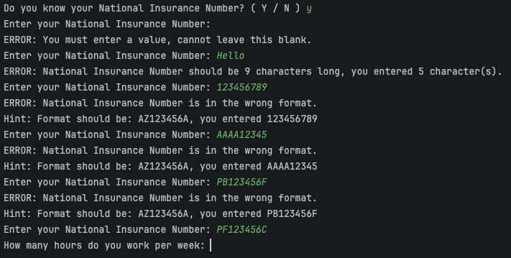
- Works for yes, Yes, YES, YEs, YeS, yES, yEs, yeS, y, Y
- Specific error message if length is not correct
- Only accepts correct format of AA123456A

Work Hours:
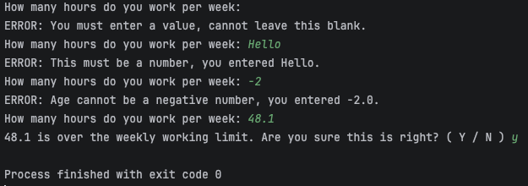
- Null checking
- Only accepts integers and floating-point numbers above -1
- If over 48, asks if the user is sure (because that’s over the legal limit), if no, asks again.

Paste your revised code here:

import re
def check_yes_no(value_entered):
if value_entered not in ("y", "yes", "n", "no"):
print("ERROR: Please enter Y / N")
return False
return True
def check_not_null(value_entered):
if value_entered == "":
print("ERROR: You must enter a value, cannot leave this blank.")
return False
return True
def check_valid_string(value_entered):
if any(char.isdigit() for char in value_entered):
print(f"ERROR: Surname cannot contain a number, you entered {value_entered}.")
return False
return True
def check_valid_number(number_entered, age_hours):
try:
match age_hours:
case "age":
valid_age = int(number_entered)
return check_valid_age(valid_age)
case "hours":
valid_hours = float(number_entered)
return check_valid_hours(valid_hours)
except ValueError:
# if what entered is not a number, error
print(f"ERROR: This must be a number, you entered {number_entered}.")
return False
def check_valid_age(valid_number):
if valid_number < 0:
print(f"ERROR: Age cannot be a negative number, you entered {valid_number}.")
return False
elif valid_number >= 130:
print(f"ERROR: Invalid age, number is too high, you entered {valid_number}.")
return False
return True
def check_valid_hours(valid_number):
if valid_number < 0.0:
print(f"ERROR: Hours cannot be a negative number, you entered {valid_number}.")
return False
elif valid_number >= 84.0: # 84.0 being 12 hours a day, 7 days a week
print(f"ERROR: This number is too high, you entered {valid_number}.")
return False
elif valid_number >= 48.0:
check = "is over the weekly working limit. Are you sure this is right? ( Y / N ) "
check_input = input(f"{valid_number} {check}").lower()
while not check_yes_no(check_input):
check_input = input(f"{valid_number} {check}").lower()
if check_input == "n" or check_input == "no":
return False
return True
def check_valid_ni_number(value_entered):
if len(value_entered) != 9: # length check for National Insurance Number, is always 9
print(
f"ERROR: National Insurance Number should be 9 characters long, you entered {len(value_entered)} character(s).")
return False
# RegEx (imported re)
ni_number_pattern = re.compile(
r"[A-Z]{2}" # 2 letters A - Z
r"\d{6}" # 6 digits
r"[A-D]", # 1 letter A - D
re.IGNORECASE
)
does_match = bool(ni_number_pattern.match(value_entered))
if not does_match:
print("ERROR: National Insurance Number is in the wrong format.")
print(f"Hint: Format should be: AZ123456A, you entered {value_entered}")
return False
return True
# Surname
surname = "Enter your Surname: "
surnameInput = input(surname)
while not check_not_null(surnameInput) or check_valid_string(surnameInput) == False:
surnameInput = input(surname)
# Age
age = "Enter your Age: "
ageInput = input(age)
while not check_not_null(ageInput) or not check_valid_number(ageInput, "age"):
ageInput = input(age)
# NIN
knowNINumber = "Do you know your National Insurance Number? ( Y / N ) "
NINumberCheck = input(knowNINumber).lower()
while not check_yes_no(NINumberCheck):
NINumberCheck = input(knowNINumber).lower()
if NINumberCheck == "yes" or NINumberCheck == "y":
NINumber = "Enter your National Insurance Number: "
NINumberInput = input(NINumber)
while not check_not_null(NINumberInput) or not check_valid_ni_number(NINumberInput):
NINumberInput = input(NINumber)
else:
print("No problem.")
# Work
workingHoursPerWeek = "How many hours do you work per week: "
workingHoursPerWeekInput = input(workingHoursPerWeek)
while not check_not_null(workingHoursPerWeekInput) or not check_valid_number(workingHoursPerWeekInput, "hours"):
workingHoursPerWeekInput = input(workingHoursPerWeek)

