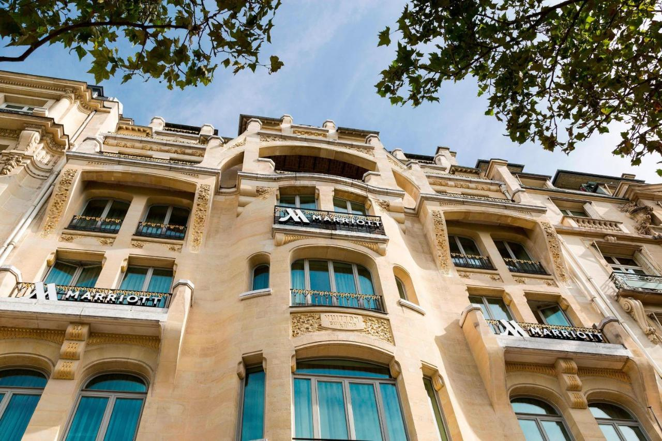
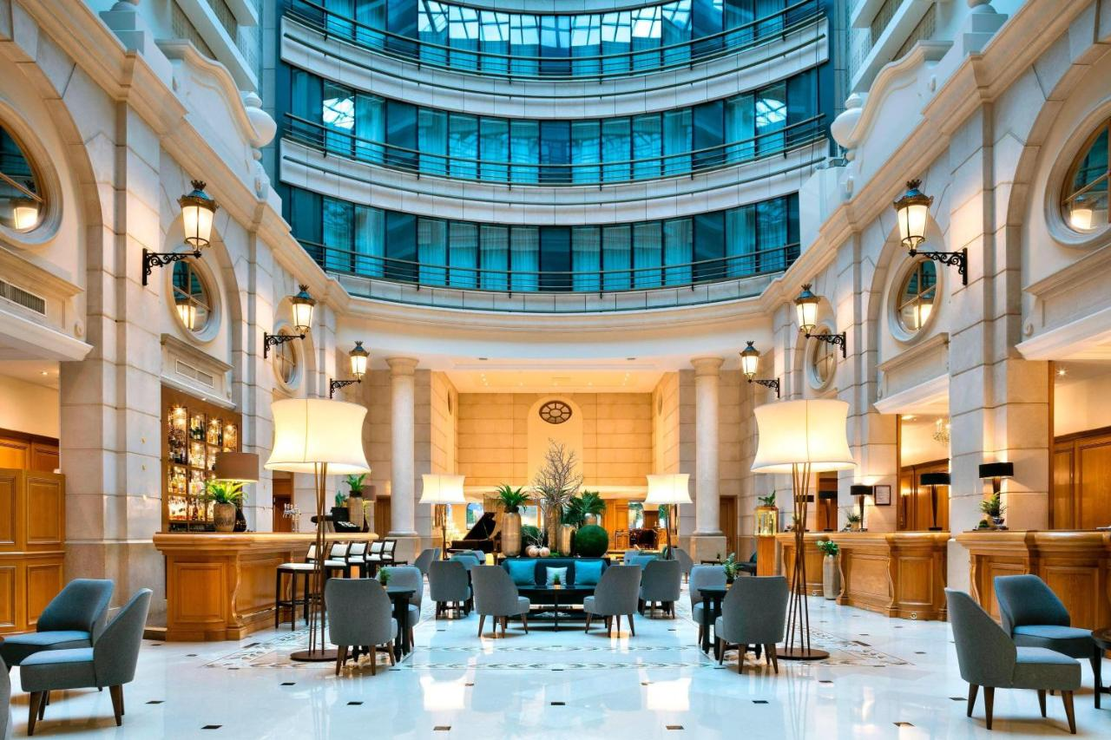
PARIS MARRIOTT CHAMPS ELYSEES HOTEL
Consultancy Report
Student Name: Apurba Das
Student ID: 2107164

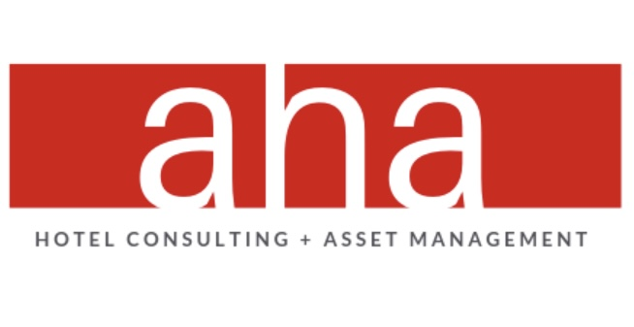

AHA Hotel Consulting

Client Name: Mark Hughes,
General Manager, PARIS MARRIOTT CHAMPS ELYSEES HOTEL
Delivery Date- 17 Nov 2023

Delivered on: 17 February, 2023

Executive summary
This is a consultancy report prepared by the AHA hotel consulting firm for the Paris Marriott Champs Elysees Hotel which is situated in Paris. This hotel is one of the well-known hotels in Paris. The customer rating is also very high in terms of behaviour, management, room service, cleanliness etc (Vansteenwegen et al, 2019). but there have arisen some problems which have not been identified by the hotel itself. So, they hire a consultancy firm so that it can help them to find out the problem and the solutions. The firm had tried its best to find out the problem.
It has identified some issues that need to be resolved. The issues include feedback issues, reputation issues, and income issues. In terms of feedback issues, the customer most of the time gives positive feedback towards the hotel (Vaeztehrani et al, 2015). Some customers also give negative reviews about the hotel such as the room temperature is not warm and the water is not hot in the evening. Most of the people like to stay in the hotel to enjoy their vacation. The reputation of the hotel is very high. But sometimes because of the behaviour of some staff, the reputation of the hotel is decreasing.
At first, the consultancy firm developed many analysis programs to learn more about the strengths and weaknesses of the hotel. It has done a PESTEL analysis to know more about the external environments of the hotel. Whether these factors are favourable to the hotel or not. Most of the factors are favourable for the hotel. Then it has developed a SWOT analysis to know about the strengths and opportunities of the hotel along with the threats and weaknesses. It has shown some threats and weaknesses of the hotel. But most of the factors are favourable to the hotel. Also, it has developed a TOWS analysis which also shows the effect of COVID-19 on the hotel (Watson and D’Annunzio‐Green, 2016).
It has found some problems with the hotel. Such a recruitment process is not good. It hired people without proper knowledge of hospitality and a proper degree of professional training. Also, it does not arrange training programs for its employees so that they can get some training on the guest service of the hotel. Without such knowledge, the guests often feel offended about staying in the hotel (Zakhary et al, 2021). Most of the time even if they come to visit the town they do not intend to stay in the hotel. Rather they switch hotels and stay at another good-rated hotel. Also, there have been some problems in the management. They often do not seem to behave with the guests in a professional way which will ultimately degrade the value of the hotel.
To sort out the problem the hotel needs to take some steps. Otherwise, this business may collapse. This business belongs to a family. So, they deal with the problem more in an emotional way rather than a professional way. First, its recruitment process needs to be changed. While it posts for the job, it should add that those candidates will get preference who have a professional degree or training in hospitality. Also, the promotion activities should also depend on professional training. It should arrange some professional training programs for its current employees so that they can gather some professional knowledge about the guests' service (Wilton, 2016). The promotion depends on the professional training knowledge. So, they feel the need to attend those training programs and want to improve themselves. The hotel needs to make some changes in its management system. Such as- it should change the working hours of the employees, change the overtime, change the uniforms, and involve them in many social activities so that they can balance their work-life.
Those activities are not easy to implement in the hotel. The employees may not accept the changes. They may try to protest themselves. So, the hotel needs to take some steps to prevent such situations. They should not be involved emotionally with the management process that needs to be strictly regulated. They can hire some professional agencies so that the employees can train themselves. Otherwise, if there is a lack of manners and professionalism among the hotel employees, the guests will not feel comfortable staying and their number of complaints will increase. Sometimes salaries may be given upon the appreciation of the guests. This will motivate them to serve the guests in a mannered way. The employees must be given their salary on time (Baum, 2018). There must be available overtime facilities. The owner should mention all the employees as part of the hotel. So, they should encourage all the employees to behave like they are part of the hotel's wellbeing. Proper training programs must be arranged so that the employees can get professional knowledge about the hotel's well-being and apply it. Promotion should be based on the merit and performance of the employees. It will encourage them to work more to gain the promotion.
The cost related to the changes in the management will be around £95,000. The cost for the arrangement of the training program will be around £15,000 and the change in the management will be around £80,000. The time needed for the training program will be around 3 months and for the management changes, it will take around 2 months. The time and amount are being assumed. The cost and time may vary according to the demand and necessity of the hotel and its employees.

Table of Contents
Executive summary 2
Introduction 6
Scope and analysis 8
SWOT analysis 9
PESTEL analysis 10
TOWS analysis 12
Recommendations and changes in management 14
Implementation of the strategies 17
Potential benefits of the recommendations 17
Cost related to the recommendations 18
Action plan 19
Conclusion 21
References 23
Appendices 30

Introduction
The whole report is a description of the consultancy of Paris Marriott Champs Elysees Hotel. This report is based on the compliments and detailed descriptions of the hotel that has received from the customers and users of the hotel services. The France is one of the most famous tourist places in the world (Ayoun and Moreo, 2018). People from all over the world come to this place to enjoy the sight, to stay for business purposes, to study reasons etc. as most of them do not have relatives or maybe they do not feel comfortable staying with their relatives, they want to stay in the hotel. For that reason, they have to find a convenient place to stay comfortably. Hotel is one of the common places to stay in the France. The Paris Marriott Champs Elysees Hotelis situated in the heart of Paris, France (Ashraf and Ani, 2022). This hotel is a 4-star hotel that is very near to Briggate and Trinity Paris Mall. This hotel is near the University of Paris and is about 4.6 km away. So, the students who come to be admitted into the university can stay in the hotel and finish their admission activities. It is about 1.5 km away from First Direct Arena. This hotel has almost 244 air-conditioner rooms for its customers. The hotel has a flat-screen television in every room for its guests (Antony et al, 2014).
There is wireless service in every room and satellite channel so that the customer can enjoy their vacation. The hotel is 10 km away from Paris Bradford International Airport. This hotel is 5 minutes away from the Paris railway. Tea and coffee facilities are available in every room (Armitstead, 2014). The hotel has an on-site restaurant which offers Italian food to its customers. The guests have rated the hotel 8.7 in terms of staff, facilities, comfort, cleanliness and location. The hotel has the finest front desk service and staff behaviour. All the rooms have a small fridge. The executive lounge is free for the guests and the bar is open. The hotel has many tourist places nearby and the guests can easily go there by train or by a walk and enjoy the sights. The hotel has 24-hour security and front desk facilities for its guests (Atkinson and Brander Brown, 2021). The hotel has no parking area but the guests can use the public area to park their car with an exchange of 16 euro per day. The safety facilities include fire extinguishers, CCTV in the outside areas and common areas, smoke alarms, 24-hour security and a safety deposit box.
The hotel has also a fitness centre and the guests can go to the gym. The fee for the breakfast for every person is GBP 17.5. the hotel has everything to disinfect and provides free sanitiser to its guests. After the COVID-19, the safety measures are being ensured strictly. Most of the customers give positive reviews about the hotel staff's behaviour and the rooms are also comfortable for the guests (Baum, 2020). But the hotel has some negative side also. Sometimes the AC does not work so the guests have to face trouble. The behaviour of some staff is also very rude. So, the hotel has appointed a consultancy firm named AHA consultancy firm to review the hotel performance and take necessary steps to improve the performance of the hotel. SWOT and PESTEL analysis will help to assess the performance of the hotel. Also, it will help to find out the weaknesses of the hotel and resolve the issues. The consultancy firm will help to improve the performance of the hotel (Bader and Lababedi, 2017). This consultancy firm is very renowned in the France and will help to resolve the negative issues of the hotel.
Most of the guests gives the positive review about the hotel performance. It has got 8.6 out of 10 rating from the guests. The performance rating of the hotel from the guests are given below:

Chart 01: Hotel perfromance chart.
Source: www.etrip.net.

Scope and analysis
Paris Marriott Champs Elysees Hotel
This hotel is one of the nearest hotels to Paris International Airport which is 10 km away from the hotel. The guests can easily find the hotel just after landing in Paris to enjoy their vacation and scenery. The hotel has some services that provide the best attraction towards its customers. The hotel is very near to the railway stations. So, the guests can easily use the rail to go travelling and enjoy their vacation. Sometimes the staff are not behaving in the right way towards their customers (Bohne, 2021). Also, sometimes the behaviour of the front desk employees is not friendly and warm towards its customers. The issues that the hotel has and that need to be resolved identified by the agency are- feedback issues, income issues, reputation issues and scope to grow.
Feedback issues: the customer most of the time gives positive feedback towards the hotel on many hotel booking apps such as- etrip, toobus, agoda etc. Most of the time the customer gives feedback regarding the hotels are- the hotel has the best locations for shopping, bars and restaurants, the staff are amazing and friendly towards its customers, the breakfast is great, and the service at the hotel is warm (Baum and Odgers, 2021). Some customers also give negative reviews about the hotel. The room temperature is not warm and the water is not hot in the evening. As the France is one of the cool temperature areas. Hot water is mostly needed in the evening. But during the evening the water is not hot and it makes it inconvenient for its customers.
Reputation issues: The behaviour of the hotel staff and front desks is very warm and friendly (Baum, 2021). So, most of the people like to stay in the hotel to enjoy their vacation. The reputation of the hotel is very high. But sometimes because of the behaviour of some staff, the reputation of the hotel is decreasing. This is becoming alarming for the future development of the hotel. This needs to be resolved by the hotel management. Otherwise, the guests will not feel comfortable to stay in the hotel.
Income issues: the purpose of the hotel business or any kind of business is to earn profit by giving the best service towards its guests and customers. The hotel always tries to give the best service to its customers (Bayoumi et al., 2019). Although it is a four-star hotel, the management always tries to give the guests a five-star hotel-like service. Obviously, for that reason, the customers always enjoy staying in the hotel and enjoying their vacation. It is a matter of expense for the hotel management. They should also regain the income from the customer. But often they have to face loss as they do not manage the required number of guests. So, the income is a big issue for the hotel (Burgess, 2017).
Scope to grow: the competition in the hotel industry is very high in Paris. To cope with the competition, the hotel needs to give the best service to its customers with a minimum budget. But often, it is very tough for the hotel management to give the best service with a minimum budget (Baltz et al, 2017). So, they have to cut off their service such as they cannot offer complimentary breakfast, good room furniture etc. to its guest. It will reduce the chance of future growth of the hotel. This increasing competition will ultimately impact the future growth of the hotel.

SWOT analysis
SWOT analysis comprises the analysis of the Strengths, weaknesses, Opportunities and Threats of the organization. It is usually used to analyse the internal factors of the hotel. The AHA consultancy firm has analysed the SWOT analysis of the hotel and found out the problems of the hotel. The analysis is given below:

Strengths | Weaknesses
- High employment.  - Famous in Paris.  - Giving the best service despite being a 4-star hotel. | - Hotel is 10 km away from airport.  - Reducing international brand image.  - Employees are being unprofessional and lack of training scope (Brotherton, 2017).
Opportunities | Threats
- Competition among luxury hotels are low.  - Chance of being recognized worldwide.  - Different innovative technologies used such as digital CX technology helps to measure the customer satisfaction through app named Mariott Bonvoy app Tsui, mobile key and check-in, use of chatbots etc. | - New laws regarding tourism in the world such as- travel restriction based on religion, do not required quarantine unless the symptoms of COVID etc.  - Competition may increase in future.  - COVID-19 has negatively impacted.
Table 01: SWOT analysis.
From the above SWOT analysis of the hotel, it can be seen that the hotel has much scope to grow. It has more strengths and opportunities options rather than threats and weaknesses (Connell, 2019). As the competition is not so big in Paris city, the hotel has more opportunity to grow and be recognized worldwide. However, due to the lack of employee training, they often behave unprofessionally with the guests. The COVID-19 effect also affects the growth of the hotel. The hotel should use the opportunities to grow in the future (Chytiri, 2015).
The SWOT analysis shows that the hotel has the opportunities to grow in the future. It should use its strengths and opportunities to develop the service in the future.

PESTEL analysis
PESTEL analysis usually discusses the external environment of the organization and shows how it is related to the growth of the organization (Rahman, 2021). The AHA consultancy firm has developed a PESTEL analysis and wants to show the external environment of the hotel. The PESTEL analysis of the hotel is described below:
PESTEL factors | Impact of those factors
Political factors | - Tourism industry regulation change.  - New taxation policy implemented.  - Real estate policy changes.
Economic factors | - Growth in the local economy due to the investment by the tourists (Carlo, 2021).  - Retailers and pharmacies also benefit.  - The hospitality industry of France employed 3.2 million people directly and 2.8 million indirectly.  - The hospitality Industry represents 9% of France employment, 6% of businesses and, 5% of the France GDP.  - Impact on the profit margin of many restaurants.
Social factors | - Increasing preference for private accommodation like Airbnb (Collier and Gregory, 2015).  - Negative impacts on the industry such as religion restriction, racism etc.  - High labour turnover especially for restaurants.
Technological elements | - Available online reservation.  - Online food delivery system.  - Automated services.  - Mobile apps are available for many hotels to reserve.
Legal factors | - Many laws and regulations are related to opening a hotel.  - Must comply with food hygiene.  - Togh food safety laws (Donaghy and McMahon‐Beattie, 2018).  - Must comply with gas safety regulations 1988.
Environmental factors | - Increased pressure on the environment.  - Massive use of water, fuel, and electricity.  - Waste of many natural sources.
Table 02: PESTEL analysis.
The PESTEL analysis of the firm shows many external opportunities and threats to the hotel industry. PESTEL analysis is related to the analysis of the whole industry to ensure the possibility of future growth of the particular hotel (Davies, 2019). It has a positive impact on the growth of the hotel. The Political factors of the hotel are really on the positive side of the hotel. The political situation is stable in the France and the Prime Minister is positive towards the hotel industry. The Economic factors are booming in the country. The hotel industry is becoming a big part of the economy of the country. Directly and indirectly, almost 6 million people are being employed by the hotel industry (Davidson and Wang, 2021). Also, 5% of GDP comes from the hotel industry income.
The Social factors are also positive for the hotel industry. People from all over the world come to the France to enjoy their vacation. So, there is a mixture of cultures from all over the world. Many students are getting jobs in restaurants and fulfilling their studies (Essawy, 2015). The technology is advancing in the tourism industry. Many hotels have their mobile app and people can book their chosen room. Also, online food delivery system is also available for the customers and they do not need to go outside to enjoy their food.
Legal factors sometimes hurt the hotel industry. Many laws and regulations have to be followed to open a new hotel. The hotel needs to cope with the hygiene factors and with the gas regulation of 1988 (Field, 2021). The Environmental factors are very strictly followed in the France. Sometimes the hotel industry puts negative pressure on the environment. Many sources of energy such as- electricity, gas, fuel, internet etc. are needed to run a hotel. Most of the energy is wasted in the hotel and obviously, it is not a positive sign for the environment. Rather the hotel can take initiative for green energy and renewable energy such as- Solar energy, combination of power and heat, geothermal, wind energy, biofuel etc.
The PESTEL analysis shows that the external factors are favourable for the hotel. The hotel has much potential for growth in the future (Gonzalez et al 2019).

TOWS analysis
This approach is a detailed version of the SWOT analysis. It is a very important tool for businesses to make strategic decisions. The AHA consultancy firm has developed a TOWS analysis on the Paris Marriott Hotel. This is given below:

 | Internal Strengths (S)  - Quality is very high.  - Service is good.  - Long-term goodwill and reputation. | Internal Weaknesses (W)  - Increasing the expansion unnecessarily.  - Run as a family business.
External Opportunities (O)  - Increasing demand after COVID-19.  - Increasing demand in the global market.  - Increasing revenue after COVID-19. | Strengths-Weaknesses (SO)  As people face lockdowns for a longer period, they will visit many places and the hotel should capture their attraction (Gregoric, 2019). | Weaknesses-Opportunities (WO)  Safety must be ensured after the pandemic COVID-19. Sometimes even after the vaccine, the problem may not diminish. So, proper health guidelines must be followed,
External Threats (T)  - COVID-19 effect does not stop.  - Increasing competition. | Strengths-Threats (ST)  Running the hotel most profitably and following the strategies to cover the loss after COVID-19 (Hoque, 2019). | Weaknesses-Threats (WT)  Following all the health steps and precautions to protect health from COVID-19 and safe hotel stay.
Table 03: TOWS analysis.
From the analysis, it can be seen that the hotel has much scope to grow. There are many aspects that the hotel can improve. The internal strengths and weaknesses of the hotel are very important to improving the service of the hotel. The hotel always provides the best quality to its customers. After the COVID-19 effect, the hotel has to face decrement in the profit (Hattangadi, 2023). The weakness of the hotel is they run the business as a family business.
It is the main weakness of the hotel. The external opportunities for the hotel are that the profit is increasing as people want to travel after the lockdown. Global market demand for the hotel industry is increasing and increasing in profit. The competition is increasing and it has become a threat.

Recommendations and changes in management
There are many problems that the hotel is facing. All the problems have been identified by the consultancy firm. The problem is seen both in internal and external factors. The problem mostly happens after the COVID-19. During COVID-19, the hotel industry has been collapsed. So, the hotel has to face many internal weaknesses. The hotel has to reduce the number of employees as the number of guests has decreased due to COVID-19. After COVID-19, the tourism industry has been booming and many tourists come to visit places in different parts of the world (Jeffrey et al, 2021). The France is one of the main places of attraction for tourists. Paris is also famous for the tourists. Many people come to visit this place. The Paris Marriott Champs Elysees Hotel is very famous for its services. Although, it is a four-star hotel. But it gives the services like a five-star hotel. It is a matter of increasing cost. So, the consultancy firm has developed an analysis of the hotel. It has found out some problems that need to be resolved. The issues that need to be resolved and the recommendations are given below:
Change in the recruitment process: the hotel has to stop its operation due to COVID-19. It has to cut off its many employees as tourists are not allowed during the COVID time. After the COVID, tourists became very interested in visiting many places. France is the most common place to visit. Paris is also beautiful and it attracts many guests to visit (Jones, 2018). As the hotel is very near to the railway and airport, people often come to stay here to enjoy their vacation. So, the hotel management has to appoint new employees. During that time, they were in a rush and they appointed people without judging them properly.
Proper care must be given during the reservation time. The hotel must ensure the proper skilled employees. Especially appoint those employees who have previous experience working in that field.
Arranging training program: The hotel can arrange some training programs for the employees so that they know how to treat the guests properly so that the guests become satisfied and come to stay in the hotel very often. The hotel can arrange its training program at its own cost (Jones and Comfort, 2021). It is costly to arrange such a training program which will ultimately increase the cost of the hotel.
So, they can hire some professional agencies so that the employees can train themselves. Otherwise, if there is a lack of manners and professionalism among the hotel employees, the guests will not feel comfortable staying and their number of complaints will increase (Kulakhmetova et al, 2022). Proper training will help the employees to know how to treat the guests in a mannered way, always ready to serve them, and always care to give them the best service. In a word, the guests must be satisfied and they should come to visit the place more and more. Also, there is a solution to this problem hiring employees who have a professional degree or professional training.
It will give them extra profit. Sometimes the training is not enough to make the employees more professional. They should be more careful and use this gathered learning in their workforce (Ladkin and Riley, 2016). Otherwise, such professional degree, experience or training will not work out. So, the organization must be careful while implementing these techniques on the employees.
Change in the management: Running a business is very tough nowadays. Especially hotel business is especially tough to continue. The competition is very high. Also, the hotel business needs to be followed by many rules and regulations. It has many costs to run the hotel (Ladkin and Riley, 2022). Even if the hotel does not get the proper number of guests, it has to pay off all of its employees and pay for the servicing.
The hotel management have to renovate their hotel according to the preferences of the guests which increases the cost. But if such issues are handled emotionally, it will ultimately increase the cost. So, those issues need to be handled professionally. The management of the hotel sometimes collapses (Lewis and McCann, 2014). The employees often do not behave properly as most of them, are recruited from relatives.
Such relatives do not have proper degrees related to the profession and lack proper training and experience. They do not behave with the guests properly. so, most often guests become dissatisfied with the hotel management and they do not come back to the hotel if they come to visit the place more often but they do not stay in the hotel rather than choosing another hotel to stay. So, it needs a huge change in the management process. The hotel owner needs to appoint some professional people on the management board to run the hotel (Larmour, 2018).
They should not be involved emotionally with the management process that needs to be strictly regulated. As the owner of the people are family. So, management often feels demotivated to serve the guests properly. They think that their job is secure as the hotel management are their relatives. Some changes in the management need to be followed. They should appoint employees who have professional degrees in the management of hotels. Nowadays this degree is very common among students. Also, they should hire those who have previous experience (Ladkin and Juwaheer, 2020). A proper budget is being given to the management and the management should pay off the cost within the budget.
They can change in the management process such as change in the salary and overtime process. Sometimes salaries may be given upon the appreciation of the guests. This will motivate them to serve the guests in a mannered way.
Changes in their work time can also be implemented. The night shift is more important than the day shift. Guests most often come to the hotel during the night time. So, services must be available during the night. Also, they go to visit the place during the day time. So, it does not need more employees during this time (Li et al, 2013). Also, overtime packages must be implemented to attract employees to work hard.
Change in the uniforms will be a great change in the management process. There are many departments in a hotel. They have room service employees, food delivery employees, chefs, front desk employees, upper-level employees etc different departments have their uniforms (Saleh and Zohry, 2022). Otherwise, the guests may feel embarrassed if they call upon upper-level employees for their room service if they do not properly recognize them. So, different uniforms will help the guests to understand which service and employees they need. They can quickly recognize the service provider.

Implementation of the strategies
The management will not agree with every decision or recommendation that the hotel owner will take. The management must resolve the issue. The management must take the necessary steps so that the employees can follow the changes. The steps that the hotel owner can take are:
The owner of the hotel can call for a board meeting with all the employees and tell them about all the changes that they want to make (Schlup, 2015). They should tell them it is for the wellbeing of the hotel.
The employees must be given their salary on time. There must be available overtime facilities.
The owner should mention all the employees as part of the hotel. So, they should encourage all the employees to behave like they are part of the hotel's wellbeing.
Proper training programs must be arranged so that the employees can get professional knowledge about the hotel's well-being and apply it.
Promotion should be based on the merit and performance of the employees. It will encourage them to work more to gain the promotion (Steed and Gu, 2019).
The management should appoint employees who have professional degrees in hospitality management (Sigala, 2019). They will be more professional in handling any worsening situation than the family owner.
The hotel owner should also give the employees proper vacation so that they can enjoy their family time. They should balance their work life. It will ultimately encourage them.

Potential benefits of the recommendations
Such recommendations must be followed by the hotel owner if they want to grow in the future. They should encourage all the employees to follow the guidelines. This will help the hotel to attract more guests. If all the internal and external factors of the hotel are under control and follow the regulations of the hotel, obviously guests will feel more comfortable to stay in the hotel and take the services.
The recommended strategies will help the hotel a lot. Sometimes only a furnished hotel does not attract tourists (Rahimi and Kozak, 2017). Also, the behaviour of the management, staff, hotel room environment, room service, and cleaning will attract tourists. Usually, tourists do not go to the same hotel over time. They want to explore new hotels and new places. But if the behaviour of the hotel is good enough, the tourist if come to this place again.
They will want to stay in that particular hotel. Even if any of the relatives of them come to visit the place, they recommend the hotel to stay. This will increase the goodwill of the hotel over a long period. Also, the timely services that they get from the hotel will attract them to stay more days in the hotel (Roubi and Litteljohn, 2014). The friendly behaviour of the hotel staff and front desk employees will also attract them and they want to stay in the hotel more often.
The more tourists stay in the hotel, the more earning capacity of the hotel will increase. This will ultimately help the employees to raise their salaries and enjoy their life. Also, a proper budget will help to cut off the cost of the hotel and use this defined budget for the improvement of the hotel. Otherwise, there has been a scope of corruption in the cost.

Cost related to the recommendations
The size of the hotel is not small. Many employees work in the hotel. Their salary is a huge cost for the hotel owner. The renovation cost is also very high for the hotel. After such activities, if the hotel has to arrange a training program for the employees it will increase the cost of the hotel. Also, change in the management will also increase the cost (Rahman, 2021). The size of the hotel may be around 10 million euros. The training cost may rise to 15,000 euros for all the employees and a change in the management may cost 80,000 euro. The cost is the estimated cost. It may vary according to the market price of many supplies.

Action plan
The recommendations have been given by the consultancy firm. Now, it’s time to implement those solutions for the improvement of the hotel. This action plan will describe the solutions, their cost, detailed description, and the time needed to accomplish the plan. There are two actions that the hotel needs to take (Riley, 2020). One is to arrange some training program so that the employee's skills can be developed to give the best service towards its guests, other is to take measures to make a change in the management. Both of the process is quite costly for the hotel. The action plan is given below:
Number | Problem | Solution | Desired outcome | Time scale | Completion date | Planned budget
01. | Low professional knowledge of the employees. | Arrange some professional training programs to train them to give the guests the best services. | After completing the professional training, the employees will be more conscious about the guest service and improve the brand image. | 3 months | 21/01/2024 | £ 15,000
02. | Low-key management, | Change in the major feature of the management. Such as hiring professional employees, changing over time, changing working hours, changing uniforms etc. (Rousaki and Alcott, 2016) | The employees become more professional, they can balance their work-life, their social life will improve and they become more dedicated to giving the best services to the guests. | 2 months | 21/12/2023 | £ 80,000
Table 04: Action plan.
Here the hotel can change its regular management and arrange some professional training for employees so that the employees can give the required services towards its guests. This plan must be actioned within the stipulated time. Although the budget for the change in management is higher than the arranging the training program. The training program is a fixed cost for the hotel. However, change in the management is not a fixed cost. This cost may vary over time as the change in the management is a continuous process (Proctor, 2020). This budgeted cost is based on the assumption. This cost may change according to the requirements of the hotel. The budget in total for these changes is around £ 95,000. This cost may change according to the time and needs of the hotel.

Conclusion
The whole report consists of the problem identification of the Paris Marriott Champs Elysees Hotel and finding a solution. The hotel is very renowned in Paris. It provides services towards its guests like 4-star and 5-star hotels. This hotel is very near to the railway and airport of Paris. So, guests often visit this place and stay in the hotel. Most of the guests are very satisfied with the hotel management service. The hotel rooms are very spacious. The employees are very friendly and cooperative towards their guests. But as the hotel is run like a family business. They often deal with any situation emotionally rather than professionally (Papadopoulos et al, 2021). The employees are being appointed without proper training and professional degree. This will ultimately degrade the services of the hotel. Also, the hotel needs some changes in the management. For that reason, this hotel consults with the AHA consultancy firm so that it can find the solution with a proper budget.
The firm have developed a PESTEL analysis. Also, the firm has developed a SWOT analysis to know about the internal strengths and weaknesses of the hotel. The strengths and opportunities are higher than the weaknesses and threats (McGunnigle et al, 2020). Also, the firm has analysed the TWOS analysis which is a detailed version of the SWOT analysis. The consultancy firm also showed many ways the firm will follow the recommendations that have been given by the consultancy firm.
This consultancy firm tried its best to find out the solutions and budget to resolve these issues. First, its recruitment process needs to be changed. It should hire those employees who have a professional hospitality degree and proper training. It should arrange a training program for its current employees. This will maybe cost 15,000 euro and the time needed to execute this plan is 3 months. Also, the change in the management such as changing working hours, changing uniforms, recruiting skilled employees, changing overtime etc. will ultimately cost £80,000. The total cost will be around £95,000. This cost may vary according to the need and time of the hotel.
It is not easy for the hotel to change the whole nature and employees of the hotel within a short period (Mullins and Davies, 2021.). It takes a lot of time to change any current situation. The employees may not agree with the changes. So, this situation must be handled with great care and in a strategic way.
It is a great pleasure for the consultancy firm to work with such a renowned hotel. The firm has tried its best to find the problem and give the best solutions along with the budget. Also, it has arranged a proper action plan with the required budget and time. We think that the relationship that we have built may continue in future and we are ready to give you the best service whenever you need it (Lockyer and Scholarios, 2018). We are extremely sorry for any kind of unwanted situations that may arise due to our unwanted fault. We think such unavoidable fault may not hamper our future relationship.

References
Ayoun, B.M. and Moreo, P.J., 2018. The influence of the cultural dimension of uncertainty avoidance on business strategy development: A cross-national study of hotel managers. International Journal of Hospitality Management, 27(1), pp.65-75.
Ashraf, R. and Ani, F.B., 2022. Role of LinkedIn Marketing in Recruitment and Selection Practices in the Hotel Industry. Transnational Marketing Journal, 10(3), pp.607-622.
Antony, J., Jiju Antony, F. and Ghosh, S., 2014. Evaluating service quality in a France hotel chain: a case study. International Journal of Contemporary Hospitality Management, 16(6), pp.380-384.
Armitstead, M., 2014. Hotel management and operations options: Intellectual capital versus financial capital. Journal of retail & leisure property, 3, pp.299-306.
Atkinson, H. and Brander Brown, J., 2021. Rethinking performance measures: assessing progress in France hotels. International Journal of Contemporary Hospitality Management, 13(3), pp.128-136.
Baum, T., 2020. Competencies for Hotel Management: Industry Expectations ofEducation. International Journal of Contemporary Hospitality Management, 2(4).
Bader, E. and Lababedi, A., 2017. Hotel management contracts in Europe. Journal of retail & leisure property, 6, pp.171-179.
Bohne, H., 2021. Recruiting for luxury: Case studies of luxury hotel brands and their co-operative activities for recruiting. Research in Hospitality Management, 11(1), pp.45-52.
Baum, T. and Odgers, P., 2021. Benchmarking best practice in hotel front office: the Western European experience. Journal of Quality Assurance in Hospitality & Tourism, 2(3-4), pp.93-109.
Baum, T., 2018. The US and the France: Comparing expectations of management trainees. The Cornell Hotel and Restaurant Administration Quarterly, 32(2), pp.79-84.
Baum, T., 2021. Management Trainees in the Hotel Industry: What Do ManagersExpect?. Journal of European Industrial Training, 15(2).
Bayoumi, A.E.M., Saleh, M., Atiya, A.F. and Aziz, H.A., 2019. Dynamic pricing for hotel revenue management using price multipliers. Journal of revenue and pricing management, 12, pp.271-285.
Burgess, C., 2017. Do hotel managers have sufficient financial skills to help them manage their areas?. International Journal of Contemporary Hospitality Management, 19(3), pp.188-200.
Baltz, A., El Ouali, M., Jäger, G., Sauerland, V. and Srivastav, A., 2015. Exact and heuristic algorithms for the travelling salesman problem with multiple time windows and hotel selection. Journal of the Operational Research Society, 66, pp.615-626.
Brotherton, B., 2017. Critical success factors in France budget hotel operations. International Journal of Operations & Production Management, 24(9), pp.944-969.
Connell, J., 2019. Branding hotel portfolios. International Journal of Contemporary Hospitality Management, 4(1).
Chytiri, A.P., 2015. Hotel Recruitment and Selection Practices: The case of Greek Hotel Units/Chains Vs Foreign Hotel Units/Chains in Greece (Doctoral dissertation, University of Kent (United Kingdom)).
Carlo, C., 2021. Critical Success Factors in Hotel Companies: A Managerial Perspective. Journal of Tourism and Hospitality Management, 9(2), pp.1-7.
Collier, P. and Gregory, A., 2015. Strategic management accounting: a France hotel sector case study. International Journal of Contemporary Hospitality Management, 7(1), pp.16-21.
Donaghy, K. and McMahon‐Beattie, U., 2018. The impact of yield management on the role of the hotel general manager. Progress in Tourism and Hospitality Research, 4(3), pp.217-228.
Davies, B., 2019. Industrial organization the France hotel sector. Annals of tourism research, 26(2), pp.294-311.
Davidson, M.C. and Wang, Y., 2021. Sustainable labor practices? Hotel human resource managers views on turnover and skill shortages. Journal of Human Resources in Hospitality & Tourism, 10(3), pp.235-253.
Essawy, M., 2015. Testing the usability of hotel websites: the springboard for customer relationship building. Information Technology & Tourism, 8(1), pp.47-70.
Field, H.M., 2021. Financial management implications of hotel management contracts: A France perspective. In Accounting and finance for the international hospitality industry (pp. 261-277). Routledge.
Gonzalez, R., Gasco, J. and Llopis, J., 2019. ICTs in hotel management: a research review. International Journal of Contemporary Hospitality Management, 31(9), pp.3583-3609.
Gregoric, M., 2019. PESTEL analysis of tourism destinations in the perspective of business tourism (MICE). In Faculty of Tourism and Hospitality Management in Opatija. Biennial International Congress. Tourism & Hospitality Industry (p. 551). University of Rijeka, Faculty of Tourism & Hospitality Management.
Hoque, K., 2019. New approaches to HRM in the France hotel industry. Human Resource Management Journal, 9(2).
Hattangadi, V., 2023. SWOT & TOWS are Effective Tools for Strategic Formulation. European Economic Letters (EEL), 13(3), pp.977-981.
Jeffrey, D., Barden, R.R., Buckley, P.J. and Hubbard, N.J., 2021. What makes for a successful hotel? Insights on hotel management following 15 years of hotel occupancy analysis in England. Service Industries Journal, 22(2), pp.73-88.
Jones, T.A., 2018. France hotel operators use of budgetary procedures. International Journal of Contemporary Hospitality Management, 10(3), pp.96-100.
Jones, P. and Comfort, D., 2021. Modern slavery statements and leading France hotel companies. Athens Journal of Tourism, 8(3), pp.147-162.
Kulakhmetova, G., Aktymbayeva, A., Assipova, Z., Baoleer, B. and Koshkimbayeva, U., 2022. Current Problems In The Tourism And Hotel Industry Taking The World's Tourist Cities As An Example. GeoJournal of Tourism and Geosites, 43(3), pp.841-849.
Ladkin, A. and Riley, M., 2016. Mobility and structure in the career paths of France hotel managers: a labour market hybrid of the bureaucratic model?. Tourism Management, 17(6), pp.443-452.
Ladkin, A. and Riley, M., 2022. Hotel management careers: a research update. Tourism Management, 15(3), pp.221-222.
Lewis, B.R. and McCann, P., 2014. Service failure and recovery: evidence from the hotel industry. International journal of contemporary hospitality management, 16(1), pp.6-17.
Larmour, R., 2018. Problems faced by managers in the hotel and catering industry. International Journal of Hospitality Management, 1(1), pp.45-47.
Ladkin, A. and Juwaheer, T.D., 2020. The career paths of hotel general managers in Mauritius. International Journal of Contemporary Hospitality Management, 12(2), pp.119-125.
Li, Y., Wang, B. and Caudillo-Fuentes, L.A., 2013. Modeling a hotel room assignment problem. Journal of Revenue and Pricing Management, 12, pp.120-127.
Lockyer, C. and Scholarios, D., 2018. Selecting hotel staff: why best practice does not always work. International journal of contemporary hospitality management, 16(2), pp.125-135.
Mullins, L. and Davies, I., 2021. What makes for an effective hotel manager?. International Journal of Contemporary Hospitality Management, 3(1).
McGunnigle, P.J. and Jameson, S.M., 2020. HRM in France hotels: a focus on commitment. Employee Relations, 22(4), pp.403-422.
Papadopoulos, O., Lopez‐Andreu, M. and Jamalian, M., 2021. Violation and lack of awareness of employment rights in the United Kingdom's hotel industry: Isolation, fragmentation and barriers to labour enforcement. Industrial Relations Journal, 52(4), pp.315-330.
Proctor, T., 2020. Strategic marketing management for health management: cross impact matrix and TOWS. Journal of Management in Medicine, 14(1), pp.47-56.
Rousaki, B. and Alcott, P., 2016. Exploring the crisis readiness perceptions of hotel managers in the France. Tourism and Hospitality Research, 7(1), pp.27-38.
Riley, M., 2020. The labour retention strategies of France hotel managers. Service Industries Journal, 10(3), pp.614-618.
Rahman, M., 2021. PESTEL analysis of the tourism industry. URL: https://howandwhat. net/pestel-analysis-tourism-industry.
Roubi, S. and Litteljohn, D., 2014. What makes hotel values in the France? A hedonic valuation model. International Journal of Contemporary Hospitality Management, 16(3), pp.175-181.
Rahimi, R. and Kozak, M., 2017. Impact of customer relationship management on customer satisfaction: The case of a budget hotel chain. Journal of travel & tourism marketing, 34(1), pp.40-51.
Sigala, M., 2019. The information and communication technologies productivity impact on the France hotel sector. International journal of operations & production management, 23(10), pp.1224-1245.
Schlup, R., 2015. Hotel management agreements: Balancing the interests of owners and operators. Journal of Retail & Leisure Property, 3, pp.331-342.
Saleh, A.S. and Zohry, M.A.E.F., 2022. Towards A Sustainable Hotel Education (An Analytical Strategic Study at The Faculty of Tourism and Hotels, Mansoura University-TOWS Matrix as A Model). International Journal of Tourism, Archaeology and Hospitality, 2(1), pp.45-74.
Steed, E. and Gu, Z., 2019. Hotel management company forecasting and budgeting practices: a survey‐based analysis. International Journal of Contemporary Hospitality Management, 21(6), pp.676-697.
Vansteenwegen, P., Souffriau, W. and Sörensen, K., 2019. The travelling salesperson problem with hotel selection. Journal of the Operational Research Society, 63, pp.207-217.
Vaeztehrani, A., Modarres, M. and Aref, S., 2015. Developing an integrated revenue management and customer relationship management approach in the hotel industry. Journal of Revenue and Pricing Management, 14, pp.97-119.
Wilton, N., 2016. Strategic choice and organisational context in HRM in the France hotel sector. The Service Industries Journal, 26(8), pp.903-919.
Witt, C.A. and Witt, S.F., 2019. Why productivity in the hotel sector is low. International Journal of Contemporary Hospitality Management, 1(2).
Wong, S.C. and Lee, P.C., 2017. Roles of the hotel training professionals—Perspectives of industry practitioners. International Journal of Hospitality & Tourism Administration, 18(1), pp.61-83.
Wills, J., 2015. The geography of union organising in low‐paid service industries in the France: lessons from the T&G's campaign to unionise the Dorchester Hotel, London. Antipode, 37(1), pp.139-159.
Wilton, N., 2018. The path of least resistance? Choice and constraint in HRM strategy in the France hotel sector. Handbook of hospitality human resources management, pp.291-313.
Watson, S. and D’Annunzio‐Green, N., 2016. Implementing cultural change through human resources: the elusive organization alchemy?. International Journal of Contemporary Hospitality Management, 8(2), pp.25-30.
Welcome to Paris Marriott Champs Elysees Hotel (no date) Paris 5-Star Luxury Hotel - Champs Elysees | Paris Marriott Champs Elysees Hotel. Available at: https://www.marriott.com/hotels/travel/pardt-paris-marriott-champs-elysees-hotel (Accessed: 08 October 2023).
Zakhary, A., Atiya, A.F., El-Shishiny, H. and Gayar, N.E., 2021. Forecasting hotel arrivals and occupancy using Monte Carlo simulation. Journal of Revenue and Pricing Management, 10, pp.344-366.

Appendices


