Programme: Master of Business Administration

Digital Marketing Strategies and Business Performance in the European Retail Industry: A Literature Review

Supervisor: Mudassar Hasan
Student: Adriana Petcu
Student ID: 2126831

Contents

Introduction / Background / Research Problem 3
Scope 4
Research Aim 4
Research Objectives 4
Research Questions 5
Preliminary Literature Search 5
Conceptual Framework 8
Research Methodology 10
Risks 11
Timeline (Gantt Chart) 12
References 13

Introduction / Background / Research Problem

The proliferation of digital technologies has dramatically altered the structure and competitive landscape of European retailing. Many retailing firms utilise digital marketing (such as, social media marketing, search engine optimisation, data analytics and online customer engagement) to enhance business performance, brand image and firm performance (Chaffey and Ellis-Chadwick, 2022). Growing digitalisation of customer interaction has created competitive pressures on retailers to develop advanced digital marketing skills if they wish to continuously grow and retain their customers (Gregory, Ngo and Karavdic, 2019). This suggests that digital marketing has ceased to be an auxiliary tool for promotion and become an essential element of the firm’s performance and competitiveness.
While studies have shown that social media digital marketing strategies have the potential to significantly influence customer experience, brand image and purchase intention (Zollo et al., 2020), despite the growth in digitalisation across Europe, some retailing firms are still unable to derive tangible performance effects from their digital marketing efforts (Dwivedi et al., 2021). Additionally, the unequal application of digital marketing strategies, data analytics and digital capability may lead to disparate effects on firm performance.
Therefore, the overarching research problem of this study is to explore the influence of digital marketing strategies on business performance in European retailing. Through an examination of relevant literatures and digital marketing practices, this study seeks to explore the ways in which digital marketing strategies influence on firm performance and competitiveness in the modern retailing environment.

Scope

The research scope of this study is to provide insights to existing knowledge and literature on the influence of digital marketing strategy on firm performance in the European retail sector. The study aims to make academic and practical contributions by providing some insights into how digital marketing strategy is crucial for business competitiveness, customer value and firm performance in the context of a highly digitalised retail market (Dwivedi et al., 2021; Chaffey and Ellis-Chadwick, 2022).

Research Aim

This study aims to analyse the effect that digital marketing strategies have on the business performance in the retail industry in Europe according to existing studies. More specifically, it will be exploring, drawing on existing literature, the effect of the digital marketing strategies such as social media, e-commerce and data-driven marketing on customer retention, competitiveness and financial performance (Chaffey and Ellis-Chadwick, 2022; Dwivedi et al., 2021).

Research Objectives

To identify the key digital marketing strategies used by the retail industry in Europe based on existing literature.
To critically evaluate, according to existing studies, the effect of digital marketing strategies on the business performance (customer engagement, brand equity and sales growth).
To analyse the influence of digital marketing capabilities and technology on competitive advantage of the retail industry in Europe, supported by existing research (Gregory, Ngo and Karavdic, 2019; Saura, Palos-Sánchez and Cerdá Suárez, 2017).

Research Questions

What key digital marketing strategies are retail businesses in Europe adopting according to existing studies?
What effect do the digital marketing strategies have on business performance factors such as brand value, customer engagement and organisational growth based on previous studies?
According to existing literature, how do digital marketing capabilities and analytics influence competitive advantage and performance in retail businesses?

Preliminary Literature Search

In today’s fast-paced digital world, digital marketing has come to play a critical role in the marketing mix of retail business organisations as a tool to address the rapidly changing nature of the marketplace. As a means of fulfilling the objectives of organisations, digital marketing has become a key element in enhancing customer interaction, developing brand image and improving performance (Chaffey and Ellis-Chadwick, 2022). Digital technologies, e-commerce, social media and big data analytics have come to transform the retail industry in Europe to a large extent and, as a result, digital marketing has been recognized in various researches as an essential variable in the formation of competitive advantage and performance of organisations in the retail industry (Chaffey and Ellis-Chadwick, 2022).
Digital marketing can be defined as ‘achieving marketing objectives through applying digital technologies’ (Chaffey and Ellis-Chadwick, 2022, p. 3) and involves the use of electronic communication to create and circulate tailored messages that are capable of building and maintaining fruitful customer relationships. Chaffey and Ellis-Chadwick (2022) suggest that there are a range of digital marketing activities used to support marketing objectives, including search engine marketing, content marketing, social media marketing and managing online customer relationships. All of these activities enable organisations to reach a wider audience and also gain valuable insights into customer needs and wants. In the retail industry, digital marketing has gained prominence due to the changing needs of customers, who now expect a higher degree of personalisation, integration and customisation.
Among the various digital marketing activities, social media marketing has gained significant importance. Social media marketing involves using online services and platforms such as Facebook, Twitter, LinkedIn and blogs to facilitate dialogs with customers and prospects. Raut and Kulkarni (2020) suggest that SMM enables businesses to interact with their customers in real time. Social media is one of the most commonly used sources of information, and its usage is increasing at a very fast pace.
Studies have also shown that SMM activities are positively correlated with the brand equity of a business organisation. Zollo et al. (2020) found that SMM has a positive influence on brand equity and the effect is further mediated by customer experience and perceived value.
Digital marketing performance measurement is another area of focus in the available literature. Saura, Palos-Sánchez and Cerdá Suárez (2017) have argued that the use of web analytics and key performance indicators (KPIs) is one of the key practices in digital marketing management. The use of web analytics tools enables organisations to measure and evaluate the traffic on their websites. It further helps organisations to understand the online behaviour of their customers, which is essential in satisfying their needs. Apart from measuring the website traffic, KPIs also enable organisations to assess the performance of their website based on various parameters.
The existing literature also points to the significance of the Internet and technology in improving the efficiency of various business processes. Kabadayi, Wang and Wyer (2015) suggest that the adoption and use of the Internet and related digital technologies improve the efficiency of logistics and distribution among small and medium-sized enterprises (SMEs). Digital technology offers various digital platforms to SMEs, and the use of these platforms improves the logistics and distribution efficiency by a reduction in the distribution time and costs. Improved logistics and distribution efficiency further lead to enhanced customer service and satisfaction, which is essential for the long-term survival and success of any business organisation.
In the retail industry, there are a number of challenges that are associated with the implementation of digital marketing strategies. As suggested by Dwivedi et al. (2021), although organisations perceive digital marketing as a strategic tool for organisations to gain a competitive advantage, many organisations find it challenging to incorporate digital tool into their marketing mix. The lack of digital literacy, resources and technical knowledge are among the reasons that hinder the successful implementation of digital marketing strategies. In addition to this, the ever-changing nature of digital environment forces organisations to constantly change and adjust their digital marketing strategies to match with the current trend and technology.
The adoption of digital marketing strategies among small and medium-sized enterprises (SMEs) is among the recent research topics. According to Armiani (2024), digital platform and social media marketing are the most common digital marketing tools utilised by SMEs to widen their market scope and compete with other larger organisations. In particular, digital marketing offers SMEs an affordable promotion channel as well as the access to the global market.
The use of digital marketing strategies to target younger consumers is another area that is recently discussed. As mentioned by Rahman (2015), digital marketing plays a critical role in targeting younger generations particularly Gen Y. The findings suggest that digital marketing campaigns that are specifically designed for digitally connected consumers lead to a higher engagement and interaction with the brands. This is particularly important for the European retail industry as younger generations are the dominant group of digital consumers that have a high tendency to influence the purchasing trend in the industry.
While the significance of digital marketing strategies has been widely discussed in the existing literature, there is still a limited understanding of the influence of digital marketing strategies on the business performance of European retail organisations. Most of the existing studies focused on the implementation of a specific digital marketing tool and its effect on consumer behaviour rather than the strategic influence of digital marketing strategies on organisations’ business performance.

Conceptual Framework

The conceptual framework explains the effect of digital marketing strategies on business performance in the European retail sector. It suggests that digital marketing strategies is a major independent variable that affects a series of intermediate marketing variables, which have subsequent effect on the organisational performance. This framework has been developed based on the existing digital marketing literature that discusses the importance of digital channels for organisations to build customer engagement, brand assets, and competitive advantage (Chaffey and Ellis-Chadwick, 2022; Dwivedi et al., 2021).
The first part of the framework describes that digital marketing strategies is a group of key strategic actions that are undertaken by retail organisations. This includes social media marketing, e-commerce marketing, and data-driven marketing. Social media marketing is one of the digital marketing tools that allows organisations to have direct conversations with customers and build their brand awareness through regular interactions and information sharing (Raut and Kulkarni, 2020).
E-marketing strategies enable organisations to offer shopping experience to their customers and extend the market reach beyond the physical boundaries of brick-and-mortar stores (Gregory, Ngo and Karavdic, 2019). Data-driven marketing is another digital marketing action, which uses digital data and analytics to design targeted marketing campaigns (Saura, Palos-Sánchez and Cerdá Suárez, 2017).
The second part of the framework presents three intermediate variables (i. e. customer engagement, brand equity and data analytics effectiveness) that explain the underlying mechanism for the influence of digital marketing strategies on the business performance. Customer engagement is the extent to which customers interact, communicate and participate with a retail brand in a digital environment. Higher level of customer engagement is likely to build customer trust and loyalty towards the organisation (Zollo et al., 2020). Brand equity is customers’ perception of a brand, which can be created and strengthened through regular and valuable interactions with customers in the digital channels.
The effective use of data analytics in organisations helps them to measure the effectiveness of their marketing actions and modify the marketing strategies accordingly. The last part of the framework shows that the three intermediate variables have an influence on three key business performance variables (i.e. sales performance, customer retention and competitive advantage).
Those organisations that are able to apply digital marketing strategies effectively and use digital analytics to support their marketing actions are likely to achieve better sales performance, higher level of customer retention and more sustainable competitive advantage in the European retail industry (Thrassou et al., 2022).

Figure 1 – Conceptual framework
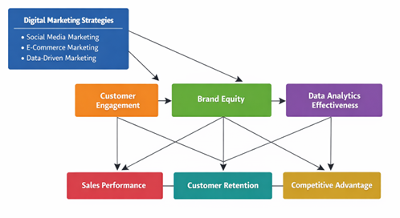

Research Methodology

This research is qualitative in nature and based on secondary data analysis. Therefore, the focus of the research is on qualitative analysis and critical examination of the existing marketing phenomena, organisational strategies and theoretical perspectives in the existing literature.
The research is secondary qualitative research as it is based on the existing knowledge and research rather than collecting new data and information through primary research. The secondary research is commonly used in business and management research as it offers the opportunity to researchers to synthesise the existing knowledge and identify patterns, relationships, gaps and inconsistencies in the existing literature (Saunders, Lewis and Thornhill, 2019).
The secondary data collected for this research will be gathered from JSTOR, Google Scholar and ScienceDirect academic databases to provide credible and authentic secondary data that will include academic books, articles and journals on the field of marketing festivals, event tourism, and marketing communication strategies.
The research design of this study is systematic qualitative literature analysis in which the existing academic and research studies are identified, evaluated and analysed systematically in order to identify, compare and contrast the existing themes and patterns relevant to the research objectives. The systematic literature analysis helps the researcher to develop a comprehensive understanding of the research topic by identifying the key themes and patterns in the existing literature (Saunders, Lewis and Thornhill, 2019).
The data analysis of this study is interpretative qualitative data analysis in which the findings of the existing literature are interpreted and categorised into themes and patterns. The qualitative data analysis enables the researcher to identify and develop the themes and patterns from the existing literature which leads to the contribution to the existing body of knowledge (Silverman, 2020). The interpretative approach to qualitative data analysis involves the comparison of different arguments and perspectives in the existing literature in order to identify the similarities, differences and trends in the existing literature. Therefore, this study interprets and categorises the findings of the existing literature into themes in order to understand the existing knowledge and contribute to it.
The ethical considerations are also an essential aspect of the research even if the research is based on secondary data and information. This study follows the ethical standards of academic research as it properly cites and references all the sources used for this study. The proper citation and referencing are essential for the academic research as they help in avoiding plagiarism and appreciating the academic and research contributions of other researchers (Bryman, 2016). This study uses the Harvard style of referencing and citation in order to appreciate the contributions and efforts of other researchers.

Risks

There are some risks that may occur in this study. The first risk is the risk of secondary data availability and validity because this study is totally based on secondary data; academic literatures and research papers. Inability to access to the latest and relevant literatures and research paper on digital marketing and retail industry in Europe will be the constraint for this study (Saunders, Lewis and Thornhill, 2019).
The second risk is the risk of researcher's biasness in which researcher may be biased to some particular view when interpreting qualitative data. The last risk is the risk of time constraint which means inability to perform all the stages of the dissertation within the allocated time. These risks can be managed by selective literature review, critical thinking and proper time management.

Timeline (Gantt Chart)

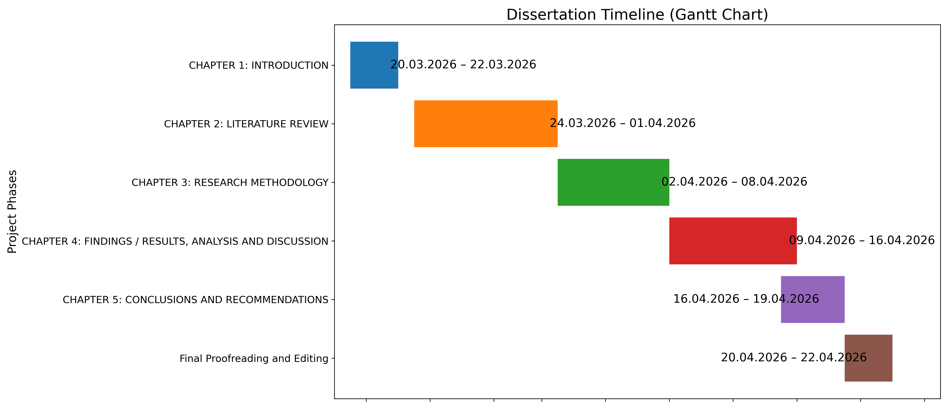

References

Armiani, A. (2024) ‘Digital marketing strategies for small and medium enterprises: Leveraging social media and e-commerce’, Management Studies and Business Journal (PRODUCTIVITY), 1(5), pp. 801–808.
Blumberg, B., Cooper, D. and Schindler, P. (2014) Business Research Methods. 13th edn. New York: McGraw-Hill Education.
Bryman, A. (2016) Social Research Methods. 5th edn. Oxford: Oxford University Press.
Chaffey, D. and Ellis-Chadwick, F. (2022) Digital Marketing. 8th edn. Harlow: Pearson Education.
Dwivedi, Y.K., Ismagilova, E., Hughes, D.L., Carlson, J., Filieri, R., Jacobson, J. and Wang, Y. (2021) ‘Setting the future of digital and social media marketing research: Perspectives and research propositions’, International Journal of Information Management, 59, p.102168.
Gregory, G.D., Ngo, L.V. and Karavdic, M. (2019) ‘Developing e-commerce marketing capabilities and efficiencies for enhanced performance in business-to-business export ventures’, Industrial Marketing Management, 78, pp.146–157.
Nuseir, M.T. (2016) ‘Exploring the use of online marketing strategies and digital media to improve brand loyalty and customer retention’, International Journal of Business and Management, 11(4), p.228.
Rahman, S.M. (2015) ‘Optimizing digital marketing for Generation Y: An investigation of developing online market in Bangladesh’, International Business Research, 8(8). Available at: https://doi.org/10.5539/ibr.v8n8p150 (Accessed: 10 March 2026).
Raut, M. and Kulkarni, S. (2020) ‘A study on the use of social media marketing strategies’, Our Heritage, 68, pp.28–34.
Saunders, M., Lewis, P. and Thornhill, A. (2019) Research Methods for Business Students. 8th edn. Harlow: Pearson Education.
Saura, J.R., Palos-Sánchez, P. and Cerdá Suárez, L.M. (2017) ‘Understanding the digital marketing environment with KPIs and web analytics’, Future Internet, 9(4), p.76.
Silverman, D. (2020) Interpreting Qualitative Data. 6th edn. London: Sage Publications.
Thrassou, A., Vrontis, D., Efthymiou, L. and Uzunboylu, N. (2022) ‘An overview of business advancement through technology: Markets and marketing in transition’, Business Horizons, 56(57), pp.1–20.
Zollo, L., Filieri, R., Rialti, R. and Yoon, S. (2020) ‘Unpacking the relationship between social media marketing and brand equity: The mediating role of consumers’ benefits and experience’, Journal of Business Research, 117, pp.256–267. Available at:
https://doi.org/10.1016/j.jbusres.2019.02.032 (Accessed: 10 March 2026).

