Living with care: The older person
Assignment 2



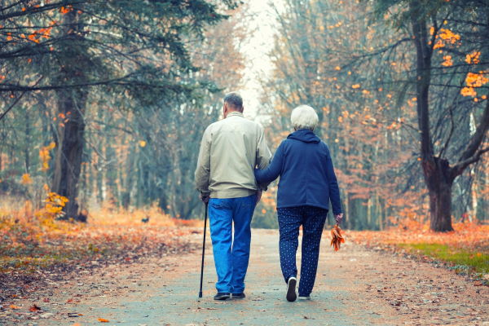

Student Name: Natalie Tully
Student Number: 2025743
Lecture: Joanne Davies
Module code: BMHP6009_BIRM

Table of Contents
Introduction 3
Ezra’s Background 3
Health and social care needs. 4
Medical care 4
Mental health issues. 5
Mobility. 5
Social care needs. 5
Covid-19 6
Support and Intervention 7
Policy and Legislation. 8
THEORY 9
The Disengagement Theory 9
Activity theory 9
Continuity Theory 10
Maslow Theory 10
Conclusion 12
Recommendation 12
APPENDIX 1 13
APPENDIX 2 14
References 15

Introduction
This report's objectives are to assess the support needs of an older gentleman, who has medical problems and explore how these conditions affect his day-to-day life. By also considering the seven physical needs of the older people which can be met by using Maslow's theory and person-centered approach. This report will aim to explore how the legislation and rights of older people are upheld and if there is a gap within the health services and what is being done to meet the standards of care for older people. This report will also investigate how vulnerable a person could be through different forms of abuse and discrimination. Furthermore, this report will outline the need for health provisions to be more accessible and affordable by looking into A.I technology aid support to enable him to be more independent. For this report, Ezra Taylor will be known as ET (see Appendix 1).
According to (UNHCR, n.d.) someone who is over 60 is to be considered an older person. Families and communities, however, frequently use additional socio-cultural indicators, such as family status (grandparents), appearance, or age-related health issues, to define age. There are many more definitions of old age, for this report will explore how the impact of how society sees older people.
“In 2050, 80% of older people will be living in low- and middle-income countries” (World Health Organisation, 2022a). This indicates that the growth pace is much faster than in the past, with the world's growing population over 60 and doubling over time, older people are living longer due to medical advances and improvements in social and environmental changes. As stated by the World Health Organisation, (2022b), improving physical and mental capacity and delaying care dependency.
This report ends with a focus on exploring health services and interventions, including policies in place. If we don’t improve the way, we provide support to older people then the NHS will struggle to meet the increasing demand for resources as well as changing needs for our older people.

Ezra’s Background
ET is a 65-year-old male, of Black Caribbean ethnicity, who has a diagnosis of diabetes, and early signs of arthritis. He lives on his own on the third floor of a flat which he can only access via the stairs. Although he has been diagnosed with health needs, he is very active attends the local gym, and regularly walks to the shops. ET is independent and does not like to rely on friends or services.
There is a potential risk that his health needs can be impacted due to his health needs worsening. ET has an early diagnosis of arthritis, and as he gets older, this may impact him more physically. Personally, this will impact his love for the gym. This is emotionally worrying for him as he is aware this may stop him from physically being mobile, and this will impact him socially by stopping him from going out. ET’s arthritis will impact him as he will be limited to going out as he does not have access to a lift to enter and leave his property which in turn will make him more dependent on others.
ET was diagnosed with type 2 diabetes in his late 40s and from this, he developed a love for the gym to manage this as the diagnosis impacted his mental health. Arthritis has effects that go beyond the physical, affecting mental health equally, increased anxiety, stress, and depression can result from coping with chronic pain, restricted movement, and loss of independence. A person's overall level of health and standard of life may deteriorate in older people with arthritis (Lwin et al., 2020).
As stated by Eustice (2015) The Centres for Disease Control and Prevention (CDC) states that arthritis affects people of all ages, however, it is more prevalent in adults 65 years and over. Arthritis appears more prevalent in 26% of women than 19% of males, affecting people of all racial and ethnic backgrounds, compared to adults who are average-weight or underweight, adults who are overweight are more prone to develop arthritis.

Health and social care needs.
Care needs to be just as important as treatment, older people should be properly valued, listened to, and treated with compassion, dignity, and respect always. They need to be cared for by skilled staff who are engaged and understand the needs of older people and have time to care (NHS England, 2014).
These are core principles that need to be considered for ET to remain empowered and independent within his own home if support is needed.

Additionally, what follows are some common circumstances when someone might need health and social care support:

Medical care
ET's medical needs can be managed at home and therefore he does not require medical care however if his medical needs become unmanageable, he may need to be cared for in a care setting. If this was the case, then he could be supported by a geriatrician, who is experienced in supporting older people with compassion and can adopt a holistic, patient-centric approach. But also enable patients to be supported at home (NHS, 2015). Which is valuable for ET to maintain his independence as much as possible.

Mental health issues.
In primary care settings, depression receives inadequate recognition and care. Due to their co-occurrence with other issues older people face, symptoms are frequently ignored and left untreated. When compared to older people who suffer from ongoing medical conditions like diabetes, depressive symptoms in older people impair functioning. According to the World Health Organization (2017), 6.6% of the total disability (DALYs) for older people is attributable to mental and neurological illnesses. Roughly 15% of those aged 60 plus have a mental illness. The most common mental health condition in old age is depression.
According to a study by Onubogu (2014), depression symptoms are brought on by pain in addition to other chronic symptoms of arthritis in older people. In the case of ET, his depression is brought on by multiple factors, including his health conditions and the worry of losing his independence.
Both arthritis and depression are dependent on each other. Arthritis can cause depression and chronic depression may further lead to the worsening of the symptoms of the disease.

Mobility.
ET has arthritis and is struggling with his joints stiffening up, at times he finds it hard to walk up the stairs to his flat, which can affect him attending the gym less often. This has a huge impact on his health and well-being, which could request a referral to physical therapy, which can assess his mobility limitations. According to nhs.uk, (2017), Pain can be lessened and prevented by exercising. Regular exercise can additionally: increase the range of motion in your joints, strengthen muscle power, decrease stiffness, and regain energy.

Social care needs.
Social needs are crucial fundamental human needs. Unfulfilled social needs might result in issues with one's physical and mental health. The requirement for older people to maintain their health and live in the community makes it crucial to meet their social demands. Diversity, proximity, the significance of the relationship, and reciprocity emerged as themes. These themes had numerous consequences for interventions, involvement in hobbies, and volunteer work, both a sense of independence and a sense of belonging to others, a community, or a neighbourhood, promote well-being. Social requirements are met by remaining engaged through volunteer work or involvement in (leisure) social activities. Therefore, Interventions should have a special emphasis on older people's freedom, engagement, and sense of connection (BRUGGENCATE, LUIJKX and STURM, 2017).
ET's social care needs are met by his interaction at his local gym, where he has built up core relationships by attending exercise classes and feels a part of his local community. Covid had a huge impact on his social care needs, as he could not access the gym. Which made ET isolated as he has no family networks.

Covid-19
Over the past couple of years, the Covid-19 pandemic has had a detrimental impact on the world. The pandemic has been particularly hard on older people with existing medical conditions, and those who were shielded were less likely than those who did not to be experiencing increased anxiety since the lockdown.
Research finds that some older people are coping with the pandemic, but a sizeable minority are finding life incredibly tough. People with chronic health conditions and those who are not feeling well were more likely to say that this is a very difficult time for them. The study demonstrates that many older individuals are experiencing higher and at times life-threatening levels of anxiety, in part because they are aware that they are seriously at risk for the virus, an invisible but deadly enemy. (Age UK, 2020).
Due to ET’s age and medical conditions, he was classed as vulnerable during the pandemic which impacted his mental and general health.
Diabetes patients noticed that they were eating less nutritiously and having become less active than normal. Consequently, this has a significant effect on the blood sugar levels of diabetics, increasing their likelihood of long-term problems from the disease, as well as various other aspects of their general health (Diabetes UK, n.d.).
Due to ET’s diabetes and arthritis, he attended his GP pre-covid for his diabetic and regular health check-ups, this supported his independence and the opportunity to socialise,
however, due to the lockdown, he was unable to attend appointments as they were mainly virtual or over the phone. This impacted him as he was unable to leave to go to his GP.

Support and intervention

For the best interests of ET, the need for early intervention is put in place to help maintain ET's independence and empower him to reach his goals. According to NHS England, (2020), The best possible care must be provided to older people when they need it for them to maintain their health and independence as long as possible, This is also backed up by Stevenson,( 2008), Everyone wants to live a longer healthy and productive life where they are treated with respect and dignity, therefore early diagnosis and interventions are essential for people to manage and plan for long-term care.
There is a new technology that could help ET be more empowered and in control of his healthcare, Artificial intelligence (AI) is the process of using digital technology to build systems that can carry out operations that are typically regarded to need human intelligence. This guidance, which is centred on the IG implications of utilising AI in health and care contexts, should promote the ethical and secure use of data for AI advancements. Which could help ET manage diabetes at home. According to the NHS Transformation Directorate,( n.d.), an innovative artificial intelligence (AI) system can transform a smartphone camera into a tool of clinical quality to detect early kidney illness which could help him with diabetes and high blood pressure. The downside to this is that ET doesn’t have a smartphone, so he can be discriminated against due to these factors, which in turn can make him disengage from social interactions with his local GP (MUO, 2023).
According to the Department of Health, (2001), ET is in a transitional phase, which means a group of older people who are transitioning between a healthy, active life and frailty. ET can benefit from different forms of support and services, but ET is more likely disadvantaged in accessing these services when in need, due to discrimination of his ethnic background and age.
The barriers that face older people from UK ethnic minority communities have commonly experienced racial discrimination throughout their lives in the UK, including when accessing health and care services (Age UK, 2021).
This can also result in a lack of understanding and language barriers, which could create mistrust when using the services and trying to provide health care to ET.
ET could also benefit from housing support if in need of adaptations, to maintain his independence and empower him to remain in his own home. With professionals or organisations working together to provide a tailored support plan. Which could also offer support with his finances, risk of isolation, understanding his diabetes, and building new relationships in his local community. However, the gap within the health services does have not enough skilled staff which would impact ET accessing these services or not meeting the quality of care in a person-centred approach due to lack of time and resources.
According to www.england.nhs.uk,(2023) the gap is currently at 112,000 without intervention, the gap could increase to 360,000 by 2037 due to the population's ageing and growth, as well as new medicines and treatments.
(ONS.Gov.UK, 2018)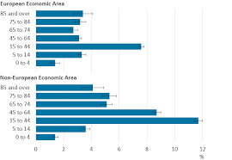

Policy and Legislation.
Several policies and legislations support the elderly to ensure they get the right care and support that meets their needs.
The Care Act (2014) strives to take steps to make sure that people are provided with the support they need to maintain their independence and maintain control over their care. This is vital in ET’s case as he will feel empowered as he can maintain his independence by making his own choices.
The Human Rights Act (1989) offers essential safeguarding for older people by assisting in the development of procedures, practices, attitudes, and culture in addition to providing solutions when human rights have been breached (Policy Position Paper Human Rights United Kingdom 2020).
According to Age UK (2020), the report on the Human rights of older persons and their comprehensive care emphasises how prejudice towards older people still exists and results in discrimination. ET is disadvantaged due to his age and ethnicity; he is an independent elderly black male who appears to be more able than most his age especially when he suffers from health needs.
Many policies and legislations are relevant in supporting ET through his older age, some of these include.
- Centre for Policy on Ageing Policies and Ageing
- The Equality Right Act (2010)
- NHS Policy - National and Regional

THEORY
According to Study.com (2022), Psychosocial theories emphasise the social, mental, and emotional elements of aging. Activity, disengagement, and continuity theories are the three main psychosocial theories on aging.

The Disengagement theory
Elaine Cumming and William Earle Henry introduced the disengagement theory in their 1961 book "Growing Old," which is a theory of aging. According to this theory, everyone tends to isolate themselves from the greater community, including social standards, their position in the community, and other members of society (Group, 2019).
This is one thing that worries ET, He values himself as being independent and not having to rely on anyone, but he is aware that he could become isolated if his arthritis worsens and is unable to attend his local gym, as ET feels the gym makes him feel empowered and he is encouraged to maintain a healthy diet and exercise regularly by his peers. If this is a concern in the future, ET will need support from services to prevent isolation, as ET does not have any family networks or socialise outside the gym.

Activity Theory
In 1961, Gerontologist Robert J. Havighurst created the activity theory of aging. The concept underpinning it is that older adults who are active are content with their lives compared to individuals who are not. According to the activity hypothesis of aging, by taking on new roles in place of their old ones, older persons can maintain the same amount of activity and social involvement as they did in their younger years. For instance, the function of volunteering can take the place of the role of employment. According to activity theory, taking on new tasks and staying active will help people improve their feelings about themselves and cope with ageing (Nimish Biloria, Sebag and Robertson, 2023 and Nieboer et al., 2005).
Due to ET's background as a personal trainer, he has always tried to maintain his fitness levels, and has been quoted by ET “Respect is everything, I’m nothing without that!” (See appendix 1). Meaning that he would not want to be seen as being weak or vulnerable, and that being active is his purpose in life it’s all he knows and loves. which could be a great concern if he needed support services, ET would need a person centre approach to engage and encourage him to reach out for support if needed (see appendix 2), thinking of him as an individual, not as statistics of the older generation.

Continuity Theory
Continuity theory is based on the idea that people retain a continuous pattern of behaviour as they age by taking on comparable responsibilities in place of lost adult positions and by keeping a consistent attitude of flexibility towards their social environment. According to Neugarten, Havinghurst, and Tobin (1968), life satisfaction is measured by how well one's present activities or lifestyle align with their life experiences.
According to the continuity theory of ageing, older people typically keep up the same social networks, habits, and pastimes that they had in their younger years. According to Kali and Cavanaugh (2016), people use tried-and-tested coping mechanisms they have acquired throughout their lives to get by daily as they get older.
In a study involving older people, it was discovered that those who had engaged in recreational activities as adolescents were more likely to continue doing so as adults (Minhat, Rahman, & Khadijah, 2013). This study supports the notion that older persons generally try to maintain as much of what they did as a child.

Maslow Theory
A Theory of Human Motivation" was a paper written by Abraham Maslow that was released in 1943. This is where he first introduced the psychological concept known as Maslow's Hierarchy of Needs. The concept is typically represented as a pyramid and has five hierarchical levels of needs. The lowest level is "Physiological," followed by "Safety, "Social", "Esteem"," and "Self-actualization, which is the highest level (McLeod 2023), also states a person must meet lower-level requirements before moving on to higher levels of needs.
According to Gudynas (2019), Maslow's hierarchy of needs indicates that older individuals desire to feel appreciated by those around them, have confidence in themselves, and feel accepted by others. Older adults tend to feel successful in their efforts to meet their demands for self-esteem as they get older.
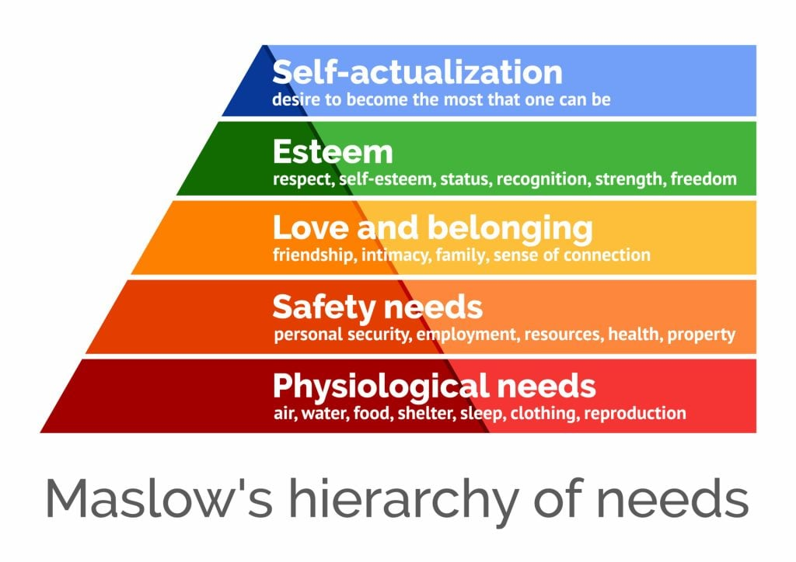
(McLeod, 2023)

Subsequently, it is vital to understand that there’s no one solution for all. Every person has different expectations, preferences, and priorities, whilst some may place a greater emphasis on fulfilment and personal growth, other older people may prioritise social relationships and a sense of self-worth. A person-centered approach is required to comprehend and meet each older person's unique needs and objectives. A Person-centered approach prioritises ET’s well-being, dignity, and overall quality of life while respecting his social, emotional, and cultural preferences (Eaton et al. 2015). (See Appendix 2)
Maslow's theory mentions the significance of self-esteem, and ET may have a particular need for this given that he is feeling insecure because of his increasingly old age, deteriorating mobility, and perceptions of his diminished self-care abilities. His ability to remain socially active and preserve his self-confidence is essential for keeping both his mental and physical well-being in a good state.

Conclusion
After analysing the information, you can see that ET and older people of his ethnic background, find it harder to get the right support from the health services, that early interventions and more understanding of different ethical backgrounds need to be paramount within the NHS. which focuses on a person centre approach to promoting independence.
In society today with older people living longer, the aim should be to empower them to have the skills to live and feel part of their community. This will help with isolation, loneliness, and depression.
Gaps in the health service are another reason why ET will not receive the proper care that is needed for his ongoing health conditions and to live as independently as long as he can, due to lack of resources and funds.

Recommendation
Ezra could benefit from support from his local GP to ensure his coping ok with his day to day, has well as checking on his mental health, as Ezra has a close relationship with his GP for whom he trusts. According to www.scie.org.uk, (n.d.), GPs serve as a patient's best interest advocate, advocating for and safeguarding a patient's rights to the best and most suitable health and/or social care.
To ensure Ezra does not fall through the gap of the healthcare system due to his ethnic background and age, he could benefit from an advocate to speak on his behalf and ensure his rights and needs are met in a holistic manner. These needs can be met by someone Ezra trusts due to him being a proud man, his close circle of friends is in his local gym, which he builds up with the manager.
Ezra could benefit from having support from his local housing for adaptions to his home for him to maintain his independence and benefit from a safe and well visit. Which offers a range of support including loneliness and social isolation (Anon, n.d.).
These recommendations aim to meet Ezra's needs in a tailored holistic approach, for Ezra to be in control of his own choices, be guided and encouraged to maintain his fitness level, and eat a well-balanced diet. There will on ongoing changes and recommendations as Ezra's health and well being change.

APPENDIX 1

Ezra Taylor – Aged 65
Ezra is black Caribbean ethnicity is divorced, who separated from his wife 30 years ago and lives on his own in a one bed third floor flat accessed by stairs. He has lived in the same area since he was 20 years old. He regularly walks to the local shops where he is known by everyone in his local community and is a respected proud man. Ezra has been quoted saying that “respect is everything, I’m nothing without that”.
Ezra has always been active since his early 40s, due to his diagnosis of type 2 diabetes, which is where he loves for the gym started and became a personal trainer at the age of 20, but due to his break down in his married, led to Ezra live an unhealthy lifestyle and quit his job, but was encouraged to go back into the gym after his diagnosis of diabetes. Which helped Ezra maintain his independence and build back up his social networks.

Family and friends
Ezra has no family networks, due to his marriage breakdown, and has no children, his mother died 10 years ago, has had no contact with his dad since he was a young adult who lives in Jamaica. Ezra likes to keep himself to himself but has a network of friends in his local gym which is his focus in his life. He doesn’t like to ask for help or be seen as vulnerable. His network of friends at the gym helps and encourages him to eat healthy and keep doing as much exercise as he can.
Health and wellbeing
Ezra is a very active man, but his health conditions of type 2 diabetes and his early signs of arthritis, worries him as he is finding it hard to walk up and down the stairs of his flat, even more though his love and independence of attending his local gym could be at risk. Which could result in him feeling isolated and excluded from his local community and his network of friends. Ezra does not like to burden anyone with his problems, a man who will just get on with it and not complain, but this is a concern to his mental health and his accessing services if needed which will make him vulnerable.

APPENDIX 2
PERSON-CENTERED
PCPOPweb3.pdf (ndti.org.uk)

References
Age UK (2017). Briefing: Human rights of older persons and their comprehensive care. (online) Available at: https://www.ageuk.org.uk/globalassets/age-uk/documents/reports-and-publications/reports-and-briefings/equality-and-human-rights/age-uk---human-rights-of-older-persons-and-their-comprehensive-care---july-2017.pdf (Accessed: 20 August 2023).

Age UK (2020). Age UK Research on Impact of the Pandemic on Our Older Population’s Health. (online) Age UK. Available at: https://www.ageuk.org.uk/latest-press/articles/2020/10/age-uk--research-into-the-effects-of-the-pandemic-on-the-older-populations-health/ (Accessed: 22nd August 2023).

Age UK (2021). Breaking down the barriers of ethnic inequalities in health | Discover. (online) Age UK. Available at: https://www.ageuk.org.uk/discover/2021/october/breaking-down-the-barriers-of-ethnic-inequalities-in-health/ (Accessed: 18 August 2023).
‌
Anon, (n.d.). Safe and Well - West Midlands Fire Service. (online) Available at: https://www.wmfs.net/our-services/safe-and-well/ (Accessed: 20 August 2023).

‌

Atchley R., 1989. A continuity theory of normal aging. The Gerontologist 29: 183-190.

BRUGGENCATE, T.T., LUIJKX, K.G. and STURM, J. (2017). Social needs of older people: a systematic literature review. Ageing and Society, (online) 38(9), pp.1745–1770. doi:https://doi.org/10.1017/s0144686x17000150.
‌
Diabetes UK. (n.d.). The effects of coronavirus on the health of people with diabetes. (online) Available at: https://www.diabetes.org.uk/research/our-research-projects/scotland/effects-of-coronavirus (Accessed: 19 August 2023).

Department of Health (2001). Modern Standards and Service Models National Service Framework for Older People National Service Framework for Older People Contents. (online) Available at: https://assets.publishing.service.gov.uk/government/uploads/system/uploads/attachment_data/file/198033/National_Service_Framework_for_Older_People.pdf (Accessed: 21 August 2023).

Eaton, S., Roberts, S. and Turner, B. (2015). Delivering person centred care in long term conditions. BMJ, (online)350(feb10 14), pp.h181–h181. doi:https://doi.org/10.1136/bmj.h181.

Eustice, C. (2015). Does Aging Cause Arthritis? (online) Verywell Health. Available at: https://www.verywellhealth.com/age-and-arthritis-189653 (Accessed: 21 August 2023).

‌Group, S. (2019). Definition of the Disengagement Theory of Aging. (online) Sociology Group: Welcome to Social Sciences Blog. Available at: https://www.sociologygroup.com/disengagement-theory/#google_vignette (Accessed: 13 August 2023).

Kail, R.V. and Cavanaugh, J.C. (2017). Essentials Of Human Development: A Life-Span View. 2nd ed. Australia: Cengage Learning.

Lwin, M.N., Serhal, L., Holroyd, C. and Edwards, C.J. (2020). Rheumatoid Arthritis: The Impact of Mental Health on Disease: A Narrative Review. Rheumatology and Therapy, 7(3). doi:https://doi.org/10.1007/s40744-020-00217-4.

‌ McLeod, S. (2023). Maslow’s Hierarchy of Needs. (online) Simply Psychology. Available at: https://www.simplypsychology.org/maslow.html (Accessed: 22nd August 2023).

MUO. (2023). 10 Positive and Negative Impacts AI Is Already Having on Healthcare. (online) Available at: https://www.makeuseof.com/ai-positive-negative-impacts-healthcare/ (Accessed: 21 August 2023).
‌

NHS (2015). Geriatric medicine. (online) Health Careers. Available at: https://www.healthcareers.nhs.uk/explore-roles/doctors/roles-doctors/medicine/geriatric-medicine (Accessed: 18 August 2023).

‌NHS England (2014). England Safe, compassionate care for frail older people using an integrated care pathway. (online) Available at: https://www.england.nhs.uk/wp-content/uploads/2014/02/safe-comp-care.pdf (Accessed: 23rd August 2023).

nhs.uk. (2017). Arthritis - Living with arthritis. (online) Available at: https://www.nhs.uk/conditions/arthritis/living-with/#:~:text=As%20long%20as%20you%20do (Accessed: 24 August 2023).
NHS England (2020). Improving Care for Older People. (online) England.nhs.uk. Available at: https://www.england.nhs.uk/ourwork/clinical-policy/older-people/improving-care-for-older-people/ (Accessed: 20 August 2023).

‌ Neugarten, B. L., Havighaurst, & Tobin, S. S. (1968). “Personality and Patterns of Aging”. In Neugarten (Ed.), Middle Age and Aging (pp. 173-180). Chicago: University of Chicago press.

Nieboer, A., Lindenberg, S., Boomsma, A. and Bruggen, A.C.Van. (2005). Dimensions Of Well-Being And Their Measurement: The Spf-Il Scale. Social Indicators Research, 73(3), pp.313–353. doi:https://doi.org/10.1007/s11205-004-0988-2.

Nimish Biloria, Sebag, G. and Robertson, H. (2023). The Empathic City. Springer Nature.

ONS.Gov.UK (2018). Living Longer - Office for National Statistics. (online) Ons.gov.uk. Available at: https://www.ons.gov.uk/peoplepopulationandcommunity/birthsdeathsandmarriages/ageing/articles/livinglongerhowourpopulationischangingandwhyitmatters/2018-08-13 (Accessed: 22nd August 2023).
Onubogu, U.D. (2014). Pain and Depression in Older Adults With Arthritis. Orthopaedic Nursing, 33(2), pp.102–108. doi:https://doi.org/10.1097/nor.0000000000000035.

Policy Position Paper Human Rights United Kingdom. (2020). Available at: https://www.ageuk.org.uk/globalassets/age-uk/documents/policy-positions/ageism-and-equalities/human-rights-feb-2020.pdf#:~:text=The%20Human%20Rights%20Act%201998%20%28the%20HRA%2C%20which (Accessed: 22 August 2023).

‌Stevenson, A. (2008). Older people: Early intervention and prevention. (online) Community Care. Available at: https://www.communitycare.co.uk/2008/10/29/older-people-early-intervention-and-prevention/ (Accessed:19 August 2023).

‌Study.com. (2022). Available at: https://study.com/academy/lesson/psychosocial-theories-of-aging-activity-theory-continuity-theory-disengagement-theory.html#:~:text=Psychosocial%20theories%20focus%20on%20the (Accessed: 20 August 2023).

NHS Transformation Directorate. (n.d.). Healthy.io: Smartphone albuminuria urine self-testing. (online) Available at: https://transform.england.nhs.uk/ai-lab/explore-all-resources/understand-ai/healthyio-smartphone-albuminuria-urine-self-testing/ (Accessed: 23 August 2023).
‌

UK Government (2014). Care Act 2014. (online) Legislation.gov.uk. Available at: https://www.legislation.gov.uk/ukpga/2014/23/contents/enacted (Accessed: 23rd August 2023).

UNHCR. (n.d.). Older persons. (online) Available at: https://emergency.unhcr.org/protection/persons-risk/older-persons (Accessed: 22nd August 2023).

www.england.nhs.uk. (2023). NHS England» Record Recruitment and Reform to Boost Patient Care under First NHS Long Term Workforce Plan. (online) Available at: https://www.england.nhs.uk/2023/06/record-recruitment-and-reform-to-boost-patient-care-under-first-nhs-long-term-workforce-plan/ (Accessed: 21 August 2023).

World Health Organization (2017). Mental health of older adults. (online) Who.int. Available at: https://www.who.int/news-room/fact-sheets/detail/mental-health-of-older-adults (Accessed: 23 August 2023).

World Health Organization (2022). Aging and health. (online) World Health Organization. Available at: https://www.who.int/news-room/fact-sheets/detail/ageing-and-health (Accessed: 22nd August 2023).
‌ www.scie.org.uk. (n.d.). GP services for older people: a guide for care home managers - GPs’ role in relation to the resident, the home and the wider NHS - The GP as point of access to primary and secondary care. (online) Available at: https://www.scie.org.uk/publications/guides/guide52/gp-roles/point-of-access.asp#:~:text=The%20GP (Accessed: 20 August 2023).

‌

‌

‌

