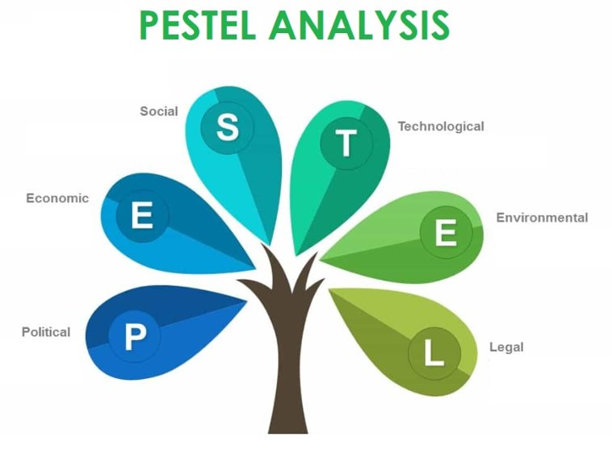
Business, Culture and Change in Context

Key Influences

The PESTLE analysis tool looks at different key external factors which influence organisations and help us to make important, informed decisions about how we react, in order to achieve the best outcomes. (Waite et al, 2021) Using this tool, it is possible to identify a number of key external influences that are likely to impact Hywel Dda as an organisation. Factors to consider include; political, such as the effects of Brexit after the UK left the EU; economic factors such as the financial difficulties that the NHS has faced for a long time; sociocultural factors such as an ageing population; technological factors such as improvements in medical equipment; legal factors such as lawsuits brought on by families unhappy with the quality of care received by a loved one or environmental factors such as air pollution and climate change which may affect health. (Bush, no date)

One of the biggest social aspects that we need to consider is that of an ageing population in our rural health board. Hywel Dda University Health Board (HDUHB) provides care over three counties to a population of approximately 385,600. One quarter of this population are over the age of 65 and it is predicted that this figure will increase by 31.4% by 2043. Those aged 85 and over will rise by 6%. (HDUHB, no date)



Key Influences
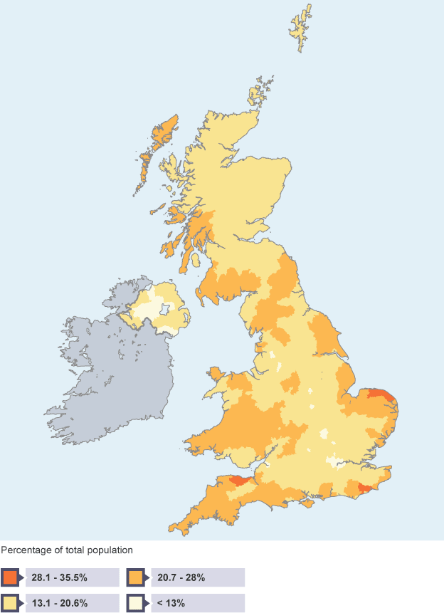
HDUHB covers a vast area. This map shows the percentage of the population aged 65+ in the UK and clearly shows that the area covered by HDUHB has a much older demographic than much of the UK. (BBC Bitesize, 2017)

There is added pressure on our already stretched NHS services due to the fact that people are living much longer and also many are moving to West Wales in their retirement years. People in their older years tend to have more chronic health conditions such as respiratory illness, cancer, type 2 diabetes, heart disease, arthritis and Alzheimer’s disease. These can be costly to manage, will incur further costs due to extra staff needed and there will be a knock-on effect for other services such as home care and meals on wheels.
In order to continue providing effective and efficient care for a growing population with complex conditions, we must look at adapting our services. (Vernon, 2016)

As the biggest employer in the UK, the NHS has developed its organisational mission, vision, values and purpose. Our goals include delivering excellent health care and patient experience and building a service we can be proud of. ​
​
Our long-term goals involve transforming health and well-being services to help prevent long -term illnesses and deaths in our patients today and well into the future. This involves exploring what happens outside of our hospitals. The Future Generations Act 2015 sets out our vision to deliver health and care services by collaborating with other services within our communities. (Public Health Wales, no date)

Organisational Goals

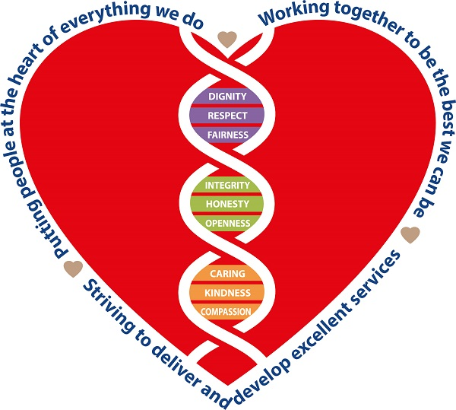
It is our goal to deliver care closer to, or in patients own homes, providing it is medically safe to do so. In order to rise to this challenge there will need to be big changes and its success will depend on building strong working relationships and partnerships with everyone in the community. This social model of health care has been accelerated by the Covid-19 pandemic recently and considers a wide range of factors which have an impact on health and well-being such as the reality of people with chronic health conditions living longer. (GOV.UK, 2018)

Organisational Goals

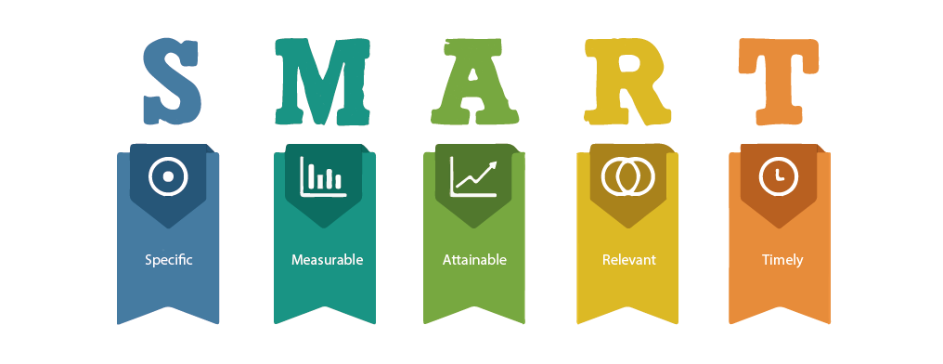
It is vitally important for all organisations to plan and develop goals and objectives to motivate and provide direction for staff. Successful goals follow the SMART structure meaning they are specific, measurable, achievable, relevant and time bound. It also helps to make goals relevant and current and is good practice to evaluate and review objectives ensuring that the cycle continues. ​(Waite et al, 2021)
​
Our employees need to understand the objectives set in order to achieve them. They should be motivating but also challenging and employees should have everything they need to successfully achieve them. However, things do not always go to plan, so it is also important to be flexible and have alternative plans in place in case anything unexpected does happen. reference

Products, Services and Customers

The National Health Service began on 5th July 1948 at Park Hospital, near Manchester and was founded by Aneuran Bevan who was then the Minster of Health. The concept was to provide health care to everybody, not just those who were better off financially. Before the NHS, patients were expected to pay for treatments themselves. The idea to fund the NHS from general taxation was formed and meant that everybody including visitors to the country was entitled to free health care. Aneuran Bevan recognised that the services needed to benefit everyone, be cost free and provision based on need rather than profiteering. (Brain, 2021)
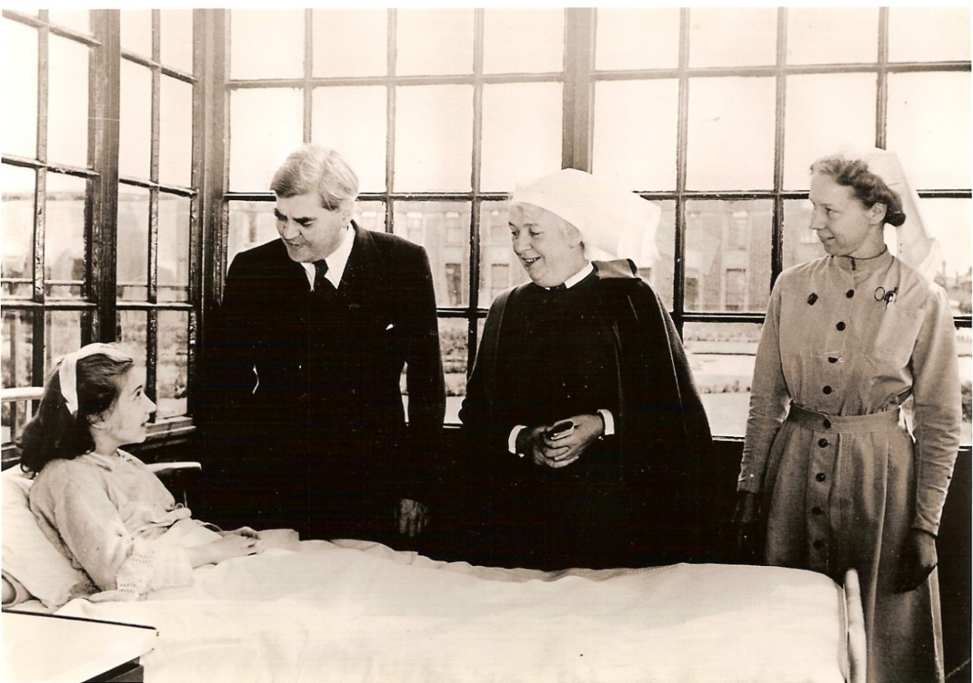

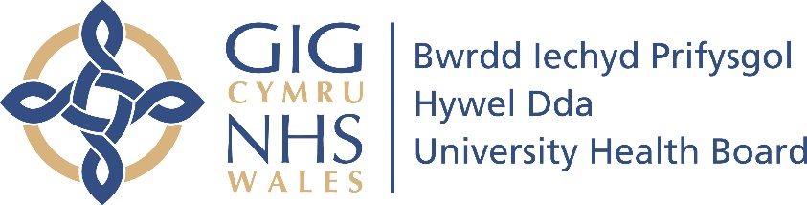
Products, Services and Customers
Hywel Dda provides and delivers health care services in Carmarthenshire, Pembrokeshire and Ceredigion to members of the public in a range of settings from GP surgeries, dentists, pharmacies and opticians to hospitals, community hospitals and Mental Health and Learning Disabilities services. We are also responsible for:

- “improving physical and mental health outcomes
- promoting wellbeing
- reducing health inequalities across their population
- commissioning services from other organisations to meet the needs of their residents”
(england.nhs.uk, 2005)

The NHS is completely funded by public money and is usually the first port of call for anyone with health issues. There is a lack of choice for customers seeking health care and an increasing demand for us to meet patient needs and expectations which is proving difficult after the pandemic. (Sage, 1991) The only other alternative is private health care which historically has been accessed mostly by older patients and those who are able to afford it. However, since Covid there has been an increase in UK residents paying for private medical treatment due to difficulties in accessing NHS care. (Campbell,2022)

Technology
The range of technology available to all of us today has improved exponentially over the years. Wi-Fi first became available in 1997 and developed significantly between 2000 and 2005 (Anon, 2016) opening up new possibilities such as accessing the world wide web on personal devices from anywhere we could get a signal. In 2020, 97% of UK households were reported to have internet access (Anon, 2022) and many businesses now offer free Wi-Fi to their customers meaning a plethora of information literally at our fingertips.

Technology has never been more important that during the recent Covid-19 pandemic when it enabled many of us to work from home using video conferencing software such as Zoom or Teams to communicate with colleagues. These interactive platforms allow us to share documents, add comments or ask questions in the chat, respond with emoticons and record meetings. These developments have helped to create new ways of hybrid working for many and have been advantageous to both employees and employers alike. We are able to communicate and collaborate with people and other organisations across the globe through email, video calls, messaging and social media. It has improved ways in which we work and learn, from automated email systems to VR education. (Waite et al, 2021)



Technology

Mobile phones have developed to integrate features such as voicemail, email, cameras and web access and their improved memory capacity means they are now just as powerful as computers. These smartphones and social media apps such as Facebook, WhatsApp, You Tube and Tik Tok have enabled us to share photos, videos and events with friends and family instantly. Social and interactive media plays an important role in HR and L&D, being used for recruitment purposes as well as giving employees a means of communication and providing organisations with insights into how they are seen by their customers. (Hayden, 2021)

Organisational Culture
Organisational culture focusses on the values, beliefs, traditions, habits, and purpose of a workforce and directly influences employee behaviour. It is expected that employees should share these ideals and that they are reflected in the way that they work. According to Fincham and Rhodes (2005) organisational culture is “The set of beliefs, values, and norms that represent the unique character of an organisation and provide the context for its actions.”

Organisational culture is governed by the structure, value, leadership and people practice within that organisation and helps people to understand how to connect with each other. Organisations must actively demonstrate their core values in order to create a positive workplace culture. It is imperative to always be inclusive so that employees understand and feel that their opinions matter and that they have a sense of belonging. (Waite et al, 2021)

Strong leaders are an important aspect within an organisation as they help to drive a positive organisational climate with a shared vision and aspiring goals that motivate employees. Leaders should act as role models, demonstrating honesty and openness, working efficiently as part of a team and offering learning and development opportunities as well as a fair reward system. (Young, 22)

Positive organisational culture is so important because it helps employees to feel that they matter, creates a civilised workplace and helps with job retention. Without a positive culture, an organisation will struggle to satisfy customer needs and as a result will fail to meet business objectives. Evaluating organisational culture regularly to understand and maintain the commitment, engagement and retention of staff is essential to maximise performance.

Organisations as Whole Systems

Hywel Dda consists of an array of different departments each with their own unique function which together help to provide a healthcare service to the public. We cannot function successfully if any part is missing or not working well. We must all work together as a team in order to meet the organisational needs and goals. The responsibilities of each department are thoughtfully planned in order to achieve positive results. Each department is dependent on the others and any action in one area has an impact on another. (Waite et al, 2021)

For example, patients being referred to us from GP surgeries will directly impact the demands within our hospitals and a lack of beds for elderly patients within the community will impact the length of time patients waiting in A&E are admitted to wards.

“A system is a collection of parts and processes organised around a purpose and each system is embedded in other systems.”

(Pawar, M, no date)

Organisations as Whole Systems
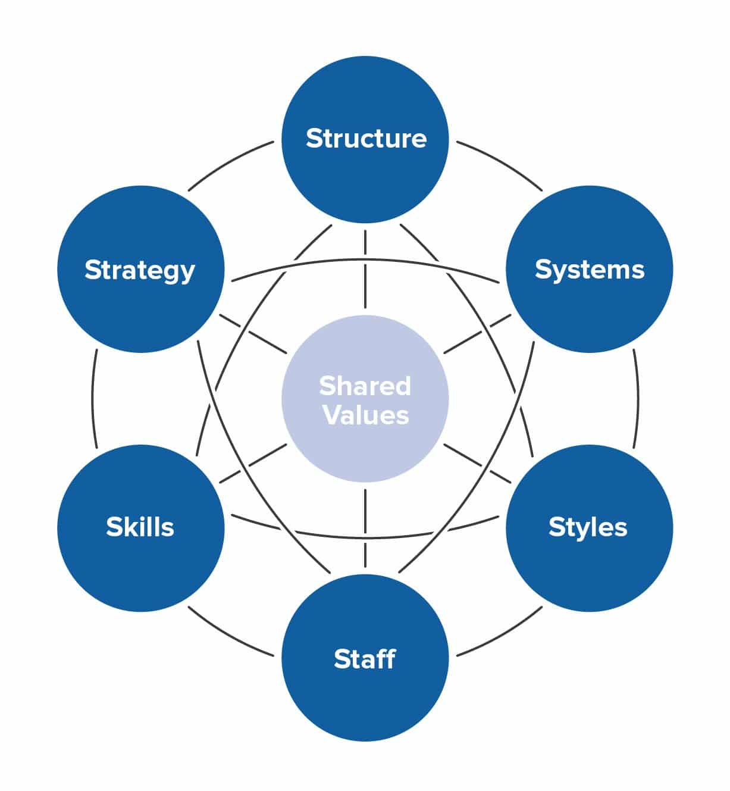

Robert Waterman, Tom Peters and Julian Phillips developed the McKinsey 7-S framework model in 2008 which identifies seven components which are all connected in the web style diagram. These are structure, systems, style, staff, skills, strategy and shared values. Each of these components relies on the others to deliver products and services successfully within our organisation and any effective change stems from the relationship between all seven.

In order to thrive, our organisation must be open to change. An effective organisation is reactive, adaptable and diverse and this was very much put to the test during the recent pandemic. Making changes in one area is almost impossible without making changes in another. Proposals for any changes which deviate from the McKinsey framework are not recommended. (Waite et al, 2021)

Change Management
There are many factors that influence organisational change including opportunities for expansion, financial depression, changes in objectives, new technology, a competitive market and supply and demand pressures to name a few. Change is not an option; it is a necessity. Organisations must embrace and implement change in order to fulfil business objectives and it is important to think about the best way to manage change. (CIPD, 2021)

Right from the very concept of change, organisations must consider and communicate with their employees in order to continue meeting objectives, remain attentive and keep ticking along. It is imperative that any change is managed thoughtfully and that those implementing changes are supported. There is evidence to suggest that delivering changes can be challenging with “failure rates frequently cited as 70%.” (George, 2021) One example of such failure is Blockbuster video rentals who failed to appreciate the customer’s desire for convenience and keep up with competitors such as Netflix. (McKinnen, 2022)

Change Management
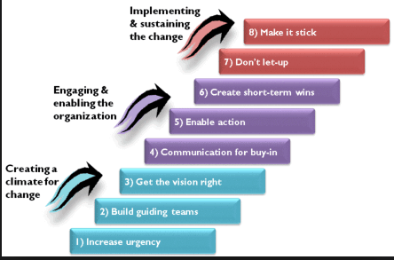
There are a number of models available to assist organisations in making changes including Kotter’s 8 step model, Lewin’s model and the Kubler Ross model. Kotter’s model has three phases which look at introducing changes, attracting attention and then executing and maintaining changes. Lewin’s model is simple but gives fewer options for regressing and the Kubler Ross model which looks at the different stages that people go through when change is introduced. (Waite et al, 2021)

When change is managed well it improves employee motivation and productivity, but any lack of communication means that change will be managed poorly, employees will not understand the importance for change and this in turn creates conflict and the inability to achieve goals.

The People Professional Role

The role of people professionals is to “support the vision and goals of the organisation” and “empower an organisation’s people to thrive - both individually and collectively.” (CIPD, no date) People professionals are vital to the management of change in an organisation and are key to the success or failure of any changes. They play a hand in building and developing change using a variety of techniques. They must instigate the change process and make decisions about the best approach to embed the changes taking into consideration the challenges that arise from those who resist change. They recognise and understand the workforce culture which enables them to communicate information and visions between managers and employees but also bring messages back to organisational leaders. (Taylor and Woodhams, 2002)

“People are arguably the most important asset to any business” (Peters, 2020) and the best decisions are made by a group of people rather than an individual. Previously, people professionals used to work hard in the background, but are now becoming more widely acknowledged as they develop ways to build, understand and communicate change to us. They have to be sensitive in the way they relate changes to employees in order to engage enthusiasm for the change. It is important to make employees feel that they can contribute, thus reducing the likelihood of conflict. The role of the people professionals is often to try and change mindsets so that employees welcome changes that are being implemented rather than resist them. As experts in their field, they aim to ensure the commitment of employees by developing an holistic approach to change management. (CIPD, 15)

The Impact of Change
The Kubler Ross change management model depicts a curve of reactions that people naturally follow when experiencing change. These reactions are particularly prevalent if a change is unexpected. The natural progression of reactions is shock and denial in the first instance, followed by anger, bargaining, depression and finally acceptance.

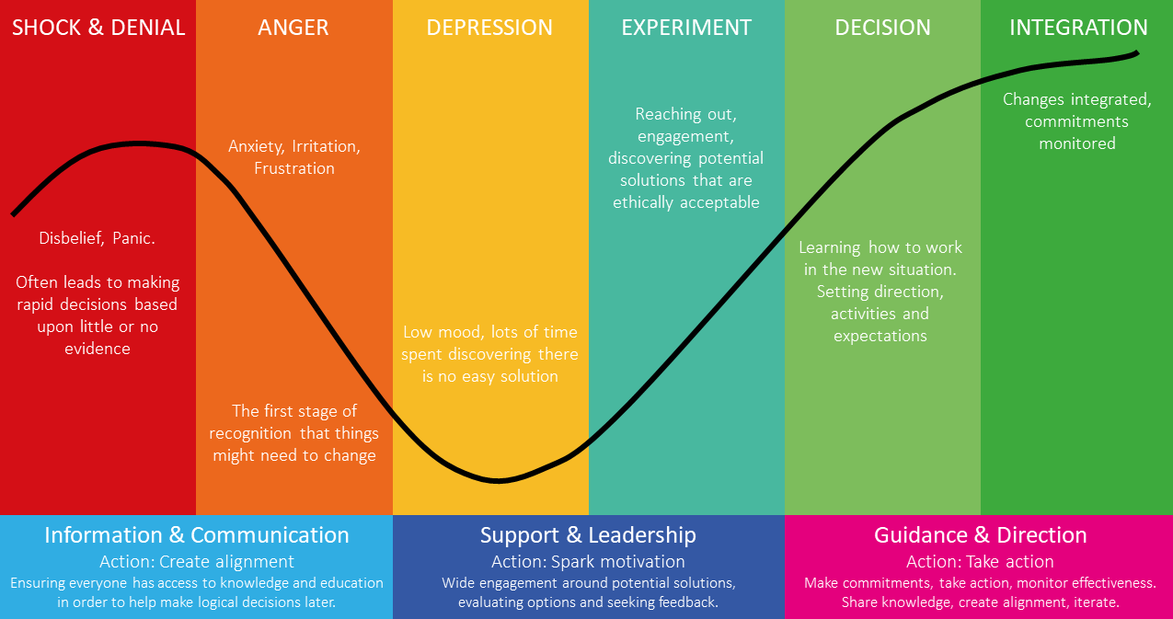

The manner in which each person responds to change is very personal to them and aspects such as upbringing, outlook on life and personality traits will affect these reactions. Some people may find it harder adapting to change but the fact is, it happens all of the time. Some of us will embrace a change easily whilst others are trepidatious. Every reaction is unique to both the individual and the situation and can depend on the timing of the change or the longevity of it. Some changes we make ourselves and some are imposed on us. We will have positive reactions to some and negative reactions to others. (Noori, 2015)

The Impact of Change

Whilst we recognise that everybody reacts differently to change, it is important to consider the negative impact that some changes can have on people. In some cases, changes can cause people increased stress or anxiety especially if there are financial implications such as with redundancy. Kubler Ross’s model does not appreciate the complexity of people’s emotions and the fact that everybody’s journey will be at a different speed. Some people will progress quickly through each stage whilst others may linger at certain points or miss a step completely.

Understanding how people react can be very advantageous as it enables us to support staff who may take longer to accept changes. Being able to recognise these responses to change enables managers and staff alike to manage change effectively. (Pentaurum HR, 2020)

REFERENCES

Anon (2016) Available at: http://www.blogeero.com (Accessed: ???)
Anon (2022) Hywel Dda University Health Board Profile Available at: http://www.gov.uk (Accessed: 31/10/22)
BBC Bitesize (2017) How the UK population is changing in the 21st century – OCR Available at: http://www.bbc.co.uk (Accessed: 1/11/22)
Campbell, D (2022) ??????????????????????? Available at: http://theguardian.com) (Accessed 15/11/22)
Anon (2005) Institute for innovation and improvement. Working in systems, process and systems thinking) Available at: http://wales.nhs.uk (Accessed 29/11/22)

Waite, K. et al. (2021) People Practice: A Complete Guide. Edition. London: Kogan Page
Noori, A. (2015) Why do people react differently to change? Available at: URL (Accessed: 3/12/22).
Bush, T. (2015) ????? Available at: http://www.pestleanalysis.com (Accessed: 8/11/22).
About us (Year that the site was published/last published) Available at: http://www.hduhb.nhs.uk (Accessed: 31/10/22).
How the UK population is changing in the 21st Century OCR (2017) Available at: http://www.bbc.co.uk
Vernon, Prof M.J. (2016) Our ageing population presents the NHS with its greatest challenge Available at: http://nhsengland.co.uk (Accessed:31/10/22)
What is PESTLE Analysis? An important business analysis tool (no date) Available at: http://www.perstleanalysis.com (Accessed: 8/11/22)
The Core Principles of NHS Wales (no author 3/10/16) Available at: http://www.wales.nhs.uk (Accessed: 8/11/22)
Working to achieve a healthier future for Wales (no author or date) Available at: http://www.phw.nhs.wales (Accessed: 9/11/22)
NHS Wales Planning Framework 2020/23 (no author or date) Available at: http://www.gov.uk (Accessed: 9/11/22)
Our Services (No author or date) Available at: http://www.wales.nhs.uk) (Accessed: 15/11/22)
Brain, Jessica (2021) The Birth of the NHS Available at: http://www.historic-uk.com (Accessed: 15/11/22)
Consider your options – there are several alternatives to A+E (No author 10/4/18) Available at: http://www.medway.nhs.uk (Accessed:???)
Sage, Geoffrey C (1991) Customers and the NHS Available at: http://www.emerald.com (Accessed: 15/11/22)
(No author, 2021) Share of households with internet access in the UK and EU 2009-2020 Available at: http://www.statista.com (Accessed:???)
Hayden, David (2021) Digital Learning Available at: http://www.CIPD.co.uk (Accessed: ???)
Understanding Organisational Culture (no author, 2015) Available at: http://www.managers.org.uk (Accessed: ???)
Culture and Behaviour (no author or date) Available at: http://www.CIPD.co.uk (Accessed: ????)
Fincham, R and Rhodes, (2005) Principles of Organisational Behaviour, Oxford University Press, Oxford) (Accessed:???)

Podcast 107:Landing transformational change (2015) (Accessed:????)
George, Steve (2021) Change Management Available at: http://www.CIPD.co.uk (Accessed: ????)
Taylor, S. and Woodhams, C. (2022) Studying Human Resource Management: A Guide to the Study, Context and Practice of HR. 3rd edn. CIPD - Kogan Page
Why work in people practice (no date) Available at: http//www.CIPD.co.uk (Accessed: ????)
Peters, R (2020) Why we call it the people profession (no date) Available at: http//www.CIPD.co.uk (Accessed: 3/12/22)
Pawar, M (no date) Organisations as Living Systems: Lessons From Physiology Available at http://thesystemthinker.com (Accessed: 29/11/22)
McKinnen, T (2022) 8 reasons why Blockbuster failed Available at: http://www.indigi9digital (Accessed 3/12/22)
Pentaurum HR (2020) Available at: http://pentaurumsolutions.co.uk (Accessed: 3/12/22)
Vernon, PMJ (20216) ?????????????? Available at: http://nhsengland.co.uk (Accessed: ??????)
Young, J (2022) Organisational climate and Culture Available at: http://CIPD.co.uk (Accessed 26/11/22)

