CRITICAL FACTORS THAT LEAD START-UPS TO SUCCEED BEYOND THREE YEARS

Module code: LCMB7004
Student name: MOHAMMED SHOEB
Date: 26-04-2023

Table of Contents
Introduction 3
Characteristics and Nature of Start-ups in the contemporary scenario 3
Fundamentals of different factors lead start-ups to succeed beyond three years 4
The start-up ideas 5
Conclusion 5
References 6

Introduction
As per the report of Pisoň (2021), we are currently living in the golden era for startups as contemporarily, startups have been reported to be more efficient in flourishing in the most suitable ecosystems. Business firms currently at their initial stages are being directly benefited by having the required access to an abundance of capital resources. Furthermore, in this digital age, startups are capable of funding their businesses at such initial stages that is crucial for rapidly expanding in the target market within the desired period of time. Other than this, rapid technological advancement has become more mainstream and normalised that further has been reported to allow startups to take help of adequate opportunities for merging with the already established business giants. Therefore, the infrastructure-related costs have been found to be reduced to a major extent that further supports the businesses at such a beginning stage to allocate the required resources within the desert time period.
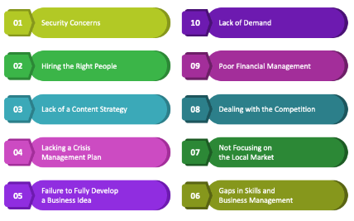
Figure 1: Challenges Faced by Startups
(Source: Self-Made)
On the other hand, due to the heavy market competition, startups also have been reported to face a number of challenges in establishing their core business operations within the target markets. Heavy market competition, developing the most effective startup ideas, determining the most suitable leadership approaches, identifying the new market, and determining the best product-market fit along with business model have been identified to be the most common challenges faced by startups in the contemporary business environment (Rauf et al., 2021). This report has covered the nature and characteristics of startups expanding in the current competitive environment through the beginning section whereas the next session has shed light on different factors that have been reported to lead startups to succeed beyond 3 years. The final section of this report has elaborated startup ideas to be one of the most significant factors for businesses operating at the beginning stages.

Characteristics and Nature of Start-ups in the contemporary scenario
As per the report of Robina-Ramírez et al. (2019), Currently, the business environments have become so complex that have been reported to introduce additional challenges to the startups that are still in the beginning phases. Therefore, the complexity of the target markets has been reported to compel startups to consider additional measures while determining business ideas or developing strategic approaches. In the following, some of the additional considerations are elaborated in brief.
- Business Locations
According to the statement of Tateossian (2022), Location can be found to play a significant role in allowing a business firm, especially a startup to fetch the desired competitive advantages over a particular period. Since this is closely related to determining the product varieties or fulfilling the requirements of the target consumer base belonging to the target location, this has been found to be significant for startup businesses to gain certain competitive advantages by acquiring the desired competitive positions.
- Legal Structure
The local administrative bodies also have been found to play significant roles in allowing a startup business to further develop business policies and procedures. In this case, the startup businesses operating at the initial stages are bound to follow the rules and regulations introduced by the local governmental bodies. In the contemporary scenario, there are different types of businesses including Sole Proprietorship, limited liability company, Joined Ventures, and strategic partnerships, and each of these require the business partners to agree to certain legal documentation for establishing successful business partnerships. This often is reported to be a complex as well as a time-consuming process that can cause delays to set up the startup business operations initially.
- Funding Strategies
The contemporary market volatility introduces a lot of opportunities to startup businesses regarding identifying the most suitable funding strategies that can further help them flourish in the target market (Achimská, 2020). Therefore, this has been found to play one of the most significant roles for startup businesses to include this within their consideration list.
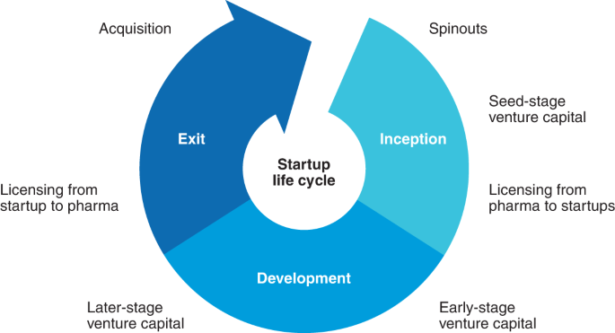
Figure 2: Life Cycle of a Startup
(Source: Self-Made)

Fundamentals of different factors lead start-ups to succeed beyond three years
As per the report of Kalyanasundaram et al. (2021), around 305 million startups are introduced annually in the contemporary scenario. Therefore, market competition along with congestion have been found to contribute much to increasing the complexity of a market over time. Among these around 10% have been found to succeed whereas the rest 90% thrive in the market rapidly increasing the market competition. Due to the complex nature and characteristics of the target global markets, countless factors can be identified that can influence a startup business in one way or another. Among such factors, some of those are elaborated briefly in the following.
- Timing
This particular factor can make all the difference for a Startup business to determine either its success or failure. In this case, proper alignment needs to be done between the offering of a startup business firm and the demands of the target markets. Therefore, timing plays one of the most significant roles for such a startup operating at its initial stages to introduce itself in the market (Tateossian, 2022).
- Talent Acquisition
This often has been found to be a challenge for a startup as in most cases, the right talents are already acquired by the established business firms operating in the same market. Therefore, this has been found to be a major factor for a startup.
- Leadership
This can be stated to be the most crucial factor for a startup as this determines the approaches and goals of the company that further measure its overall capabilities (Tateossian, 2022).

The start-up ideas
As stated by Moskovicz (2021), the idea of a startup has been found to be one of the most significant factors as this can determine the core operational functions of the business as well as the strategic approaches the company will be following to meet its goals and objectives. Therefore, ideas can be developed in such a particular way that can allow the company to avoid heavy market competition without compromising on fulfilling the rapidly evolving demands of the consumers belonging to the target markets. Furthermore, growth opportunities also can be determined by developing unique startup ideas whereas the opposite can lead to succeed beyond three years.

Conclusion
It can be concluded that numerous success factors contribute towards the continuity of start-ups beyond three years. For example, being able to break-even with the startup costs, managing talent and others are important factors that startups to succeed beyond three years. The initial three years are the acid-test for the startups and can go wrong if these factors are not considered and taken care of.

References
Achimská, V., 2020. Start-ups, bearers of innovation in globalizing environment and their valuation. In SHS Web of Conferences (Vol. 74, p. 01001). EDP Sciences.
Kalyanasundaram, G., Ramachandrula, S. and Mungila Hillemane, B.S., 2021. The life expectancy of tech start-ups in India: what attributes impact tech start-ups' failures?. International Journal of Entrepreneurial Behavior & Research, 27(8), pp.2050-2078.
Moskovicz, A., 2021. Post-pandemic Scenario for University Startup Accelerators.
Pisoň, Z., 2021. The Future of Tech Startups in Central & Eastern Europe.
Rauf, R., Wijaya, H. and Tari, E., 2021. Entrepreneurship education based on environmental insight: Opportunities and challenges in the new normal era. Cogent Arts & Humanities, 8(1), p.1945756.
Robina-Ramírez, R., Fernández-Portillo, A. and Díaz-Casero, J.C., 2019. Green start-ups’ attitudes towards nature when complying with the corporate law. Complexity, 2019.

