Appendices

Appendix A Blank Observation Notes Form

Observation Notes

Date:

Lesson details:

Classroom environment:
(Focusing on the general engagement of the whole class).

Student 1

Leuven Scale of Involvement score:

Leuven Scale of Well-being score:

Other comments:

Student 2

Leuven Scale of Involvement score:

Leuven Scale of Well-being score:

Other comments:

Student 3

Leuven Scale of Involvement score:

Leuven Scale of Well-being score:

Other comments:

Appendix B Leuven Scale of Well-being and Involvement Scores

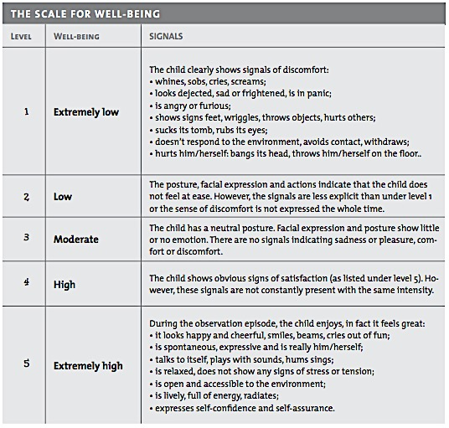
Figure 1: A table indicating score for the Leuven scale of well-being (Laevers et al., 2005).

Appendix C Leuven Scale of Involvement Scores
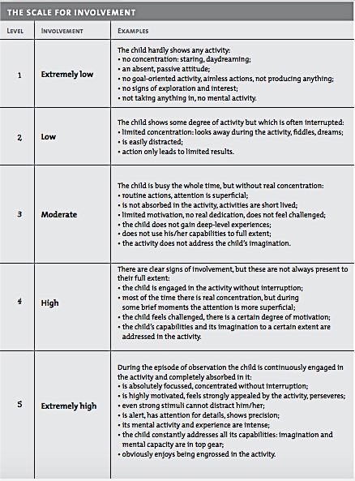
Figure 2: A table representing score for the Leuven scale of involvement (Laevers et al., 2005).

Appendix D Lesson study 1 notes
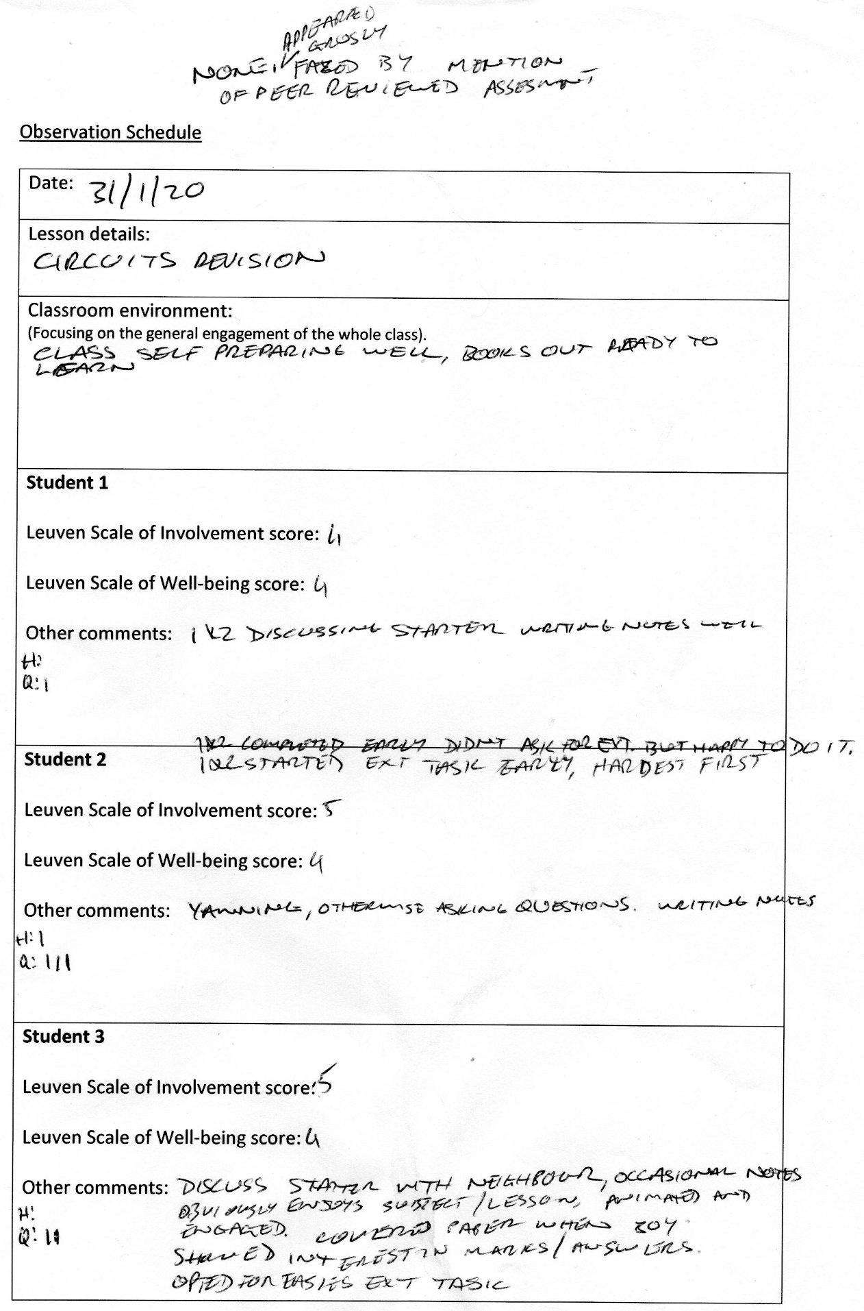

Appendix E Lesson study 2 Notes
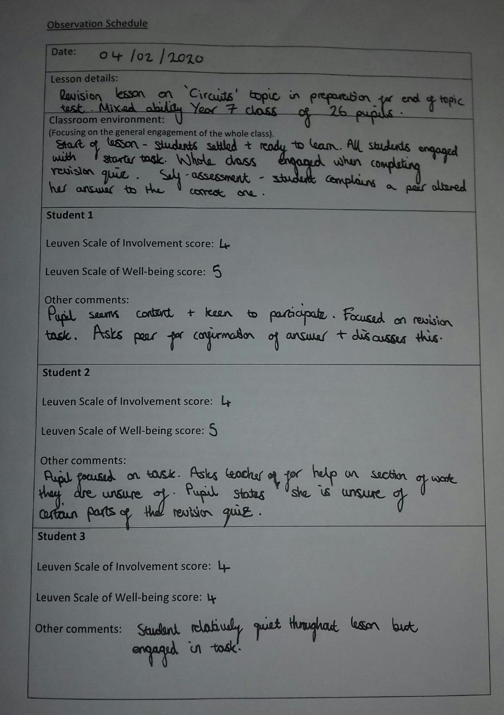

Appendix F Focus Group Interview Questions
Warm up questions:
A. What have you enjoyed most about science lessons so far since starting secondary school?
B. How do you feel the lesson was today?
1. How did you feel about having your work peer assessed?
2. Why do you think you feel this way?
3. How do you feel about peer assessing someone else's work?
4. Why do you think you feel this way?
5. What do you think the benefits of peer assessments are?
6. What are the disadvantages of peer assessment?
7. Put the following in order of how useful you find the different formative assessment forms?
Self-Assessment Peer-Assessment Teacher-Assessment
8. Why?
9. Put the following in order of how comfortable you are with the different formative assessment forms?
Self-Assessment Peer-Assessment Teacher-Assessment
10. Why?
11. Any other thoughts on peer assessment?

Appendix G Ethics form
APPLICATION FOR ETHICAL APPROVAL

In order for research to result in benefit and minimise risk of harm, it must be conducted ethically. A researcher may not be covered by the University’s insurance if ethical approval has not been obtained prior to commencement.

The University follows the OECD Frascati manual definition of research activity: “creative work undertaken on a systematic basis in order to increase the stock of knowledge, including knowledge of man, culture and society, and the use of this stock of knowledge to devise new applications”. As such this covers activities undertaken by members of staff, postgraduate research students, and both taught postgraduate and undergraduate students working on dissertations/projects.

The individual undertaking the research activity is known as the “principal researcher”.

Ethical approval is not required for routine audits, performance reviews, quality assurance studies, testing within normal educational requirements, and literary or artistic criticism.

Please read the notes for guidance before completing ALL sections of the form.

This form must be completed and approved prior to undertaking any research activity. Please see Checklist for details of process for different categories of application.

Delete the Guidance Notes at the end of the form BEFORE submitting your application

SECTION A: About You (Principal Researcher)
Full Name: |  | Derek Lockhart
Tick all boxes which apply: |  | Member of staff: | ☐ | Honorary research fellow: | ☐
Undergraduate Student | ☐ | Taught Postgraduate Student | ☒ | Postgraduate Research Student | ☐

Institute/Academic Discipline/Centre: | Yr Athrofa
Campus: | SA1
E-mail address: | dlockhart.151664@student.uwtsd.ac.uk
Contact Telephone Number: | 07427445973
For students:
Student Number: | P151664
Programme of Study: | PGCE Secondary (Physics)
Director of Studies/Supervisor: | Catherine Morgan (Module Lead)

SECTION B: Approval for Research Activity
Has the research activity received approval in principle?  (please check the Guidance Notes as to the appropriate approval process for different levels of research by different categories of individual) |  | YES | ☒ | NO | ☐
 |  |  |  | Date
If Yes, please indicate source of approval (and date where known): Approval in principle must be obtained from the relevant source prior to seeking ethical approval | Research Degrees Committee |  | ☐
 | Institute Research Committee |  | ☐
 | Other (write in)  Ethics Commitee |  | ☒ | 17th Dec 19

SECTION C: Internal and External Ethical Guidance Materials
Please list the core ethical guidance documents that have been referred to during the completion of this form (including any discipline-specific codes of research ethics, and also any specific ethical guidance relating to the proposed methodology). Please tick to confirm that your research proposal adheres to these codes and guidelines.
UWTSD Research Ethics & Integrity Code of Practice | ☒
UWTSD Research Data Management Policy | ☒
Ethical Guidelines for Educational Research BERA (2018) | ☒

SECTION D: External Collaborative Research Activity
Does the research activity involve collaborators outside of the University? |  | YES | ☐ | NO | ☒
If Yes, please provide the name of the external organisation and name and contact details for the main contact person and confirmation this person has consented to their personal data being shared.as part of this collaboration.
Institution
Contact person name
Contact person e-mail address

Has this individual consented to sharing their details on this form? |  | YES | ☐ | NO |  |  | ☐
Are you in receipt of a KESS scholarship? |  | YES | ☐ | NO |  |  | ☒
Is your research externally funded |  | YES | ☐ | NO |  |  | ☒
Are you specifically employed to undertake this research in either a paid or voluntary capacity? | Voluntary | YES | ☐ | NO |  | ☒
 | Employed | YES | ☐ | NO |  | ☒
Is the research being undertaken within an existing UWTSD Athrofa Professional Learning Partnership (APLP) | If YES then the permission question below does not need to be answered. | YES | ☒ | NO |  |  | ☐
Permission to undertake the research has been provided by the partner organisation | (If YES attach copy)  If NO the application cannot continue | YES | ☐ | NO |  |  | ☐

Where research activity is carried out in collaboration with an external organisation
Does this organisation have its own ethics approval system? | YES | ☐ | NO | ☒
If Yes, please attach a copy of any final approval (or interim approval) from the organisation

SECTION E: Details of Research Activity
Indicative title: | How peer assessment can be effectively employed to improve learning.
Proposed start date: | 6th Jan 2020 | Proposed end date: | 21st Feb 2020
Introduction to the Research (maximum 300 words)
Ensure that you write for a Non-Specialist Audience when outlining your response to the three points below:
- Purpose of Research Activity
- Proposed Research Question
- Aims of Research Activity
- Objectives of Research Activity
Demonstrate, briefly, how Existing Research has informed the proposed activity and explain
- What the research activity will add to the body of knowledge
- How it addresses an area of importance.
Purpose of Research Activity

I am investigating the effectiveness of peer assessed marking in the classroom environment. The evidence will be collected based on a lesson observation and subsequent interviews with three randomly selected pupils from the class that have provided oral assent and parental consent. This will provide positive feedback to improve classroom delivery.

(this box should expand as you type)
Research Question

How can peer assessment can be effectively employed to improve learning.

(this box should expand as you type)
Aims of Research Activity

To improve personal teaching practice by investigating the advantages of peer assessed learning from the student’s perspective.

(this box should expand as you type)
Objectives of Research Activity

Improve personal practice within the classroom by analysing peer assessment as a marking strategies and its implications on assessment for learning.

(this box should expand as you type)
Proposed methods (maximum 600 words)
Provide a brief summary of all the methods that may be used in the research activity, making it clear what specific techniques may be used. If methods other than those listed in this section are deemed appropriate later, additional ethical approval for those methods will be needed.
In order to undertake this research, the following strategies will be undertaken

Lesson Study and Observation
The lesson study is a method if improving classroom delivery (Takahashi and McDougal, 2016) by peer analysis of a lesson delivery to seek improvements. The lesson is redelivered after adjustment to identify if the intended improvements are evident. Observations of the lesson will be taken by the research partner.

Interview Questions
As part of the lesson study process, an interview will be conducted with three pupils from each lesson, this will be used as part of the raw data collection used to amend the first lesson delivery. The interview will be anonymised to ensure BERA guidelines are followed. The interview will be audio recorded to aid transcription.

Reflection
As a result of the data collected the lesson is reflected upon using the ARC model and amended with the aim of improving delivery and the impact of the peer assessment section of the lesson.

Literature Review
A literature review will be completed to compare the research findings.

(this box should expand as you type)

Location of research activity
Identify all locations where research activity will take place.
A South Wales comprehensive school which is a mixed sex school in a reasonably affluent area (6% FSM), the school has approximately 1100 pupils and provides to key stage 3 & 4.

(this box should expand as you type)
Research activity outside of the UK
If research activity will take place overseas, you are responsible for ensuring that local ethical considerations are complied with and that the relevant permissions are sought. Specify any local guidelines (e.g. from local professional associations/learned societies/universities) that exist and whether these involve any ethical stipulations beyond those usual in the UK (provide details of any licenses or permissions required). Also specify whether there are any specific ethical issues raised by the local context in which the research activity is taking place, for example, particular cultural and/or legal sensitivities or vulnerabilities of participants.
(this box should expand as you type)
Use of documentation not in the public domain: Are any documents NOT publicly available? | NO | ☒
 | YES | ☐
If Yes, please provide details here of how you will gain access to specific documentation that is not in the public domain and that this is in accordance with prevailing data protection law of the country in question and England and Wales.

(this box should expand as you type)

SECTION F: Scope of Research Activity
Will the research activity include: | YES | NO
Use of a questionnaire or similar research instrument? | ☒ | ☐
Use of interviews? | ☒ | ☐
Use of diaries? | ☐ | ☒
Participant observation with their knowledge? | ☒ | ☐
Participant observation without their knowledge? | ☐ | ☒
Use of video or audio recording? | ☒ | ☐
Access to personal or confidential information without the participants’ specific consent? | ☐ | ☒
Administration of any questions, test stimuli, presentation that may be experienced as physically, mentally or emotionally harmful / offensive? | ☐ | ☒
Performance of any acts which may cause embarrassment or affect self-esteem? | ☐ | ☒
Investigation of participants involved in illegal activities? | ☐ | ☒
Use of procedures that involve deception? | ☐ | ☒
Administration of any substance, agent or placebo? | ☐ | ☒
Working with live vertebrate animals? | ☐ | ☒
Other primary data collection methods, please explain in this box  For example, ‘focus groups’. Please indicate the type of data collection method(s) in this box and tick the accompany box. | ☐ | ☒
Details of any other primary data collection method:  An anonymised questionnaire as an aide memoire for the researcher and to annotate pupil relies.  The interviews will be conducted immediately after each of the two teaching sessions with volunteer pupils who have given verbal assent and provided parental consent.  The observation will be carried out by the non-teaching research partner in full view and informed knowledge of the classroom pupils.  The interview will be audio recorded to aid transcription of the interview and will be anonymous and deleted after transcription.  (this box should expand as you type) | ☐ | ☒
If NO to every question, then the research activity is (ethically) low risk and may be exempt from some of the following sections (please refer to Guidance Notes).

If YES to any question, then no research activity should be undertaken until full ethical approval has been obtained.

SECTION G: Intended Participants
Who are the intended participants: | YES | NO
Students or staff at the University? | ☐ | ☒
Adults (over the age of 18 and competent to give consent)? | ☐ | ☒
Vulnerable adults? | ☐ | ☒
Children and Young People under the age of 18? (Consent from Parent, Carer or Guardian will be required) | ☒ | ☐
Prisoners? | ☐ | ☒
Young offenders? | ☐ | ☒
Those who could be considered to have a particularly dependent relationship with the investigator or a gatekeeper? | ☐ | ☒
People engaged in illegal activities? | ☐ | ☒
Others (please identify specifically any group who may be unable to give consent) please indicate here and tick the appropriate box. | ☐ | ☒
Other – please indicate here:  (this box should expand as you type) | ☐ | ☒

Participant numbers and source
Provide an estimate of the expected number of participants. How will you identify participants and how will they be recruited?
How many participants are expected? | Two year 7 classes, <30 per class.  3 pupil interviewees per class  (this box should expand as you type)
Who will the participants be? | Year 7 classes as directed by School  (this box should expand as you type)
How will you identify the participants? | A selection of mixed abilities, spread across the range and chosen from those students that opt-in to the research. In accordance with BERA guidelines the pupils will be anonymous.  (this box should expand as you type)

Information for participants: | YES | NO | N/A
Will you describe the main research procedures to participants in advance, so that they are informed about what to expect? | ☒ | ☐ | ☐
Will you tell participants that their participation is voluntary? | ☒ | ☐ | ☐
Will you obtain written consent for participation? | ☒ | ☐ | ☐
Will you explain to participants that refusal to participate in the research will not affect their treatment or education (if relevant)? | ☒ | ☐ | ☐
If the research is observational, will you ask participants for their consent to being observed? | ☒ | ☐ | ☐
Will you tell participants that they may withdraw from the research at any time and for any reason? | ☒ | ☐ | ☐
With questionnaires, will you give participants the option of omitting questions they do not want to answer? | ☒ | ☐ | ☐
Will you tell participants that their data will be treated with full confidentiality and that, if published, it will not be identifiable as theirs? | ☒ | ☐ | ☐
Will you debrief participants at the end of their participation, in a way appropriate to the type of research undertaken? | ☒ | ☐ | ☐
If NO to any of above questions, please give an explanation
(this box should expand as you type)

Information for participants: | YES | NO | N/A
Will participants be paid? | ☐ | ☒ | ☐
Is specialist electrical or other equipment to be used with participants? | ☐ | ☒ | ☐
Are there any financial or other interests to the investigator or University arising from this study? | ☐ | ☒ | ☐
Will the research activity involve deliberately misleading participants in any way, or the partial or full concealment of the specific study aims? | ☐ | ☒ | ☐
If YES to any question, please provide full details
(this box should expand as you type)

SECTION H: Anticipated Risks
Outline any anticipated risks that may adversely affect any of the participants, the researchers and/or the University, and the steps that will be taken to address them.

If you have completed a full risk assessment (for example as required by a laboratory, or external research collaborator) you may append that to this form.
Full risk assessment completed and appended? |  | Yes | ☐
 |  | No | ☒
Risks to participants
For example: emotional distress, financial disclosure, physical harm, transfer of personal data, sensitive organisational information
Risk to Participant:  Small risk of negative affect to pupils’ self-esteem through not being selected for the research.  Pupil pressure to give correct answers  Safeguarding issues due to small group interview.  Pupil anonymity  (this box should expand as you type) | How will you mitigate the Risk to Participant  Pupils will be selected at random from those pupils that provide both oral assent and parental consent this should mitigate any feelings of rejection.  Pupils will not be coached or pressurised to provide correct answers.  All researchers are DBS holders  (this box should expand as you type)
If research activity may include sensitive, embarrassing or upsetting topics (e.g. sexual activity, drug use) or issues likely to disclose information requiring further action (e.g. criminal activity), give details of the procedures to deal with these issues, including any support/advice (e.g. helpline numbers) to be offered to participants. Note that where applicable, consent procedures should make it clear that if something potentially or actually illegal is discovered in the course of a project, it may need to be disclosed to the proper authorities
All research activity is peer assessment focused any incidental disclosure of a sensitive information will be handled in accordance with school policy

(this box should expand as you type)
Risks to investigator
For example: personal safety, physical harm, emotional distress, risk of accusation of harm/impropriety, conflict of interest
Risk to Investigator:  Very small risk of allegation from pupils in the classroom whilst completing the research  (this box should expand as you type) | How will you mitigate the Risk to Investigator:  A member of school faculty will be present at all times, any incidents or allegations will be dealt with in accordance with school policy.  (this box should expand as you type)
University/institutional risks
For example: adverse publicity, financial loss, data protection
Risk to University:  Very small risk of adverse effect on the relationship between the school and the university through data protection issues and adverse publicity.  (this box should expand as you type) | How will you mitigate the Risk to University:  Researchers will behave in professional manner throughout and the rights of participants will be preserved, data handling will be in accordance with university procedures.  (this box should expand as you type)

Disclosure and Barring Service
If the research activity involves children or vulnerable adults, a Disclosure and Barring Service (DBS) certificate must be obtained before any contact with such participants. | YES | NO | N/A
Does your research require you to hold a current DBS Certificate? | ☒ | ☐ | ☐

SECTION I: Feedback, Consent and Confidentiality
Feedback
What de-briefing and feedback will be provided to participants, how will this be done and when?
Consent forms given to all participants for the completion of parents/ guardians. Pupils will be asked for verbal assent and be reminded of their right to withdraw at any time.

(this box should expand as you type)
Informed consent
Describe the arrangements to inform potential participants, before providing consent, of what is involved in participating. Describe the arrangements for participants to provide full consent before data collection begins. If gaining consent in this way is inappropriate, explain how consent will be obtained and recorded in accordance with prevailing data protection legislation.
Consent form accompanied by comprehensive information sheet explaining the purpose of the research, the methods used. The consent forms will be returned to the school prior to the start of the research and available to ensure pupils have parent’s consent to participate.

(this box should expand as you type)
Confidentiality / Anonymity
Set out how anonymity of participants and confidentiality will be ensured in any outputs. If anonymity is not being offered, explain why this is the case.
Pupils will be anonymised in accordance with the BERA guidelines. All data collected will be secured only in UWTSD IT accounts and be deleted on completion of the PGCE course.

(this box should expand as you type)

SECTION J: Data Protection and Storage
In completing this section refer to the University’s Research Data Management Policy and the extensive resources on the University’s Research Data Management web pages (http://uwtsd.ac.uk/library/research-data-management/).
Does the research activity involve personal data (as defined by the General Data Protection Regulation 2016 “GDPR” and the Data Protection Act 2018 “DPA”)? | YES | NO
“Personal data” means any information relating to an identified or identifiable natural person (‘data subject’). An identifiable natural person is one who can be identified, directly or indirectly, in particular by reference to an identifier such as a name, an identification number, location data, an online identifier or to one or more factors specific to the physical, physiological, genetic, mental, economic, cultural or social identity of that natural person. | ☐ | ☒
If YES, provide a description of the data and explain why this data needs to be collected:
(this box should expand as you type)
Does it involve special category data (as defined by the GDPR)? | YES | NO
“Special category data” means sensitive personal data consisting of information as to the data subjects’ –  (a) racial or ethnic origin,  (b) political opinions,  (c ) religious beliefs or other beliefs of a similar nature,  (d) membership of a trade union (within the meaning of the Trade Union and Labour Relations (Consolidation) Act 1992),  (e) physical or mental health or condition,  (f) sexual life,  (g) genetics,  (h) biometric data (as used for ID purposes), | ☐ | ☒
If YES, provide a description of the special category data and explain why this data needs to be collected:
(this box should expand as you type)
Will the research activity involve storing personal data and/or special category data on one of the following: | YES | NO
Manual files (i.e. in paper form)? | ☐ | ☒
University computers? | ☐ | ☒
Private company computers? | ☐ | ☒
Home or other personal computers? | ☐ | ☒
Laptop computers/ CDs/ Portable disk-drives/ memory sticks? | ☐ | ☒
“Cloud” storage or websites? | ☐ | ☒
Other – specify: | ☐ | ☒
For all stored data, explain the measures in place to ensure the security of the data collected, data confidentiality, including details of password protection, encryption, anonymisation and pseudonymisation:
(this box should expand as you type)
All Data Storage
Will the research activity involve any of the following activities: | YES | NO
Electronic transfer of data in any form? | ☒ | ☐
Sharing of data with others at the University? | ☒ | ☐
Sharing of data with other organisations? | ☐ | ☒
Export of data outside the European Union or importing of data from outside the UK? | ☐ | ☒
Use of personal addresses, postcodes, faxes, emails or telephone numbers? | ☐ | ☒
Publication of data that might allow identification of individuals? | ☐ | ☒
Use of data management system? | ☐ | ☒
Data archiving? | ☐ | ☒
If YES to any question, please provide full details, explaining how this will be conducted in accordance with the GDPR and DPA (and/or any international equivalent):
All data will be anonymised at the point of collection, and only shared with the research partner and University marker. The remaining data and findings of the research will be made available to participants and parents upon request. Data will only be transferred within the confines of the University IT system and will be deleted upon completion of the course.

(this box should expand as you type)
List all who will have access to the data generated by the research activity:
Researcher, Research partner, UWTSD markers.

(this box should expand as you type)
List who will have control of, and act as custodian(s) for, data generated by the research activity:
Researcher, research partner.

(this box should expand as you type)
Give details of data storage arrangements, including security measures in place to protect the data, where data will be stored, how long for, and in what form. Will data be archived – if so how and if not why not.
All data will be stored on UWTSD IT account for the duration of the PGCE course and deleted upon its completion.

(this box should expand as you type)
Please indicate if your data will be stored in the UWTSD Research Data Repository (see https://researchdata.uwtsd.ac.uk/ ). If so please explain. (Most relevant to academic staff)
No, the data will not be stored in the UWTSD repository.

(this box should expand as you type)
Confirm that you have read the UWTSD guidance on data management (see https://www.uwtsd.ac.uk/library/research-data-management/) | YES | ☒
 | NO | ☐
Confirm that you are aware that you need to keep all data until after your research has completed or the end of your funding | YES | ☒
 | NO | ☐

SECTION K: Declaration
The information which I have provided is correct and complete to the best of my knowledge. I have attempted to identify any risks and issues related to the research activity and acknowledge my obligations and the rights of the participants.

In submitting this application I hereby confirm that I undertake to ensure that the above named research activity will meet the University’s Research Ethics and Integrity Code of Practice which is published on the website: https://www.uwtsd.ac.uk/research/research-ethics/
Signature of applicant: | Derek Lockhart | Date:  17/12/2019

For STUDENT Submissions:
Director of Studies/Supervisor: |  | Date:  17/12/19
Signature: | Catherine Morgan | Date:  17/12/19

For STAFF Submissions:
Academic Director/ Assistant Dean: |  | Date:
Signature: |  | Date:

Checklist: Please complete the checklist below to ensure that you have completed the form according to the guidelines and attached any required documentation:
☒ | I have read the guidance notes supplied before completing the form.
☒ | I have completed ALL RELEVANT sections of the form in full.
☒ | I confirm that the research activity has received approval in principle
☐ | I have attached a copy of final/interim approval from external organisation (where appropriate)
☐ | I have attached a full risk assessment (and have NOT completed Section H of this form) (where appropriate) ONLY TICK IF YOU HAVE ATTACHED A FULL RISK ASSESSMENT
☒ | I understand that it is my responsibility to ensure that the above named research activity will meet the University’s Research Ethics and Integrity Code of Practice.
☒ | I understand that before commencing data collection all documents aimed at respondents (including information sheets, consent forms, questionnaires, interview schedules etc.) must be confirmed by the DoS/Supervisor, module tutor or Academic Director.
☒ | I have deleted the guidance notes before submitting the PG2 for consideration

RESEARCH STUDENTS AND STAFF ONLY
All communications relating to this application during its processing must be in writing and emailed to pgresearch@uwtsd.ac.uk , with the title ‘Ethical Approval’ followed by your name.
You will be informed of the outcome of your claim by email; therefore it is important that you check your University and personal email accounts regularly.

STUDENTS ON UNDERGRADUATE OR TAUGHT MASTERS PROGRAMMES should submit this form (and receive the outcome) via systems explained to you by the supervisor/module leader.

This form is available electronically from the Academic Office web pages: https://www.uwtsd.ac.uk/academic-office/appendices-and-forms/

Application Process

All staff research projects and all research students must submit the Ethical Approval Form to the University Research Ethics Committee via the Academic Office (pgresearch@uwtsd.ac.uk). Staff research directly in relation to personal study for taught undergraduate or Masters programmes should be submitted via the Institute procedures explained below.

Taught masters and taught undergraduate research Ethical Approval Forms are considered within Institutes. Institutes will provide details of the specific processes for this. Where the Ethical issues within any single ethical application are of particular concern the Institute will refer these to the University Research Ethics Committee. Any student activity that involves the collection of primary data needs to undergo Ethical approval, this includes assignment work as well as dissertations.

Notes for guidance in completion of this form

Section A: About You
Please complete all relevant sections

Section B: Approval for research activity
Research proposals must be approved in principle before applying for Ethical Approval. The proposal approval only becomes final when the ethical approval is received.

The process for proposal approval varies according the individual and programme of study:
- Research students, by application on form PG1 to the Research Degrees Committee
- Taught students by review of research proposal within Institutes (Institutes provide specific details of these processes)
- Staff, by agreement by the Academic Director/Assistant Dean

Section C: External Ethical Guidance materials
Many discipline areas are required to operate with the discipline specific codes of research ethics (for example health, psychology, education etc.), any such codes must be listed and you must tick to confirm that you have consulted with these.

Section D: External Collaborative Research Activity
Provide details of the external collaborative partners, where appropriate you might want to submit a copy of the external collaboration agreement with the Ethical Approval Form. If the partner requires the research to be subject to its own internal Ethical approval process then please provide details of that process and a copy of any final (or interim) approvals received from the organisation.

Section E: Details of Research Activity
Remember that the individuals reviewing this Ethical Approval Form may not have seen your research proposal, and also may not be experts in the specific area of your research. The information provided should therefore be jargon free and clearly stated.
Indicative Title: please use the same title as used on the research proposal.
Purpose: the Ethical approval process will want to ensure that the methods you propose are adequate and appropriate to address the research aims and objectives. Excessive additional data collection can be seen as unethical.
Proposed Methods: the Ethical approval process seeks to ensure that you understand the methods that are intended, and that the implementation of those methods will be appropriate and without unnecessary impact on respondents. This section must explain how the methods described will lead to the collection of necessary and sufficient data, but not excessive data. Please be specific.
Location: this needs to mention geographical location and also local situation (for example, within Local Authority Offices in Cardiff, using a private room but close to other individuals). If you are collecting data within an organisational setting then you need to explain the permissions that you have obtained to do this.
Research Activity outside of the UK: please complete this section in detail, and note any guidance you have received. Also describe your own familiarity (or not) with the location that you will be utilising.

Section F: Scope of Research Activity
Please tick ALL of the research activities that might be undertaken. If any additional types of activity are intended then please add an extra box and describe these.
If you have answered no to all questions in F then sections G and J do not need to be completed. Section H should be considered, and may be completed. Signatures are still required in section K.

Section G: Intended Participants
Please tick all categories that might apply.
Numbers & Source: if you are using a series of different methods or research activities please list numbers for each stage/phase. Be clear about how you will find respondents. Will you use intermediaries, and if so how? How will you ensure compliance with your sampling strategy?
Information for participants: all participants should be appropriately informed about the research, what is expected of them and what will happen to the information that they provide. The Ethical review process does not ask to see this documentation, but requires this to be reviewed and approved by the Director of Studies in the case of research students, the supervisor/module tutor in relation to students on taught programmes and the Academic Director/Assistant Dean in relation to staff research.

Section H: Anticipate Risks
All research carries some level of risk. The answers you provide to questions in this section will be reviewed to ensure that you have an appropriate understanding of the type of risks involved and how you can mitigate against these risks. If you have completed a full risk assessment, as required for example for laboratory work, field work, clinical tests, diving operations, or by a collaborative partner, you may append that to this form. In that case, please tick the box indicating this has been provided. You will not then be required to complete Section H.
Risk to participants Think very carefully about how your actions/questions/discussions might affect the people you are involving as participants. You might identify the risk as small but it would still be a risk. Many types of question have the potential to make respondents less content with their life / job; you need to recognise and try to ameliorate any such effects
If these are business owners, time with you may reduce profit.
In some locations physical risk is very real to both participants and yourself, please consider this.
Risk to you, the researcher Think about where you will meet people, if there are any dangers involved in the location. If you are meeting people as individuals think about using a public place. In general do not visit people in their own homes or remote locations. If you are talking to individuals about certain issues think about how their responses might affect you emotionally. What about the risk of collecting insufficient data?
Risk to the University When undertaking your research, you are acting as a member of the University (student or staff). Professionalism is important, so it is important to be well organised and well prepared. Punctuality, clarity etc. are all part of this. What will you do to ensure this? You must ensure you do not harm the good name of the University in any way and do nothing to undermine the reputation of the research it conducts and sponsors. Upholding high standards of conduct and integrity are vital in this regard. You must also conduct the research in such a way to minimise the potential for claims of negligence made against the University, its researchers and any collaborating individual or organisation. In this respect you should always comply with ethical, legal and professional frameworks, obligations and standards as required by statutory and regulatory authorities, as well as the university’s Research Integrity and Ethics Code of Practice. Research misconduct in this respect can take many forms, including:
- fabrication: making up results or other outputs (eg, artefacts) and presenting them as if they were real
- falsification: manipulating research processes or changing or omitting data without good cause
- plagiarism: using other people’s material without giving proper credit
- failure to meet ethical, legal and professional obligations: for example failure to declare competing interests; misrepresentation of involvement or authorship; misrepresentation of interests; breach of confidentiality; lack of informed consent; misuse of personal data; and abuse of research subjects or material
- improper dealing with allegations of misconduct: failing to address possible infringements such as attempts to cover up misconduct and reprisals against whistle-blowers

Adverse Outcomes. Think carefully about the possibilities, and cover here

Section I: Feedback, Consent and Confidentiality
Feedback to participants: outline your approach. Will interview transcripts be shared with respondents to check accuracy? Will summaries of questionnaire analysis be made available to respondents in some way? Will an overview report be provided? How and when?
Informed consent: Draft letter / e-mail / or heading (or footer) section of questionnaire must be approved by DoS/supervisor (if research student), supervisor/module tutor if taught student, or Academic Director / Assistant Dean if a member of staff.
Confidentiality/Anonymity. Explain clearly how you will ensure confidentiality and anonymity.

Section J: Data Protection and Storage
Before completing this section it is necessary to read the University’s Research Data Management information. The questions that follow are designed to ensure compliance with the Data Protection Act as well as established research protocols.

Many research activities will involve electronic transfer of data and use of data management systems in the summarisation and analysis of data. You will need to explain these in relation to compliance with the Data Protection Act.
Think carefully about who will have access to your data, this will include supervisors and examiners. Also that a thesis will be made available via the University library and the British Library system. If you are seeking an access bar for a period of time after completion then mention it here. If you will provide a copy of your findings, or intend to give a presentation, to a facilitating/ supporting/accessing organisation then explain that in this section. But also think about the general principle of data sharing, as explained in the Research Data Management information.
In terms of storage of data please ensure security, and also mitigate against loss of data.

Section K: Declaration
Ensure the appropriate countersignatures have been provided
Look carefully at the checklist and ensure that you comply with and tick all that are relevant to your research.

