Section 1

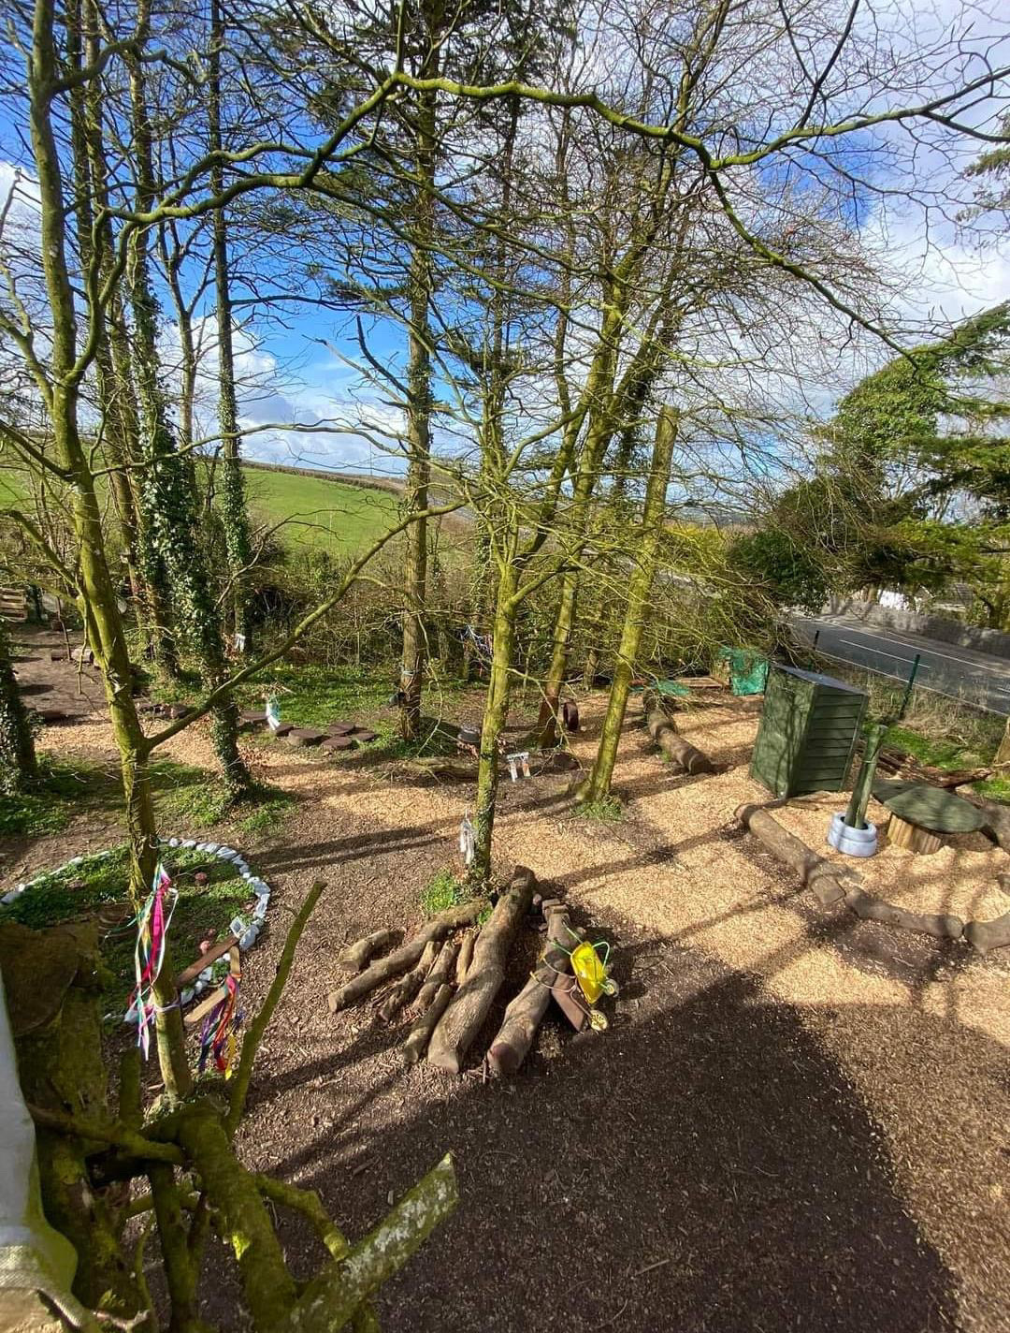

Section 2

Children will emphasise their learning in any environment using their imagination and the resources they have around them. Having an environment like the image I have chosen above will promote a child’s scientific learning and thinking in numerous ways. During the early year’s stages of a child’s life, children will explore plants, creatures, and objects in their natural environment. Science appeals to children’s inquisitive minds as they will try to work things out and this is where the child’s curiosity will link in to explore and experiment. According to curriculum for Wales (2022) ‘The knowledge and deep understanding gained through experiencing what matters in science and technology can help children live independent and fulfilling lives that sees them contributing to society and culture in many different ways.

9:30 am – Full or empty Activity

‘’In today’s session we will be going outdoors to explore and investigate what we can see, hear, feel, and smell. What do you think we may be able to see outdoors in our forest area?’’. Cian replied ‘’Trees’. ‘’ Well done Cian, why do you think we have trees in our outdoor area?’’. ‘’To climb miss’’. ‘’well, you’re not wrong Cian, we can climb trees but remember only with adults’ permission and supervision, however what about if we think about the weather?’’. ‘’well, when it’s a hot sunny day I always sit under the tree away from the sun’’ replied Anna. ‘’ What a fantastic answer
Anna well done; trees also help stop the wind travelling fast to keep us nice and cool when its sunny’’. ‘’These trees all grow different colour leaves to miss’’. ‘’that’s so right Cian well done, so if we look up to the trees now is there any leaves on the trees?’’. ‘’No’’ replied the children. ‘’I wonder why that could be?’’.
‘it’s because its autumn and all the leaves are on the floor’’ Anna Shouted. ‘’what a great answer Anna, ok so now, I would like you Anna to grab a basket and fill your basket full of any leaves you can find’’. ‘’Cian I would like you to fill your basket half full of any leaves you can find and then come back to show me’’.
The children both rushed back with their baskets. ‘’ok so Anna is your basket full or half full? ‘’it is full’’ Anna replied. ‘’How do we know that Anna’s basket is full Cian?’’ ‘’because it’s all the way to the top and you can’t put anymore in there’’ He replied. ‘’Great work Cian, now then what about Cians basket Anna, is cians full or half full?’’. ‘’Cian’s is half full because he has only filled it to the middle of the basket and there is still more room left’’. ‘’correct guys well done’’.

10:15am – Mini Beast activity

Now we will go and explore and try and find some bugs and animals. ‘’What animals do you think we would find in our forest area?’’. ‘’maybe some worms and spiders’’ Cian replied. ‘’I wonder where the spiders and worms may live’’. Bella looked around the forest area ‘’I think under the leaves and twigs miss’’. ‘’shall we go and see if we can find any guys?’’. ‘’yes, let’s go!’’.
‘’miss I found a woodlouse on the log’’. ‘’well, I wonder if we lift this log up do you think there may be more underneath?’’. ‘’why do they live under the logs miss?’’ Anna asked. ‘’well by living under the logs it keeps them nice and warm and safe from bigger animals like birds and sometimes minibeast like to eat the rotting wood’’. So now we know minibeast like woodlouse, worms and spiders like to live under wood and like to keep nice and warm, I wonder if you could build your own bug hotel using the twigs, stones and logs we have here to keep our mini beats safe’’. ‘’yes, we can do that they will love our hotel, I am going to use lots of wood, so they have lots to eat if they get hungry, let’s go’’ Cian excitedly said.
‘’look miss, look at our hotel’’. The children both shouted. ‘’amazing work guys, so what have you used and why have you used these resources?’’. ‘’so, this is the bedroom, where they can use the logs as beds and they can hide under them if they see any big animals coming, then we used the leaves as blankets and we put some acorns and twigs here to, for there to eat if they get hungry’’. ‘’well, done guys you really have worked hard there and thought of how to make sure the bugs are able to live and stay safe’’. Science is an important area in a child’s development. The curriculum for Wales (2022) states ‘knowing about structures and functions of living things enables learners to understand how these things grow, develop and reproduce successfully’. Anna and Cian will develop an understanding of the factors which may affect the health of organisms which allows them to make informed decisions about physical health and how we impact the natural world.

11:00am- Heavy and light Activity.

‘’so, when you were moving the logs and leaves to build your bug hotel, what was the heaviest item?’’. ‘’The logs miss they were heavy’’ Cian replied. ‘’so, what about if we put a log and 20 leaves on each side of our balance scale which side do you think would go down?’’. ‘’the log miss because that’s way heavier than the leaves’’ Anna confidently replied. ‘’I wonder how many leaves we would have to use to keep the balance scale level with the log’’. ‘’loads and loads and loads because leaves don’t weight anything, and the log is super heavy’’ said Anna. By anna and Cian understanding forces and weight will help benefit them with the knowledge of predicting and controlling the behaviour of our environment this can help learners overcome future challenges and use our plants resources efficiently and sustainably (Curriculum for Wales, 2022).
‘’What do you think happens to the leaves when it rains, and the leaves get wet?’’. ‘’do they get heavier?’’ Cian asked. ‘’Correct Cian they would get heavier than a dry leaf, so when it rains what happens to the ground?’’. ‘’it will get wet also miss and there will be puddles’ replied Anna. ‘Well done Anna the mud will turn from a solid to a liquid because of the rainwater, it will turn the mud into a puddle’’. ‘’miss why doesn’t the rain wash away all the mud?’’ Anna asked. ‘’well mud will not dissolve in water just like some things such as sugar. ‘’I wonder why half the ground is wet and half the ground is dry in this area?’’. ‘’well maybe the trees are blocking the rain in this area so that’s why it’s only wet where there are no trees’’ Anna answered. ‘’I think your right Anna. So, what do you guys think happens to the puddles on a dry day, where do they disappear too?’’. ‘’They dry up’’ Cian replied. ‘’yes, Cian they do, there is a special word for this do you think you know what it is?’’.
‘’the word is evaporation, so this is when the liquid like the puddle will turn into a gas, and this is because of the sun and its heat helps the water evaporate’’. ‘’that is so cool miss’’ Anna said. ‘’and then once the gas called water vapour goes into the air this is when it creates clouds in the sky’’. ‘’This lesson is so fun miss I love learning outside’’ Cian excitedly shouted.

Children learn and take in so much from being outdoors as there is so many resources around them, these resources will encourage them to use their imagination and curiosity to support their learning unexpectedly. The Curriculum for Wales (2022) believes ‘being encouraged to use logic, evidence and creativity, learners will be supported to inquire into and apply scientific knowledge to further understanding of how our world works’.
The photo above offers so many opportunities for children to develop the scientific learning from the natural resources shown and just the use of their creativity and imagination. The support of the ‘I wonder’ questioning from practitioners helps encourage the children to think for themselves and to expand their knowledge instead of being given the answers directly. This is also supported with the ‘curiosity approach’, This approach is a creative and innovative method of supporting child development in early years by placing the children at the heart of learning and provides innumerable opportunities for the children to explore, imagine and create. (Hawthorne 2021).

Section 3:

RISK BENEFIT ASSESSMENT

Location / Activity: | Outdoor forest Area | Date: | September 19th 2023
Assessor: | Brooklyn Smith | Review date: | March 19th 2024

The boxes in the table below will expand as you type into them; pre-entered text is simply for illustration. You should delete irrelevant items and replace with text relevant to your circumstances.
Your overall risk rating – Low, medium or high – is based on your judgement about whether the BENEFITS of the activity or opportunity outweigh the RISKS.

Experience exploring outdoor space in photograph | How will young people BENEFIT from this activity? | Hazards and associated risks | Who is at risk? | PRECAUTIONS in place to reduce the risk of injury | Overall risk after precautions  RATING: L/M/H
Walking Slippery/ uneven ground | Encourages children to use their balance and improves their coordination developing their gross motor skills | This may cause Physical injuries such as cuts, bruising, bleeding and possibly fractures or sprains.  Children may be at risk of Slipping and tripping. | Children and adults | Set rules before the activity and discuss with the children they will need to walk and be sensible in certain areas of the forest | L
Weather | Stimulate the child’s immune systems, encourage their growth, well-being, and sense of adventure. | Change of weather or being dressed inappropriately for the weather may lead to the Children get sun burnt or unwell. | Children and Adults. | Children must wear appropriate clothing to suit weather conditions.  Encourage the children to apply sun cream in warm conditions.  Encourage the children to use the identified shaded areas. | L
Climbing Trees | Develops Gross motor skills, encourages the child’s independence and perseverance.  By participating in Physical health activities, Children can develop positive, informed behaviours that encourage them both to care for and respect themselves and others (Curriculum for Wales, 2022) | Children may get Splinters when climbing the trees.  Physical injuries might happen if children are not being supervised or are not behaving appropriately.  The child may be at Risk of falling if they are not careful and being supervised. | Children | Make the children aware of the risks of climbing the trees by having a discussion before the activity.  Adults and practitioners must always supervise the tree areas | L
Sensory experiences | Use of their five senses (touch, hear, see, smell and taste).  Children will gain self-confidence. | Children may develop Allergies to new things around them.  Stings and Bites may appear to a child.  Children may choke if they attempt to put something in their mouths without being advised not to. | Children  And adults | Adults must always supervise and observe children.  Adults must check the resources and area for safety before allowing the children to explore and learn.  All staff to be aware of any possible allergies.  Always having a First aid kit available and accessible  Children to be pre warned not to put anything in their mouth and taught the dangers of choking.  Children must be encouraged to wash their hands after session when touching insects or outdoor resources, | L
Misuse of equipment and resources | Children will learn from mistakes and the misuse of equipment and want to re try correctly. Through enabling learners to manage risks ad take on different roles and responsibilities will support learners to become creative contributors ready to play a full part in life. (Curriculum for Wales,2022). | Children may obtain a physical injury from lifting heavy resources such as the logs such as strains or fractures.  Children may lose confidence in using the equipment again. | Children | Remove any resources or equipment that may need repairing.  Practitioners must demonstrate how to use resources and equipment before allowing the children to use independently.  Adults must check equipment before each session.  Any equipment being used must be age appropriate. | L

Section 4

In early years, mathematical and scientific concepts are essential in a child’s learning. The most reliable way to promote this is using outdoor environments. This essay will evaluate how adults working with early years children can support and encourage their engagement with mathematical and scientific concepts in the outdoor settings. I will draw upon relevant theorists and strategies that promote children’s mathematical and scientific thinking in the outdoor environments. By adults incorporating maths and science into a child’s outdoor experience, adults can support the child’s cognitive, social, and physical development. However, the adult’s role is crucial in supporting and maximizing the children’s outdoor learning.
During a child’s scientific and Mathematical development in early years, adults have a crucial role in supporting this. According to (Jan white, no date), ‘Young children need practitioners who value and enjoy the outdoors themselves, see the potential and consequences it has for young children’s well-being and development, and want to be outside with them. By providing the best use of the outdoors effectively, adults support child - led learning’. Child led play allows children to take lead in the play and adults respond to the child’s reactions or interest. Additionally, White (no date) also states ‘the adult role outdoors must be as deeply considered as that indoors. Adults attitude, commitment and positive thinking are essential to a child’s outdoor learning process. Welsh assembly government (no date) also supports this and states ‘it is essential that parents and carers too understand its value. Research shows their attitudes to children’s experiences are crucial and important in developing children’s confidence and self-esteem. The outdoors experience of young children is most effective as a partnership between adults.’
Adults have a role to create an enabling environment by providing suitable resources, encouraging the child’s curiosity, and introducing loose parts in children’s outdoor scientific and mathematical learning. For practitioners and adults to create an enabling environment they will need to think about how the outdoor areas of learning can be experienced as holistically as possible and as Jan White (no date) said ‘the adult role outdoors must be as deeply considered as that indoors’, Welsh assembly government (no date) agrees with this and states ‘adults need to give as much thought to continuous and focused provision in planning outside as they do for activities indoors’. By adults creating a well-resourced and planned environment outdoors will enable the children to learn independently and participate in child-led activities, by the adult being prepared and planning what they would the like the outcome of the science and mathematical lessons to be, will support them in supplying suitable and effective resources for the children. Effective preparation and organisation will then lead to the observation process being more effective and reliable, although the child will be leading the activity it is the adult’s role to observe whilst being a supportive presence for the child to be engrossed in the activity, stepping back, observing and being patient to see what emerges from the activity. Jean Piaget (1896) believed observing the children and talking to them about their own ideas and concepts enables adults to gain insights into the children’s learning. (Martin, 2021) Piaget highlights more of a hands-on experience and active engagement through constructing knowledge. On the other hand, another constructivist was Vygotsky. According to (Martin,2021), Vygotsky (1896) saw development as being rooted in social relationships that provide a framework for learning through dialogue and instruction. By adults observing and guiding children this can provide valuable learning opportunities and promotes higher-order thinking, problem solving abilities and the development of language and communication skills.
During scientific and mathematical learning in early years, adults must introduce children to loose parts, this encourages the children to use their creativity and imagination to use the loose parts freely to make it into anything they wish. Gov.uk (no date) believes, ‘adults must give children enough space and time to experience and explore to help and encourage them to develop their own curiosity and creativity. A child’s imagination and creativity are enriched through their awareness of art and other children around them’. Loose parts can be freely used by the children to create, explore textures, and develop curiosity (Play Scotland, 2023). According to the curiosity approach (2019) Reggio Emilia, Maria Montessori, and Emmi pikler inspired the Curiosity Approach and believed ‘children are innate learners, capable to seek answers and to explore, investigate and to be curious. Similarly, to this Nicolson (1971) believes ‘everyone can be creative and inventive, this can be shown when observing children of all abilities playing with loose parts. (Creative star, 2017). Adults must ensure the environment used to carry out a scientific or mathematical activity has lots of loose parts and variables, these could be manmade such as tyres, rope, guttering and planks of woods or natural such as twigs, leaves, stones, and rocks, with these resources the children can think about concepts such as weight, length, volume, gravity, and friction. Nicholson (1971) believes when an adult creates a space that is excessively neat and unchanging, this is making it difficult for children to engage in playful activities, it is suggested that the adult has taken away the opportunity for children to express their creativity. (Creative star, 2017).
An approach that supports Nicholson’s theory of ‘loose parts’ is Anna Ephgrave’s ‘planning in the moment’. This approach believes children have the natural curiosity and desire to learn, so in relation to lose parts, planning in the moment complements the freedom to choose from all the available resources to develop the child’s learning in the own way. (Creative star 2017). However, there are many different opinions on outdoor learning and the nature of outdoor play. According to Little (2015) article, ‘Mothers overwhelmingly acknowledged the benefits of risky outdoor play, tension existed between their desire to provide opportunities for their children to safely engage in such play and overcoming their own fears and concerns about their children’s safety’. Little (2015) also states ‘A number of studies over the past decade have noted a trend towards over-protective parenting practices that restrict children’s activities and limit children’s independent mobility and engagement with their neighbourhoods’. Loose parts allows children to become aware of risks and teaches them how to manage physical and emotional risk over protective parents are restricting their children, White (no date) believes ‘Children are seriously disadvantaged if they do not learn how to approach and manage physical and emotional risk, Young children need to be able to set and meet their own challenges, become aware of their limits and push their abilities (at their own pace), be prepared to make mistakes, and experience the pleasure of feeling capable and competent.
In regards to risk taking and giving the children opportunities, Forest schools can offer children the opportunity to take risks within an outdoor area that has been assessed by adult as being as safe as is reasonable, by adults giving the children the opportunity to have a forest school can also change the attitude of the adults to take new risks to, this will benefit the child as it will give children better opportunities to be more aware of hazards and how to take sensible risks in the future. (Knight, 2009). Child-led play is at the heart of forest school and its function, Knight (2009) states ‘’forest school is about an internal process of holistic development, something that is difficult to achieve in a busy classroom’’. Gov.wales (no date) supports forest schools and explains it provides ‘hands on, learning experiences which encourage children to explore and challenge themselves. This leads to the development of confidence and self-esteem as well as a growing appreciation of their natural environment.’. Several settings and schools may not have the forest school set up; however, adults and practitioners can organise visits to designated areas of the community which allow children to explore and discover independently whilst making informed decisions about how to deal with unfamiliar situation and challenges (Gov.uk, no date). In New Zealand their curriculum ‘Te whariki’ has the principle of empowerment- empowering all children to learn and grow. Similarly, forest school has the same aspiration, based on valuing the skills and contribution of each child. As well as this, Te Whariki believes relationships are vital and children learn through responsive and reciprocal relationships with people, Forest schools aim to provide these different relationships. (Knight,2009). On the other hand, one interpretation that could be useful to the forest school in respect of the recording system, like the Reggio Emilia approach is where the children can select what it to be recorded and how. (Knight, 2013) Adults can provide camera and iPads to the children outdoors to allow them to record their own work, and take recordings of each other’s work for example, one child could record another balance on a log or a child could take photos of their bug hotel. This allows the child and adult to then observe their work and discuss or write notes for the future, this allows the children to personally develop and feel valued.
The use of loose parts and the encouragement and support from adults then benefits the use of curiosity approach for children, whilst experimenting and learning during the scientific and mathematical teaching. It is the role of the adult to inspire and nurture an inquisitive mind in every child, the adult must observe the child and then set up those provocations to learning the child’s intertest. Meta cognitive talk was used during the learning story in section 2, where questions such as ‘I wonder what would happen…’ or ‘why is this happening’… the adult can support a child’s curiosity by asking open ended questions to encourage discussion and to fan the flames of a child curiosity. (The curiosity approach,2019). Children become curious when they feel safe and fearless, the constant ‘’don’t do this, don’t do that’’ from adults will diminish the child’s willingness to be curious. If an adult is not invested in the outdoor experience with the child the child may not be as curious as they would be with an adult that was invested, as the child wants someone to feel safe around and someone to discover and enjoy the experience of the outdoors freely with. (Curiosity approach, 2019).
The adult’s role in a child’s learning and development is crucial in all areas, as Welsh assembly government (no date) stated ‘Research shows adults attitudes to children’s experiences are crucial and important in developing children’s confidence and self-esteem’. This is empathised by two theorists, Bruner, and Vygotsky, who supports scaffolding from adults and peers. Bruner believed the more experienced other in the learning process was fundamental, He saw the role of the adult as ensuring that assistance carefully matched to the learners needs (Smidt, 2011). Similarly, Vygotsky describes the scaffolding in which ‘the more capable adult aids the less capable child to go beyond their developmental level and create new learning’. (Holzman, 2009). In relation to supporting scientific learning outdoors Vygotsky’s approach believes without the adults guidance and support the children would not benefit their current understanding and develop more advanced scientific concepts., this is a perfect example of meta cognitive talk, without the adults asking open ended questions the children would not be able to extend their learning and reflect on what has been learnt, they gain deeper knowledge and understanding of what is being taught.
Overall, the key component in a child’s scientific and mathematical learning is not the resources, the adults Role and interaction is just as effective as physical resources. If the adults are encouraging, supporting, and modelling possibilities, the children will begin to do them same. Theorists have done research and proved that the adult’s role and behaviours affect the child’s overall behaviours. The child will decide on how they want to learn and then it is the adult’s role to model, support and nurture a child to see beyond the literal.

References

Creative star (2017). Simon Nicholson and the theory of loose parts. Available at: https://creativestarlearning.co.uk/early-years-outdoors/simon-nicholson-and-the-theory-of-loose-parts-1-million-thanks/. [Accessed 20.09.2023]

Gov.uk (No date). Outdoor learning handbook. https://hwb.gov.wales/storage/fcb8539c-9be7-4883-8542-35d7b54b56f2/foundation-phase-outdoor-learning-handbook.pdf. [Accessed 22.09.2023]

Gov.uk (No date). Imagination and creativity. Available at: https://help-for-early-years-providers.education.gov.uk/expressive-arts-and-design/imagination-and-creativity#why-imagination-and-creativity-are-important. [Accessed 22.09.2023]

Hawthorne. H (2021). Curiosity Approach In early years: Importance and ideas. Available at: https://www.highspeedtraining.co.uk/hub/curiosity-approach-in-early-years/#:~:text=The%20Curiosity%20Approach%20is%20a%20creative%20and%20innovative%20method%20of,explore%2C%20imagine%2C%20and%20create. [Accessed 21.09.2023]
Helen Little (2015). Mothers’ beliefs about risk and risk-taking in children’s outdoor play, Journal of Adventure Education and Outdoor Learning, 15:1, 24-39, DOI: 10.1080/14729679.2013.842178
Holzman. (2009). Vygotsky at work and play. Routledge. Pg 113

Knight.S (2009). Forest schools and outdoor learning in the early years. London. SAGE publications.

Knight.S (2013). Forest schools and outdoor learning in the early years. 2nd edn. London. SAGE publications.

Martin. E (2021). Jean Piaget and Lev Vygotsky. Available at: https://www.earlyyearseducator.co.uk/features/article/pioneers-jean-piaget-and-lev-vygotsky. [Accessed 21.09.2023]

Play Scotland (2023). Loose parts play. Available at: https://www.playscotland.org/resources/print/Play-Scotland-Loose-Parts-Leaflet.pdf?plsctml_id=10934. [Accessed 21.09.2023]

Smidt. (2011). Introducing Bruner: a guide for practitioners and students in early years education. Routledge.

The curiosity approach (2019). How can we encourage curiosity in early childhood? Available at: https://www.thecuriosityapproach.com/blog/how-can-we-encourage-curiosity-in-early-years#:~:text=Encourage%20children%20through%20their%20interests,%2C%20who%2C%20when%20and%20where. [Accessed 19.09.2023]

Welsh assembly Government (No date). Outdoor learning handbook. Available at: https://hwb.gov.wales/storage/fcb8539c-9be7-4883-8542-35d7b54b56f2/foundation-phase-outdoor-learning-handbook.pdf. [Accessed 20.09.2023]

Welsh Government (2022). Curriculum for Wales. Available at: https://hwb.gov.wales/curriculum-for-wales/. [Accessed 20.09.2023]

White, J. (No date). Early years outdoor Vision and Wales for outdoor play. Learning through Landscapes. (2-5). [accessed 21.09.2023]

