Chapter 3 - Methodology

Introduction

This section of the project will outline the research design and approach taken to achieve the objectives set out in the research proposal. These are:

- To investigate whether attending mental health calls where the police are not the most appropriate agency is having a detrimental impact on morale among South Wales Police officers who are in their probationary period or new in-service (under five years);

- To investigate whether this high number of calls to mental health incidents is linked to poor retention of probationer and new in-service officers in South Wales Police;

- To establish whether South Wales Police probationers and new in-service officers believe that the Right Care, Right Person initiative is making a difference or will make a difference to their workload and deployment in the future

This part of the dissertation will establish the research framework and methods to be used for data collection and analysis in Chapter 4.

Research Strategy
3.1.1. The Research Onion
The research onion created by Saunders et al in 2007 will provide the framework for this research. This is a suitable framework because it facilitates a clear understanding of the different stages of the research process and helps to explain how they are connected.
The research onion is shown in Figure 1.1
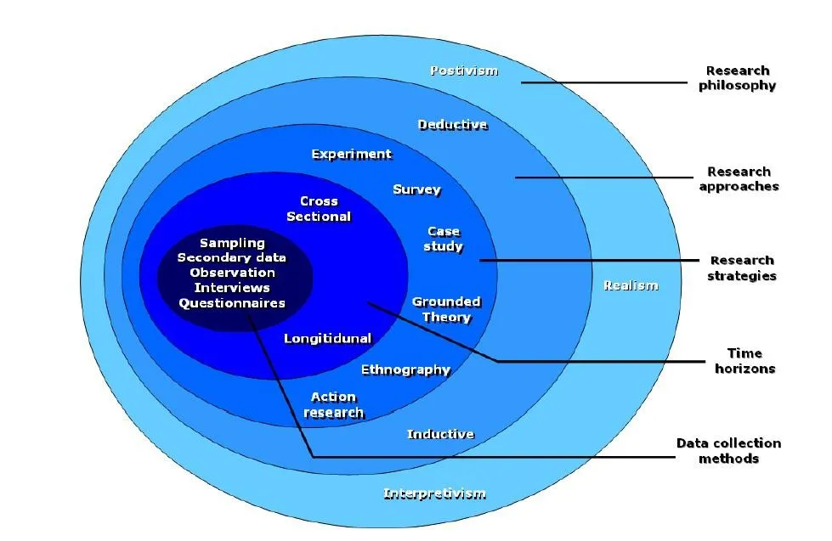

Fig. 1.1

The research onion is one of the most common frameworks in academic writing (Saunders et al. 2007). The diagram shown above illustrates different layers of research which are practical and straightforward to use. Its visual presentation of the various research components make it a manageable framework to use for this study.
    - Research Philosophy
The outer layer of the research onion illustrates the different philosophies which can be adopted when carrying out research objectives in academic writing. The subject chosen for this research will utilize interpretivism as this approach allows the researcher to consider the social and cultural factors which might influence responses from the sample group. An interpretivist approach is the most suitable philosophy underpinning the research as answers to surveys will be subjective. They may require an element of involvement from the researcher to obtain a holistic understanding of the individual and the factors which may potentially have influenced their response. This is supported by the findings of Bryman (2012)) who explains that context is vital in understanding the behaviour, beliefs and values of respondents in the sample.
    - Approach
This research will adopt a deductive approach to the study of data collected. This approach is best suited to the research questions because the researcher begins with the theory that, in this case, mental health calls are having a detrimental effect on police officers’ morale. The research will either prove or disprove this theory.

    - Strategy
The strategy for conducting this research will be to issue questionnaires via social media and South Wales Police intranet system. The questionnaires will be targeted at probationers in the force and those officers who have been in post for less than five years (referred to throughout this research as being new-in-service). The decision to use questionnaires to gather the data for the research objectives of this project is based on their suitability in providing both qualitative and quantitative data about respondents’ views on mental health calls and the impact on their morale. This method will also allow respondents to expand their responses by making additional comments where appropriate (Bell and Opie, 2002).
3.1.5 Choice
The most suitable design for this research project will be a mixed method design, utilizing both qualitative and quantitative data. This allows the researcher to combine the different types of data within a single study and has become popular in social science research in recent years (Timans, Wouters and Heilbron, 2019). Although the findings of the research are expected to be based largely on qualitative data, quantitative methods will need to be used in order to express findings in numerical form as appropriate.
    - Time Horizon
Because this research project is a small study, a ‘Cross-sectional’ time horizon is best suited to meeting the objectives outlined in the Introduction of this chapter. It is low in cost and can be implemented quickly, but because this framework gathers information from a single point in time, results may not necessarily provide an accurate representation of respondents’ thoughts and feelings over a longer period of time.
  - Data Collection
3.2.1. Data collection
Because of time constraints, data collection took place in the form of a questionnaire issued to participants via the force intranet system. A copy of the questionnaire can be found in Appendix A of the dissertation.
3.2.2. Questionnaire design
The online questionnaire was designed with a range of open and closed questions. This approach recognized that participants might be short of time where closed questions would be quicker to complete, but also allowed respondents to expand on their responses with open questions too. There were ten questions in total.
    - Sample
The questionnaire will be distributed to probationers and new-in-service South Wales Police officers as this is the group targeted in the research aimed at meeting the research objectives. It will be limited to South Wales Police officers for practical reasons.
  - Data Analysis

The data obtained will be presented using tables or pie charts with possible support from Google Data. This will allow the findings to be presented clearly.
  - Limitations and potential problems
I may not receive enough respondents to my questionnaire, meaning my sample size would not be large enough for meaningful results to be obtained.
3.5 Summary of Chapter
This chapter has successfully explained the research methodology for the project.

930 words.

References
Bell, J., and Opie, C (2002). Learning from research: getting more from your data. Open University Press.
Bryman, A. (2012), Social Research Methods, Oxford University Press, Oxford.
Saunders, M.. Lewis, P. and Thornhill, A. (2007) Research Methods for Business Students 6th ed. London: Pearson
Timans, R., Wouters, P. & Heilbron, J. Mixed methods research: what it is and what it could be. Theor Soc 48, 193–216 (2019). https://doi.org/10.1007/s11186-019-09345-5

