Contents
Introduction 2
Geographical Information Systems 2
The Start of GIS 2
Cartographic Representation 3
Mapping 4
Thematic Mapping 4
Data Visualisation 9
Visual Variable Properties 10
Types of Information 11
Types of Data in GIS 12
Combining Multiple Layers 12
Case Study 13
Meningitis Overview 13
Data Source 15
Findings 15
Bibliography 17

Introduction

Geographical Information Systems

A Geographical Information System is a specifically designed framework that captures, manipulates and analyses spatial and geographical data. It is a tool that helps users combine spatial data such as maps with other types of data such as graphs or tables. GIS provides a way to integrate and analyse the spatial relationship between objects which is extremely important as most data comes with notable geographical components [1].
This technology aids users in providing an actionable intelligence from the different types of data applied with geographic science. Geospatial data is analysed to find the location and relationships of features, the density of these features, the happenings inside an AOI (area of interest) and the change of an AOI over time [2].

The Start of GIS

The origins of GIS started back in 1854 when spatial analysis was used in London when cholera was abundant in the city. John Snow, a British physician mapped out the locations of outbreaks as no one knew how the disease originated. In a marvellous breakthrough by connecting geography with public health, he later discovered that cases of the diseases were usually found along the water lines. This event also sparked the study of epidemiology (the study of disease spread). However, it was not until 1968 when Roger Tomlinson, now renowned as the “Father of GIS” created the term Geographic Information System in his paper. This was the time when GIS involved the use of computers and cemented itself as a software tool used to store map data [2].

Cartographic Representation

Cartography represents the study and practice of map creation in order to communicate spatial, topographic and geographic information in the most effective manner. Cartography and GIS together provides spatial relationships to be presented in a structured representation. Cartography representations add quality to the display of feature geometry.
Representations give users the ability to change a features appearance by containing the symbol information with feature geometry within feature classes. This aids users to further improve the visualisation and display and provide more precise specifications. Representations represent a feature classes’ property that is stored in system tables within the geodatabase and feature class. This feature class allows more than one representation linked with it thus making the ability to display the same data uniquely on varying maps. Representation rules have symbol layers and geometric effects to determine how features in a representation are drawn.

Cartographic Visualisation
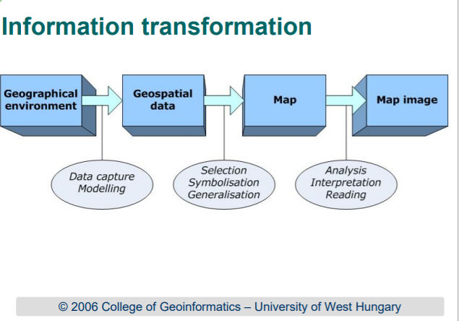
The information transformation process [4]

Mapping

Maps help users identify and locate geographic objects. The shape and the colour of symbols representing objects let users know their characteristics. Maps also provide spatial relations and aid users by providing an overview of a certain distribution.

Thematic Mapping

A thematic map represents a visual representation of specific location’s attributes. These attributes within the map are usually points of interest for the creator which usually includes properties of a geographic region such as a specific population as well as qualitative properties like illustrative information such as types of disease in a given area. Thematic map data can come from original data, existing data or a hybrid of the two [4].
Thematic maps can be utilised to display the differences between two areas such as ethnicity, income, age and so on. Thematic map’s information may be provided at different levels such as state, city, region or census.
The accuracy of the data and geocode is responsible for the accuracy of the map. This is why data preparation plays a huge role in this analysis and data must be properly accurate for the assurance of an accurate thematic map. Reference map data must also be considered as it is important for creators to note the nature of boundaries from the reference data as they will affect the end result in the thematic map as well.
The types of thematic maps include:

Choropleth Maps
Choropleth maps have shaded or areas with patterns related to the statistical variable located on the map. The data is aggregated on predefined areal units. This type of map is best used for standardized or evenly distributed data within the areal units.
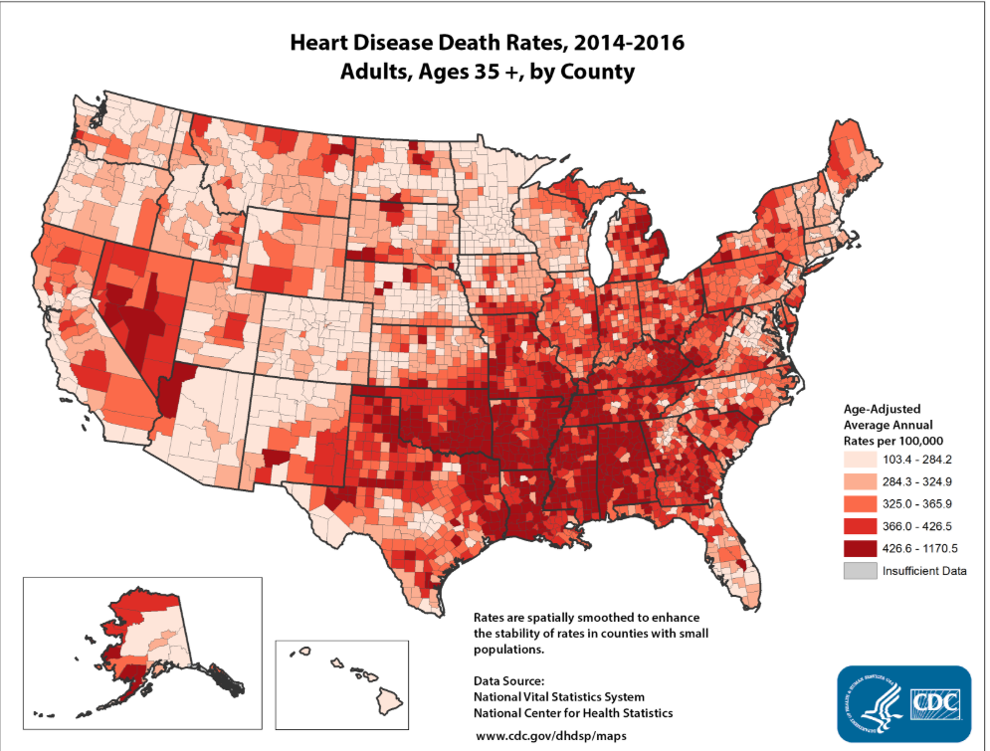
Example of a choropleth map [5]

Graduated Symbol Map
Graduated Symbol Maps have symbols of different sizes to emphasize the relative quantitative values. They are often used with location or point data. This type of map is usually used when variation exists in the data and the aim of the map is to display the magnitudes of specific locations.
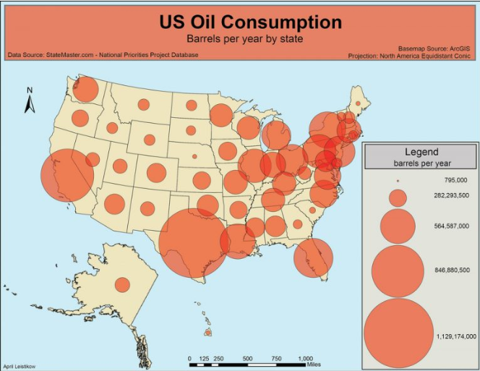
Example of a graduated symbol map [6]

Dot Map
Dot maps utilises dots to display a feature or event. They depict a spatial pattern and relative density. Each dot represents a certain amount of data. Areas with more dots show a higher concentration of values in a certain area while less dots show a lower concentration. They are best utilised for data counting and displaying multiple data sets.
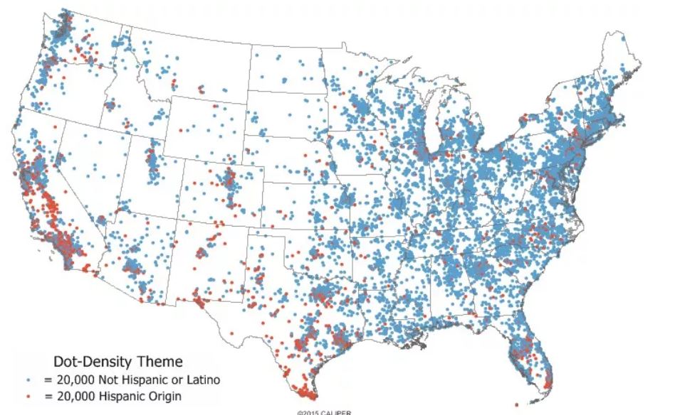
An example of a dot map [7]

Isopleth Map
Isopleth maps are a contour map which shows continuous data. For instance, the weather is a continuous data. Data in this map is displayed with lines which connect to equal numerical value points or with similar value ranges of similar colours and patterns. These maps are most effective to highlight gradual change over space.
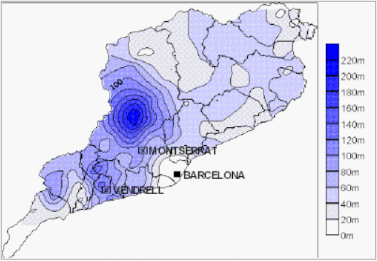
An example of an isopleth map [8]

Cartograms
Cartograms have distorted spatial geometry of mapped areas to showcase an attribute such as population or age. They resize and exaggerate variables on attribute values. It is best used with mapping techniques and can be manually or digitally constructed.
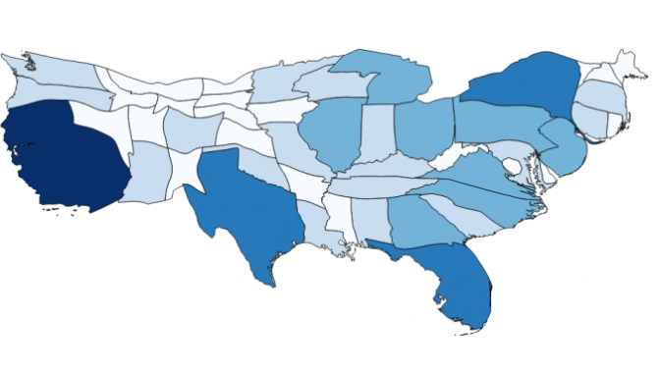
Example of a cartogram [9]

Data Visualisation
In GIS, users will often visualize the data that they have. Even though, some data such as maps from a server include a rendering, most of the time, it is the GIS users that define how the geographical data is perceived and rendered. GIS also brings elements from scientific visualization alongside the concepts from classic cartography. Geovisualization which involves multidimensional data rendering brings about a more rich approach than the previous one.
Visual variables are properties of visual elements that are used in geometric elements to provide geographical information. The types of variables include shape, size, position, hue, texture, value and orientation.
The position variable is seldom used as the genuine position of a rendered element is favoured.
The shape variable is defined by an object’s perimeter. It is mostly used to point data with a symbol or shape to locate the exact coordinates of a location to be rendered. This variable is hard to use on linear symbols while requiring shape alteration for areal symbols.
The size variable shows the symbol’s dimensions. With points, it is used by changing the symbol’s size while with lines, the thickness is usually changed. Areal symbols do not use this variable except for texture fills, where it is applied to textures and not the symbol itself.
The texture variable indicates the pattern used in the symbol body. With a dash pattern, it is used with lines and often used in areal symbols.
The colour variable has the most importance as its components, hue and value are used as visual variables as well. Hue represents the name of the colour and can be changed depending on the hue of the surrounding elements. Value represents the colour’s darkness and is used to distinguish between lighter and darker colours.
The orientation variable is used on most point symbols excluding ones that are hard to identify the orientation due to the symmetry. It is also applied on areal symbols but on the texture and not on linear symbols.
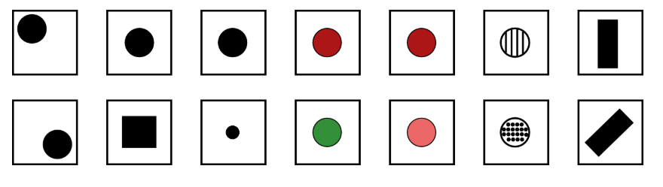
Picture showing the visual variables from position, shape, size, hue, value, texture and orientation [4]

Visual Variable Properties

The four properties include:
Associative – A variable has associative properties when it does not change the visibility of an element. An element does not gain more importance using it.
Selective – A variable has selective properties when they create different symbol categories when applied.
Ordered – A variable has ordered properties when it is possible to represent a specific ordering.
Quantitative – A variable has quantitative properties when it can express ratios apart from being ordered.

Types of Information

Nominal
Nominal information is represented by the visual variable shape. It displays what is located on different parts of a map instead of the quantity found. It leans towards base cartography more than thematic cartography. Utilising different symbols for line and point elements are common while for areal symbols, texture and hue are the usual solution.
Ordinal
As values of a variable define the order, visual variables with ordered properties are required to visualize ordinal information.
Interval and Ratio
Visual variables with ordered properties are usually used for this type. Size is the most appropriate variable as it has a quantitative property.
Several strategies exist for maximizing information that a map provides. These strategies include equal intervals and natural intervals (percentile). Each strategy provides a different view in the visualization of data.
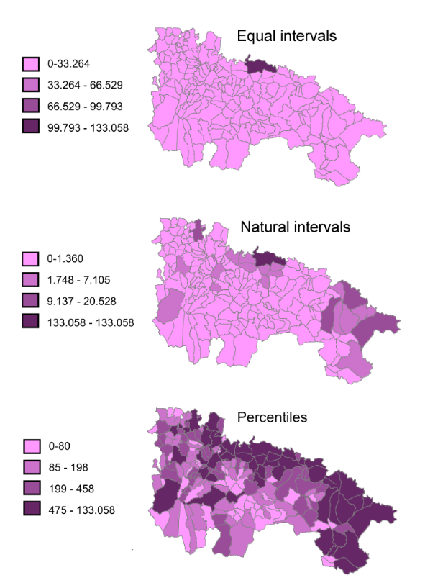
Picture showing the different effect of strategies on data visualization [4]

Types of Data in GIS

Combining Multiple Layers

Combining layers aids map users to fully grasp and interpret the information provided. When layers are combined, it must be done with synergy in mind by correctly ordering layers and utilising symbology that does not confuse or interfere with others. Layer ordering is essential as only the top layer of information is seen for the same location.
Raster layers are used as base layers as they cover up data underneath. This is because these layers fill spaces and holds values in all their cells. It is important not to layer them inappropriately or users might lose information.
It is recommended to order vector layers by prioritising polygons then lines then points for the best visibility. Most GIS have a layer transparency setting as well that can be applied to both layers. With raster layers however, transparency is only partial by rendering certain cells in a specific value range.
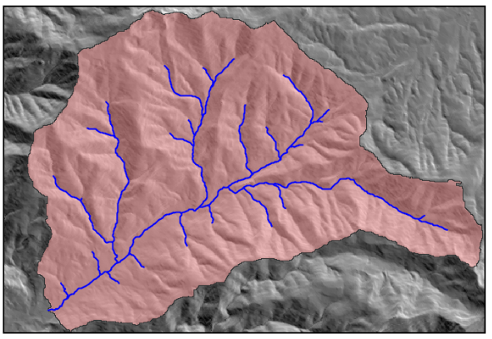
An example of using transparency for two layers [4]

Case Study

Meningitis Overview

Meningitis is a serious infection that affects the protective membranes (meninges) of the brain and spinal cord by inflammation.
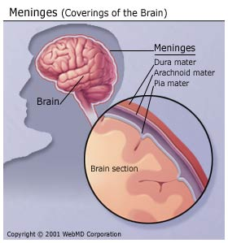
Picture showing the meninges location [1]
The most common types of the disease are viral and bacterial meningitis. Viral meningitis is the most common out of the lot but thankfully is not as severe and the infected usually recover without treatment. It is also not likely to catch this form of meningitis from an infection person as even if they contracted the virus, it is unlikely to develop into meningitis [2]. Bacterial meningitis however is extremely dangerous and needs immediate medical attention. Even with treatment, the fatality rate is still at 34% in 2006 [3]. It is also easily contagious and spreads through close contact with other people.
The causes of meningitis vary between the difference types but all the forms behave in the same way by reaching the spinal cord or brain through the bloodstream. It then builds up to a serious infection setting up in the lining of these parts. Non-contagious meningitis however does not have an infection stage.
The symptoms of this disease for people over 2 years old include the loss of appetite, a stiff neck, a sudden high fever, feeling nauseous with a headache, being extra sensitive to light, inducing seizures and a skin rash that does not vanish under a glass [4]. For babies, symptoms include a stiff body, being unresponsive, a high-pitched cry, a soft bulge on their forehead and loss of appetite [5].
With the advances in modern medicine, vaccines for the disease have been created and widespread. The main vaccines for meningitis treat bacterial forms as they are the most lethal. The meningococcal conjugate vaccine covers the four most common bacterial serotypes (4 in 1). This vaccine lasts a higher duration and provides great protection especially if amplified with maintained booster shots.
The MenB vaccine was made and offered for babies of 8 weeks, 16 weeks and a year. This vaccine protects them from the meningococcal group B bacteria. This bacterium alone makes up about 90% of meningococcal cases for young children and represents a serious life-threatening infection [6]. Without proper vaccination, the needless loss of life incurred would just increase over time which is why education about the subject is of paramount importance.

Data Source

Datasets were pulled from the website https://www.healthmapwales.wales.nhs.uk/IAS/home/. The website consists of various dataset related to the Welsh area. The needed statistics are areas at OA, LSOA and MSOA level based on census boundaries. Datasets related to immunisation and vaccines were pulled.
The datasets used to calculate the Townsend index was pulled from INFUSE, UK Data Services. The data included
- People aged 16-74: Economically active: Employees Part-time
- People aged 16-74: Economically active: Employees Full-time
- People aged 16-74: Economically active: Self – employed
- People aged 16-74: Economically active: Unemployed
- People aged 16-74: Economically active: Full-time student
- Households: Owner occupied: Owns outright
- Households: Owner occupied: Owns with a mortgage or loan
- Households (number of cars or vans): None
- All households

Findings

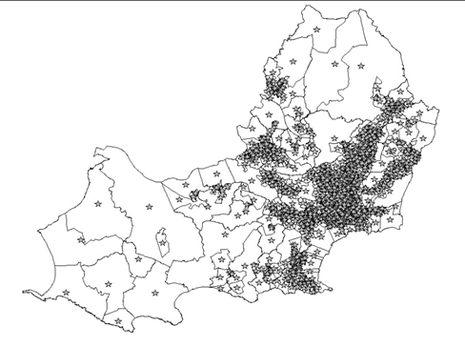

The map generated by MapInfo (GIS) shows the various areas of deprivation index with the concentration of good health residents. The base layer of the map targets areas in Swansea. The sub urban areas are usually areas of deprivation as there are fewer residents compared to the cities. The deprivation index is generated from the percentage of unemployment, overcrowding and the Z-score from the Townsend Index.
The star symbol represents the people of age 16-76 who have good health/fairly good health. It can be deduced that residents of deprived areas have worse health while residents of less deprived areas have an overall better health. Thus, vaccines should be recommended and pushed for the residents of deprived areas as meningitis is a bigger risk in those areas.

Bibliography

[1] | B. E. Mennecke and M. D. Crossland, "Geographic Information Systems: Applications and Research Opportunities for Information Systems Researchers," Proceedings of the 29th Annual Hawaii International Conference on System Sciences, 1996.
[2] | J. Martindale, "Mapping and Geographic Information Systems (GIS) : What is GIS?," ResearchGuides, [Online]. Available: https://researchguides.library.wisc.edu/GIS.
[3] | GISGeography, "What is Geographic Information Systems (GIS)?," GISGeography, 2019. [Online]. Available: https://gisgeography.com/what-gis-geographic-information-systems/.
[4] | A. Guszlev, "Cartographic visualisation in GIS," 2006. [Online]. Available: http://uhulag.mendelu.cz/files/pagesdata/eng/socrates_ip/teaching_materials/cartography.pdf.
[5] | what-when-how, "Thematic Maps (GIS and Spatial Analysis) Part 1," what-when-how, [Online]. Available: http://what-when-how.com/gis-and-spatial-analysis-for-the-social-sciences/thematic-maps-gis-and-spatial-analysis-part-1/.
[6] | CDC, "Heart Disease Death Rates, Total Population Ages 35+," CDC, 2018. [Online]. Available: https://www.cdc.gov/dhdsp/maps/national_maps/hd_all.htm.
[7] | D. Orden, "The complexity of drawing good proportional symbol maps," MappingIgnorance, 2013. [Online]. Available: https://mappingignorance.org/2013/12/16/the-complexity-of-drawing-good-proportional-symbol-maps/.
[8] | Caliper Corporation, "What is a dot-density map?," Caliper Corporation, [Online]. Available: https://www.caliper.com/glossary/what-is-a-dot-density-map.htm.
[9] | GeographyFieldwork, "Choropleth Maps," GeographyFieldwork, 2018. [Online]. Available: https://geographyfieldwork.com/DataPresentationMappingTechniques.htm.
[10] | GISGeography, "Cartogram Maps: Data Visualization with Exaggeration," GISGeography, 2018. [Online]. Available: https://gisgeography.com/cartogram-maps/.
[11] | V. Olaya, "Visualization of geographical data," [Online]. Available: https://volaya.github.io/gis-book/en/Visualization.html.
[12] | D. Brennan, "What Is Meningitis?," WebMD, 2018. [Online]. Available: https://www.webmd.com/a-to-z-guides/understanding-meningitis-basics.
[13] | CDC, "Meningitis," CDC, 2017. [Online]. Available: https://www.cdc.gov/meningitis/index.html.
[14] | D. van de Beek, J. de Gans, A. Tunkel and E. Wijdicks, "Community-acquired bacterial meningitis in adults," 2006.
[15] | Mayo Clinic, "Symptoms & Causes Overview," Mayo Clinic, 2018. [Online]. Available: https://www.mayoclinic.org/diseases-conditions/meningitis/symptoms-causes/syc-20350508.
[16] | NHS, "Symptoms Meningitis," NHS, 2016. [Online]. Available: https://www.nhs.uk/conditions/meningitis/symptoms/.
[17] | NHS, "MenB vaccine," 2018. [Online]. Available: https://www.nhs.uk/conditions/vaccinations/meningitis-b-vaccine/.

