Module: Research Methods II

Module Code: ECPS5009

Title: Motivational factors that influence university students to apply for and engage with a university degree programme: a thematic analysis.

Abstract
Self-Determination theory (Deci & Ryan, 2017) is commonly used to identify motivations within an educational setting. The purpose of this study was to investigate the role of what motivates university students to apply and engage with a university course. Thematic analysis was used to interpret themes in transcript data from a focus group of four university students. 2 main themes were interpreted, which included improvement and university experience. Subthemes included the family influences, career, enthusiasm of lecturers/teaching personnel as well as peer influence. Themes and subthemes are discussed, as well as implications for further research regarding motivation with the consideration of Self-Determination theory as well as additional factors.

Introduction
Motivation is the driving force behind all decisions an individual makes, one theory within psychology that offers an explanation as to why an individual is motivated is Social-Determination Theory (SDT) (Deci & Ryan, 2017). One use of SDT is to understand an individual’s motivation within an educational setting, in terms of intrinsic motivation, for example the enjoyment of a subject being learnt, and extrinsic motivation, which can be influenced by positive or negative outcomes (Lin, McKeachie, & Kim, 2003). SDT also states that in order for intrinsic motivation to occur, autonomy, competence and relatedness must also be fulfilled (Deci & Ryan, 2017).
When investigating the relationship between a sense of belonging in university and motivation, Pedler, Willis and Nieuwoudt (2021) found that those with a higher sense of belonging within their university setting reported higher enjoyment regarding their studies as well as increased motivation when compared to students who felt they had a lower sense of belonging. As well as this, there was an increased sense of belonging in those who had parents attend university when compared with first-generation university students. This is supported by research conducted on Slovak students whereby significant importance was placed on attending a university programme by students who have had parents attend higher education than first-generation university students (Šabíková et al., 2023). In contrast to these findings, . It is evident that parental influences can have an impact on an individual's motivation to apply to a university programme, as well as the level of engagement.
When evaluating Czeck university student motivation and quality of the university chosen, the most significant factor on motivation for students was the quality of the teaching personnel delivering lectures. This included rating positively on factors such as teacher personality (Fajčíková & Urbancová, 2019). This is further evident when looking at student performance, whereby subject-specific enthusiasm and enthusiasm for teaching the subject were correlated with student performance (Mahler, Großschedl, & Harms, 2018). Noori et al. (2020) found university students in Afghanistan’s motivation was significantly positively impacted by the way in which the lecturer engaged with students and how they were treated.
This research aims to investigate the motivational factors on university students’ motivation through the form of thematic analysis, to interpret and identify reoccurring themes and subthemes.

Method
Participants
Participants were selected to take part in the study based upon provisions of interest noted by applicants to the university during the application process over a period of two years. Communication to obtain participants from this sample was sent via email, including a brief outline of the purpose of the study and contained information on the location, date and time of the study. Four university students responded and agreed to take part in the focus group.
Data Collection (combination of design, materials, procedure)
A semi-structured interview was used by the researcher in order to obtain participants. This consisted of ten open ended questions which allowed for prompts to elicit responses. The interview process was a 60 minute focus group consisting of four participants. This focus group was then transcribed by the researcher for data analysis. Names were replaced with pseudonyms in order to discuss findings within this paper to ensure no participants could be identified by the information provided in the transcript. The final transcript was then provided to second-year undergraduate students for the purpose of a research report.
Data Analysis
Thematic analysis was selected to analyse the raw data from the transcript in order to identify themes and patterns. Braun and Clarke’s (2006) six-phase analysis was used here to transcribe the data. The transcript was read through on several occasions to gain familiarity with the raw data. Next, comments and initial codes were noted on the margin of the transcript to reduce larger data into familiar codes. This was then followed by using codes and notes made to expand and identify patterns within the transcript to be developed into themes. Statements were reviewed in order to determine relevance as well as if this was a single or group opinion. The next stage of analysis involved reviewing themes and gathering data to support these themes to determine if the data selected was in support of identified themes. Analysis was conducted to define and create themes, which in turn led to the final creation of themes and subthemes.
Results
The aim of this research was to investigate the way in which motivation has an impact on university students. Thematic analysis was applied to data from a focus group transcript to interpret themes and subthemes from the data set. From this, two prominent themes of improvement and university experience were interpreted. Below is a table that identifies these themes and subthemes with supporting quotes from the transcript.
Table 1.
A table of themes, subthemes and supporting quotes obtained from the transcript.
Themes | Sub-themes | Supporting quotes
Improvement | Family influence | “my dad wanted me to do something in uni.”  “he just wanted me to go to uni because he did I think.”  “he’s pushed me to do the best I can do.”  “why don’t you go and do something else then”  “I have to do well if I want to get to the position where I feel comfortable and I can give the girls a comfortable life.”  “no one in my family has ever been to uni”  “I went to work with my dad one day and that was it”
Improvement | Career | “fun into a career.”  “be the boss”  “I don’t really want to work for someone else - aim high right?”  “get a decent job and earn a decent amount of money.”  “act as a stepping stone”
University experience | Peer influence | “so the modules I’ve enjoyed the most are the bits that I’ve had to interact with people basically.”  “I really don’t like the interaction at all.”  “I just kind of like to do my own thing.”  “but it’s nice to just – just be around other people”  “I didn’t really come to university to make friends.”  “they had an impact – a negative impact on my motivation to be there.”  “I just don’t belong with these people.”
University experience | Lecturer enthusiasm | “And the lecturer was, just, really … he loved it”  “his passion for it made me really excited to go in each week and learn about more stuff”  “But the lecturer was just... I dunno – cool?”  “He explained things really well and just had a bit of personality about him. And that just made the task much easier.”  “that one part will always stand out as being interesting”  “it’s quite easy to, to be in a class where you feel like you are getting what you need to be getting from your lecturers.”  “when you can relate to them and can understand what they’re saying and they don’t just use the really big terms”

Theme 1: Improvement
Subtheme 1: Family influence
Alex states at the beginning of the focus group that “my dad wanted me to do something in uni.” (page 3, line 53) and “he just wanted me to go to uni because he did I think.” (page 4, lines 74-75). Later on, Alex mentions their dad as “my main motivation” (page 20, line 571) and “he’s pushed me to do the best I can do.” (page 22, line 572). Furthermore, parental influence is shown by Emily who quoted their mother within the transcript with “why don’t you go and do something else then” (page 21, line 556) in response to the lack of motivation to carry on with what they were previously doing. Both of these individuals suggest that parental influence can have a motivational impact. Mark had also stated that university education was never a consideration before, as “no one in my family has ever been to uni” (page 19, line 492) and goes on to state “I went to work with my dad one day and that was it” (page 19, line 494).
Other family influences are also seen throughout the transcript. Sarah highlighted “I want a better life for me and the girls” (page 5, line 118) and “I have to do well if I want to get to the position where I feel comfortable and I can give the girls a comfortable life.” (page 23, lines 597-599), this idea is evident throughout “It’s all to try and give them a better life” (page 18, lines 475-476).
Subtheme 2: Career
All participants mention future career prospects. Alex begins with stating course choice was to turn “fun into a career.” (page 3, line 73), as well as “I don’t really want to work for someone else - aim high right?” (page 7, line 180) suggesting the motivation for a future career. Mark chose a subject that they are already familiar with and states “I thought it would be interesting to carry on in an area I already know, but like, on the other side ya’know?” (page 4, lines 85-86) and this idea of career progression is explored when Mark states wanting to “be the boss” (page 7, line 167). Sarah had also stated their motivations for completing a university degree as “get a decent job and earn a decent amount of money.” (page 16, line 411) as a result of a CV writing workshop within the university. Emily also states that the degree chosen would “act as a stepping stone” (page 21, line 550) toward the future career prospects and “it’s useful to have a degree” (page 21, line 551).
Theme 2: University Experience
Within the transcript, it was evident that the individual experiences of university life participants had impacted their motivation, both positively and negatively. Subthemes here included social/peer interactions, lecturer enthusiasm and enjoyment of the subject/modules.
Subtheme 1: Lecturer enthusiasm
Lecturer enthusiasm appeared to be a positive motivational factor; this was true of all participants of the focus group. Emily had stated that one lecturer was passionate, saying “his passion for it made me really excited to go in each week and learn about more stuff” (page 13, lines 342-343), which implicates that motivation to attend lectures can be impacted by the enthusiasm displayed. Alex also experienced a similar scenario, stating “he explained things really well and just had a bit of personality about him. And that just made the task much easier.” (page 17, lines 437-438), later commenting “that one part will always stand out as being interesting” (page 17, line 450). Sarah also mentioned “it’s quite easy to, to be in a class where you feel like you are getting what you need to be getting from your lecturers.” (page 25, lines 648-649) and Sarah also stated an interaction a faculty member on CV writing was “so good” (page 15, line 393) and “really interactive” (page 15, line 394), motivating Sarah to “enhance my CV” (page 16, lines 410-411).
Subtheme 2: social and peer interactions
Interactions with peers appeared to be a prominent subtheme within the transcript, there were both positive and negative. Positively, Sarah had stated that she had really enjoyed the social aspect of the university course “so the modules I’ve enjoyed the most are the bits that I’ve had to interact with people basically.” (page 9, lines 231-232) as well as Mark stating, “but it’s nice to just – just be around other people” (page 10, lines 257-258). Emily’s experience discussed during the focus group was negative, stating “they had an impact – a negative impact on my motivation to be there.” (page 23, lines 629-630) as well as Alex stating, “I really don’t like the interaction at all.” (page 8, line 234).
Discussion
Two to the main themes highlighted within the transcript were that of improvement and university experience. Subthemes included the family influences on improvement as well as career. Subthemes identified within the university experience theme were enthusiasm of lecturers/teaching personnel as well as peer influence.
Parental influence research by Mitchall and Jaeger (2018) found that first-generation university students had self-determination enhanced when they received support from parental figures as well an enhancement regarding career prospects and educational attainment as a result of high parental involvement. Also mentioned in this research was the decrease in motivation when it came to the limit of choice regarding university education. This was also evident within research from Buoy (2013), who found amotivation was scored significantly higher in those with parents that exercised high control. A sense of belonging is also considered to be a contributing factor to motivation, negative stereotypes and social stigmatization had an effect on student motivation within an immigrant student population (Froehlich et al., 2022).
Future career prospects has links into extrinsic motivation under the idea of identified regulation (Ryan & Deci, 2020), there is also a suggestion of intrinsic motivation from the subtheme of careers, as there was discussion surrounding the enjoyment of the subject chosen for higher education study. Career prospects has previously been identified as a motivator for university students’ engagement in literature, being cited as a main theme in a variety of thematic analyses (Senior, et al., 2018). When given a questionnaire surrounding motivations for choice, university undergraduate students placed high importance on career prospects and correlated positively with an individual’s life goal of wealth (Skatova & Ferguson, 2014).
Lecturer enthusiasm was a prominent theme within the transcript. Roth et al. (2007) shows evidence that teachers who are autonomously receiving personal accomplishment in turn will result in students showing autonomous motivation. Further literature places high importance on student interactions with faculty as a significant contributor to self-reported learning among the university population (Lundberg, 2014). As mentioned within Ryan and Deci (2020), although there is sufficient evidence to suggest that teacher influence has a positive impact on motivation of students there is also a need to support teachers who have the same three basic psychological needs. The importance of need satisfaction is further highlighted by Moè and Katz (2022), which found that need frustration in turn impacts teaching motivation, having a negative impact on student motivation and places value on supporting teacher need within academia.
Peer influence has a prominent motivational impact on student’s academic experiences. As stated previously in research by Pedler, Willis and Nieuwoudt (2021), those with a higher sense of belonging within their university setting reported higher enjoyment regarding their studies as well as increased motivation when compared to students who felt they had a lower sense of belonging. As well as this, students who had a higher level of social engagement within a university setting. Furthermore, group learning was seen as a positive predictor of student engagement, especially when peers are considered to be more capable which led to more successful learning (Boateng, Attiogbe, & Kunbour, 2022).
However, it should be considered that the area of education is vastly changing, other considerations to be placed on factors that impact motivation on university, such as personality traits (Skatova & Ferguson, 2014), the well-being of the educator’s impact on learning (Moè & Katz, 2022) as well as taking on board the suggestion of inclusivity and wellbeing from SDT (Ryan & Deci, 2020) to foster positive learning environments.

References
Boateng, J., Attiogbe, E., & Kunbour, V. (2022). Influence of adult learners’ self-direction on group learning. Cognet Social Sciences.
Braun, V., & Clarke, V. (2006). Using thematic analysis in psychology. Qualitative Research In Psychology, 77-101.
Buoy, M. (2013). The Influence of P The Influence of Parental Inv ental Involvement on Academic Motiv ement on Academic Motivation. Eastern Illinois University , 1-25.
Deci, L., & Ryan, R. (2017). Self Determination Theory: an introduction and overview. In L. Deci, & R. Ryan, Self-determination theory: Basic psychological needs in motivation, development, and wellness (pp. 3-28). London: The Guilford Press.
Fajčíková, A., & Urbancová, H. (2019). Factors Influencing Students’ Motivation to Seek Higher Education—A Case Study at a State University in the Czech Republic. Sustainability, 4699.
Froehlich, L., Gulli Brokjøb, L., Nikitin, J., & Martiny, S. (2022). Integration or isolation: Social identity threat relates to immigrant students’ sense of belonging and social approach motivation in the academic context. Special Issue: Stigma and Social Relationships, 264-290.
Lin, Y.-G., McKeachie, W., & Kim, Y. (2003). College student intrinsic and/or extrinsic motivation and learning. Learning and Individual Differences, 251-258.
Lundberg, C. (2014). Peers and Faculty as Predictors of Learning for Community College Students. Community College Review, 79-98.
Mahler, D., Großschedl, J., & Harms, U. (2018). Does motivation matter? – The relationship between teachers’ self-efficacy and enthusiasm and students’ performance. PLoS ONE, 1-18.
Mitchall, A., & Jaeger, A. (2018). Parental Influences on Low-Income, First-Generation Students’ Motivation on the Path to College. The Journal of Higher Education, 582-609.
Moè, A., & Katz, I. (2022). Need satisfied teachers adopt a motivating style: The mediation of teacher enthusiasm. Learning and Individual Differences.
Noori, A., Said, H., Nor, F., & Ghani, F. (2020). The Relationship between University Lecturers' Behaviour and Student Motivation. Universal Journal of Educational Research, 15-22.
Pedler, M., Willis, R., & Nieuwoudt, J. (2021). A sense of belonging at university: student retention, motivation and enjoyment. Journal of Further and Higher Education, 397-408.
Roth, G., Assor, A., Kanat-Maymon, Y., & Kaplan, H. (2007). Autonomous Motivation for Teaching: How Self-Determined Teaching. Journal of Educational Psychology, 761-774.
Ryan, R., & Deci, E. (2020). Intrinsic and extrinsic motivation from a self-determination theory perspective: definitions, theory, practices and future directions. Contempoary Educational Psychology, 1-11.
Šabíková, N., Valentová, K., Masaryk, R., Neusar, A., & Sokolov, L. (2023). Exploring the impact of generational differences on university study decisions in Slovakia. Tuning Journal for Higher Education, 2386-3137.
Senior, R., Bartholomew, P., Soor, A., Shepperd, D., Bartholomew, N., & Senior, C. (2018). “The Rules of Engagement”: Student Engagement and Motivation to Improve the Quality of Undergraduate Learning. Frontiers in Education.
Skatova, A., & Ferguson, E. (2014). Why do different people choose different university degrees? Motivation and the choice of degree. Personality and Social Psychology.

Appendix
Appendix A: Consent Form
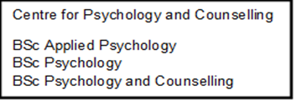


Participant Consent Form

Title of the Study: Exploring motivation in university students
Research Team: Stacey Coleman
Date: 06/09/23

Please review the statements below and indicate your response by circling either 'Yes' or 'No':

- I confirm that I have read and understand the Information Sheet for the above study. | Yes | No
- I had an opportunity to ask questions and have them answered satisfactorily. | Yes | No
- I understand that I may ask further questions at any time. | Yes | No
- I understand that my participation is voluntary, and I am free to withdraw from the study at any time without penalty or giving any reason. | Yes | No
- I understand that my fully anonymized data will be utilized for a second year research methods project whereby students will be provided with the focus group transcript to analyse. | Yes | No
- I understand that I may decline to answer any particular questions. | Yes | No
- I agree to the interview being recorded for transcription purposes. | Yes | No
- I understand that I have the right to ask for the recording to be turned off at any time during the interview. | Yes | No
- I understand that any data collected will remain confidential and that any identifiable information provided by me will be removed or replaced with a pseudonym. | Yes | No
- I understand that I may withdraw my consent at any time during the focus group and up to one week later (up until 13/09/23). After this point, my data will be stored anonymously and confidentially. | Yes | No
- I understand that the anonymised data provided will be securely stored and accessible only to the members of the research team directly involved in the study, and that confidentiality will be maintained. | Yes | No
- I give my permission for the anonymised transcript of the focus group to be used for learning activities by students. | Yes | No
- I agree to maintain the confidentiality of all members involved in the focus group and will not discuss any of the conversations had during this focus group with anyone outside of the focus group. | Yes | No
- I confirm that I am over 18 years old. | Yes | No
- I agree to take part in the above study. | Yes | No
Participant Name Date Participant Signature
________________________ __________ ________________________

Researcher Name Date Researcher Signature
________________________ __________ ________________________
Appendix B: Interview Questions
Focus group: Exploring factors affecting motivation in undergraduate students.

Interview Schedule:
- As a starting point, could you please tell me what you think is meant by the term ‘motivation’?
- What motivated you to apply for the course you are currently studying?
- What are either your short- or long term goals related to your education?
- What parts of your studies do you find most enjoyable? why is this?
- Can you share an example of a time when you felt genuinely excited and motivated to work on a particular assignment or project?
Prompt: what contributed to that feeling?
- Can you explain whether there are any external factors - outside of your enjoyment in the subject - that influence your motivation to perform well at university?
- How do you manage your motivation when subjects or modules don't fully align with the things you're interested in?
- Can you explain how you think interactions with other people on your course can impact your motivation to learn and success?
Prompt: for example, interactions with lecturers, or other people on the course
- Is there anything about the university you are studying at itself that contributes to your overall motivation to attend?
- One of the main things reported by university students all across the UK is balance between academic commitments and personal life - or work-life balance. how do you maintain a positive work-life balance and how does this affect your motivation?
- Finally, if you had to choose just one thing that you would say has been the most influential in making you motivated to carry on with your course, what would it be?

Appendix C: Fully Annotated Focus Group Transcript
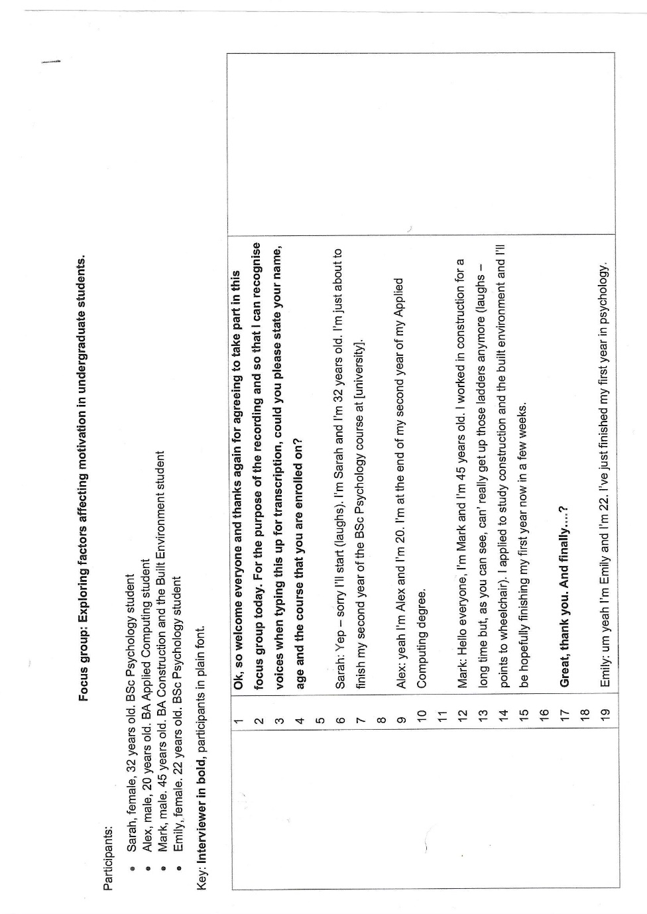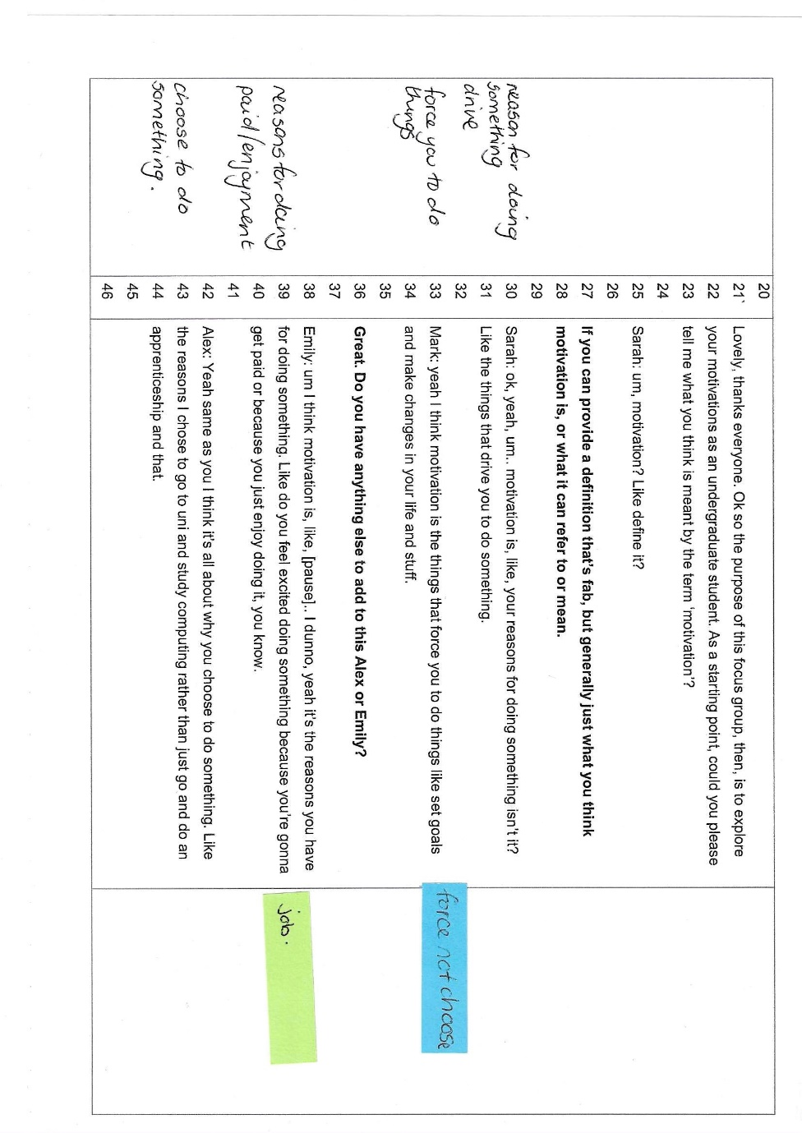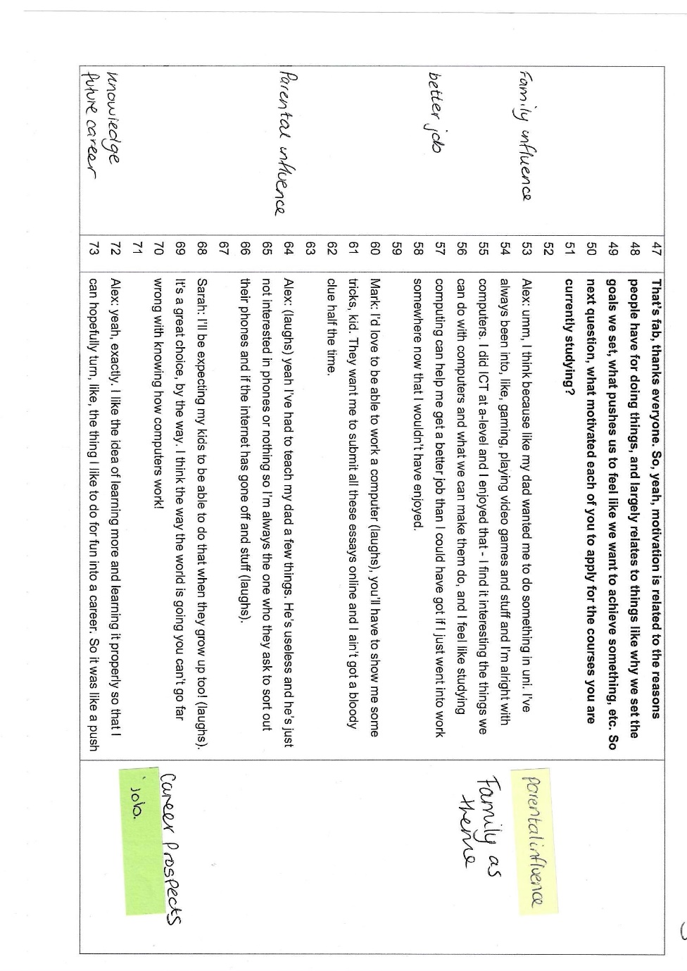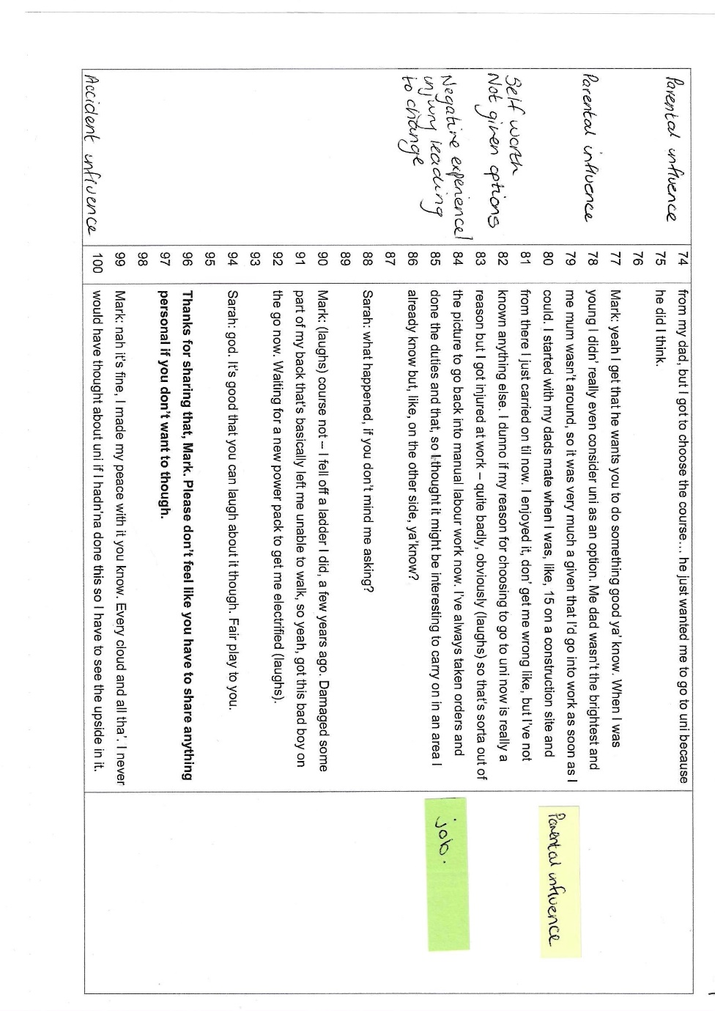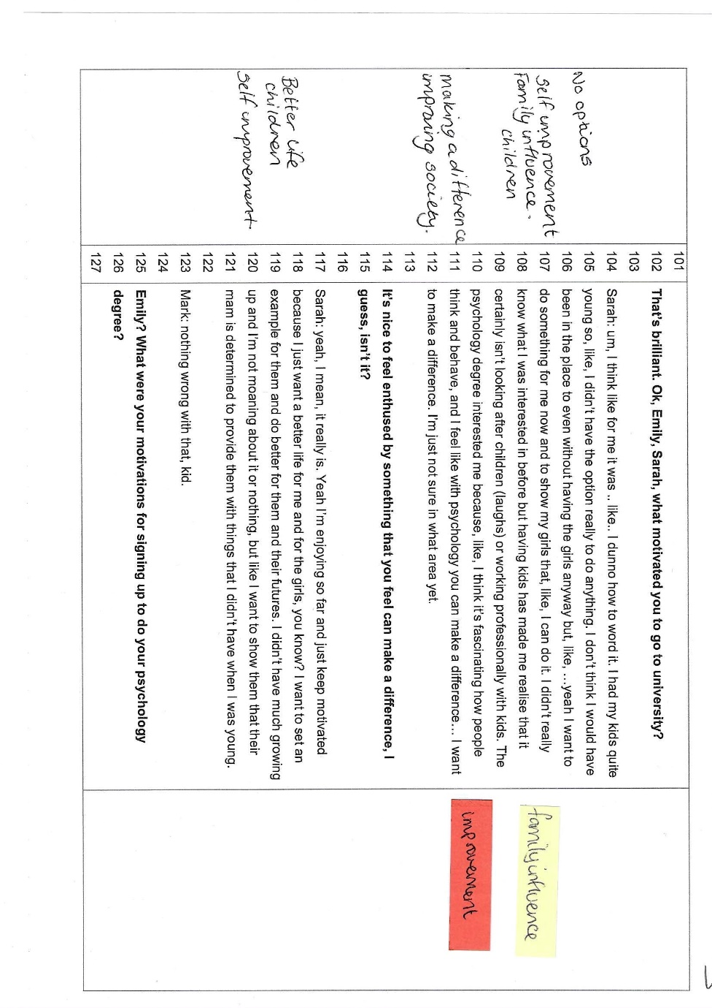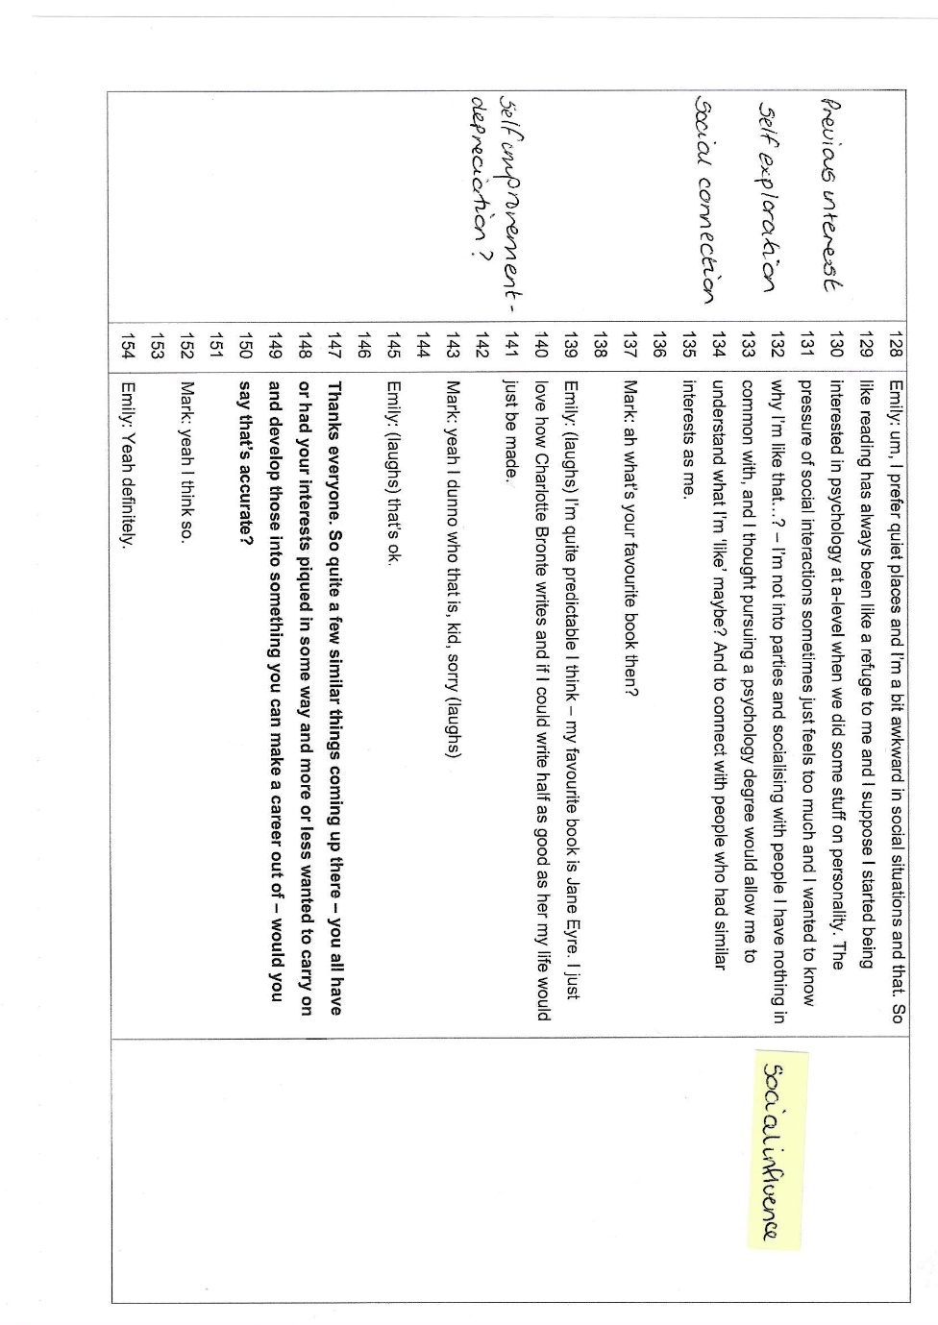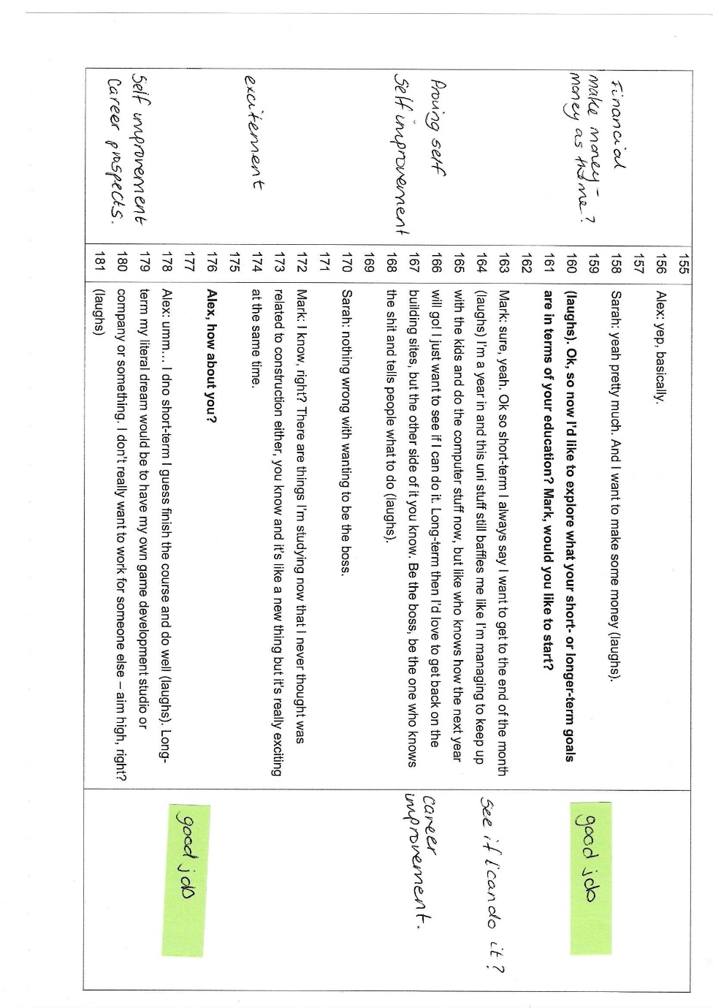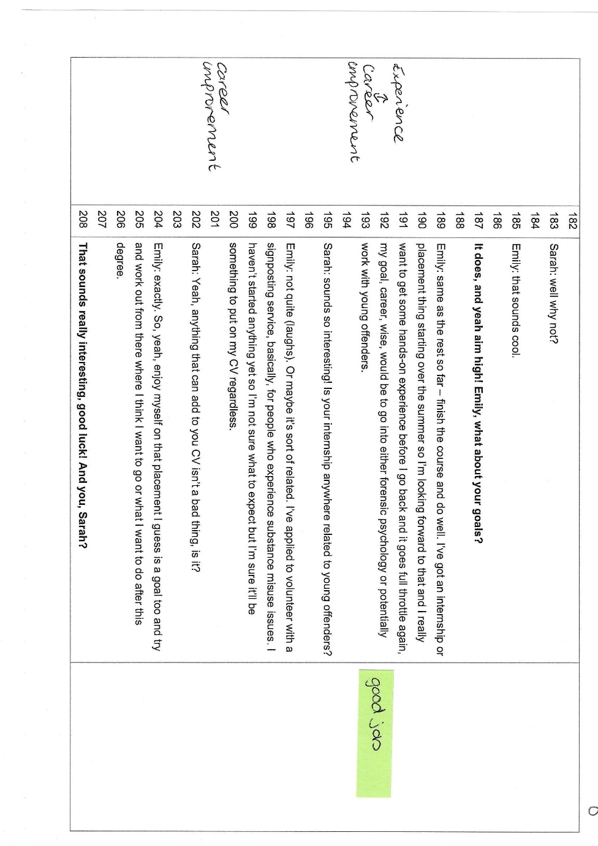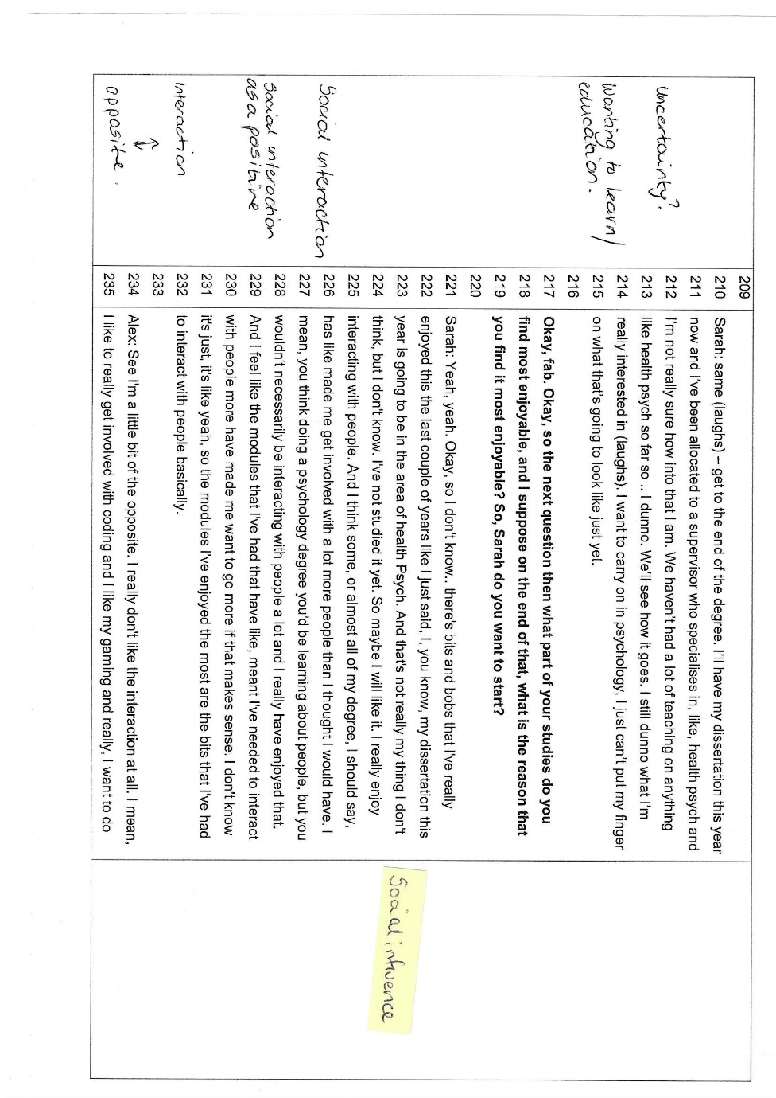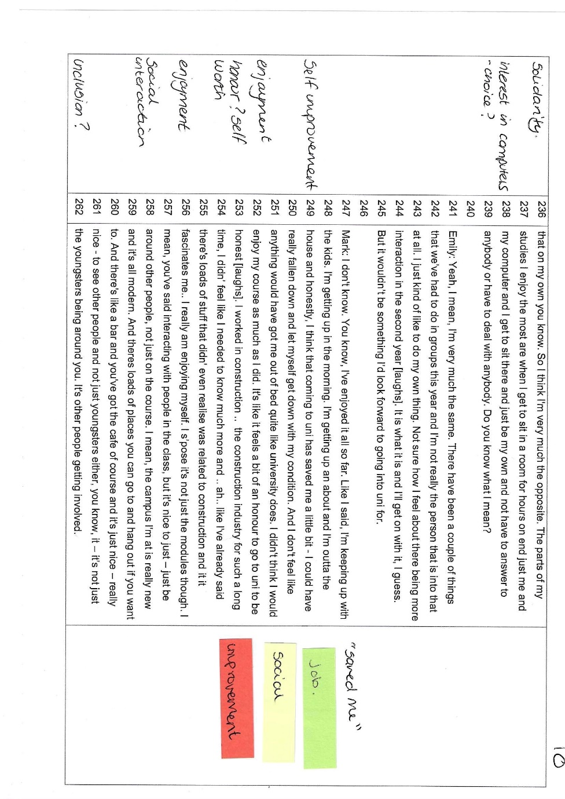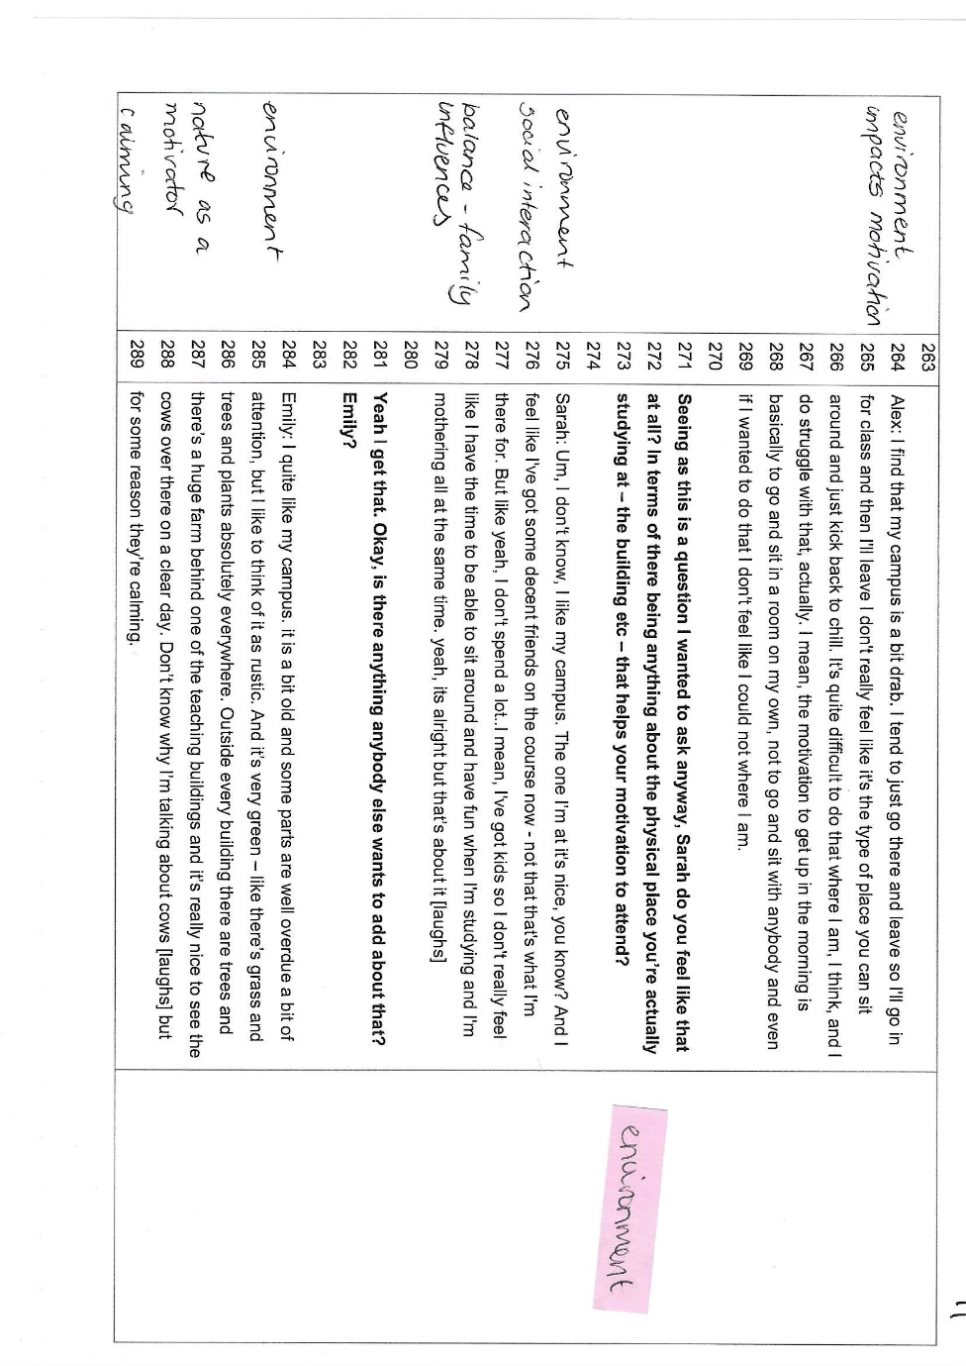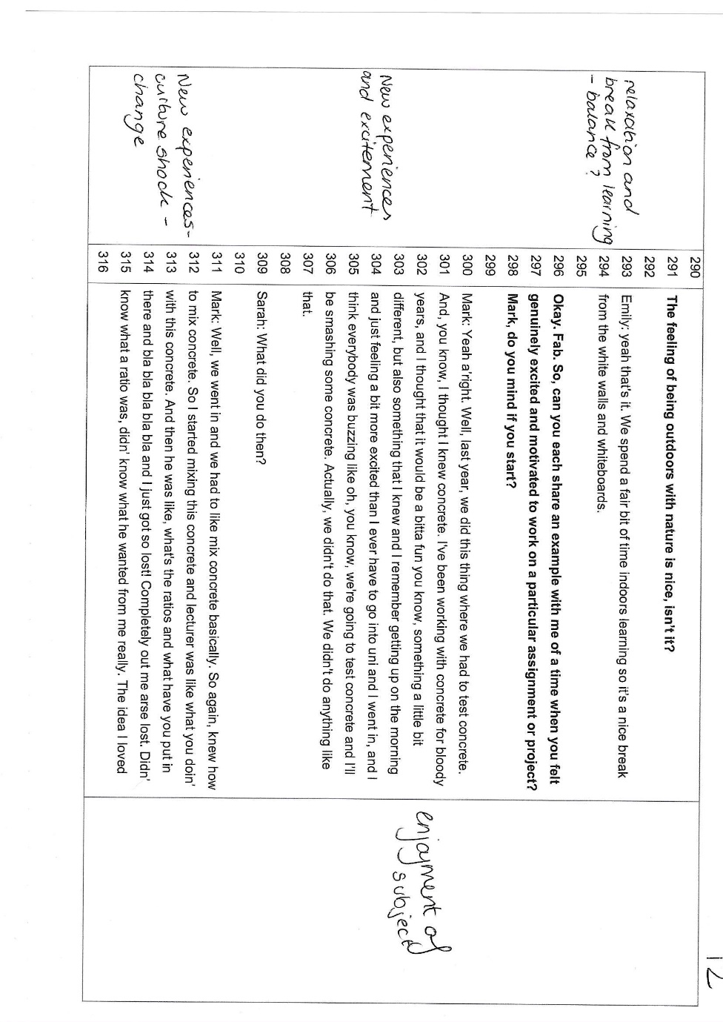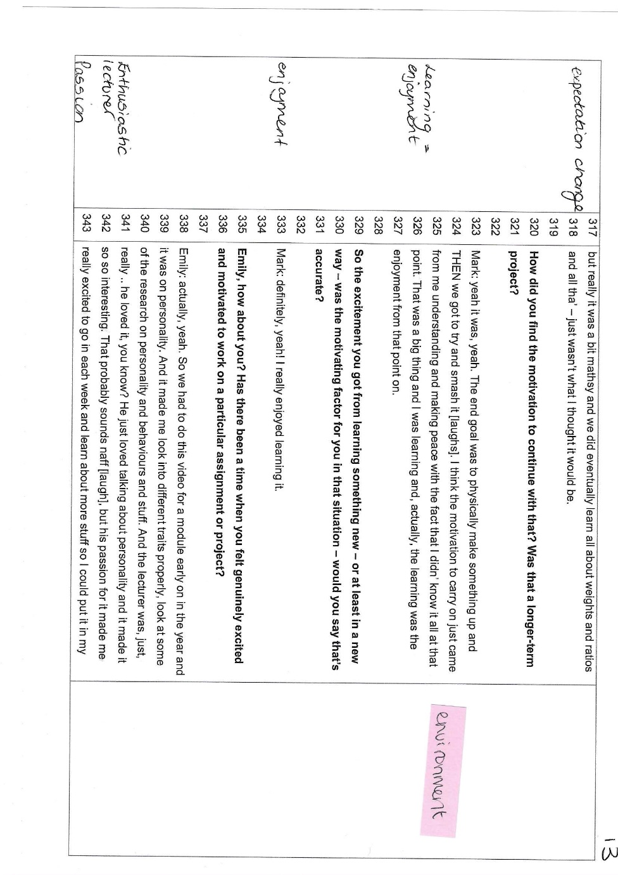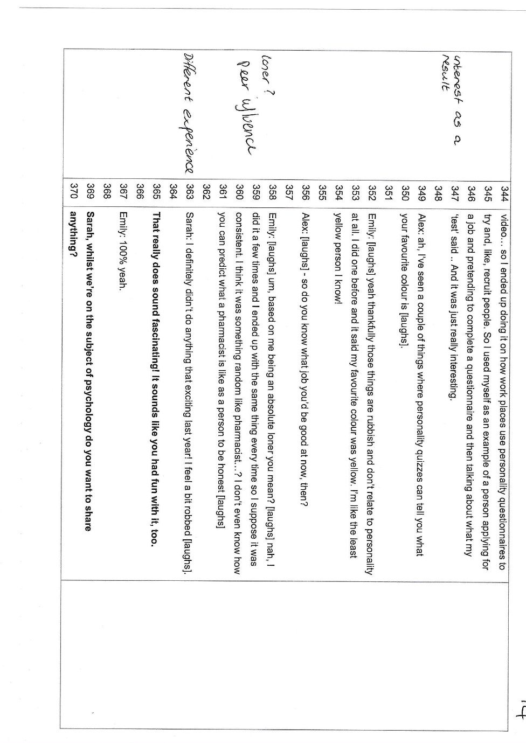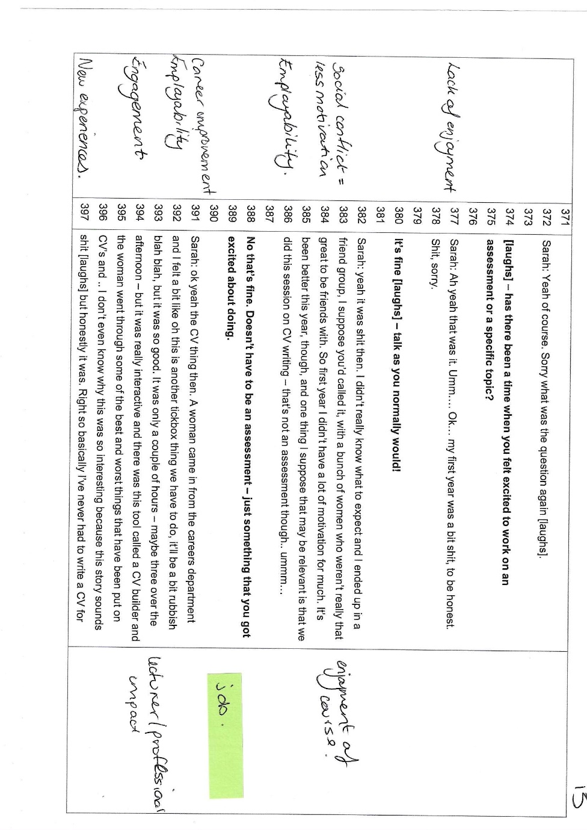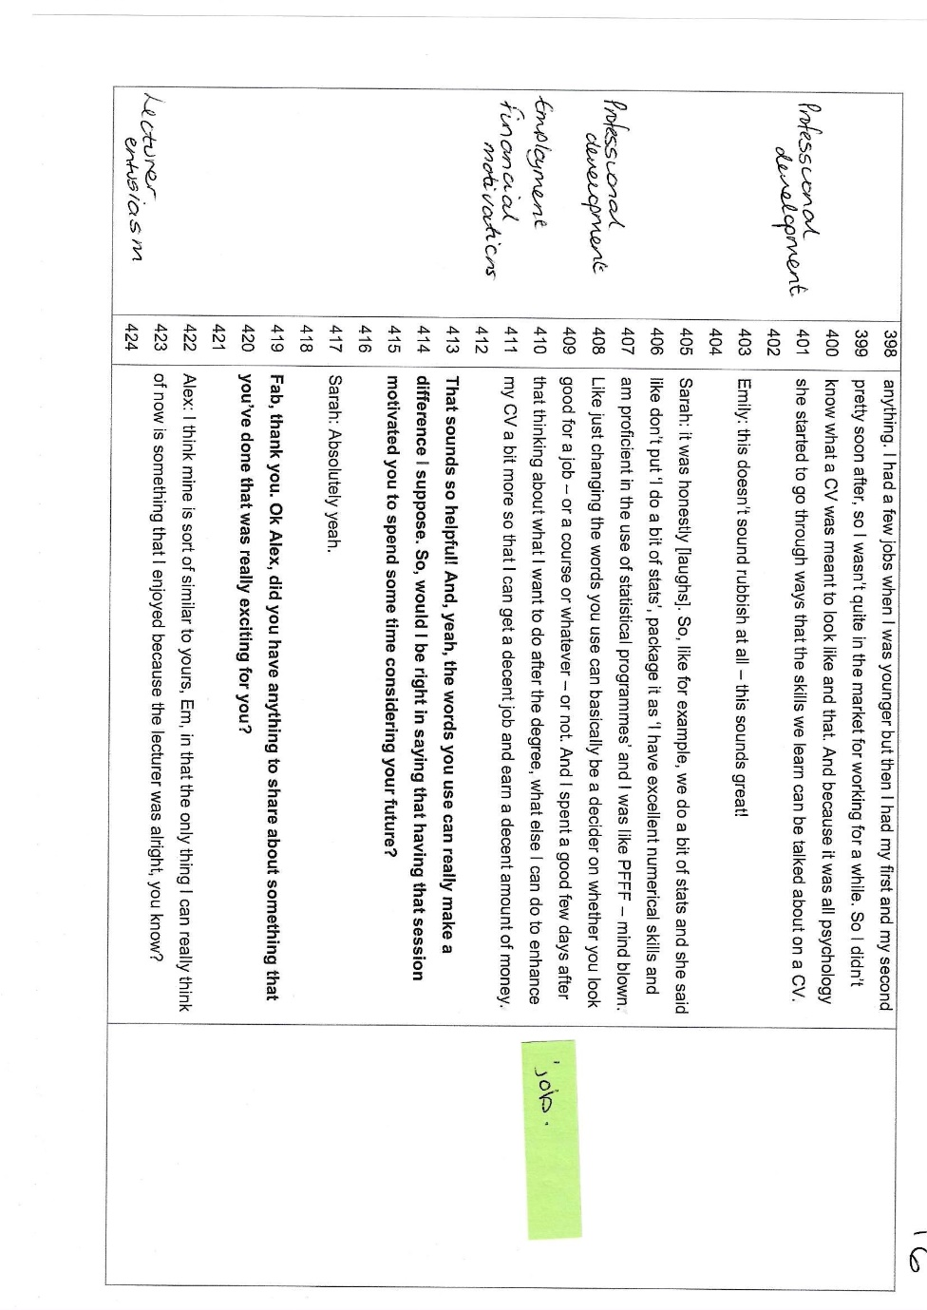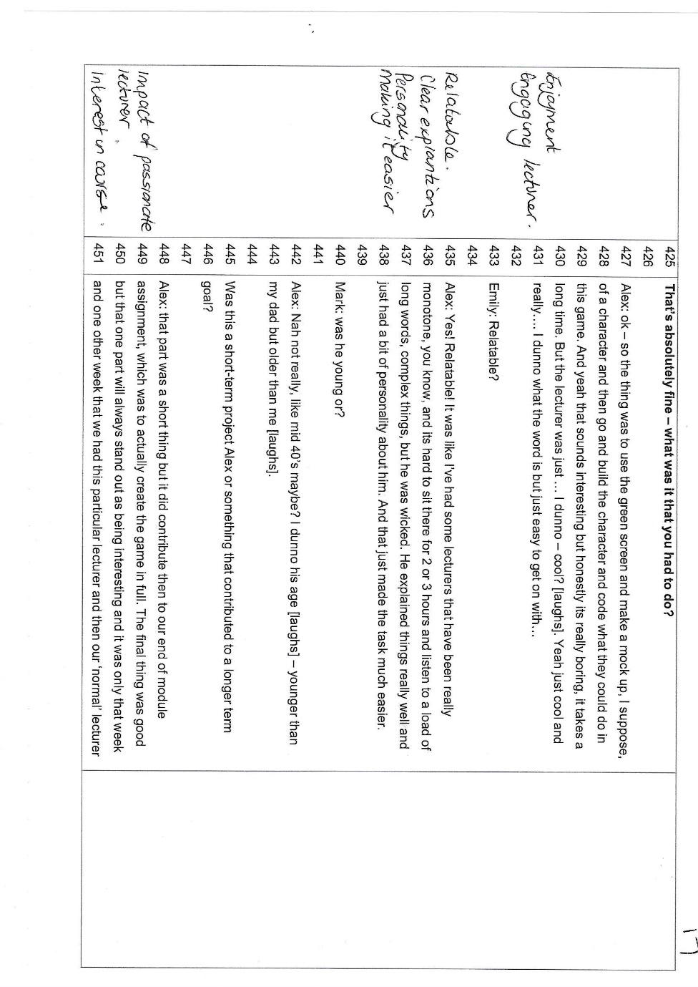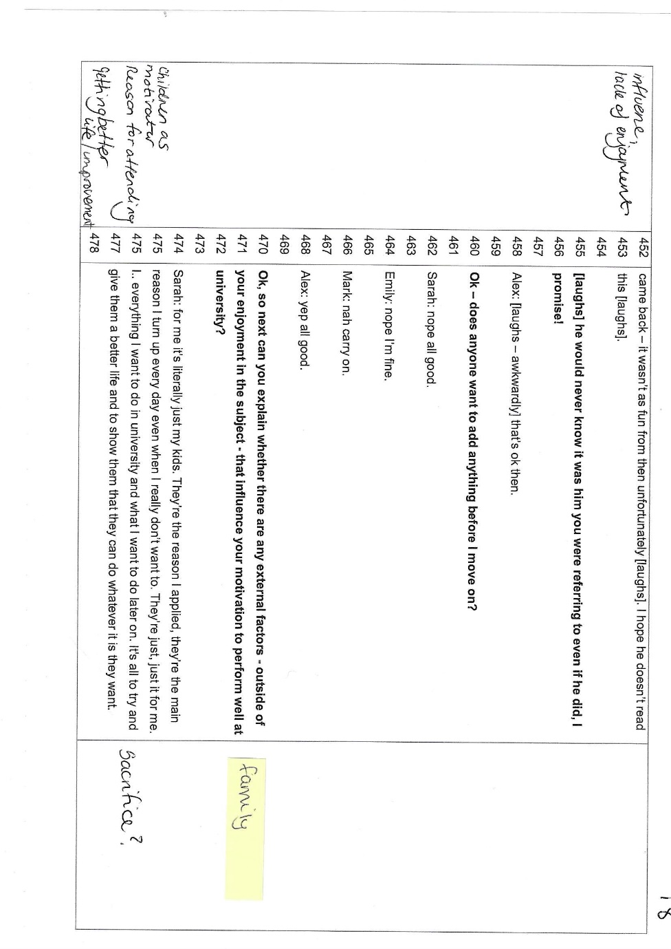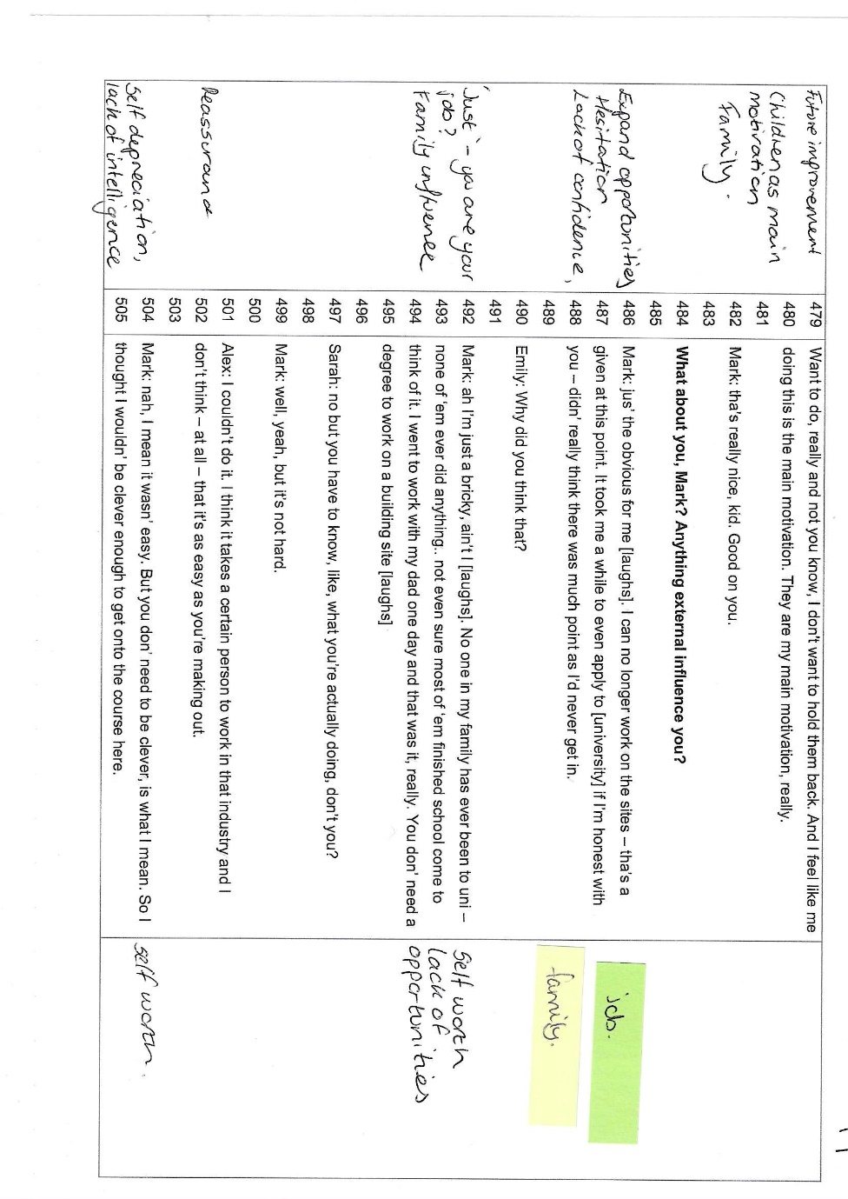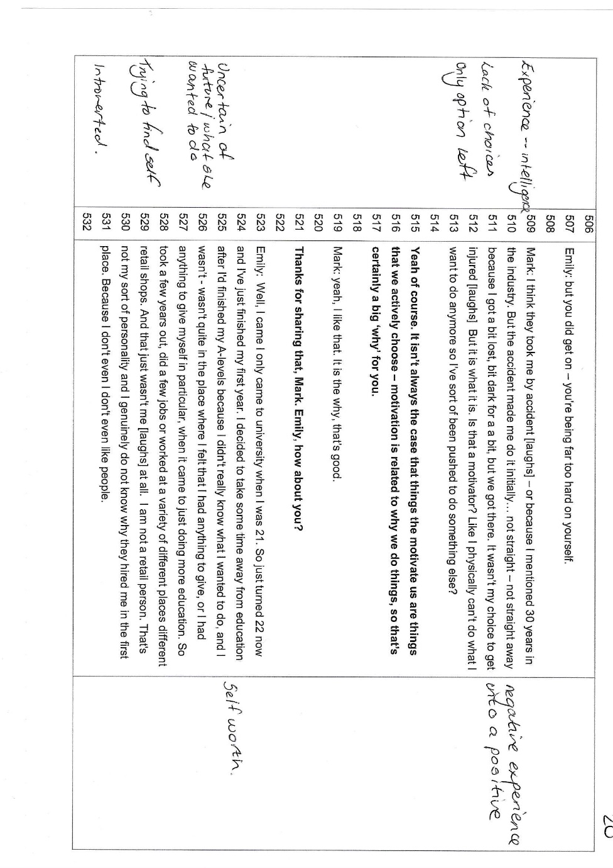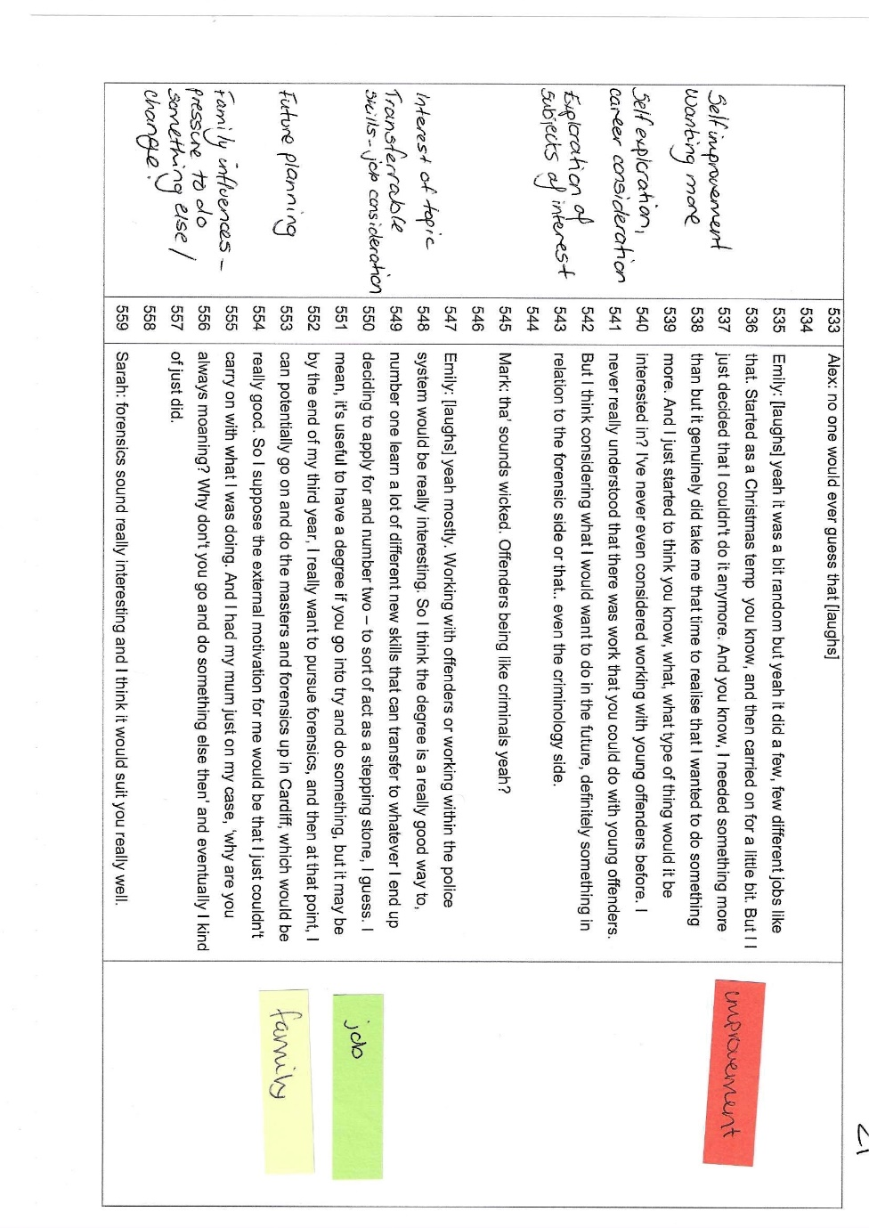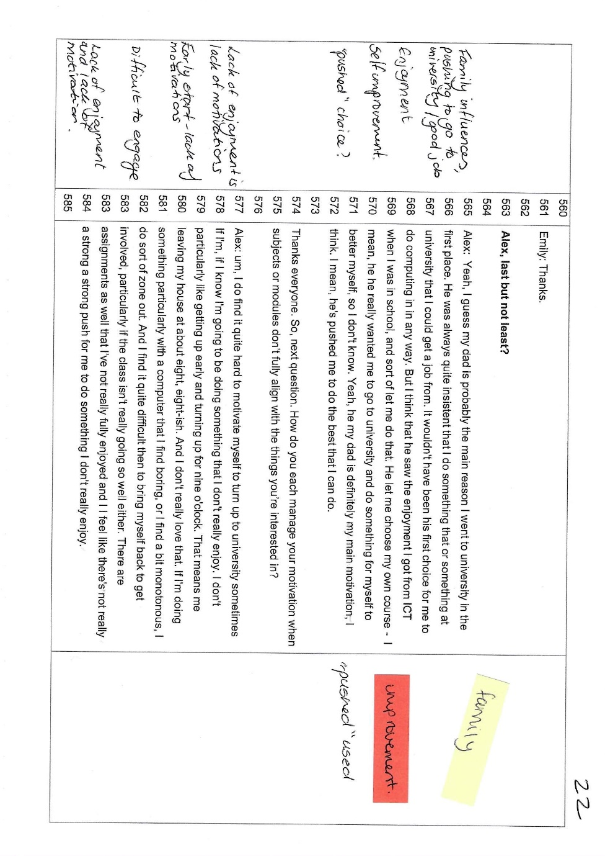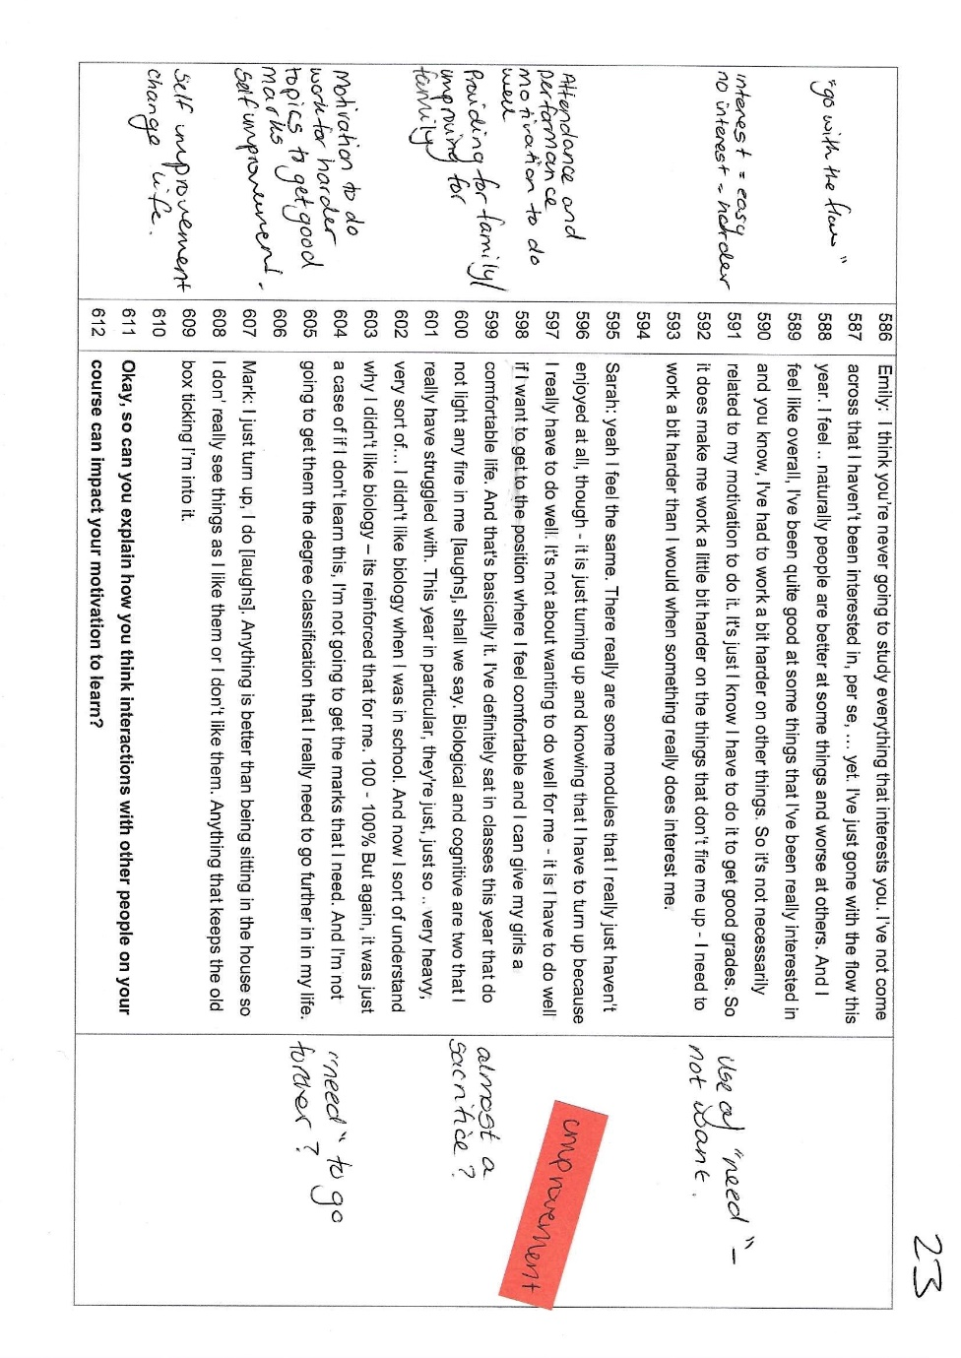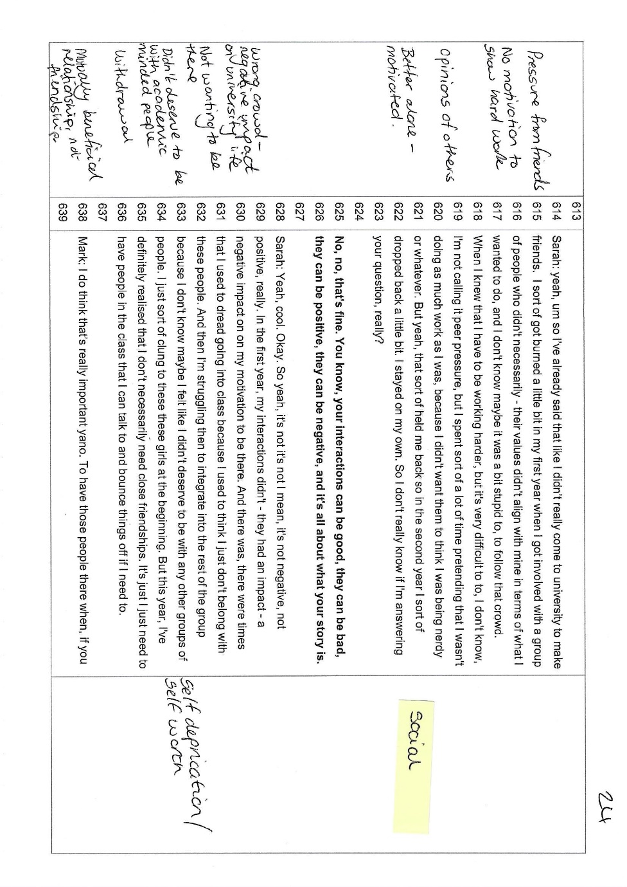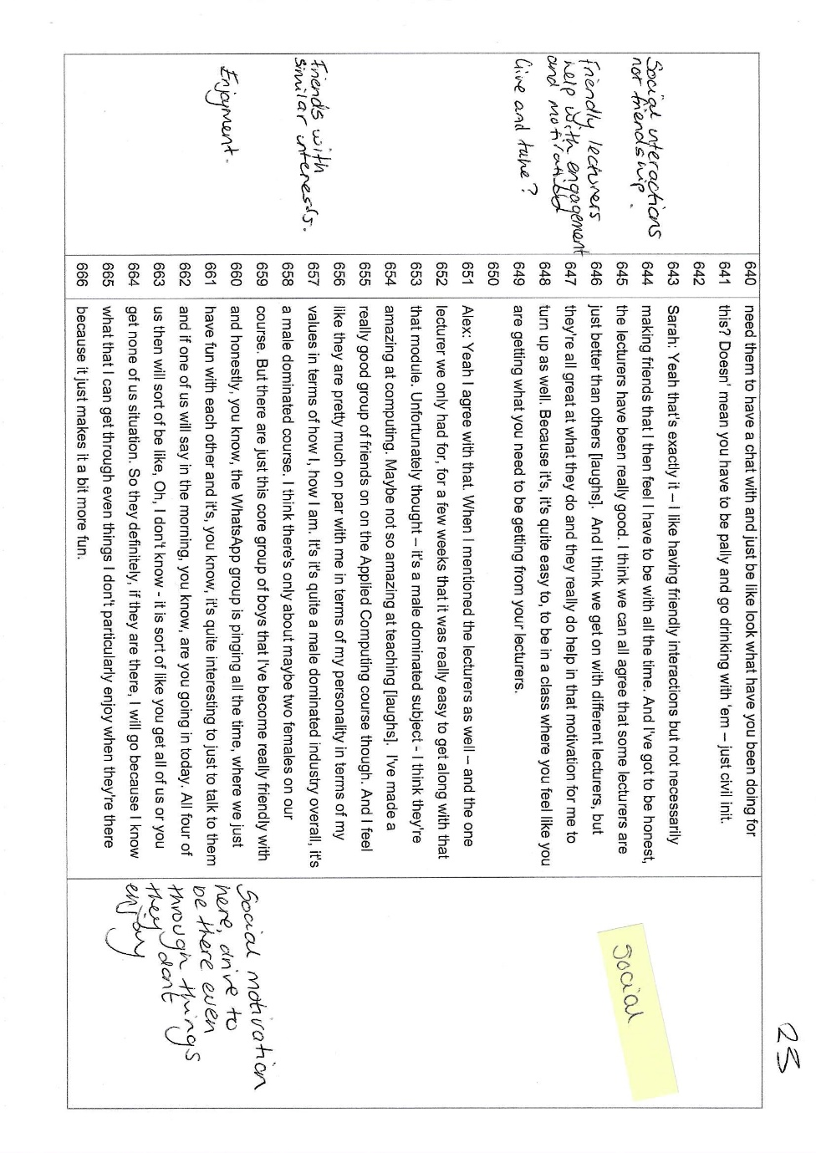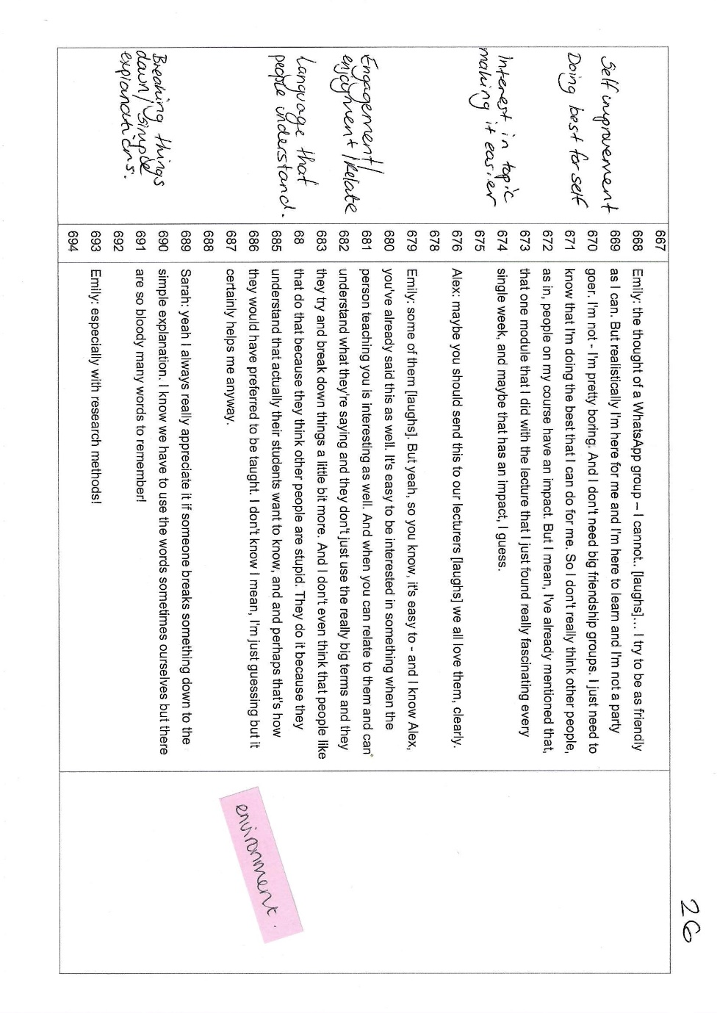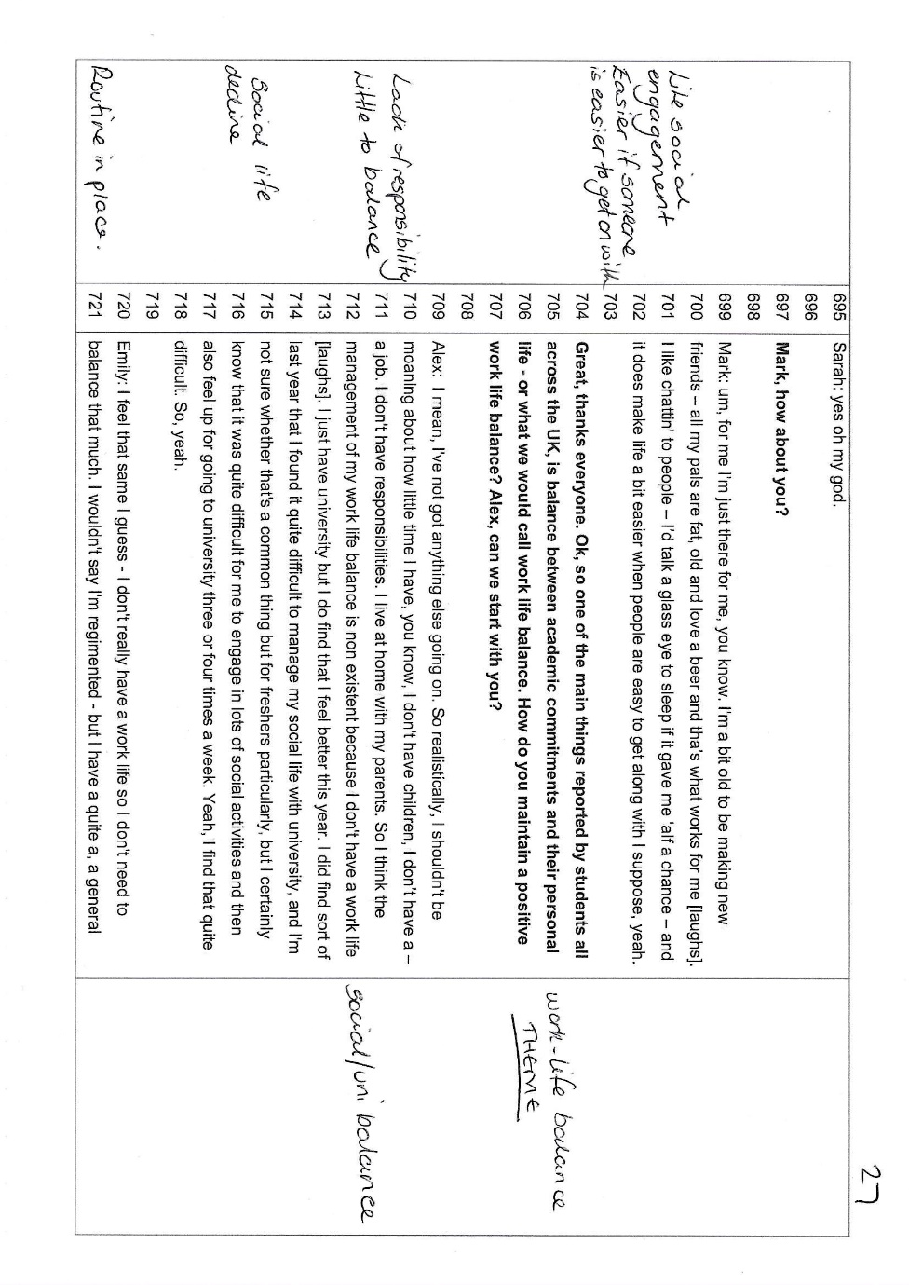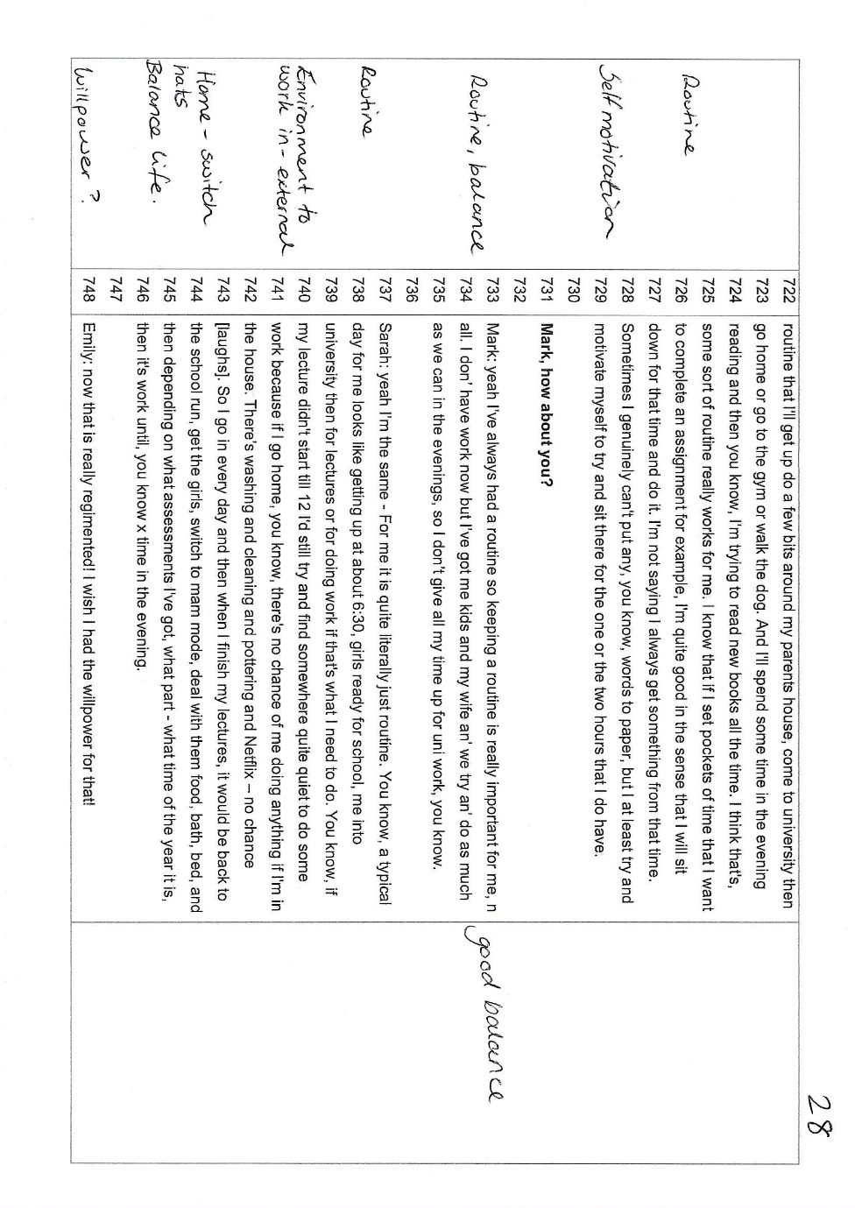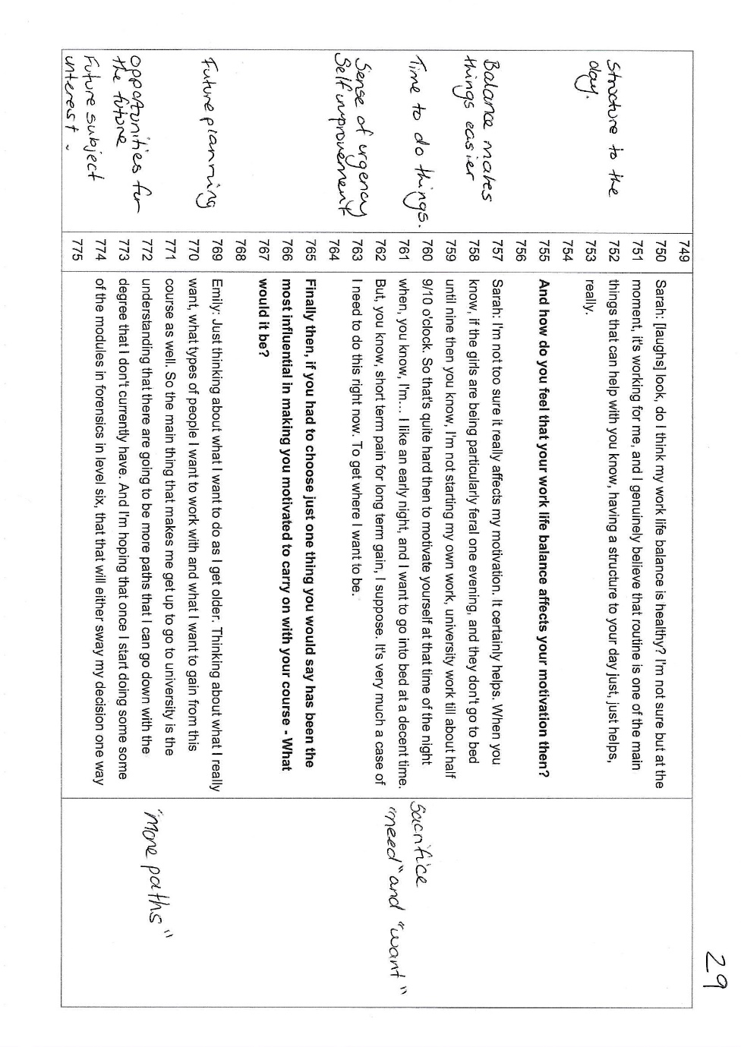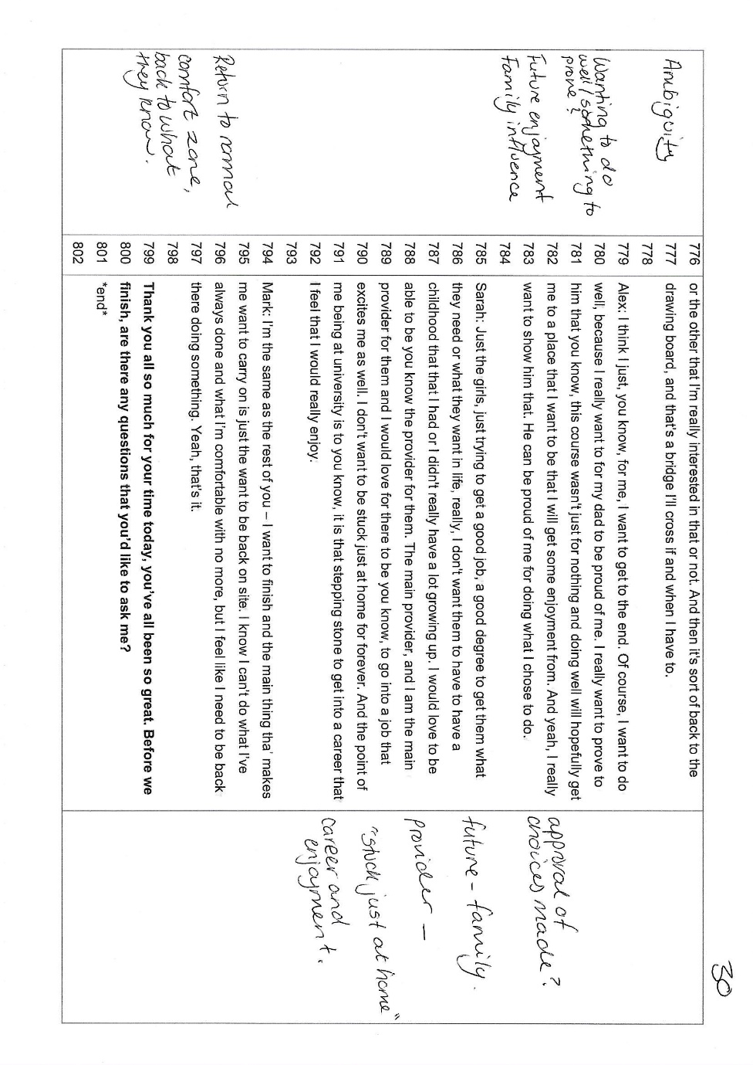
Appendix D: Debrief Form

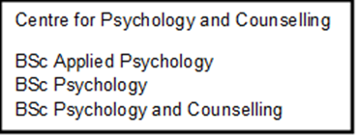

Participant Debrief Sheet

Title of the Study: Exploring motivation in university students
Research Team (include contact details): Stacey Coleman – stacey.coleman@uwtsd.ac.uk
Date: 06/09/23

Thank you for taking part in this study. The aim of the study is to explore the motivations of university to attend university, and to maintain their engagement on their chosen university programmes. We hope that you have found the focus group today interesting and if you would like to speak to the researcher about any of the topics discussed today, please feel free to contact them at any time on the email address noted above.

I would like to remind you that you have provided consent to maintain confidentiality of the information disclosed here today, so please ensure you do not discuss anything that has been shared today with anyone outside of the focus group.

Your data will be stored confidentially in accordance with the Data Protection At (2018). If you wish to withdraw your data from the study at this point, please tell the researcher now. If you wish to withdraw your data at a later stage, please note that you will be required to contact the researcher to make this known by no later than 31st September 2023, as after this point the data will be transcribed ready to provide to undergraduate students for use for their assessments.

Once again, thank you for taking the time to participate in this study.

Stacey Coleman CPsychol
University of Wales Trinity Saint David

