
Assignment 1
Network Operating Systems and Services

Joshua RIGBEY
RIG 17833857
08/02/2024

Contents
Introduction 1
Hypervisors 1
Features 2
Type 1 2
Type 2 2
Advantages 3
Type 1 3
Type 2 3
Hypervisor of Choice – VMware Workstation 3
IP Addressing 4
IPv4 4
IPv6 4
Virtual Network - Swansea DC > Swansea PC 5
Virtual Network - Swansea PC > Swansea DC 8
Virtual Network - London DC (LD-DC) > London PC 11
Virtual Network - London PC > London DC 15
References 18

Introduction
I have been hired as an IT-Professional by a multinational corporation called NOSS. There are currently two locations that NOSS operates and those locations are Swansea and London. Based upon the topology given, I am required to build, deploy, configure and manage a virtualised network based on my choice of virtualisation.

Hypervisors
A hypervisor also known as a VMM, is a piece of software that allows the user to create and run a virtual machine. The whole purpose of a hypervisor is to allow one host computer to support multiple guest VMs through the act of sharing its resources such as memory and processing virtually [1].
There are two types of hypervisors, these hypervisors are the following:
- Type 1 hypervisor – A type 1 hypervisor also known as a bare-metal hypervisor is a layer of software that features an installation that sits directly on top of a server and its underlying hardware. This type of hypervisor provides additional performance and stability as it doesn’t run within the operating system itself [2]. Some examples of the type 1 hypervisors are Microsoft Hyper-V and oracle VM server.
- Type 2 hypervisor – A type 2 hypervisor also known as a hosted hypervisor is a layer of software that unlike the type 1 hypervisor which doesn’t run on the operating system, runs on the conventional operating system [3]. This type of hypervisor offers convenient testing, additional access to productivity tools and allows easy management in terms of exporting and importing virtual machines [2].

Features

Type 1
The features of a type 1 hypervisor are as follows:
- Bare metal installation – As mentioned above, type 1 hypervisors are installed directly on the physical hardware eliminating the requirement for a host operating system. This allows the visor to gain better performance and security in comparison to its counterpart, the type 2 hypervisor.
- Resource allocation – The type 1 hypervisor allows for resources to be allocated to the virtual machine allowing the additional performance increase due to the ability to allocate CPU, memory, storage and network devices to the virtual machine based on the user’s requirements.
- Scalability – The type 1 hypervisor is designed for enterprise level projects and as such, has the scalability to support up to hundreds or even thousands of virtual machines across multiple hosts within a data centre environment.
- High Availability – This type of hypervisor includes features such as live migration, fault tolerance and failover mechanisms which ensures the continuous operation of these virtual machines in the event of any failures be it hardware or software.

Type 2
The features of a type 2 hypervisor are as follows:
- Hosted installation – The type 2 hypervisor unlike their counterpart the type 1 hypervisor, is installed on top of the host’s operating system. This makes it easier for the user(s) to install and configure the virtual machines.
- Compatibility – This type of hypervisor offers greater compatibility as they are able to operate on a various number of operating systems as they rely on the host’s operating system for hardware abstraction and overall device support.
- Resource sharing – The type 2 hypervisor allows the user to share system resources such as the CPU, memory, and disc space between the host’s system and the virtual machine proving beneficial for desktop virtualisation or testing environments.
- Desktop Integration – This type of hypervisor offers the feature of seamless integration between the desktop and the virtual machine. The features this offers are clipboard sharing, file drag and drop and even the support of USB devices.

Advantages

Type 1
The advantages of a type 1 hypervisor are the following:
- Better performance – In comparison to its counterpart, the type 1 hypervisor offer better performance due to the direct access to the host’s hardware resources such as CPU, RAM, storage and network devices.
- Better Security – There is no host operating system within this hypervisor meaning that the overall attack surface of the virtual machine is smaller meaning fewer vulnerabilities to exploited.
- More Stability – The absence of a host operating system means fewer operating system related issues that could potentially impact the overall performance of the virtual machine.
- More resources – There is no need to share additional resources with the host’s operating system allowing the virtual machine to be allocated additional CPU, RAM, storage and network devices [4].

Type 2
The advantages of a type 2 hypervisor are the following:
- Cost efficient – These hypervisors are cost efficient; they have less capabilities and are less secure than their counterpart meaning that its not as expensive as a type 1 hypervisor.
- Easier to use – The type 2 hypervisor tends to be easier to use as it isn’t as complex to set up compared to its counterpart the type 1 hypervisor which complexity matches someone who has technical knowledge or is tech-savvy [4].
- Convenient for testing purposes – These hypervisors are convenient and useful when it comes to testing new software or research projects due to the ability to run multiple instances of different operating systems [5].

Hypervisor of Choice – VMware Workstation
While both types of hypervisors have advantages and disadvantages, I have decided to go with a type 2 hypervisor known as VMware workstation. The reason I have a chosen this hypervisor is for a multitude of reasons. One of these reasons would be the features that this hypervisor offers which are the following:
- Uses the same technology to power virtual machines that powers vSphere.
- Provides high fluid and responsive graphics when running 3D applications.
- Includes a new CLI tool known as ‘VCTL’ which allows the user to build and run containers and Kubernetes clusters with VM-level isolation and networking.
- Supports complex IPv4 and IPv6 virtual networks with additional network latency and bandwidth simulations [6].
The two main features that caught my eye with this hypervisor would be the support of complex IPv4 and IPv6 virtual networks and the resource sharing. Due to the nature of the request to set up a virtual network, I believe that this would be greatly beneficial in terms of not only the overall use of the virtual machine and the network but the performance too.
The feature of resource sharing (as mentioned above) allows the user to allocate more resources to the machine instead of sharing some with the host’s operating system allowing a smoother operation and more allocated resources to the given project, in this case being setting up the virtual network.

IP Addressing
An IP address also known as internet protocol address is a network address that is assigned to the computer. These addresses are a unique identifying number which is assigned to every device that has connections to the internet. Communication over both WANs and LANs use IP addresses in order to send information from one place to another.

IPv4
IPv4 addresses also known as internet protocol version 4 are 32-bit numbers which can be expressed in hexadecimal notation. The most common format is known as a ‘dotted quad’ or ‘dotted decimal’ even. Example of this format would be: 192.0.2.146 [7].

IPv6
Similar to its predecessor, the IPv6 also known as internet protocol version 6 is a network layer protocol which allows communication across a network. As mentioned briefly above, each device has an assigned IP address which is used to identify where said device is. IPv6 features a packet that has 40 extended octets built in it; this means that users can scale the protocol for future endeavours without impacting its core structure.
These addresses feature a 128-bit address compared to its predecessor which has a 32-bit address. The 128-bit address is digested down in to 8 groups with each group containing 16 bits consisting of 4 hexadecimal numbers and colons to separate the groups from each other.
Some but not all advantages of IPv6 are as follows:
- More reliability and speed – IPv6 support multicast addresses allowing more bandwidth intensive packet flows to reach many destinations at once
- Larger address space – This address offers more address space boosting the overall efficiency and the handling of packets better./
- More robust security compared to IPv4 – In comparison to its predecessor IPv4, IPv6 features IPSecurity which ensures data privacy and data integrity [8].

Virtual Network - Swansea DC > Swansea PC
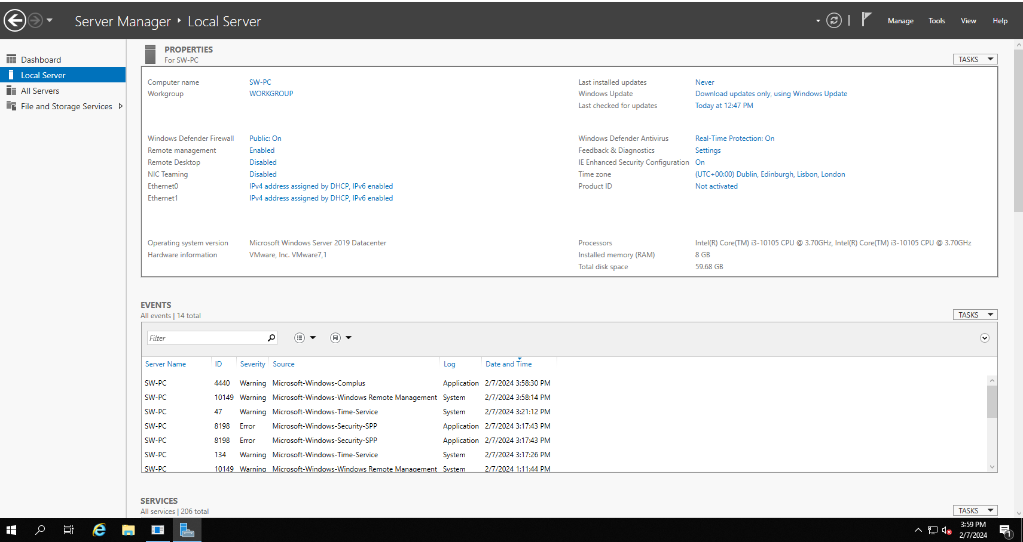
As you can see below, the name of the server has been changed

The screenshot below shows the configuration of the IP address as well as the subnet mask, default gateway and preferred DNS server.
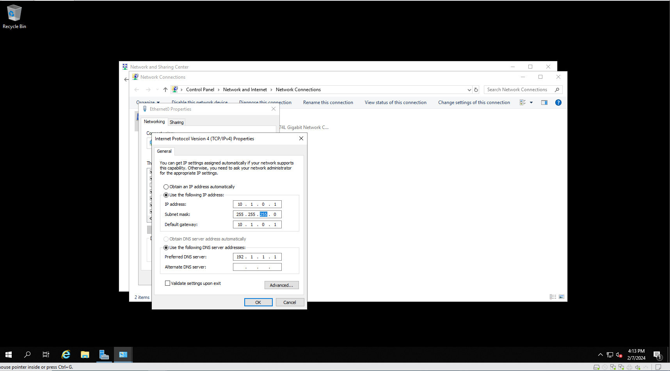

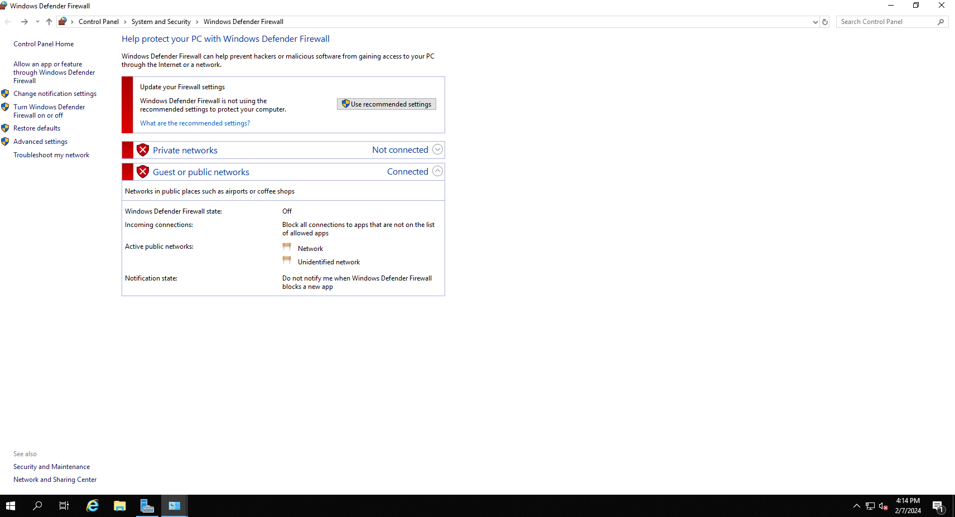
The screenshot below shows the firewall settings being turned off.

As you can see in the screenshot below, the region and location has been changed to United Kingdom.
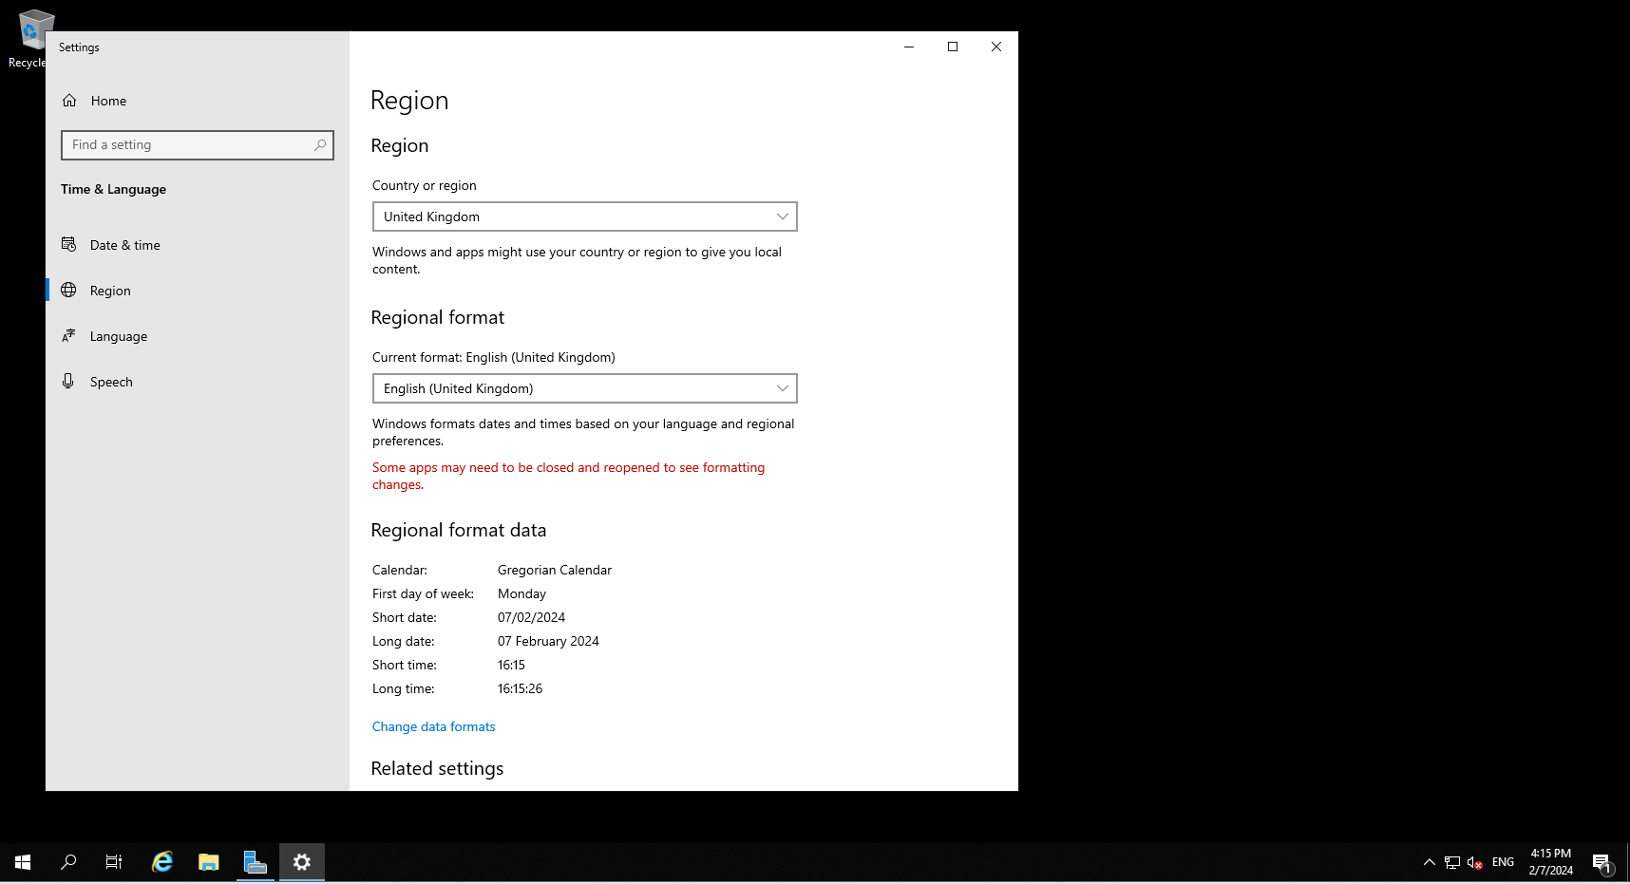

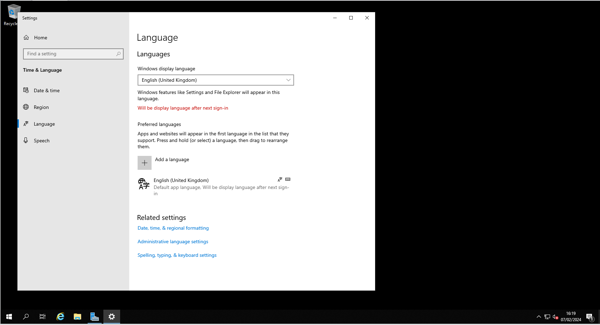
As you can see in the screenshot below, the language has been changed to United Kingdom.

As you can see in the screenshot below, the Swansea workstation is pinged using the “ping 10.1.0.2” command.
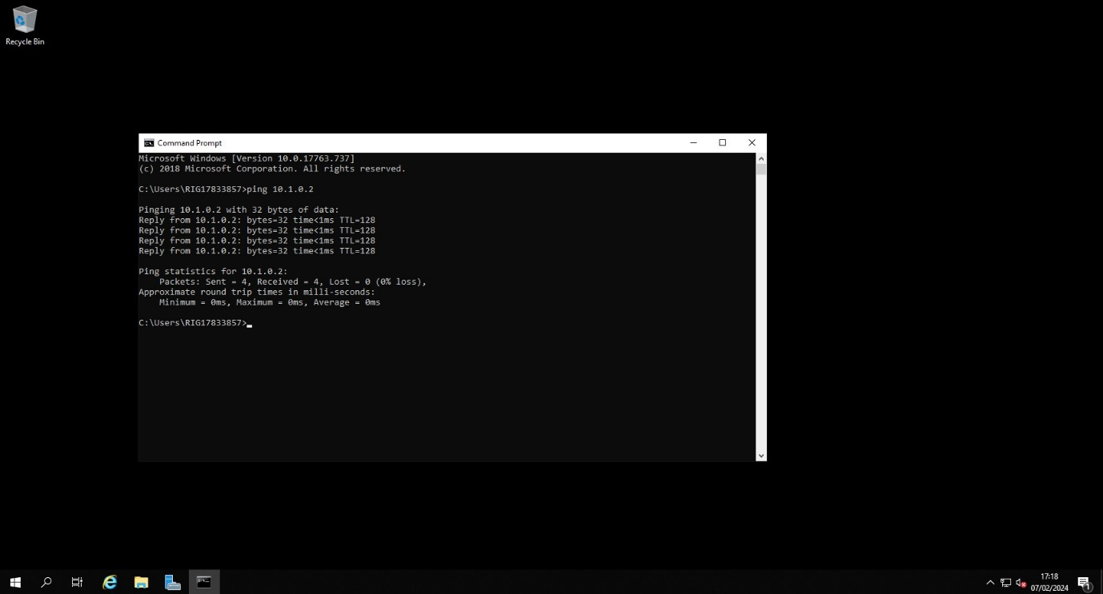

Virtual Network - Swansea PC > Swansea DC

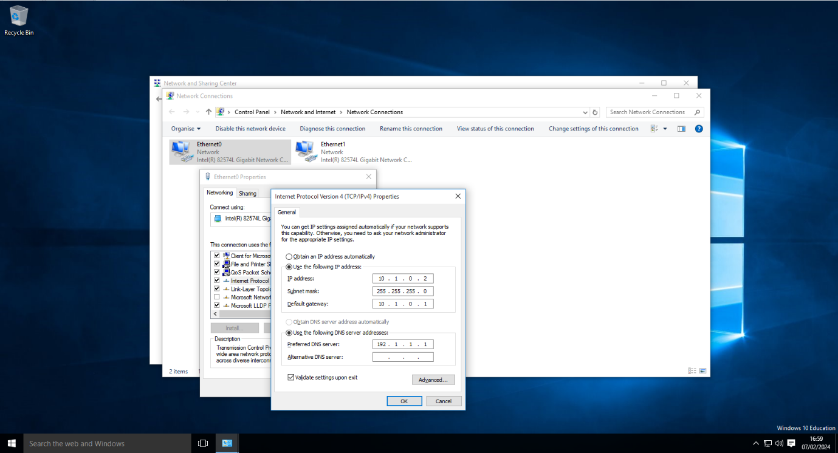
As you can see in the screenshot below, the IP addresses are set up on the Swansea PC.

As you can see below, the date and time of the Swansea PC has been changed to London UTC.

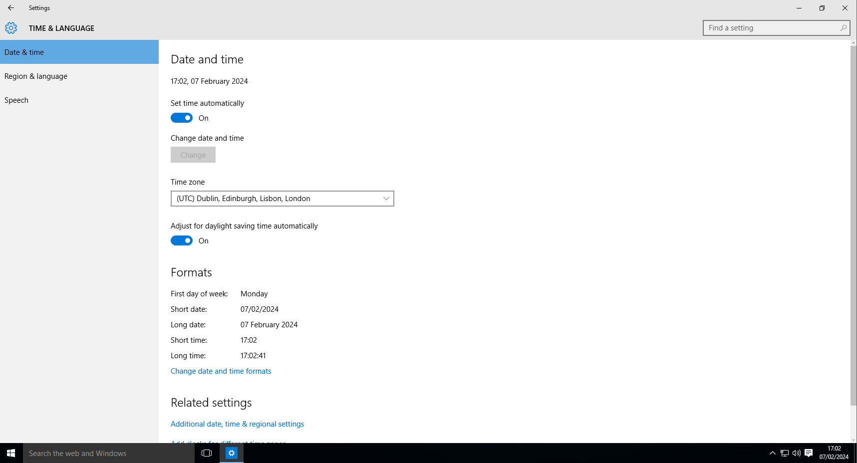
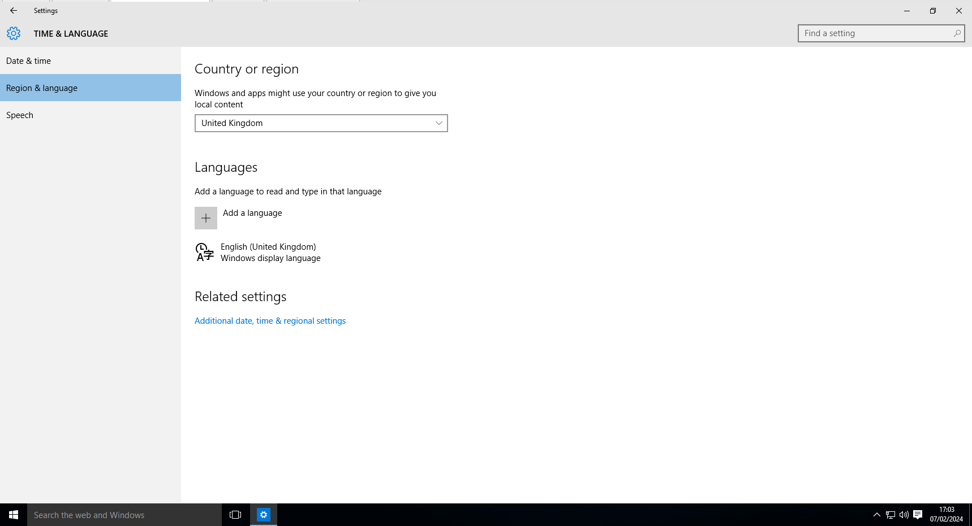
As you can see below, the country or region of the Swansea PC has been changed to United Kingdom.

As you can see below, the firewall settings of the Swansea PC have been turned off.

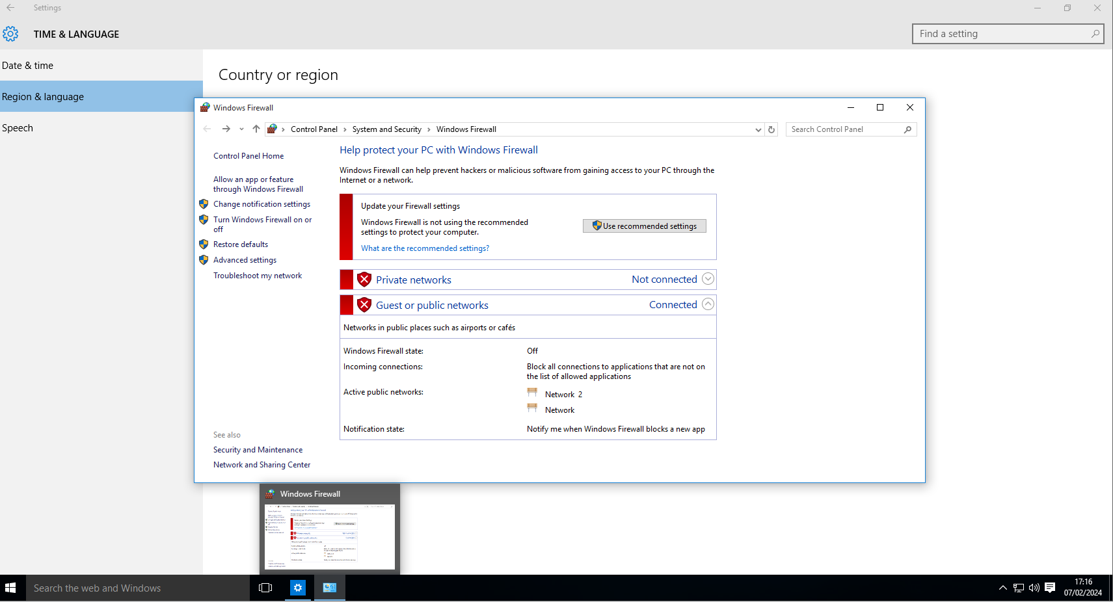

As you can see below, an administrator account has been set up on the Swansea PC.
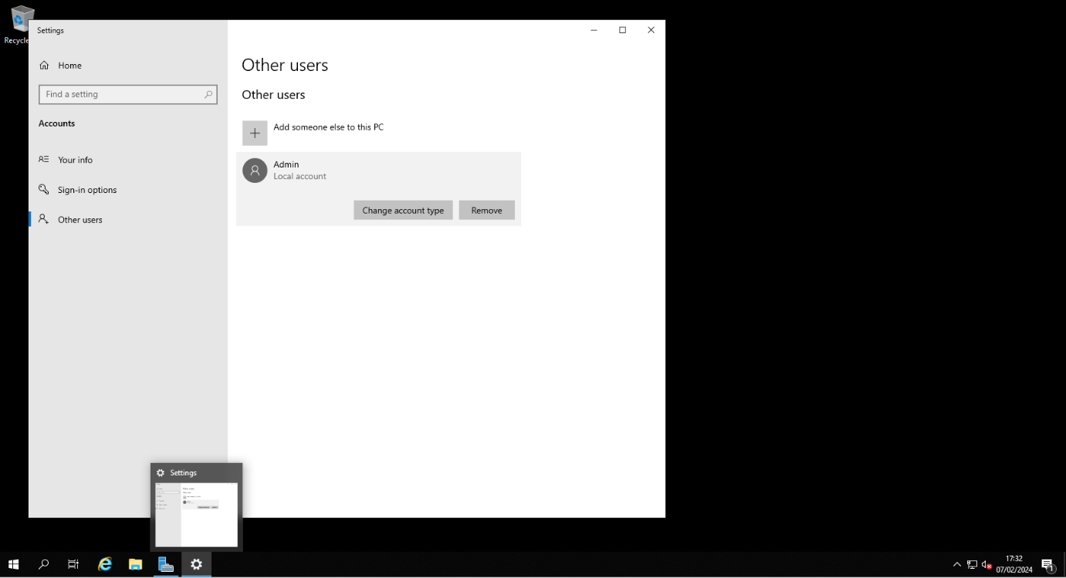

As you can see in the screenshot below, the Swansea Domain has been pinged using the “ping 10.1.0.1” command in the command prompt.
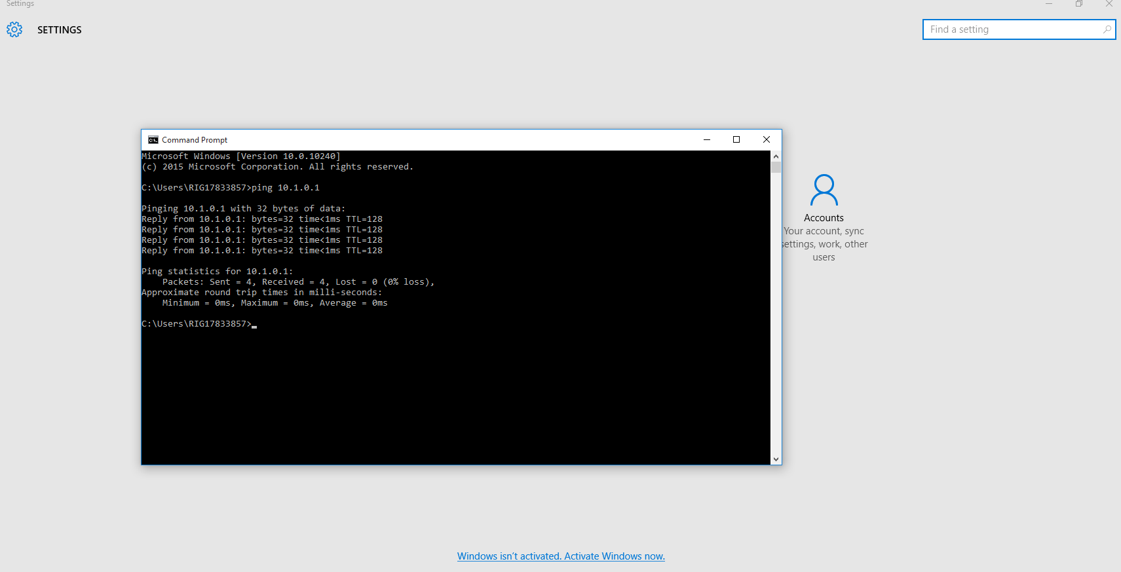

Virtual Network - London DC (LD-DC) > London PC
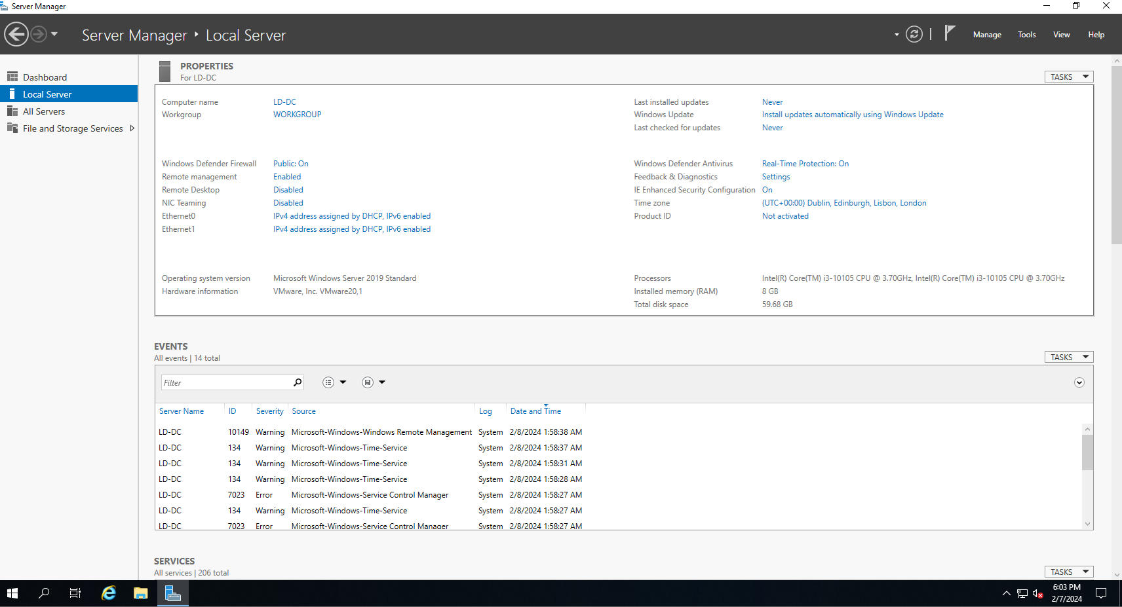
As you can see in the above screenshot, the name of the domain computer has been changed to LD-DC.

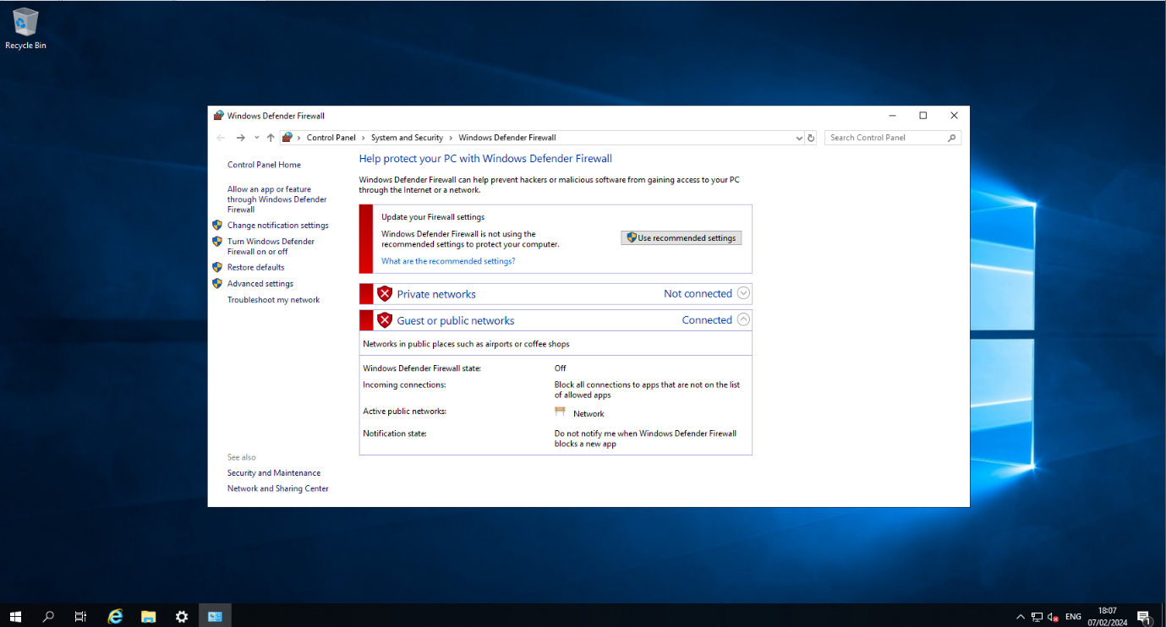
As you can see in the above screenshot, the firewall has been turned off on the LD-DC computer.

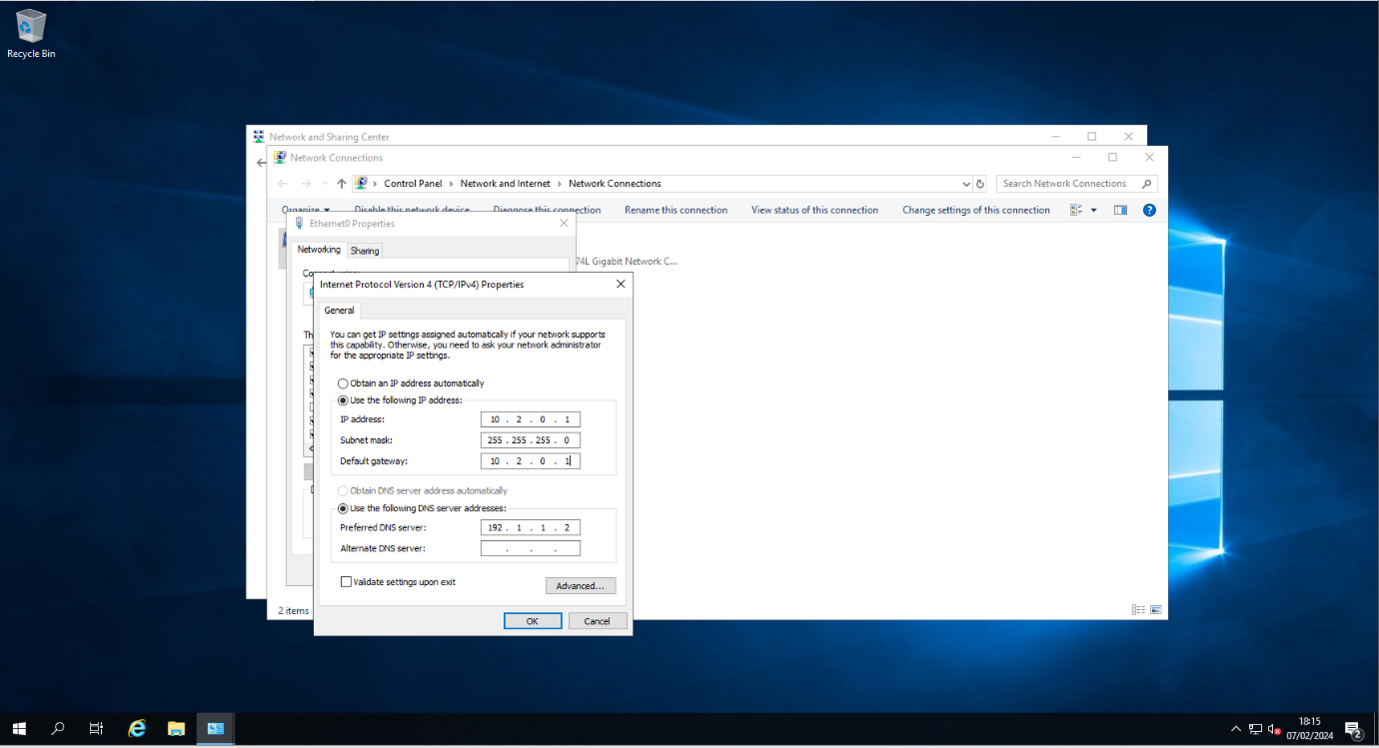
As you can see in the above screenshot, the IP address, the subnet mask, default gateway, and preferred DNS server has been changed.
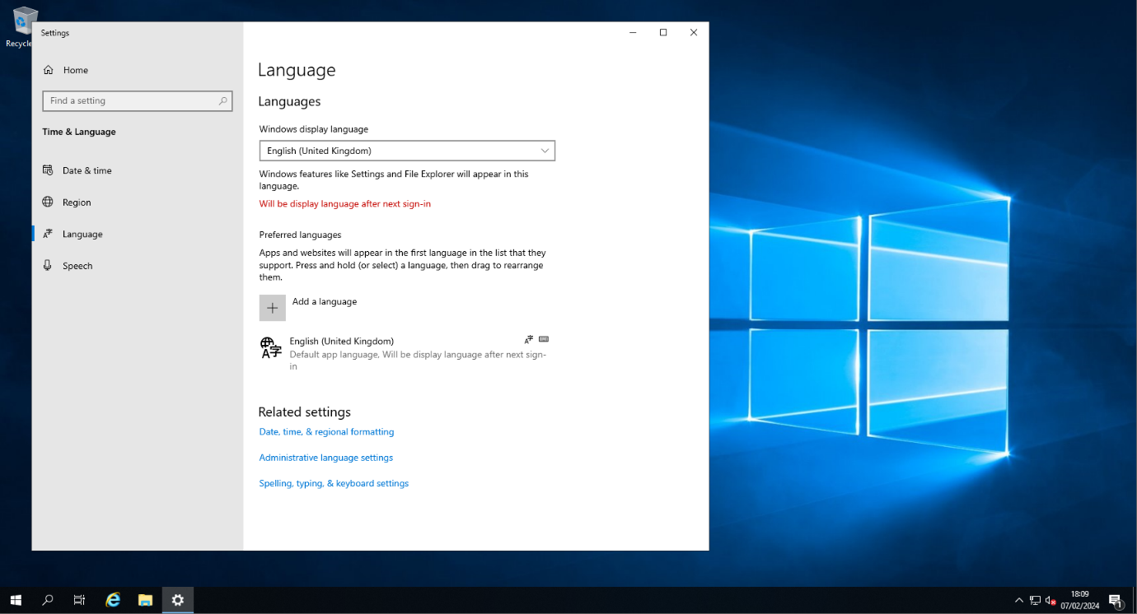
As you can see in the above screenshot, the language has been changed to United Kingdom.
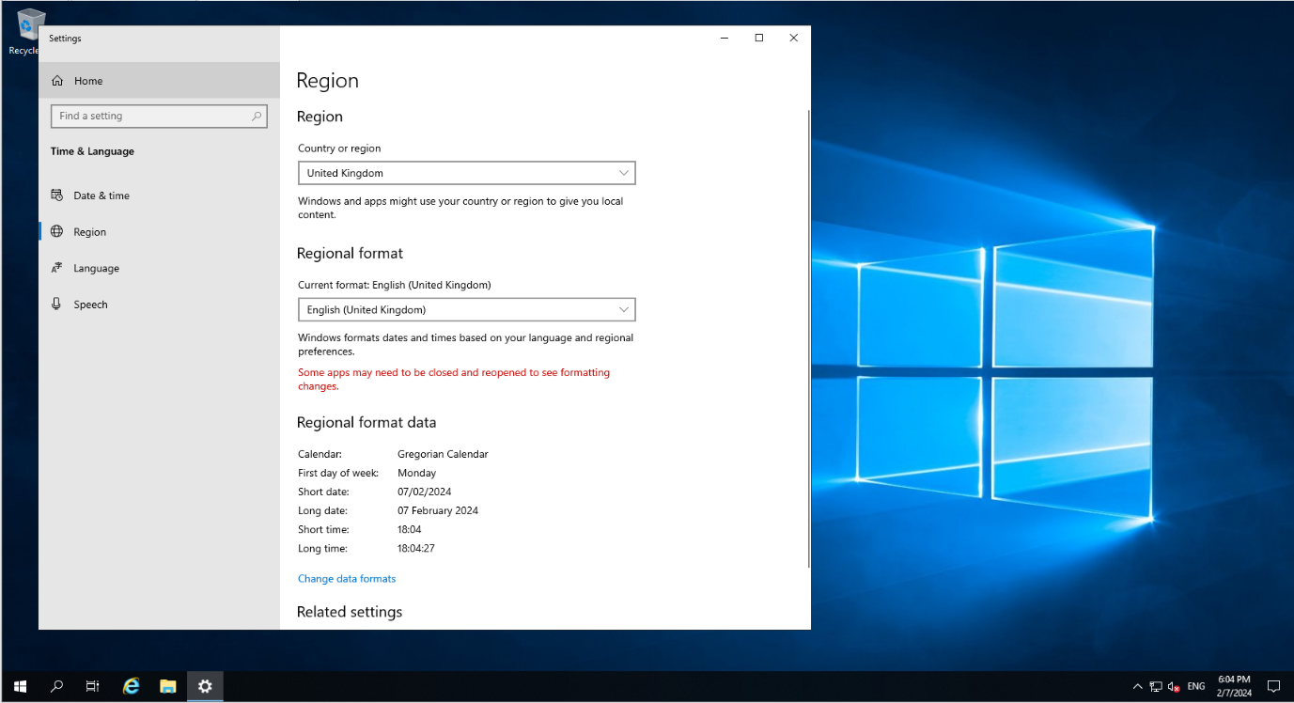
As you can see in the above screenshot, the country or region has been changed to United Kingdom
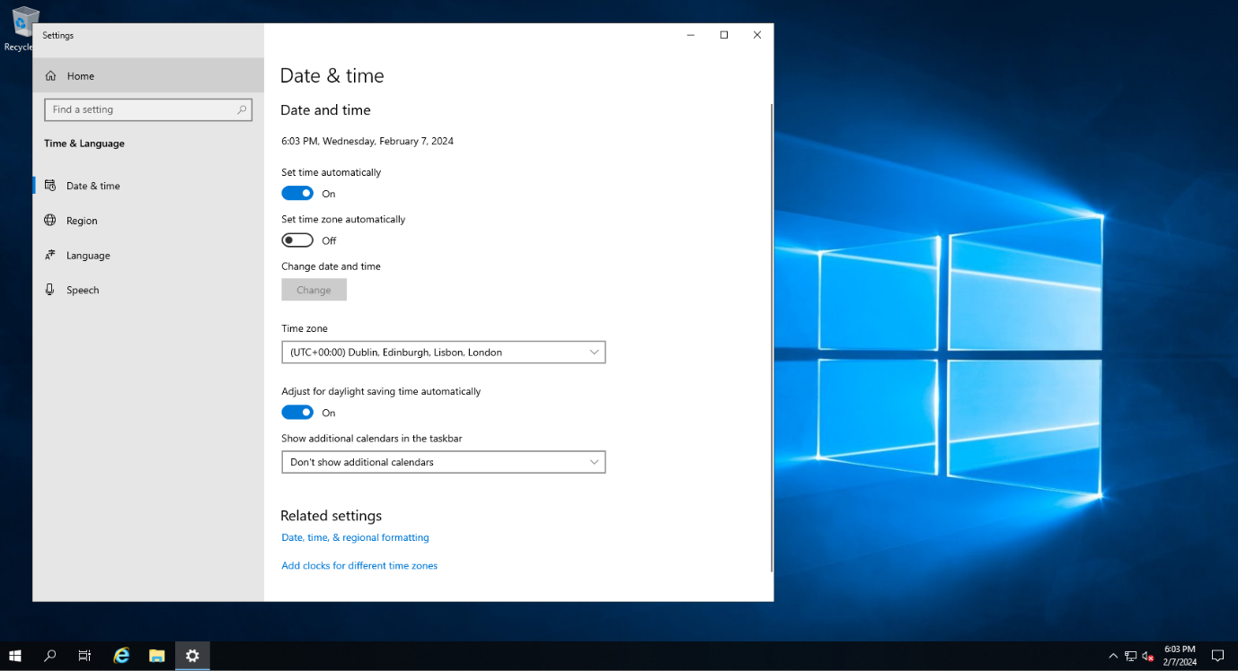
As you can see in the above screenshot, the date and time has been set to London UTC.

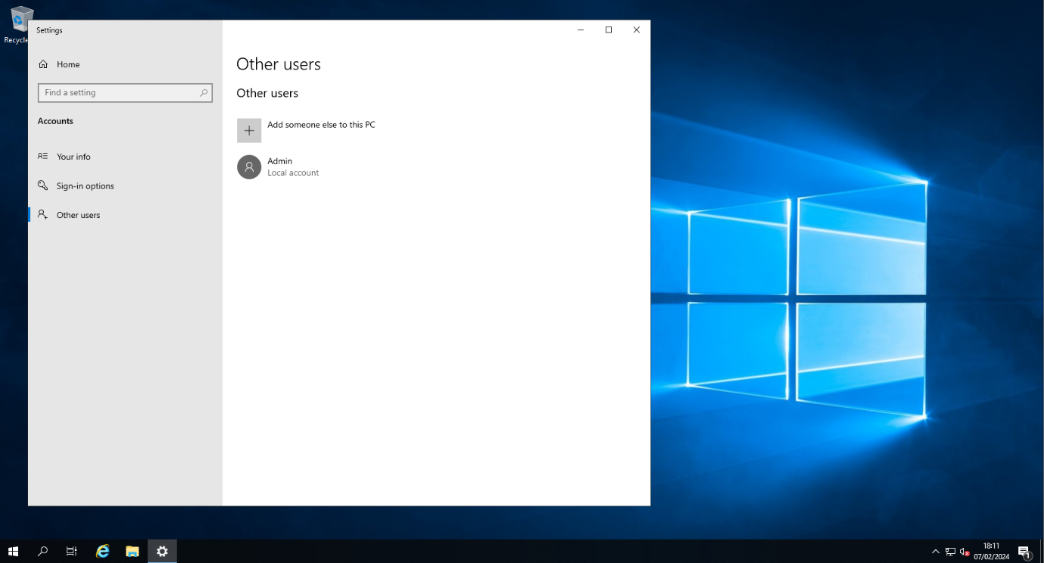
As you can see in the above screenshot, an administrator account has been set up on the LD-PC.
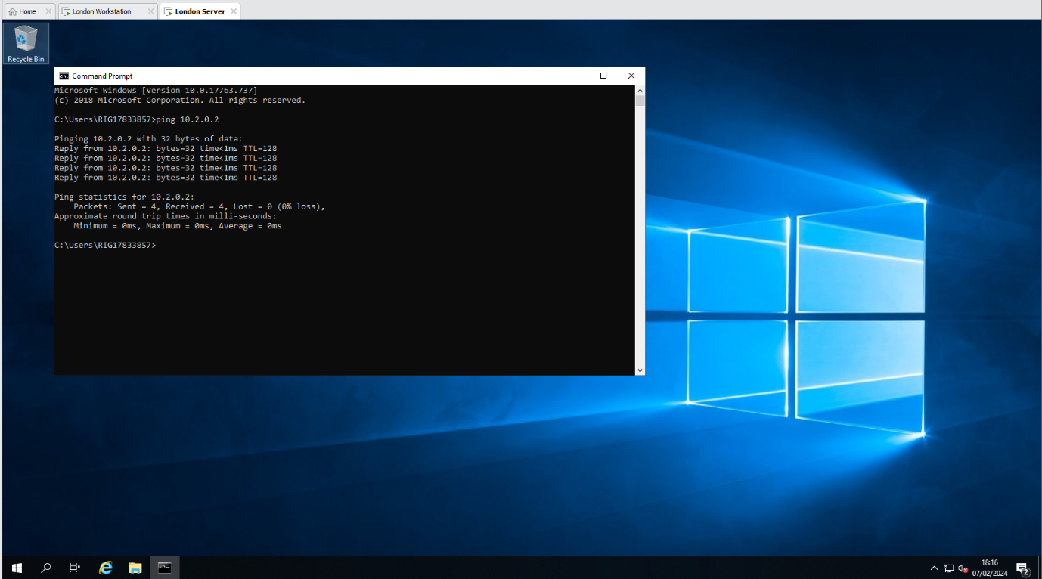
As you can see in the above screenshot, the London PC has been pinged using the “Ping 10.2.0.2” command in the command prompt.

Virtual Network - London PC > London DC
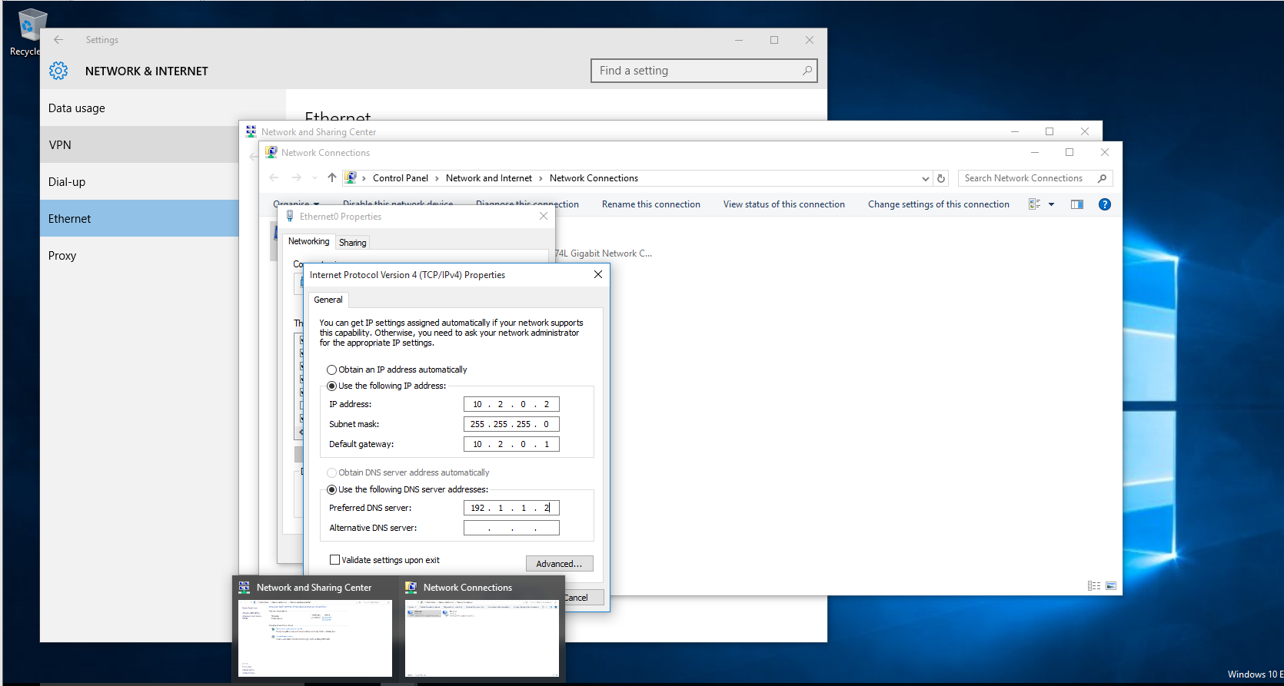
As you can see in the screenshot above, the IP address, subnet mask, default gateway and preferred DNS server has of the London PC has been changed.
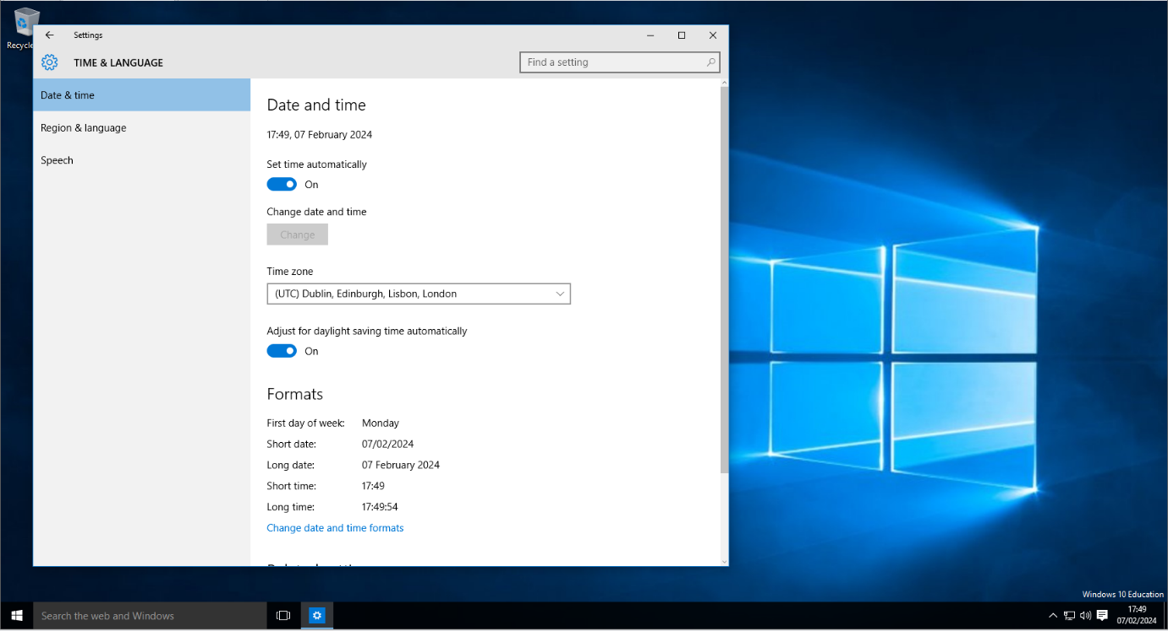
As you can see in the above screenshot, the date and time of the London PC has been changed to London UTC.

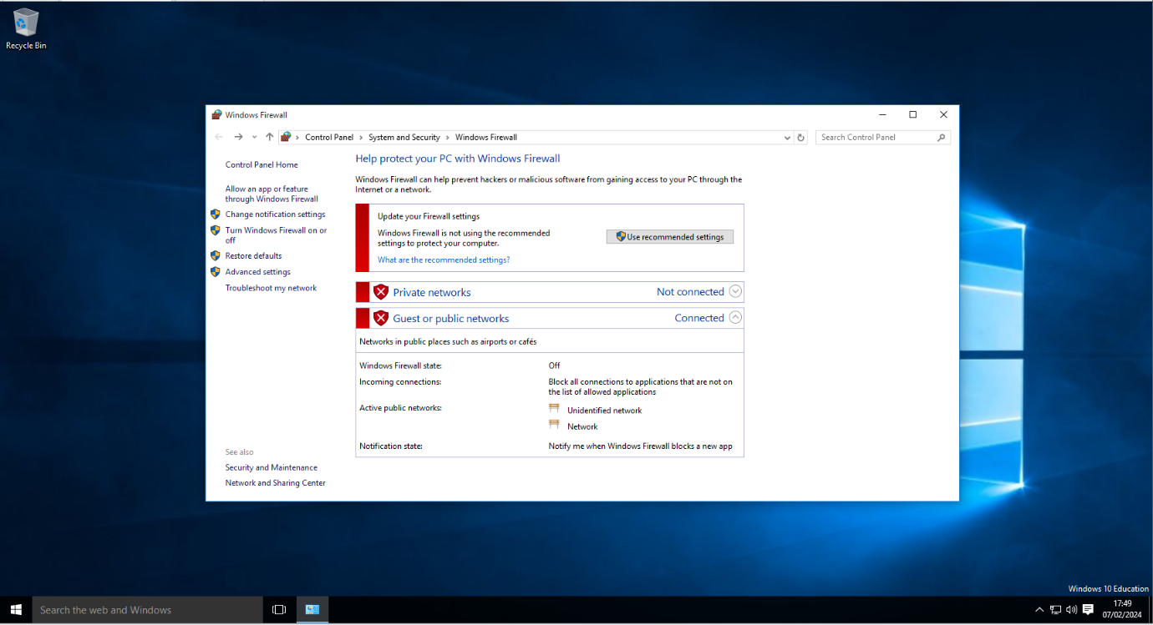
As you can see in the above screenshot, the firewall of the London PC has been turned off.

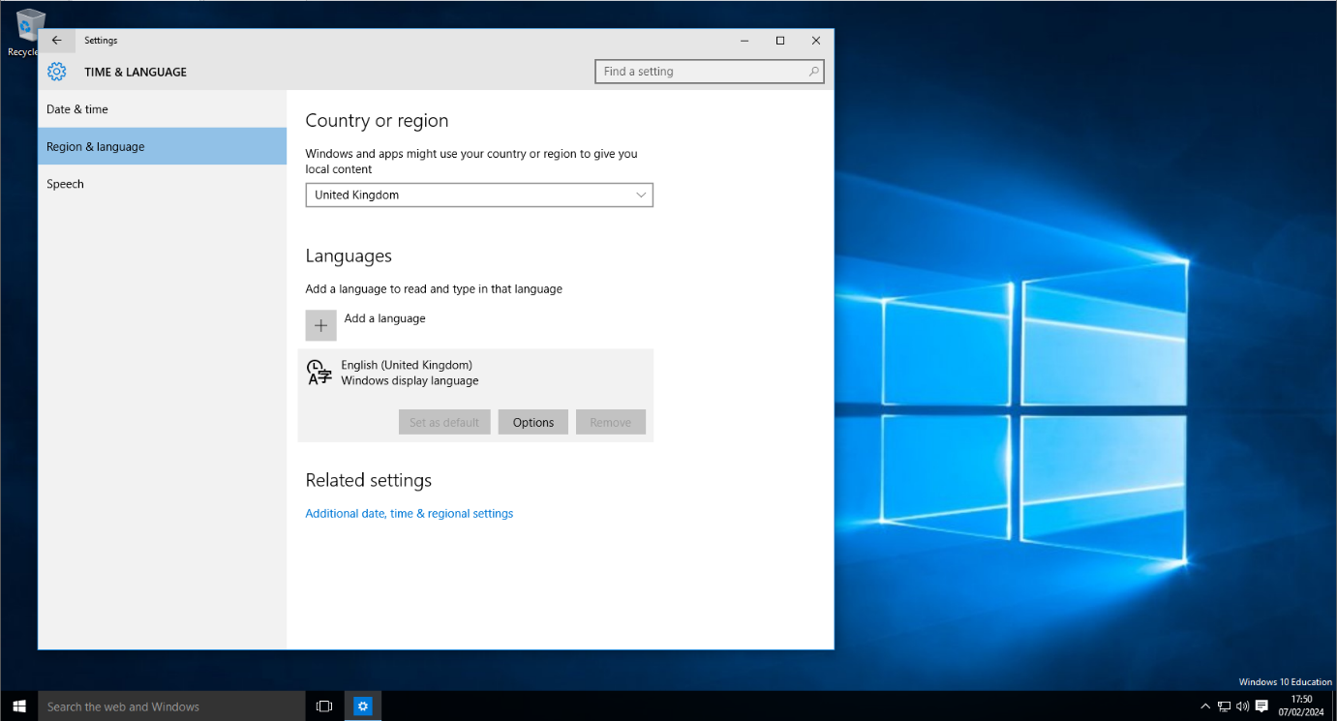
As you can see above, the country or region of the London PC has been changed to United Kingdom.

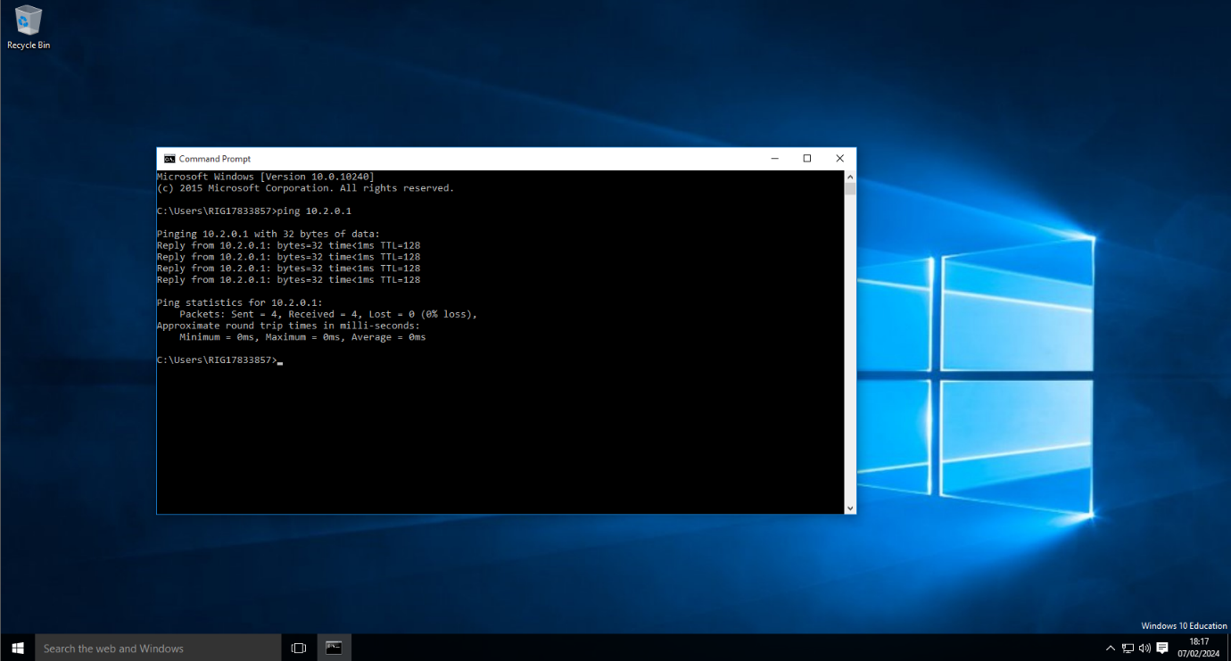
As you can see in the above screenshot, the London PC has been pinged using the “Ping 10.2.0.1” command in the command prompt.

References
[1] “What is a Hypervisor? | VMware Glossary,” VMware, Aug. 04, 2022. https://www.vmware.com/uk/topics/glossary/content/hypervisor.html

[2] “What is a hypervisor?,” www.redhat.com, Jan. 03, 2023. https://www.redhat.com/en/topics/virtualization/what-is-a-hypervisor

[3] S. Simic, “How to Implement Validation for Restful Services with Spring,” Knowledge Base by phoenixNAP, Jan. 24, 2019. https://phoenixnap.com/kb/what-is-hypervisor-type-1-2

[4] “What Are the Different Types of Hypervisors in Cloud Computing?,” Parallels Remote Application Server Blog - Application virtualization, mobility and VDI, Oct. 31, 2022. https://www.parallels.com/blogs/ras/types-of-hypervisor-in-cloud-computing/

[5] “Type-1 vs Type-2 Hypervisor,” BDRSuite, Dec. 02, 2022. https://www.bdrsuite.com/blog/type-1-and-type-2-hypervisor/

[6] “Pros and Cons of VMware Workstation Pro 2024,” www.trustradius.com, Dec. 15, 2023. https://www.trustradius.com/products/vmware-workstation-pro/reviews?qs=pros-and-cons#product-demos.

[7] “What is an IP Address? How it works? How to Locate it?,” Fortinet. https://www.fortinet.com/uk/resources/cyberglossary/what-is-ip-address

[8] K. Yasar, “What is IP address (Internet Protocol Address)? | Definition from TechTarget,” WhatIs.com. https://www.techtarget.com/whatis/definition/IP-address-Internet-Protocol-Address

‌
‌

‌

‌

‌

‌

‌

