
LDE Assignment 1
E-Portfolio
21 November 21, 2025
Module Name: Learning In the Digital Era
Module Code: ACCA 4025
Student Name:mohamed Fofanah
Student ID:2510890
Lecturer’s Name: Koushik Modak

E-Portfolio Link: mofofanh@gmail.com
University of Wales Trinity Saint David
London campus

Table of Contents
Introduction 1
Task 1: Essential Academic and Employment Skills for the future career Path 1

Task 1 (a): Report on Essential Academic and Employment Skills 3
Task 1 (b): Evaluation of Task 1 (a) based on Similarity report 4
Task 2: Collaborative Mind Map and Individual Poster 5
Mind Map (Collaborative) 5
Poster (Individual) 5
Task 3: Forming a Team 6
Step-by-step process of using RefWorks with visuals.......................................................7
Task 4: E-Portfolio CrAeation and Evaluation 9
Task 4 (a): E-Portfolio Creation 9
Task 4 (b): Illustrative Review of E-Portfolio tool Selection 10
Conclusion........................................................................................................................10
References 11
Task 1 References: 11
Task 3 References: 11

Introduction
Success in education and the workplace depends on a combination of personal and professional competencies. These skills enable individuals to learn efficiently, adapt to challenges, and perform effectively in collaborative settings. Key skills include communication, critical thinking, digital literacy, time management, and teamwork

Task 1: Essential Academic and Employment Skills for the future career Path
Successful study and employment depend on a combination of academic, digital, and interpersonal skills that help individuals perform effectively in learning and professional environments.

Time Management

Successful time management is essential for achieving personal and professional goals. Effective time management includes techniques like using alerts, prioritising work, organising calendars, maximising productivity, and scheduling reminders. Competent people achieve more in less time, which lowers stress and boosts output.
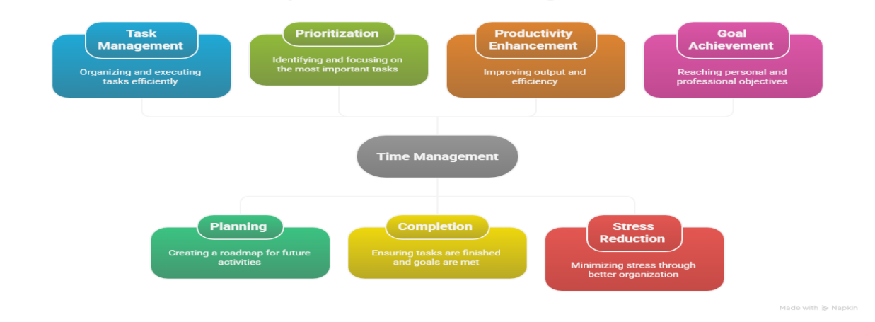

Critical Thinking & Problem-Solving
These skills help learners break down complex tasks, make informed decisions, and create innovative solutions—critical abilities in modern industries.
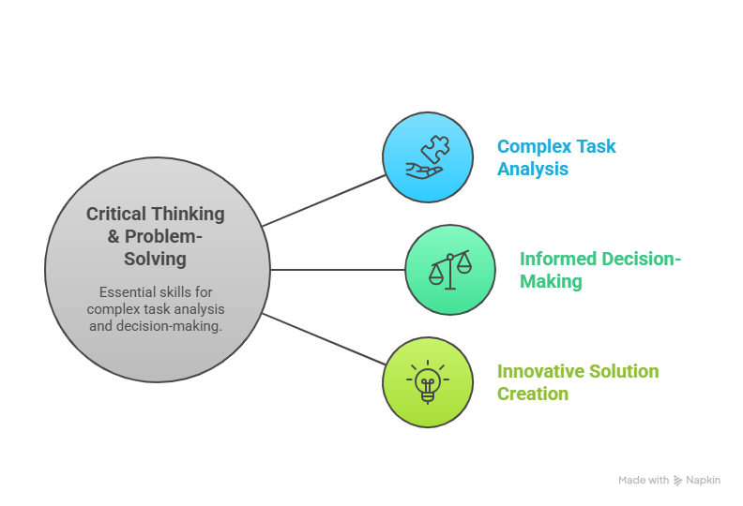

Communication Skills
Effective communication supports teamwork, professional writing, presentations, and maintaining strong workplace relationships.

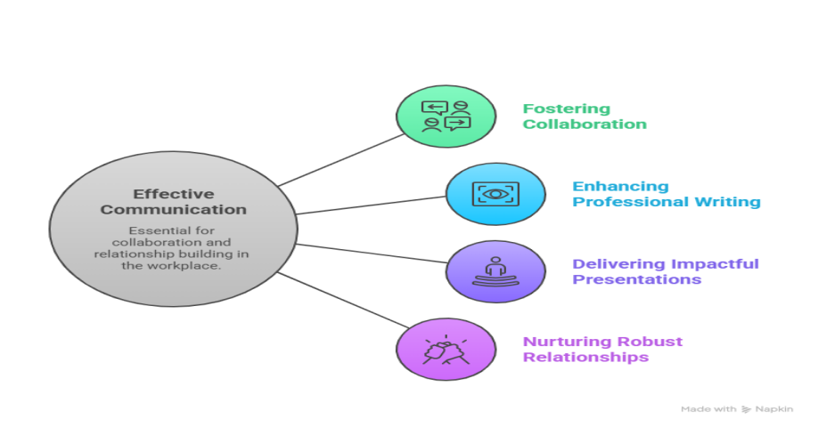

Digital Literacy

Most careers rely on technology, so understanding digital tools, platforms, and information management is essential.

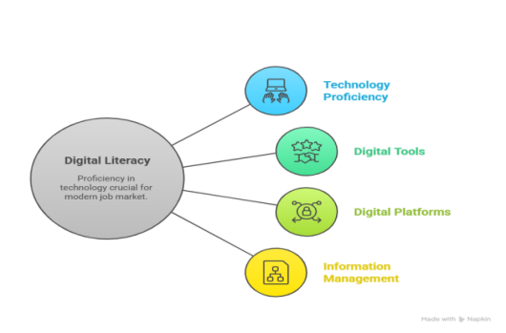

Adaptability & Self-Motivation
These skills help individuals handle challenges, stay focused, and grow in fast-changing environments.
In my chosen career in Computer Science, these skills are essential. Time management will help me complete programming tasks and meet project deadlines. Critical thinking will support debugging, algorithm design, and system analysis. Communication skills will allow me to explain technical concepts to clients and collaborate with teammates. Digital literacy is fundamental in using programming tools and emerging technologies. Adaptability will help me keep up with new software trends and evolving industry requirements.

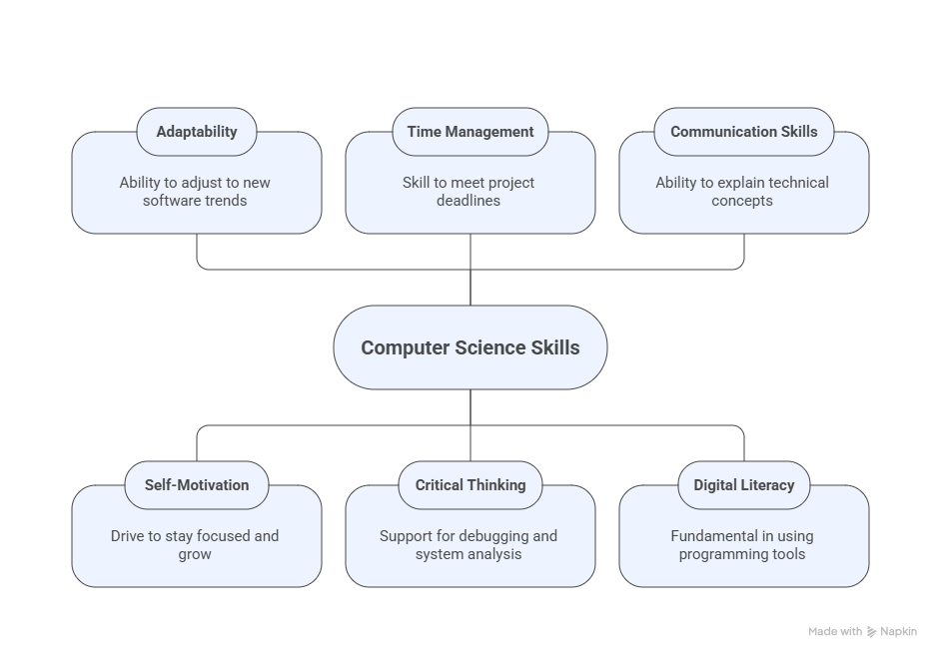
Task 1 (a)
Report on Essential Academic and Employment Skills How to improve the similarity
In order to increase my similarity, I must spend some time learning about the domain-specific characteristics that mostly influence similarity. Iteratively improve feature selection by considering domain and performance.
However, in this document there was only 19% similarity and the other were about references.Taking the situation into account while calculating similarity, words or phrases should be considered in their surrounding context to capture complex relationships and meanings.
The next time, try other approaches, pre-trained models, and fineHor-tuning strategies to maximise performance. To adapt models to specific tasks, incorporate domain-specific knowledge.

Task 1 (b): Evaluation of Task 1 (a) based on Similarity Report

References:
[1]S. Covey, The 7 Habits of Highly Effective People. Free Press, 2013.
[2] P. A. Kirschner and J. J. G. van Merriënboer, “Urban myths in education,” Educational Psychologist, vol. 48, no. 3, 2013.
[3] National Association of Colleges and Employers, “Career readiness,” 2024. [Online]. Available: https://www.naceweb.org
[4] J. C. Bean, Engaging Ideas. Jossey-Bass, 2011.
[5] M. Robles, “Executive perceptions of top 10 soft skills,” Business Communication Quarterly, 2012.

Task 2: Mind Map and Individual Poster Mind Map

Poster
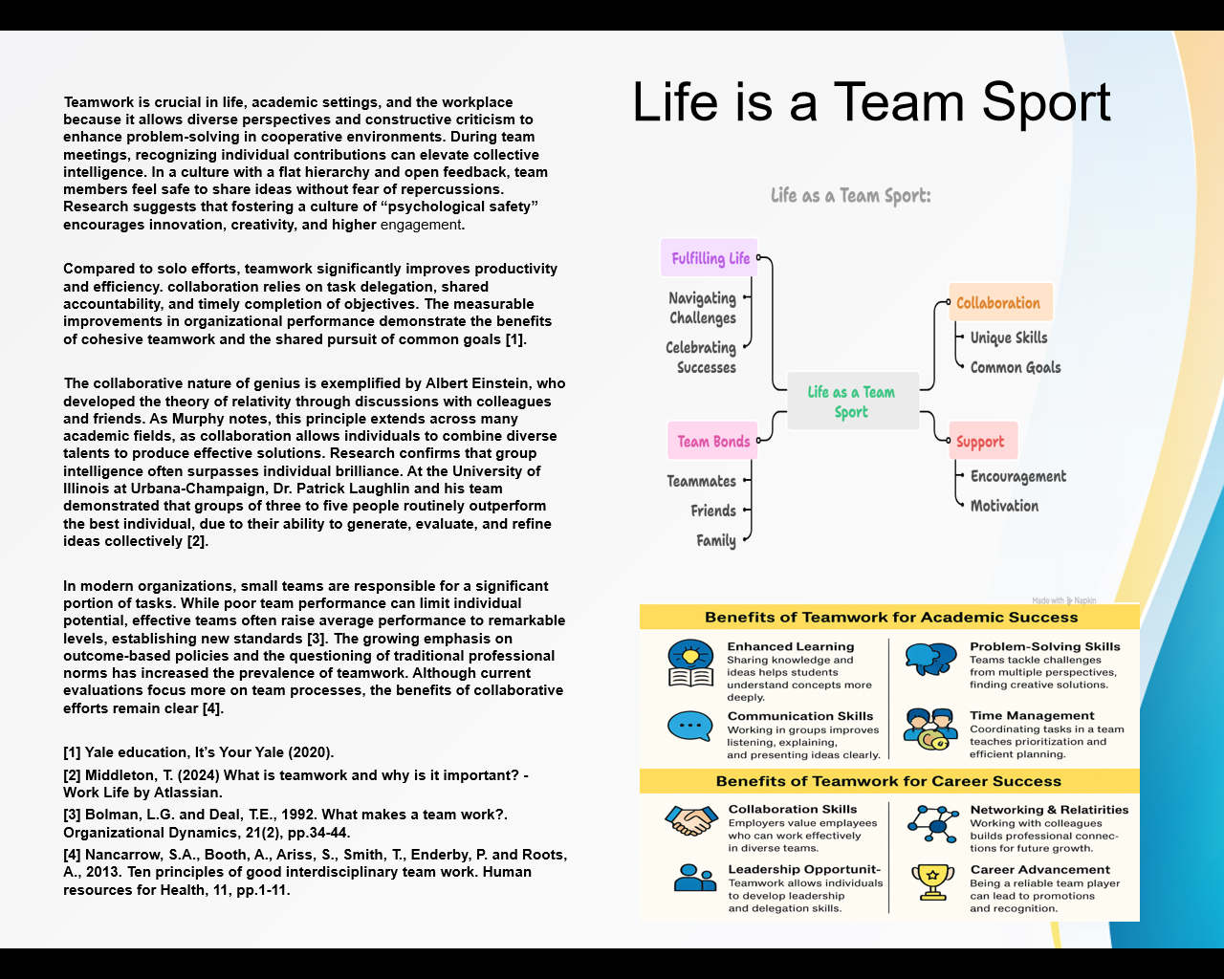
Mind Map
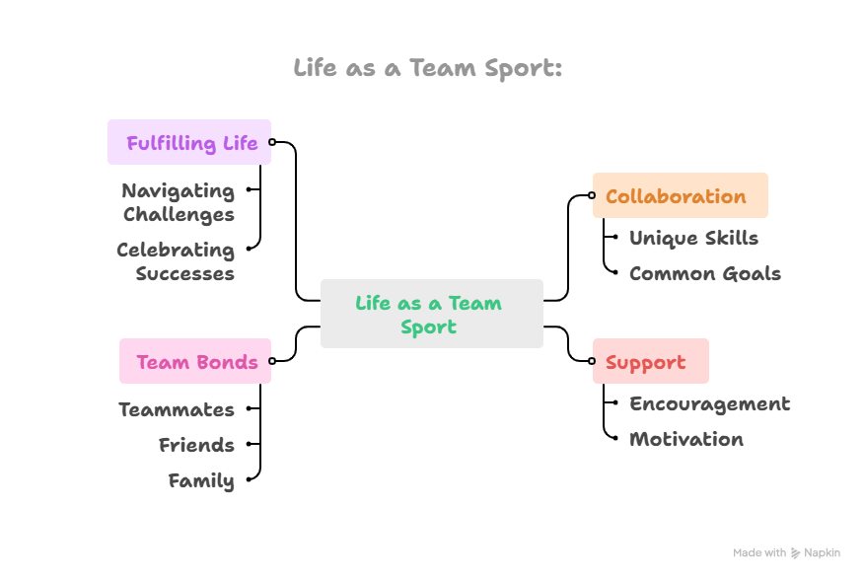

Task 3: Forming a Team

Teamwork plays a vital role in achieving collective success, and scholars have long emphasize the importance of collaboration in both organisational and educational contexts. Scarnati (2001) defines teamwork as “a cooperative process that allows ordinary people to achieve extraordinary results,” highlighting its transformative potential. Similarly, Harris and Harris (1996) argue that a shared purpose is at the core of any effective team, as it strengthens relationships and ensures alignment toward common objectives. Collaboration is most effective when individuals come together to exchange knowledge, skills, and perspectives in pursuit of shared outcomes. Numerous studies reiterate that maintaining focus on a united goal is one of the most critical elements of successful teamwork (Fisher, Hunter, & Macrosson, 1997; Johnson & Johnson, 1995, 1999; Parker, 1990).

In contemporary organisations and increasingly within higher education teams are recognised as essential structures for problem-solving and productivity. For a team to function positively and productively, members must work harmoniously and create an environment where everyone feels motivated to contribute. Luca and Tarricone (2001) emphasise that cooperation and social interdependence must outweigh competition and individualism as members adapt to collaborative work. Research consistently identifies several qualities necessary for effective teamwork, including commitment to shared goals, mutual dependence, interpersonal skills, open communication, appropriate group organisation, and strong support for processes that reinforce responsibility and direction.

Team leadership also plays a fundamental role in shaping how well a team performs. Effective leaders do more than make operational decisions—they cultivate a shared vision and invest emotionally in the development of their team. Strong leadership requires competence, confidence, and reflective thinking, encouraging members to evaluate their motivations and take proactive steps toward improvement.

Furthermore, setting strategic goals is critical to guiding collective effort. Leaders must establish ambitious yet aligned objectives that acknowledge interdependencies across departments, while remaining flexible in response to changing conditions. Traditional SMART goals, while useful, may limit strategic execution; instead, adopting FAST goals frequently discussed, ambitious, specific, and transparent—helps strengthen accountability and ensures that progress remains visible and measurable. By embracing these principles, teams can maximise their performance and contribute meaningfully to transnational success.

Step-by-step process of using RefWorks with visuals

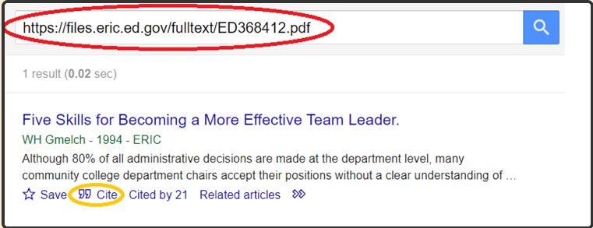

First, I choose an article at Google Scholar that I already summarize, after summarized, I click on the cite

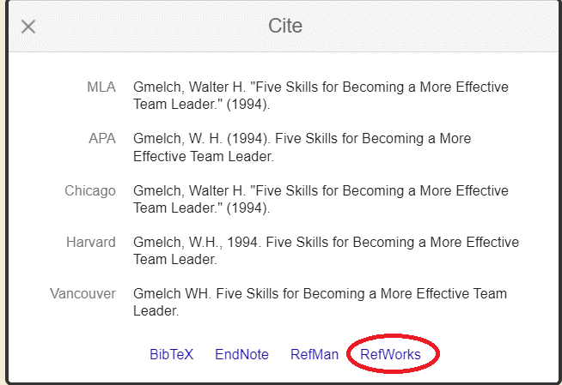

After clicking on "cite," four options will appear (Bibtex, EndNote, Refman, RefWorks). Click on RefWorks

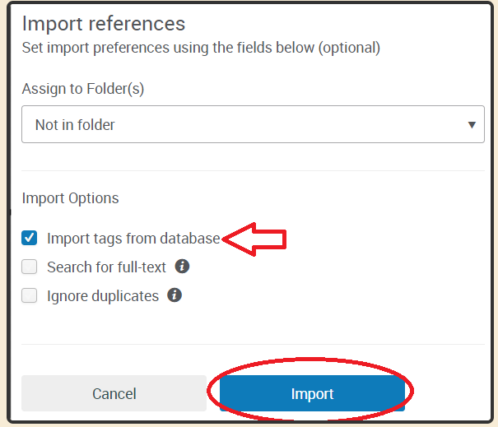

After selecting RefWorks select import tags from database and click on import references

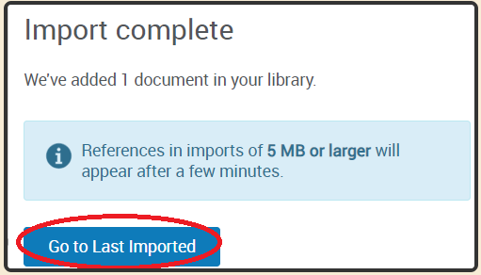

After, click on “Go to Last Imported

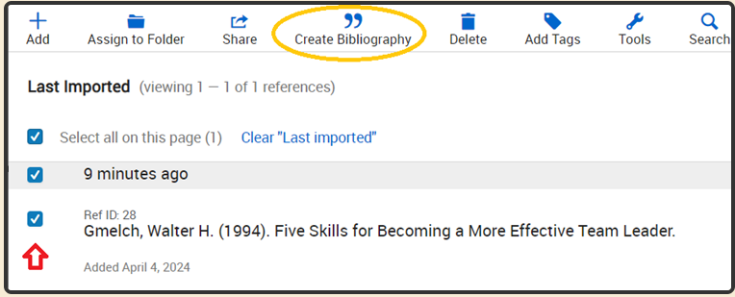

So, select the document and click on the Create Biibliography.

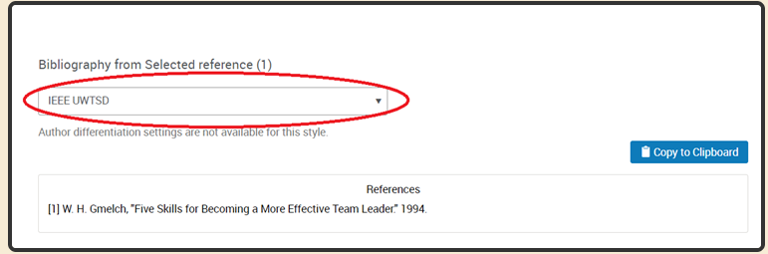

Once you have selected IEE UWTSD, your references will be completed.

References
[1] P. Tarricone and J. Luca, "Successful teamwork: A case study," 2002.
[2] W. H. Gmelch, "Five Skills for Becoming a More Effective Team Leader." 1994.
[3] P. D. Bachiochi, et al., "The qualities of an effective team leader," vol. 18, no. 1, pp.11-28, 2000.
[4] Sull, D. and Sull, C., 2018. With goals, FAST beats SMART. MIT Sloan Management Review, 59(4), pp.1-11.

Task 4: E-Portfolio Creation and Evaluation

Task 4 (a): E-Portfolio Creation
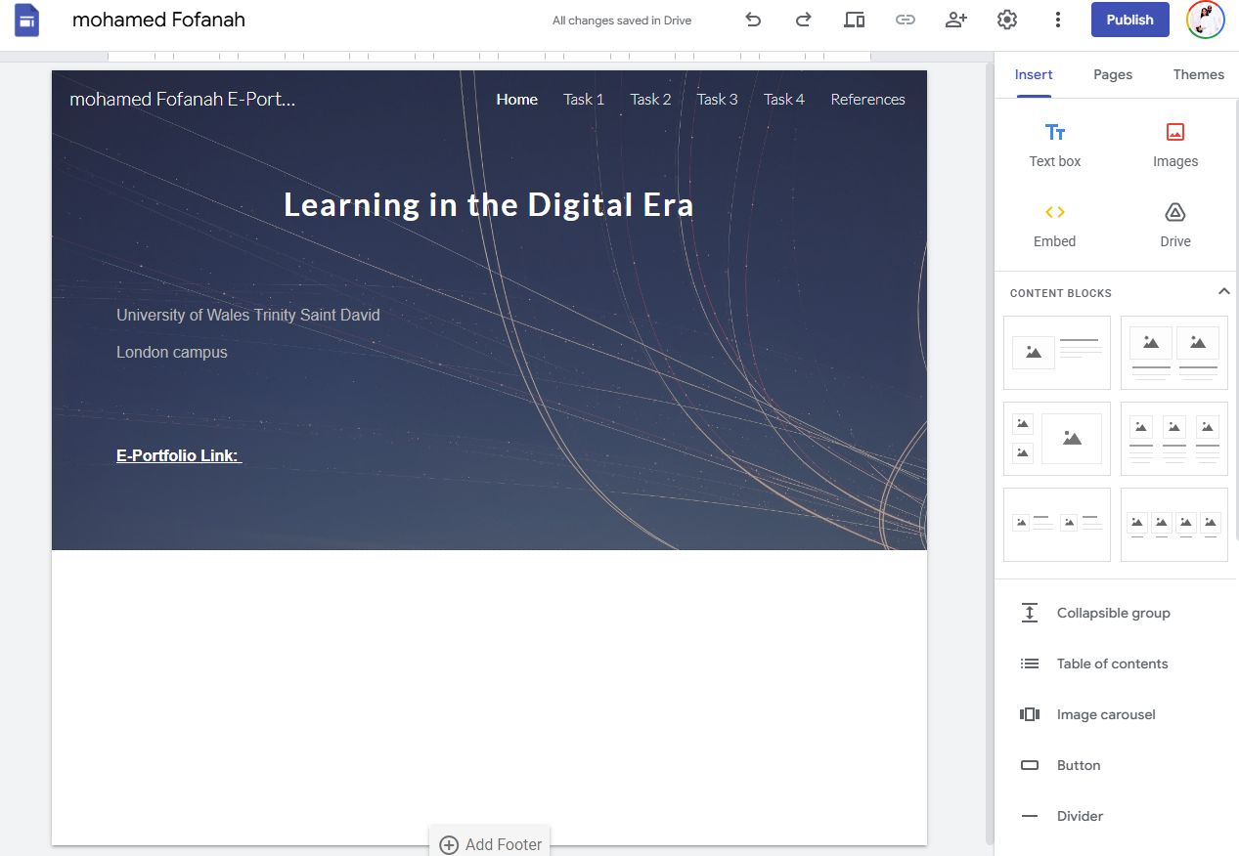

Task 4 (b): Illustrative Review of E-Portfolio tool Selection

I created my e-portfolio using Google Sites, a platform that allowed me to design and customize my pages easily. Before starting this course, I had already been exploring the basics of web design, so building the portfolio on Google Sites helped me apply and expand that knowledge. Using this tool not only strengthened my existing skills but also enabled me to gain a deeper understanding of effective website layout, visual design, and online presentation.


Conclusion
In summary, essential skills such as communication, time management, critical thinking, teamwork, and digital literacy provide the foundation for success in both study and employment. These abilities help individuals manage complex tasks, collaborate effectively, and adapt to new challenges in an increasingly competitive world. By developing and strengthening these skills, students and professionals can improve their performance, increase their confidence, and create stronger opportunities for future career growth.

References

Task 1 References:
- S. Covey, The 7 Habits of Highly Effective People. Free Press, 2013.
[2] P. A. Kirschner and J. J. G. van Merriënboer, “Urban myths in education,” Educational Psychologist, vol. 48, no. 3, 2013.
[3] National Association of Colleges and Employers, “Career readiness,” 2024. [Online]. Available: https://www.naceweb.org
[4] J. C. Bean, Engaging Ideas. Jossey-Bass, 2011.
[5] M. Robles, “Executive perceptions of top 10 soft skills,” Business Communication Quarterly, 2012.
Task 3 References:
[1] P. Tarricone and J. Luca, "Successful teamwork: A case study," 2002.
[2] W. H. Gmelch, "Five Skills for Becoming a More Effective Team Leader." 1994.
[3] P. D. Bachiochi, et al., "The qualities of an effective team leader," vol. 18, no. 1, pp.11-28, 2000.
[4] Sull, D. and Sull, C., 2018. With goals, FAST beats SMART. MIT Sloan Management Review, 59(4), pp.1-11.

