DS 1 Template

My Screenshots/Photos
- Please add 4–6 screenshots or photos of your digital life.
- You can use your phone or laptop.
- For each screenshot, write one or two sentences explaining what it shows.

Screenshot/Photo 1
ClassDojo

ClassDojo shows that I use technology in my everyday life. I use it to keep in touch with my children’s school, check messages and see what my children are doing. It helps me stay up to date and makes things easier for as a parent.

Screenshot/Photo 2
Messenger
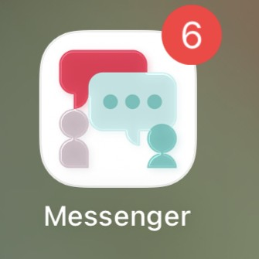
Messenger helps me work as part of a team because I can quickly contact my colleagues. We can share important updates, let each other know about cancellations or medication changes, and ask questions when needed. This helps us work together and make sure everyone has the right information.

Screenshot/Photo 3
Moodle

I use Moodle regularly at university to access my course materials and submit my assignment. I find it helpful because it keeps all my work in one place and help me stay organised. I feel that Moodle had made managing my studies easier and helped me feel more connected to my course.

Screenshot/Photo 4
Timetable
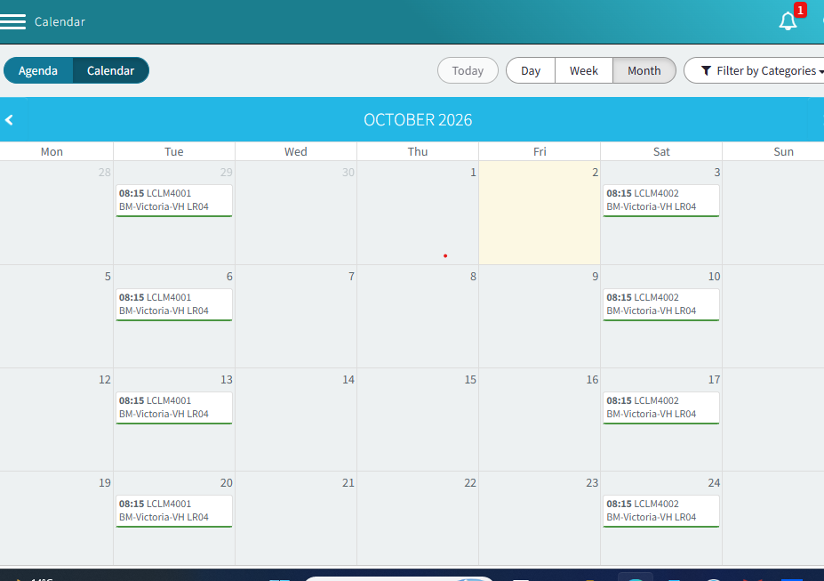
I use my university timetable to know when my classes and study time are.it helps me plan my week and manage my time better. Having a timetable is imported to me because it keeps me organised and help me feel less stressed.it also helps me stay focused on my university work.

Screenshot/Photo 5
New digital skills

I use new digital skills to learn how to stay safe online, I can find each term information in here. I can access my work easily and keep up with my studies.

Screenshot/Photo 6
Linked in

Linked in is important for me because it helps me build my professional profile and connect with employers and other professionals. It also helps find job opportunities and learn more about different careers. For me it is useful for preparing for my future career and showing my skills and experience.

My Short Reflection
- Write 5–8 simple sentences about your digital life.
- You can use the sentence starters below if helpful.
Digital skills are essential to me because technology plays an important role in both my personal and professional life. I use ClassDojo to communicate with my children’s school and remain informed about their education. In my workplace, I use messenger to communicate effectively with colleagues and receive important update, including changes to shifts and medication. I also use Moodle independently to access learning materials and submit my academic work, which has helped improve my confidence with digital technology. My digital timetable supports me in managing my responsibilities and staying organised, particularly during busy periods. I have recently started exploring LinkedIn to develop my professional profile, build connections and demonstrate my ongoing development. Although I am becoming increasingly confident with digital platform, I would like to continue developing my knowledge of different applications and digital tools. Overall technology enables me to remain connected, organised and informed across my personal, academic and professional life.

Sentence starters
- I use digital tools to …
- I feel confident when I …
- I want to improve …
- I often use these tools: …
- I sometimes feel nervous about …
- I hope this module will help me …
- Digital skills are important for me because …
You can write more if you want.

Submission Checklist
Before you submit, please check:
​​​ ☐ I added 4–6 screenshots
☐ I wrote short sentences for each screenshot
☐ I wrote my short reflection
☐ My work is my own
☐ My file opens correctly
​​☐ My file opens correctly

