Name:_________________________________

Student Number: ________________________
__________________________________________________________

WORKSHEET 1 – TESTING (Using Variables)

- Original code:
[Copy and paste your original code from Moodle into this box. Do not change it.]

- Code Testing

For each test below, run your code and enter the values provided. Provide a screenshot of the programme running. Did the programme behave correctly or did it do something unexpected? Fill in a box for each test below. You should present 14 separate boxes, 1 for each test. (Note: the first box is provided as a template)

Surname:
- Enter JONES
- Leave blank
- Enter 123

Car registration:
- Enter BG56UDU
- Leave blank
- Enter BG56345DFE (ie too long for a UK car registration number)

Age
- Enter 34
- Enter 150
- Enter -4
- Enter a letter

Hours per week of lectures
- Enter 12
- Enter 15.5
- Enter -4
- Enter 150 (ie longer than the maximum possible hours that the University is open in a week)

Test:
Surname i. Enter JONES

Screenshot(s) of output:
Surname
i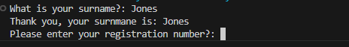
ii 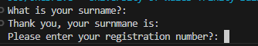
iii 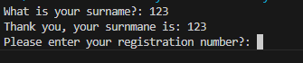
Registration
i 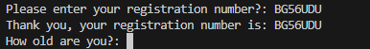

ii 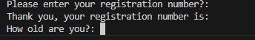
iii 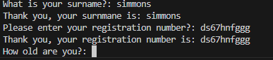
Age
i 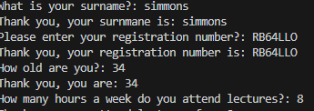
ii 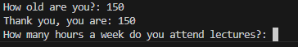
iii 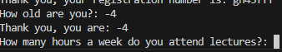
iiii
Hours per week
i 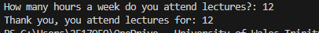
ii
iii
iiii
Result: Did the program behave as expected ie syntactically and logically correct?
No
If NO, what problems were encountered and why? Suggest how things could be improved.
I have not added Validations into my code, therefore people can enter values that are incorrect. The integer classification has stopped people adding letters to age and hours but other than that people cade add what they want.

(Copy and paste a box similar to the above for each of the rest of the tests)
- Consider the results of the above tests and revisit your original code in order to address the tests that failed. (Note: you may not be able to solve all of the problems that were originally encountered, but solve as many as you can.)

Paste your full revised code here :

[Copy and paste your full revised code here – note, do not use a screenshot]

Surname = str(input("What is your surname?: "))
print("Thank you, your surnmane is:", Surname)
RegNumber = str(input("Please enter your registration number?: "))
print("Thank you, your registration number is:", RegNumber)
Age= int(input("How old are you?: "))
print("Thank you, you are:", Age)
WeeklyLectures = int(input("How many hours a week do you attend lectures?: "))
print("Thank you, you attend lectures for:", WeeklyLectures)

