PROBLEM-SOLVING AND DECISION-MAKING ROLE-PLAY AND REPORT
Student name: Donatas Keliauskas
Student number:2120434
Lecturer: Laila Maazouz

Table of content

Introduction 3
Analysis 3
Define a complex problem in the workplace including its scope and impact 3
Analyze information on the identified problem, to help inform the decision-making process 4
Propose a range of alternative solutions to the problem 4
Use a decision-making technique to evaluate a range of solutions to identify the most appropriate option 5
Develop a plan for implementing the solution 5
Communicate the plan to stakeholders 6
Assess appropriate monitoring and review techniques to ensure the successful implementation of the solution 7
Conclusion 7
Reference 8

Introduction
In this course of the report, it is going to be recognized that the identification of problem-solving techniques and tools will be analyzed. There are a few aspects that are going to be described which are the complex problems in the workplace that have an impact on the—identification of the problem and helping them in the decision-making process as well. The purpose and alternative solution to the problem will also be defined. With the help of decision-making techniques, it is going to be evaluated what is the range of solutions that could be identified by those appropriate methods. The implementation of the solution will be developed as planned. The stakeholder communications and the appropriate monitoring while reviewing their techniques that ensure the successful performance of the solution will be analyzed accurately in terms of the organization. Through this, it will be identified that all the techniques would help in the decision-making process.

Analysis

Define a complex problem in the workplace including its scope and impact
Causes of the problems
Conflict issues among staffs are identified as the staff members are suffering conflicts between them. Because of feeling uncomfortable many staff members can also probably leave the job. The communication between the staff members is very poor. Because of fewer communication Disputes can arise Between groups of people (Agustian et al., 2022). People having different points of view, Values, needs, and interests Can also arise Conflicts between them. Conflicts may be productive or unproductive. Whatever it is but because of this the environment Of the company will be disturbed. There are fewer activities for staff Because of which the engagement among each other Is very low. Not having a clear job role Can also be a problem, Because of which Staff members are unable to complete their tasks perfectly. Employees according to their qualifications and skills should be appointed so that they can do their job easily. A perfect work Training should be given to the staff before joining and her lack of training is one of the reasons. Unskillful employees can take time to complete a job, Which can hamper the time management. A good management makes the company run better but The management of this company is also not good. Because of having such issues the environment of the company may become worse (Wakefield et al., 2021). All the disputes and issues should be sorted and everyone should do their work honestly.
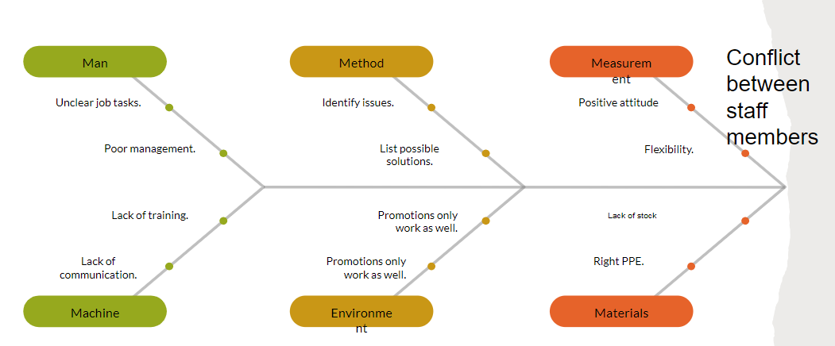
Figure 1: Cause and effect of the problems
(Source: Wakefield et al., 2021)

Analyze information on the identified problem, to help inform the decision-making process
Effect of the issues
The conflict between staff members Is the reason that is making the environment of the company worse. not having proper communication between the staff members Can create problems. To solve this issue Some policies and rules should be made, where proper engagement of all members will be mandatory (Lysaght et al., 2019). Unclear job roles are also one of the reasons, so some activities for the staff should be made where proper jobs will be differentiated accordingly. To put the work system in place A training should be given to the staff members. Having a training structure According to the Departments of the organization And recognizing training needs that will be better for the staff members Of different backgrounds and Departments Can be impactful for the company. training programs for a certain period should be designed to understand the job better. This will help do the jobs properly. Quiz and small tests should be taken also by which it will be better to understand how much the staff have learned and will have enthusiasm for doing it perfectly. By Identifying the issues possible solutions will be made. After a certain period of time promotions should be given Which can work as well to encourage staff to do their job perfectly. A positive attitude regarding work will be beneficial. Flexibility can also work as well. Stocks should be full. Some strategies should be made That will be impactful For the organization (Akter et al., 2019). To run the whole organization aptly a proper management is needed, which can manage the whole company correctly.

Propose a range of alternative solutions to the problem
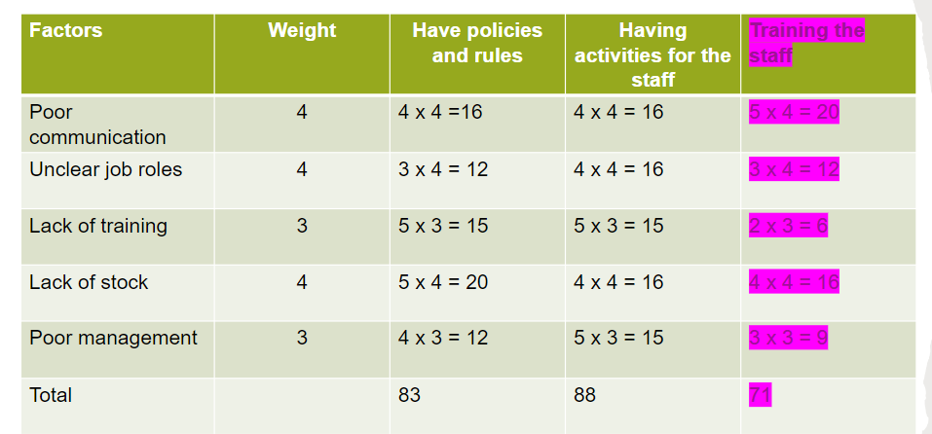
Figure 2: Matrix for solution
(Source: Influenced by Ashraf et al., 2019)
The range of alternative solutions to that certain problem has been identified as to create some activities for the staff which states that to inspire their employees in working so that they could do better work in their workplace the work environment of their department must be incorporated with few alternative activities which code eventually enhance the morality of their employees and they would like to work without any hesitations. And unhealthy competition which leads to unnecessary disputes through these conflicts at the workplace eventually ruins the environment of the organization or the department (Li et al., 2019). Having policies and rules in their workspace which could bind their employees into working accurately otherwise they are maybe severe actions. Through this policy, it is going to be overlooked whether the employees are working accurately as per the terms of the employment contract or not. Through this, it is going to analyze the employee's performance and which will eventually help the staff management. And finally, in the staff training program, it has been identified that these types of techniques are implemented by their manager or higher authority which showcases their employees in a specific manner that could help them enhance their knowledge and skills even further. It provides specific skills and knowledge that could eventually enhance their productivity even more. It has been found to be a compulsory role at some level of training that offers their members a certain role by maintaining them and training them for that certain role (Ashraf et al., 2019). It has a great importance as it directly affects their work which could also help the organization in an enhanced manner.

Use a decision-making technique to evaluate a range of solutions to identify the most appropriate option
The usage of decision-making techniques that evaluate the range of solutions by identifying most of the appropriate options is analytic hierarchy processes. Through this process, it has been identified that it helps to mitigate any intuition or subjectivity which goes over to be a decision (Guo, 2020). Through this, it can be blinkered that the perspective could be naturally accurate which is close to human nature. It has a few remarkable techniques which lead them into making first decisions that have a personalized experience however it could be an uncommon issue within the organization or the staff management as it could overall be a leadership. Through this, it can be identified that it solidifies and analyzes all the integration which could be used in decision making at staff management as if their issues and creates a certain solution which could be accurate in terms of their working. Cost or benefit analysis they are usually used in financial decision making which has the sole purpose of acquiring a financial data that might require few decision-making prospects as it might wish to use another decision-making technique by analyzing those subjective ideas and analyzing them even for the so that it could be the accurate evaluation of the appropriate staff management system . Through this, it has been observed that this decision-making technique eventually focuses on the staff management as the financial benefit could boost the morale of their employees after they get a bonus (Campos-Guzmán et al., 2019). And as per the analytic hierarchy process, it helps them to take Complex decisions with the help of group solutions.

Develop a plan for implementing the solution
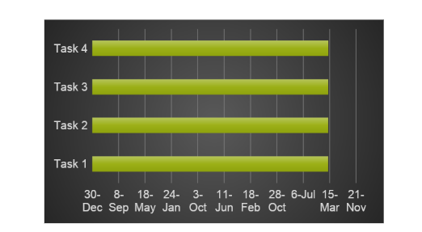
Figure 3: Implementation plan
(Source: Influenced by Ershad Sarabi et al., 2019)
Developing a plan for implementation of the solution that has a few steps which are defining their goal before the implementation process and determining their complement within that time span. Conducting research that has a broad set of ideas and their sole goal is to achieve their goal by conducting research such as observations, surveys, and many more (Bibri and Krogstie, 2020). Through this, it would analyze the first section to develop a plan for the implementation of a solution. Outlining their risks on which kinds of risks could be outsourced before implementing the solution. Scheduling milestones is one of the most important sections as it plans a process by binding future points that tracks the progress before the execution of the solution so that they have an accurate idea of what they are doing and whether it is accurate or not. After analysis, it certainly observes all the probable risks and all the appropriate matrices that could be identified. Assigning tasks and responsibilities includes of team members who are assigned their respective tasks and responsibilities in the team in terms of doing their job accurately without intervening with anyone and bothering their colleagues or staff members from their team and the responsibilities to which they are assigned to. Finally, the allocation of resources is the most accurate way to reduce any kind of risk while completing a certain project (Ershad Sarabi et al., 2019). As it ensures the availability of their project and resources, it overlooks all the processes and the software which could be implemented while completing those sections. The resources may include physical or technical materials as well as it totally overlooks the team members' project.

Communicate the plan to stakeholders
The communication of plans with the stakeholders should be assigned accurately as it totally identifies the establishment and it determines the meaning that has a direct and indirect interest in the project and also has observed that stakeholders may be interested in the project work it depending on their characters as it has a general perspective which managers and executes the process which is planned. Setting objectives with the stakeholder the communication plans have a most important set of analyses that identifies all the roles of defining and for a serial future that could be identified to be a great time for the execution of the plan. The communication must encounter a few setbacks as it totally overlooks all the set of analyses that totally depend on them and what kind of work which could be completed after having a communication of those plans (Lauff et al., 2020). The establishment of the method after communication determines that after communicating now they are going to decide the accurate method that could apply to the implementation of that plan. It has an effective way to determine such a communication channel that has the most effective way to consider that the receiver has analyzed those messages accurately without sharing. And finally the usage of gathered data through this it can be determined accurately that the Project objective and the plans which are going to be implemented have some communication plan which observes their methods.

Assess appropriate monitoring and review techniques to ensure the successful implementation of the solution
The accessing of appropriate monitoring and reviewing of those techniques has been split into the matrix result which is the poor communication in the organization having unclear job roles and lack of training. And the poor management and lack of stock are some of the problems which are monitored in the organization the accurate way are to implement such techniques that ensure a successful solution requires training their staff which requires the implementation of a working system in their workplace as it outsourced the lack of training and overlooks all the issues that have been recognized in the workplace. Create a certain training structure that recognizes a training need (Upadhyay and Sampalli, 2020). Through this, it observes that the recognition of the problem and the implementation of the solution needs to be implemented accurately as it requires all the issues and their solutions. Through these, it analyzes all the design training programs which overlook the training processes and their program which should be overloaded in the organization without facing any problems in due time. Having policies and rules also helps them to create a solution that could apply to them in terms of the employees working effectively in the workplace or department that could boost their morality with financial matters.

Conclusion
In the above report, it has been identified that the complex problems in the workplace have been defined accurately while analyzing that information and helping them with certain decision-making processes. The purpose and the solutions are also described while using decision making techniques that have a range of solutions. The development of a plan to implement the solutions has been described which could analyze the way of staff issues and create a certain solution that could be applicable for that period. The communication of the plan with other stakeholders has also been described and the monitoring and reviews of techniques to implement a successful solution have also been implemented reportedly. It can be concluded that after the implementation of such aspects, it analyzes all the problems and helps them with the decision-making process which code solves all the problems with staff management.

Reference
Agustian, H.Y., Finne, L.T., Jørgensen, J.T., Pedersen, M.I., Christiansen, F.V., Gammelgaard, B. and Nielsen, J.A., 2022. Learning outcomes of university chemistry teaching in laboratories: A systematic review of empirical literature. Review of Education, 10(2), p.e3360.
Akter, S., Bandara, R., Hani, U., Wamba, S.F., Foropon, C. and Papadopoulos, T., 2019. Analytics-based decision-making for service systems: A qualitative study and agenda for future research. International Journal of Information Management, 48, pp.85-95.
Ashraf, S., Abdullah, S. and Abdullah, L., 2019. Child development influence environmental factors determined using spherical fuzzy distance measures. Mathematics, 7(8), p.661.
Bibri, S.E. and Krogstie, J., 2020. The emerging data–driven Smart City and its innovative applied solutions for sustainability: The cases of London and Barcelona. Energy Informatics, 3(1), pp.1-42.
Campos-Guzmán, V., García-Cáscales, M.S., Espinosa, N. and Urbina, A., 2019. Life Cycle Analysis with Multi-Criteria Decision Making: A review of approaches for the sustainability evaluation of renewable energy technologies. Renewable and Sustainable Energy Reviews, 104, pp.343-366.
Ershad Sarabi, S., Han, Q., L. Romme, A.G., de Vries, B. and Wendling, L., 2019. Key enablers of and barriers to the uptake and implementation of nature-based solutions in urban settings: A review. Resources, 8(3), p.121.
Guo, K.L., 2020. DECIDE: a decision-making model for more effective decision making by health care managers. The health care manager, 39(3), pp.133-141.
Lauff, C.A., Knight, D., Kotys-Schwartz, D. and Rentschler, M.E., 2020. The role of prototypes in communication between stakeholders. Design Studies, 66, pp.1-34.
Li, S., Jin, X., Xuan, Y., Zhou, X., Chen, W., Wang, Y.X. and Yan, X., 2019. Enhancing the locality and breaking the memory bottleneck of transformer on time series forecasting. Advances in neural information processing systems, 32.
Lysaght, T., Lim, H.Y., Xafis, V. and Ngiam, K.Y., 2019. AI-assisted decision-making in healthcare. Asian Bioethics Review, 11(3), pp.299-314.
Upadhyay, D. and Sampalli, S., 2020. SCADA (Supervisory Control and Data Acquisition) systems: Vulnerability assessment and security recommendations. Computers & Security, 89, p.101666.
Wakefield, M., Williams, D.R. and Le Menestrel, S., 2021. The future of nursing 2020-2030: Charting a path to achieve health equity. National Academy of Sciences.

