

Hotel Placement - Managing Guest Service Operations

Prepared by
Rashma Rahman
Student ID: 2012848

Module Name
Managing Guest Service Operations
(BMIH6003)

Lecturer’s Name
Dr Jayne Griffith-Parry and Robyn Griffiths

Word Count
1,282 words
Table of Contents
Maldrons hotel Newcastle: 3
Reflection: 4
Description: 5
Feelings: 5
Evaluation: 6
Analysis: 6
Conclusion: 7
Action plan: 7
References 8

Maldrons hotel Newcastle:
Maldron Hotel Newcastle located in Newcastle city is a well-known place, in this area, this hotel is called the four-star hotel. I have worked for these organizations for several days, to complete my academic curriculum, but for this, I am "Managing the guest service operation" of these organizations. Through my placement here, various types of experience, knowledge and performance have been obtained, which will work as guest service operation several skills of the organization, which has helped me to understand my workplace, besides, through the placement in this organization, self-development in academic and vocational fields (Casado, 2012). There has been an improvement. Apart from these, I have been able to gain knowledge and experience in academic work and increase my skills. Although I encountered some negative aspects in the experience of placement here, because there is not much importance on the small issues of guest service here, from the hotel management side, due to which I failed to get several important benefits from being the managing director. On the other hand, through this hotel, I have been able to acquire and improve various specific skills, such as - communication skills, teamwork, leadership, customer service, financial management, empathy, emotional intelligence, attention to detail and interpersonal skills etc. (Bardi, 2011). As these skills have helped me improve academically and personally, they will be more useful in my future career and professional job.

Reflection:
Reflection is a reflection of something, the idea of ​​what kind of experience I had during the placement at Maldron Hotel, which is useful for students' studies and future careers to acquire different skills. So here are the pros and cons of the various skills I acquired from Waldron hotel regarding the guest management department. After the placement, to analyze my experiences, I reflected on learning and experiences separately in six stages namely: description, feelings, evaluation, analysis, conclusion and action plan.
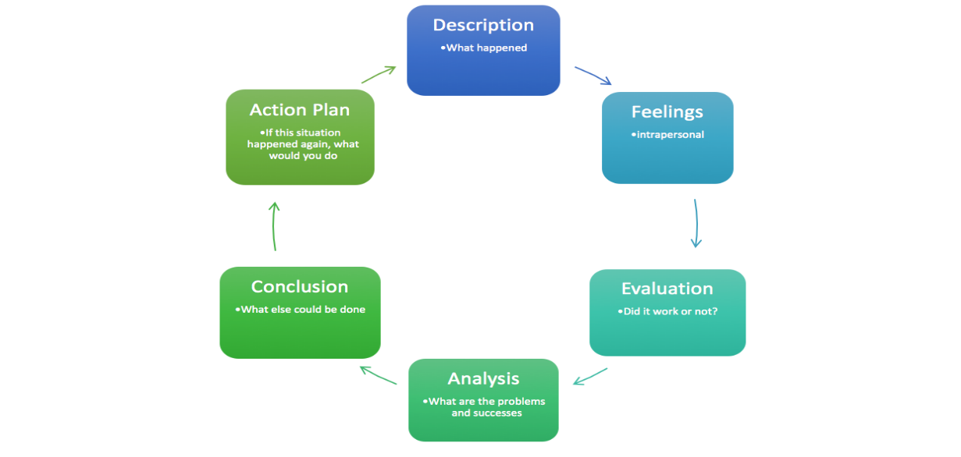
Figure 3: Gibbs Reflective Cycle
Source: (ASET, 2022)

Description:
During my placement at Maldron Hotel, I mainly worked for the managing guest service operation department, where I learned various skills, such as: how to provide flawless, high class and professional guest service, analyse customer feedback, and direction to improve overall. rating, responding to guests’ needs and conducting themselves in a friendly and attentive manner during all guest encounters. Moreover, I learned how to upgrade as a guest service manager here. However, I encountered some negative aspects in the experience of placement here, because there is not much importance on the small issues of guest service here, from the hotel management side, due to which I failed to get several important benefits from being the managing director. But apart from these, during the placement period at Maldron Hotel, I had to go through different phases. So here about the placement, a mixed feeling of bad and good worked. Due to this, I could not take opportunities to learn several skills.

Feelings:
Maldon hotel is known as a famous place in Newcastle city. So, before placement here, it was like a dream for me. So, when I got the opportunity of placement here, I was very excited about the new experience of working with their organizations. Although as a newly joined placement worker at the hotel, like everyone else I was very nervous and tense too. But gradually by learning different skills, my tension and inertia towards different jobs are removed instead I can enjoy the work more by learning new skills and keeping myself connected with different types of new guests all the time. So, it can be said that regarding my placement at Hotel Maldron, the experience before and after the placement was different, but the combination of the two was different and my feelings were different.

Evaluation:
Evaluation is the meaning of predicted or actual impacts of such a proposal or result. In any work, evaluation systematic method, practice, intervention or initiative to understand how it achieves its goals. Which I got from my placement experience at Maldron hotel. Both good and bad aspects are discussed in the evaluation, in the case of maldron hotel placement in Newcastle, I was able to learn performance, productivity, and development strategy in various fields from other employees, managers and staff in the guest management department. On the other hand, in terms of negative issues, aspects in the experience of placement here, because there is not much importance on the small issues of guest service here, from the hotel management side, due to which I failed to get several important benefits from being the managing director (qaa.ac.uk, 2023). Another problem, I faced during my placement which is, departmental issues, like the guest management department did not have a good relationship with the food and beverage department, due to which I was not able to acquire any other knowledge outside of guest management. Moreover, in some cases due to the extra work pressure of the departmental managers, due to not getting the expected support from them, I did not get proper information or learnings from them.

Analysis:
The analysis is the final analysis or examination of a task at the end of its completion. Basically, through analysis, solutions to various types of problems are found and by making a decision concrete, the problems are solved. During my placement at Maldron hotel for careless and indifferent customer service there is not much importance on the small issues of guest service here, from the hotel management side. So, in this case, it is important to say that if the hotel managers of every department work more seriously towards these problems, those who will come for placement next will not face various problems like me. Moreover, it is important to pay special attention to the overall performance of the hotel (Haag, 2013). They need to adopt different types of new approaches where there are different types of departmental issues, by doing this the organization will find more active employees and by giving their best efforts, they will move the organization towards further development.

Conclusion:
The conclusion is meant to stand up a summing up of the complete work at the end of a work, the resulting outcome of a statement, point or decision, and settle arrangement is the work of conclusion. After the learning and activities of my placement at Maldron Hotel, I can conclude that I got some skills and opportunities throughout the major of this managing guest service operation placement, where major skills like communication skills, teamwork, leadership, customer service, financial management, empathy, emotional intelligence, attention to details and interpersonal skills etc. These skills will help me a lot in the future for my academic, vocational and various professional careers and through these skills, I am now problem-solving, organizational skills, creativity, speaking problems, staying positive, aiming and interpersonal skills to help me more achievement in my life (Haag, 2013).

Action plan:
The action plan is, according to the specific goals of work, taking steps, through which the crucial steps are completed by the strategic plan. Before the placement at Maldron hotel, my action plan was to acquire knowledge through various skills development, so I identified some selective skills for my future, to facilitate my future job career. Therefore, where and how the course and placement for skill development will be beneficial, I continue to work accordingly and get the opportunity to gather skills by preparing myself.

References
asetonline.org (2022) Aset Good Practice guides ASET. Available at: https://www.asetonline.org/resources/aset-good-practice-guides/ (Accessed: March 5, 2023).
Bardi, J.A. (2011) Hotel Front Office Management. Hoboken, NJ: John Wiley & Sons.
Casado, M.A. (2012) Housekeeping management. Hoboken: Wiley.
Haag, E.(E.E. (2013) Internship guide: Work placements step by step, Amazon. Eleven International Pub. Available at: https://www.amazon.com/Internship-Guide-Work-Placements-Step/dp/9490947881 (Accessed: March 5, 2023).
maldronhotelnewcastle.com (2023) 4-star hotel in Newcastle upon Tyne: Maldron Hotel Newcastle (2023) 4 Star Newcastle Hotel. Available at: https://www.maldronhotelnewcastle.com/ (Accessed: March 5, 2023).
qaa.ac.uk (2023) Advice and guidance. Available at: https://www.qaa.ac.uk/the-quality-code/advice-and-guidance (Accessed: March 5, 2023).

